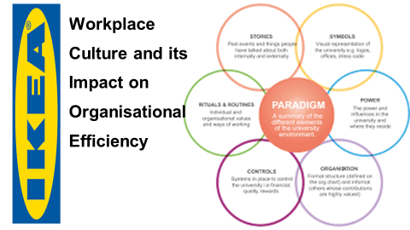

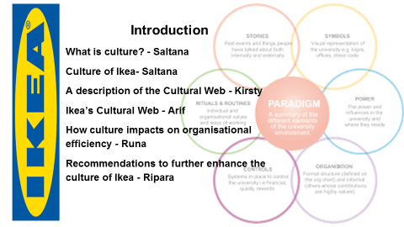
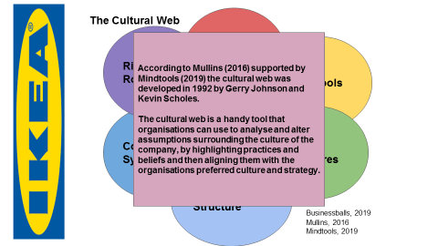
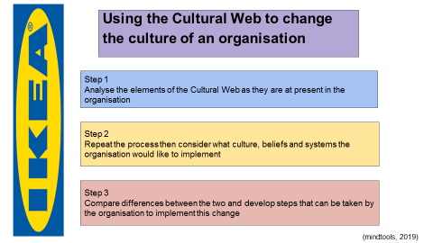

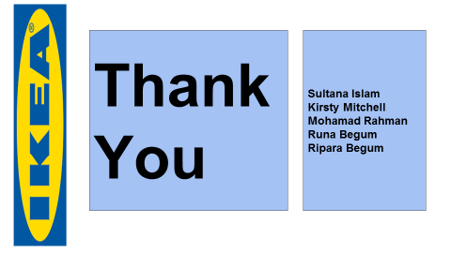
According to Scholes and Johnson (1992), cited by Businessballs (2019) and supported by Mullins (2016) the Cultural Web is a useful tool for analyzing and altering assumptions surrounding the culture of a company. It can be used to highlight specific practices and beliefs, and to subsequently align them with your company’s preferred culture and strategy.
The Cultural Web, developed by Gerry Johnson and Kevan Scholes in 1992, provides an approach for looking at and changing your organization's culture. Using it, you can expose cultural assumptions and practices, and set to work aligning organizational elements with one another, and with your strategy (Mindtools, 2019).
According to Scholes and Johnson (1992), cited by Businessballs (2019) and supported by Mullins (2016) the Cultural Web is a useful tool for analyzing and altering assumptions surrounding the culture of a company. It can be used to highlight specific practices and beliefs, and to subsequently align them with your company’s preferred culture and strategy.

The Elements
Johnson and Scholes identified six distinct but interrelated elements which contribute to what they called the “paradigm”, equivalent to the pattern of the work environment, or the values of the organization. They suggested that each may be examined and analyzed individually to gain a clearer picture of the wider cultural issues of an organization. The six contributing elements (with example questions used to examine the organization at hand) are as follows:

Symbols

This is the visual representation of the company; how they appear to both employees and individuals on the outside. It includes logos, office spaces, dress codes and sometimes advertisements.

· What kind of image is associated with the company from the outside?

· How do employees and managers view the organization?

· Are there any company-specific designs or jargon used?

· How does the organization advertise itself?

Very Swedish
Big blue building
Logo same colors as Swedish flag - blue and yellow

Maze like
Flat pack furniture
Idea

A diverse workplace where you feel a sense of belonging
Working at the IKEA Group means that you are part of an inspiring, fun, and fast-paced environment. We’re the world’s largest home furnishing retailer, with more than 137,000 co-workers and operates in 30 countries, but we value working in a diverse and inclusive environment. Here you can always be yourself – in fact we actively encourage it!

At IKEA, we invite you to bring your whole self to work! We respect each other, our differences, and are curious and open-minded. So, no matter where you work in the world, you’ll most likely rub shoulders with a diverse group of people – with different backgrounds, skills, and with positive attitudes.

We provide equal opportunities in recruitment and development to all people – regardless of age, gender identity, sexual orientation, physical ability, ethnicity, race, nationality, religion, or any other dimension of their identity. We believe that creating an inclusive workplace is everyone’s responsibility (Ikea.com 2019).
IKEA the wonderful everyday
Power Structures

This is the genuine power structures and responsible individuals within the organization. It may refer to a few executives, the CEO, board members, or an entire managerial division. These individuals are those who hold the greatest influence over decisions, and generally have the final say on major actions or changes.

· Who holds the power within the organization?

· Who makes decisions on behalf of the company?

· What are the beliefs and culture of those as the top of the business?

· How is power used within the organization?

Stories and Myths

These are the previous events – both accurate and not – which are discussed by individuals within and outside the company. Which events and people are remembered by the company indicates what the company values, and what it chooses to immortalize through stories?

· What form of company reputation is communicated between customers and stakeholders?

· What stories do people tell new employees about the company?

· What do people know about the history of the organization?

· What do these stories say about the culture of the business?

Organization Structures

This refers to both the hierarchy and structure designated by the organization. Alongside this, Johnson and Scholes also use it to refer to the unwritten power and influence that some members may exert, which also indicate whose contributions to the organization are most valued by those above them.

· How hierarchical is the organization?

· Is responsibility and influence distributed in a formal or informal way?

· Where are the official lines of authority?

· Are there any unofficial lines of authority?

Control Systems

These are the systems and pathways by which the organization is controlled. This can refer to many things, including financial management, individual performance-based rewards (both measurement and distribution) and quality-control structures.

· Which processes are strongly and weakly controlled?

· In general, is the company loosely or tightly controlled?

· Are employees rewarded or punished for performance?

· What reports and processes are used to keep control of finance, etc.?

Rituals and Routines

This refers to the daily actions and behaviors of individuals within the organization. Routines indicate what is expected of employees on a day-to-day basis, and what has been either directly or indirectly approved by those in managerial positions.

· What do employees expect when they arrive each day?

· What experience do customers expect from the organization?

· What would be obvious if it were removed from routines?

· What do these rituals and routines say about Organisational beliefs?

According to Essays, (2016) Kamprad’s shopping at local stores and travelling in the economy class, whilst his employees following the suit, are examples of their simplicity and cost-conscious tradition.
Cultural Web to Change
According to MindTools, (2019) the first step of changing the culture of the organization is to analyses elements of the Cultural Web as they are in the present. The next step is to repeat the process, examining each element, but this time considering what one would like the culture, beliefs and systems to be. This can then subsequently be compared with the ideal culture, and the differences between the two can be used to develop achievable steps towards change within the company. One will likely only then realize the true strengths and weaknesses of the organisations’ current culture, what the various hinderances are to growth, and how to go about changing specific elements to develop and achieve success (mindtools, 2019).

A new strategy can evolve from this by looking at introducing new beliefs, and prioritizing positive reinforcement of current, successful ones. Hopefully, by integrating this system of analysis, managers can find themselves able to break free of ritual and belief systems within a company to achieve real change and innovation.

According to Scholes and Johnson (1992), cited by Businessballs (2019) and supported by Mullins (2016) the Cultural Web is a useful tool for analysing and altering assumptions surrounding the culture of a company. It can be used to highlight specific practices and beliefs, and to subsequently align them with your company’s preferred culture and strategy.
The Elements
Johnson and Scholes identified six distinct but interrelated elements which contribute to what they called the “paradigm”, equivalent to the pattern of the work environment, or the values of the organisation. They suggested that each may be examined and analysed individually to gain a clearer picture of the wider cultural issues of an organisation. The six contributing elements (with example questions used to examine the organisation at hand) are as follows:
Symbols
This is the visual representation of the company; how they appear to both employees and individuals on the outside. It includes logos, office spaces, dress codes and sometimes advertisements.
· What kind of image is associated with the company from the outside?
· How do employees and managers view the organisation?
· Are there any company-specific designs or jargon used?
· How does the organisation advertise itself?

Very Swedish
Big blue building
Logo same couloirs as Swedish flag - blue and yellow
Maze like
Flat pack furniture
Idea
A diverse workplace where you feel a sense of belonging
Working at the IKEA Group means that you are part of an inspiring, fun, and fast-paced environment. We’re the world’s largest home furnishing retailer, with more than 137,000 co-workers and operates in 30 countries, but we value working in a diverse and inclusive environment. Here you can always be yourself – in fact we actively encourage it!
At IKEA, we invite you to bring your whole self to work! We respect each other, our differences, and are curious and open-minded. So, no matter where you work in the world, you’ll most likely rub shoulders with a diverse group of people – with different backgrounds, skills, and with positive attitudes.
We provide equal opportunities in recruitment and development to all people – regardless of age, gender identity, sexual orientation, physical ability, ethnicity, race, nationality, religion, or any other dimension of their identity. We believe that creating an inclusive workplace is everyone’s responsibility (Ikea.com 2019).
IKEA the wonderful everyday
Power Structures
This is the genuine power structures and responsible individuals within the organisation. It may refer to a few executives, the CEO, board members, or an entire managerial division. These individuals are those who hold the greatest influence over decisions, and generally have the final say on major actions or changes.
· Who holds the power within the organisation?
· Who makes decisions on behalf of the company?
· What are the beliefs and culture of those as the top of the business?
· How is power used within the organisation?
Stories and Myths
These are the previous events – both accurate and not – which are discussed by individuals within and outside the company. Which events and people are remembered by the company indicates what the company values, and what it chooses to immortalise through stories?
· What form of company reputation is communicated between customers and stakeholders?
· What stories do people tell new employees about the company?
· What do people know about the history of the organisation?
· What do these stories say about the culture of the business?

Organisation Structures
This refers to both the hierarchy and structure designated by the organisation. Alongside this, Johnson and Scholes also use it to refer to the unwritten power and influence that some members may exert, which also indicate whose contributions to the organisation are most valued by those above them.

· How hierarchical is the organisation?
· Is responsibility and influence distributed in a formal or informal way?
· Where are the official lines of authority?
· Are there any unofficial lines of authority?

Control Systems
These are the systems and pathways by which the organisation is controlled. This can refer to many things, including financial management, individual performance-based rewards (both measurement and distribution) and quality-control structures.

· Which processes are strongly and weakly controlled?
· In general, is the company loosely or tightly controlled?
· Are employees rewarded or punished for performance?
· What reports and processes are used to keep control of finance, etc?

Rituals and Routines
This refers to the daily actions and behaviours of individuals within the organisation. Routines indicate what is expected of employees on a day-to-day basis, and what has been either directly or indirectly approved by those in managerial positions.
· What do employees expect when they arrive each day?
· What experience do customers expect from the organisation?
· What would be obvious if it were removed from routines?
· What do these rituals and routines say about organisational beliefs?
According to Essays, (2016) Kamprad’s shopping at local stores and travelling in the economy class, whilst his employees following the suit, are examples of their simplicity and cost-conscious tradition.
Cultural Web to Change
The first step of changing the culture of the organisation is to analyse elements of the Cultural Web as they are in the present. The next step is to repeat the process, examining each element, but this time considering what one would like the culture, beliefs and systems to be. This can then subsequently be compared with the ideal culture, and the differences between the two can be used to develop achievable steps towards change within the company. One will likely only then realise the true strengths and weaknesses of the organisation’s current culture, what the various hinderances are to growth, and how to go about changing specific elements to develop and achieve success (mindtools, 2019).
A new strategy can evolve from this by looking at introducing new beliefs, and prioritising positive reinforcement of current, successful ones. Hopefully, by integrating this system of analysis, managers can find themselves able to break free of ritual and belief systems within a company to achieve real change and innovation.

References
Businessballs, (2019) Cultural Web - Johnson and Scholes, 1992. [online]. Available from: https://www.businessballs.com/strategy-innovation/cultural-web-johnson-scholes/. (Accessed 27/05/2019).
Mindtools, (2019). The Cultural Web Aligning Your Organization's Culture with Strategy. [online] Available from: https://www.mindtools.com/pages/article/newSTR_90.htm. (Accessed 27/05/2019).
Mullins, L. (2016) Management and Organisational Behaviour
The Leadership Centre, (2019) Cultural Web [online]. Available from: https://www.leadershipcentre.org.uk/artofchangemaking/theory/cultural-web/. (Accessed 19/06/2019).
Essays. (2018). IKEAs Cultural Web Model. [online]. Available from: https://www.ukessays.com/essays/marketing/ikeas-cultural-web-model-marketing-essay.php?vref=1. (Accessed 10/06/2019).

