Ryan Morris
Student No: 1550957
1550957@student.uwtsd.ac.uk
Software Engineering HND
L4 - Computer Architecture and Operating Systems
(Operating Systems)
(ACCA4022)
03/04/2023

Contents
Introduction 2
Task 1 - Key functions of general Operating Systems 3
Task 2 – Use of Windows OS CLI commands 5
Task 3 – Use of Linux OS CLI commands 10
Task 4 – Use of Windows OS (batch) scripts 15
Task 5 – Use of Linux OS scripts (Bash) 18
Appendices 21
Conclusion 21
OS Types - OS Tutorial 1 Activity 21
Interacting with LinkedIn Learning – PowerShell 7 Essential Training 22
References 23

Introduction

The following assignment is the amalgamation of my studying and research completed along side in class tutorials on Operating Systems. I began by studying key features as well as different types of operating systems and then moved on to basic scripting, allowing me to create simple programs to prompt users for information and utilise for loops etc. The module has greatly improved my knowledge of the CLI and how to navigate the file structures in different OS’s using the command line which in time will allow me to become more proficient at performing key tasks faster, without using the GUI.

Task 1 - Key functions of general Operating Systems

The key function of an operating system is to manage the software and hardware on a PC, as well as providing an interface for users. It handles input and output, and controls file, memory and process management. It also controls hardware devices, for example, printers.

Kernel – The kernel is a central program which provides services for all parts of the operating system. It sits between the computer’s hardware and the GUI. The kernel is responsible for task, disk and memory management and is loaded the entire time a PC is on. “The kernel is the primary interface between the hardware and the processes of a computer”. [1]

Virtual Memory - Virtual memory is an OS process which utilises both hardware and software to ‘create’ more memory when physical memory is low. Virtual memory temporarily transfers data from RAM to disk storage to free up memory on the RAM to allow the PC to function as normal. A disadvantage of using VM is that is can take a bit longer to switch between applications using virtual memory. [2]

A process or job scheduler is an OS function which handles how processes are run on the CPU. It allows multiple processes to run simultaneously while managing how the CPU shares resources. The figure below is a typical job queue.
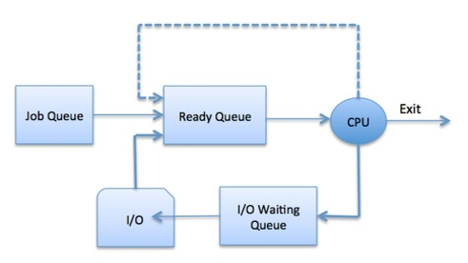 [3]

A thread is job which the computer is processing, multithreading is when an application is processing more than one job (thread) at once, an example of this would be having multiple tabs open in a web browser, each tab can be a different thread. [4]

Context switching is when the PC runs two or more threads on the same CPU core (multithreading) Rapidly switching between each thread, it is also known as concurrent programming, allowing the PC to run multiple processes at once.

Finally, security is an important function of an OS. OS can help protect the computer system as they can provide antivirus protection as well as come with a built-in firewall to filter traffic coming into the system for unusual activity. OS can also provide authentication via usernames and passwords, preventing unauthorised persons from accessing the computer. [5]

Task 2 – Use of Windows OS CLI commands

cd.. moves you up one level of the directory tree. [6]
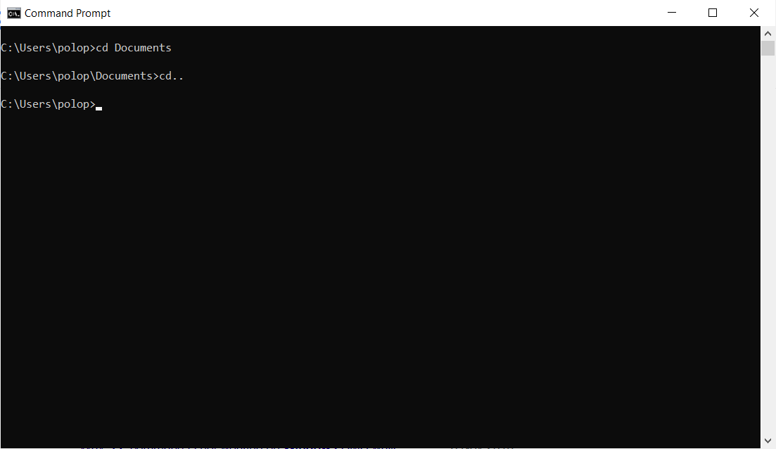

cd../.. moves you up 2 levels of the directory tree.
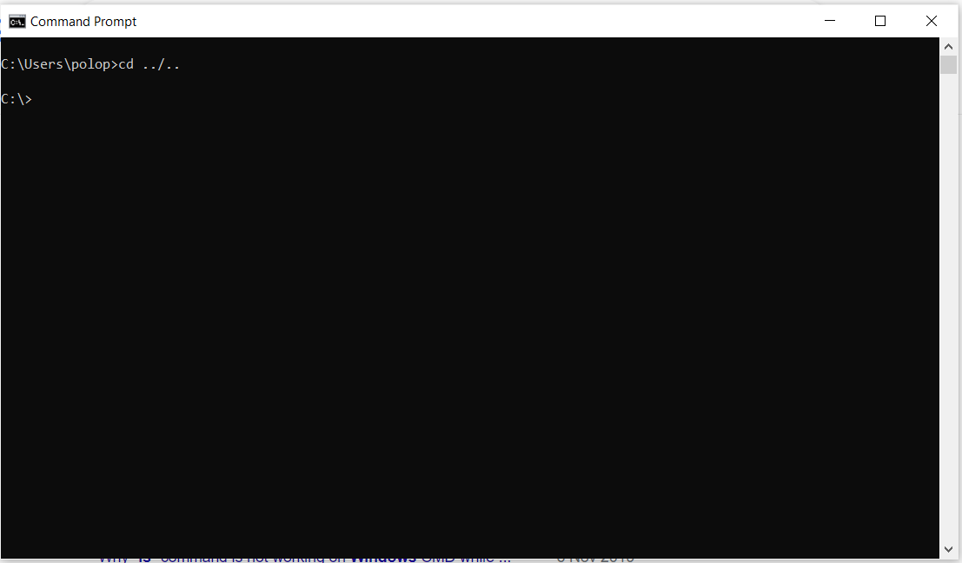

cls – This is used for when you have too much information on your command prompt, it clears your screen. [7]
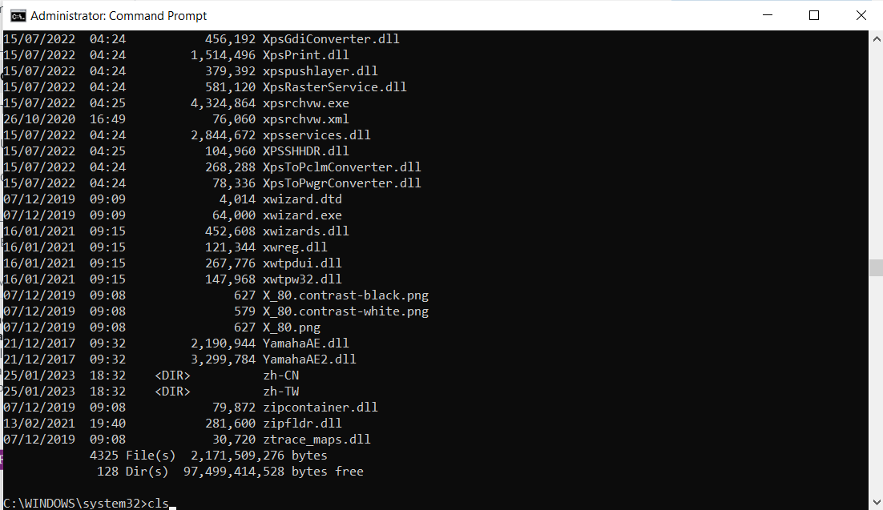

mkdir – makes a folder in the current directory named whatever is typed after ‘mkdir’
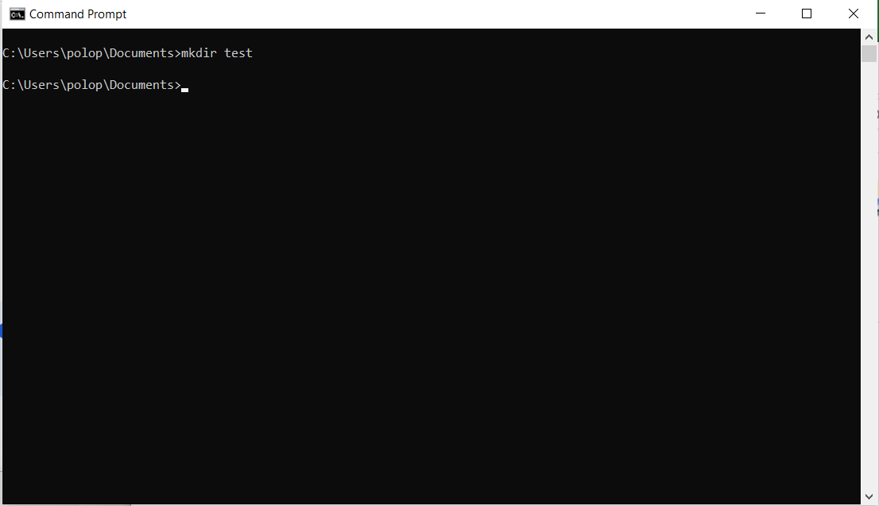

rmdir – removes a folder in the current directory named whatever is typed after ‘rmdir’
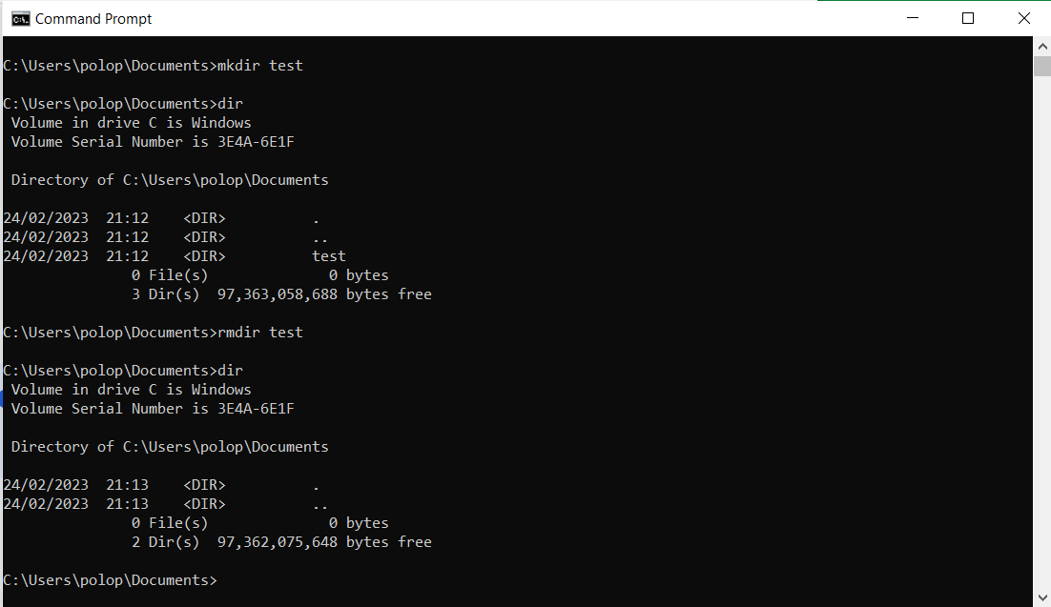

whoami – prints your username on the command prompt screen
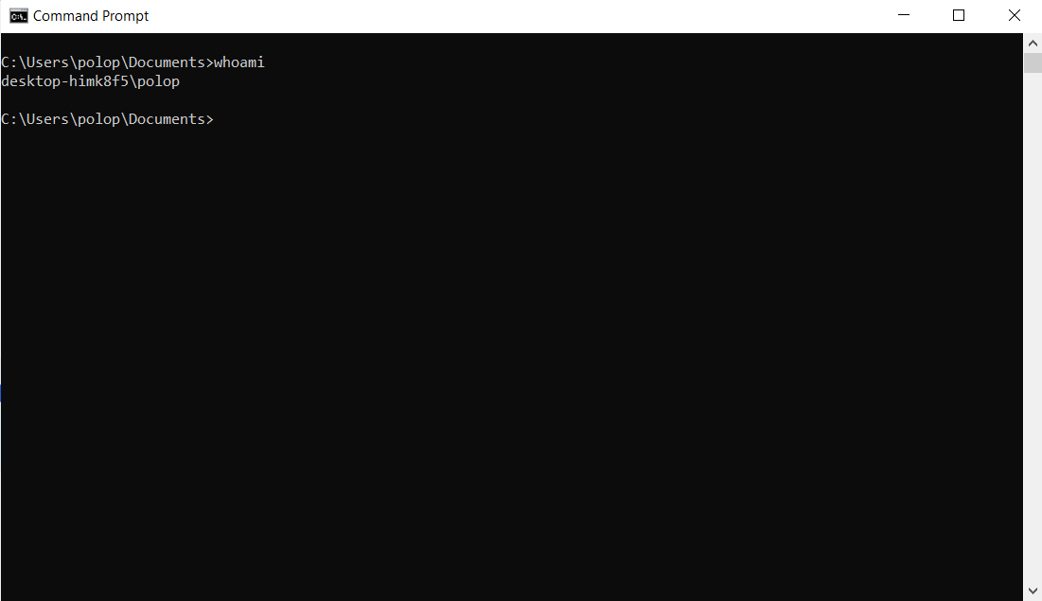

Tasklist – this command shows which processes are currently running on the machine
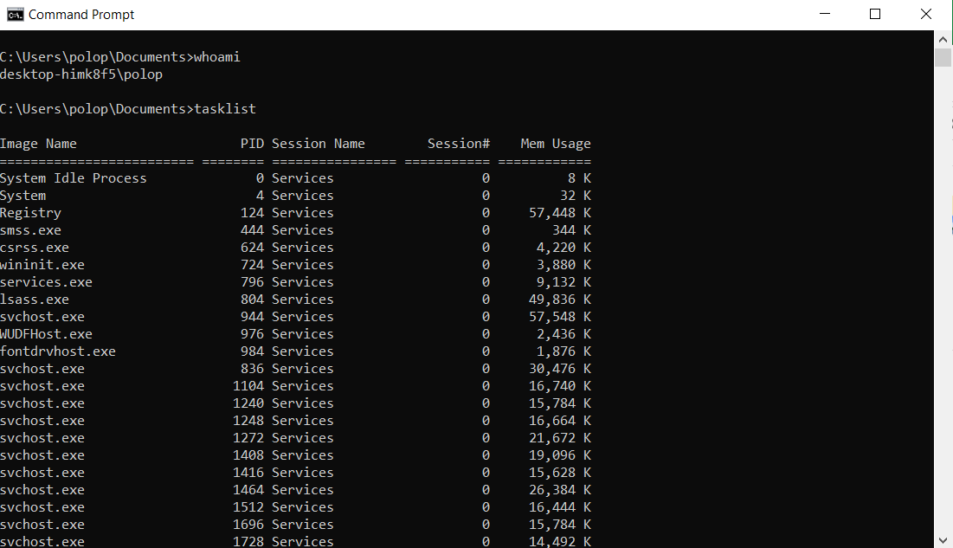

color – used to change the background or text colour of your command prompt, this uses the hexadecimal number scheme. [8]
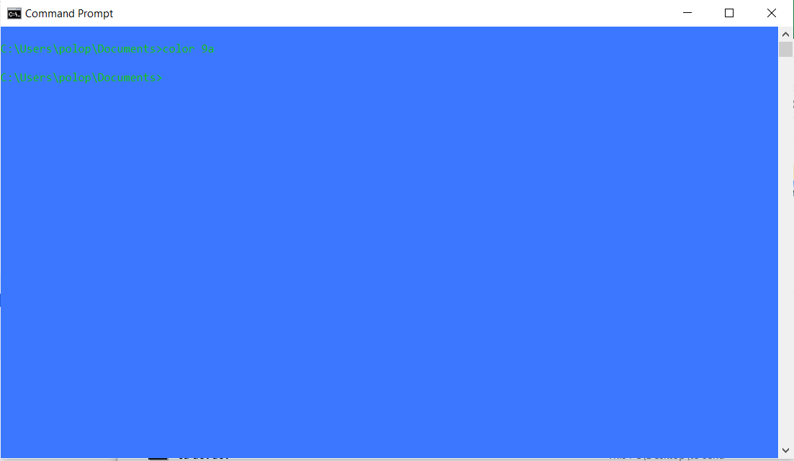

Help – This command gives a list of command prompt commands and a brief description.
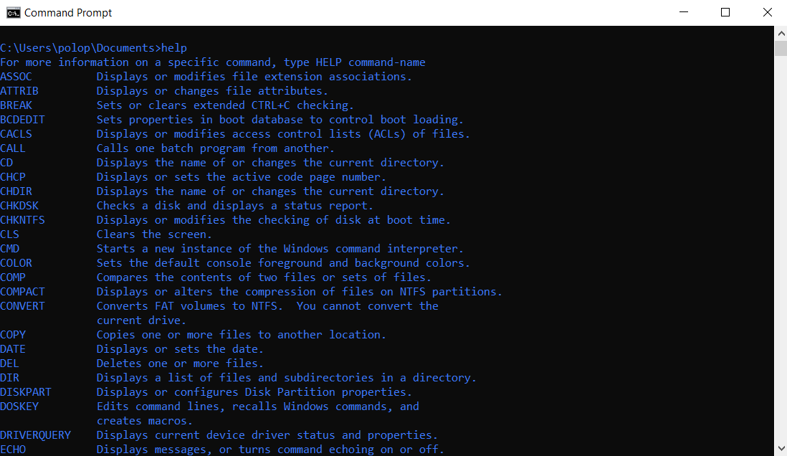

Task 3 – Use of Linux OS CLI commands

Pwd – Print working directory shows where in the file structure you are current located. [9]
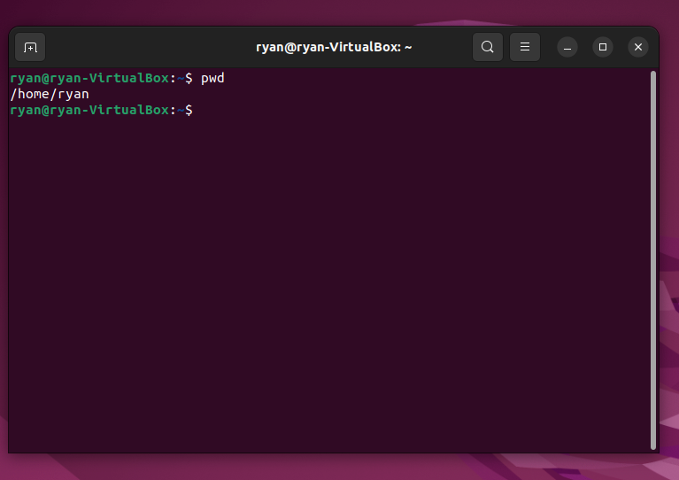

Ls – List shows the contents of the current directory [10]
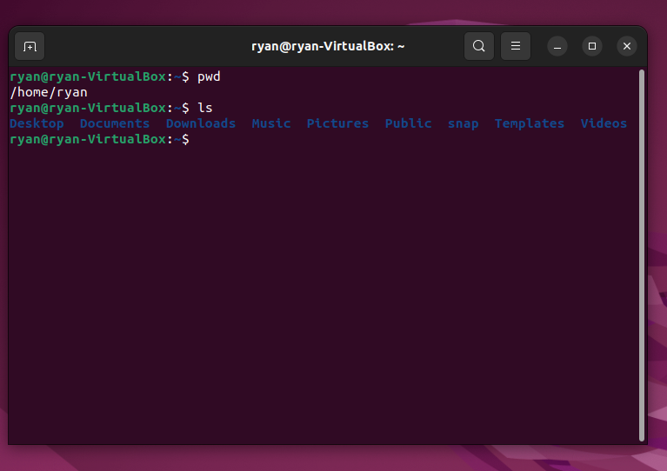

Cd- Change directory, allows you to navigate to a different directory
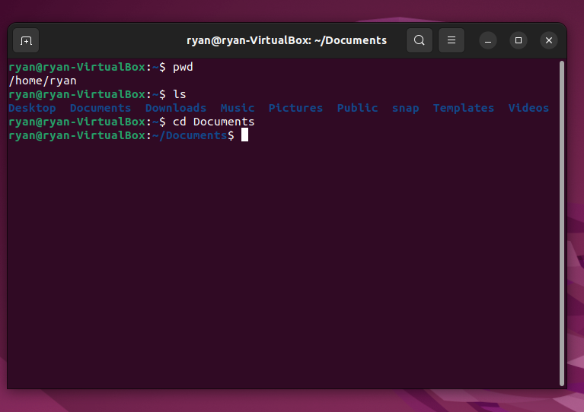

Cd .. – Moves you back ‘up’ the file structure as shown in image.
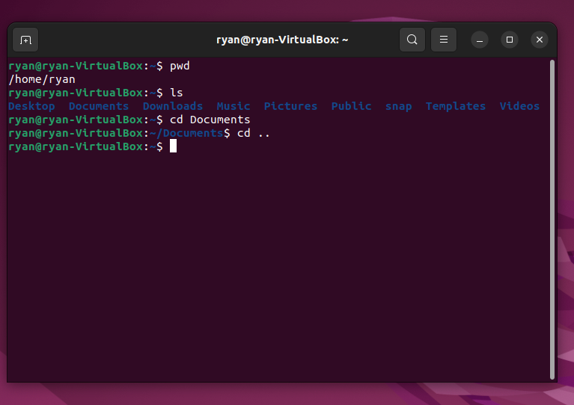

Clear – This clears your terminal window if it becomes too cluttered (image prior to executing command).
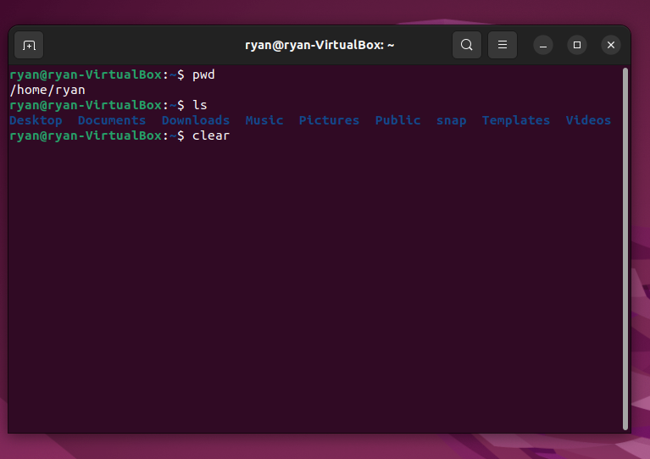

Mkdir – Make Directory creates a directory within the current directory. [11]
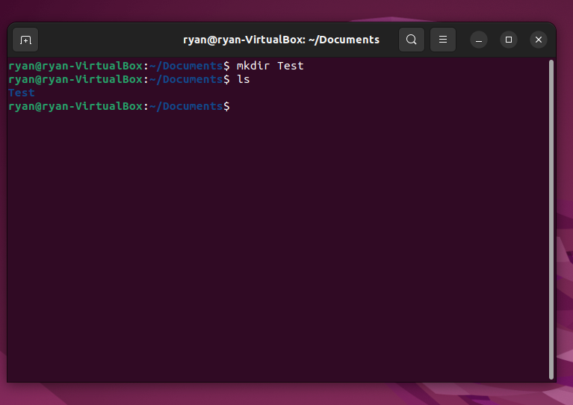

Rmdir – Remove Directory deletes the selected directory.
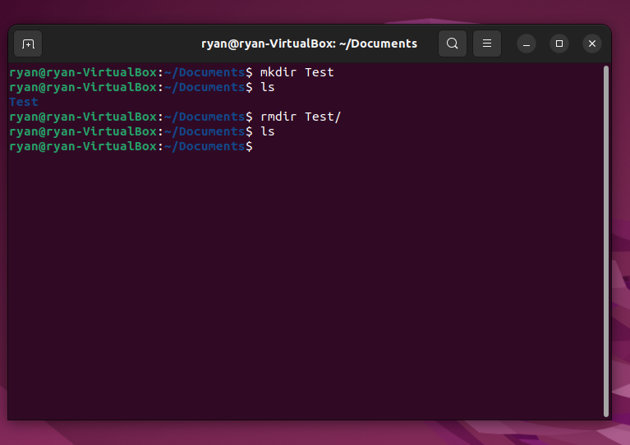

Whoami – This prints the current user
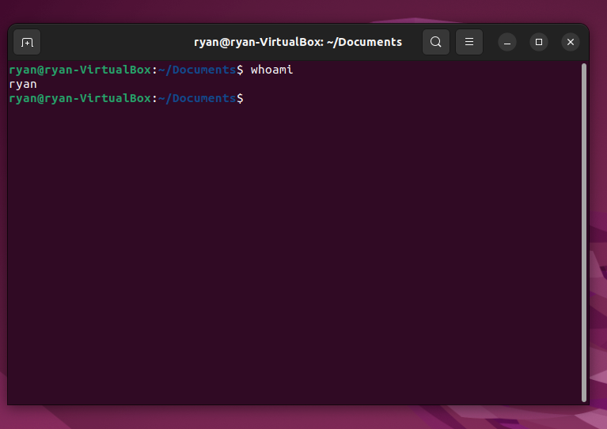

Help – This displays lots of useful commands which can be used within the terminal.
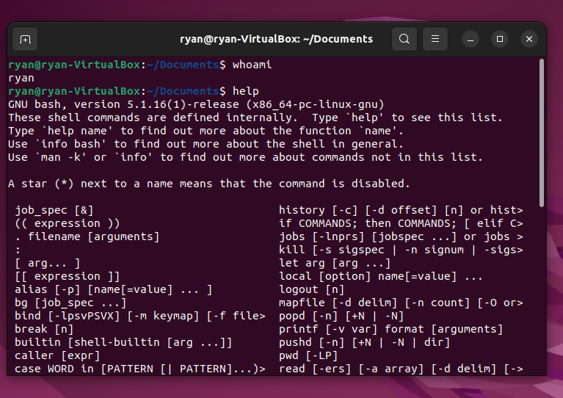

Task 4 – Use of Windows OS (batch) scripts

I have created a series of batch programs to practice using variables, functions, arithmetic etc using batch scripts.

Using arrays, for loops and if/else statements in a batch script, note I was having trouble ‘echoing’ the colours so had to utilise the setlocal enabledelayedexpansion command [12]:
@echo off
setlocal enabledelayedexpansion

echo Which of the following is your favourite colour??

set "colour[0]=Red"
set "colour[1]=Orange"
set "colour[2]=Green"
set "colour[3]=Blue"
set "colour[4]=Pink"
set "colour[5]=Purple"
set "colour[6]=Other"

for /l %%i in (0,1,6) do (
echo [%%i] !colour[%%i]!
)

set /p choice=Enter the number of your favourite colour:

if "%choice%"=="6" (
set /p UserColour=Enter your favourite colour:
set "FavColour=!UserColour!"
) else (
set "FavColour=!colour[%choice%]!"
)

echo Your favourite colour is: %FavColour%
pause
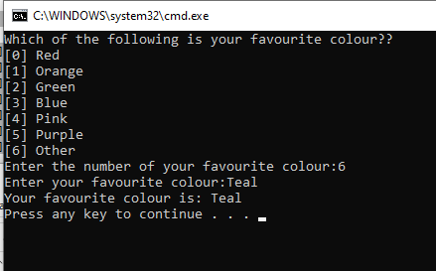

Next I utilised a function to complete some simple maths:
@echo off

echo Lets do some maths...

set /p num1=Enter the first number:
set /p num2=Enter the second number:

call :maths %num1% %num2%

echo The sum of %num1% and %num2% is %result%
pause

:maths
set /a result=%1+%2

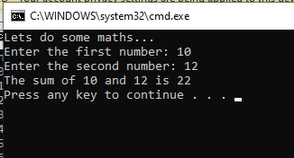

I then created a for loop which will count up to a number defined by the user in 2’s:
@echo off

echo Pick a number and I will count up to it in 2s
set /p userNo="What number would you like me to count to in 2s?"

echo userNo=%userNo%

for /L %%v in (0, 2, %userNo%) do (
echo %%v
)

Pause

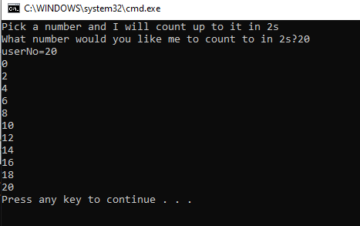

I created a script to ask a user what their name and age is and included a function including an if statement to ensure the user is 16 year old or older:
@echo off

set /p name="What is your name? "

:input_age
set /p age="What is your age? - note you must be over 16 years old to run this script "

if "%age%"=="" (
echo Please enter your age.
goto input_age
) else if %age% LSS 16 (
echo You must be at least 16 years old.
goto input_age
)

echo Your name is %name% and your age is %age%.
pause

Task 5 – Use of Linux OS scripts (Bash)

Below is my code for a simple RSVP script for a wedding:

#!bin/bash

echo Wedding RSVP

echo "What is your name?"
read name
echo "hello, $name"

read -p "Are you coming to the wedding? (yes/no)" response

if [[ "$response" == "No" || "$response" == "no" || "$response" == "N" || "$response" == "n" || "$response" == "NO" ]]; then
echo "That's a shame $name, thanks for letting us know."
exit 1

else
echo "That's great $name, we're looking forward to seeing you!"
fi

read -p "How many plus 1s are you bringing with you?" guests
party=$((1 + guests))
if (( guests >= 1 )); then
echo "Great, you are coming as a party of $party"
else
echo "You'll have a great time by yourself!"
fi

for ((i=1;i<=$party;i++)); do

food_choice()
{
echo "Please select which meal choice you would prefer:"
echo $1
echo $2
echo $3
echo $4
read choice
}

food_choice "1. Beef" "2. Chicken" "3. Vegetarian" "4. Pork"

case $choice in
1) echo "Guest $i has selected Beef.";;
2) echo "Guest $i has selected Chicken.";;
3) echo "Guest $i has selected Vegetarian.";;
4) echo "Guest $i has selected Pork.";;
*) echo "Invalid choice. Please start over.";;
esac
done

goodbye()
{
echo "Thanks for RSVPing."
}

goodbye
[13]
[14]

Here is the script running through:
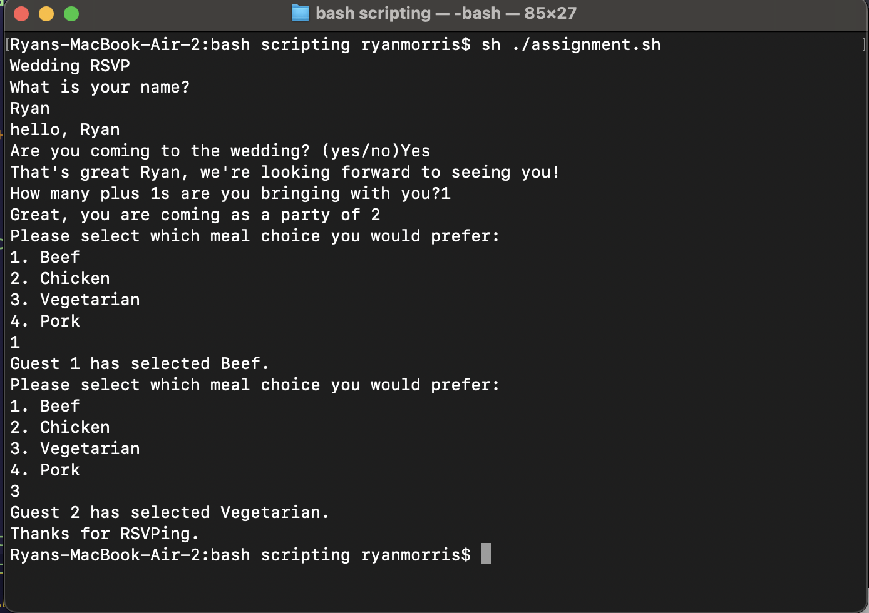

Here is the script if I cut it short and say I’m not going to the wedding:
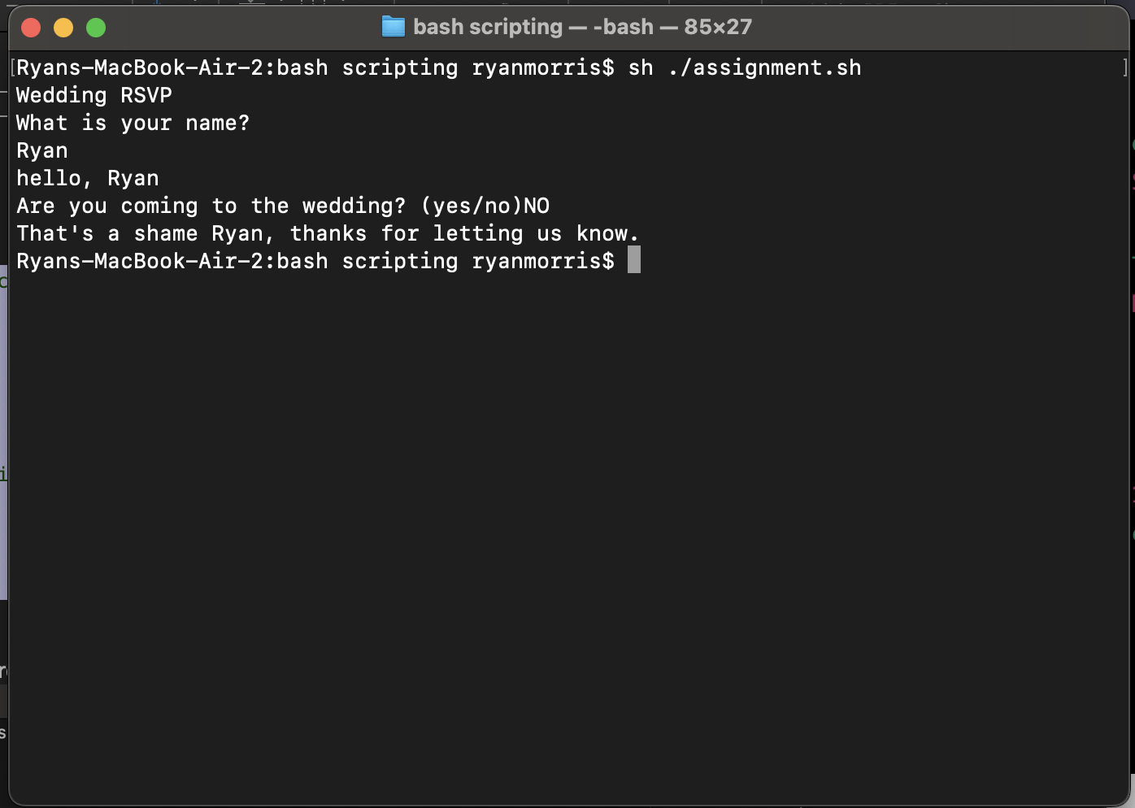

Appendices

Conclusion

I have learnt a lot of important information during this Operating Systems module, including the differences between general, embedded, network and real time operating systems. My general OS knowledge has greatly improved and I can confidently identify the key aspects and features of operating systems. I am now very interested in the time saving capabilities of utilising the CLI in various operating systems. Going forward I am going to build on my new knowledge of Bash/Bat/PowerShell scripting to create more useful and helpful scripts.

OS Types - OS Tutorial 1 Activity

A general operating system is an operating system that typically runs on a desktop or laptop computer which is responsible for the user interface and allocating memory as well as input/output control. [15] Common versions of operating systems include Windows, Mac OS and Linux.
A network operating system (also known as NOS) used primarily to link several computers and devices to a network and share that networks resources, such as data, applications, printers and files. [16]
Embedded operating systems are operating systems which are loaded onto devices rather than computers. For instance an ATM machine will use an embedded OS which will enable the software which sits on top of the OS communicate the hardware of the ATM machine. Embedded OS are typically more simple than a general OS and perform fewer tasks, taking the ATM example, the embedded OS will allow the software to read the users debit card information and communicate with the hardware ‘under’ the OS to dispense money. Other applications of embedded OS include traffic lights, POS terminals, elevators and even mobile phones. [17]
Real Time Operating Systems (RTOS) are used in manufacturing machines around the world and often have no GUI. As they are used in manufacturing, they need to be lightweight and be capable of performing precise, reliable and repeatable actions within a few hundred milliseconds. [18] E
Mobile OSs are operating systems which run on mobile devices such as mobile phones, tablets, smart watches etc. The two most common mobile operating systems are Android and iOS although there are many other. Some advantages for mobile Oss are that they have the ability to run multiple tasks at once and allow the freedom as they are loaded onto mobile devices. [19]

Interacting with LinkedIn Learning – PowerShell 7 Essential Training

To complement my studies I have been working through a LinkedIn Learning course on PowerShell. This stood me in good stead for our in class tutorial on PowerShell and also gave me a good understanding of basic PowerShell commands, many of which are transferrable to Command Prompt and have helped me with this assignment. [20]

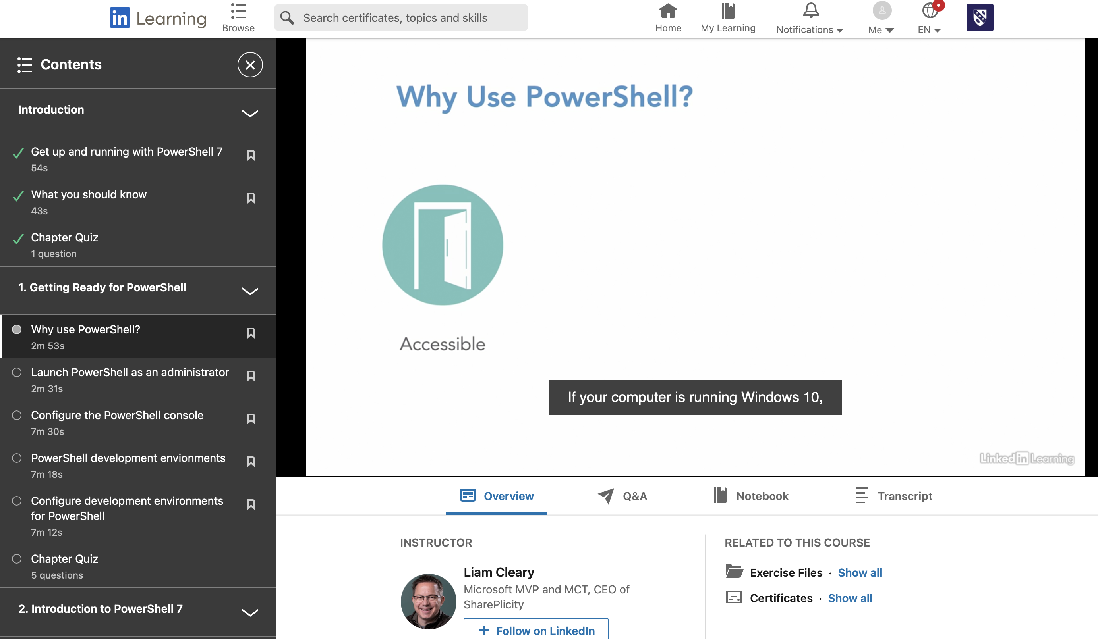

References

[1] | baeldung, "What is an OS Kernel?," baeldung, 9 11 2022. [Online]. Available: https://www.baeldung.com/cs/os-kernel. [Accessed 02 15 2023].
[2] | S. P. S. L. Alexander S. Gillis, "What is Virtual Memory?," TechTarget, [Online]. Available: https://www.techtarget.com/searchstorage/definition/virtual-memory#:~:text=Virtual%20memory%20is%20a%20common,(RAM)%20to%20disk%20storage. [Accessed 12 02 2023].
[3] | Tutorials Point, "OS - Process Scheduling," Tutorialspoint, [Online]. Available: https://www.tutorialspoint.com/operating_system/os_process_scheduling.htm. [Accessed 15 02 2023].
[4] | GeekForGeeks, "Thread in Operating System," GeenforGeeks, [Online]. Available: https://www.geeksforgeeks.org/thread-in-operating-system/. [Accessed 15 02 2023].
[5] | study.com, "The Role of Operating Systems in Security," study.com, [Online]. Available: https://study.com/academy/lesson/the-role-of-operating-systems-in-security.html#:~:text=It%20has%20user%20authentication%20methods,traffic%20entering%20into%20the%20system. [Accessed 15 02 2023].
[6] | IBM, "Changing to antother directory (cd command)," IBM, [Online]. Available: https://www.ibm.com/docs/en/aix/7.2?topic=directories-changing-another-directory-cd-command. [Accessed 20 02 2023].
[7] | Wikipedia, "CLS (command)," Wikipedia, [Online]. Available: https://en.wikipedia.org/wiki/CLS_(command)#:~:text=In%20computing%2C%20CLS%20(for%20clear,any%20output%20generated%20by%20them.. [Accessed 20 02 2023].
[8] | VasuDev4, "Color cmd command," GeeksForGeeks, [Online]. Available: https://www.geeksforgeeks.org/color-cmd-command/. [Accessed 20 02 2023].
[9] | IBM, "pwd Command," IBM, [Online]. Available: https://www.ibm.com/docs/en/aix/7.1?topic=p-pwd-command. [Accessed 25 02 2023].
[10] | Sindhu, "Linux "ls" Command," Atatus, [Online]. Available: https://www.atatus.com/blog/ls-command-in-linux-with-example/. [Accessed 25 02 2023].
[11] | G. Jevtic, "How to Create a Directory in Linux with mkdir Command," Pheonixnap, [Online]. Available: https://phoenixnap.com/kb/create-directory-linux-mkdir-command. [Accessed 25 02 2023].
[12] | SS64, "EnableDelayedExpansion," SS64, [Online]. Available: https://ss64.com/nt/delayedexpansion.html. [Accessed 30 03 2023].
[13] | V. Gite, "Bash For Loop Examples," CyberCiti, 20 02 2023. [Online]. Available: https://www.cyberciti.biz/faq/bash-for-loop/. [Accessed 2023 03 22].
[14] | Linuxize, "Bash Case Statement," Linuxize, 22 11 2019. [Online]. Available: https://linuxize.com/post/bash-case-statement/. [Accessed 22 03 2023].
[15] | The Free Dictionary, "General-Purpose Operating Systems," The Free Dictionary, [Online]. Available: https://encyclopedia2.thefreedictionary.com/General-purpose+operating+system. [Accessed 02 02 2023].
[16] | Cyber Threat Portal, "Example of Network Operating System," Cyber Thread Portal, 07 11 2021. [Online]. Available: https://cyberthreatportal.com/example-of-network-operating-system/. [Accessed 06 02 2023].
[17] | B. Lutkevich, "embedded operating systems," TechTarget, [Online]. Available: https://www.techtarget.com/iotagenda/definition/embedded-operating-system. [Accessed 04 02 2023].
[18] | Windriver, "What is a Real-Time Operating System (RTOS)?," WNDRVR, [Online]. Available: https://www.windriver.com/solutions/learning/rtos. [Accessed 04 02 2023].
[19] | P. Narasimman, "Types of Operating System," Knowledge Hut, 24 01 2023. [Online]. Available: https://www.knowledgehut.com/blog/web-development/types-of-operating-system. [Accessed 06 02 2023].
[20] | L. Cleary, "LinkedIn Learning," LinkedIn, 17 12 2020. [Online]. Available: https://www.linkedin.com/learning/powershell-7-essential-training/why-use-powershell?autoSkip=true&autoplay=true&resume=false&u=77966930. [Accessed 28 02 2023].

