

LEVEL 5

Burger King
MODULE CODE: LCBB5003
MANAGEMENT ECONOMICS

ASSESSMENT TYPE: ASSIGNMENT
ASSESSMENT/COMPONENT: 1
COMPONENT WEIGHTING: 50%
WORD COUNT: 2 482 Words
SUBMISSION DETAILS:
Name: Cosmin Adrian Mitu
Student Number: 2021613

Table of Contents

1. Introduction 3
2. Question 1 3
2.1. Overview of the chosen product and its related company 3
2.2. The reason behind choosing Burger King 4
3. Question 2 4
3.1. Introduction to the demand-supply equilibrium 4
3.2. Determinants of the demand for burgers 5
3.2.1. Price of the substitutes 6
3.2.2. Price of the complements 7
3.2.3. Consumer Income 7
3.2.4. Consumers’ tastes & preferences 8
3.2.5. Consumer’s future price expectation 8
3.2.6. Demographics (Number of consumers) 9
4. Question 3 9
4.1. Substitution effect in defining the demand elasticity 9
4.2. Income effect in defining the demand elasticity 10
4.3. The pricing policy of Burger King 11
5. Conclusion 12
References 13

Introduction
The purpose of this report is to study different economic concepts in the context of global business and the use of these concepts in the managerial decision-making of companies. This report consists of 3 parts that are to be assessed. Firstly, a brief overview of the company and its chosen product will be provided besides providing the reasons behind choosing that business and product for this assessment. In the second question, the determinants of the demand for a commodity will be studied in the context of the chosen business. And, finally, the factors affecting the price elasticity of demand and income elasticity of that product will be studied based on substitution effect and income effects.
This paper is based on various concepts of managerial economics. In this discipline of Economics, both business and economics-related ideas are brought together. Mainly the internal and external economic factors that can impact global businesses are analyzed by the managerial economics concepts. Both microeconomic and macroeconomic tools are used in this context. How those economic measures impact the decision-making of the management, an extension of growth and sustainability of the firms are also studied under this discipline (WallStreetMojo, 2022).

Question 1

Overview of the chosen product and its related company
The burger is one of the most popular fast-food items in the world and one of the most likable dishes as well. As Burger started to get more popular among the youth, some companies started their business based on the preparation and sale of this product. Burger King is one of those companies that have made hamburgers a world-wide famous fast-food item. The company from the USA is operating in multiple countries of the world and has several branches in respective countries. The company was first set up in 1953 by Keith Kramer and Mathew Burns initially while the current franchise of Burger King was founded by David Edgerton and James McLamore one year later. The company is currently headquartered in Florida of USA and the company has a total assets value of 4.94 billion US dollars till 2021 while the turnover was 1.81 billion US dollars. Other than hamburgers, the company is also equipped in preparing chicken french fries, soft drinks, Milkshakes, Desserts, etc. food items (Burger King, 2022). The company produces a kind of hamburger that is also referred to as its signature product. The name of that hamburger is 'Whopper'.

The reason behind choosing Burger King
Considering the global business environment of fast food, burgers have become everyone's favorite and almost the whole market has been taken over by hamburgers. Burger King is one of the top names in the fast-food market. The occurrence of the pandemic has changed the global business perspective and the change in market demand and supply has affected the financial outcomes of the company. Burger King has also changed its business strategies to meet the new demand-supply equilibrium of the fast-food market. All these economic aspects will be analyzed in this paper in the context of Burger King.

Question 2

Introduction to the demand-supply equilibrium
Demand and supply are the two basic forces of the market in the context of economics. The price and quantity that are to be purchased and sold after the mutual agreement of both buyers and sellers are determined by the demand-supply equilibrium of the market or the economy. The point at which the negatively sloped demand curve of a good intersects with the positively sloped supply curve of the good is termed the equilibrium point. This point is the combination of a particular price and quantity at which both customers and suppliers agreed to exchange that quantity of the product. The products that have a negatively sloped demand curve also have discriminating prices in the competitive market (Baker., 2003).
As the data for quantity demanded and quantity supplied as certain prices of the burgers of Burger King has not been accessed by the student, in-general data has been used to prepare the following demand-supply equilibrium to describe the concept.

Demand-supply equilibrium of Burgers at the Burger King
Price (£) | Quantity demanded | Quantity supplied
3 | 10 | 2
7 | 9 | 5
12 | 7 | 7
15 | 5 | 10
20 | 3 | 12

Using this data, the following demand-supply equilibrium module has been produced-
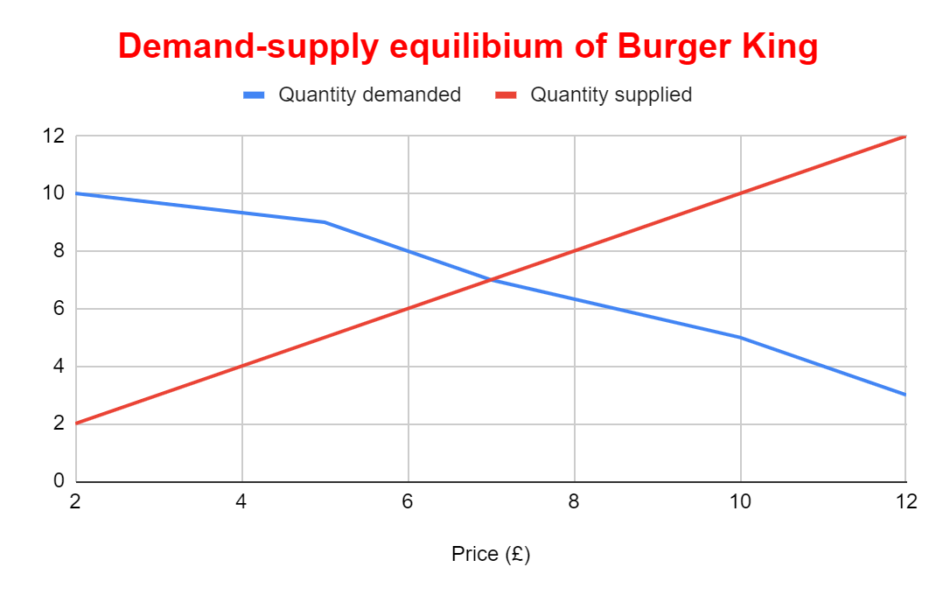
Fig. 1: A basic demand-supply equilibrium
(Source: Prepared by self, 2022)
This diagram reflects that the equilibrium quantity of burgers at Burger King is 7 and the equilibrium price is £7 at which those 7 units of burgers will get exchanged.

Determinants of the demand for burgers
After studying the demand-supply schedule of the market for burgers, in this section, the determinants of the demand for burgers will be addressed. These factors are also influential in addressing whether the demand for burgers will increase or decrease because of the effects of these factors.
    - Price of the substitutes
Substitutes are products that can be consumed in place of other products having almost identical features and utility but a different existence. In the books of economics, the demand for the main product goes up when the price of its substitute goods increases and the opposite happens when the price of the substitutes falls. Pizzas, French fries, etc. are some of the substitutes for hamburgers and in the context of Burger King, KFC, McDonald's, Hardee, and Luhby’s are some of the main alternatives of Burger King (Comparably, 2022).
McDonald’s, which is one of the main competitors of Burger King, has increased the price of its burgers by around 20%. On the other hand, Burger King has also increased the price of its burgers, but by around 10%. The cheapest cheeseburger from Burger King costs £0.99 now while the cost of the cheapest cheeseburger from McDonald’s is £1.19 (Food Menu Prices, 2022). So, surely the demand for burgers from Burger King will increase as it has been in the last 5 years.
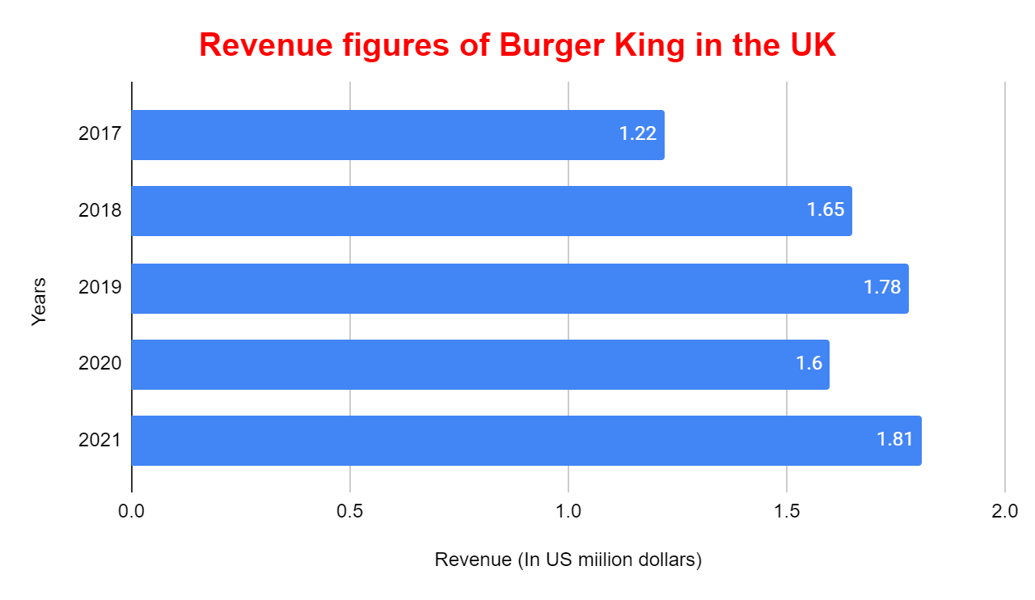
Fig. 2: Increase in sales of Burger King UK
(Source: Statista, 2022)

    - Price of the complements
The use of complements is also seen in the context of microeconomics and particularly in the demand modules of respective products. According to the books of managerial economics, an increase in the price of complements will reduce the demand for the actual product because complements are often consumed with the primary products. Cheese, sauce, and cold drinks are often regarded as complements of the Burgers of Burger Kings.
Different sources have showcased that the prices of cold drinks and other compliments have increased in the UK because of high inflation. Even the price of the burgers has increased as well. So, it is to be expected that the demand for burgers can fall shortly as well (Yahoo! Finance, 2022).
    - Consumer Income
The income of the consumers is one of the main determinants of the demand for food products. Fast food items such as burgers are not the daily necessary products that have to be purchased at any cost. Rather these are considered in the luxury items category. So, if the income of the consumers falls then the demand for burgers will get lower as well. Again, if the income of the people increases, they will most likely purchase luxury food items which would ultimately affect an increase in the demand for the products.
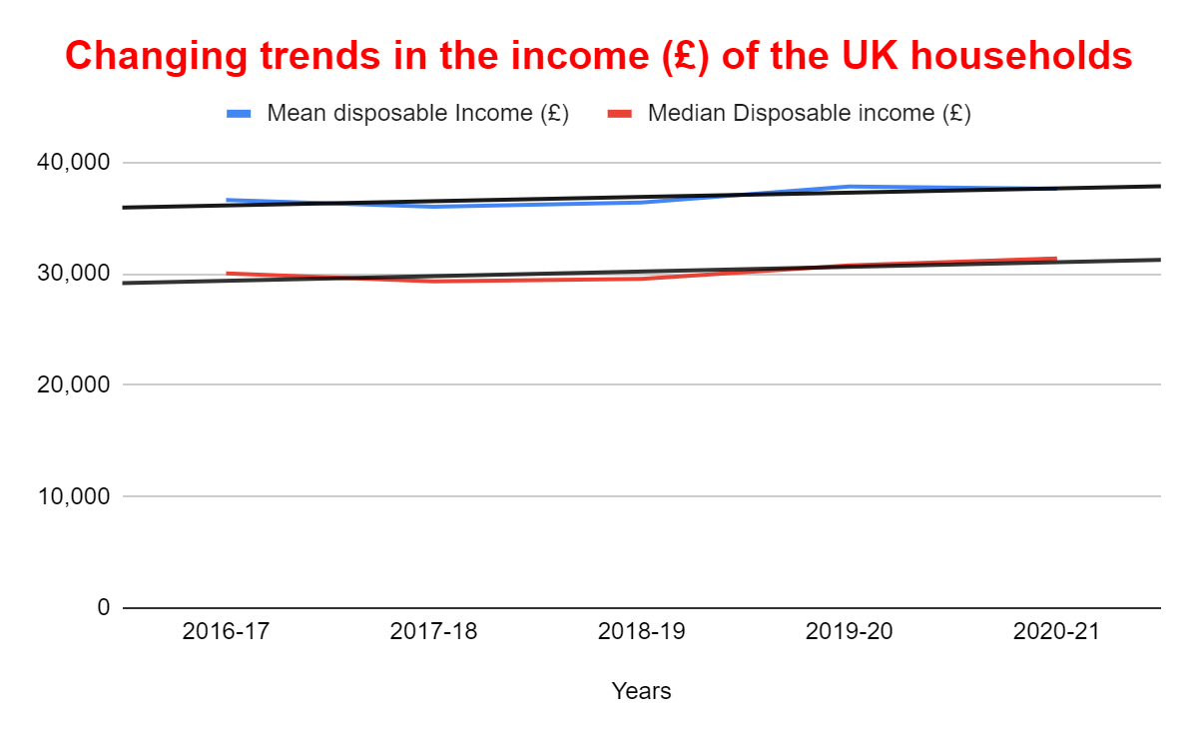
Fig. 3: Changing trends in the income of the UK households
(Source: Office for National Statistics, 2022)
As the mean income of UK consumers has increased in recent years, this would induce a reduction in the demand for burgers from Burger King.

    - Consumers’ tastes & preferences
Tastes and choices of the products also lead to changes in the demand for that product. If the taste of the people changes in favor of the product, then its demand will increase. On the other hand, if people don't prefer consuming that particular good then the demand for that product will reduce.
In the UK, people have started liking burgers more. Data states that in 2013, the consumption of Burgers was 15 grams per person per week while in 2019-20, the average consumption of each consumer in the UK is 23 grams per week. These figures do support the increase in the demand for burgers while increasing sales of Burger King shown earlier depict that the demand for burgers of Burger King has increased as well (Statista, 2022).
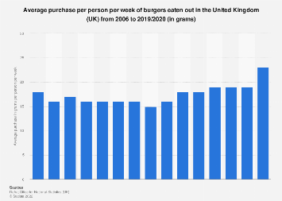
Fig. 4: Increased consumption of Burgers in the UK
(Source: Statista, 2022)

    - Consumer’s future price expectation
When consumers expect that the future price of a product can increase, then its demand at the present will increase as well. People will purchase more quantities of those products so that they don't need to buy products in the future when the price will increase. This would induce the demand to go up (JSTOR, 2022).
The prices of burgers are increasing in the UK. Burger King has also increased the price of its burgers. The forecast is that the prices can increase further because of the high inflation. So, the consumers would look to purchase more burgers right now, that is the demand for the burgers will increase at the moment.
    - Demographics (Number of consumers)
An increase in the number of buyers of burgers would increase the demand for the burgers. Data from Daily post entails that almost 2.5 billion beef burgers are consumed by the UK people in recent years. These figures are higher than before. These figures also depict that the demand for burgers has increased a lot in the UK in recent years as the number of customers has increased, depicted by the increasing number of sales (Getty., 2022).

Question 3

Substitution effect in defining the demand elasticity
In microeconomics and managerial economics, the substitution effect mainly addresses the nature of the cross-price elasticity of the product. Cross-price elasticity is defined as the % change in the quantity demanded of a product due to a 1% change in the price of substitute goods. Often the products having more substitutes available are said to have a high elasticity of demand as there are multiple alternatives available for consumption. The value of price elasticity is positive and greater than 1 as well. On the other hand, if the products complement each other, their cross-price elasticity will have a low and negative value, that is the demand for the commodity is less elastic or inelastic (Andreyeva et al., 2010).
The substitutes and complements of burgers have increased in recent years in the UK as the inflation rate of the commodities has leaped. An increase in the price of the substitutes will increase the demand and demand elasticity as well. People would shed away from purchasing burgers if the price of their substitutes reduces. And a burger is kind of a luxury item so the value of cross-price elasticity will be greater than 1. On the other hand, the price of the complements is also increasing in the UK so this would tend the cross-price elasticity of burgers to fall as well.
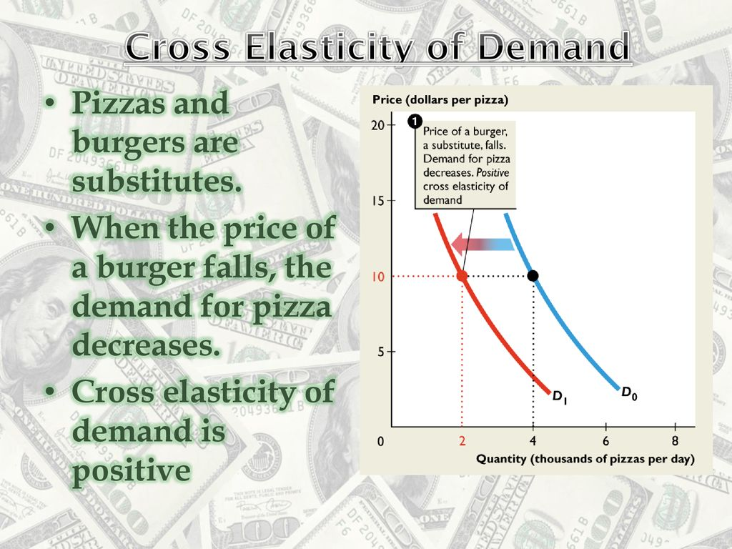
Fig. 5: A diagram of the cross-price elastic demand curves
(Source: SlidePlayer, 2022)

Income effect in defining the demand elasticity
In economics, the income effect is used to determine the nature of the demand elasticities of a product. The change in the quantity demanded of a product because of a unitary change in the income of the consumer is referred to as the income elasticity of demand for that product (Andreyeva et al., 2010). Now, this change in quantity demanded at a price is reflected by a change in demand for that product. Now if this change in demand takes place because of an increase in real income, this phenomenon is called the income effect. Real income is a bit different from money income as real income is the quantity of a good that will be purchased in exchange for the money income. For example, suppose that the money income of a company is £6000 and they want to purchase a machine that costs £12. So, the number of machines bought by the company is 50 which is also the real income of the company.
In the UK, households are facing low-income growth in recent years. The mean disposable income of UK consumers has fallen in the past 2-3 years. This will impact the demand for burgers to fall. Also, the demand for burgers is income-elastic because it is not a necessary good.
The mean and median income of the UK consumers
Years | Mean disposable Income (£) | Median Disposable income (£)
2016-17 | 36,621 | 30,026
2017-18 | 36,017 | 29,308
2018-19 | 36,397 | 29,548
2019-20 | 37,839 | 30,762
2020-21 | 37,622 | 31,385
(Source: Office for National Statistics, 2022)
Here is how the mean and median disposable income of UK households have fared in the last 5 years. People of the UK are currently going through a rough phase and therefore they would look to purchase fast food items like burgers as much less as possible and the elastic demand for the burgers will fall.

The pricing policy of Burger King
Burger King belongs to the fast-food industry of the UK. Some of the most suitable pricing policies for companies in the fast-food industry are value pricing, penetrative pricing, customary pricing, bundle pricing, etc. There are mainly two pricing policies that are followed by Burger King. In the UK, there are many companies in the fast-food industry such as KFC, McDonald's, etc. who also act as competitors of Burger King selling almost identical products. Therefore, Burger King has set competitive prices that are very much equal to the prices of KFC and McDonald’s. In the competitive market, prices mainly stay low and this policy has sealed and floored the price of the burgers inside a certain range. Another pricing policy is the psychological pricing policy. Burger King has set the prices of its burgers in such a way that would induce the customers to purchase them thinking that the prices are quite reasonable (Rahman., 2022).
A pricing policy that would be suitable in the current scenario is bundle pricing. In the UK, the cost of inflation is high and that is reflected in the increased prices of burgers. So, providing some combo offers to the customers would make them feel that these combos are more profitable for them but ultimately, the company itself would make a relevant profit by selling those products at the combo prices.

Conclusion
It is to be concluded that Management economics is not the direct discipline of economics by itself. Moreover, managerial economics mainly acts as the application of economic policies that can affect the decision-making of the internal and external members of the company. A complete assessment of the demand for Burger King's fast-food items, particularly burgers has provided a complete idea of how various factors are affecting its demand and demand elasticities. This will help to assess more business-related problems using managerial economic tools in near future.

References
Baker, J. B. (2003). Competitive Price Discrimination: The Exercise of Market Power Without Anticompetitive Effects. Antitrust LJ, 70, 643.
SlidePlayer. (2022) Cross elasticity and income elasticity - ppt download. Available at: https://slideplayer.com/slide/13804050/ (Accessed: November 25, 2022).
Comparably (2022). Burger King competitors. Available at: https://www.comparably.com/companies/burger-king/competitors (Accessed: November 25, 2022).
Office for National Statistics. (2022) Average household income, UK: Financial year ending 2021, Average household income, UK - Office for National Statistics... Available at: https://www.ons.gov.uk/peoplepopulationandcommunity/personalandhouseholdfinances/incomeandwealth/bulletins/householddisposableincomeandinequality/financialyearending2021 (Accessed: November 25, 2022).
Getty, (2022) UK eats 2.5 billion burgers a year, Channel 5 doc claims, North Wales Live. Available at: https://www.dailypost.co.uk/news/tv/uk-eats-25-billion-burgers-23866977 (Accessed: November 25, 2022).
Rahman, M. (2022) Marketing mix of Burger King (BK), how and what. Available at: https://howandwhat.net/marketing-mix-burger-king/#:~:text=Burger%20King%20also%20uses%20psychological,different%20prices%20in%20different%20locations. (Accessed: November 25, 2022).
JSTOR (2022)The impact of demand and price expectations on the behavior of ... Available at: https://www.jstor.org/stable/1809693 (Accessed: November 25, 2022).
Burger King. (2022) Online offers and ordering. Available at: https://www.bk.com/about-bk (Accessed: November 25, 2022).
Yahoo! Finance. (2022) Pepsi drinks could see more price hikes in the first quarter of 2022 Available at: https://uk.finance.yahoo.com/news/pepsi-drinks-could-see-more-140353293.html (Accessed: November 25, 2022).
Statista. (2022) Published by S. Lock and 27, J. Burger King's revenue 2021, Available at: https://www.statista.com/statistics/266462/burger-king-revenue/ (Accessed: November 25, 2022).
Food Menu Prices. (2022) D.S. and says:, L. Burger King UK menu & prices (updated: November 2022), Fast Available at: https://www.fastfoodmenuprices.com/uk/burger-king-menu-prices-uk/ (Accessed: November 25, 2022).
Statista. (2022)Shahbandeh, M. Eating out: Burger consumption in the UK 2020, Available at: https://www.statista.com/statistics/284584/eating-out-weekly-consumption-of-burgers-in-the-united-kingdom-uk/ (Accessed: November 25, 2022).
WallStreetMojo. (2022). Team, W.E. (2022) Managerial economics,. Available at: https://www.wallstreetmojo.com/managerial-economics/ (Accessed: November 25, 2022).
Andreyeva, T., Long, M. W., & Brownell, K. D. (2010). The impact of food prices on consumption: a systematic review of research on the price elasticity of demand for food. American journal of public health, 100(2), 216-222.

