
Reuse Behaviour: A Study of Consumer Perception Towards Reusable Containers

Chloe Wilson
1810485
Level 6 BA Business and Management

BMSP6012

Word count: 12,937

Declaration

- This work has not been previously accepted in substance for any degree and is not being concurrently submitted in candidature for any degree.

- This dissertation is being submitted in partial fulfilment of the requirements for the degree Business and Management.

- This dissertation is the result of my own independent work and investigation, except where otherwise stated.

- Other sources are acknowledged by footnotes giving explicit references. A bibliography is appended.

- I herby give consent for my dissertation, if accepted, to be available for photocopying and for interlibrary loan, and for the title and summary to be made available to outside organisations.

Name: Chloe Charlotte Kate Wilson
Student ID number: 1810485
Supervisor: Jessica Shore
Date of submission: 19th April 2021
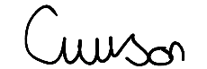
Signature………………….
Acknowledgments

I wish to acknowledge and thank all of the people involved both directly and indirectly in the development of this investigation.

I would like to thank my supervisor Jessica Shore for her guidance and Alex Bell for his sustainability module which inspired me to pursue the research investigation.

I would like to thank the zero-waste stores that I visited who were kind enough to upload my questionnaire on their social media pages, as well as to the 320 participants who took the time to complete the questionnaire.

Finally, I would like to express my thanks to my friends and peers and especially my family for their continued support, motivation and encouragement.

Abstract

The increasing volume of single-use plastic packaging has been widely acknowledged as being a significant global environmental concern. In response to this reuse systems have been considered as a solution to reduce waste and achieve long-term sustainability.
The aim of this research project was to evaluate reusable containers, specifically, providing an understanding of consumer behaviours, motivations and perceptions towards reuse systems. This has been achieved by conducting secondary research to gain a comprehensive view of the phenomena before conducting empirical research based on consumers in West Wales. A quantitative survey approach was used to compare the different shopping behaviours and motivating factors between two groups of consumers which included a comparison of general shoppers and zero-waste shoppers. The questionnaires received a total of 320 responses and this data was statistically analysed and compared using the Mann-Whitney U test.
A gap in the existing literature was identified and therefore this investigation revealed that there are different behaviours between the two groups of consumers. For example, convenience and branding were deemed more important by general shoppers and packaging material, product label information and environmental concerns were viewed more importantly by zero-waste shoppers.
The empirical findings largely correlated with the literature review.

Contents

Chapter 1: Introduction 9
1.1 Purpose of Research 9
1.2 Research Questions 10
1.3 An Overview of the Dissertation Structure 10

Chapter 2: Literature Review 12
2.1 Single-Use Plastic 12
2.2 Ellen MacArthur Foundation 13
2.3 Consumer Behaviour and Perceptions Towards Reuse Systems 15
2.4 Consumer Behaviour Theories 16
2.5 Benefits and Barriers to Reuse Container Adoption 20
2.6 Rise of Zero-Waste Stores and Refill Systems 23
2.7 The Rise of Milk Vending Machines 24
2.8 Legislation 24
2.9 Literature Review Summary 27

Chapter 3: Methodology 28
3.1 Philosophies 29
3.2 Approaches 29
3.3 Strategies 30
3.4 Choices 30
3.5 Time Horizons 31
3.6 Techniques and Procedures 31
3.7 Ethical Considerations 36
3.8 Limitations 37
3.9 Methodology Overview 37

Chapter 4: Findings 38
4.1 Finding’s Overview 51

Chapter 5: Analysis 52
5.1 Mann-Whitney U Tests of Closed-Ended Questions 53
5.2 Analysis Overview 59

Chapter 6: Discussion 60
6.1 Research Questions 60
6.2 Discussion Overview 68

Chapter 7: Conclusion 69
7.1 Recommendation One: Increase Awareness 71
7.2 Recommendation Two: Increase Refill System Accessibility 71
7.3 Recommendation Three: Introduce Vending Machines 72
7.4 Further Research 72

Chapter 8: Bibliography 73

Chapter 9: Appendices 82
9.1 Appendix 1 82
9.2 Appendix 2 84

List of Figures
Figures | Name and reference | Page Number
Figure 1 | Global plastic production by industrial sector (Geyer, et al 2017) | 13
Figure 2 | Waste Management Hierarchy (DEFRA,2011) | 14
Figure 3 | Reuse Models (Ellen MacArthur Foundation, 2019) | 15
Figure 4 | Diagram of Theory of Planned Behaviour (Arora, et al 2017) | 17
Figure 5 | Diagram of Maslow’s Hierarchy of Needs (Oved,2017) | 19
Figure 6 | Map identifying zero-waste stores in West Wales (Google Maps, 2021) | 23
Figure 7 | Saunders Research Onion (Saunders,2012) | 29
Figure 8 | Questions for Questionnaire | 34
Figure 9 | Age of respondents | 39
Figure 10 | Location of respondents | 40
Figure 11 | Important features in grocery buying decisions. | 41
Figure 12 | Respondent’s level of awareness of single-use plastic. | 43
Figure 13 | Respondent’s consideration of environmental impacts of the packaging of a product | 44
Figure 14 | Respondent awareness of zero-waste stores. | 45
Figure 15 | Where the respondents shop. | 46
Figure 16 | Unrecyclable plastic | 47
Figure 17 | Reusable containers | 48
Figure 18 | The motivations for respondents to bring their own containers to a store | 50
Figure 19 | Mann-Whitney U Test - Convenience/ time available and branding/ graphical appearance | 53
Figure 20 | Mann-Whitney U Test - Packaging material, product label information and environmental concerns | 54
Figure 21 | Mann-Whitney U Test - Pricing/ special offers, quality, proximity to shop, online/ home delivery, hygiene/ cleanliness | 55
Figure 22 | Mann-Whitney U Test – Level of awareness of the effect of single-use plastic | 56
Figure 23 | Mann-Whitney U Test – Consideration of the environmental impact of the packaging of a product in the buying decision | 57
Figure 24 | Mann-Whitney U Test – Awareness of zero-waste stores | 58
Figure 25 | Mann-Whitney U Test – Reusable containers | 59
Figure 26 | One-Sample Kolmogorov-Smirnov Test | 64
Figure 27 | UN Environment Ten Step Proposal (UNEP,2018) | 83
Figure 28 | Pricing of zero-waste stores in comparison to supermarkets | 85

Chapter 1: Introduction

Historically, reusable packaging has been used in certain sectors in the UK for decades, even centuries, as demonstrated by the delivery of milk in bottles which was established in the 1880s (Lofthouse, et al 2017). However, this system significantly declined since the 1950’s, largely due to the discovery of polypropylene and the production of plastics for packaging purposes. The manufacturing of plastic exceeds 9 billion metric tonnes worldwide, with 5 billion metric tonnes being accumulated as waste (Tiseo,2020). The qualities of plastic are undeniable, however, if existing consumption trends and waste management procedures remain then this will result in 12 billion tonnes of plastic waste by 2050 (UNEP,2018). Managing one of the most significant environmental issues of our time will require legislation, organisation compliance and most importantly consumer acceptance. It is believed that reuse systems are a vital aspect of the solution to reduce plastic pollution, reduce waste and achieve long-term sustainability (Haws, et al 2014).

Purpose of Research

The purpose for this research project is to examine the requirement for reusable packaging systems as an alternative option to single use plastic. Previous research investigations into this subject primarily concentrate on reduce and recycle practices, with limited consideration given to reuse systems (Ertz, et al 2017). However, reuse systems are deemed as an essential waste management practice to mitigate environmental impacts.
The adoption of reusable containers is subject to consumer acceptance as the transition and cultural shift required involves individuals to change long-term habitual shopping behaviours. If Governments opted to enforce legislation on single-use plastic or if businesses eliminated single-use plastic, then consumers cannot be compelled to co-operate. This justifies the necessity to attain an understanding of consumer behaviours and perceptions towards reusable containers and refill systems in the food and grocery marketplace.

Research Questions

The motivation for this research project can be attributed to answering the following questions:

- If consumers are extremely aware of the environmental impact of single-use plastic packaging, will they seek sustainable alternatives?
- Are consumers who live in West Wales aware of what a zero-waste store is?
- What are the benefits and barriers of reusable container adoption from a consumer perspective?
- Will there be different behaviours, perspectives and motivations between general shoppers and zero-waste shoppers?
- Can consumers be encouraged by society to adopt a sustainable lifestyle?
- Is there a need for incentivisation or legislation with regards to reusable containers?
These research questions will be answered in accordance with the evidence gathered from a literature review and empirical research findings.

1.3 An Overview of the Dissertation Structure

A literature review will be conducted to allow a comprehensive understanding of the research subject. Specifically, reusable containers will be evaluated from a consumer perspective by analysing consumer behaviour theories, the advantages and disadvantages of reuse adoption, as well as determining relevant legislation.
In a society where legislation is not compelling consumers to purchase using reusable containers, it is necessary to determine what factors are motivating the people who already use this option, referred to in this study as the ‘zero-waste shoppers’. These motivating factors will be analysed in order to establish how they differ in behavioural terms from shoppers who do not use reuse systems, which will be referred to as ‘general shoppers’. This will be achieved through the construction of the methodology chapter and undertaking empirical evidence gathering through a survey.
The findings, analysis and discussion chapters will evaluate the different behaviours, motivations and perceptions of the two groups of consumers, this will be performed through the use of statistical analysis, before relating the results to existing literature findings.
The following research objectives all provide a structure for this investigation:
- To investigate the need for a replacement to single-use plastic packaging by identifying sustainable solutions, specifically reusable containers.
- To analyse the barriers to reusable container adoption from a consumer perspective.
- To identify the different shopping behaviours and motivations of two consumer groups in West Wales by collecting empirical data.
- To evaluate and compare the different shopping behaviours and motivations of two consumer groups in West Wales in comparison to secondary research findings.

Chapter 2: Literature Review

This chapter will investigate the need for a replacement to single-use plastic packaging, by specifically exploring reuse systems. Reuse systems will be analysed from a consumer perspective by providing insight into consumer behaviour theories, as well as the benefits and barriers of reuse adoption. This will effectively answer objectives one and two:
- To investigate the need for a replacement to single-use plastic packaging by identifying sustainable solutions, specifically reusable containers.
- To analyse the barriers to reusable container adoption from a consumer perspective.
The rise of zero-waste stores, refill systems and milk vending machines will be discussed and relevant legislation will be acknowledged.

2.1 Single-Use Plastic

It is widely acknowledged that the increasing volume of single-use plastic packaging is a significant concern. Single-use packaging is the largest plastic production sector globally which produces 400 million tonnes each year (see fig 1) (Geyer, et al 2017). The material is multifunctional through being versatile, lightweight, cost-effective, hygienic and convenient, however, once used, its disposal is associated with severe environmental and economic impacts (Wood, et al 2019). The economic damage to the world’s marine ecosystem caused by plastic amounts to $13 billion annually.
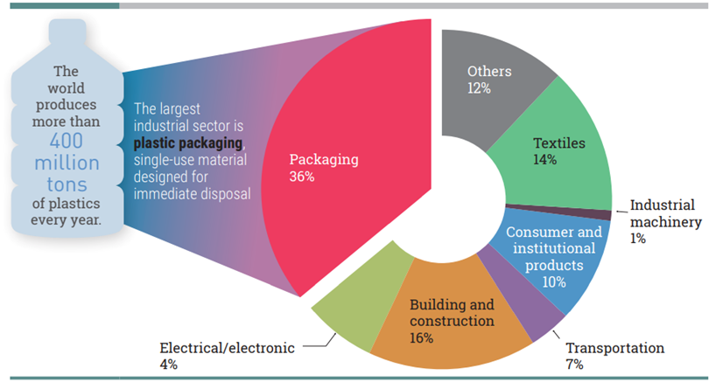

Figure 1: Global plastic production by industrial sector (Geyer, et al 2017)

2.2 Ellen MacArthur Foundation

The Ellen MacArthur Foundation was established in 2009 with the aim of advancing the development to a circular economy which is centered on the foundation of designing out waste and pollution, retaining products and materials and revitalising natural systems (Ellen MacArthur Foundation, 2017). It maximises the value of resources to benefit both the economy and the environment (Smith,2021). The world currently operates within a linear economy which follows a ‘take-make-waste’ method and it is assumed that resources are abundant (Upadhayay, et al 2019). For example, plastic production involves the use of finite resources including oil and gas and is frequently designed for single-use purposes before being accumulated as waste (Pellis, et al 2021). Due to this, the management of waste is becoming increasingly important (Inglezakis, et al 2015) as our relationship with plastic requires reconsideration.
Substitute materials for single-use plastic including glass, paper, aluminium and wood are all viable options, however, they produce increased environmental costs in the quantities required for replacement (Smith,2021). Additionally, according to The Ellen MacArthur Foundation (2017) alternative materials have been recognised as leading to potentially significant and unintentional effects, including carbon emissions, water usage and food waste. Additionally, non-conventional plastics including biodegradable, bio-based and compostable materials are being advocated as potential alternative sustainable materials (Greenpeace,2019). However, the Environmental Investigation Agency (2018) considers that non-conventional plastics, ‘will not solve the plastic pollution crisis, which requires a more comprehensive strategy emphasising reduction, reuse and redesign’. The adoption and production of non-conventional plastics on a large scale presents the risk of complicating waste management and recycling systems as well as requiring additional land which in-turn provides competition for the agricultural industry and potentially causes biodiversity loss (CE Delft, 2017).
The Waste Management Hierarchy is a framework depicted by DEFRA (2011) which is in line with the transition to a circular economy (see fig 2). The hierarchy demonstrates that prevention and reuse opportunities should be considered before recycling (Smith,2021).
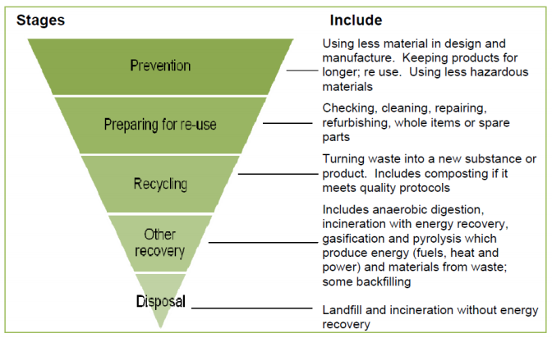

Figure 2: Waste Management Hierarchy (DEFRA,2011)

Although recycling is essential, it is not a sustainable long-term strategy. Reuse models should be considered as an alternative option in an attempt to mitigate the requirement for single-use plastic (Ellen MacArthur Foundation, 2017). Reuse refers to any activity that extends the life of an item (Allegrini, et al 2015) and is known to be more effective than recycling in waste reduction, resource conservation and maintaining value of life (Ertz, et al 2017). Kedzierski, et al (2020) state that there is a profound lack of knowledge about reuse systems and that they represent the opportunity to retain the performance of the material, achieve cost reductions in material use and minimise environmental impacts (Coelho, et al 2020). The Ellen MacArthur Foundation (2019) established four reuse models (see fig 3). For the purpose of this research project the ‘refill on the go’ model will be explored which requires consumers to refill their containers at an instore dispensing system.
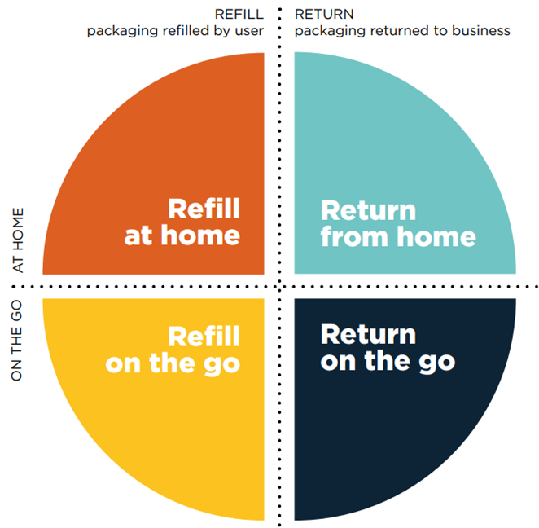
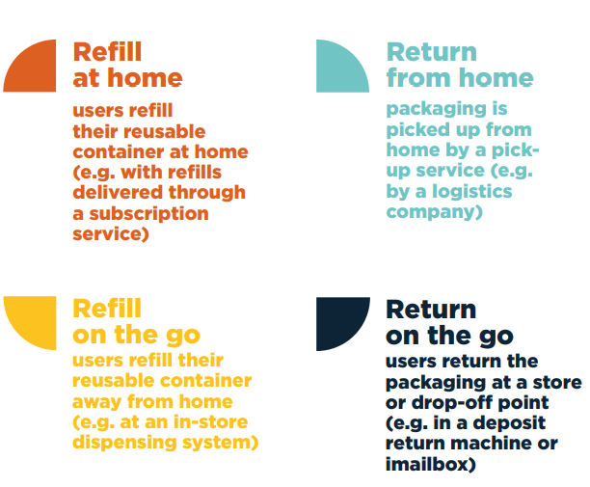

Figure 3: Reuse Models (Ellen MacArthur Foundation, 2019)

2.3 Consumer Behaviour and Perceptions Towards Reuse Systems

According to (Nordin, et al (2010) any proposed packaging development should examine consumer perceptions, behaviours and habits as well as attitudes and environmental opinions to ensure consumer acceptance and satisfaction (Prakash, et al 2017). The notion of consumer knowledge has become progressively important regarding the question of how sustainability influences consumer buying behaviour (Rhein, et al 2020). MarketLine (2020) reveals that consumer demand is shifting with 91% of UK respondents supporting the concept of products without single-use plastic. It is proposed that the increasing adverse evidence of single-use plastic packaging has changed consumer perception which exerts pressure on the food industry to adapt to consumer demands.

2.4 Consumer Behaviour Theories

It is necessary to understand different consumer perceptions and motivations towards reusable containers and this will be achieved by exploring consumer behaviour and perspective theories.

Attitudinal Perspective Theory and Awareness
The Attitudinal Perspective Theory was established in the 1970s and suggests that as environmental awareness is increased this will encourage eco-friendly behaviour and in-turn have an impact on purchasing decisions (Borden,1997). However, a study conducted by Kollmuss et al (2002) argued that increased awareness did not contribute to any substantial increase in changed environmental behaviour and highlighted the need for a more complex theory. It was observed that direct experiences had more of an impact on behaviours in comparison to indirect experiences including awareness and knowledge (IBID). Although, it is possible for behaviours to gradually change if consumers are enlightened through persistent scientific findings, knowledge or information (Popovic, et al 2019). Boz, et al (2020) state that sustainable packaging is currently not expressed clearly to consumers as research reveals that some consumers would not be able to recognise sustainable packaging and do not have a clear perspective of what it involves.

The Theory of Planned Behaviour
The Theory of Planned Behaviour (TPB) was established in 1985 by Ajzen and is an extension of the Theory of Reasoned Action (TRA) 1975. TPB is a social psychological theory that is used to determine and understand behaviours. It proposes that behaviours are defined by behavioural intentions, which in-turn are influenced by a combination of three factors, including attitude towards the behaviour, subjective norms and perceived behavioural control (see fig 4) (Arora, et al 2017).
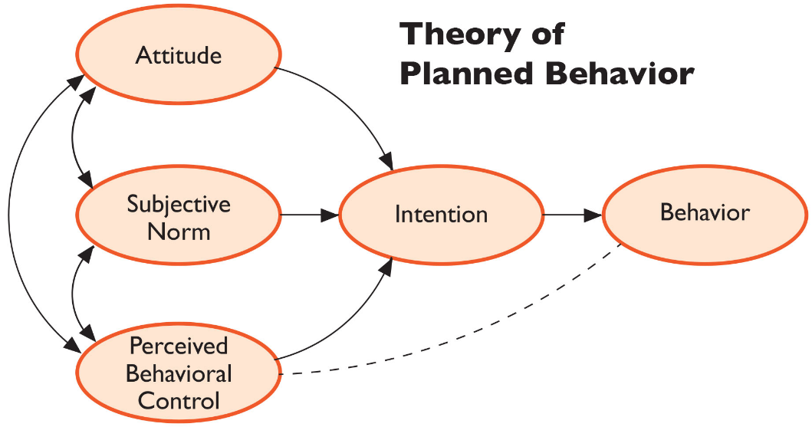

Figure 4: Diagram of Theory of Planned Behaviour (Arora, et al 2017)
The apprehension regarding the environment can be related to consumer behaviour as consumers consider that they have an active role to play in reducing environmental impacts by selecting sustainable products (Rokka, et al 2008). Similarly, Coelho, et al (2020) state that many consumers seek eco-friendly packaging once they are aware of the environmental effects of single-use plastic. Awareness and social behaviour can significantly impact a consumer’s selection for reusable containers which emphasises the importance of providing access to reusable solutions (Babader, et al 2016). However, Davies, et al (2016) state that sustainable purchasing patterns typically include something more than value concerns as consumers do not consistently make the effort to select sustainable packaging alternatives. The environmental aspect of packaging is one consideration within consumer preferences, however, this is balanced against benefits, including convenience (Lindh, et al 2016). For example, Rokka, et al (2008) revealed that even the most environmentally driven consumers do not select products entirely determined on sustainability qualities and interchange between other preferences. Similarly, Lindh, et al (2016) identified that convenience, proximity to the shop and product packaging were dominant aspects in consumer buying behaviour in contrast to environmental aspects.
Sustainable packaging requires consumers to trade-off other benefits which develops an attitude behaviour or value-action gap (Olson,2013). This arises when a consumer’s beliefs and intentions are not followed through (Signori, et al 2016). It needs to be acknowledged that some consumers may express their preference for environmentally focused packaging, however, this may not frequently reflect in their willingness to pay (WTP) when they are purchasing products (Goucher-Lambert, et al 2015). Barber, et al (2014) state that consumers would be willing to pay increased prices for sustainably packaged groceries, however, only if the quality was of a higher standard such as organic, Fairtrade or finest compared to conventional goods.

Subjective Norms and the Hawthorne Effect
Subjective Norms are an aspect of the TPB and refers to the combination of behavioural pressures which society has set and how an individual should act to comply with certain perceptions (Hagger, et al 2006). Social pressure can be initiated by family, friends or social groups and many individuals want to be perceived as ‘doing the right thing’ when making a decision (Rex, et al 2015). It has been identified that Subjective Norms are a determinator of an individual’s intention to recycle (Mannetti, et al 2004) and to potentially select sustainable packaging alternatives.
Similarly, the Hawthorne Effect indicates that consumers are more inclined and motivated to act if they believe that someone is observing their actions. This potentially indicates that consumers would change their buying behaviour and purchase more sustainable products to avoid being scrutinised (Sedgwick,2012).

Maslow’s Hierarchy of Needs
Maslow’s Hierarchy of Needs is not specifically a consumer behaviour theory, however, it can potentially support the judgment of purchasing decisions in relation to sustainable packaging. The Hierarchy was established in 1943 and is a theory based on human motivation and needs (see fig 5) (Oved,2017). There are five levels of needs including physiological, safety, love, esteem and self-actualisation. If basic needs are not fulfilled, then this restricts progression to the next stage of the hierarchy (IBID). Maslow’s Hierarchy can be related to consumer behaviour, for example plastic packaging fulfils basic needs as is it is recognised to be hygienic and convenient (Rensburg, et al 2020). It is argued that limiting different packaging materials, including single-use plastic could potentially contribute to the spread of foodborne viruses and bacteria (Ridler,2018). There are concerns whether refill systems fulfil hygiene expectations as products are exposed to cross contamination between consumers (IBID).
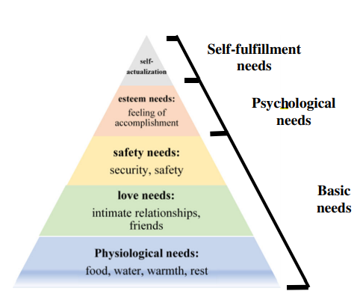

Figure 5: Diagram of Maslow’s Hierarchy of Needs (Oved,2017)

The coronavirus pandemic has seriously contributed to the increase in plastic waste as well as impacting refill schemes. For example, campaigners have urged the Welsh Government to take action to limit the extent of unnecessary single-use plastic. The pandemic has temporarily interrupted several refill schemes due to concerns about the spread of the virus (Flint,2020) and these concerns could continue and potentially make consumers apprehensive about refill systems.

Stern’s Impulse Theory
Stern’s Impulse Theory (1962) is differentiated in comparison to other consumer behaviour theories as it is concerned with impulse behaviour, rather than rational action. The theory is categorised into four sections of impulse behaviour which include, pure impulse, reminded impulse, impulse purchases and planned impulse decisions (Sharpio,2014). Impulse purchase behaviour can be influenced by external factors, for example, marketers play an important role in influencing consumers to impulse buy (Mohan, et al 2013). Pricing has been recognised as the most significant contributor to impulse behaviour, especially in the retail market as consumers can be enticed through special offers. According to Stern (1962) grocery products are purchased frequently, therefore reduced time is focused on planning. Additionally, it is recognised that increased product availability in multiple store locations will increase the opportunities for impulse purchases (Agarwal, et al 2019).

2.5 Benefits and Barriers to Reuse Container Adoption
The following section will explore the benefits and barriers associated with reuse adoption from a consumer perspective. This will be achieved by analysing convenience, packaging material, brand loyalty, choice and pricing factors.
Convenience
According to British Plastics Federation (2021) modern lifestyles require food to be supplied in a convenient manner and many consumers currently believe this can only be achieved through single-use plastic. For example, consumer acceptance of reusable containers is affected by the inconvenience of having to carry, refill and wash containers each time they shop (Coelho, et al 2020). According to Matchar (2019), ‘packaging is inextricably linked with modernity and convenience’ which suggests that it is unrealistic for refill systems and zero-waste stores to replace supermarkets entirely. Additionally, refill systems are perceived as impractical for consumers that have a hectic lifestyle or are located in the city with no vehicle (IBID). However, the Ellen MacArthur Foundation (2019) argues that reuse models ensure that consumer desires can be accommodated as the necessary amount can be selected and content can be personalised. This is particularly beneficial to single household consumers who require small quantities of products.

Packaging Material
According to Zekiri, et al (2015) packaging material can have a significant influence on buying behaviour as the material can be associated with important values of the product. For example, the packaging material can affect consumer perception and alter the perceived quality of certain products (IBID). However, packaging can have a low priority and a secondary role in product selection, but nevertheless once a consumer is made aware of environmental impacts then this can create negative perceptions (Chukwu, et al 2018). ThoughtWorks (2018) state that UK shoppers want to reduce packaging and purchase products in sustainable materials and that this was considered and ranked more important than price considerations.

Brand Loyalty
Brands operating in the grocery market have a challenging role in acquiring, retaining and enhancing customer loyalty (Jensen,2011). Argouslidis, et al (2018) state that loyal consumers develop a long-term relationship with a grocer or specific brand and are generally less price sensitive. This could potentially affect a consumer’s willingness to convert from their habitual conventional products to reusable containers. However, Dick et al (1994) criticise the behavioural view and reveal that some consumers are ‘spuriously loyal’ and are susceptible to offers from competitive brands. Additionally, purchasing can be initiated by different factors rather than brand loyalty. This could involve a customer’s preference for convenience or product availability (Jensen,2011).

Choice
Consumers believe that they acquire the freedom of choice to purchase from a variety of grocery products (Davari, et al 2017). However, a decrease in grocery choice can have an adverse impact on perceived freedom which can restrict free behaviour (Argouslidis, et al 2018) and can cause a psychological reaction (Brehm,1996). Zero-waste stores and refill systems offer a limited variety of products compared to supermarkets which may affect a change in behaviour.
The Nudge Theory (2008) can persuade people to make informed choices without removing consumer freedom of choice. For example, brands and shops have a vital role in influencing consumer behaviour and it is suggested that changes or ‘nudges’ should be introduced progressively (Mont, et al 2014). Despite the increasing evidence of the harm of plastic use, this increased awareness is not having an impact on consumer decision making, therefore the nudge theory could be used to make cumulative small changes (Ledsham,2021).

Pricing
A study conducted by Lofthouse et al (2009) revealed that consumers would presume that the cost of refillable products would be reduced compared to conventional products in single-use plastic packaging. Alternatively, Statista revealed that 40% of consumers were concerned that if products were not supplied in plastic that price increases would arise (Sonnichsen,2020). However, Alalauri, et al (2015) reveals that Millennials stated that packaging plays a vital role in their buying decision and that they were prepared to pay premium prices for environmentally focused brands.

2.6 Rise of Zero-Waste Stores and Refill Systems

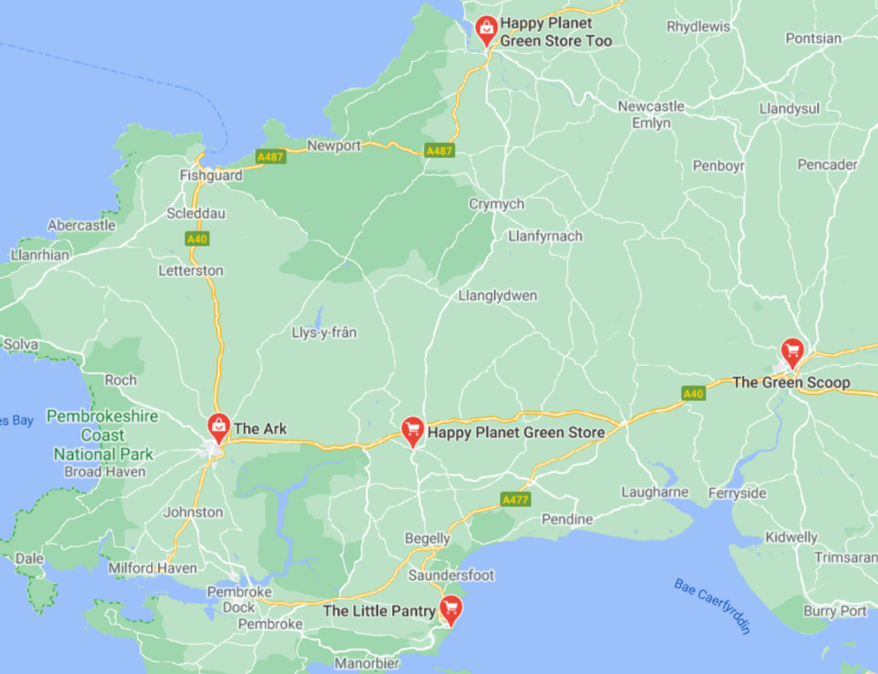
The zero-waste lifestyle is increasing as consumers are demanding a plastic-free shopping experience (Walker,2020). This has resulted in the emergence of zero-waste stores that herald the opportunity to reduce single-use plastic packaging by providing dispensing systems and reusable containers (Odijk, et al 2019). There are five zero-waste stores located in West Wales which were established in 2018 (Happy Planet Green Store, The Little Pantry and The Ark), 2019 (The Green Scoop) and 2020 (Happy Planet Green Store Two) (see fig 6) (Google Maps, 2021). The Ark was established in 2011, however, did not offer refill systems until 2018. This highlights that consumers have access to the new shopping concept that allows them to change their buying behaviours (Jamshidian,2021).
Figure 6: Map identifying zero-waste stores in West Wales (Google Maps, 2021)
In 2019, it was reported that the top ten supermarkets in the UK use 810,000 tonnes of single-use plastic annually as well as, ‘958 million bags for life and 1.2 billion plastic produce bags for fruit and vegetables’ (Greenpeace,2019). However, several supermarkets have adopted the concept of refill stations that allow consumers to have a plastic free shopping experience (Bullett,2021). Waitrose was one of the first supermarkets in the UK to introduce reuse and refill systems in 2019 which proved to be popular with 90% of consumers satisfied and eager for it to remain (Jackson,2019). Although, it must acknowledged that there are a very limited number of supermarkets that offer refill systems in West Wales.

2.7 The Rise of Milk Vending Machines
In recent years milk vending machines have grown in popularity, especially in Wales (Thomas,2020). Technologies exist to allow consumers to measure quantities of an item from a dispensing system (Murena, et al 2020). This eliminates cross contamination between consumers and potentially reduces the perception of refill systems being unhygienic. Vending machines provide supermarkets with the opportunity to adopt an alternative system that eliminates single-use plastic and meets the requirements of the circular economy. Additionally, businesses can have a more direct relationship with dairy farmers as the machines rely on local proximity, which in-turn can produce economic benefits and reduce environmental impacts (Pereira, et al 2018).

2.8 Legislation

It must be acknowledged that consumers as well as governments and businesses need to contribute to the transition to reusable packaging as the effect is minimal when it is just adopted by a single party (Beitzen-Heineke, et al 2017). Supermarkets must limit single-use plastic packaging and provide alternative shopping methods and Governments must take charge and reinforce voluntary commitments (Birch,2018). According to Coelho, et al (2020) policies are vital for the development of reusable packaging systems in Business-to-Consumer markets. It can be identified that Belgium, Finland and Denmark have taxed single-use plastic systems and Germany have compulsory deposit systems. In the UK a plastic packaging tax will be enforced from April 2022 which will apply to consumers purchasing goods in plastic packaging. The tax will apply if the packaging is not at least 30% recycled material (Gov.UK, 2020).

Carrier Bag Levy
Wales was the first country in the UK to introduce a 5p levy under The Single Use Carrier Bags Charge Regulations 2010. The purpose of this levy was to decrease plastic consumption, reduce litter and encourage reusable bags which has proven to be successful as single-use carrier bag rates declined by 71% between 2011 and 2015 (Sutherland,2020).

Recycling Scheme
Previous assessments indicate that Wales is currently the leader for recycling rates in the UK, second in Europe and third globally. The Welsh Government has proposed plans for the country to be recycling, reusing or composting 70% of waste by 2025 and is aiming to have zero-waste by 2050 (BBC News, 2019). In 2019, Pembrokeshire County Council introduced a new recycling scheme which uses a mixture of six bags and boxes and was initially considered ‘too complicated’ by residents (BBC News, 2019). However, consumers have complied with the changes and in 2020 the scheme was recognised as the ‘best-performing’ in Wales with 72% of household waste being recycled (Sinclair,2020). As previously depicted by Defra (2011), prevention and reuse systems are considered more important and effective than recycling as demonstrated through the Waste Management Hierarchy.

UN Environment Ten Step Proposal
The UN Environment Programme formulated a ten-step proposal for governments to adopt to improve waste management (see appendix 1) (UNEP,2018). The main findings highlighted that governments need to provide financial incentives to encourage consumers to switch their buying behaviour and change habits. Additionally, governments must interact with a range of stakeholders by increasing awareness of single-use plastic, fund innovation and development for substitute materials as well as ensuring plastic products are sufficiently labelled (IBID).

Where are Wales with Reuse Systems?
It can be identified that Wales has acknowledged several aspects of the ten-step proposal with regards to reuse systems. In 2020 The Welsh Government released a ‘Beyond Recycling Report’ which outlines their visions for transitioning to a circular economy, with reuse systems being identified as a critical component to achieve zero-waste (Welsh Government, 2020). Reuse systems are essential, as in 2016 180,000 tonnes of waste collected in Wales was reusable and only 10,000 tonnes were effectively reused (Welsh Government, 2017).
The Welsh Government engaged with 1,000 stakeholders to understand how the circular economy can be adopted by society. It was recognised that prohibiting or enforcing taxes on single-use plastics, such as the carrier bag levy, is a vital mechanism that the government can impose. However, it was also argued that it should be more incentivised rather than enforced by encouraging and engaging society to take action (Welsh Government, 2020). This is essential as the cultural and economic change required for this system is challenging.

2.9 Literature Review Summary
This chapter has provided a comprehensive understanding of reusable containers, refill systems and zero-waste stores. It is extensively acknowledged that a switch from plastic consumption to reusable container adoption must be driven by changes to consumer behaviours and perceptions. Therefore, the following two objectives have been achieved:
- To investigate the need for a replacement to single-use plastic by identifying sustainable solutions, specifically reusable containers.
- To analyse the barriers to reusable container adoption from a consumer perspective.
The literature review has identified that:
- The rapid production and consumption trends of plastic provide significant environmental impacts.
- Reuse systems have been revealed to be an essential long-term strategy in comparison to recycling techniques.
- If environmental awareness is increased, then this will potentially inspire eco-friendly behaviour and have an influence on purchasing decisions.
- Many consumers seek eco-friendly packaging once aware of the effect of single-use plastic, however, this is balanced against benefits including convenience.
- Subjective norms can have an impact on an individual’s behaviour to select sustainable packaging alternatives.
- Consumers impulse purchase rather than take rational action.
- There are several barriers to reuse adoption including hygiene, convenience, packaging material, brand loyalty, choice and pricing.
- The zero-waste lifestyle is increasing due to the emergence of zero-waste stores and milk vending machines.
- Enforcing taxes or providing incentives must be considered to encourage consumers and businesses to act and change habitual behaviours.

Chapter 3: Methodology

The literature review considered objectives one and two by providing an understanding of the requirement for reusable containers as well as identifying the advantages and disadvantages of reuse adoption from a consumer perspective.
In a society where legislation is not compelling consumers to purchase using reusable containers, what is motivating the people who use this option, referred to here as the ‘zero-waste shoppers’ and how they differ in behavioural terms from shoppers who do not, which we shall refer to as ‘general shoppers’?
There is a lack of research into understanding the different shopping behaviours and motivations towards reusable containers. Therefore, this chapter aims to achieve the third objective:
- To identify the different shopping behaviours and motivations of two consumer groups in West Wales by collecting empirical data.
Comparing zero-waste shoppers and general shoppers allows a deeper understanding of the different behaviours and motivations of the two groups. Effectively, this insight will enable recommendations to be proffered in order to motivate general shoppers to use reusable containers.
To achieve this, the Saunders Research Onion (2012) will be adopted to guide the methodology chapter. The framework provides a comprehensive structure (Scott,2014) consisting of six different layers which will be uncovered in order to seek an understanding of the research phenomenon (Sinha, et al 2018). The Research Onion is deemed the most appropriate framework for this investigation as it was specifically developed for business studies and social sciences (Melnikovas,2018). The framework’s coherent step-by-step structure allows the development of research to be directed through the selection of relevant philosophies, approaches, strategies, choices, time horizons and techniques and procedures (see fig 7) (Muranganwa, et al 2014). There will also be considerations of ethical issues and limitations.
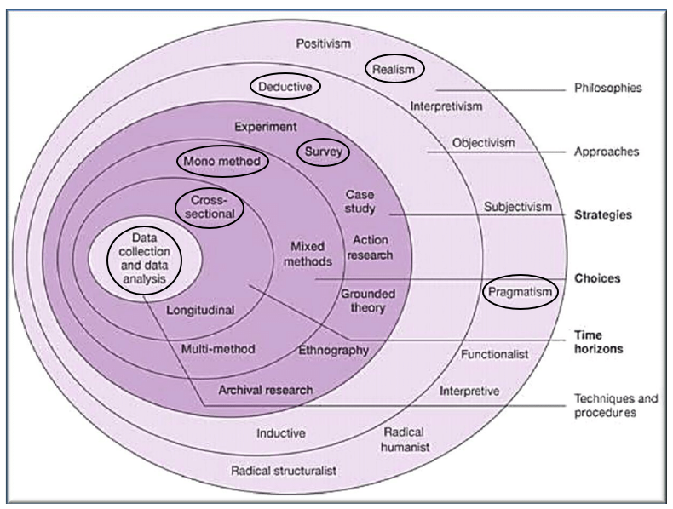

Figure 7: Saunders Research Onion (Saunders,2012)
3.1 Philosophies
Ontology is the study of reality and includes realism and how the reality influences the behaviour of people. It also includes pragmatism which uses theories to identify a solution to a given issue (Thesismind,2019). Therefore, realism and pragmatism will be the philosophies that underpin the research project in its goal to understand what motivates consumers to use or not use reusable containers.

3.2 Approaches
Deductive research is a ‘top-down approach’ which aims to examine existing theories by starting from a general level, extracting specific inference and then developing a hypothesis to determine whether there is a relationship. A deductive approach is frequently associated with quantitative research (Woiceshyn, et al 2018). In contrast to this, inductive research is a ‘bottom-up approach’ and is concerned with developing a new theory by analysing trends and patterns when making empirical observations through qualitative research (Dudovskiy,2018). A deductive approach will be selected for this research project as existing theories related to consumer perception and behaviour will need to be examined against empirical research findings.

3.3 Strategies
A critical assessment of existing research relating to the phenomena of the study will need to be conducted (Bryman, et al 2015). This will be achieved through a literature review by using a variety of books, journals and websites. However, due to the nature of the study empirical research will need to be conducted as anecdotal evidence from the literature review alone could be unreliable.
This research project will use surveys to gather consumer perceptions and behaviours of reusable containers. Surveys are a form of quantitative research that allows information and data to be gathered in order to obtain insight to understand a particular group’s behaviours and characteristics (Apuke,2017). Questionnaires are an example of a structured survey and have been selected for this research project (Bryman, et al 2015). However, interviews are deemed more flexible than questionnaires as they are not limited and can provide deep insights as interviewers can prompt respondents (Phellas, et al 2011). Despite these benefits, interviews will not provide a representative sample of the population which is essential for the research.
It will also be necessary to visit the zero-waste stores to establish the products that they offer as well as the pricing of products in comparison to supermarkets (see appendix 2 for results).

3.4 Choices
A mono method involves using a single quantitative or qualitative data collection technique with data analysis procedures (Saunders,2012). This research project uses a quantitative research approach which is ‘concerned with collecting numerical data that is analysed using mathematical methods such as statistics’ (Aliaga, et al 2006). Quantitative research intends to discover a large variety of views related to a specific topic allowing perceptions to be identified and analysed (Apuke,2017). In contrast to this, qualitative research emphasises words rather than statistical analysis (Bryman, et al 2015) and uses a small group of people. Qualitative research aims to identify themes by exploring individual experiences and how people perceive a certain topic (Creswell,2014). Due to this, the quantitative research approach will be used as it is deductive in nature (Elkatawneh,2016) which allows consumer behaviours and motivations to be identified in relation to existing themes and theories. A mixed method approach involves combining both quantitative and qualitative data collection techniques which provides further in-depth results and validity (Gov.UK, 2020). However, this can become complex and requires additional resources including time which is not feasible for this study.

3.5 Time Horizons
Cross-sectional research is the most suitable design for this study and involves collecting data from a range of respondents at a single point in time (Malter, et al 2008) which allows variables to be observed rather than influenced (Thomas,2020). Longitudinal research requires several months of data collection which is not viable for this research project due to the time frame constraint (Scott,2014).

3.6 Techniques and Procedures
Survey Design
A questionnaire will be created using the software Google Forms as it provides a variety of different question types including multiple choice and text (Google,2021). It is essential to provide a combination of open-ended and closed-ended questions. Open-ended questions can be time consuming which can potentially affect response rates as well as bringing bias as respondents will want to be perceived as being environmentally concerned. In contrast to this closed-ended questions may not provide sufficient analysis which highlights the need to combine both techniques (Biggam,2008). The questionnaire will be limited to eleven questions to reduce ‘respondent fatigue’ and to potentially increase response rate (Bryman et al 2011) (see fig 8).
Questions | Type of question | Relation to Literature Review Headings
- How old are you? | Closed | To ascertain if the opinion changes with age.
- What town or village do you live in? (Please stated in the box below) | Open | Rise of Zero-Waste Stores and Refill Systems  It is necessary to determine whether consumers are aware of zero-waste stores in West Wales, considering several have been established since 2018.
- What is important to you in your grocery buying decisions (Select level of importance for each of the ten features) | Closed | Benefits and Barriers to Reuse Container Adoption  The benefits and barriers to reusable container adoption will be assessed by requiring the respondents to rank the level of importance for each grocery buying feature. This will help to clarify the different motivations between general shoppers and zero-waste shoppers.
- On a scale of 1-5 how aware are you of the effect that single-use plastic has on the environment? (5 being extremely aware and 1 being unaware)  - How often do you consider the environmental impact of the packaging of a product in your buying decision? | Closed  Closed | Single-use Plastic and Consumer Behaviour Theories  It will be essential to establish whether the increasing adverse awareness of single-use plastic influences consumer behaviour and whether it reflects in their buying decision. This will be tested against consumer behaviour theories, for example The Attitudinal Perspective Theory suggests increased awareness will encourage and impact purchasing decisions.
- Do you know what zero-waste food stores are?  - Where do you shop? (Please tick all applicable if you shop there at least once a month)  - Supermarket  - Convenience store  - Zero-waste store  - Produce market  - Other (please specify) | Closed  Open | Rise of Zero-Waste Stores and Refill Systems  There are five zero-waste stores located in West Wales, therefore it is essential to establish whether consumers are aware of the different shopping experiences. Additionally, it will be necessary to determine how many consumers shop at a zero-waste store regularly.
- Which of the following do you do? (Please tick all that apply)  - Avoid purchasing a product if it was in black/non-recyclable material.  - Avoid purchasing a product if it was in single-use plastic.  - Pay more for a product if the packaging has less impact on the environment.  - None of the above. | Open | Single-use Plastic and Consumer behaviour theories  If consumers are aware of the impact of single-use plastic packaging on the environment, then it will be vital to establish whether they avoid unsustainable materials. If consumers do not avoid these materials, then it will be necessary to determine whether they are influenced by impulse purchases or whether other benefits including convenience are more dominant.
9. Would you be prepared to bring your own containers to a store and purchase your products from dispensers on a regular basis?  10. Pease state why to the previous question | Closed  Open | Benefits and Barriers of Reuse Adoption  If consumer acceptance of reusable containers is not attained, then it will be essential to identify ‘why’ and whether this correlates with the barriers identified in the literature review.
11. What would motivate and encourage you to bring your own containers to a store to purchase products? | Open | Legislation  It will be essential to identify whether there is a need for incentivisation or enforcement to encourage consumers to use reusable containers.
Figure 8: Questions for Questionnaire
Data Collection
The questionnaire will be uploaded via Facebook which is the leading and most popular online social network. This ensures that a large variety of consumers can be captured as well as receiving prompt responses (Kosinski, et al 2015). Additionally, three zero-waste stores located in Pembrokeshire will be approached to request whether the questionnaire can be uploaded via their social media pages. This is essential as a balanced argument needs to be presented of consumers who shop at zero-waste stores as well as the general public. This provides a broad spectrum and representative selection of the population which is deemed essential (Biggam,2008).
Digital questionnaires have distinctive technological, demographic and response characteristics (Ho,2014). This could potentially affect the validity of sample representativeness as consumers who do not utilise Facebook will be disregarded. However, due to Covid-19 it will not be possible to data collect in person.

Sampling
Random sampling refers to randomly selecting respondents that are recognised from the population for meeting the criteria of a study (Emerson,2015). Although the overall study is categorised under random sampling, the use of stratified sampling will also be required. This involves dividing the population into subcategories and obtaining a random sample that is representative of each group (Taherdoost,2016). This ensures that the consumers who shop at zero-waste stores are encouraged to take part in the research and this provides a representative sample of the zero-waste shoppers.
Pearson et al (2010) state that a minimum of 100 responses are needed to be obtained from the questionnaire distribution to ensure that the data is representative and reliable. This research project will aim to achieve a minimum of 100 responses from general shoppers as well 100 responses from zero-waste shoppers.

Reliability and Validity
Validity refers to the research methods that are used to collate and evaluate empirical data, whereas reliability refers to where the research was conducted and completed as well as sample selection information (Biggam,2008). Questionnaires are viewed as reliable and valid data collection techniques as a large number of opinions can be obtained (Akinci, et al 2015). However, this is only achievable if the questionnaire design and layout are coherent and understandable (Bryman, et al 2011). This will be ensured through a pilot questionnaire which will allow preliminary questions to be assessed and modified before distribution (Song, et al 2015).

Analysis
Statistical analysis methods will be used to examine the data provided from the closed-ended questions from the questionnaire. The IBM SPSS Software will be utilised, specifically using the Mann-Whitney U test. The Mann-Whitney U test has been chosen as it allows the comparison of two distinct groups when using the same variables. The IBM SPSS software has revolutionised research investigations by allowing researchers to perform complex statistical analysis (Frey,2017). The tests will allow differences to be identified between general shoppers and zero-waste shoppers. This will provide an understanding of the different behaviours, perceptions and motivations between the two groups.

3.7 Ethical Considerations

The research project will be completed in accordance with UWTSD’s ethical standards by completing an ethics form and obtaining permission from the research supervisor. Ethical considerations including anonymity and confidentiality will be considered (Bell, et al 2014) as the privacy protection of respondents must be ensured. For example, respondents will be informed that their participation is voluntary and that they have the right to stop and withdraw at any time. All answers will be anonymous and the data gathered will be stored with password protection on one device to avoid and eradicate misuse.

3.8 Limitations
Bias
Boz et al (2020) state that social desirability bias often occurs when distinguishing consumer opinions and perceptions when using surveys. For example, respondents may state that they are sustainably focused in accordance with socially accepted norms, however, they may not essentially behave that way and their actions may not reflect sustainable standards. This could potentially affect the legitimacy and reliability of the study.
Facebook
Although Facebook represents a significant pool of respondents, it does provide limitations. As previously mentioned, this research project will use an overall random sampling method, however, the use of stratified sampling will be required to ensure opinions are obtained from zero-waste shoppers. The sharing feature on social media could potentially jeopardise some responses (Gerson, et al 2017) as the questionnaire could be shared amongst consumers who are not environmentally conscious and have different behavioural attitudes.

3.9 Methodology Overview
To conclude the Saunders Research Onion has guided the methodology chapter by allowing appropriate research methods to be considered and selected. Quantitative research, in the form of a questionnaire, will allow a representative sample of the population to be analysed. This is essential as it will enable the different shopping behaviours of general shoppers and zero-waste shoppers to be compared.

Chapter 4: Findings

The following section presents the primary research findings. A total of 320 responses were obtained from the questionnaire distribution. This was achieved by utilising a random sampling method which received 160 responses from general shoppers as well as using a stratified sampling method which received 160 responses from zero-waste shoppers. The data sample is reliable and representative of the population as it has exceeded the minimum required number of 100 responses (Pearson et al 2010).

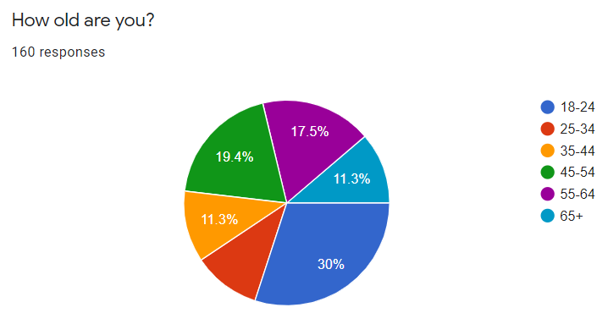
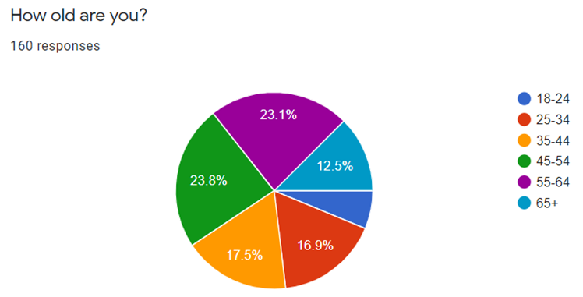
Question 1
General shoppers

Zero-waste shoppers

Figure 9: Age of respondents
Figure 9 identifies that a variety of age groups completed each questionnaire. The largest completion rate for general shoppers was 30% in the age category 18-24, however, this was the smallest category for zero-waste shoppers. Whilst analysis was going to be undertaken on this question to ascertain whether attitudes differed by age, with hindsight it was felt that beyond the scope of the research investigation, although could provide a topic for future research.
Question 2
General shoppers
Zero-waste shoppers

Figure 10: Location of respondents
Figure 10 shows that the largest number of respondents completing both questionnaires were located in Haverfordwest and surrounding areas. Unfortunately, some respondents who lived outside of West Wales completed the questionnaires despite requesting people not to.
Question 3
General shoppers
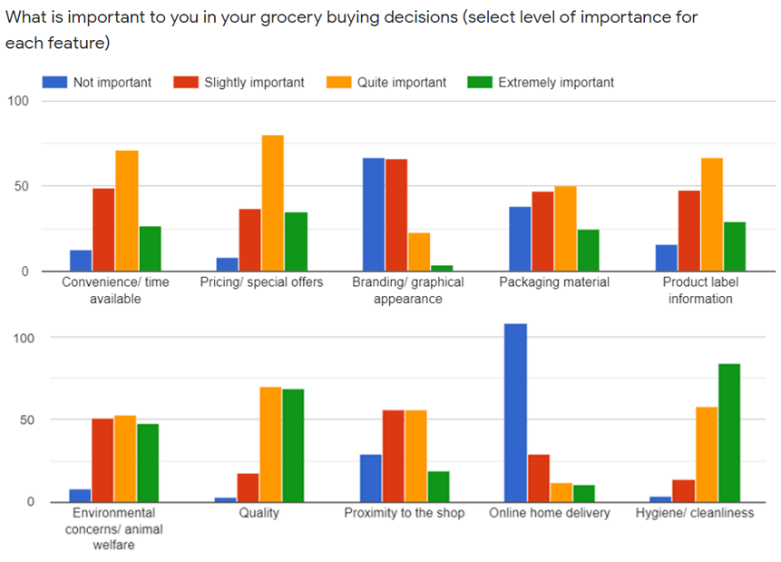
Zero-waste shoppers
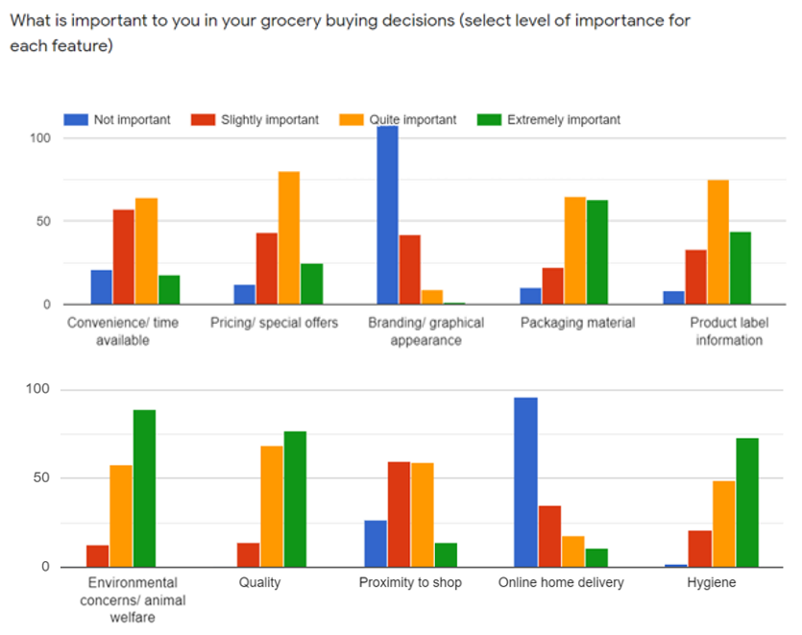

Figure 11: Important features in grocery buying decisions
- 60% of general shoppers and 50% of zero-waste shoppers found convenience extremely or quite important.
- 72% of general shoppers and 66% of zero-waste shoppers considered pricing and special offers to be extremely or quite important.
- 47% of general shoppers and 80% of zero-waste shoppers deemed the packaging material of a product to be extremely or quite important.
- 63% of general shoppers and 92% of zero-waste shoppers believed that environmental concerns and animal welfare were extremely or quite important.
- 89% of general shoppers and 76% of zero-waste shoppers considered hygiene to be extremely or quite important.
- Online home delivery and branding/ graphical appearance were rated the least important feature by both groups of consumers.

Question 4
General shoppers
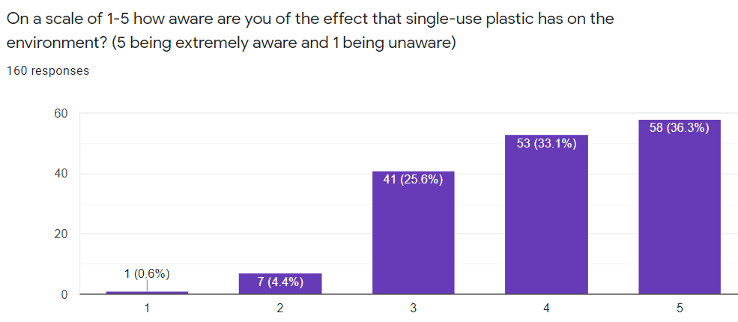
Zero-waste shoppers
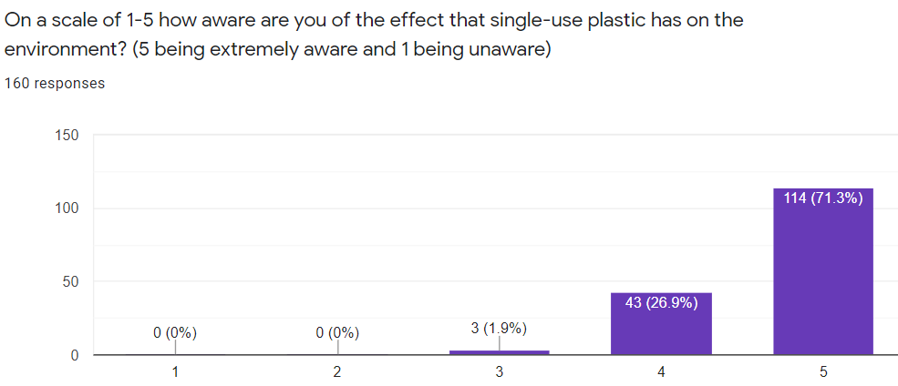

Figure 12: Respondent’s level of awareness of single-use plastic
Figure 12 highlights that 69% of general shoppers feel that they are extremely or quite aware of the environmental impact that single-use plastic has on the environment. In comparison, 98% of zero-waste shoppers were extremely or quite aware.

Question 5
General shoppers
Zero-waste shoppers
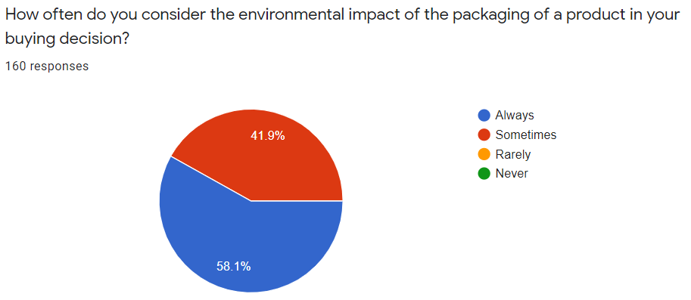

Figure 13: Respondent’s consideration of environmental impacts of the packaging of a product
Figure 13 reveals that 77% of general shoppers sometimes or always consider the environmental impact of the packaging of a product in their buying decision, in comparison 100% of zero-waste shoppers always or sometimes consider this.

Question 6
General shoppers
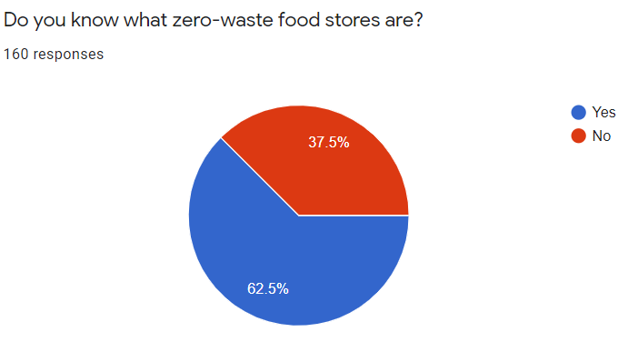
Zero-waste shoppers
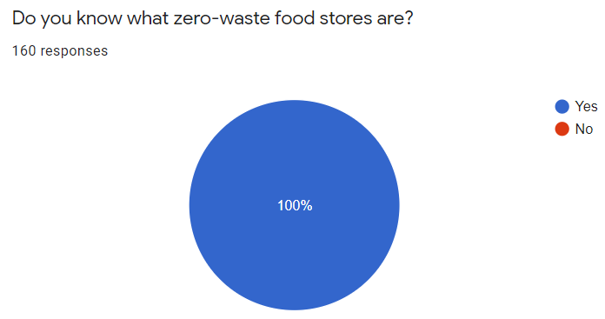

Figure 14: Respondent awareness of zero-waste stores
Figure 14 shows that 63% of general shoppers were aware of what a zero-waste grocery store was, however, 37% of respondents were unaware. In contrast to this, 100% of zero-waste shoppers were aware of zero-waste grocery stores.
Question 7
General shoppers
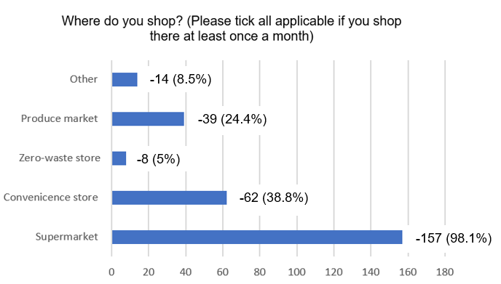
Zero-waste shoppers
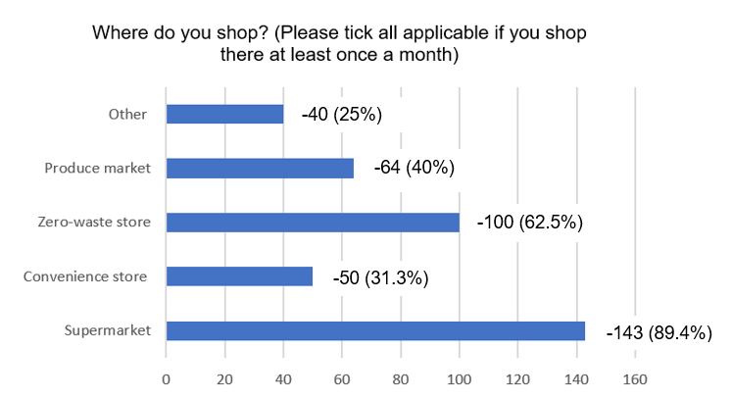
Figure 15: Where the respondents shop
Figure 15 highlights that supermarkets were the most popular shop for both group of consumers. Additionally, 63% of zero-waste consumers shop at a zero-waste store and only 5% of general shoppers do. ‘Other’ responses included online home delivery, local independent shops and farm shops.
Question 8
General shoppers
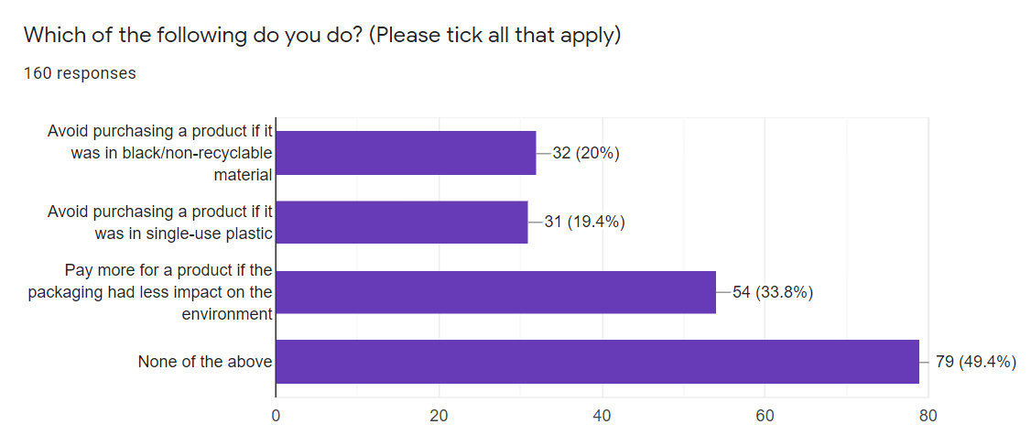
Zero-waste shoppers
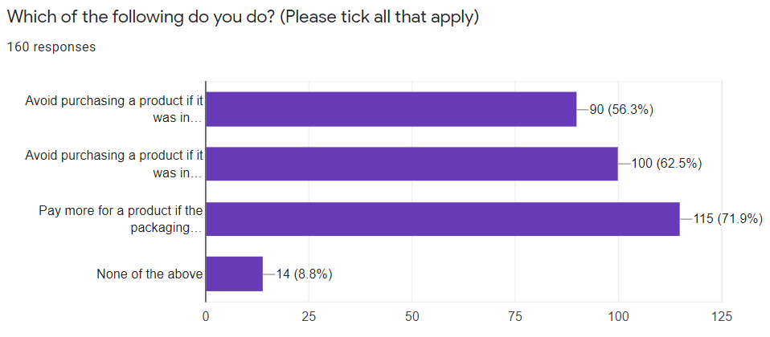

Figure 16: Unrecyclable plastic
Figure 16 identifies that 49% of general shoppers do not avoid purchasing a product in black/ non-recyclable material or single-use plastic and do not pay more for a product if the packaging has less impact on the environment. However, only 9% of zero-waste shoppers do none of the above.
Question 9
General shoppers
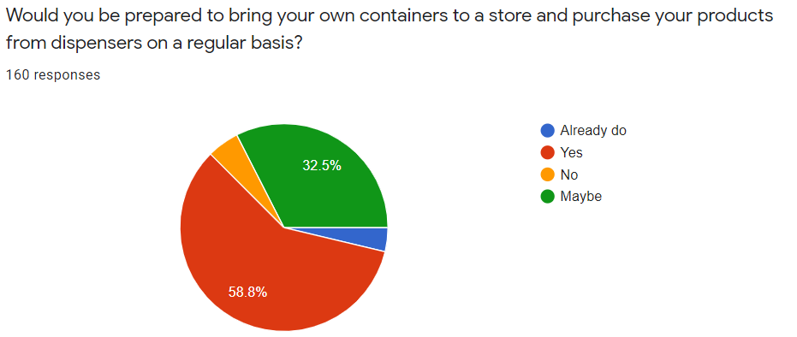
Zero-waste shoppers
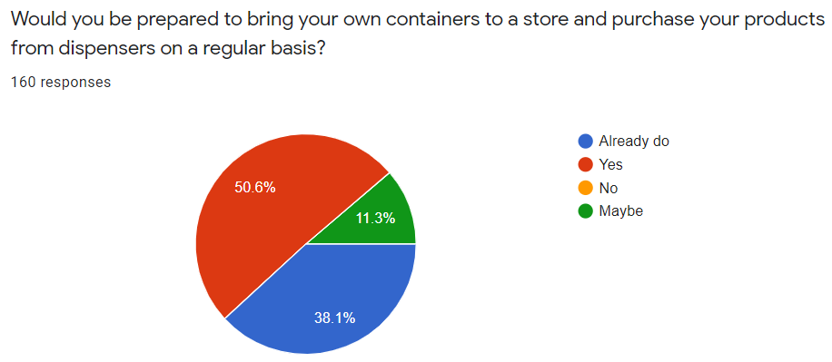
Figure 17: Reusable containers
Figure 17 reveals that 59% of general shoppers would be prepared to bring their own containers to a store to purchase products from a dispenser regularly. In comparison 89% of zero-waste shoppers stated that they would or that they already do.
Question 10
Question 10 required the respondents to state WHY they would or would not be prepared to bring their own containers to a store to purchase products regularly. Below are some of the responses:
General shoppers
- ‘I would use reusable containers if more shops offered the opportunities to allow me to do so, however, it would have to be reasonably priced’.
- ‘Reusable containers limit the amount of single-use plastic which in-turn is better for the environment’.
- ‘Currently not aware of this method of shopping’.
- ‘This method of shopping isn’t convenient as it requires organisation as I can’t go on my way home from work’.
- ‘I would consider using reusable containers if it were an easy and effective system, however, it could be unhygienic if it is self-serve’.
- ‘I like the idea of reusable containers, but when I go shopping currently, I usually have a set time and prefer convenience’.
Zero-waste shoppers
- ‘I think refill systems are great as they massively reduce the use of packaging. It also means I can get the exact amount I need so I have less food waste’.
- ‘I want to reduce my environmental impact and this is a great way to do so’.
- ‘There is no need to repeatedly buy packaged items when you can reuse containers hundreds of times’.
- ‘The pandemic stopped me visiting zero-waste stores and purchasing online’.
- ‘It is a state of mind I have to put myself in and once you start doing it, it gets easier to remember’.
- ‘I find it cheaper and more environmentally friendly to fill my containers at the zero-waste store for the products I am able to. I do try to purchase as many products as I can from the zero-waste store instead of going to the supermarket, however, products are limited’.
Question 11
General shoppers
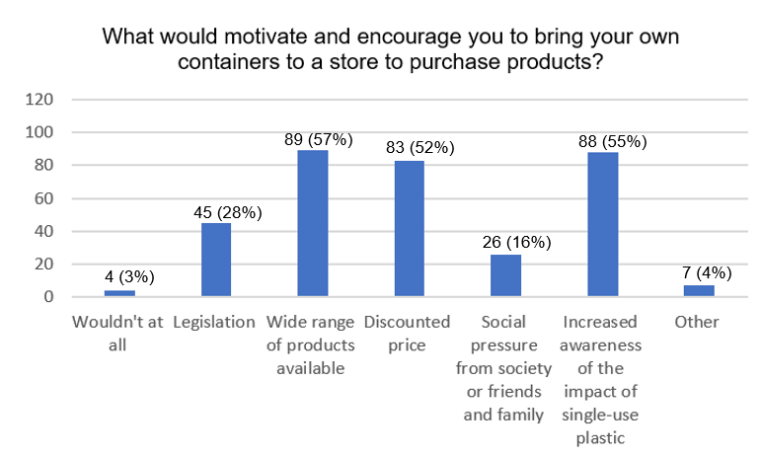
Zero-waste shoppers
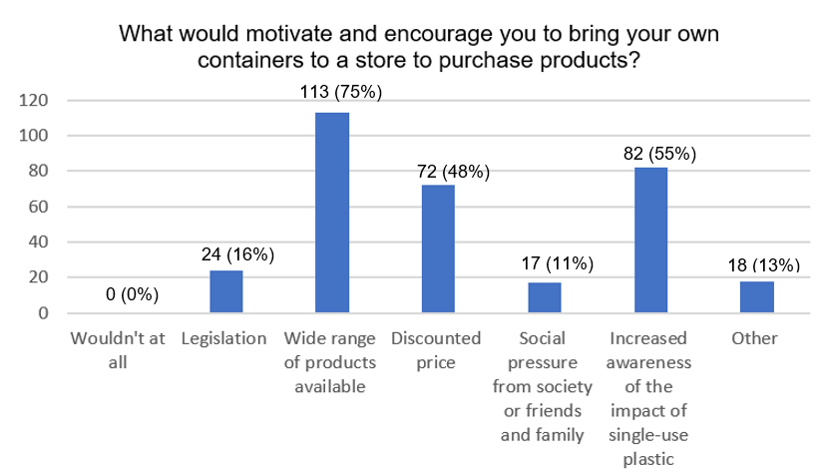

Figure 18: The motivations for respondents to bring their own containers to a store
Figure 18 identifies that the two most significant motivations for both groups of consumers to bring their own containers to a store to purchase products were wide range of products available and increased awareness of the impact of single-use plastic. For example, 57% of general shoppers and 75% of zero-waste shoppers selected wide range of products and 55% of both groups selected increased awareness.
‘Other’ responses included –
- Several consumers stated proximity and location.
- Several consumers stated availability of shops that offer refill systems.
- Several consumers stated opening hours.
- ‘I already bring my own containers to zero-waste stores, however, wider range of products and discounted price would make it even more appealing’.
- ‘A system that is well designed’.

Finding’s Overview
A summary of the main findings are bullet pointed below:
- Convenience and branding are viewed as more important by general shoppers and packaging material, product label information and environmental concerns are viewed as more important by zero-waste shoppers.
- 69% of general shoppers and 98% of zero-waste shoppers feel extremely or quite aware of the environmental impact of single-use plastic.
- 77% of general shoppers and 100% of zero-waste shoppers always or sometimes consider the environmental impact of the packaging of a product.
- 63% of general shoppers and 100% of zero-waste shoppers are aware of what a zero-waste food store is.
- 98% of general shoppers and 89% of zero-waste shoppers purchase products from supermarkets.
- Only 5% of general shoppers purchase products from zero-waste stores.
- 34% of general shoppers and 72% of zero-waste shoppers would pay more for a product if the packaging had less impact on the environment.
- 63% of general shoppers and 89% of zero-waste shoppers would or already do bring their own containers to a store to purchase products regularly.

Chapter 5: Analysis

The methodology chapter explained that a combination of open-ended and closed-ended questions would be utilised. Closed questions allow quantifiable information to be recognised in order for statistical assessment. The data provided through closed-ended questions (Q3, Q4, Q5, Q6, Q9) has been evaluated using the software IBM SPSS. To allow statistical comparisons between the two questionnaires, the Mann-Whitney U Test has been used. The test compares differences between two independent groups when the dependent variable is either ordinal or continuous, but not normally distributed (Mann, et al 1947). The dependent variable will be the answers from the questionnaires, which are ordinal. The independent variables will be the two focus groups, general shoppers and zero-waste shoppers. The null hypothesis for the test is that the probability of X being greater than Y is equal to the probability of Y being greater than X.
The significance level will be used to determine whether there are any statistically significant differences between the two medians. A significance level of 0.05 indicates a 5% risk of concluding that a significant difference exists (Minitab,2019).
Ha is the alternative hypothesis and means that the difference between the medians is statistically significant and the two populations are not equal, therefore the null hypothesis (Ho) is rejected and the alternative hypothesis (Ha) is accepted (Zach,2018).
Therefore, Ho is the null hypothesis and means that the difference between the medians is not statistically significant and the two groups are equal, therefore the null hypothesis (Ho) is accept (Zach,2018).

5.1 Mann-Whitney U Tests of Closed-Ended Questions

Q3 – What is important to you in your grocery buying decisions? (select level of importance for each of the ten features)
Convenience/ time available and branding/ graphical appearance
Ho – There is no significant difference between general shoppers and zero-waste shoppers regarding convenience/time available and branding/graphical appearance.

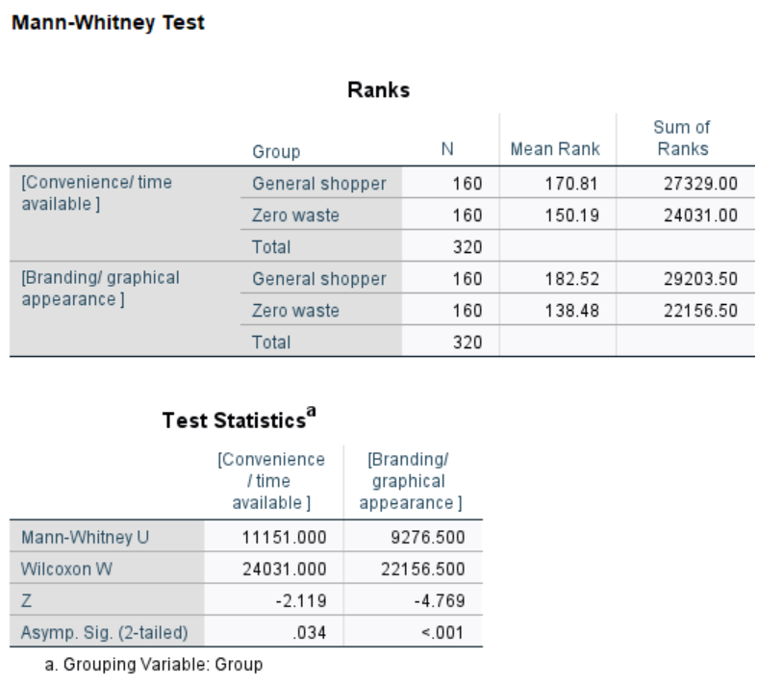

Figure 19: Mann-Whitney U Test - Convenience/ time available and branding/ graphical appearance

Ho is rejected and Ha is accepted as the Mann-Whitney U test concludes that there is a statistically significant difference between the two groups of consumers based on convenience/time available and branding/graphical appearance and general shoppers who perceived these two features as more important than zero-waste shoppers.
Figure 20: Mann-Whitney U Test - Packaging material, product label information and environmental concerns
Packaging material, product label information and environmental concerns
Ho – There is no significant difference between general shoppers and zero-waste shoppers regarding packaging material, product label information and environmental concerns.
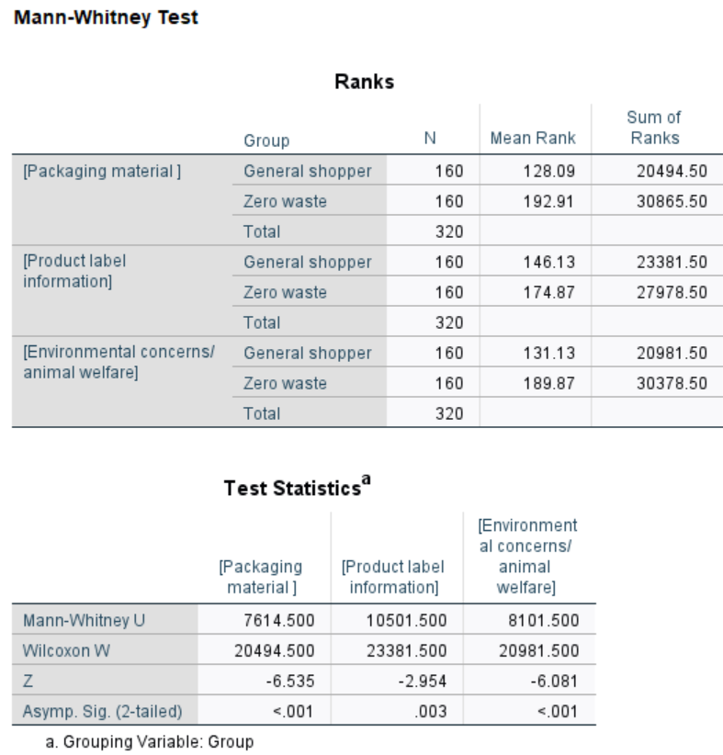

Ho is rejected and Ha is accepted as the Mann-Whitney U test concludes that there is a statistically significant difference between the two groups of consumers based on packaging material, product label information and environmental concerns and zero-waste shoppers who perceived these features as more important than general shoppers.

Figure 21: Mann-Whitney U Test - Pricing/ special offers, quality, proximity to shop, online/ home delivery, hygiene/ cleanliness
Pricing/ special offers, quality, proximity to shop, online/ home delivery, hygiene/ cleanliness
Ho – There is no significant difference between general shoppers and zero-waste shoppers regarding pricing, quality, proximity to the shop, online home delivery and hygiene/cleanliness.
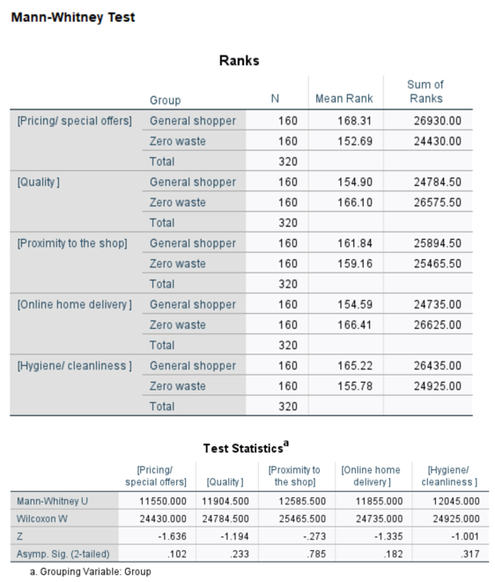

Ho is accepted as the Mann-Whitney U test concludes that there is no statistically significant difference between the two groups of consumers based on pricing, quality, proximity to the shop, online home delivery and hygiene/cleanliness as the mean rank is comparable.
Q4 – On a scale of 1-5 how aware are you of the effect that single-use plastic has on the environment? (5 being extremely aware and 1 being unaware)
Ho – There is no significant difference between general shoppers and zero-waste shoppers regarding how aware they are of the effect that single-use plastic on the environment.
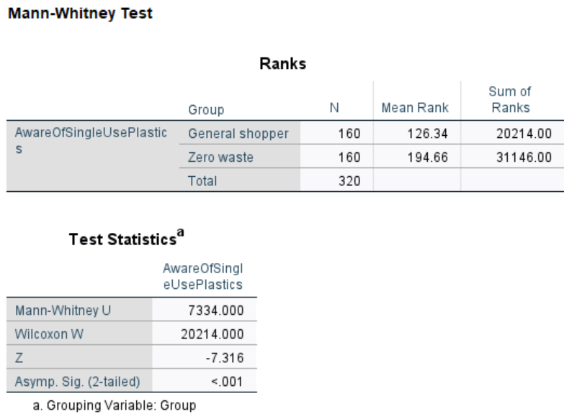

Figure 22: Mann-Whitney U Test – Level of awareness of the effect of single-use plastic

Ho is rejected and Ha is accepted as the Mann-Whitney U test concludes that there is a statistically significant difference between the two groups of consumers based on awareness as more zero-waste shoppers are aware of the effect that single-use plastic has on the environment.

Q5 - How often do you consider the environmental impact of the packaging of a product in your buying decision?
Ho – There is no significant difference between general shoppers and zero-waste shoppers regarding how often they consider the environmental impact of the packaging of a product in their buying decision.

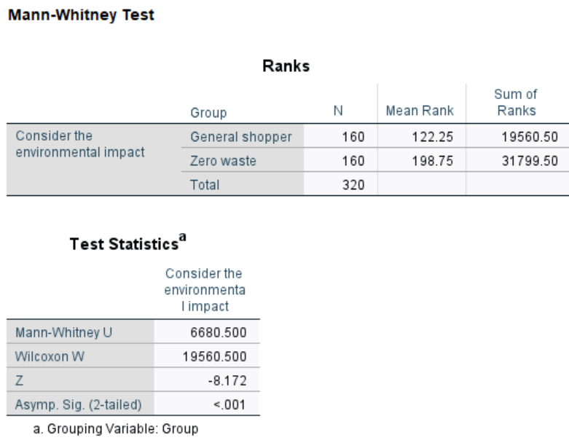
Figure 23: Mann-Whitney U Test – Consideration of the environmental impact of the packaging of a product in the buying decision

Ho is rejected and Ha is accepted as the Mann-Whitney U test concludes that there is a statistically significant difference between the two groups of consumers based on how often they consider the environmental impact of the packaging of a product in their buying decision with more zero-waste shoppers considering this.

Q6 – Do you know what zero-waste food stores are?
Ho - There is no significant difference between general shoppers and zero-waste shoppers regarding whether they know what a zero-waste stores are.

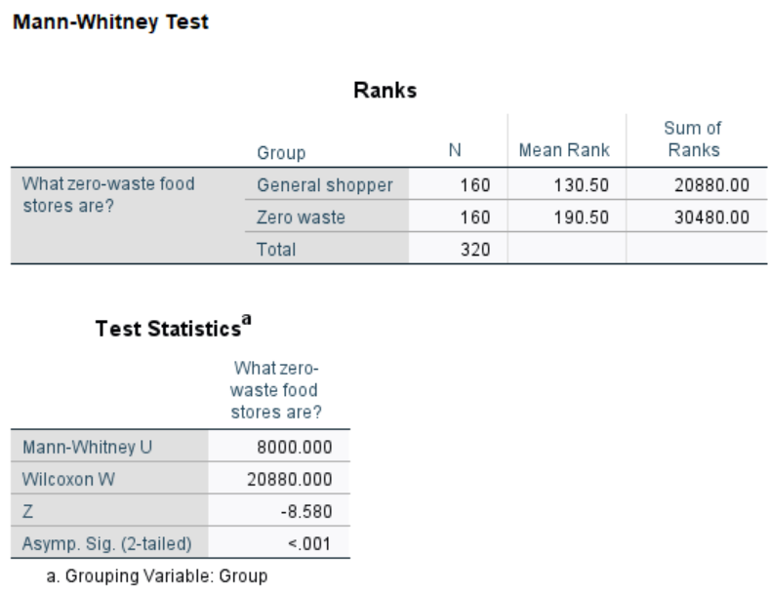
Figure 24: Mann-Whitney U Test – Awareness of zero-waste stores

Ho is rejected and Ha is accepted as the Mann-Whitney U test concludes that there is a statistically significant difference between the two groups of consumers based on whether they know what zero-waste food stores are as more zero-waste shoppers know they exist.

Q9 - Would you be prepared to bring your own containers to a store and purchase your products from dispensers on a regular basis?
Ho – There is no significant difference between general shoppers and zero-waste shoppers regarding whether they would be prepared to bring their own containers to a store on a regular basis.
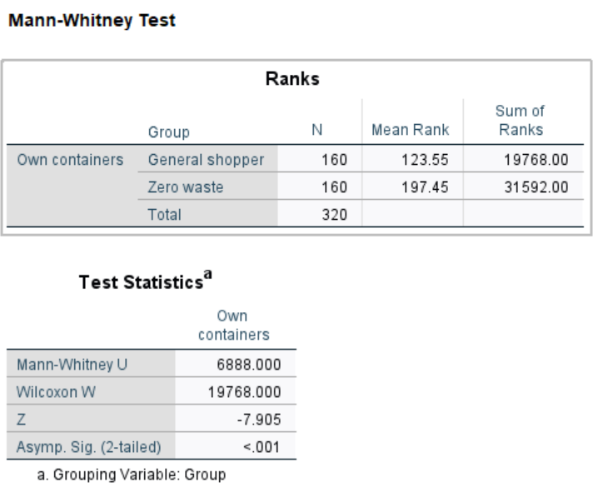
Figure 25: Mann-Whitney U Test – Reusable containers
Ho is rejected and Ha is accepted as the Mann-Whitney U test concludes that there is a statistically significant difference between the two groups of consumers based on whether they would be prepared to bring their own containers to a store on a regular basis as more zero-waste shoppers would be prepared to do this.

5.2 Analysis Overview
The Mann-Whitney U tests have revealed that there are statistically significant differences between general shoppers and zero-waste shoppers. These results will be discussed in further detail in the following chapter.

Chapter 6: Discussion

The closed-ended questions from the Mann-Whitney U tests have identified statistically significant differences between general shoppers and zero-waste shoppers. These results, as well as the findings from the open-ended questions, will be discussed in further detail and in relation to the literature review findings and in accordance with the research questions. As a result, this chapter will achieve objective four:
- To evaluate and compare the different shopping behaviours and motivations of two consumer groups in West Wales in comparison to secondary research findings.

6.1 Research Questions

- If consumers are extremely aware of the environmental impact of single-use plastic packaging, will they seek sustainable alternatives?
The Mann-Whitney U test revealed that there was a statistically significant difference between the two groups of consumers with zero-waste shoppers being more aware of the effect that single-use plastic has on the environment. Despite this, the findings from question 4 revealed that an impressive 69% of general shoppers felt that they were extremely or quite aware of the impact. The Attitudinal Perspective Theory established in the 1970s indicated that when environmental awareness is increased then this would encourage eco-friendly behaviour and have an impact on purchasing decisions (Borden,1997). However, it could be argued that this theory is outdated as Kollmuss et al (2002) highlighted that there is a need for a more complex philosophy. Similarly, empirical findings from question 7 showed that only 5% of general shoppers purchased products from zero-waste stores and question 9 showed that only 4% currently bring their own containers to a store to purchase products, regardless of being aware of the impact of single-use packaging. Additionally, question 8 revealed that 49% of general shoppers do not avoid purchasing a product in black/non-recyclable material or single-use plastic and do not pay more for a product if the packaging had less impact on the environment. Therefore, awareness of the impact of single-use plastic is one aspect, however, other factors are influencing purchasing decisions. Potentially, more awareness and education are required on the harm of black plastic in order to drive up the awareness level of general shoppers from its current level of 69% to achieve a tipping point where their awareness level leads them to use reusable containers.
Stern’s Impulse Theory (1962) suggested that consumers portray impulse behaviour in contrast to planned and rational actions. Pricing was recognised as a significant contributor to impulse purchasing and insufficient time is dedicated to planning purchases. The primary research findings from question 3 revealed that 72% of general shoppers considered pricing or special offers to be extremely or quite important.
To conclude, awareness is relevant and within the zero-waste group it manifests itself in their purchasing decision, however, in the general shopper group it does not as consumers are potentially influenced to impulse purchase. For example, consumers may be enticed by special offers which means reduced considerations are made to the sustainability aspect of the packaging material.

- Are consumers who live in West Wales aware of what a zero-waste store is?
The primary research data from question 6 revealed that 100% of zero-waste shoppers were aware of what a zero-waste food store involved. This was predicted as these consumers were targeted through stratified sampling. However, only 63% of general shoppers were aware of what a zero-waste food store was. This result was surprising as there are five zero-waste stores located in West Wales and three of these stores were established in 2018 (Google Maps, 2021). Empirical findings from question 2 revealed that the largest number of respondents completing both questionnaires were located in Haverfordwest or surrounding areas and The Ark located in Haverfordwest have offered refill systems since 2018. Jamshidian (2021) states that zero-waste stores are increasing, therefore consumers have access to different methods of shopping to allow them to switch their buying behaviour. However, the UNEP (2018), revealed that more awareness is required to inform consumers about reuse systems and the different methods of shopping available. The findings undoubtedly indicate that Pembrokeshire County Council have a duty to raise awareness of alternative sustainable shopping experiences to encourage consumers to potentially change habitual shopping behaviours.

- What are the benefits and barriers of reusable container adoption from a consumer perspective?
Convenience, packaging material, brand/shop loyalty, choice, pricing and hygiene are all potential barriers of reusable container adoption and will all be discussed in further detail below.

Convenience
The Mann-Whitney U test from question 3 showed that there was a statistically significant difference between the two consumer groups, as more general shoppers ranked convenience as extremely and quite important. As Coelho, et al (2020) suggested, modern lifestyles have affected the acceptance of reusable containers as they are perceived to be inconvenient due to carrying, refilling and washing them.
The Theory of Planned Behaviour recognises that once a consumer is aware of the effect of single-use plastic, then they will attempt to purchase sustainably packaged products (Babader, et al 2016). However, it is argued that packaging is one feature within a consumer purchasing decision, but this is balanced against other benefits as convenience was viewed to be a dominant feature (Lindh, et al 2016). Empirical research findings from question 10 highlighted that convenience was a dominant factor for general shoppers. For example, several respondents stated that reuse systems are not a convenient as they require organisation and time which is not possible with hectic lifestyles and existing routines. One respondent stated:
‘This method of shopping isn’t convenient as it requires organisation as I can’t go on my way home from work’.

Packaging Material
The Mann-Whitney U test from question 3 revealed that there was a statistically significant difference between the two groups of consumers as more zero-waste shoppers perceived the packaging material of a product to be extremely or quite important. Zekriri, et al (2015) state that packaging materials can have a significant influence on buying behaviour and can affect consumer perception. It is evident that packaging material has a significant influence on the buying behaviour of zero-waste shoppers as demonstrated from the empirical results from question 8. For example, 56% of consumers would avoid purchasing a product in black/non-recyclable material, 63% would avoid purchasing products in single-use plastic and 72% would pay more for a product if the packaging had less impact on the environment. Additionally, ThoughtWorks (2018) state that UK consumers want to reduce packaging and purchase products in sustainable materials and that this was considered and ranked more important than price considerations. However, Chukwu, et al (2018) acknowledged that packaging is a low priority and has a secondary role in product selection. This is potentially the rationale for general shoppers as empirical findings from question 3 revealed that packaging material was rated extremely or quite important by 47%, however, quality was rated extremely or quite important by 87% and pricing was rated extremely or quite important by 72%. This links with Sterns Impulse Theory (1962) that states consumers frequently impulse purchase rather than making rational actions. This was particularly the case with grocery products as they are purchased regularly.

Brand/Shop Loyalty
The Mann-Whitney U test from question 3 indicated that there was a significant difference between the two groups of consumers as more general shoppers ranked branding and graphical appearance as extremely or quite important in comparison to zero-waste shoppers. Argouslidis, et al (2018) state that loyal consumers can create long-term relationships with a brand or grocer which potentially affects their willingness to convert or change behaviours. However, empirical evidence from question 7 also indicated that both groups of consumers purchase products from at a variety of shops, although supermarkets evidently received the most responses. It could be argued that the majority of consumers are ‘spuriously loyal’ (Dick, et al 1994) and are vulnerable to alternative factors in comparison to brand loyalty (Jensen,2011). For example, when using the One-Sample Kolmogorov-Smirnov Test as shown in figure 26, it can be seen that the mean rank is higher for pricing, convenience and hygiene compared to branding. This shows that both groups of consumers consider these as more important features in the buying decision when compared to branding.

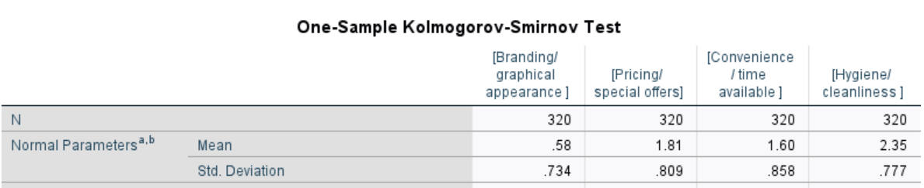
Figure 26: One-Sample Kolmogorov-Smirnov Test
Choice
Empirical research findings from question 11 highlighted that the most significant motivation for both groups of consumers to bring their own containers to a store to purchase products was a wide range of available products. For example, 57% of general shoppers and 75% of zero-waste shoppers selected this incentive feature. Davari, et al (2017) highlighted that consumers consider that they have the freedom of choice to purchase from a selection of groceries and that a decrease in product choice can affect free behaviour and cause psychological reactance (Breham,1996). Zero-waste stores lack the storing capacity in comparison to supermarkets, therefore they are only able to offer a limited variety of product options. Consumer freedom of choice is potentially having an impact on where consumers shop as primary research findings from question 9 identified that only 5% of general shoppers currently purchase products from zero-waste stores.

Pricing
The Mann-Whitney U test from question 3 demonstrated that there was no significant result based on pricing between the two groups of consumers as the mean rank was comparable. However, findings from question 11 revealed that 48% of zero-waste shoppers and 52% of general shoppers would be encouraged and motivated to bring their own containers to a store if discounted prices were provided. Lofthouse, et al (2009) stated that several consumers would presume that the pricing of reusable products would be decreased in comparison to conventional products in single-use plastic. Additionally, 40% of consumers were concerned that if groceries were not offered in single-use packaging that prices would increase (Sonnichsen,2020). Appendix 2 revealed that the majority of pricing per 100g was more expensive from zero-waste stores. Despite this, the Ellen MacArthur Foundation (2019) revealed that refill systems allow consumer needs to be accommodated as the required quantity can be chosen. Additionally, empirical research findings from question 10 revealed that several zero-waste consumers perceived zero-waste stores cheaper. For example, one respondent stated:
‘I find it cheaper and more environmentally friendly to fill my containers at the zero-waste store for the products I am able to’.
It could be argued that zero-waste stores can potentially prove to be cheaper than supermarkets as consumers may be less enticed and portray less impulsive behaviour as they are not influenced by marketing (Mohan, et al 2013).

Hygiene
The Mann-Whitney U test from question 3 identified that there was no significant difference between the two groups of consumers based on hygiene as the mean rank was comparable. When examining the responses in more detail, it can be distinguished that 89% of general shoppers and 76% of zero-waste shoppers considered hygiene as extremely or quite important. Maslow’s Hierarchy of needs recognises that there are five levels of needs and if basic needs are not fulfilled then it restricts progression to the next level (Oved,2017). Plastic packaging fulfils basic needs as it is viewed as hygienic and convenient (Rensburg, et al 2020). Empirical research findings from question 10 indicated that several general shoppers were concerned whether reusable containers would be hygienic, for example, one respondent stated:
‘I would consider using reusable containers if it were an easy and effective system, however, I don’t like the thought of refill systems as it could be unhygienic if it is self-serve’.
Therefore, it could be suggested that reusable containers do not potentially fulfil certain hygienic needs for general shoppers. However, it could be argued that from that from a zero-waste shopper perspective reuse systems fulfil hygiene needs as they use their own reusable containers.
It could also be argued that zero-waste shoppers have reached the peak of Maslow’s Hierarchy and are self-actualising by achieving self-fulfilment and feelings of accomplishment.

- Will there be different behaviours, perspectives and motivations between general shoppers and zero-waste shoppers?

The Mann-Whitney U tests have demonstrated that there are different shopping behaviours and perceptions between the two groups of consumers. For example, there was a statistically significant difference between convenience and branding/ graphical appearance as general shoppers perceived these features as more important. In contrast to this zero-waste shoppers perceived packaging material, product label information and environmental concerns as more important.

- Can consumers be encouraged by society to adopt a sustainable lifestyle?
Surprisingly, empirical research findings from question 11 showed that only 16% of general shoppers and 11% of zero-waste shoppers would be encouraged to bring their own containers to a store to purchase products based on the social pressure from society, friends or family. It has been previously argued that subjective norms are an element of the Theory of Planned Behaviour which recognises that many individuals want to be seen as ‘doing the right thing’ (Rex, et al 2015). This is instigated by social pressures that society has set and how people should behaviour to fulfil certain perceptions (Hagger, et al 2006). It could be argued that subjective norms are still relevant today as they have been recognised to be a determinator of an individual’s intention to recycle (Mannetti, et al 2004) as well as encouraging consumers to adopt reusable containers. The relatively small percentages identified in this study suggest that the subjective norms are not as important as first considered.

- Is there a need for incentivisation or legislation with regards to reusable containers?
As previously discussed, there is a need for Local Authorities to raise awareness of alternative sustainable shopping experiences as empirical research findings from question 6 showed that 38% of general shoppers were unaware of what a zero-waste store involved. Additionally, primary research findings from question 11 indicated that 28% of general shoppers would only be motivated to bring their own containers to a store due to legislation. Additionally, 16% of zero-waste shoppers selected legislation, which potentially suggests that these consumers perceive this as an important factor to motivate additional consumers to adopt a similar lifestyle. Previous legislation has proven to be successful, for example, the carrier bag levy effectively resulted in a decline of 71% between 2011 and 2015 for single-use bags (Sutherland,2020). Additionally, when Pembrokeshire County Council introduced a new recycling scheme 72% of household waste was recycled in 2020 (Sinclair,2020). The Welsh Government have already interacted with stakeholders to understand how a circular economy can be progressed and adopted by society and it was recognised that legislation is vital (Welsh Government, 2020). However, it could be argued that more incentives need to be provided to consumers before legislation is enforced as the cultural shift for reusable container adoption is challenging. This could be implemented in accordance with the Nudge Theory which recognises that Governments and organisations need to encourage people to make informed choices without removing freedom of choice (Mont, et al 2014). This can be achieved by progressively introducing changes to influence consumer behaviour. This is essential as Ledsham (2021) stated that the increasing adverse evidence of single-use plastic was having a limited impact on consumer purchasing decisions.

Discussion Overview

To conclude, this chapter has achieved objective four:
- To evaluate and compare the different shopping behaviours and motivations of two consumer groups in West Wales in comparison to secondary research findings.

An understanding of the different motivating factors between both groups of consumers has been provided. For example, convenience and branding/graphical appearance were considered more important by general shoppers and packaging material, product label information and environmental concerns were deemed more important by zero-waste shoppers.

Chapter 7: Conclusion

This conclusion will summarise the findings identified from the literature review and empirical study and proffer recommendations for future research.
By comparing two groups of consumers, using the Mann-Whitney U statistical test to analyse the survey data, this study has answered the six research questions and shown that:
- When consumers are extremely aware of the environmental impact of single-use plastic packaging, they will seek alternatives. For example, an impressive 69% of general shoppers and 98% zero-waste shoppers felt that they were extremely or quite aware of the impact. However, it was established that only 4% of general shoppers currently bring their own containers to a store to purchase products, despite their level of awareness.
- All of the zero-waste shoppers living in West Wales were aware of what a zero-waste store was, however, only 63% of general shoppers were familiar with a zero-waste store which was surprising as there are five in the vicinity.
- There are barriers to reusable container adoption as demonstrated through convenience, packaging material, brand loyalty, choice, pricing and hygiene.
- There are different shopping behaviours between the groups of consumers as identified in the Mann-Whitney U tests. For example, general shoppers perceived convenience and branding as more important features in comparison to zero-waste shoppers who viewed packaging material, product label information and environmental concerns as more important features.
- It is questioned whether consumers can be encouraged by society to adopt a sustainable lifestyle as only 16% of general shoppers and 11% of zero-waste shoppers would be encouraged to bring their own containers to a store to purchase products based on pressure from society, friends or family.
- Incentivisation is needed to encourage consumers to use reusable containers. For example, 57% of general shoppers and 75% of zero-waste shoppers would be more motivated if there was a wider range of products available. However, there is possibly a need for legislation as 28% of general shoppers and 16% of zero-waste shoppers considered this to be important.
This research investigation has provided a comprehensive understanding of the different shopping behaviours between general shoppers and zero-waste shoppers through using the structure from the four research objectives:
- To investigate the need for a replacement of single-use plastic by identifying sustainable solutions, specifically reusable containers.
- To analyse the barriers of reusable container adoption from a consumer perspective.
- To identify the different shopping behaviours and motivations of two consumer groups in West Wales by collecting empirical data.
- To evaluate and compare the different shopping behaviours and motivations of two consumer groups in West Wales in comparison to secondary research findings.
Objectives one and two were achieved in the literature review, objective three was achieved in the methodology and objective four was achieved in the discussion.
Despite reuse systems being an essential element in the battle to reduce plastic packaging, consumer acceptance and compliance is challenging. Consumer behaviour theories frequently correlated with empirical evidence, for example, The Theory of Planned Behaviour recognised that once a consumer is aware of the effect of single-use plastic, then they will attempt to purchase sustainably packaged products. However, it was also argued that alternative benefits are dominant within the purchasing decision as well as Stern’s Impulse Theory recognising that consumers are influenced to impulse buy. Empirical research findings revealed that awareness is dominant within the zero-waste group and manifests itself in the purchasing decision, however, within the general shopper group it does not and this was specifically associated with convenience factors.
To conclude, it would be necessary for Governments and businesses to take action to encourage general shoppers to use reusable containers. Despite previous legislation proving to be effective, including the carrier bag levy and recycling system, reuse implementation requires long-term habitual behaviours and motivations to be changed. Therefore, governments can encourage reuse adoption through incentivisation rather than enforcement. For example, The Nudge Theory was recognised as a potential resource for Governments as well as businesses as it can be used to implement changes progressively without restricting freedom of choice.
The following recommendations have been proffered to assist the development of reusable container adoption which includes increasing further awareness of single-use plastic packaging and the importance of reuse systems, increasing refill accessibility and introducing vending machines.

7.1 Recommendation One: Increase Awareness
The majority of general shoppers stated that they were extremely or quite aware of the effect that single-use plastic has on the environment, however, it could be argued that this awareness is having a limited impact on shopping behaviours. For example, only 19% of respondents avoid groceries in single-use plastic packaging and only 5% shop at zero-waste stores. Due to this it is recommended that Governments and businesses take action to increase awareness of reuse systems as well as providing incentives. This could be achieved by reducing the price in comparison to conventional packaged products in order to encourage reuse adoption. Awareness and discounted price were recognised in the empirical research findings as important motivators to encourage consumers to use reusable containers. In the long-term reuse systems may potentially become legislated for, if the Welsh Government want to achieve zero-waste by 2050. Previous enforcements have proven to be successful as shown with the carrier bag levy and Pembrokeshire recycling system due to consumer compliance. However, to entirely transform shopping experiences and change long-term habitual behaviours could prove to be significantly challenging.

7.2 Recommendation Two: Increase Refill System Accessibility
The investigation revealed that convenience and proximity to the shop were important features in consumer purchasing decisions. There are five zero-waste stores located in West Wales, however, due to modernity and hectic lifestyles many consumers believed it would be inconvenient to purchase groceries at the supermarket as well as zero-waste stores. It was recognised that zero-waste stores do not essentially provide the desired amount of product options. Due to this, it would be necessary for supermarkets in West Wales to incorporate refill systems which would potentially encourage consumers to change their behaviours. Supermarkets have the storage capacity to be able to implement refill systems on a larger scale, however, this could result in unfair competition for local zero-waste stores. Additionally, if supermarkets were to implement this system not all consumers would be potentially willing to participate as the entire concept of reusable containers was perceived by some as inconvenient and not adoptable with current lifestyles.

7.3 Recommendation Three: Introduce Vending Machines
Milk vending machines have been recognised as popular models in Wales. A similar concept could be adopted for a variety or products in order to encourage consumers to use reusable containers. Empirical research findings indicated that general shoppers were concerned that refill systems were unhygienic due to cross-contamination from self-service. Additionally, consumers stated that they would consider changing shopping habits if refill systems were easy and effective to use. Due to these findings, it is recommended that vending machines are implemented to reduce cross-contamination as well providing ease of use. Realistically vending machines could be introduced in supermarkets, however, it is unlikely that this concept could be adopted in zero-waste stores.

7.4 Further Research
This research project has provided an extensive overview of the advantages and disadvantages of reusable containers from a consumer perspective. Further research would be necessary to assess the implications of the reuse systems from a supermarket perspective and this would help in understanding the slow uptake of this system, especially in West Wales. Secondly, this investigation gathered information regarding respondents age, however, the analysis of this data was beyond the scope of the project. Future research could compare the behaviours and perceptions to age or indeed other socio-economic characteristics which would provide a deeper dive into the barriers associated with reuse systems.

Chapter 8: Bibliography

Agarwal, A., & Chetty, P. (2019, September 10). Use of Hawkins Stern’s impulse buying theory (1962) in online shopping. Retrieved from Project Guru: https://www.projectguru.in/hawkins-sterns-impulse-buying-theory-online-shopping/
Akinci, C., & Saunders, M. (2015). Using Questionnaire Surveys for Within-Organisation HRD Research. In Handbook of Research Methods on Human Resource Development (pp. 353-365). Cheltenham: Edward Elgar.
Alalauri, H., Thunstrom, B., & Fristedt, M. (2015, January). Future of packaging for the Millennials. Retrieved from Storaenso: https://mb.cision.com/Public/11784/9710629/bd1372aab18ef1e7.pdf
Aliaga, M., & Gunderson, B. (2006). Interactive Statistics. London: Pearson .
Allegrini, E., Vadenbo, C., Boldrin, A., & Astrup, T. (2015). Life cycle assessment of resource recovery from municipal solid waste incineration bottom ash. Journal of Envrionmental Management, 132-143.
Apuke, D. (2017). QUANTITATIVE RESEARCH METHODS A SYNOPSIS APPROACH. Kuwait Chapter of the Arabian Journal of Business and Management Review, 40-47.
Argouslidis, P., Dionysis , S., Kühn, A., & Alexis, M. (2018). Consumers’ reactions to variety reduction in grocery stores: a freedom of choice perspective. European Journal of Marketing, 1931-1955.
Arora, S., Singha, K., & Sahney, S. (2017). Understanding consumer’s showrooming behaviour. Asia Pacific Journal of Marketing and Logistics, 409-431.
Babader, A., Ren, J., Jones, K., & Wang, J. (2016). A system dynamics approach for enhancing social behaviours regarding the reuse of packaging. Expert Systems with Applications, 417-425.
Barber, N., Bishop, M., & Gruen, T. (2014). Who pays more (or less) for pro-environmental consumer goods? Using the auction method to assess actual willingness-to-pay. Journal of Environmental Psychology, 218-227.
BBC News . (2019, November 01). Recycling: New Pembrokeshire waste scheme 'too complicated'. Retrieved from BBC News: https://www.bbc.co.uk/news/uk-wales-50255600
BBC News. (2019, January 05). Going plastic-free: The rise of zero-waste shops. Retrieved from BBC News: https://www.bbc.co.uk/news/uk-wales-46574402
Beitzen-Heineke, E., Balta-Ozkan, N., & Reefke, H. (2017). The prospects of zero-packaging grocery stores to improve the social and environmental impacts of the food supply chain. Journal of Cleaner Production, 1528 - 1541.
Bell, J., & Waters, S. (2014). Doing Your Research Project: A Guide for First-Time Researchers. Berkshire: Open Press University.
Biggam, J. (2008). Succeeding with Your Master’s Dissertation: A Step-by-Step Handbook. Berkshire: Open University Press.
Birch, S. (2018, October 16). Battle against Plastic Waste. Retrieved from Ethical Consumer: https://www.ethicalconsumer.org/food-drink/battle-against-plastic-waste
Borden, R. (1977). One More Look at Social and Environmental Psychology: Away from the Looking Glass and into the Future. Personal Soc Psychol Bull, 407–411.
Boz, Z., Korhonen, V., & Sand, C. (2020). Consumer Considerations for the Implementation of Sustainable Packaging: A Review. Sustainability, 1-34.
Brehm, J. (1966). A theory of psychological reactance. Oxford: Academic Press.
British Plastics Federation. (2021). Why do we need plastic packaging? Retrieved from British Plastics Federation: https://www.bpf.co.uk/packaging/why-do-we-need-plastic-packaging.aspx#:~:text=Plastic%20packaging%20serves%20several%20important%20functions%20in%20our,by%20moisture%2C%20humidity%2C%20gases%2C%20microorganisms%2C%20insects%20and%20light.
Bryman, A., & Bell, E. (2011). Business Research Methods. Oxford: Oxford University.
Bryman, A., & Bell, E. (2015). Business Research Methods. Oxford: Oxford University Press.
Bullett, J. (2021, January 26). Plastic packaging: which supermarket topped this year’s league table? Retrieved from Greenpeace: https://www.greenpeace.org.uk/news/supermarket-plastic-league-table-rankings/
CE Delft . (2017). Biobased Plastics in a Circular Economy Policy. Retrieved from CE Delft : https://www.cedelft.eu/publicatie/biobased_plastics_in_a_circular_economy/2022
Chukwu, B., & Enudu, T. (2018). THE IMPACT OF PRODUCT PACKAGING ON CONSUMERS PURCHSING BEHAVIOUR. International Journal of Economics, Commerce and Management, 708-725.
Coelho, P., Corona, B., Klooster, R., & Worrell, E. (2020). Sustainability of reusable packaging–Current situation and trends. Resources, Conservation & Recycling: X, 1-11.
Creswell, J. (2014). Qualitative, Quantitative, and Mixed Methods Approaches. London: SAGE Publications .
Davari, A., Iyer, P., & Guzman, F. (2017). Determinants of brand resurrection movements. European Journal of Marketing, 1896-1917.
Davies, I., & Gutsche, S. (2016). Consumer Motivations for Mainstream “Ethical” Consumption. European Journal of Marketing, 1-36.
DEFRA . (2011, June). Guidance on applying the Waste Hierarchy. Retrieved from Department for Environmental Food and Rural Affairs : https://assets.publishing.service.gov.uk/government/uploads/system/uploads/attachment_data/file/69403/pb13530-waste-hierarchy-guidance.pdf
Dick, A., & Basu, K. (1994). Customer loyalty: Toward an integrated conceptual framework. Journal of the Academy of Marketing Science, 1-99.
Dudovskiy, J. (2018). The Ultimate Guide to Writing a Dissertation in Business Studies: A Step-by-Step Assistance. Business Reseracher Methodology.
Elkatawneh, H. (2016). Comparing Qualitative and Quantitative Approaches. SSRN Electronic Journal, 1-5.
Ellen MacArthur Foundation . (2019). Reuse: Rethinking Packaging. Retrieved from Ellen MacArthur Foundation: https://www.ellenmacarthurfoundation.org/assets/downloads/Reuse-book.pdf
Ellen MacArthur Foundation. (2017). OUR MISSION IS TO ACCELERATE THE TRANSITION TO A CIRCULAR ECONOMY. Retrieved from Ellen MacArthur Foundation: https://www.ellenmacarthurfoundation.org/
Ellen MacArthur Foundation. (2017). PLASTICS AND THE CIRCULAR ECONOMY. Retrieved from Ellen MacArthur Foundation: https://www.ellenmacarthurfoundation.org/explore/plastics-and-the-circular-economy
Emerson, R. (2015). Convenience Sampling, Random Sampling, and Snowball Sampling: How Does Sampling Affect the Validity of Research? Journal of Visual Impairment & Blindness, 164-168.
Environmental Investigation Agency. (2018). Unpacking non-conventional plastics . Retrieved from Environmental Investigation Agency: https://eia-international.org/report/unpacking-non-conventional-plastics/
Ertz, M., Huang, R., Jo, M.-S., Karakas, F., & Sarigollu, E. (2017). From single-use to multi-use: Study of consumers' behavior toward consumption of reusable containers. Journal of Environmental Management, 334-344.
Flint, R. (2020, September 27). Covid-19: Single-use plastic impact 'will last forever'. Retrieved from BBC News: https://www.bbc.co.uk/news/uk-wales-54265590
Frey, F. (2017). SPSS (software). In J. Matthes , C. Davis, & R. Potter , International encyclopedia of communication research methods (pp. 1-2). New Jersey: Wiley.
Gerson, J., Plagnol, A., & Corr, P. (2017). Passive and Active Facebook Use Measure (PAUM): Validation and relationship to the Reinforcement Sensitivity Theory. Personality and Individual Differences, 81-90.
Geyer, R., Jambeck, J., & Law, K. (2017). Production, use, and fate of all plastics ever made. Science Advances, 1-5.
Google. (2021). Google Forms: Free Online Surveys for Personal Use. Retrieved from http://www.google.co.uk/forms/about/
Google Maps. (2021, March 29). Zero-waste stores west wales. Retrieved from Google Maps: https://www.google.co.uk/maps/search/zero+waste+stores+west+wales/@51.8886948,-4.9883475,10z
Goucher-Lambert, K., & Cagan, J. (2015). The Impact of Sustainability on Consumer Preference Judgments of Product Attributes. Journal of Mechanical Design, 1-11.
Gov.UK. (2020, June 02). Mixed methods study. Retrieved from Gov.UK: https://www.gov.uk/guidance/mixed-methods-study
Gov.UK. (2020, November 26). Plastic packaging tax. Retrieved from Gov.UK: https://www.gov.uk/government/publications/introduction-of-plastic-packaging-tax/plastic-packaging-tax
Greenpeace. (2019). Checking out on plastics: A survey of UK supermarkets’ plastic habits. Retrieved from Environmental Investigation Agency and Greenpeace: https://eia-international.org/wp-content/uploads/Checking-out-on-plastics.pdf
Hagger, M., & Chatzisarantis, N. (2006). Self‐identity and the theory of planned behaviour: Between‐ and within‐participants analyses. British Journal of Social Psychology, 731-757.
Haws, K., Winterich, K., & Naylor, R. (2014). Seeing the world through GREEN-tinted glasses: Green consumption values and responses to environmentally friendly products. Journal of Consumer Psychology, 336-354.
Ho, J. (2014). A Research Note on Facebook-based questionnaire survey for academic research in business studies. EUROPEAN ACADEMIC RESEARCH, 9243-9257.
Inglezakis, V., & Moustakas, K. (2015). Household hazardous waste management: A review. Journal of Envrionmental Management, 310-321.
Jackson, M. (2019, September 13). Plastic packaging: How are supermarkets doing? Retrieved from BBC News: https://www.bbc.co.uk/news/uk-49674153
Jamshidian, H. (2021, March 28). Success! 10% more household waste was recycled in 2019/20 in Pembrokeshire according to Haverfordwest film The Ark. Retrieved from Western Telegraph: https://www.westerntelegraph.co.uk/news/19187949.success-10-household-waste-recycled-2019-20-pembrokeshire-according-haverfordwest-film-ark/
Jensen, J. (2011). Consumer loyalty on the grocery product market: an empirical application of Dick and Basu's framework. The Journal of Consumer Marketing, 333-343.
Kedzierski, M., Frere, D., Maguer, G., & Bruzaud, S. (2020). Why is there plastic packaging in the natural environment? Understanding the roots of our individual plastic waste management behaviours. Science of The Total Environment, 1-9.
Kollmuss, A., & Agyeman, J. (2002). Mind the Gap: Why Do People Act Environmentally and What Are the Barriers to Pro-Environmental Behavior? Environmental Education Research, 239-260.
Kosinski, M., Matz, S., Gosling, S., Popov, V., & Stillwell, D. (2015). Facebook as a Research Tool for the Social Sciences: Opportunities, Challenges, Ethical Considerations, and Practical Guidelines. The American Psychologist, 543–556.
Ledsham, N. (2021). Engaging Consumers to Reduce and Recycle. Retrieved from The Sustainability Institute by ERM: https://www.sustainability.com/thinking/engaging-consumers-to-reduce-and-recycle/
Lindh, H., Olsson, A., & Williams , H. (2016). Consumer Perceptions of Food Packaging: Contributing to or Counteracting Environmentally Sustainable Development? PACKAGING TECHNOLOGY AND SCIENCE, 1-23.
Lofthouse, V., Bhamra, T., & Trimingham, R. (2009). Investigating Customer Perceptions of Refillable Packaging and Assessing Business Drivers and Barriers to Their Use. PACKAGING TECHNOLOGY AND SCIENCE, 335–348.
Lofthouse, V., Trimingham, R., & Bhamra, T. (2017). Reinventing refills: guidelines for design. Packaging Technology and Science, 809-818.
Malter, A., Ganesan, S., & Moorman, C. (2008). Cross-Sectional Versus Longitudinal Survey Research: Concepts, Findings, and Guidelines. Journal of Marketing Research, 1-52.
Mann, H., & Whitney, D. (1947). On a Test of Whether one of Two Random Variables is Stochastically Larger than the Other. Ann. Math. Statist, 50 - 60.
Mannetti, L., Pierro, A., & Livi, S. (2004). Recycling: Planned and Self-Expressive Behaviour. Journal of Environmental Psychology, 227–236.
MarketLine . (2020, July 22). Loop launches first online service for groceries in reusable packaging. Retrieved from Packaging Gateway: https://www.packaging-gateway.com/comment/loop-launches-first-online-service-for-groceries-in-reusable-packaging/
Matchar, E. (2019, February 15). The Rise of ‘Zero-Waste’ Grocery Stores. Retrieved from Smithsonian Magazine: https://www.smithsonianmag.com/innovation/rise-zero-waste-grocery-stores-180971495/
Melnikovas, A. (2018). Towards an Explicit Research Methodology: Adapting Research Onion Model for Futures Studies. Journal of Futures Studies, 29–44.
Minitab. (2019). Interpret the key results for Mann-Whitney Test. Retrieved from Minitab: https://support.minitab.com/en-us/minitab-express/1/help-and-how-to/basic-statistics/inference/how-to/two-samples/mann-whitney-test/interpret-the-results/key-results/
Mohan, G., Sivakumaran, B., & Sharma, P. (2013). Impact of store environment on impulse buying behavior. European Journal of Marketing, 1711-1732.
Mont, O., Lehner, M., & Heiskanen, E. (2014). Nudging. A tool for sustainable behaviour? Sweden: Lund University.
Muranganwa, R., & Thinyane, M. (2014, January). Design and implementation of a multi-agent opportunistic grid computing platform. Retrieved from ResearchGate: https://www.researchgate.net/publication/313792758_Design_and_implementation_of_a_multi-agent_opportunistic_grid_computing_platform
Murena, E., Sibanda, V., Sibanda, S., & Mpofu, K. (2020). Design of a Control System for a Vending Machine. Procedia CIRP, 758-763.
Nordin, N., & Selke, S. (2010). Social Aspect of Sustainable Packaging. PACKAGING TECHNOLOGY AND SCIENCE, 317–326.
Odijk, S., & Poggenpohl, A. (2019, November 14). Going Plastic Free: The Rise of Zero Waste Shopping. Retrieved from Greenpeace: https://www.greenpeace.org/usa/rise-zero-waste-shopping/
Olson, E. (2013). It’s not easy being green: the effects of attribute tradeoffs on green product preference and choice. Journal of the Academy of Marketing Science, 171–184.
Oved, O. (2017). Rethinking the Place of Love Needs in Maslow’s Hierarchy of Needs. Society, 537–538.
Pearson, R., & Mundform, D. (2010). Recommended Sample Size for Conducting Exploratory Factor Analysis on Dichotomous Data. Journal of Modern Applied Statistical Methods, 359-368.
Pellis, A., Malinconico, M., Guarneri, A., & Gardossi , L. (2021). Renewable polymers and plastics: Performance beyond the green. New BIOTECHNOLOGY, 146-158.
Pereira, A., Villanueva-Rey, P., Vence, X., Moreira, M., & Feijoo, G. (2018). Fresh milk supply through vending machines: Consumption patterns and associated environmental impacts. Sustainable Production and Consumption, 119-130.
Phellas, C., Bloch, A., & Seale, C. (2011). Structured methods: interviews, questionnaires and observation. Researching Society and Culture, 181-205.
Popovic, I., Bossink, B., & Sijde, P. (2019). Factors Influencing Consumers’ Decision to Purchase. Sustainability, 1-22.
Prakash, G., & Pathak, P. (2017). Intention to buy eco-friendly packaged products among young consumers of India: A study on developing nation. Journal of Cleaner Production, 385-393.
Rensburg, M., Nkomo, S., & Dube, T. (2020). The ‘plastic waste era’; social perceptions towards single-use plastic consumption and impacts on the marine environment in Durban, South Africa. Applied Geography, 1-9.
Rex, J., Lobo, A., & Leckie, C. (2015). Evaluating the Drivers of Sustainable Behavioral Intentions: An Application and Extension of the Theory of Planned Behavior. Journal of Nonprofit & Public Sector Marketing, 263-284.
Rhein, S., & Schmid, M. (2020). Consumers’ awareness of plastic packaging: More than just environmental concerns. Resources, Conservation & Recycling, 1-11.
Ridler, J. (2018, October 02). Food Safety Expert Criticises EU Packaging Proposal. Retrieved from Food Manufacture : https://www.foodmanufacture.co.uk/Article/2018/10/02/Food-safety-expert-criticises-EU-packaging-proposal
Rokka, J., & Uusitalo, L. (2008). Preference for green packaging in consumer product choices – Do consumers care? International Journal of Consumer Studies, 516–525.
Saunders, M. (2012). Research Methods for Business Students . Harlow: Pearson Education Ltd .
Scott, L. (2014). Proceedings of ARCOM Doctoral Workshop on Research Methodology. ARCOM Doctoral Workshop (pp. 1-84). Dublin: Dublin Institute of Technology.
Sedgwick, P. (2012). The Hawthorne effect. BMJ (online), 1-2.
Shapiro, J. (2014). Impulse Buying: A New Framework. Developments in Marketing Science: Proceedings of the Academy of Marketing Science, 76-80.
Signori, S., & Forno, F. (2016). Closing the Attitude-Behaviour Gap: The Case of Solidarity Purchase Groups. Agriculture and Agricultural Science Procedia, 475-481.
Sinclair , T. (2020, November 27). It’s official! Pembrokeshire is best at recycling in Wales. Retrieved from The Pembrokeshire Herald: https://pembrokeshire-herald.com/62373/its-official-pembrokeshire-is-best-at-recycling-in-wales/
Sinha, T., Clarke, S., & Farquharson, L. (2018). Shrek, Saunders and the Onion Myth: Using Myths, Metaphors and Storytelling. European Conference on Research Methodology for Business and Management Studies. Oxford : Kidmore End.
Smith, L. (2021, April 07). Plastic waste. Retrieved from House of Commons Library: https://commonslibrary.parliament.uk/research-briefings/cbp-8515/
Song, Y., Son, Y., & Oh, D. (2015). Methodological Issues in Questionnaire Design. Journal of Korean Academy of Nursing, 323-328.
Sonnichsen, N. (2020, Janruary 31). Consumer concerns about supermarkets transitioning away from plastic packaging in the United Kingdom (UK) in 2017. Retrieved from Statista: https://www.statista.com/statistics/817744/non-plastic-packaging-concerns-united-kingdom-uk/
Stern, H. (1962). The Significance of Impulse Buying Today. Journal of Marketing, 59–62.
Sutherland, N. (2020, October 19). Plastic bags - the Single Use Carrier Bag Charge. Retrieved from House of Commons Library: https://commonslibrary.parliament.uk/research-briefings/cbp-7241/#:~:text=Wales,%20Northern%20Ireland%20and%20Scotland%20introduced%20a%205p,given%20out,%20increase%20their%20re-use%20and%20reduce%20litter.
Taherdoost, H. (2016). Sampling Methods in Research Methodology; How to Choose a Sampling Technique for Research. SSRN Electronic Journal, 18-27.
Thesismind . (2019, June 29). Analysis of Saunders Research Onion. Retrieved from https://thesismind.com/analysis-of-saunders-research-onion/#:~:text=Saunders%20et%20al%20sees%20research%20process%20as%20unwrapping,cover%20one%20step%20first%20before%20proceeding%20to%20another.
Thomas, B. (2020, November 08). How a Llanelli milk farmer went from pouring thousands of gallons down the drain to hour long queues and selling out in hours. Retrieved from Wales Online: https://www.walesonline.co.uk/news/wales-news/llaeth-beynon-dairy-milk-machine-19219374
Thomas, L. (2020, May 08). What is a cross-sectional study? Retrieved from Scribbr: https://www.scribbr.com/methodology/cross-sectional-study/
ThoughtWorks. (2018). Conscious consumption replaces decadent waste society as Britain is on the brink of a food revolution. Retrieved from ThoughtWorks: https://www.thoughtworks.com/news/
Tiseo, I. (2020, August 28). Plastic waste in the UK - Statistics & Facts. Retrieved from Statista: https://www.statista.com/topics/4918/plastic-waste-in-the-united-kingdom-uk/
UNEP. (2018, June 21). Roadmap to healthier, cleaner oceans adopted by UN Environment and European Commission. Retrieved from United Nations Environment Programme: https://www.unep.org/news-and-stories/press-release/roadmap-healthier-cleaner-oceans-adopted-un-environment-and-european
UNEP. (2018, June 05). The state of plastics: World Environment Day Outlook 2018. Retrieved from UN Environment Programme: https://www.unep.org/resources/report/state-plastics-world-environment-day-outlook-2018
Upadhayay, S., & Alqassimi, O. (2019). Transition from Linear to Circular Economy. Circular Economy, 62-74.
Walker, G. (2020). THRILLS & SPILLS: There's a huge public appetite for reducing plastic in retail, but there's more to establishing a successful refillable solution than meets the eye. C-Store looks at the issues to consider. Convenience Store, 20.
Welsh Government . (2017, October 19). Local Authority Municipal Waste Management Report for Wales, 2016-17. Retrieved from Statistics for Wales : https://gov.wales/sites/default/files/statistics-and-research/2019-01/171019-local-authority-municipal-waste-management-2016-17-en.pdf
Welsh Government . (2020). Beyond Recycling: A strategy to make the circular economy in Wales a reality. Wales: The Welsh Government.
Welsh Government . (2020, April 24). Circular economy strategy. Retrieved from Welsh Government: https://gov.wales/circular-economy-strategy
Woiceshyn, J., & Daellenbach, U. (2018). Evaluating Inductive versus Deductive Research in Management Studies: Implications for Authors, Editors, and Reviewers. Qualitative Research in Organizations and Management An International Journal, 1-28.
Wood, C., & Border, P. (2019, July 02). Plastic Food Packaging Waste. Retrieved from UK Parliament: https://post.parliament.uk/research-briefings/post-pn-0605/
Zach. (2018, December 21). Mann-Whitney U Test. Retrieved from Statology : https://www.statology.org/mann-whitney-u-test/
Zekiri, J., & Hasani , V. (2015). THE ROLE AND IMPACT OF THE PACKAGING EFFECT ON CONSUMER BUYING BEHAVIOUR. Special Issue , 232-240.

Chapter 9: Appendices

9.1 Appendix 1

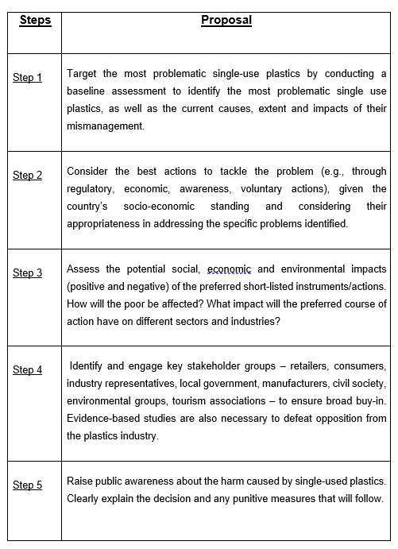
UN Environment Ten Step Proposal

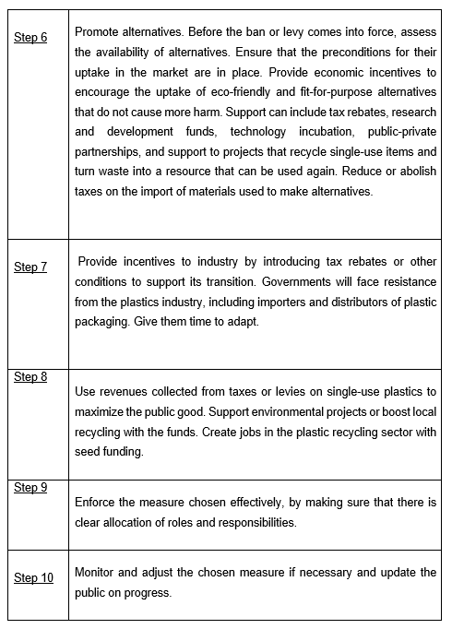
Figure 27: UN Environment Ten Step Proposal (UNEP,2018)

9.2 Appendix 2

Pricing of zero-waste products in comparison to supermarkets
Zero- Waste Stores | Supermarket (Tesco) | Price Comparison
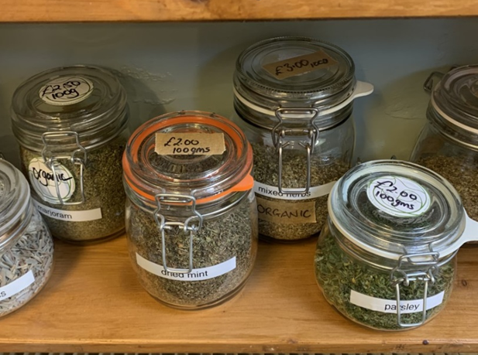 | 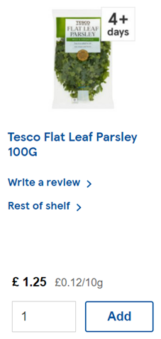 | 100g of parsley –  Zero-waste store - £2.00  Tesco - £1.25  Tesco is 75p cheaper
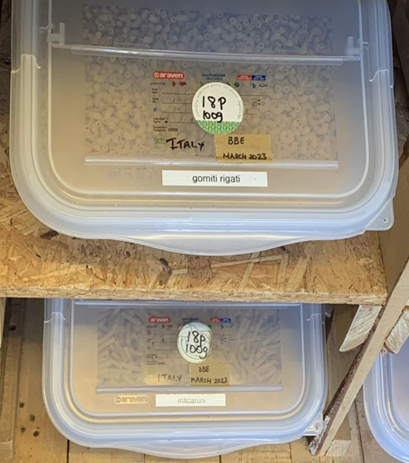 | 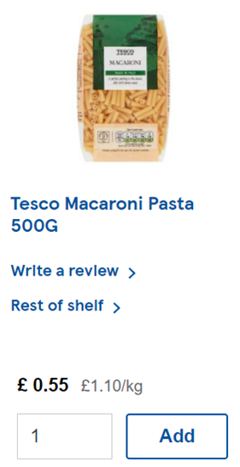 | 100g of macaroni –  Zero-waste store – 18p  Tesco – 11p  Tesco 7p cheaper
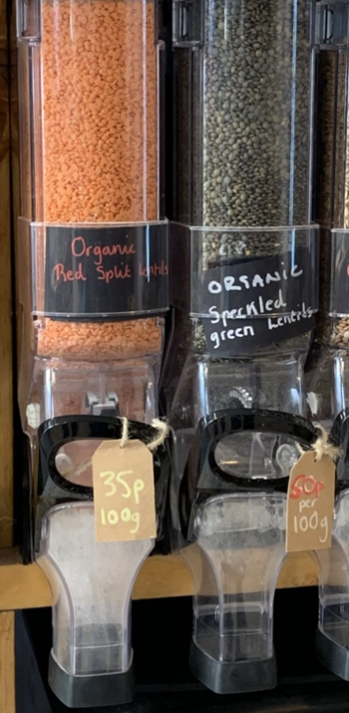 | 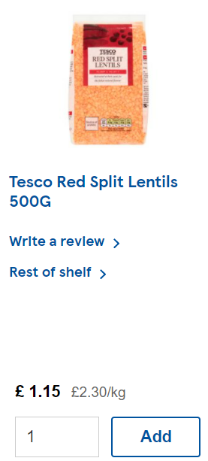 | Red split lentils –  Zero-waste store – 35p  Tesco – 23p  Tesco is 12p cheaper
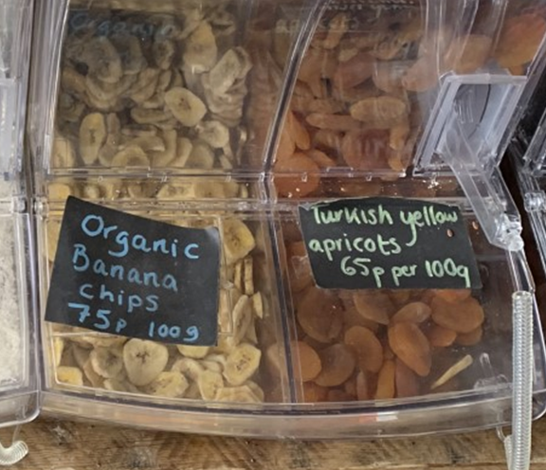 | 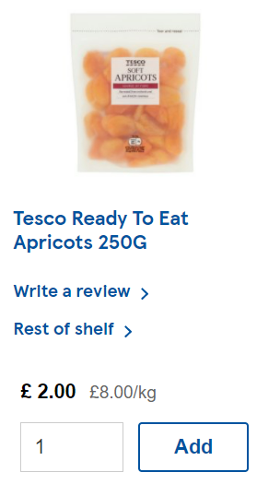 | 100g of dried apricots –  Zero-waste store – 65p  Tesco – 80p  Zero-waste store 15p cheaper

Figure 28: Pricing of zero-waste stores in comparison to supermarkets

