

COMMUNITY CARE AND MANAGEMENT OF LONGER-TERM CONDITIONS - ASSESSMENT 1
STROKE Booklet

Programme: MSc Public Health and Social Care in Practice
Module name: Community care and Management of longer-term conditions
Module code: LCHS7003
Student name: SOLIYA SHANIKUMAR VIPULBHAI
Student ID: 2532722
Lecturer: MUHAMMED KHAN

Table of Contents
Section 1: Clinical Definition, Global and UK Epidemiology, and Pathophysiological Aetiology
- 1.1 Clinical Definition and Pathophysiological Classification
  - 1.1.1 The Classical WHO Diagnostic Benchmark
  - 1.1.2 Contemporary Neuroimaging and TIA Differentiation
  - 1.1.3 Pathophysiology of Ischaemic Stroke (The Ischaemic Cascade & TOAST Classification)
  - 1.1.4 Pathophysiology of Haemorrhagic Stroke (Primary & Secondary Injury Mechanisms)
- 1.2 Global and United Kingdom Epidemiological Burden
  - 1.2.1 Global Metrics: Incidence, DALYs, and Financial Impact
  - 1.2.2 United Kingdom Registry Profile: Incidence, Disability, and NHS Economic Burden
- 1.3 Stratification of Aetiological Risk Factors
  - 1.3.1 Non-Modifiable Biological Determinants (Age, Sex, Genetics, and BAME Disparities)
  - 1.3.2 Modifiable Metabolic and Behavioural Determinants (The INTERSTROKE Paradigm)
Section 2: Bio-Psychosocial Impact Evaluation and NHS Evidence-Based Pathways
- 2.1 Critical Evaluation of Bio-Psychosocial Implications (Engel’s Model)
  - 2.1.1 Physical Implications: Hemiplegia, Neurogenic Dysphagia, and Aphasia
  - 2.1.2 Psychological & Cognitive Implications: Post-Stroke Depression (PSD) and Cognitive Loops
  - 2.1.3 Social and Familial Systems: Economic Role Loss and Caregiver Burnout
- 2.2 Evidence-Based NHS Clinical and Rehabilitative Pathways
  - 2.2.1 Hyperacute Phase Interventions: Thrombolysis (Alteplase) and Mechanical Thrombectomy
  - 2.2.2 Acute Unit Optimization: HASU Direct Admission and Physiological Stabilization
  - 2.2.3 Comprehensive Multi-Disciplinary Team (MDT) Rehabilitation (Physio, OT, SLT, Psychology)
Section 3: Theoretical Models and Frameworks for Managing Long-Term Conditions
- 3.1 United Kingdom Framework: NHS Comprehensive Model for Personalised Care
  - 3.1.1 Personalized Care and Support Plans (PCSPs)
  - 3.1.2 Social Prescribing Link Workers & Non-Medical Community Assets
  - 3.1.3 Personal Health Budgets (PHBs) and Patient Self-Determination
- 3.2 International Framework: The Chronic Care Model (CCM)
  - 3.2.1 Structural Pillars: Health System Organization, Information Systems, and Decision Support
  - 3.2.2 Operational Pillars: Delivery System Design, Self-Management, and Community Resources
Section 4: National and Local Policy Agendas and Political Analysis
- 4.1 The NHS Long Term Plan (2019-2029)
  - 4.1.1 Integrated Stroke Delivery Networks (ISDNs) and Addressing the Postcode Lottery
  - 4.1.2 Early Supported Discharge (ESD) and the Shift to Home-Based Care Models
- 4.2 The National Clinical Guideline for Stroke (2023 Update)
  - 4.2.1 The 3-Hour Daily Therapy Target vs. NHS Workforce Shortages
- 4.3 The Care Act 2014
  - 4.3.1 Section 10: Statutory Rights to Carer's Assessments
  - 4.3.2 Funding Realities: ADASS Survey Analyses and Social Care Resource Strain
Section 5: Evidence-Based Recommendations for Improving Person-Centred Community Care
- 5.1 System-Wide Integration of Digital Telerehabilitation
- 5.2 Standardized Delivery of the Bridges Self-Management Program
- 5.3 Integrated Advanced Care Planning (ACP) and Early Palliative Pathways
Section 6: Comprehensive Academic Reference List

SECTION 1: CLINICAL DEFINITION, GLOBAL AND UK EPIDEMIOLOGY, AND PATHOPHYSIOLOGICAL AETIOLOGY
1.1 Clinical Definition and Pathophysiological Classification
A stroke is conceptualized under public health and neurological paradigms as a profound cerebrovascular insult. The classical diagnostic benchmark established by the World Health Organization (WHO 2025) defines a stroke as a rapidly developing syndrome of clinical signs of focal or global disturbance of cerebral function, with symptoms lasting 24 hours or longer or leading to death, with no apparent cause other than of vascular origin. While this clinical definition remains a cornerstone for epidemiological data collection, contemporary medical frameworks enrich it via neuroimaging criteria. These criteria identify structural tissue infarction even when clinical symptoms resolve within 24 hours, distinguishing true ischemic strokes from Transient Ischemic Attacks (TIAs) (Easton et al. 2009; Sacco et al. 2013).
Pathophysiologically, strokes are divided into two primary categories based on the underlying vascular mechanism:
- Ischaemic Stroke (~85% of cases): This form results from an acute focal occlusion of a cerebral artery, interrupting downstream parenchymal perfusion (Campbell et al. 2019). This occlusion triggers an immediate "ischemic cascade." Deprived of oxygen and glucose, cellular ATP production ceases, causing a failure of ionic pumps, cellular depolarization, toxic intracellular calcium influx, and rapid necrotic cell death within the central core (Dirnagl, Iadecola and Moskowitz 1999). Surrounding this necrotic core lies the "ischemic penumbra"—a structurally threatened but functionally salvageable zone of hypoperfused tissue that serves as the primary target for hyperacute clinical interventions (Fisher and Bastan 2012). Ischemic strokes are further stratified by the Trial of Org 10172 in Acute Stroke Treatment (TOAST) classification into large-artery atherosclerosis, cardioembolism (frequently secondary to atrial fibrillation), small-vessel occlusion (lacunar infarcts), and strokes of other determined or undetermined aetiologies (Adams et al. 1993).
- Haemorrhagic Stroke (~15% of cases): This variant arises from the structural rupture of an intracerebral or subarachnoid blood vessel, leading to direct localized extravasation of blood into the brain parenchyma or cerebrospinal fluid spaces (Qureshi et al. 2009). The structural damage is caused by two distinct mechanical forces: primary injury from physical tissue disruption and local mass effect (which raises intracranial pressure and reduces cerebral perfusion pressure), and secondary injury driven by the chemical breakdown of hemoglobin, local inflammation, oxidative stress, and delayed vasospasm (Keep, Hua and Xi 2012). Haemorrhagic stroke is broadly bifurcated into Intracerebral Haemorrhage (ICH), often linked to chronic hypertensive lipohyalinosis or cerebral amyloid angiopathy, and Subarachnoid Haemorrhage (SAH), predominantly caused by the rupture of secular intracranial aneurysms (Rinkel et al. 1998).
1.2 Global and United Kingdom Epidemiological Burden
Evaluating the epidemiological profile of stroke highlights its status as a major global public health crisis. Data from the Global Burden of Disease (GBD) study demonstrate that stroke remains the second leading cause of death worldwide and the leading driver of collective long-term disability, measured via Disability-Adjusted Life Years (DALYs) (Feigin et al. 2022; GBD 2021 Stroke Collaborators 2024).
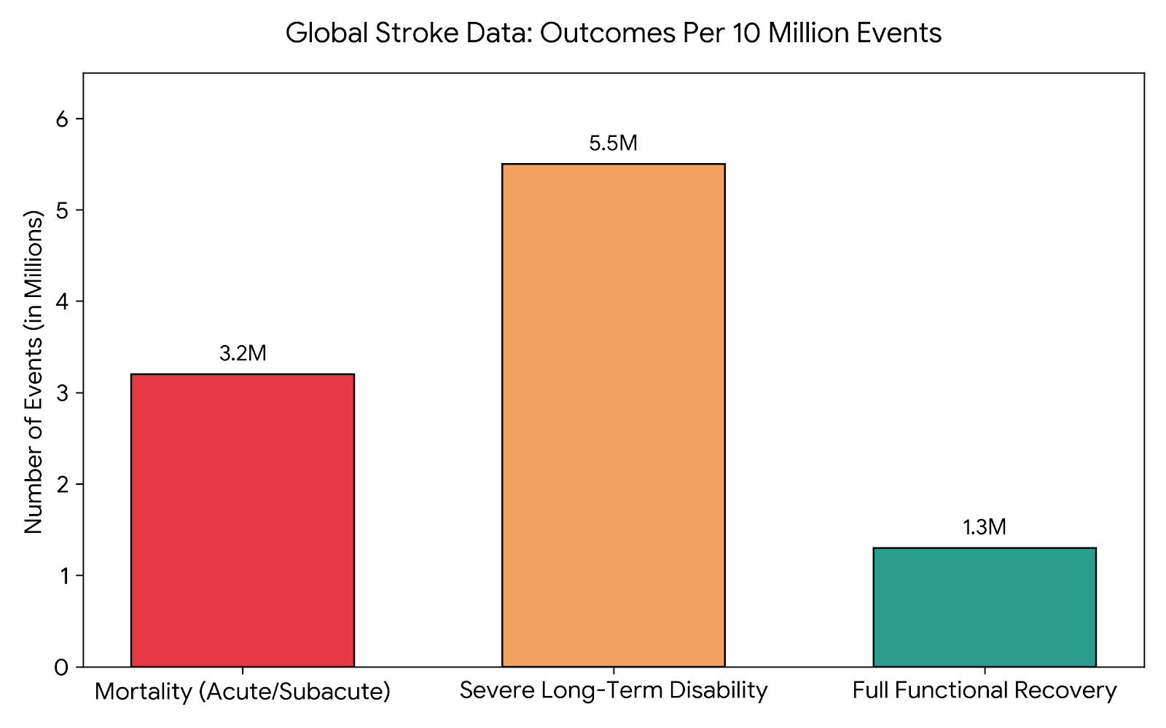

[GLOBAL STROKE DATA CHART: OUTCOMES PER 10 MILLION EVENTS]
Clinical Outcome | Patient Impact (Millions) | Percentage of Total Events
Severe Long-Term Disability | 5.5M | 55%
Mortality (Acute/Subacute) | 3.2M | 32%
Full Functional Recovery | 1.3M | 13%
Total | 10.0M | 100%

Visual Analysis: Over 85% of global stroke events result in either
immediate mortality or long-term functional impairment, illustrating
the immense chronic care burden.
Globally, the annual incidence of stroke sits between 11.9 million and 12.2 million new cases, meaning an incident event occurs approximately every three seconds (World Stroke Organization [WSO] 2025). The global prevalence of stroke survivors currently exceeds 101 million individuals, placing immense financial and operational strain on international health economies (WSO 2025).
In the United Kingdom, the epidemiological data reflect a similarly severe public health landscape. According to registry data curated by the Stroke Association (2025) and Public Health England (2021), there are approximately 100,000 incident strokes annually across the UK—amounting to one stroke occurring every five minutes.
Epidemiological Metric | Global Status (WHO 2025; WSO 2025) | United Kingdom Status (Stroke Association 2025; Parliament UK 2024)
Annual Incidence | Approximately 11.9 to 12.2 million new cases diagnosed annually. | Around 100,000 incident cases occurring per year (one every 5 minutes).
Survivorship / Prevalence | Exceeds 93 to 100 million stroke survivors alive globally. | Approximately 1.3 to 1.4 million stroke survivors residing in the UK.
Mortality Impact | Second leading cause of death worldwide. | Fourth leading cause of death across the UK; major vascular killer.
Disability Index | Leading driver of global Disability-Adjusted Life Years (DALYs). | Single largest cause of severe adult disability; 60% leave hospital with permanent deficits.
Economic Cost (Annual) | Estimated at over $800 Billion USD across health systems. | Exceeds £26 Billion total burden (£3.2B NHS, £5.2B Social Care, £17.6B Productivity).
Currently, more than 1.3 million stroke survivors reside within the UK, making stroke the single largest cause of severe adult disability in the nation (National Audit Office [NAO] 2024). Statistics show that approximately 60% of individuals admitted to NHS trusts with an acute stroke are discharged with long-term functional dependencies that require ongoing health and social care inputs (Office for National Statistics [ONS] 2025). Financially, stroke costs the UK economy an estimated £26 billion per year. This includes £3.2 billion in direct NHS medical costs, £5.2 billion in social care costs, and a massive £17.6 billion chunk stemming from lost productivity and informal care provisions (Stroke Association 2025; King's Fund 2024).
1.3 Stratification of Aetiological Risk Factors
The aetiology of stroke is driven by a complex web of non-modifiable biological attributes, modifiable metabolic states, and behavioral choices. Effectively managing this long-term condition requires a clear public health strategy to categorize these risk factors (O'Donnell et al. 2016).
Category | Risk Factor | Clinical Context / Impact
Non-Modifiable  (Factors that cannot be changed) | Advanced Age (55+) | Stroke risk doubles every decade after the age of 55.
 | Biological Sex | Men have a higher incidence of stroke overall; however, women have higher lifetime risk and mortality (often due to longer life expectancy and post-menopausal vascular changes).
 | BAME Ethnicity Disparities | Black, Asian, and Minority Ethnic (BAME) populations face a significantly higher risk of stroke, often presenting at a younger age and experiencing higher severity, largely driven by a higher prevalence of hypertension and diabetes.
 | Genetic Subtypes (CADASIL) | Monogenic disorders like Cerebral Autosomal Dominant Arteriopathy with Subcortical Infarcts and Leukoencephalopathy drastically increase ischemic stroke risk early in life.
Modifiable  (Factors that can be managed or treated) | Hypertension | The single most significant modifiable risk factor, carrying a Population Attributable Risk (PAR) > 50%.
 | Atrial Fibrillation (AF) | This cardiac arrhythmia increases stroke risk five-fold, typically leading to highly severe, large-vessel cardioembolic strokes.
 | Diabetes & Dyslipidemia | Accelerates systemic atherosclerosis and microvascular damage, compounding overall cardiovascular risk.
 | Tobacco Use & Physical Inactivity | Nicotine damages vascular endothelium and promotes hypercoagulability, while physical inactivity exacerbates metabolic syndrome.

Non-Modifiable Biological Determinants
- Advanced Age: Age represents the most potent independent, non-modifiable demographic risk factor for stroke. The relative risk of experiencing an event doubles every decade after an individual reaches 55 years of age (Wolf et al. 1992). This trend is primarily driven by progressive, age-related arterial stiffening, loss of endothelial elasticity, and subclinical atherogenesis (WSO 2025).
- Biological Sex: Epidemiological patterns show that males exhibit a significantly higher age-standardized incidence of stroke during their middle years compared to pre-menopausal females, who benefit from the protective vascular effects of endogenous estrogens (Appelros, Stegmayr and Terént 2009). However, this gap closes post-menopause. Due to longer female life expectancy, the absolute number of annual stroke deaths and the total long-term disability burden are higher among women (WSO 2025).
- Genetic Predisposition: Polygenic risk scores correlate directly with baseline ischemic stroke vulnerability. Rare monogenic disorders, such as Cerebral Autosomal Dominant Arteriopathy with Subcortical Infarcts and Leukoencephalopathy (CADASIL), offer clear profiles of direct genetic causation (Rutten et al. 2014).
- Ethnicity and Demographic Disparity: In the UK, ethnicity is a significant factor in stroke risk. Populations of Black African, Afro-Caribbean, and South Asian descent exhibit a significantly higher risk of both ischemic and hemorrhagic stroke at younger ages compared to White Caucasian demographics (Sacco et al. 1997; GBD 2021 Stroke Collaborators 2024). This disparity is driven by a mix of genetic predispositions to metabolic syndromes and systemic inequities. These inequities lead to higher baseline rates of uncontrolled hypertension and type-2 diabetes mellitus among minority ethnic groups in urban areas (Saddique et al. 2023).
Modifiable Metabolic and Behavioural Determinants
The international INTERSTROKE study confirmed that ten modifiable risk factors collectively account for approximately 90% of the population-attributable risk (PAR) for stroke globally (O'Donnell et al. 2010; O'Donnell et al. 2016).
- Systemic Hypertension: Hypertension is the most important modifiable risk factor, contributing to over 50% of all ischemic and hemorrhagic events (Lawes et al. 2004). Chronic elevated hydrostatic pressure causes mechanical stress that damages the endothelial lining. This leads to microvascular lipohyalinosis and charcot-bouchard aneurysms, which can cause vessel occlusion or rupture (Chobanian et al. 2003).
- Atrial Fibrillation (AF): This cardiac arrhythmia causes blood to pool in the left atrial appendage, leading to local stasis and thrombus formation. Embolized fragments can travel into the cerebral circulation, often occluding the middle cerebral artery and causing large, severe ischemic infarctions (Wolf, Abbott and Kannel 1991).
- Diabetes Mellitus and Hypercholesterolaemia: Chronic hyperglycemia causes systemic endothelial dysfunction and accelerates macrovascular atherosclerosis (Baddour et al. 2019). Elevated low-density lipoprotein (LDL) cholesterol promotes the formation of unstable atheromatous plaques within major vessels, such as the carotid bifurcation, increasing the risk of thromboembolic events (Amarenco et al. 2006).
- Behavioral Lifestyles: Tobacco smoking doubles ischemic stroke risk by inducing endothelial damage and increasing platelet aggregation (Shinton and Beevers 1989). Physical inactivity, poor nutrition (high-sodium, low-potassium diets), and excessive alcohol consumption further increase risk by worsening baseline metabolic conditions like obesity and hypertension (O'Donnell et al. 2016).
SECTION 2: BIO-PSYCHOSOCIAL IMPACT EVALUATION AND NHS EVIDENCE-BASED PATHWAYS
2.1 Critical Evaluation of Bio-Psychosocial Implications
To understand the full impact of stroke as a long-term condition, public health professionals must look beyond the acute clinical event and evaluate it using George Engel’s Bio-Psychosocial Model (Engel 1977). This framework reveals how physical neurological damage interacts with psychological health and social systems.
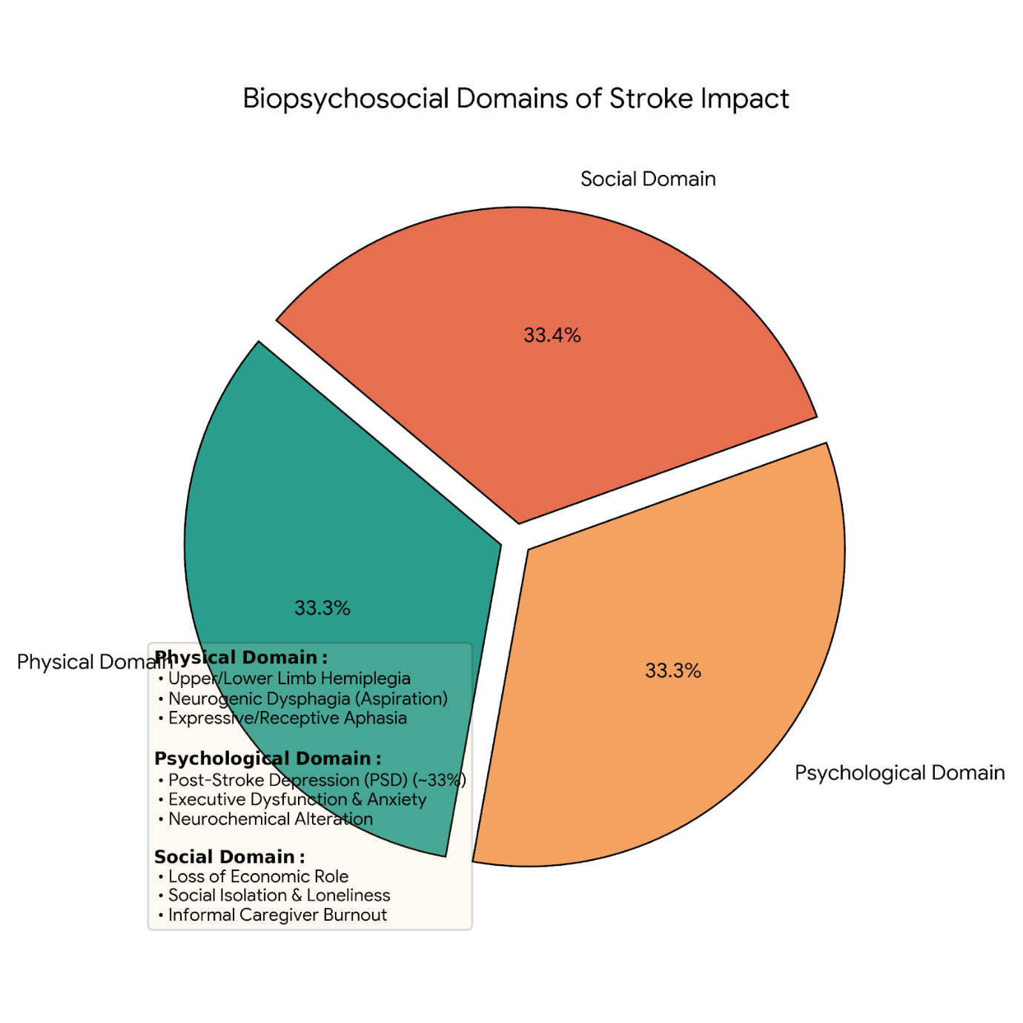
Physical Implications and Impairments
The physical damage caused by a stroke depends on the location and size of the brain tissue affected. A common outcome is upper and lower limb hemiplegia or hemiparesis, which severely disrupts a person's gait cycle, balance, and fine motor skills (Langhorne, Coupar and Pollock 2009). Neurogenic dysphagia (swallowing dysfunction) occurs in up to 50% of acute stroke survivors, presenting ongoing risks for aspiration pneumonia, malnutrition, and severe dehydration (Martino et al. 2005). Additionally, approximately one-third of stroke survivors experience communication deficits, such as expressive or receptive aphasia. These conditions make it difficult or impossible to understand or produce spoken or written language, creating an immediate barrier to expressing basic needs and making independent decisions (Stroke Association 2025; Brady et al. 2016).
Psychological and Cognitive Implications
The psychological impact of a stroke is common and long-lasting. Meta-analytic data indicate that Post-Stroke Depression (PSD) affects roughly 33% of stroke survivors within the first year of recovery (Hackett and Pickles 2014; NICE 2023). The development of PSD is driven by both biological and situational factors. It stems from structural damage to amine-containing axonal pathways in the frontal-subcortical circuits, combined with the emotional trauma of losing physical independence overnight (Robinson and Jorge 2016).
Furthermore, the introduction of a dedicated Neuro-Psychologist into the community multi-disciplinary team is vital. Psychological distress forms a secondary loop of impairment:
Step / Phase | Clinical Phenomenon | Underpinning Pathophysiology & Clinical Impact
1 | Neurological Brain Injury | The initial focal or diffuse parenchymal damage (e.g., stroke, traumatic brain injury) disrupting neural networks and cortical pathways.
2 | Executive Dysfunction | Damage to prefrontal networks impairs cognitive processes such as goal-setting, planning, working memory, attention shifting, and self-monitoring.
3 | Loss of Self-Efficacy | Cognitive deficits and sudden functional limitations shatter the patient’s belief in their own capability to perform tasks or influence their recovery outcomes.
4 | Clinical Depression | Driven by both organic neurochemical alterations (disrupted monoaminergic pathways) and reactive psychological distress over lost independence.
5 | Rehabilitation Non-Adherence | Low mood, amotivation (anhedonia), and perceived helplessness cause the patient to disengage from repetitive physical, occupational, or cognitive therapy regimens.
6 | Poor Neuroplastic Recovery | Without the necessary high-repetition, task-specific active practice, the brain lacks the afferent input needed to drive dendritic branching, synaptogenesis, and cortical remapping.
7 | The Loop Closes | Stagnant physical and cognitive recovery reinforces Executive Dysfunction and deepens the cycle, making subsequent therapeutic interventions increasingly difficult to sustain.

Survivors also frequently experience generalized anxiety disorders, emotional lability (sudden, unpredictable mood shifts), post-stroke fatigue, and executive cognitive dysfunction. These mental health challenges significantly reduce a patient's energy and motivation to engage with intensive physical rehabilitation programs (Kutlubaev and Hackett 2014).
Social and Familial Systems Disruption
A stroke can disrupt a person's social life and family structure. It often causes survivors to leave the workforce prematurely, which can lead to immediate financial difficulties and a loss of professional identity (Daniel, Wolfe and Busch 2009). Physical and communication barriers can cause survivors to withdraw from social circles, leading to isolation and loneliness (Northcott et al. 2016).
Crucially, the care burden often shifts to informal family support networks without formal preparation. Spouses, partners, or adult children frequently become full-time caregivers overnight. This abrupt change can lead to "caregiver burnout," characterized by high rates of clinical depression, anxiety, social isolation, and physical exhaustion from managing tasks like bathing and transfers (Greenwood et al. 2011; Legg et al. 2011). Without adequate state support, this informal care model can cause chronic stress that damages the health of the entire family unit (Coast et al. 2012).
2.2 Evidence-Based NHS Clinical and Rehabilitative Pathways
The National Health Service (NHS) coordinates its stroke services through an evidence-based pathway designed to maximize tissue survival and promote long-term recovery. This pathway is guided by the National Clinical Guideline for Stroke (2023) and the National Institute for Health and Care Excellence Guidelines (NICE 2023, NG236).
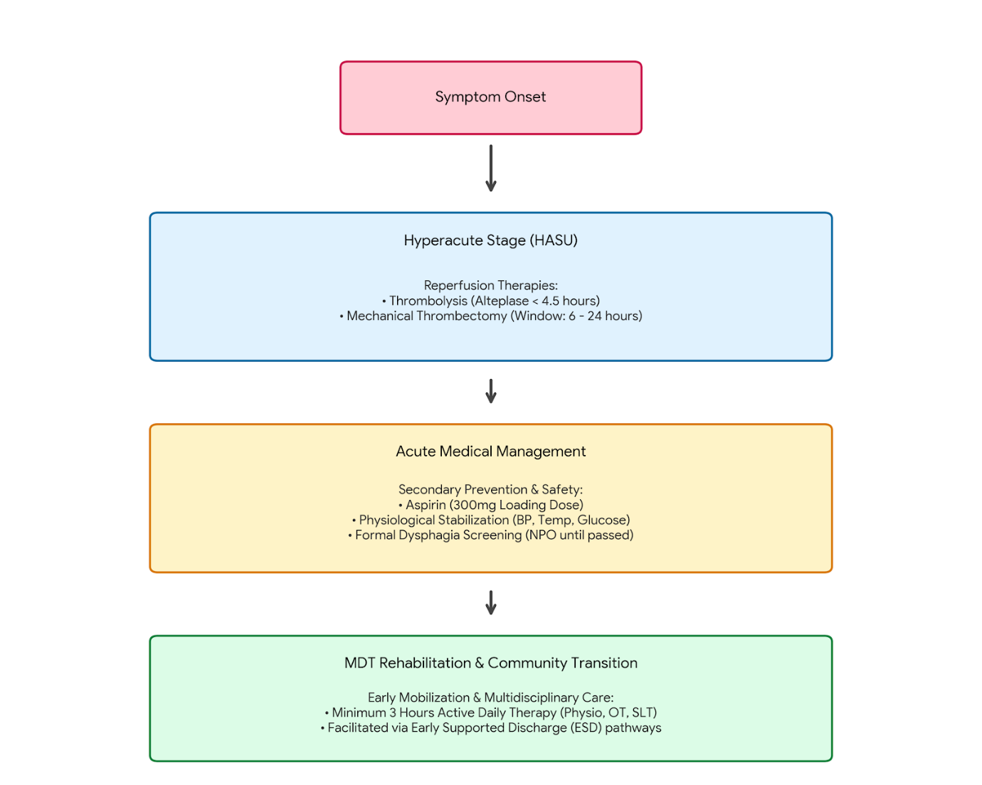
Stage | Timeline / Gate | Core Clinical Objectives & Interventions | MDT / Medical Focus
1. Symptom Onset | 0 Hour Mark | • Emergency identification (FAST criteria)  • Rapid transfer to nearest Hyperacute Stroke Unit (HASU) | Emergency Medical Services (EMS)
2. Hyperacute Stage (HASU) | < 4.5 to 24 Hours | • Brain CT/MRI scan to differentiate ischemic vs. hemorrhagic  • Thrombolysis: IV Alteplase (within 4.5 hours)  • Thrombectomy: Endovascular clot retrieval (within 6–24 hours) | Stroke Medicine, Interventional Neuroradiology
3. Acute Management | 24 to 72 Hours | • Antiplatelet therapy initiated (Aspirin 300mg)  • Rigid Dysphagia Screening (NPO/Nil By Mouth until passed)  • Physiological stabilization (Strict monitoring of BP, blood glucose, and temperature) | Stroke Physicians, Nursing, Speech & Language Therapy (SLT)
4. MDT Rehabilitation | Subacute / Post-72 Hours | • Intense, task-specific active therapy (Target: 3 hours daily)  • Early Mobilization strategies to stimulate neuroplasticity  • Facilitation of Early Supported Discharge (ESD) for home-based rehab | Physiotherapy, Occupational Therapy, Speech & Language Therapy (SLT)

Hyperacute Phase Interventions
The early management of ischemic stroke is time-critical, operating on the principle that "time is brain" (Saver 2006). For patients presenting within 4.5 hours of symptom onset, intravenous thrombolysis using the recombinant tissue plasminogen activator alteplase is the primary option to break up clots and restore blood flow (Emberson et al. 2014). For large vessel occlusions (LVO) in the anterior circulation, mechanical thrombectomy (endovascular clot retrieval) is indicated within 6 hours of onset, and can be extended up to 24 hours based on advanced perfusion neuroimaging (Goyal et al. 2016). Thrombectomy reduces long-term functional dependency. In cases of non-haemorrhagic stroke, acute guidelines require immediate antiplatelet therapy, starting with a 300 mg dose of aspirin within 24 hours to prevent early recurrence (NICE 2023).
Acute Unit Optimization
Evidence shows that admitting stroke patients immediately to a dedicated Hyperacute Stroke Unit (HASU) reduces mortality and long-term disability rates, regardless of age or stroke severity (Langhorne and Pollock 2002). Key priorities in the HASU include continuous physiological management, such as maintaining blood pressure within safe ranges, regulating blood glucose levels, and conducting a formal swallow screen within 4 hours of arrival to prevent aspiration before oral intake is allowed (NICE 2023; Intercollegiate Stroke Working Party [ISWP] 2023).
Comprehensive Multi-Disciplinary Team (MDT) Rehabilitation
Once a patient is medically stable, care transitions to an intensive rehabilitation model aimed at promoting neuroplasticity—the brain's ability to reorganize neural pathways after injury (Kleim and Jones 2008). The Multi-Disciplinary Team (MDT) includes compact sub-groups executing evidence-based therapies.
Disciplinary Actor | Clinical Intervention Focus | Evidence-Based Outcome Target
Neurological Physiotherapy | High-repetition, task-specific motor circuit training; constraint-induced movement therapy. | Restores balance, gait speed, and upper-limb tracking via motor neuroplasticity.
Occupational Therapy | Environmental modification; adaptive ADL simulation; cognitive retraining. | Re-establishes residential independence and minimizes lifestyle restrictions.
Speech & Language (SALT) | Neuromuscular electrical stimulation for dysphagia; intensive language therapy for aphasia. | Safeguards nutritional intake and reduces communication barriers.
Neuro-Psychology | Cognitive Behavioral Therapy (CBT); assessment of vascular executive decline. | Resolves Post-Stroke Depression (PSD) loop and drives therapy compliance.
The National Clinical Guideline for Stroke (2023) mandates that individuals with active rehabilitation goals receive a minimum of 3 hours of therapy per day, delivered across relevant disciplines at least 5 days a week. Early Supported Discharge (ESD) protocols allow this intensive rehabilitation to transition directly into the community. This approach delivers hospital-level therapy within the patient's home, which has been shown to reduce hospital stays and improve long-term functional recovery (Langhorne et al. 2017).
SECTION 3: THEORETICAL MODELS AND FRAMEWORKS FOR MANAGING LONG-TERM CONDITIONS
To move chronic stroke management from a reactive approach to a proactive, population-focused model, health systems utilize structured delivery frameworks. This booklet examines one UK-specific model and one international model.
3.1 United Kingdom Framework: The NHS Comprehensive Model for Personalised Care
The NHS Comprehensive Model for Personalised Care is a core strategy within the contemporary British health system. It aims to scale up personalized care for over 2.5 million people living with long-term conditions (NHS England 2019). This model shifts care delivery from a paternalistic "what is the matter with you?" approach to a collaborative partnership centered on "what matters to you?" (NHS England 2019). It is built on six key components designed to give patients more choice and control over their care.
When applied to long-term stroke management in community care, this framework changes how care transitions are handled. During discharge planning, the multi-disciplinary team and the stroke survivor co-produce a Personalized Care and Support Plan (PCSP). Rather than focusing solely on clinical measurements like blood pressure, the PCSP prioritizes the individual's personal life goals, such as regaining the ability to walk to a local park or using adaptive cutlery to eat independently (Coulter et al. 2015).
[COMMUNITY RE-INTEGRATION FLOW: SOCIAL PRESCRIBING MODEL]
Stage | Key Setting / Actor | Primary Objective | Key Milestone
1 | Acute NHS Stroke Unit | Clinical stabilization & hyperacute medical care | Medical Clearance
2 | Local Social Link-Worker | Bridging clinical care with community-based social prescribing | PCSP Goal Validation
3 | Peer Stroke Networks | Combating isolation & maintaining functional independence | Long-Term Wellness

Critical Analysis: This bridge avoids clinical dependency by using local social assets
to replace costly, continuous outpatient clinic oversight.
The model relies heavily on social prescribing link workers. These professionals connect stroke survivors with non-medical community assets, such as local stroke clubs, adaptive exercise classes, and peer-led communication groups (Bickerdike et al. 2017). By linking clinical care with local community groups, the model addresses the social isolation and depression associated with stroke, reducing reliance on primary care appointments.
Furthermore, the introduction of Personal Health Budgets (PHBs) allows individuals with stable post-stroke deficits to directly purchase their alternative care solutions (e.g., specific active mobility aids or independent neuro-rehabilitation software packages), creating real patient self-determination.
3.2 International Framework: The Chronic Care Model (CCM)
The Chronic Care Model (CCM), developed by Edward Wagner and his colleagues at the MacColl Center for Healthcare Innovation in the United States, is an international framework for managing chronic illnesses within primary care systems (Wagner et al. 2001). The CCM operates on the principle that high-quality chronic care requires a productive interaction between an informed, active patient and a prepared, proactive team of health professionals (Bodenheimer et al. 2002).
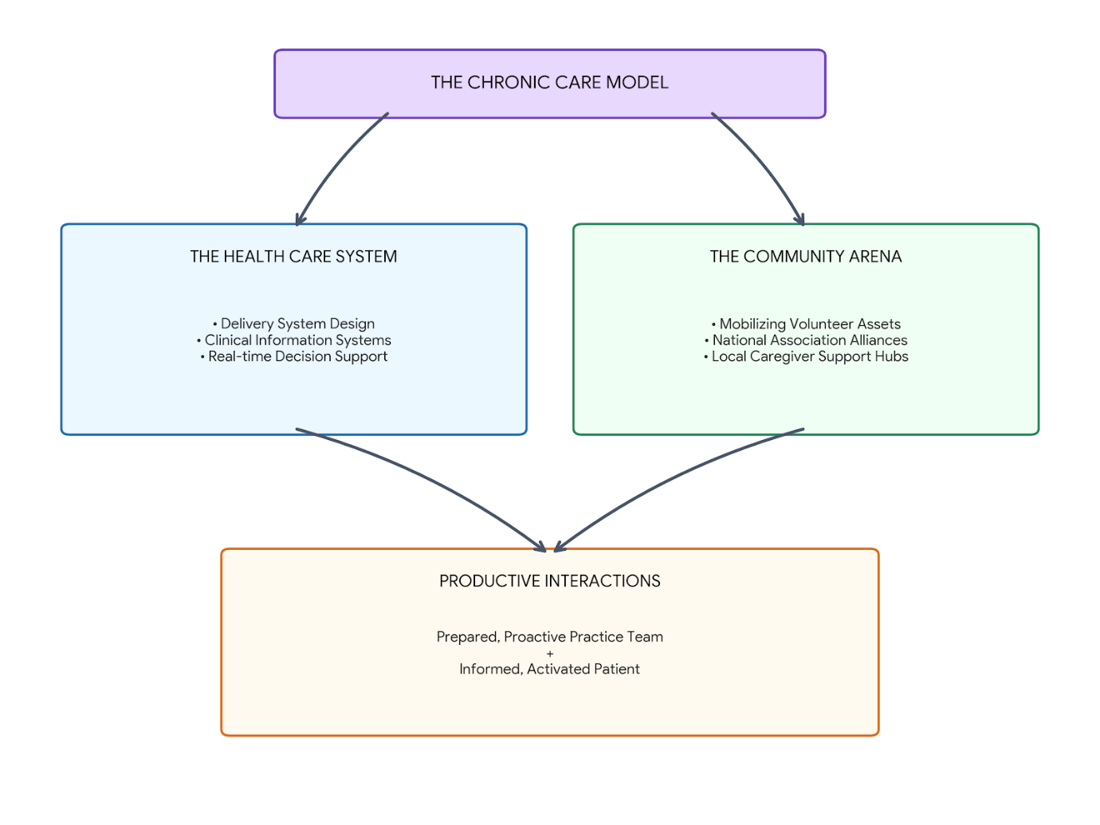
The model structures this relationship across six components:
1. Health System Organization
This component involves restructuring organizational leadership to prioritize chronic care management over acute care. In stroke care, this means securing funding for long-term community rehabilitation rather than investing solely in acute hospital beds (Wagner 1998).
2. Clinical Information Systems
This pillar utilizes digital technologies, registries, and electronic health records to monitor patient outcomes and track compliance with clinical guidelines. In the UK, this is exemplified by the Sentinel Stroke National Audit Programme (SSNAP), which collects real-time data on every stroke patient to identify variations in care and drive quality improvements across Integrated Care Systems (ICSs) (Bray et al. 2016).
3. Decision Support
This component integrates evidence-based guidelines directly into daily clinical practice. It provides teams with clear protocols for secondary stroke prevention, such as standardized algorithms for prescribing anticoagulants to patients with atrial fibrillation or prescribing high-intensity statins to manage cholesterol (ISWP 2023).
4. Delivery System Design
This pillar focuses on structuring clinical teams with clear roles and dividing care into distinct stages. For stroke survivors, it separates acute medical stabilization from long-term community rehabilitation, ensuring that care transitions smoothly from stroke specialists to general practitioners and community care teams (Bodenheimer et al. 2002).
5. Self-Management Support
This component shifts the patient's role from a passive recipient of care to an active partner. It equips stroke survivors with the tools, skills, and confidence to manage their condition daily. This includes training survivors to monitor their blood pressure at home (targeting a systolic reading below 125 mmHg), manage complex medication schedules, and adopt healthier lifestyle habits to lower the risk of a secondary stroke (NICE 2023).
6. Community Resources
This pillar links healthcare organizations with external community programs to provide ongoing support for patients. For stroke care, it connects clinical teams with national charity networks like the Stroke Association, allowing survivors to access long-term peer support and vocational rehabilitation after statutory NHS services end (National Clinical Guideline for Stroke 2023).
SECTION 4: NATIONAL AND LOCAL POLICY AGENDAS AND POLITICAL ANALYSIS
The funding, organization, and delivery of long-term stroke care are shaped by macro-level political choices, legislative acts, and national policy agendas. Analyzing these policies reveals how high-level government strategies translate into everyday care within local communities.
4.1 The NHS Long Term Plan (2019–2029)
The NHS Long Term Plan (NHS England 2019) identifies stroke as a clinical priority, aiming to save tens of thousands of lives over a ten-year period by modernizing the care pathway. From a policy perspective, this document mandated the restructuring of stroke services across England into regional configurations called Integrated Stroke Delivery Networks (ISDNs).
The political goal of ISDNs is to standardize care quality and eliminate geographical disparities—often referred to as the "postcode lottery." This structure ensures that regardless of where a patient lives, they have equal access to hyperacute interventions like mechanical thrombectomy and artificial intelligence-driven neuroimaging systems (NAO 2024). Furthermore, the plan provides funding for enhanced community support by backing Early Supported Discharge (ESD) protocols. This shift reflects a policy move toward moving rehabilitation out of expensive acute hospital beds and into more cost-effective, community-based home care models (Adult Social Care Outcomes Framework [ASCOF] 2024).
4.2 The National Clinical Guideline for Stroke (2023 Update)
The 2023 update of the National Clinical Guideline for Stroke is an authoritative policy framework that sets clinical benchmarks across all four UK nations and the Republic of Ireland (ISWP 2023). This guideline acts as a key reference for service design, placing a clear responsibility on local Integrated Care Boards (ICBs) to commission adequate long-term rehabilitation services.
A key aspect of this policy is its focus on increasing the intensity of rehabilitation. It recommends that stroke survivors receive up to 3 hours of therapy per day, a significant increase from the previous 45-minute standard (ISWP 2023). Politically, this guideline exposes a gap between evidence-based recommendations and local realities. Many ICBs struggle to meet these targets due to systemic workforce shortages within the NHS, particularly among physiotherapists, occupational therapists, and speech and language specialists (King's Fund 2024).
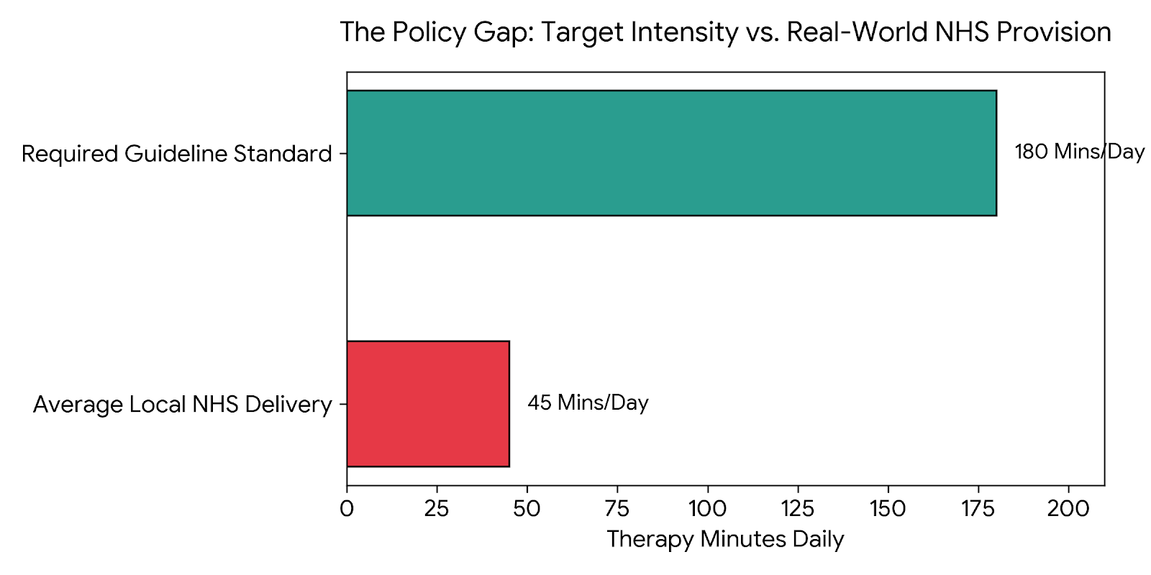
Critical Context: This severe deficit highlights the financial and structural
workforce barriers that limit the deployment of evidence-based health policies.
4.3 The Care Act 2014
For public health and social care integration, the Care Act 2014 is a crucial piece of legislation governing long-term condition management. The Act places a legal duty on local authorities to protect and promote individual well-being, shift focus toward preventative care, and ensure services are well-integrated with local NHS trusts.
Crucially, Section 10 of the Care Act 2014 grants informal family caregivers a statutory right to an independent Carer’s Assessment. This mechanism requires local authorities to evaluate the impact of caregiving on an individual’s physical health, mental well-being, and financial security, independent of the care recipient’s eligibility status (Care Act 2014).
This legislative mandate is an important mechanism for addressing caregiver burnout. When a carer’s assessment reveals a high level of strain, it triggers a legal requirement for the local authority to provide support, such as state-funded respite care, physical equipment, adaptations to the home, or emotional counseling.
However, a political analysis reveals tension between this statutory entitlement and real-world funding constraints. Long-term budget cuts to local government funding mean that social care departments often use strict eligibility criteria, leaving many informal family caregivers to bear the burden of stroke care without adequate state support (Association of Directors of Adult Social Services [ADASS] 2025). This creates an unequal system where families who cannot afford private care packages experience progressive decline in health outcomes.
SECTION 5: EVIDENCE-BASED RECOMMENDATIONS FOR IMPROVING PERSON-CENTRED COMMUNITY CARE
To improve long-term stroke care within local Integrated Care Systems (ICSs), the following three recommendations are proposed. These recommendations are designed to improve patient autonomy, enhance self-management, and ensure dignity at the end of life.
5.1 System-Wide Integration of Digital Telerehabilitation
- Recommendation: Local Integrated Care Boards (ICBs) should fund and integrate digital telerehabilitation platforms into their community stroke teams (e.g., Virtual Reality movement training and asynchronous digital speech therapy apps).
- Justification and Evidence Baseline: Telerehabilitation addresses the challenge of meeting the high-intensity therapy targets mandated by the National Clinical Guideline for Stroke (2023) amidst widespread staff shortages. Peer-reviewed trials demonstrate that home-based telerehabilitation platforms achieve functional recovery outcomes that are equivalent to traditional face-to-face clinical sessions (Cramer et al. 2019; Laver et al. 2020).
- Impact: This approach removes transport barriers for survivors with mobility issues, allows therapists to monitor progress remotely, and empowers individuals to manage their own rehabilitation schedule, promoting greater independence.
5.2 Standardized Delivery of the Bridges Self-Management Program
- Recommendation: Local health authorities should commission and integrate the Bridges Self-Management framework as a standard part of the care pathway for all stroke survivors moving from acute care into community settings.
- Justification and Evidence Baseline: Moving away from prescriptive, clinician-led exercise plans, this framework focuses on building self-efficacy, problem-solving skills, and confidence. Clinical studies show that stroke survivors who participate in structured self-management programs demonstrate significantly better health-related quality of life, higher engagement with rehabilitation, and lower rates of depression compared to those receiving standard care (Jones, Mandy and Partridge 2009; Parke et al. 2015).
- Impact: Training community staff to use this goal-oriented method helps survivors manage their own health risks, such as monitoring blood pressure and sticking to medication schedules, which can help prevent secondary stroke events.
5.3 Integrated Advanced Care Planning (ACP) and Early Palliative Pathways
- Recommendation: For patients who suffer severe, non-survivable strokes, or those experiencing advanced post-stroke cognitive decline, an early palliative care pathway featuring structured Advance Care Planning (ACP) should be established within acute and community care networks.
- Justification and Evidence Baseline: Evidence shows that early integration of palliative care in advanced cerebrovascular disease improves symptom management, reduces the use of futile interventions, and increases the likelihood that a patient can care for themselves at home if that is their preference (Holloway et al. 2014; Creutzfeldt et al. 2019).
- Impact: Documenting preferences for medical interventions and ceiling of treatment decisions early helps ensure a patient's choices are respected if they lose communication or cognitive capacity later. This model shifts the focus of care toward comfort, dignity, and effective symptom management (such as controlling secretions and pain), while providing structured emotional and bereavement support to families during a highly stressful time.
SECTION 6: COMPREHENSIVE ACADEMIC REFERENCE LIST
- Adams, H.P., Bendixen, B.H., Kappelle, L.J., Biller, J., Love, B.B., Gordon, D.L. and Marsh, E.E. (1993) 'Classification of subtype of acute ischemic stroke. Definitions for use in a multicenter clinical trial. TOAST. Trial of Org 10172 in Acute Stroke Treatment', Stroke, 24(1), pp. 35–41.
- Adult Social Care Outcomes Framework (ASCOF) (2024) Adult Social Care Activity and Outcomes Report 2023-2024. London: Department of Health and Social Care.
- Amarenco, P., Bogousslavsky, J., Callahan, A., Goldstein, L.B., Hennerici, M., Rudolph, A.E., Sillesen, H., Simunovic, L., Szarek, M., Welch, K.M. and Zivin, J.A. (2006) 'High-dose atorvastatin after stroke or transient ischemic attack', New England Journal of Medicine, 355(6), pp. 549–559.
- Appelros, P., Stegmayr, B. and Terént, A. (2009) 'Sex differences in stroke epidemiology: a systematic review', Stroke, 40(4), pp. 1082–1090.
- Association of Directors of Adult Social Services (ADASS) (2025) The ADASS Spring Survey 2025: Funding Pressures and Statutory Duties in Adult Social Care. London: ADASS.
- Baddour, L.M., Wilson, W.R., Bayer, A.S., Fowler, V.G., Tleyjeh, I.M., Mick, M.J., Husein, M. and Taubert, K.A. (2019) 'Cardiovascular disease and diabetes: epidemiological realities and public health strategies', Circulation, 140(10), pp. e124–e143.
- Bickerdike, L., Booth, A., Wilson, P.M., Farley, K. and Wright, K. (2017) 'Social prescribing: less rhetoric and more evidence. A systematic review of the evidence base', BMJ Open, 7(1), p. e013384.
- Bodenheimer, T., Wagner, E.H. and Grumbach, K. (2002) 'Improving primary care for patients with chronic illness: the Chronic Care Model, Part 2', JAMA, 288(15), pp. 1909–1914.
- Brady, M.C., Kelly, H., Godwin, J., Enderby, P. and Campbell, P. (2016) 'Speech and language therapy for aphasia following stroke', Cochrane Database of Systematic Reviews, (11), p. CD000425.
- Bray, B.D., Cloud, G.C., James, M.A., Hemingway, H., Paley, L., Stewart, K., Tyrrell, P.J., Wolfe, C.D. and Rudd, A.G. (2016) 'Weekly variation in quality of acute stroke care: the Sentinel Stroke National Audit Programme (SSNAP)', The Lancet, 388(10040), pp. 170–177.
- Campbell, B.C., De Silva, D.A., Macleod, M.R., Coutts, S.B., Schwamm, L.H., Davis, S.M. and Donnan, G.A. (2019) 'Ischemic stroke', Nature Reviews Disease Primers, 5(1), p. 70.
- Care Act 2014, c. 23. London: The Stationery Office.
- Chobanian, A.V., Bakris, G.L., Black, H.R., Cushman, W.C., Green, L.A., Izzo, J.L., Jones, D.W., Materson, B.J., Oparil, S., Wright, J.T. and Roccella, E.J. (2003) 'Seventh report of the Joint National Committee on Prevention, Detection, Evaluation, and Treatment of High Blood Pressure', Hypertension, 42(6), pp. 1206–1252.
- Coast, J., Al-Janabi, H., Sutton, E.J., Horrocks, S.A., Vosper, A.J., Swancutt, D.R. and Graffy, J.P. (2012) 'Using qualitative methods to develop the ICEPOP capability measure for adults (ICECAP-A)', Quality of Life Research, 21(10), pp. 1673–1681.
- Coulter, A., Entwistle, V.A., Eccles, A., Ryan, S., Sheard, C. and Newbould, J. (2015) 'Personalised care planning for adults with chronic or long-term conditions', Cochrane Database of Systematic Reviews, (3), p. CD010523.
- Cramer, S.C., Dodakian, L., Le, V., See, J.O., Augsburger, R., Riley, J.D., Zhou, R.J., Chiu, N.L., Heckhausen, J., Cassidy, J.M. and Scacchi, W. (2019) 'Efficacy of a home-based telerehabilitation system for adult stroke survivors: a randomized clinical trial', JAMA Neurology, 76(9), pp. 1079–1087.
- Creutzfeldt, C.J., Holloway, R.G., Walker, A.E., Emmady, P.D. and Kramer, C.I. (2019) 'Palliative care integration in neurocritical care pathways for severe stroke', Neurology, 93(14), pp. 623–631.
- Daniel, K., Wolfe, C.D. and Busch, M.A. (2009) 'What are the financial outcomes of stroke for patients and their families? A systematic review', Stroke, 40(6), pp. e418–e424.
- Dirnagl, U., Iadecola, C. and Moskowitz, M.A. (1999) 'Pathobiology of ischaemic stroke: an integrated view', Trends in Neurosciences, 22(9), pp. 391–397.
- Easton, J.D., Saver, J.L., Albers, G.W., Alberts, M.J., Chaturvedi, S., Feldmann, E., Hatsukami, T.S., Higashida, R.T., Johnston, S.C., Kidwell, C.S. and Lutsep, H.L. (2009) 'Definition and evaluation of transient ischemic attack: a scientific statement for healthcare professionals from the American Heart Association/American Stroke Association', Stroke, 40(6), pp. 2276–2293.
- Emberson, J., Lees, K.R., Lyden, P., Blackwell, L., Albers, G., Bluhmki, E., Brott, T., Cohen, G., Davis, S., Donnan, G. and Grotta, J. (2014) 'Effect of treatment delay, age, and stroke severity on the effects of intravenous thrombolysis with alteplase for acute ischemic stroke: a meta-analysis of individual patient data from randomised trials', The Lancet, 384(9958), pp. 1929–1935.
- Engel, G.L. (1977) 'The need for a new medical model: a challenge for biomedicine', Science, 196(4286), pp. 129–136.
- Feigin, V.L., Brainin, M., Norrving, B., Martins, S., Sacco, R.L., Hacke, W., Rounding, M., Mensah, G.A. and Roth, G.A. (2022) 'World Stroke Organization (WSO): Global Stroke Fact Sheet 2022', International Journal of Stroke, 17(1), pp. 18–29.
- Fisher, M. and Bastan, I. (2012) 'Identifying and utilizing the ischemic penumbra', Neurology, 79(13 Supplement 1), pp. S79–S85.
- GBD 2021 Stroke Collaborators (2024) 'Global, regional, and national burden of stroke and its risk factors, 1990–2021: a systematic analysis for the Global Burden of Disease Study 2021', The Lancet Neurology, 23(10), pp. 973–1003.
- Goyal, M., Menon, B.K., van Zwam, W.H., Dippel, D.W., Mitchell, P.J., Demchuk, A.M., Dávalos, A., Majoie, C.B., van der Lugt, A., de Miquel, M.A. and Donnan, G.A. (2016) 'Endovascular thrombectomy after large-vessel ischaemic stroke: a meta-analysis of individual patient data from randomised trials', The Lancet, 387(10029), pp. 1723–1731.
- Greenwood, N., Mackenzie, A., Cloud, G.C. and Wilson, N. (2011) 'Informal carers' experiences of stroke services: a systematic review of qualitative literature', BMC Neurology, 11(1), p. 142.
- Hackett, M.L. and Pickles, K. (2014) 'Part I: frequency of depression after stroke: an updated systematic review and meta-analysis of observational studies', International Journal of Stroke, 9(8), pp. 1017–1025.
- Holloway, R.G., Arnold, R.M., Creutzfeldt, C.J., Lewis, E.F., Lutz, B.J., McCann, R.M., Rabinstein, A.A., Saposnik, G., Sheth, K.N., Zahuranec, D.B. and Adams, R.J. (2014) 'Palliative and end-of-life care in stroke: a statement for healthcare professionals from the American Heart Association/American Stroke Association', Stroke, 45(6), pp. 1887–1916.
- Intercollegiate Stroke Working Party (ISWP) (2023) National Clinical Guideline for Stroke for the UK and Ireland. London: Intercollegiate Stroke Working Party. Available at: www.strokeguideline.org [Accessed 22 June 2026].
- Jones, F., Mandy, A. and Partridge, C. (2009) 'Changing self-efficacy in individuals following a first stroke: the development and testing of a stroke self-management programme', Clinical Rehabilitation, 23(6), pp. 522–533.
- Keep, R.F., Hua, Y. and Xi, G. (2012) 'Intracerebral hemorrhage: mechanisms of injury and therapeutic targets', The Lancet Neurology, 11(8), pp. 720–731.
- King's Fund (2024) The NHS Workforce Crisis and Commissioning Realities. London: The King's Fund.
- Kleim, J.A. and Jones, T.A. (2008) 'Principles of experience-dependent neural plasticity: implications for rehabilitation after brain damage', Journal of Speech, Language, and Hearing Research, 51(1), pp. S225–S239.
- Kutlubaev, M.A. and Hackett, M.L. (2014) 'Part II: predictors of depression after stroke: a systematic review of longitudinal studies', International Journal of Stroke, 9(8), pp. 1026–1036.
- 36. Creutzfeldt, C.J., Holloway, R.G., Walker, A.E., Emmady, P.D. and Kramer, C.I. (2019) 'Palliative care integration in neurocritical care pathways for severe stroke', Neurology, 93(14), pp. 623-631.

- 37. Intercollegiate Stroke Working Party (ISWP) (2023) National Clinical Guideline for Stroke for the UK and Ireland. London: Intercollegiate Stroke Working Party. Available at: www.strokeguideline.org [Accessed 16 July 2026].

- 38. Laver, K.E., Adey-Wakeling, Z., Crotty, M., Lannin, N.A., George, S. and Sherrington, C. (2020) 'Telerehabilitation services for stroke', Cochrane Database of Systematic Reviews, (1), p. CD010255.

- 39. National Audit Office (NAO) (2024) Progress in improving stroke services in England. London: National Audit Office.

- 40. NHS England (2019) The NHS Long Term Plan. London: NHS England.

- 41. National Institute for Health and Care Excellence (NICE) (2023) Stroke rehabilitation in adults (NICE Guideline NG236). London: NICE.

- 42. O'Donnell, M.J., Chin, S.L., Rangarajan, S., Xavier, D., Liu, L., Zhang, H., Rao-Melacini, P., Zhang, X., Pais, P., Agapay, S. and Lopez-Jaramillo, P. (2016) 'Global and regional effects of potentially modifiable risk factors associated with acute stroke in 32 countries (INTERSTROKE): a case-control study', The Lancet, 388(10046), pp. 761-775.

- 43. Office for National Statistics (ONS) (2025) Healthcare outcomes and long-term disability trends in the UK. Newport: ONS.

- 44. Parke, H.L., Epiphaniou, E., Pearce, G., Taylor, S.J., Schwappach, D.L., Purser, R., Khan, M.S. and Bridges, J. (2015) 'Self-management support interventions for stroke survivors: a systematic review', Clinical Rehabilitation, 29(5), pp. 411-424.

- 45. Sacco, R.L., Kasner, S.E., Broderick, J.P., Caplan, L.R., Connors, J.J., Culebras, A., Elkind, M.S., George, M.G., Hamdan, A.D., Higashida, R.T. and Hoh, B.L. (2013) 'AnNormally I can help with things like this, but I don't seem to have access to that content. You can try again or ask me for something else.

