Q.1 (A)
STP stands for Spanning Tree Protocol. It is a network protocol. The logical loop-free topology is built by this for the network Ethernet. The STP operations are done following some topological steps. The STP builds a topology with the four-step. These four steps are STP builds a spanning tree that provides all the connections between the nodes within the network which is connected to layer-2 bridges. These STP operations follow the ring topology.
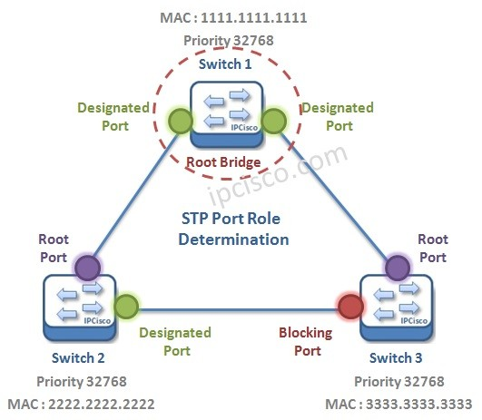
Figure operations of STP
- “Elect the root bridge”
- “Elect the root ports”
- “Elect designated ports”
- “Elect alternate ports”
At the time of the STP operations, the “bridge protocol Data” Unit gets was used for sharing the information. BPDUs are used for electing the “Root Bridge”, “root ports”, “designated ports”, and “alternate ports”. “BPDU has a bridge id that understands the switch needed for the BPDU”. The BID consists of the bridge priority, the extended system id, and the mac address of the switch.
Port roles also help to determine the STP operations. STP port roles are root port, designated port, and non-designated port. The root port helps to connect the switch with the root bridge. A designated port helps to can connects the switch with the non-root bridge. It helps to determine the cost value.
Q.1 (B)
The process switching is the oldest and strong packet switching technique.
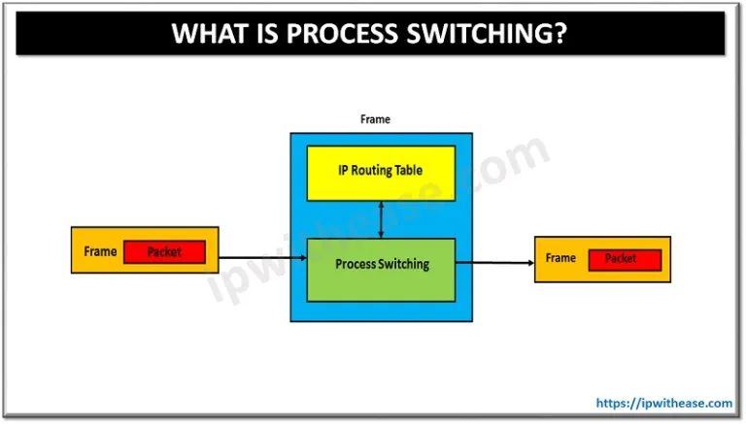
Figure Process switching
Process switching is the process through which the router forwards the data or decisions as the data packets go through the router and process the switch. The CPU of the router helps to select the process of switching.

Q.2 (A)
The Hierarchical internetworking model is a three-layer model for network design first proposed by Cisco. It divides enterprise networks into three layers: Core, Distribution, and Access layer.
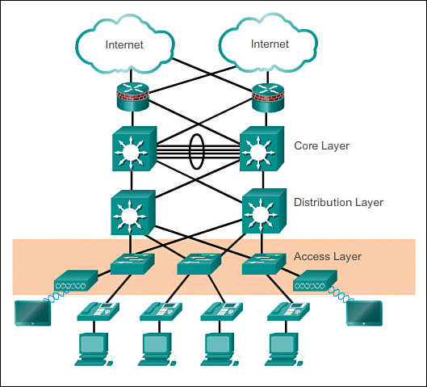

Core Layer: Core Layer consists of biggest, fastest, and most expensive routers with the highest model numbers and Core Layer is considered as the back bone of networks. Core Layer routers are used to merge geographically separated networks. The Core Layer routers move information on the network as fast as possible. The switches operating at core layer switches packets as fast as possible.

Distribution layer: The Distribution Layer is located between the access and core layers. The purpose of this layer is to provide boundary definition by implementing access lists and other filters. Therefore, the Distribution Layer defines policy for the network. Distribution Layer include high-end layer 3 switches. Distribution Layer ensures that packets are properly routed between subnets and VLANs in your enterprise.

Access layer: Access layer includes acces switches which are connected to the end devices (Computers, Printers, Servers etc). Access layer switches ensures that packets are delivered to the end devices.

Q.2 (B)
EIGRP the following five types of packets:
- Hello—Hello packets are used for neighbor discovery. They are sent as multicasts and do not require an acknowledgment. (They carry an acknowledgment number of 0.)
- Update—Update packets contain route change information. An update is sent to communicate the routes that a particular router has used to converge; an update is sent only to affected routers. These updates are sent as multicasts when a new route is discovered, and when convergence is completed (when the route becomes passive). To synchronize topology tables, updates are sent as unicasts to neighbors during their EIGRP startup sequence. Updates are sent reliably.
- Query—When a router is performing route computation and does not have a feasible successor, it sends a query packet to its neighbors, asking if they have a successor to the destination. Queries are normally multicast but can be retransmitted as unicast packets in certain cases; they are sent reliably.
- Reply—A reply packet is sent in response to a query packet. Replies are unicast to the originator of the query and are sent reliably.
- ACK—The ACK is used to acknowledge updates, queries, and replies. ACK packets are unicast hello packets and contain a nonzero acknowledgment number. (Note that hello and ACK packets do not require acknowledgment.).
Q.2 (C)
i) Fast convergence on OSPF: OSPF fast convergence is an important feature of the OSPF. It helps to increase the speed of the routers. It is also included some components like partial route calculation and the OSPF intelligent timer. It helps to benefit network performance.
ii) Partial updates on OSPF: The term partial means the update is done only on the information about the changes of the routers. These are like new links and a link is now available.
iii) Multi-network layer support of OSPF: It is a segmentate used by more than two routers. OSPF prefers this by looking at the interface as an Ethernet interface is used as a multi-layer network. It helps in creating the point-to-point interface.
iv) Successor and feasible successor of OSPF: The successor is a router that helps to build the best metric to achieve the goal or destination. It is a most sorted router. The feasible successor is a path that is used as a backup to achieve the same destination.

Q.3
To design and develop a secure scalable network in the university there are certain steps and components that are needed to execute the design and the developed implementation process on the university campus. The technical attributes of the smart networking process can help the university to set up a smart communication system under the strong network architecture on the campus. The secure scalable networking system includes the parameters of “Firewalls”, “VLAN”, “Subnet”, “DMZ”, “Service quality”, “Hierarchy”, “Spanning tree”, “Port Channel”, “Wireless communication process”, “Port Security” and the “physical security” in the university campus. These 11 design attributes and parameters are needed to provide a solid and strong network for the university campus.
The network management process is the second most important thing to design and implement a strong network on the university campus. Some important details that the IT networking infrastructure should have to follow in the university campus before the implementation process is like; a clear and transparent map of the network should have to follow before the beginning of the process. A strong cabling process is required for the implemented structure and the layout, the type, quantity and the location of all of the usable devices of the network. These networks are required for the network management process, the IP addressing structure must be required for the management process and finally a detailed overview of the network security architecture has to be done before the implementation of the networking project in the university campus.
In the university, a quality rich high available network design requires the generous reliability of each individual network. This high availability of network architecture on the university campus required high-quality software and hardware components for industrial usage. In addition, with this, the strong network architecture can help in the process of digital transformation for the global business structure of the university. This digital transformation process can help to get a smart and digital learning solution for the students in the university. Mobile and remote access to the process can improve the productivity and the backend architecture of the whole management system in the university.

