Starbucks Strategy Review

Jossett Hector
2706750

SG7003 Business Simulation with Professional Development!
Douglas Akwasi Adu
University of East London
July 21, 2024

Introduction
This paper focuses on a five year strategy review of Starbucks throughout the years 2019- 20203. Starbucks is one of the world leading coffee speciality companies. This industry is one of the largest industries in the world. Starbucks is found in multiple countries worldwide. Starbucks operates under the following mission, “With Every Cup, With Every Conversation, With Every Community – We Nurture The Limitless Possibilities Of Human Connection”.
Starbucks prides themselves in upholding diversity and equality among their staff and have many programmes geared towards upholding the wellbeing of their staff. The Herzberg's Two-factor Theory also emphasises that Starbucks prioritises the working conditions of their employees through competitive salaries and benefits which satisfies the workplace hygiene. Starbucks faces a high competitive rivalry, power of buyers and threats of substitutes, a moderate power of buyers and weak power of suppliers.
Starbucks currently owns more than 40% of mark share of the coffee industry in the US. There revenues have increased every year except in 2020 due to the covid-19 pandemic. Starbucks strategy is to expand their global business by opening stores in new and existing market, as well as increasing sales in their existing stores to increase market share. However, in 2022 they have implemented a new strategy to grow revenues.
While Starbucks have reported a growth in revenue their current ratio and return on equity is negative. The higher these ratios are the better because it provides a greater rate of return to shareholders. Hence, Starbucks will need to implement strategies to increase their revenue to have a positive financial position. Many recommendations were discussed to strengthen Starbucks company and to make it more profitable.

Methods
This report was conducted using many journal articles focused on Starbucks and its operations as well as the coffee industry. A study entitled “Analysis of Starbucks Organizational Culture on Employee Motivation, Based on Herzberg's Two-factor Theory” is used to study Starbucks factors to determine if it operates in an healthy environment. In addition, Starbucks annual reports were analysed with articles from many credible newspapers. Starbucks doesn’t have a posted Business Plan hence, their individual policies were reviewed.

Business Description
Starbucks is one of the world leading companies that specialises in roasting, marketing and retailing specialty coffee through their stores. They operates in approximately 83 countries as of 2023. Starbucks continuously invests in their brand to ensure that there is increased revenue and growth within the organisation. There primary objective is to continue to uphold their reputation as one of the most recognised coffee serving business globally. Hence, they continue to drive innovations in their beverages, equipment used and the technologies used. Starbucks business is quite purposeful and they believe in working cohesively with their stakeholders to leave a positive footprint. Hence, their coffee is sourced ethically as well as they have initiated many sustainable practices to protect the planet.

Vision and Strategy
Mission Statement
According to Starbucks.com website the current mission is “With Every Cup, With Every Conversation, With Every Community – We Nurture The Limitless Possibilities Of Human Connection.” In an article entitled a new mission for Starbucks, it was stated that in this world where loneliness and division thrives people are always searching for ways to overcome this hence, by being there as a constant in these people’s lives it helps them to connect with themselves and others. (Starbucks, 2023).

Values
Starbucks values underpins the areas of craft, results, courage, belonging and joy. According to Starbucks “We deliver performance through the lens of humanity. Their values underpins the following factors craft, results, courage, belonging and joy.
Human Resources
Starbucks aim to employ a culture of inclusiveness and supportiveness. Respect, kindness and dignity are placed at the forefront to ensure that they are providing a safe and stimulating work environment for employees and other stakeholders. They believe that the stronger their workforce is the more they can make a difference in the life of others and drive human connections.
Starbucks believe in fostering an equal opportunity for all and uses these principles when going through the hiring and onboarding processes. In addition, there are independent teams who assess their processes such as auditing and compliance, mentorship programmes, anonymous surveys and setting goals directed at diversity.
Starbucks stated that they review the business environment and labour markets to ensure that their employees are receiving competitive salary. According to Loyd, et.al, 2021,” Starbucks employees are more generously compensated than most workers in the restaurant industry with higher than average salaries and stock options. The company was the first private company in the country to offer stock options to salaried and hourly employees”. Based on this information it can be seen that Starbucks truly cares about the wellbeing of staff as they have advised.
In a study entitled “Analysis of Starbucks Organizational Culture on Employee Motivation, Based on Herzberg's Two-factor Theory” conducted by Lu in 2023. The study focused on motivational factors and workplace hygiene which usually are the main causes of either job satisfaction or unhappiness in employees. The conclusion of the study was that Starbucks prioritises the working conditions of their employees through competitive salaries and benefits which satisfies the workplace hygiene. As a result their employees are motivated and feels like they belong. (Lu, 2023).
Starbucks Culture
Starbucks is not only a culture it is a lifestyle. The Starbucks experience is incorporated using greater customer service and digital experience as well as aesthetically pleasing stores that fits the personalities of the communities in which they operate. Hence building brand loyalty and company reputation. The Starbucks’ lifestyle helps patrons not only understand themselves, but also become a version of themselves through the symbols, ideas, and ideologies that the corporation values”. (Batchelor and Krister, 2012)

Performance review of each year’s progress
Industry trends/ attractiveness
Coffee is one of the most traded commodities in the world. According to Czarniecka-Skubina, et.al, (2021), “in 2017–2018, the global production of coffee beans from around 60 countries reached approximately 9513 million tonnes”. According to Business Insider the coffee industry is a fast growing industry and is expected to achieve market is projected to reach US$144.68 billion in 2025. This is up from US$ 116.14 Billion in 2023.
Given this, Starbucks is in a thriving environment and they need to come up with innovative practices to continue to tap into the global markets and dominates.
Competition Analysis
Porter’s Five Forces
Competitive rivalry
Starbucks faces many competition and hence faces a high competitive rivalry. Over the last five years Starbucks has reported that their primary competitors are from specialty coffee shops. They also face competition from large businesses in fast food restaurant sector such as McDonalds and also businesses in the ready-to-drink coffee beverage market such as Dunkin Donuts, in addition they face competition from international companies globally. For instance in the UK Costa a UK company has majority market share in the coffee industry. In addition Starbucks competes with restaurants for desired locations as well as experienced staff.
Threat of New Entrants
The threats of new entrants in the coffee industry is moderate. Starbucks reported in their 2019-2023 reports that, “competition from large new entrants or well-funded smaller companies in their domestic and international markets could hinder growth and adversely affect our sales and results of operations in those markets”. (Starbucks,2019). They also mentioned that many smaller businesses that are speciality coffee stores also continue to open in their markets which can result in decreased market share. However, while smaller businesses have a smaller operational prices, if they wanted to scale their brand to the size of Starbucks it would take a lot of resources. Also, Starbucks has built a positive brand reputation.

Power of buyers
The bargaining power of buyers is quite high. As there are many competitions customers can easily switch to a different brand. Buyer can therefore easily force competitors against each other. This strategy is used to drive down prices and demand improvement on the quality of products and services. This reduces the profit potential of Starbucks. In 2021 and later annual reports Starbucks has also reported that if they are unable to meet the needs of consumers who requires healthier options then this could have a negative impact on their business. Hence, this could lead to more consumers finding healthier options given the rise in health conscious individuals.
Power of suppliers
The power of suppliers is quite weak. This is due to the fact that there are many suppliers available. According to Starbucks their products are source from a variety of suppliers in the US and also internationally. Starbucks reports that sometimes it’s hard to find suppliers in some international markets going through political unrest, poor infrastructure or instability. However, overall Starbucks has a high number of suppliers available and can easily switch if a supplier does not meet their needs. Due to this Starbucks have more power over the suppliers.
Threat of substitutes
There are many substitutes on the market as well as individuals who makes the products themselves. Hence the threat of substitutes is high. Starbucks has very high brand reputation however, their products are usually quite expensive. Starbucks also serves the same products that can be substituted elsewhere.
In the last five years Starbucks has faced high competitive rivalry, power of buyers and threat of substitutes are the factors with the highest power. While power of suppliers remains the least. However, despite facing many high factors Starbucks has used their strategy of expansion to open new stores in existing and new markets to increase sales and hence increase their market share.
Market choice/ share
Starbucks operates in approximately 83 countries as of 2023. Over 50% of stores are located in United States as reported by Statista in October 2023.
Graph Showing the countries Starbucks operates in- October 2023(Statista.com)
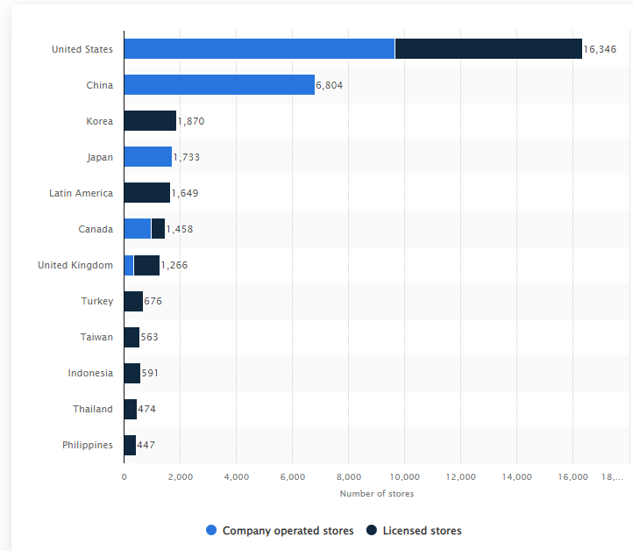

In United States, Starbucks has dominated the market compared to other companies. Starbucks major competitors in the speciality coffee sector in the U.S. market are Dunkin Donuts, Tim Hortons, Dutch Bros Coffee and Caribou Coffee. (Statista, 2020)
2019: As reported by World Coffee portal in 2019, in the US Starbucks owns a 40% share of the market valued at US $47.5 billion dollars. (World Coffee Portal (2021)
2020: As reported by Statista.com in 2020, the total market value of the branded coffee store industry was U.S. 36 billion dollars in 2020. There was a decrease in the market value due to the Covid-19 pandemic. Starbucks continued to dominate 40% of the market.
2021: In 2021 due to covid the market was similar to 2020 with a slight increase in sales.
2022: Market value of the United States coffee shop industry reached 45.8 billion U.S. dollars in 2022. Starbucks had a market share of 40%. (Statista.com)
2023: Market value was 49.5 billion dollars with 40% share. In this year it reached pre-pandemic value. (World Coffee Portal,2023)

Internal capabilities
A SWOT Analysis will be used to find the internal capabilities of Starbucks.
Strengths  - Brand reputation  - Large market share  - Personalised service to attain human connection. | Opportunities  - Delve into healthier or vegan options.  - Form partnerships and alliances with other stores.  - Expand operations in new markets or existing markets such as in Asia (Rodrigues, 2019)
Weaknesses  - High prices  - Not many healthy options  - Products can easily be substituted by other brands. | Threats  - Huge competition from other big brands or smaller companies.  - Market changes such as the covid-19 pandemic.

Simulation performance results
Strategy
Between 2019- 2021 Starbucks strategy was to expand their global business by opening stores in new and existing market, as well as increasing sales in their existing stores to increase market share. This strategy had worked for them as their revenue had increased from 26 billion in 2019 to 29 billion in 2021. In 2022, Starbucks formulated a new strategy called the Reinvention Plan. Starbucks had decided to focus on elevating their stores to make it even better for their stakeholders as well as building their rewards programme. (Starbucks Stories, 2023).
In a press release in 2023, Starbucks believes that their Reinvention plan had fuelled revenue growth as net revenue increased by 12% from 2022 to 2023. (Starbucks stories, 2023).
In the coffee industry in the U.S. Starbucks major direct competitor is Dunkin Donuts. Dunkin Donuts strategy is to focus on existing stores to drive sales while continuing to modernise their business using their “four strategic pillars: menu innovation, restaurant excellence, unparalleled convenience, and brand relevance”.
This has resulted in Starbucks having a much higher revenue and market share compared to Dunkin Donuts as they had gone through an aggressive expansion. Starbucks' Reinvention strategy had refocused their strategy, similarly to Dunkin Donuts to improve their existing stores and also to build human connections. This had also resulted in an increase in their revenue. Both companies strategy is different but works for them based on the strengths of their company.
Financial Data Analysis
Over the last five years Starbucks has a healthy revenue growth however, there is a drop in revenue in 2020 due to the onset of the covid-19 pandemic.

The return on equity of Starbucks throughout the five years have reported a negative value. (Appendix 1). According to Choiriyah et al., 2021, “The higher this ratio, the better because it provides a greater rate of return to shareholders. Negative shareholder's equity means that the liabilities of the company is higher than the total assets. Hence, Starbucks currently is unable to provide a great return for its shareholders and must increase its revenue
Starbucks current ratio have increased in 2020 after which it had gradually decreased. “The acceptable current ratio varies from industry to industry. If current liabilities exceed current assets where the current ratio is below 1, then the company may have problems in fulfilling its short-term liabilities”. (Rochim &amp; Ghoniyah2, 2017). Given this Starbucks may have issues fulfilling its short-term liabilities.

Future Plans and Recommendations

- The coffee industry is one of the fastest growing industries in the world. Hence, Starbucks can continue to offer more innovative products and also keep up with different cultures and traditions to increase sales and revenue. In addition, they can delve into Tea and Fresh Juice products mix industry. In addition Starbucks needs to keep up with customers changing needs by creating healthier options.

- Starbucks advertises that they ensure that fairness and equality is maintained in their human resources and people management processes. While this seems it to be true for some locations, there has not been scandals in others where Starbucks had alleged closed stores that were on the verge of unionisation. (HRNews, 2023).Starbucks has also been included in scandals regarding racial firing. (Walsh, 2023). Hence, Starbucks needs to ensure that they are being ethical and fair in their practices. They needs to have independent and fair auditing processes, be transparent in their findings and ensure that all policies are strictly enforced. If not, they can lose big contracts for instance Cornell University will not be renewing their contract with Starbucks due to these scandals.(Canham, 2023)

- Based on Starbucks competitive study it was found that there is a threat of competitive rivalry, power of buyers and threat of substitutes. Hence, Starbucks needs to ensure that they are offering differentiation in their product offerings. They need to ensure that they continue to stay ahead of the competition using personalisation to drive human connections. Starbucks also needs to keep on improving their customer loyalty and rewards programs to continue attracting customers to their stores.

- Starbucks had stated that all their products are ethically sourced . Starbucks has the following three goals to improve sustainability with their packaging. They aim for packages to be “100% reusable, recyclable or compostable, sourced from 50% recycled material and made using 50% less virgin fossil fuel-derived sources”. (Pyzyk, 2024). However, in their ESG report in 2023 it was reported that their carbon footprint increased by 8%. (Mirza, 2024). Starbucks needs to ensure that they are keeping within their targets for their sustainability practices as this can have an impact on their organisation. “Corporate sustainability and social responsibility (CSR) have become a strategic imperative for companies, as they are an integral part of the optimal long-term strategy”.( Samaibekova, 2023). Hence, it is imperative that Starbucks not only focuses on financial gains but also achieve sustainability by improving their CSR strategies centred around sustainability.

- Starbucks currently has a new strategy to help develop existing stores and increase their reward members in order to increase profits. While Starbucks has achieved growth in their revenues throughout the year, their return on equity has been negative. In order to improve the ROE, the company needs to increase its revenue. This can be done by continuing to expand in untapped companies outside of the U.S.A. Starbucks could also renegotiate with their suppliers to bring down prices of products. “Starbucks can increase net earnings by increasing sales or reducing operating expenses rather than increasing prices”. (Li, 2022). In addition, they can implement more partnerships in other countries to share benefits and risks. In addition, Starbucks can check competitors such as Dunkin Donuts to learn more about how they focus on increasing sales in existing stores to implement this aspect of their strategy.

References
Batchelor, B. & Krister, K. (2012). Starbucks: A case study examining power and culture via radical sociodrama. PRism 9(2): http://www.prismjournal.org/homepage.html
Canham-Clyne, A. 2023/08/18/, "Cornell will not renew Starbucks contract amid student pressure", Restaurant Dive,pp.1.
Czarniecka-Skubina, E., Pielak, M., Sałek, P., Korzeniowska-Ginter, R. & Owczarek, T. 2021, "Consumer Choices and Habits Related to Coffee Consumption by Poles", International Journal of Environmental Research and Public Health, vol. 18, no. 8, pp. 3948.
Choiriyah, C. et al. (2021) ‘The effect of return on assets, return on equity, net profit margin, earning per share, and operating profit margin on stock prices of banking companies in Indonesia Stock Exchange’, International Journal of Finance Research, 1(2), pp. 103–123. doi:10.47747/ijfr.v1i2.280.
Global Coffee Market (2021 to 2025) - insights & forecast with potential impact of covid-19 - researchandmarkets.com (2021) Business Wire. Available at: https://www.businesswire.com/news/home/20211208005778/en/Global-Coffee-Market-2021-to-2025---Insights-Forecast-with-Potential-Impact-of-COVID-19---ResearchAndMarkets.com (Accessed: 21 July 2024).
Li, X. (2022). Discuss starbucks under the COVID-19 pandemic from the Finance. Proceedings of the 2022 International Conference on Economics, Smart Finance and Contemporary Trade (ESFCT 2022), 4–11. https://doi.org/10.2991/978-94-6463-052-7_2
Loyd, S., Jackson, W.T. & Gaulden, C. 2001, Starbucks Coffee: High Octane, Jordan Whitney Enterprises, Inc, Arden.
Lu, X. (2023) ‘Analysis of Starbucks organizational culture on employee motivation, based on Herzberg’s two-factor theory’, Advances in Economics, Management and Political Sciences, 39(1), pp. 171–176. doi:10.54254/2754-1169/39/20231960.
Mirza, Z. (2024, March 4). Starbucks loses ground on emissions reduction, sets new 2030 sustainability goals. ESG Dive. https://www.esgdive.com/news/starbucks-loses-ground-on-emissions-reduction-sets-new-2030-sustainability/709214/
"NLRB Rules Starbucks Violated Labor Law by Closing Ithaca Stores", 2023/07/10/, HRNews,
Pyzyk, K. 2024/02/27/, "Starbucks adds 3 new 2030 sustainability goals for packaging", Restaurant Dive..
Rochim, R. and Ghoniyah2, N. (2017) ‘Analysis on the effect of current ratio, cashflow from
operation to debt, firm size and return on equity on stock return’, International Journal
of Islamic Business Ethics, 2(3), p. 41. doi:10.30659/ijibe.2.3.41-51.

Rodrigues, M.A. 2019, Equity Research-Starbucks, Universidade de Lisboa (Portugal).
Walsh, J. 2023/06/21/, $25.6M awarded in Starbucks lawsuit: Jury: White employee fired due to her race, Vineland, N.J.
Samaibekova, Z. et al. (2021) ‘Corporate Sustainability and Social Responsibility’, E3S Web of Conferences, 250, p. 06003. doi:10.1051/e3sconf/202125006003.
World Coffee Portal (2021) Major chains driving us coffee shop growth – but overall market slows, World Coffee Portal. Available at: https://www.worldcoffeeportal.com/Latest/News/2019/Major-chains-driving-US-coffee-shop-growth-%E2%80%93-But-o (Accessed: 21 July 2024).
(2023) What’s next? Starbucks unveils long-term growth strategy for a limitless future. Available at: https://stories.starbucks.com/stories/2023/whats-next-starbucks-unveils-long-term-growth-strategy-for-a-limitless-future/ (Accessed: 20 July 2024).
(No date) A new mission for Starbucks. Available at: https://stories.starbucks.com/stories/2023/a-new-mission-for-starbucks/ (Accessed: 20 July 2024).

Appendix
Starbucks Business information
General
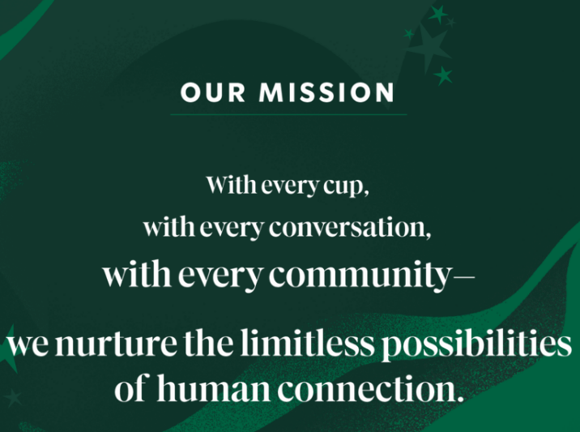


Our Values
We deliver performance through the lens of humanity:

Craft
We delight in the rigor of the details-no matter what our job is
We learn and teach in the pursuit of growth
We deliver excellence with passion and creativity

Results
We consistently achieve our goals with focus, integrity, and drive
We continuously innovate to stay ahead
We exceed the expectations of the people we serve

Courage
We embrace difficult conversations, with respect, to make us all better
We pursue audacious ideas beyond our comfort zone
We do the right thing, even when it's hard

Belonging
We actively listen and connect with warmth and transparency
We recognize and appreciate every person for who they are
We treat each other with dignity and care

Joy
We take pride in our work and have fun while doing it
We celebrate each other and our wins
We create great vibes to bring the best out of others

Our Promises
The mutual success we collectively commit to:
Our Partner Promise — Bridge to a better future
Our Customer Promise — Uplift the everyday
Our Farmer Promise — Ensure the future of coffee for all
Our Community Promise — Contribute positively
Our Environmental Promise — Give more than we take
Our Shareholder Promise — Generate long-term returns

People
Our aspiration is to be people positive—investing in humanity and the well-being of everyone we connect with, from our partners to coffee farmers to the customers in our stores and beyond.

Inclusion & Diversity
We are rooted in our mission to nurture the limitless possibilities of human connection. We are committed to creating environments where everyone is welcome and belongs.

Our Partners
Our partners are at the center of the Starbucks Experience and our culture has been built with a long line of partners who dared to make Starbucks a different kind of company.
Throughout our history, we've been dedicated to our mission: With every cup, with every conversation, with every community — we nurture the limitless possibilities of human connection.
Led by partners, for partners, Starbucks Partner Networks create moments of connection that promote diversity, foster inclusion and contribute to the success of our partners and our company.
As we create the future of Starbucks, we are continuing to improve the partner experience so our partners can thrive — at work, individually and together. Core to this is ensuring that Starbucks is an inclusive, diverse, equitable and accessible company — a place where all are welcome, and a place where our partners know they belong.

Developing and maintaining an inclusive workforce

Mentoring partners: Building on the success of our mentorship program, we expanded opportunities to all partners, including 400 U.S.-based store and district manager.

Anti-bias curriculum: Developed with Arizona State University, we designed 15 courses available to the public at no cost.

Pay equity: We are committed to consistently achieving and maintaining 100% gender and race pay equity in the U.S.

Setting and maintaining representation goals
We pride ourselves in living our mission and values with a clear approach: real inclusion and belonging requires intent and is not defined only by metrics.
In the U.S., our goal is to achieve racial and ethnic diversity of at least 30% at all corporate levels and at least 40% at all retail and manufacturing roles by 2025. We also aim to achieve at least 50% women working across all corporate levels, 55% women working across all retail roles and 30% women working in manufacturing roles. Our current workforce diversity information is available here.
Our goal is to enhance our efforts in reaching a broader pool of candidates and reaching talent that brings new perspectives and experiences to improve our business and workplace. To do this, we are prioritizing inclusivity in our recruitment practices, partner engagement, and continuing to provide opportunities for inclusive leadership training.

Coffee & Craft
Coffee is at our heart, inspiring our craft and driving innovation—in our drinks, our food, our stores and new ways we bring the Starbucks experience to you wherever you are.
Customer Experience
From the original third place to the latest kinds of Starbucks stores and ways to get your order to your favourite merchandise and more, we’re all about connecting and meeting you where you are.
Starbucks Financial- (2019-2023)
SBUX | Starbucks Corp. Annual Income Statement - WSJ
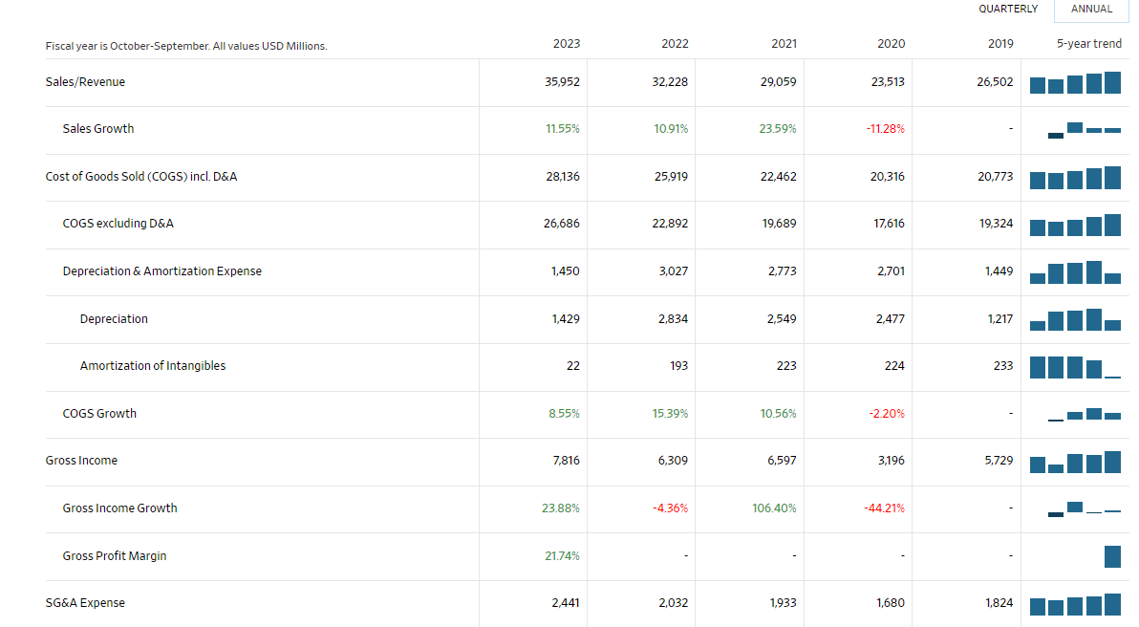

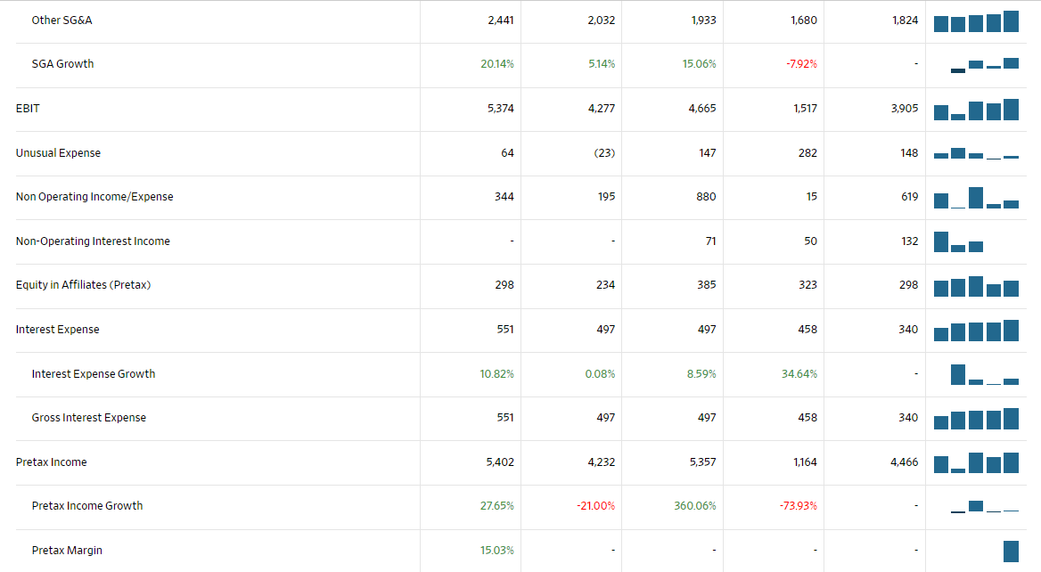
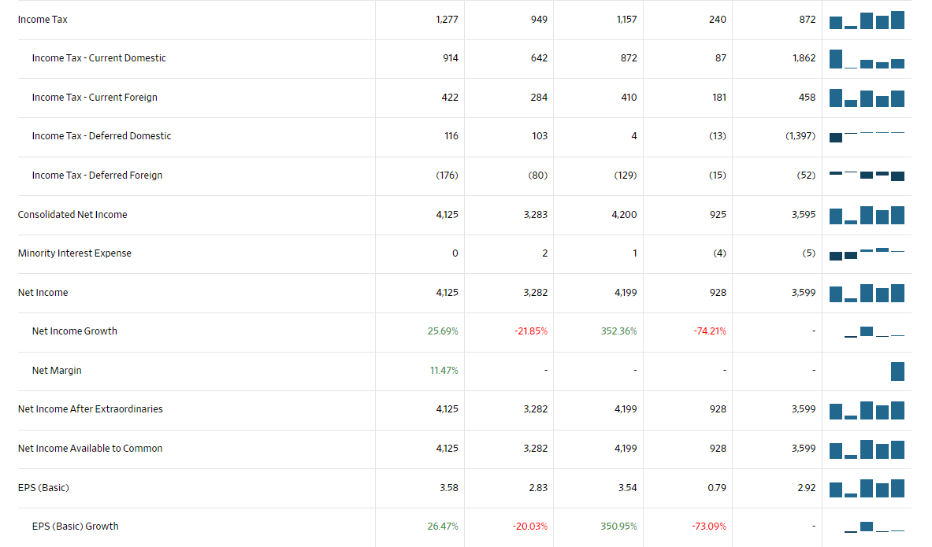
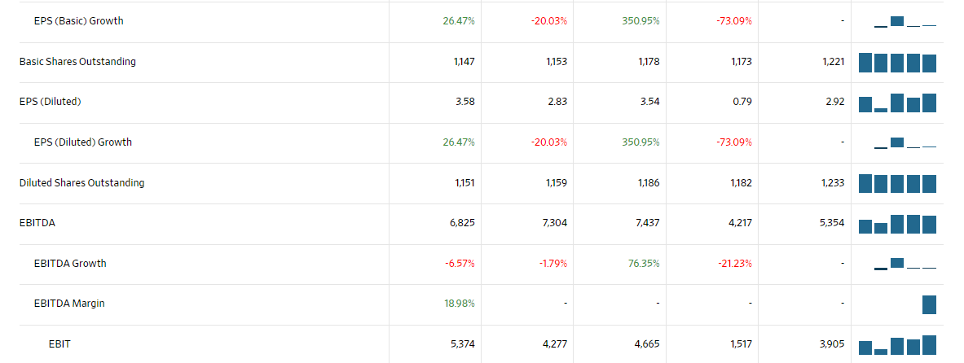

Financial Analysis
ROE= net profit/equity
2023= 4.29 billions/-8.61billions
= -51.35%

2022= $3.32 billions/ $-8.67 billions
= -38.19%
2021= $4.39billions/ $-8.45 billions
= -62.28%
2020= $0.67B/$-7.90B
= -8.35%
2019= $3.73B/$-6.76B
= -66.68%

