Active House Project Reflection

We, as a cohort of first year architecture students, were divided into groups of four and given the task to design an ‘active’ House or Building. An Active Building is described as “a building which supports the energy network by intelligently integrating renewable energy technologies for heat, power and transport.” (Active Building Centre, 2019) Active Buildings are designed with various sustainable principles in mind. The building its self is largely Passive Haus derived, in that the materials used are carefully selected in order to achieve maximum performance This means using as little energy as possible to heat or cool the building in different climates like day or night or summer or winter. The overall aim is to be able to achieve maximum comfort with as little energy use as possible. Various technologies are also used to control certain aspects of the building. An Active House will have a sort of energy production that would allow surplus electricity to be fed into the grid or even enable the house to be off grid. Electric cars are encouraged by having electric chargers supplying each parking space. Our brief was to design an Active House and submit our scheme into the Home for 2030 competition.
As a group, we started to explore the extensive range of weather-related issues we face in the UK. Flooding, we found, is a prevalent and topical issue currently. Due to the very recent history of flooding caused by two consecutive storms recently, we decided to design around this. We also found that in the UK there is a huge amount of land deemed useless for building because it is prone to heavy flooding. We decided to try and design a building that could be built on a food plane. This also increases the building volume potential drastically because it utilises otherwise un-inhabitable land.
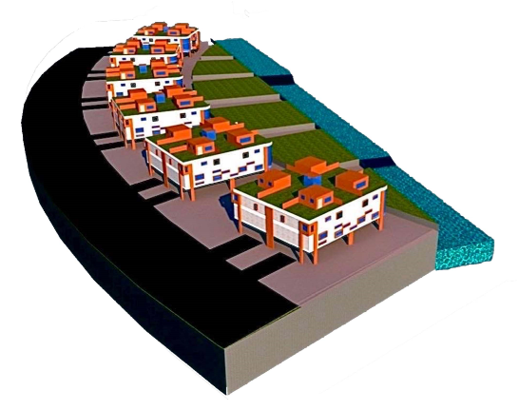
Our concept is a series of two-storey complexes, raised on pillars in order to protect the building from extensive flooding. The area under the building is intended for car parking for the occupants. There are electric car charging stations to supply each parking bay. The first floor is all open plan, designed specifically for office for office space. This allows ample flexibility in the layout of the space with furniture like desks and cabinets. Above the office space are the living quarters. The second floor is divided into six moderately sized apartment flats. Having the offices and the apartments in the same building eliminates the commute to work every day; saving time and eliminating any energy use from commuting to a place of work. The layout of the flats on the second floor has been designed specifically to enable ample flexibility and therefore making the building relatively future proof.
There are four larger flats at each of the four corners of the building on the second floor. Four more, slightly smaller sections are created between the four larger flat spaces against the walls. Two of the smaller rooms are flats, designed to provide facilities for either temporary guests or for family members who might need to be closer to other family. The smaller room created on the north facing wall is a gym for the occupants and the remaining space on the west facing side of the building is split into a laundry room and a control room to house various controls and meters. This leaves a cruciform shape in the centre of the floor plan where an accessible lift sits, central to the whole building. This runs from the ground, where the parking spaces are, through the building and onto the roof terrace where there is an extra room above each of the four corner flats accessed by a small staircase in each flat. The whole scheme aims to sustainably encourage independent living whilst creating a community within the whole complex and each building.
The buildings are carefully placed within the scheme in order to take advantage of south facing facades. The glass spans the most area on the south facing wall this includes two large windows on both corners of the south facing façade that stretch across two floors. Most of the energy for the complex is generated via hydroelectric generators powered by an artificial watercourse that runs adjacent to the buildings. The water course will also help evacuating water in the event of major flooding.
The basis of the building construction is a timber frame, supported on concrete pillars. Because our building is designed to sit on a flood plain, we decided to use pile foundations. This will also allow flexibility to allow for variable ground conditions. The building is also clad in locally sourced timber to decrease the carbon footprint. Parts of the building will have transpire solar collectors on the walls. These are metal panels that provide a pocket of air, that is encouraged to hold heat, on the outside of the building. This decreases the thermal conductivity of the overall wall structure (increasing the U-Value). The internal insulation used, is stone wool. Aside from being a very dense insulation in comparison with other more common variants, it also acts as fire retardant. Stone wool also acts as a good sound insulator. There are shutters on most of the windows where possible, creating an air gap between the window and the shutter dramatically reducing the heat loss through windows. They also provide some added security. All glass used is triple glazed to meet passive haus requirements.
I think that our group worked relatively well together. We divided tasks between us. Below is an image of the rendered photoshop model of the finished design.
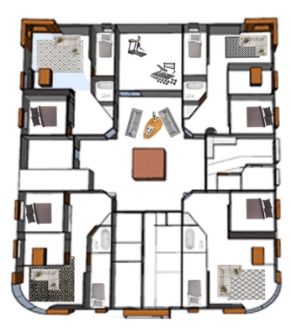
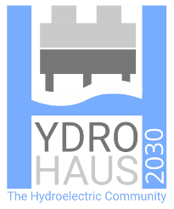
We were all involved with various aspects of the design. Throughout the project, we all communicated our ideas to each other and decided the best designs between us. I have found that this project has been extremely valuable in that I have gained lots of experience in technological design. We, as a group have gained an insight into the Active Building concept. In order to complete this project, we all had to increase our breadth of knowledge in order to then inform some of our design decisions. We also entered the ‘Home for 2030’ competition. Below is the logo that we designed, also the name and catchphrase that we came up with.
This required us to create a series of presentation sheets, explaining our concept. This included photoshop renders, elevations, sections and descriptions of the technology that we decided to use. This project has also allowed each of us to practice and better our skills in cad modelling and presenting.

References

Active Buildings Centre (2019) https://www.activebuildingcentre.com/ date accessed: 2.03.2020

