
LCMB7035

Master of Business Administration
Student Name: Iyappan Balakrishnan
Student ID: 2434791

Title: The Influence of Online Customer Reviews on Consumer Buying Behaviour: A Case Study of Marks & Spencer in the UK Fashion Retail Industry.

Supervisor: Dr. Eno Maycock.
Lecturer: Hoang Nguyen.
Masud Ibrahim.
DECLARATION
I, Iyappan Balakrishnan declare that this dissertation has been composed by myself, that the work contained herein is entirely my own except where explicitly stated otherwise in the text, and that this work has not been submitted for any other degree or qualification, in whole or in part, except as specified.

Signature:Iyappan Balakrishnan.
Date: 28/08/2026.

ACKNOWLEDGEMENT
I would like to express my sincere gratitude to my lecturers and academic supervisors for their valuable guidance, feedback and encouragement throughout my MBA journey. Their support helped me develop my academic knowledge, research skills and confidence. I am also deeply thankful to my family and friends for their patience, motivation and continuous emotional support during challenging periods. Finally, I would like to thank everyone who contributed directly or indirectly to the completion of this dissertation and supported me throughout my studies.
Table of Contents
CHAPTER 1: INTRODUCTION 6
1.1 Background and Problem Statement 6
1.2 Research Aim 8
1.3 Research Objectives 8
1.4 Research Questions 8
1.5 Significance / Relevance of the Study 8
1.6 Brief Research Methodology 10
1.7 Structure of rest of project 10
CHAPTER 2: LITERATURE REVIEW 12
2.1 Introduction 12
2.2 Online Customer Reviews 12
2.3 Consumer Buying Behaviour 14
2.4 Online Reviews and Consumer Perception 16
2.5 Positive and Negative Reviews 17
2.6 Review Credibility and Trust 19
2.7 Star Ratings, Review Quality and Review Volume 20
2.8 Online Reviews and Purchase Decisions 21
2.9 Customer Satisfaction, Brand Trust and Repeat Purchase 23
2.10 Theoretical Framework 24
2.11 Research Gap 25
2.12 Conclusion of Chapter 26
CHAPTER 3: RESEARCH METHODOLOGY 27
3.1 Introduction and Purpose of the ChapterThis research will use 27
3.2 Research Philosophy 27
3.3 Research Approach 28
3.4 Research Strategy 29
3.5 Research Design 30
3.6 Justification for the Chosen methods 31
3.7 Literature Search Strategy and Selection Criteria 32
3.8 Data Collection Methods 34
3.9 Data Analysis 34
3.10 Quality Appraisal and Research Rigour 37
3.11 Ethical Considerations 38
3.12 Methodological Limitations 39
3.13 Chapter Summary 40
CHAPTER 4: FINDINGS / RESULTS, ANALYSIS AND DISCUSSION 41
4.1 Introduction 41
4.2 Presentation of Findings 42
4.3 Analysis of Results 72
4.4 Discussion of Results 75
4.4.1 Integrated Interpretation and Comparison of the Findings 75
4.4.2 Interpretation Through the Theory of Planned Behavior 76
4.4.3 M&S-Specific and Strategic Implications 77
4.4.4 Limitations of the Findings 78
4.5 Chapter Summary 78
CHAPTER 5: CONCLUSIONS AND RECOMMENDATIONS 80
5.1 Summary of main findings 80
5.2 Conclusion based on the research questions 80
5.3 Recommendation (Practical and Theoretical) 81
5.3.1 Practical Recommendations 81
5.3.2 Theoretical Recommendations 82
5.4 Limitation of Research 83
5.5 Recommendation for Future Work 83
Reference 85

Contents of Figures
Figure 01: Internet penetration in the UK 6
Figure 02: Profit before tax of M&S 7
Figure 03: Retail sales value and volume growth 13
Figure 04: Customers Reading Reviews 14
Figure 05: Purchase Decision Process 15
Figure 06: Positive and Negative Customer Reviews 18
Figure 07: Review Credibility 21
Figure 08: Research Onion 27

Contents of Tables
Table 01: Search Strategy 32
Table 02: Inclusion and Exclusion Criteria 33
Table 03: Example of the Coding Process 35
Table 04: Systematic Literature Review 42
Table 05: Thematic Codes 72

CHAPTER 1: INTRODUCTION

1.1 Background and Problem Statement
Customer reviews online are considered to be a significant component in consumer buying behaviour as customers rely more on the experience of other shoppers before making a buying decision (Rachmiani et al., 2024). This is particularly relevant in online fashion retailing since customers are not able to feel the fabric and test the fitting, compare the accuracy of the colours or test the product comfort before purchasing (Creusen et al., 2025). Thus, reviews serve as word-of-mouth and can assist consumers to minimise doubts prior to buying fashion products. This is directly related to the proposed dissertation topic which is the effect of online customer reviews on consumer purchasing behaviour towards the Marks & Spencer (M&S) in the UK fashion retailing sector.
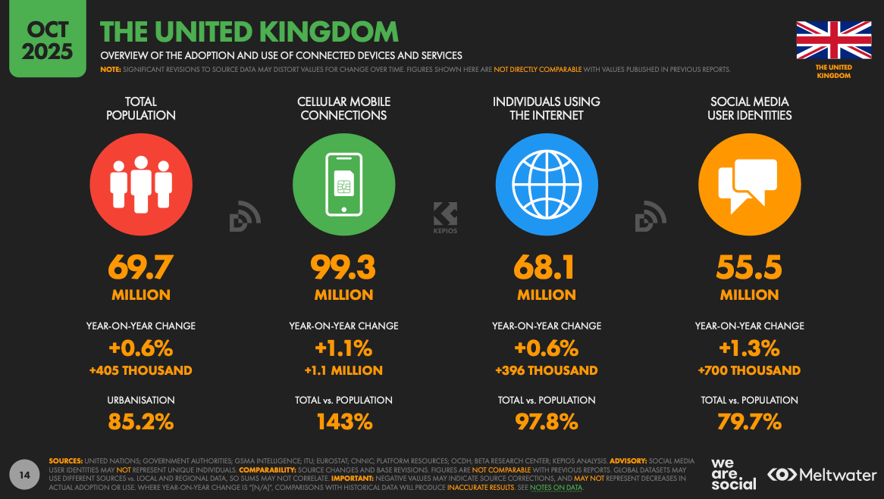
  - Figure 01: Internet penetration in the UK
Source: (Thompson, 2025)
UK market offers a good backdrop to this study since online shopping and online searching of information has become a normal consumer behaviour. The internet penetration in the UK is 97.8% with 67.8 million internet users, and 54.8 million identities of social media users in 2025 (Thompson and Thompson, 2025). This indicates that the majority of consumers in the UK are much exposed to online information, peer reviews, product reviews, and online comments and social media recommendations before purchasing products. Late 2025, DataReportal also registered 68.1 million UK internet users and 55.5 million active social media user identities, indicating that the online consumer environment was highly developed into 2026 (Kemp, 2025).
Marks & Spencer are an appropriate case organisation in the sense that it is among the most well-known retail brands in the UK with an excellent reputation of quality, trust and value (Kelk, 2024). The fashion performance of the company has however been under pressure of late. In 2025/26, M&S announced that group adjusted profit before tax would decline to £671.4 million (compared to a decline to 881.1 million) (M&S, 2025; Statista, 2026). Its Fashion, Home and Beauty sales plunged by 7.7 and adjusted operating profit in the same segment was £213.4 million. This is significant since the fashion category relies heavily on customer confidence and online shopping experience.
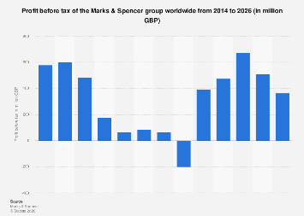
  - Figure 02: Profit before tax of M&S
Source: (Statista, 2026)
It was a more serious problem since M&S was disrupted by a cyber-attack, impacting online shopping of clothes and inventory. This disturbance may harm customer experience, leave negative online reviews and decrease trust in the brand in terms of online shopping (BBC, 2025). This is especially true in the fashion retailing industry where a single bad customer experience can not only influence a single customer, but it can also influence an entire group of future customers should it be documented in reviews, ratings or social media forums.
Hence, the primary issue of research is that despite being widely known that online customer reviews are influential, it is not completely understood how various review variables like credibility, star ratings, volume of reviews, positive reviews and negative reviews influence consumer buying behaviour in the particular case of M&S fashion retailing in the UK (Majumder et al., 2022). The current literature tends to talk about online reviews in general, although there is a lack of focus on established UK fashion retailers, in which brand trust already exists. This gives a reason why it is essential to know whether reviews reinforce M&S customer confidence or negative review patterns have the ability to undermine buying intention, satisfaction and repeat purchase behaviour. This study therefore investigates how online customer reviews influence consumer buying behaviour towards Marks & Spencer in the UK fashion retail industry

1.2 Research Aim
To analyse how online customer reviews influence consumer buying behaviour towards Marks & Spencer in the UK fashion retail industry.

1.3 Research Objectives
- To identify the role of online customer reviews in shaping consumer perceptions of M&S fashion products.
- To examine how positive and negative reviews influence consumer trust and purchase decisions.
- To analyse how review credibility, star ratings, review quality and review volume affect buying behaviour.
- To evaluate how M&S can use customer reviews to improve customer satisfaction, brand trust and repeat purchase behaviour.

1.4 Research Questions
- How do online customer do reviews influence consumer buying behaviour towards Marks & Spencer in the UK fashion retail industry?

1.5 Significance / Relevance of the Study
The study is important as it is based on one of the topical and practical problems in the UK fashion retail sector: the impact of online customer review on consumer purchasing behaviour. There is uncertainty among consumers in online fashion shopping as they are not able to physically examine clothes and then make a purchase (Adeola et al., 2021). They are not able to verify the content, fitting, colour, comfort or general quality they do in a physical store. Thus, online reviews will play a significant role as they will enable customers to make judgments on the suitability, reliability and purchase of a product. This renders the study relevant since it explores the influence of reviews on the formation of trust, confidence and purchase decision in the context of Marks & Spencer.
The research is significant to Marks & Spencer since the firm is in a competitive fashion retail market where the confidence of the customer and brand image is critical. M&S already enjoys a good reputation on quality and reliability and online reviews will either build on this reputation or undermine it (Li et al., 2023). Good reviews can persuade new buyers, facilitate repeat buyers and enhance confidence of customers. Nevertheless, bad reviews concerning the size, quality, delivery, returns or web-based service may deter prospective customers. Thus, the study can assist M&S to know which aspects of reviews influence the most buying behaviour like credibility of the reviews, star ratings, volume, positive comments and negative experiences.
The findings of this study can also be applied to retail managers and digital marketing teams as it can be used to enhance more effective review management. As an illustration, when customers are highly persuaded by the elaborate reviews, then M&S should motivate customers to make more specific reviews regarding fit, fabric, size and quality of products (Graesch et al., 2024). Having less trust due to negative reviews, the company will be able to be more active in responding to complaints and act on feedback to better its products and services. By doing so, the research can assist businesses to stop at merely gathering reviews but leverage the reviews as a means of customer understanding, service enhancement and competitive edge.
The academic relevance of the study is also in that it adds to the general knowledge on electronic word-of-mouth and consumer decision-making in fashion retailing. Numerous researches are written about online reviews in the general e-commerce, but this study deals with a well-established and known retailer in the UK fashion industry. This is necessary since the behaviour of consumers might vary between a brand that people trust such as M&S in the high-street and new online-only fashion stores. Thus, the research can contribute to understanding whether online reviews remain powerful in case the brand is already familiar with the customers and trusted.

1.6 Brief Research Methodology
This research used a secondary research methodology based on a Systematic Literature Review. The research will neither gather primary data on the consumers (Phillips and Barker, 2021). It will conduct an analysis of the existing scholarly and industry sources on online customer reviews, consumer trust, purchase intention and buying behaviour. The philosophy to follow in the research is an interpretivist philosophy since the research is aimed at consumer perceptions, meanings and decision-making behaviour (Pervin and Mokhtar, 2022). The study was inductive as there will be no predetermined hypothesis that will be tested, the themes will be produced based on the current literature. The databases included Google Scholar, Scopus, Emerald and ScienceDirect, among others, as well as Marks & Spencer reports, reports in the retail industry, and online review sites. The PRISMA process will aid in the process of selecting appropriate studies by identifying, screening, eligibility and inclusion (Sohrabi et al., 2021). Thematic analysis was used to analyse the collected data to determine important patterns associated with the credibility of the review, the number of stars, the number of reviews, the trust and buying behaviour.

1.7 Structure of rest of project
Chapter 1: Introduction
The chapter begins with the research background and problem statement, which is then followed by the research aim, objectives and research questions. It also talks about the importance and relevance of the work, a concise research methodology and the outline of the dissertation.
Chapter 2: Literature Review
This chapter summarises some of the critical scholarly domains that are associated with online customer reviews, consumer trust, purchase intention and buying behaviour. It critically analyses the available literature, creates research gaps, outlines the conceptual framework and concludes the primary arguments of the literature.
Chapter 3: Research Methodology
The chapter elaborates the research philosophy, the assumptions, research design and research approach. It defends the methodology adopted, data collection techniques, ethical issues and reasons why secondary research and thematic analysis will be appropriate in this study.
Chapter 4: Findings, Analysis and Discussion
This chapter illustrates the findings of the research based on the literature and secondary sources chosen. It discusses major themes and explains the findings in terms of the research objectives, research questions and literature.
Chapter 5: Conclusions and Recommendations
This chapter recaps the primary findings, provides responses to the research questions and makes useful and theoretical suggestions. It also gives the limitations of the research and gives recommendations on future research.

CHAPTER 2: LITERATURE REVIEW

2.1 Introduction
Purpose of the Literature Review
The chapter focuses on the available academic and industry research and understanding of how online customer reviews can affect consumer buying behaviour in the UK fashion retail market.
The link between customer reviews and consumer buying behaviour
Customer reviews have a very strong impact on consumer buying behaviour since they offer actual experience, eliminate uncertainty and aids in establishing trust prior to purchase. Positive reviews raise confidence, enhance brand credibility and decision to purchase, whilst negative reviews may stimulate doubt and decrease purchase intention. Consumers tend to compare ratings and reviews and then select products or services.
Focus on M&S and UK Fashion
It is designed to explore how reviews influence consumer attitude towards Marks & Spencer fashion products particularly when they are unable to judge size, fabric, colour or comfort of the product prior to buying. It also explores how positive and negative reviews impact on trust and purchase intent, as well as reviewing the credibility of reviews.

2.2 Online Customer Reviews
Online Customer Reviews
According to Florea et al. (2025), in the UK fashion retailing, the customer reviews will have a significant influence on the customer perceptions as it is hard to judge the fashion products just with the pictures online. Customers are unable to touch, inspect stitching, test fit, match the colour with natural lighting or evaluate comfort prior to purchase. Thus, reviews become the electronic word of mouth and make consumers less uncertain when purchasing (Ospina-Agudelo et al., 2025). For fashion retailers, words like “true to size”, “poor material”, “colour different from picture” or “good quality for the price” will directly affect the customer's perception of the product quality and perceived value and reliability.
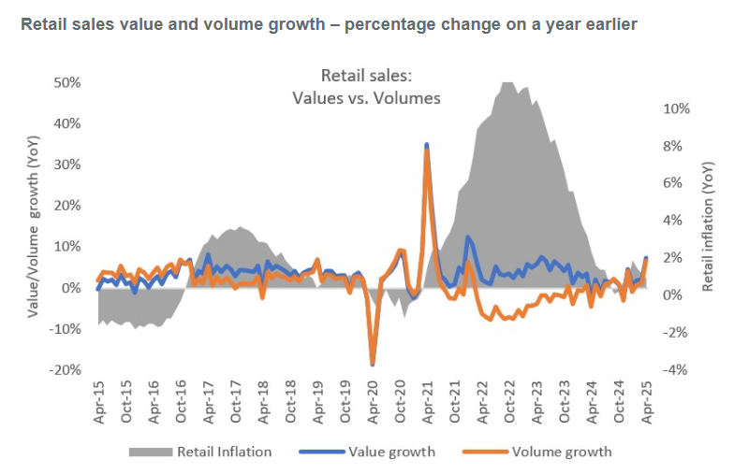
  - Figure 03: Retail sales value and volume growth
Source: (Retail Economics, 2025)
Rise of Reviews in e-commerce and fashion Retail
Digital engagement is extremely high in the UK which makes it a suitable context for this issue. As of early 2025, there were 67.8 million internet users in the UK which translates to a penetration of 97.8% of the population, and 54.8 million social media user identities in the UK (79.0%). This means that the majority of UK consumers are reading product detail, ratings, reviews and consumers' opinions prior to making a purchase online (Kemp, 2025). Fashion Retailing is also important online. Retail Economics noted that online sales values have risen by 5.9% year-on-year in April 2025 and online Clothing & Footwear values have risen by 6.1% year-on-year. In April 2025, online sales accounted for 25.9% of total retail sales as well. In other words, online reviews are not only informative but also are a component of the larger digital shopping landscape (Retail Economics, 2025).
Consumer relying on reviews when making purchase decisions
But Rachmiani et al. (2024) stated that not all online customer reviews form accurate and balanced perceptions. Customers might be influenced by a handful of negative reviews, particularly when the negative feedback is about some of the fashion-related concerns like sizing, returns, delayed delivery or fabric quality. Meanwhile, positive reviews could boost trust, but there is always the possibility that some of those reviews do not accurately represent the experience of every customer, as fashion is subjective (Yang and Li, 2023). For instance, a dress that one customer will say is comfortable and stylish, another will claim is bad fitting or poor value. Consumer perceptions are unstable and very subject to individual expectations.
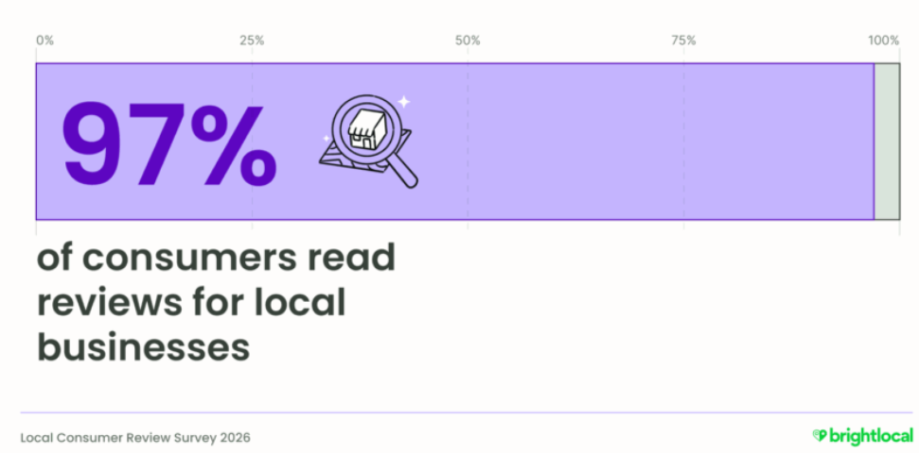
  - Figure 04: Customers Reading Reviews
Source: (Paget, 2025)
Recent behaviour in review demonstrates the increasing significance of the opinions of customers. According to the 2026 consumer review survey conducted by BrightLocal, 97% of consumers read online reviews, with 41% always reading reviews when looking for new businesses, up from 29% a year ago (Paget, 2025). According Ahn and Lee (2024), however, consumers typically use six review sites, indicating that retailers cannot just rely on reviews on their own websites. This is because for fashion retailers in the UK, like Marks & Spencer, what customers think about the brand might not just be influenced by the M&S product reviews, but also the Google reviews, Trustpilot reviews, social media and other discussion sites. Thus, the impact of online reviews on perception is strong but it depends on their credibility and consistency, review detail and whether the customer thinks that the review is representative of his fashion needs or not.

2.3 Consumer Buying Behaviour
Definition of Consumer Buying Behaviour
As opined by Graham (2024), consumer buying behaviour refers to the manner in which the customers think, feel and behave prior to, during and after obtaining a product or service. It encompasses the recognition of the need by the consumer, information seeking, alternative evaluation, purchasing decision and post purchase reactions. This behaviour is informed by individual factors like income, lifestyle, age and preferences, social, cultural and psychological factors (Jie et al., 2022). Online purchases are also affected by digital reviews, social media, brand reputation, product ratings and online recommendations that influence consumer buying behaviour.
Stages of the Buying Decision Process
The consumer takes the buying decision process usually starting with the need recognition, during which the consumer realises that there is a problem or desire. An example is a customer realising that he/she requires new clothes, a cell phone or even a household product (Mehrguth, 2023). The second step is information search where the consumer searches to get information about the products available, prices, brands and features. It may occur via websites, search engines, social media, word-of-mouth and reviews made by customers or their friends and influencers.
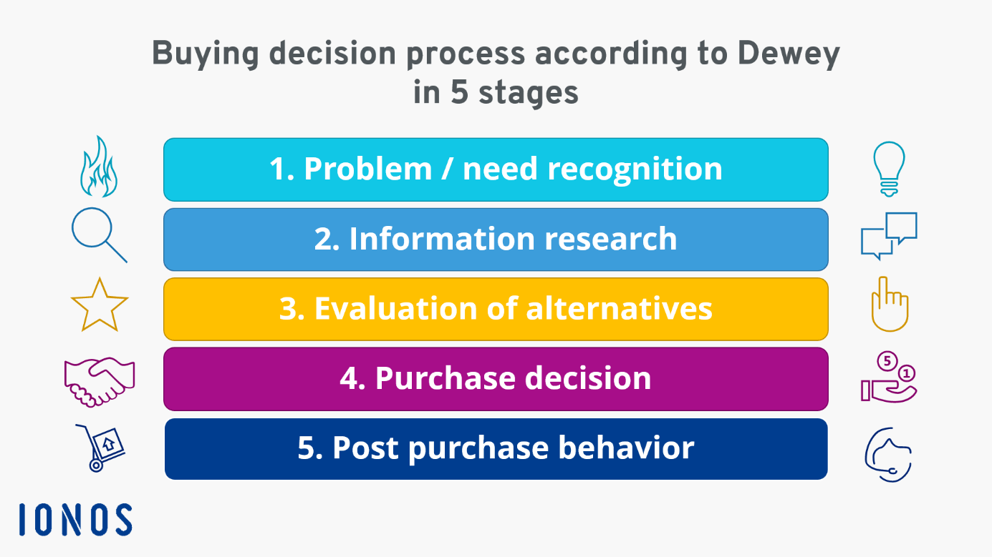
  - Figure 05: Purchase Decision Process
Source: (IONOS, 2025)
The third phase is to evaluate alternatives whereby the consumers compare the various products or brands and then they make a decision. They can compare the price, quality, delivery, delivery options, reviews and value in general. The purchase decision is the fourth stage where the consumer will choose the product that satisfies his/her needs and make the purchase (Dwivedi and McDonald, 2025). The last is the post purchase behaviour where the consumer determines whether the product was as expected or not. Satisfied customer can leave a positive review, repurchase with the brand or refer to other people. However, complaints, returns or negative reviews might be a result of dissatisfaction.
Influence of Online Information
Consumer perception, evaluation and choice is highly influenced by online information. The descriptions of products, pictures, ratings, reviews, and influencer posts are used to make the judgment on quality and reliability (Ahn and Lee, 2024). There is a possibility of building trust and reducing uncertainty with positive online reviews and discouraging purchasing behaviour with negative online reviews. The social media also has an impact on perception by demonstrating how products are applied in life.
Consumers, when in the evaluation process will tend to compare various brands by using online rating, comment and price comparison sites (Chen et al., 2022). This enables them to make better decisions. It also influences the final choice as online information can make consumers have more chances to purchase products which seem to be reliable, popular, and highly rated. Thus, online data has a significant part in influencing the current consumer purchasing behaviour.

2.4 Online Reviews and Consumer Perception
First Impressions of Products
The importance of online reviews lies in the provision of the initial impression of a product. Customers tend to rely on reviews, star ratings, comments and photos of people who have already purchased a fashion product before they actually lay their hands on or even touch the product. These reviews form a preliminary opinion regarding the fact that the product may appear trustworthy, trendy and worthy of purchase (Lim et al., 2024). The existence of numerous positive reviews can instantly give a product a more reliable look, and a product with low ratings might lead to reluctance. In the case of fashion products first impressions mean much as the customers desire to be assured of size, colour, fabric and look before they buy. Thus, reviews are an online variant of the word of the mouth and assist the customers in developing a point of view in a short time.
Product Quality Perception
The quality of the products is also determined by reviews. In online shopping, the consumers are not able to touch the cloth, inspect the stitching or even test the product and then purchase it (Mo, Li and Fan, 2022). Consequently, they refer to reviews in order to know whether the item is as it is described in the description. Remarks regarding the material, comfort, fitting, durability and value for money, will aid a customer to make a decision whether the product is of high quality or not. Good fabric, correct sizing and durable usage are positive remarks that could enhance the perceived quality of a fashion product. Nevertheless, negative comments regarding bad stitching, thinness or colour variance or poor fit can decrease confidence. Although the product image may appear appealing, the quality perception may be destroyed by the unfavourable customer experiences (Ehasan et al., 2026). This demonstrates that reviews do not consist of mere opinions but are also evidences that the customers employ to minimise uncertainty.
Impact on M&S Fashion Items
In the context of M&S fashion products, online reviews may have a significant impact on customer attitudes due to the frequent correlation of the brand with quality, comfort and reliability. The reviews can also assist customers to make decisions on various sizes, styles and colours (K, S and Panakaje, 2023). Negative reviews may, however, have an impact on the attitudes even of a trusted brand such as M&S. When customers see the same complaints regarding sizing problems, low-quality of fabrics or products that do not match the pictures on the Internet, they might postpone or even prevent purchasing. Thus, the reviews not only affect personal product preferences but also have a broader impact on the attitudes to M&S fashion (Busalim et al., 2022). All in all, online reviews assist customers in making a choice regarding whether or not M&S fashion pieces satisfy their expectations in terms of style, quality and trust.

2.5 Positive and Negative Reviews
Review the impact of positive reviews on confidence and purchase intention.
As opined by Fernandes et al. (2022), positive and negative reviews both have a different impact on consumers' trust because consumers tend to rely on the experiences of other consumers before buying fashion items online. Trust is crucial in UK fashion retail, as buyers cannot directly inspect it prior to purchase. Positive reviews can help to alleviate uncertainty by validating the quality, size, colour, fabric and delivery of the product. As per Dr Atif Aziz et al. (2024), comments like “good fit”, “high quality material” or “fast delivery” are repeated with the customers and they feel that the product is reliable. This can lead to higher confidence and drive purchasing decisions, especially for existing brands like Marks & Spencer, where consumers have a familiar positive perception of the brand's quality and value.
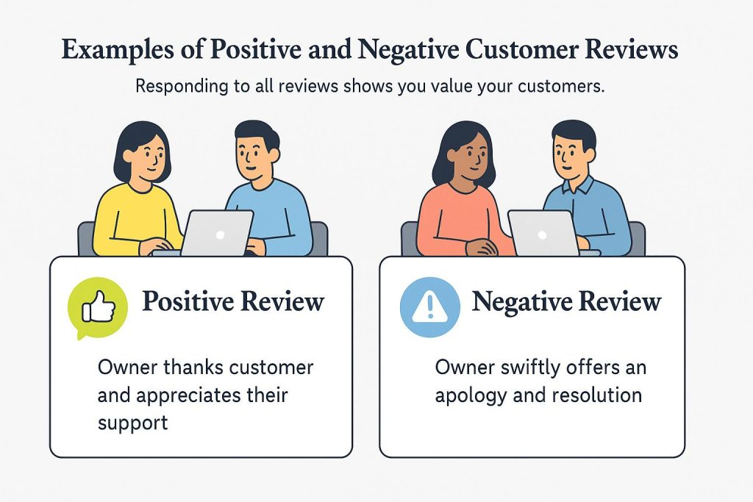
  - Figure 06: Positive and Negative Customer Reviews
Source: (Business, 2025)
Review the impact of negative reviews on hesitation, distrust or rejection.
Negative reviews are more likely to have a psychological impact because consumers are more risk averse. One negative comment regarding the fabric quality, sizing or the challenging returns could cause customers to pause, particularly when the comment has to do with a typical fashion-shopping issue (Du et al., 2025). Customers may lose their trust if they see the same problem multiple times, such as “runs small” or “colour is not as shown”. This can impact the buying process as customers may either not buy the product, opt for another product or go to a different retailer.
Compare how consumers respond to positive versus negative feedback.
But Cao (2023) argued that not all negative reviews are harmful. A combination of positive and negative reviews in some cases can make a review section appear truer to life. If reviews are all positive, customers might be mistrustful as it may appear to be manipulated or unrealistic. Negative reviews can also assist customers to make better choices; they can indicate potential drawbacks to the product. For instance, a dress marked “too long for shorter customers” might not deter all sales, but will give the right customers confidence in their purchase.
But Kang et al. (2022) argued that good reviews do not always lead to customer buying. Positive reviews that are overly positive may not be taken as seriously by some customers, particularly if they do not include much detail or are repetitive. For instance, a review that states “excellent product” may not inspire the same level of trust as a review that details how the product fits, the fabric, comfort and washing. So, when it comes to positive reviews, being specific, recent and having a few other reviews that are also positive is more effective (Akhilendra and Aravendan, 2023). In the fashion retailing sector, the value of the review is frequently reliant on the customer's capability to link it with their requirements, for example, body shape, size choice or style expectations.

2.6 Review Credibility and Trust
Overview on review credibility
As opined by Mo et al. (2022), consumers do not treat all reviews the same and that is why review credibility, review star ratings, review quality and review volume are important factors that affect their buying behaviour online. A detailed review that provides an explanation for the good or bad of a product is generally more convincing than a brief review like “nice product” or “bad quality”. The star rating is a rapid indicator of product performance. Richter et al. (2025) stated that a very high rating can establish trust and confidence in the product before a customer even reads the written comments, whilst a lower rating may deter purchase even before they read the written comments.
Trust in the reviewer affecting trust in the product
Credibility on the reviewer has a direct impact on credibility of the product since consumers tend to assess the product based on the experience of the reviewer. The reviewer should look authentic, elaborate and resemble the buyer and this makes the review more realistic (Xu et al., 2025). This will render the product appear to be safer, more dependable and worth buying. As an illustration, a customer can be confident when a reviewer describes the fit, quality of fabrics as well as comfort of an M&S clothing item.
Factors that make reviews seem believable
Reviews appear to be realistic when they are elaborate, real and uniform. Specific product features, including the quality of the fabric, size, colour, comfort, delivery and value for money are detailed with reviews. This helps to make the review more helpful than a mere comment of a good product. Authenticity is another significant factor since, in many cases, there are valid reviews, balanced opinions, actual experience and even customer photos. A review that states strengths and weaknesses albeit few, seems more truthful. Believability also gets enhanced by consistency. When most of the customers make such comments, like correct sizing or good material, the consumers will tend to believe the review and the product.

2.7 Star Ratings, Review Quality and Review Volume
The role of star ratings in shaping quick purchase judgments
Star ratings assist the consumer to make a snap judgment as to whether to purchase or not since they give a summary of the experience of other customers at a glance. Most shoppers review the average rating before reading the entire reviews in order to determine whether to consider a product or not. A high rating will produce a good first impression and the product will be assumed to be good quality, reliable, and satisfying. Low rating may result in suspicion and lower buying intentions. In the case of M&S fashion products, star ratings could impact on whether or not customers will click on a product, compare the products with other products or abandon the site. As such, ratings are nothing more than a trust signal.
Quality of Review impacting usefulness
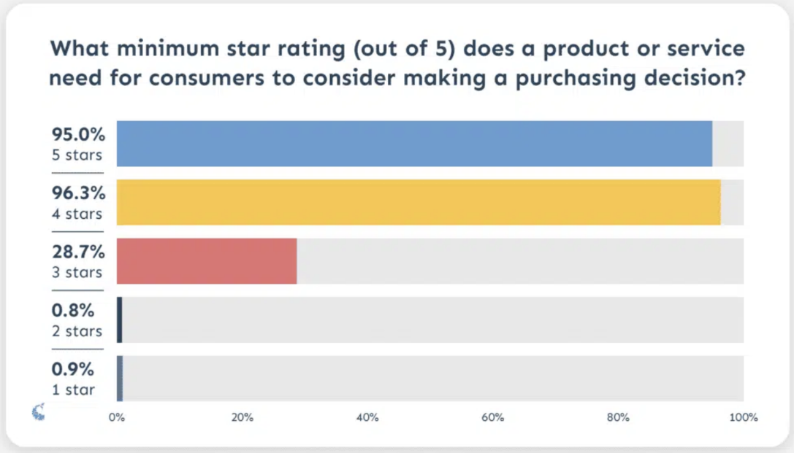
  - Figure 07: Review Credibility
Source: (Keeping and Brazil, 2023)
Review quality also influences purchasing behaviour as they offer specific information to the buying behaviour (Keeping and Brazil, 2023). Like in the above image, 95% people goes for 5-star rating to purchase a product. The key words featured in high-quality reviews about fashion retail are body fit, size correctness, fabric quality, wash performance, shipping, return, and value for money (Surjono, 2024). These details lessen perceived risk as well as aid customers decide if the product is similar to their own anticipations. But bad reviews can lead to miscommunication, particularly when they are emotional, vague and have nothing to do with the product.
Review Volume and Product Confidence
Garnefeld et al. (2021) argued that volume is also significant as it can generate social proof with more reviews. When lots of people express good reviews, the product seems more dependable. But more reviews don't necessarily result in improved decision making. If there are numerous old reviews that differ in content or address different problems, buyers will likely be leery. So, not only is the number of reviews influential in shaping buying behaviour, so too is the quality of the reviews, with regard to their credibility, detail, relevance and consistency.

2.8 Online Reviews and Purchase Decisions
Influence on Final Buying Decisions
Online reviews have a huge impact on ultimate purchasing decisions as they offer actual customer experiences when consumers are making their decisions on whether to buy or not. Shoppers go through the product reviews after they have seen pictures of the products, prices, and descriptions to ensure that the product is appropriate. Favourable reviews may prompt the customer to go ahead and make the purchase as they indicate that other consumers were happy (Guo and Zhang, 2024). In the case of M&S fashion products, the reviews on size, comfort, colour and fabric can be made to allow customers to determine whether the item fits or not. Nevertheless, the purchase decision may be halted when there are several negative reviews, even though the product may be appealing on the Internet.
Reviews, Risk and Purchase Intention
According to Zhang and Yu (2023), Reviews, perceived risk and purchase intention are clearly related. Perceived risk refers to the fear that the customer has of the product failing to meet the expectations. Online fashion shopping is riskier since customers have no opportunities to wear the clothes, touch the material or examine the true colour in order to purchase. Reviews lessen this risk by providing testimonies of individuals who have already bought the product. Positive reviews that are comprehensive and uniform lessen doubts and boost purchase intentions. The customers are also more confident since they feel that the product will probably work well as desired (Dong et al., 2025). Negative reviews, on the contrary, bring about perceived risk and decreased purchase intention. To illustrate, when a number of customers report that an M&S dress is smaller than anticipated or the garment is made of thin material, new customers might shun it.
Reducing Uncertainty in Fashion Purchases
Fashion purchases are some of the most significant areas where reviews are utilised since they are based on personal fit, looks and comfort. Basic details of the products can be provided in the descriptions, and the reviews can tell how the product functions in the real world (Eldemerdash et al., 2023). Customers can comment on the fact that the jeans fit, a jumper is soft, or a shirt does not lose its shape after washing. This eliminates doubt since the shoppers are able to contrast their needs to that of other customers.
In the case of M&S fashion products, reviews can also aid in building trust in the brand, by ensuring quality and reliability. As numerous customers provide positive feedback, customers are more open and less scared to buy. Online reviews thus contribute to the conversion of interest into the actual purchase behaviour through minimising the uncertainty, risk and confidence.

2.9 Customer Satisfaction, Brand Trust and Repeat Purchase
The link between reviews and customer satisfaction
According to Urbanska (2024), the relationship between customer reviews and brand trust and customer satisfaction/repeat purchase behaviour is highly correlated at Marks & Spencer as fashion customers tend to rely on their previous experience with other fashion customers to make purchase decisions online (M&S, 2025). But the trust can be reinforced or weakened by the word of mouth that customers have over and over through online reviews when it comes to the quality of the product, its size, timing of delivery, return policy, and their general experience.
Reviews affecting trust in M&S as a brand
Patil and Rane (2023) argued that positive reviews can lead to higher levels of custom satisfaction as it confirms that the products are meeting expectations. If consumers keep writing about the M&S fabrics, the correct fit and the comfort that the clothes provide, then new customers will be more likely to buy. This can also facilitate repeat purchase behavior in that satisfied customers may return to the same retailer if they are satisfied that they are purchasing value with each visit. By doing so, customer reviews provide social proof and help to ensure long-term customer retention.
Ehasan et al. (2026) argued that a bad review can tarnish a reputation in no time, particularly when there are identified issues that are repeated. If customers have issues with the fit, delivery time, stock, fabric quality or the return policy, they may not trust the M&S online fashion shop. This is important because the repeat purchase behaviour is not only related to product satisfaction but also the entire customer journey. If there are issues with the service and other customers are complaining about the same, they might opt out of the M&S services even if they already have their trust in the brand.
Positive review management supporting repeat purchase behaviour
Positive review management helps M&S to improve customer satisfaction through customer reviews. Detailed reviews can assist the business in recognising any common size problems, product descriptions, fabric quality and delivery service issues (Liu et al., 2021). But just gathering reviews is not enough, though. M&S have to reply to the negative reviews, strengthen their product weak points and promote certain feedback from customers. Thus, reviews only can build brand trust and repeat purchase behaviour if these are managed and leveraged to enhance customer experiences.

2.10 Theoretical Framework
Selected Theory: Theory of Planned Behaviour
This study is guided by the Theory of Planned Behaviour. This theory indicates that intention determines the consumer behaviour and that attitude, subjective norms and perceived behavioural control determine intention (Bosnjak et al., 2023). Simply put, the more customers feel positive towards a product, the more likely they would purchase it, because they would be influenced socially by others and feel that they can easily afford the purchase. Online reviews are appropriate to be studied using this theory since reviews may have a direct influence on consumer decision-making and the pre-purchase attitude to fashion products.
Interpreting Online Review Influence
The Theory of Planned Behaviour can be used to elucidate the role played by online reviews in consumer buying behaviour. Positive reviews can produce a positive impression of a product as it can seem reliable, stylish and of good quality. Reviews are also the subjective norms in the sense that consumers might feel that the opinions and experience of other customers influence them (Sutisna and Handra, 2022). Indicatively, when a lot of customers are suggesting an M&S fashion product, a new customer might have the impression that the product is socially accepted and is worth purchasing. The perceived behavioural control can also be reinforced through reviews to decrease uncertainty regarding size, fit, fabric and value. Customers are more assured of making a purchase decision when they feel that they possess adequate information.
Link to Aim and Objectives
This theory is directly related to the purpose of the study that is to study the effect that online customer review has on consumer purchasing behaviour of M&S fashion products. It plays into the goal of learning the influence of reviews on perception, trust, quality judgement and purchase intention. The theory is also useful in understanding the reasons why star rating, quality and quantity of reviews might impact the ultimate decision of customers. Thus, the Theory of Planned Behaviour offers a definite model of analysing the impact of online reviews on the attitude, decrease risk and intention to purchase in the case of M&S fashion products.

2.11 Research Gap
Previous Study Findings
Earlier research has revealed that online reviews affect the consumer buying behaviour through the development of trust, product perception and purchase intention. It is widely known that positive reviews and high star ratings as well as elaborate comments by customers can lead to less doubt and increased confidence among the consumers prior to purchase. Research also indicates that quality of the review, credibility and the volume of review are significant since customers may rely on the experience of other consumers when they are not able to physically test the product. The reviews are particularly significant in fashion retail since the customers require details concerning the size, fit, fabric, colour and comfort.
Missing Area in the Literature
Despite numerous studies on the general e-commerce and online reviews, a gap in the perception of how reviews impact buying behaviour in particular UK fashion retailers remains. The available literature concentrates to a large extent on general online shopping websites, electronics, hospitality or general store, as opposed to fashion brands with more product experience that is personal. The impact of the content of the review on customer perception of the trusted brands in the high-street is also not well explored.
Need for the M&S Context
The research is necessary as M&S is a famous fashion retailer in the UK with a good reputation of quality, comfort and reliability. Nonetheless, online reviews can also affect the level of trust and purchase of its fashion products by the customers. The investigation of M&S assists in the explanation of the impact of customer reviews on the perception, risk, and confidence and purchase intention in a particular fashion retail setting.

2.12 Conclusion of Chapter
Key Literature Points
This chapter summarised the impact online customer reviews have on consumer buying behaviour in the UK fashion retail sector focusing on Marks & Spencer. It reviewed the factors of reviews influencing consumer perceptions, trust and purchase decisions. The chapter also explored the role of review credibility, star ratings, review quality and review volume to alleviate uncertainty prior to online fashion purchase. In general, credible, detailed and managed customer reviews may help to build trust in the brand, customer satisfaction and repeat purchase behaviour.
Link to Methodology
The literature review will back the methodology chapter with a mention of the important themes that require to be analysed with the help of research. They are reviewing credibility, trust, perceived quality, risk reduction and purchase intention. As such, the following chapter will detail the research methodology, data gathering method and analysis procedure involved in the study of the impact of online reviews in consumer purchasing behaviour towards M&S fashion products.

CHAPTER 3: RESEARCH METHODOLOGY

3.1 Introduction and Purpose of the ChapterThis research will use
This chapter will explain the research methodology that will be applied to identify and interpret recurring themes on the effect of online customer reviews on consumer buying behaviour towards Marks & Spencer in the UK fashion retail industry. In alignment with research onion, the chapter describes the philosophical position, research approach, research strategy, research design, data collection method, literature search strategy, sampling process and data analysis method (Saunders, 2019). Due to the use of secondary data and systematic literature review as a basis of study, the PRISMA process, quality appraisal, research rigour, ethical considerations and methodological limitations are also explained in the chapter. Generally, this chapter offers a clear explanation as to why the research aim and objectives will be tackled.
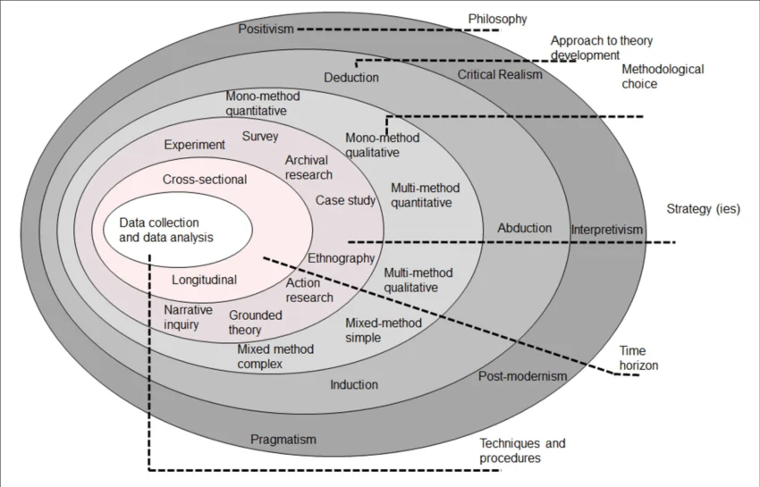
  - Figure 08: Research Onion
Source: (Saunders, 2019)

3.2 Research Philosophy
The research philosophy embraced in this study was an interpretivist research philosophy since the objective of the research was to comprehend how consumers build meanings about online customer reviews, trust and buying behaviour (Fischer, 2025). The interpretation of reviews was more suitable since not all consumers will interpret them the same: some will prefer detailed descriptions, others will react better to star ratings, review volume or negative comments. The philosophy thus favors examination of different experiences and contextual meanings that are described in the chosen literature.
The use of positivism was inappropriate as it supposes that consumer behaviour can be studied in terms of objective measurement, hypothesis testing and statistical interdependencies. This would not be sufficient to capture the differences in perceptions of review credibility, perceived risk and trust in the context of M&S fashion by the consumers. The pragmatism approach also did not fit very well since it focuses on approaches based on their practical value and is often related to the integration of various types of evidence, but in the current research, the qualitative systematic literature review was applied exclusively (Pervin and Mokhtar, 2022). Interpretivism thus provided the best philosophical fit to the qualitative nature of the study, inductive line of reasoning and thematic analysis of consumer perceptions, satisfaction and purchase intention in the context of M&S fashion context.

3.3 Research Approach
This study adopted an inductive research approach because it sought to generate contextual explanations from recurring patterns within the selected literature rather than test an existing theory through predetermined variables (Laari, 2025). Induction supports theory development by moving from specific findings concerning review credibility, positive and negative reviews, star ratings, trust, perceived risk and purchase intention towards broader interpretations of how online reviews influence M&S fashion consumers. This approach is closely associated with qualitative research because it allows meanings, experiences and relationships to emerge through thematic analysis instead of restricting the findings to predefined categories.
A deductive approach would have started with an established theory or hypothesis and tested whether anticipated relationships were supported by numerical evidence. Although the Theory of Planned Behaviour informed the interpretation of findings, the study did not statistically test its constructs or attempt to confirm causal relationships. Deduction was therefore less appropriate for the qualitative systematic literature review (Daniel and George, 2025). An abductive approach was also unsuitable because the research did not repeatedly alternate between theory generation and theory testing. Induction provided stronger alignment by enabling themes to emerge systematically from the evidence and then using them to develop an interpretive explanation of consumer buying behaviour in the M&S fashion context.

3.4 Research Strategy
A systematic literature review was chosen as the main research methodology as it allowed identifying, comparing, and synthesising available evidence on online customer reviews and consumer buying behaviour in the UK fashion retail industry transparently (Snyder, 2022). The plan assisted in testing of recurring associations among review credibility, star ratings, the quantity of reviews, trust and perceived risk and purchase intention. It was better than a traditional narrative review as pre-determined search terms, databases, screening procedures and eligibility criteria were used, which made the process of selecting studies more systematic and reproducible.
The search has firstly listed 80 records of Google Scholar, Scopus, ScienceDirect and Emerald and other industry sources. The number of duplicate records was eliminated to 73 records that were to be screened by title-and-abstract. 8 records were eliminated at this point since they failed to sufficiently discuss online reviews, consumer buying behaviour or fashion retailing. The rest 65 reports had been retrieved and fully assessed successfully. An additional 15 reports were filtered out at the eligibility step: 6 were not addressing M&S, UK fashion retailing or online customer reviews, another 5 were not addressing other industries or offline retailing, and 4 did not discuss review credibility, consumer trust or purchase intention in sufficient detail. As a result, 50 studies were included in the last review and thematic analysis.
The survey was not chosen due to the absence of primary data collection in M&S customers, and an experimental design was inappropriate due to the lack of consumer reactions under a controlled environment (Lame, 2021). Likewise, no primary case-study approach was taken. Rather, M&S offered the organisational background in terms of which the evidence provided by the more general body of literature was construed.
PRISMA Flow Diagram
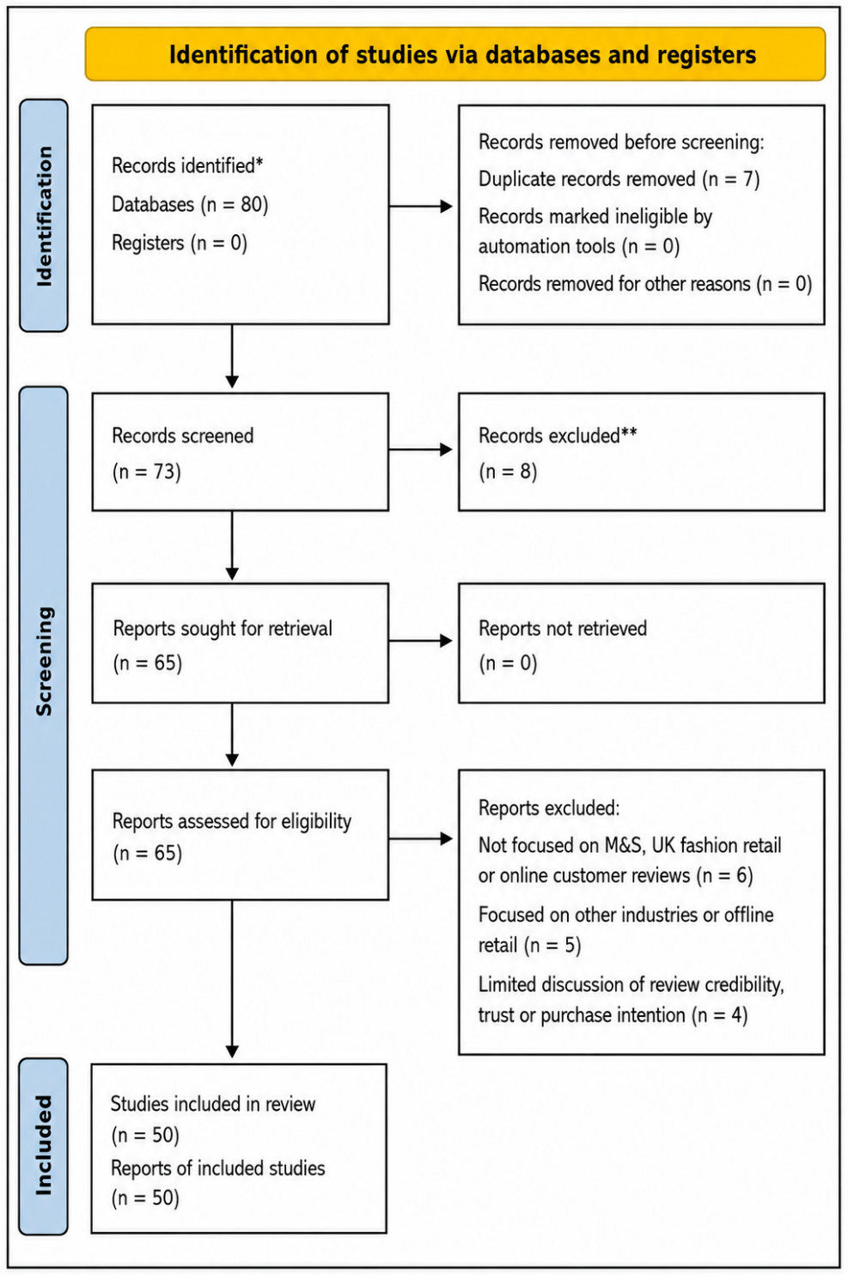
Source: Self-created

3.5 Research Design
This study employed a qualitative research design as it sought to know meanings, patterns and interpretations instead of quantifying relationships by using numerical tests (Lim, 2024). The study involved the influence of online customer reviews on consumer trust, perceived risk, satisfaction and purchase behaviour of Marks & Spencer fashion products in UK. The qualitative design was appropriate since consumer responses to reviews depend on individual expectations, credibility of the review, product experience and emotional confidence.
This design was chosen rather than a quantitative design since the research did not involve the use of questionnaires, numerical data or statistical analysis. It was also chosen over a mixed-methods design since the study did not involve any combination of primary numerical data with qualitative results (Polasa Bhuvanasri et al., 2025). Thus, a qualitative design was suitable to the secondary research design and systematic literature review design.
The study was facilitated by the design as it enabled a thorough examination of scholarly articles, industry reports and evidence review-related articles. It also assisted in the comparison of various concepts of the literature, including positive reviews, negative reviews, star ratings, volume and review quality. This rendered the design suitable to respond to the research question and fulfil objectives in the M&S UK fashion retail scenario.

3.6 Justification for the Chosen methods
The methods chosen were also rationalised since they fitted the purpose of investigating the effect of online customer reviews on consumer purchasing behaviour towards Marks & Spencer in the UK fashion retail sector. The philosophy, inductive method, qualitative design and systematic literature review strategy was employed in the study due to the nature of the topic; consumer meanings, trust, perceptions and decision-making, as opposed to numerical testing (Asmawi and Alam, 2024).
The reason why secondary data was used was to enable the researcher to utilise the already existing academic research, industry reports, company information and review related evidences without gathering data on the participants. This was the best as compared to primary research since the research was able to compare broader evidences of various sources using the time available (Mora, 2022). A survey was not chosen since it would have demanded direct access to the customers, ethical permission and statistical processing. Interviews were not chosen as well since the study was not oriented on gathering personal experiences of individual M&S customers.

3.7 Literature Search Strategy and Selection Criteria
Screening Process
A PRISMA approach was used to perform the screening process. To begin with, research was located in scholarly databases and reliable industry sources (Page et al., 2021). Duplicate studies were filtered out with titles and abstracts being filtered against the research aim. Inclusion and exclusion criteria were then used to evaluate full-text articles. The articles were chosen based on the criteria of online reviews, review credibility, star ratings, trust, purchase intention, consumer buying behaviour, fashion retail or UK retail.
Table 01: Search Strategy
Database/Source | Boolean Search String | Purpose
Google Scholar | “online customer reviews” AND “consumer buying behaviour” AND “fashion retail” | To locate general scholarly literature on online reviews and buying behaviour.
Scopus | “online reviews” AND “purchase intention” AND “consumer trust” | To locate peer reviewed articles on trust and purchase intention.
ScienceDirect | “electronic word of mouth” OR “eWOM” AND “online shopping” AND “fashion” | To gather research on the effect of review in online fashion shopping.
Emerald | “review credibility” AND “star ratings” AND “consumer decision making” | In order to locate studies on the effects of credibility and rating, review quality.
M&S Reports/Industry Sources | “Marks & Spencer” AND “fashion” AND “online customer reviews” | To contextualise the study with company and retail background.
Trustpilot/Google Reviews/M&S Website | “Marks & Spencer reviews” AND “clothing” OR “fashion reviews” | To gain insight into actual review topics associated with M&S fashion items.
Table 02: Inclusion and Exclusion Criteria
Criteria area | Inclusion criteria | Exclusion criteria
Type of source | Peer-reviewed journal articles were incorporated in order to ensure quality and reliability in academics. Where the company and industry reports were credible and offered relevant contextual evidence, they were included. | Non-academic sources like conference papers, blogs, opinion pieces and unverified websites were eliminated.
Publication date | Articles that were released within the past three to four years (2021-2026) were selected to make sure that the evidence is updated with the latest trends in online reviews and consumer behaviour. | Articles that were released earlier than 2021 were not included in the studies since they may not reflect the online review practices and consumer behaviour.
Sector focus | Articles devoted to fashion retailing, online retailing and the consumer retailing industry in general were selected. | Research on other unrelated industries, like healthcare, banking, manufacturing or business-to-business markets, was not considered.
Research topic | Articles that analysed online reviews, credibility of reviews, star ratings, quality of reviews, quantity of reviews, consumer trust, perceived risk, purchase intention or buying behaviour were considered. | Research that did not look at online reviews or their correlation to consumer decision-making and purchase behaviour was eliminated.
Relevance to the study | Relevant sources in terms of M&S, fashion retailing in the UK or similar online fashion-retail environments were included. | Not directly related to fashion retailing, online shopping or consumer decision-making sources were excluded.
Study Selection Process
The selection of the study involved the selection of sources that were directly related to the research aim and objectives (van Wee and Banister, 2023). The articles were chosen in the event that they talked about online reviews, trust, review credibility, star ratings, purchase intention, buying behaviour or fashion retail. Non-relevant, duplicated, outdated and non-academic sources were eliminated to have reliable and focused evidence.

3.8 Data Collection Methods
The research used secondary data collection as it was a systematic review of the literature as opposed to a field work. Around 50 peer-reviewed articles were chosen through the PRISMA screening procedure. In this case Google Scholar, Scopus, ScienceDirect and Emerald were considered as the databases to get these studies as they offered proper research online consumer reviews. Consumer trust as well as star ratings. The selected studies were subsequently coded and included in the thematic analysis. The data on Marks & Spencer reports, publications in the retail industry and reputable market-research materials were gathered independently to give the organisational and UK fashion-retail backdrop (Rachmiani et al., 2024). They were applied in the explanation of the digital retail environment, expectations and broader market conditions of M&S but were not considered as comparable to peer-reviewed research evidence.

3.9 Data Analysis
Coding Process
The data were analysed through the six stages of thematic analysis developed by Braun and Clarke: familiarisation, initial coding, theme generation, theme review, theme definition and reporting (Ahmed et al., 2025). The analysis focused on the 50 peer-reviewed studies retained through the PRISMA process. M&S reports and industry sources supported contextual interpretation, while Trustpilot, Google Reviews and M&S website reviews were not systematically coded.
During familiarisation, each selected study was read repeatedly, and relevant findings were recorded in a data-extraction sheet. Evidence relating to review credibility, positive and negative review valence, star ratings, review volume, customer trust, perceived risk, product quality, purchase intention and repeat purchasing was then assigned concise initial codes (Naeem et al., 2023). Coding was conducted consistently across the studies so that similar findings could be compared rather than discussed separately by author.
Table 03: Example of the Coding Process
Extract from selected evidence | Initial code | Theme | Analytical interpretation
Purchase intention was higher with strong ratings of the review when the consumers had a feeling of similarity with the reviewer. | The similarity of reviewers and positive ratings. | Review credibility and trust | The more convincing are the reviews made, the more consumers identify with the reviewer and see them as real.
Negative reviews received more attention on the part of the consumer when making a buying decision. | Negative-review attention | Perceived risk and uncertainty | Negative information can be more influential since consumers are interested in avoiding inappropriate purchases.
Credibility of the review, quality and quantity enhanced the trust and intention of purchase fashion. | Plausible and elaborate reviews. | Review credibility and trust | The consumers also consider the informational usefulness as well as reliability of the reviews before they make their purchases.
Unstable reviews enhanced doubt and decreased buying intent. | Review inconsistency | Perceived risk and uncertainty | Giving conflicting information undermines confidence since consumers are unable to build a definite product evaluation.
The remarks about fit and fabric and sizing facilitated online fashion choices. | Product-specific detail | Product evaluation and purchase intention | Detailed reviews partially counter the disadvantages of consumers being unable to visually check online fashion products.
Theme Development
The related codes were clustered into general themes. As an illustration, the authenticity of reviewers, comments and verified purchasing were categorised under review credibility and trust (Swami Gurunand Jnanathapaswi, 2021). Perceived risk and uncertainty included negative criticism, conflicting reviews, inappropriateness, delivery issues and refurbishment troubles. Review signals and social proof (star rating and review volume) and purchase intention and buying behaviour (product detail, confidence and willingness to purchase) were affected.
A review of the themes against the coded evidence was done to assure that each theme was internally consistent and different to the other. This process took the analysis to a next level of summarising individual authors by determining agreements, disagreements and repetitive relationships among the chosen studies.
Themes Answering the Research Question
The last themes proved that believable and extensive reviews had the ability to enhance trust whereas negative or incongruent reviews raised perceived risk. Star ratings and the volume of reviews formed quick initial impressions, but their impact was determined by the quality and authenticity of the reviews. Product-related remarks related to fit, material, sizing, and returns also lessened uncertainty in online shopping of fashion (Lim et al., 2024). The overall themes and results thus directly tackled the impact of online reviews on perceptions, trust and purchase behaviour of M&S fashion products.

3.10 Quality Appraisal and Research Rigour
The quality appraisal process also made sure that the 50 chosen articles were pertinent, methodologically plausible and had the ability to answer the research question. Every study was evaluated with a structured appraisal form that includes the criteria of clarity of the research aim, appropriateness of the research design, sampling method, data-collection process, analytical process, limitations and applicability to online reviews and consumer buying behaviour. The results of the appraisal were noted in the study-extraction matrix prior to the thematic analysis. Credibility, dependability, confirmability and transferability were then thought of as research rigour (Johnson et al., 2023).
Credibility
The credibility was enhanced as peer-reviewed studies were chosen in reliable databases and evidence was compared in several studies, not using only one source. Results were considered themes only when they were found repeatedly throughout the literature. Instead of being eliminated, contradictory findings were also kept and talked about instead of being eliminated, which minimized the chances of showing only evidence that would validate the expectations of the researcher.
Dependability
To obtain dependability, all records were subjected to the same search terms, period of publication, inclusion and exclusion criteria, quality-assessment questions and PRISMA screening phases (Innocenti et al., 2022). To establish an audit trail, search results, duplicate removals, exclusion decisions, extracted findings and codifications were logged. This enabled the study-selection and data analysis to be tracked and possibly repeatable.
Confirmability
The bias of the researcher was minimized by basing all the themes on extracted evidence and having a table to match extracts, initial codes and final themes. A second coding cycle was used to check the coding where the researcher re-reads the evidence and matches the codes to their original sources. In cases where a passage might have accommodated more than one theme, the meaning was revisited prior to ultimate classification. This was recognized as there was no second coder independent.
Transferability
The transferability was facilitated by the fact that the research context was M&S and the UK online fashion-retail industry were clearly defined (Drisko, 2024). The comprehensive data on the chosen studies, consumer problems and review features allow the readers to evaluate whether the results could be relevant to similar established fashion retailers. The conclusions, however, were not made that they are universally applicable to all retailers, nations or consumer groups.

3.11 Ethical Considerations
Ethical use of Secondary sources
The research was purely based on secondary data and did not imply direct contact with human subjects; hence, it posed low risk to human beings (Schmit et al., 2024). The use of peer-reviewed articles, company reports and reputable industry sources was in a responsible way.
The copyright rules were observed by paraphrasing published work and citing it. Tables, figures, theories and statistical information that were gotten elsewhere were clearly credited to their creators. The legitimate academic databases were used to retrieve copyrighted articles and no significant amount of material reproduced without acknowledgement/ permission.
The use of AI and academic integrity
The level of academic integrity was ensured through proper referencing of all ideas, theories and findings and lack of plagiarism, fabrication or selective presentation of evidence (Ngatuvai et al., 2021). The application of any artificial intelligence device was restricted to language, grammar or structural assistance and not creating or modifying the research data. Every piece of content that was supported with AI was cross-verified with the original sources and it was up to the researcher to be responsible of the accuracy, interpretation and final writing. The application of AI must also be announced in accordance with the policy of the university in terms of academic-integrity.
Secure Data Storage
Electronic folders with passwords were used to store search records, downloaded articles, quality-appraisal forms, screening decisions, extracted findings and coding tables. The researcher was the only one with access, and there were backup copies that were kept in a secure place. The files would be stored and removed based on the university data-management guidelines.
Transparent Reporting
The PRISMA flow diagram, documented search strings, inclusion and exclusion criteria, quality-appraisal records and coding examples were used to support transparency. Instead of not reporting the conflicting results and methodological limitations, they were reported, and the conclusions were able to reflect the existing evidence.

3.12 Methodological Limitations
There were some limitations in the methodology used in this study as it was carried out based on secondary data and systematic literature review. Publication bias was one limitation that was considered because published studies might largely report strong or positive results regarding online reviews and consumer behaviour whereas weak results might be less apparent (Paul and Barari, 2022). The other limitation was the researcher interpretation bias, which was that the coding and development of the themes relied on how the researcher perceived the literature that was chosen (Tennant and Ross-Hellauer, 2021). Despite the fact that the thematic analysis framework proposed by Braun and Clarke allowed making the process more structured, there was still certain subjectivity. The literature on Marks & Spencer fashion customers, in particular, was also a limitation to the study. As such, the results might not be reflective of the entire population of M&S consumers or experiences of all fashion retail in the UK.

3.13 Chapter Summary
This chapter described the methodology that was used to describe the impact of online customer reviews on consumer buying behaviour of Marks & Spencer in the UK fashion retail market. It was an acceptable basis to use interpretivism, an inductive method, a qualitative research design and a systematic literature review strategy. The process of literature search, PRISMA-based screening, secondary data collection with Braun and Clarke framework thematic analysis were also described in the chapter. Lastly, the chapter noted major methodological shortcomings.

CHAPTER 4: FINDINGS / RESULTS, ANALYSIS AND DISCUSSION

4.1 Introduction
This chapter will report the findings, analysis and discussion of systematic literature review of the impact of online customer review on consumer buying behaviour regarding Marks & Spencer in the UK fashion retailing industry. The chapter starts with the chosen studies represented in a systematic literature review table. It then interprets the results by the thematic codes which are connected with the review credibility, review star rating, review volume, credibility, perceived risk, purchase intention. These themes are related to the research aim, objectives and Theory of Planned Behaviour through the discussion. On the whole, this chapter describes the key trends found in the literature and the evidence related to the review.

4.2 Presentation of Findings
Table 04: Systematic Literature Review
Index | Author(s) | Year | Article title | Journal/source | Study aim | Methodology | Key themes/keywords | Relevance to RQ1/objectives
1 | Rachmiani, Oktadinna and Fauzan | 2024 | The impact of online reviews and ratings on consumer purchasing decisions on e-commerce platforms | International Journal of Management Science and Information Technology | Examine how online reviews and ratings affect e-commerce purchasing decisions. | Quantitative survey of 180 consumers. | Favourable feedback enhanced trust, and unfavourable feedback enhanced perceived risk and decreased purchase intention. | Provides a direct support to RQ1 and O2-O3 as it details how review valence and ratings can affect trust and purchases of M&S fashion products.
2 | Surjono | 2024 | Factors influencing online shopping decisions in the fashion industry | International Journal of Management Science and Information Technology | Identify the principal factors influencing online fashion-purchasing decisions. | Mixed-method research using questionnaires and interviews. | Online fashion decisions were influenced by reviews, trust in the platform, product-information transparency and return policies. | Bears out RQ1 and O1-O4 by demonstrating that M&S reviews have an interaction with product information, platform confidence and return assurance.
3 | Ahn and Lee | 2024 | The impact of online reviews on consumers’ purchase intentions: Examining the social influence of online reviews, group similarity, and self-construal | Journal of Theoretical and Applied Electronic Commerce Research | Determine how review ratings, group similarity and self-construal affect purchase intention. | 2×2×2 experiment and ANOVA involving 276 participants. | High ratings were more convincing when the consumer felt that he or she was similar to the reviewers. | Helps in supporting O3 by implying that M&S reviews are more likely to be influential when customers can relate to the features or fashion inclinations of the reviewer.
4 | Chen et al. | 2022 | The impact of online reviews on consumers’ purchasing decisions: Evidence from an eye-tracking study | Frontiers in Psychology | Examine consumers’ visual attention and behavioural responses to online reviews. | Controlled eye-tracking experiment. | There were more negative than positive attention paid to information by consumers, which indicates the presence of negativity bias in processing the reviews. | Supports O2 by stating why there might be a disproportionate emphasis on critical M&S reviews in relation to quality, fit or delivery.
5 | Adeola et al. | 2021 | Consumer values, online purchase behaviour and the fashion industry: An emerging-market context | PSU Research Review | Examine how consumer values and fashion consciousness affect online fashion purchasing. | Cross-sectional survey of 241 consumers. | Attitudes and online purchasing behaviour were influenced by fashion consciousness and personal values. | Offers fashion background to O1 by demonstrating how M&S reviews can be perceived in various ways based on the values and fashion engagement of the customers.
6 | Qiu and Zhang | 2024 | How online reviews affect purchase intention: A meta-analysis across contextual and cultural factors | Data and Information Management | Quantify the overall effect of online reviews and relevant moderators on purchase intention. | Meta-analysis covering 156 previous studies. | The strongest predictor was the review valence and the product, platform and cultural conditions moderated its effect. | Gives good aggregated support to RQ1 and O2-O3, especially with respect to positive and negative reviews of the M&S.
7 | Cuc et al. | 2025 | The impact of online product reviews on Gen Z consumers’ purchase intentions for fashion products in e-commerce in Hanoi, Vietnam | Architecture Image Studies | Investigate how reviews influence Generation Z fashion-purchase intentions. | Survey of 220 consumers analysed using PLS-SEM. | Credibility of reviews, quality and quantity improved consumer trust and fashion-purchase desire. | Directly answers RQ1 and O1-O3, but contextual variations between Vietnamese and UK M&S consumers need to be addressed.
8 | Hewei | 2022 | Influence of online comments on clothing impulse buying behaviour in mobile short-video app live broadcasts | Frontiers in Psychology | Examine how online comments influence impulse buying during clothing livestreams. | Questionnaire survey involving 709 consumers. | Quality of comments, quality and quantity of comments and understandability affected usefulness and impulse purchases of clothes. | Defends O3 because it shows that a great number of detailed and comprehensible remarks can speed up buying clothes online.
9 | Kang et al. | 2022 | A study on the influence of online reviews of new products on consumers’ purchase decisions: An empirical study on JD.com | Frontiers in Psychology | Identify review characteristics and topics influencing new-product purchases. | Latent Dirichlet allocation and text-mining analysis. | Themes of review volume, polarity and product and service related had a different impact on decisions. | Justifies O1-O3 by pinpointing review themes that M&S should track when launching new fashion collections.
10 | Wang et al. | 2021 | Understanding the dark side of online reviews on consumers’ purchase intentions in e-commerce | Frontiers in Psychology | Investigate how review discrepancies negatively influence purchase intention. | Controlled consumer experiments. | The adverse impact of conflicting information was realized when reviews were inconsistent to increase uncertainty and decrease purchase intention. | Helps O2 by demonstrating how uncertainty in the size or quality of M&S or value would make people less willing to buy.
11 | García-Salirrosas et al. | 2022 | Purchase intention and satisfaction of online shop users in developing countries during the COVID-19 pandemic | Sustainability | Explain online clothing-purchase intention through trust, satisfaction and perceived value. | Survey of 330 online clothing shoppers analysed using SEM. | Perceived value and purchase intention were improved with trust and satisfaction. | Favors O1, O2 and O4 by bridging the trust created during the review with satisfaction, perceived value and potential M&S repeat purchase.
12 | Dong, Park and Kim | 2025 | The role of product type in online review generation and perception: Implications for consumer decision-making | Journal of Theoretical and Applied Electronic Commerce Research | Examine how product type affects review production and perceived helpfulness. | Large-scale secondary analysis of Amazon review data. | The length of review and photos elicited varying effects of usefulness on different product categories. | Favors O3 because detailed, image-based reviews are especially useful to experience based products like M&S clothing.
13 | Ngo et al. | 2024 | Electronic word-of-mouth on social networking sites: Roles of information credibility in shaping online purchase intention | Heliyon | Examine how eWOM credibility influences online purchase intention. | Survey of 337 consumers analysed using PLS-SEM. | Perceived usefulness, information adoption and purchase intention were enhanced by the credibility of information. | Directly supports RQ1 and O23 by finding credibility and usefulness as a bridge between M and S reviews and purchasing.
14 | Cuong | 2024 | Examining how electronic word-of-mouth information influences customers’ purchase intention: The moderating effect of perceived risk on e-commerce platforms | SAGE Open | Determine how perceived risk changes the effect of eWOM on purchase intention. | Quantitative survey of 339 consumers analysed using PLS. | The usefulness and purchasing power of eWOM information were undermined by perceived risk. | Proves O2 by stating why doubt about M&S sizing, material, delivery or returns can undermine positive reviews.
15 | Peña-García et al. | 2024 | Reviews, trust, and customer experience in online marketplaces: The case of Mercado Libre Colombia | Frontiers in Communication | Examine relationships among review quality, rating-system trust and customer experience. | Survey of 326 consumers analysed using PLS-SEM. | Quality of reviews enhanced confidence towards reviews, rating system and experience in the market. | Supports RQ1 by bridging the gap between review quality and trust and the expanded M and S digital customer experience.
16 | Zhang et al. | 2021 | The impact of consumer perceived value on repeat purchase intention based on online reviews: By the method of text mining | Data Science and Management | Determine how perceived value extracted from reviews influences repeat purchasing. | Airbnb reviews analysed through LDA, sentiment analysis and structural-equation modelling. | The functional and hedonic value and epistemic and social-relationship value enhanced the repurchase intention with social value having the most significant impact. | Justifies O4 by explaining how M&S can use reviews to determine value dimensions that can prompt repeat purchases.
17 | Zinko et al. | 2021 | Responding to negative electronic word of mouth to improve purchase intention | Journal of Theoretical and Applied Electronic Commerce Research | Identify which organisational response components can restore purchase intention following negative eWOM. | Simulation-based consumer experiment. | Only the response that included an apology, explanation and dedication to fix the problem helped to increase purchase intention. | Provides a practical framework of O4 by offering a practical structure in which M&S responds to negative reviews of their fashion products.
18 | Alzate, Arce-Urriza and Cebollada | 2021 | Online reviews and product sales: The role of review visibility | Journal of Theoretical and Applied Electronic Commerce Research | Examine whether the visibility and ordering of reviews change their effect on sales. | Nine-week panel of 119 cosmetic products analysed using system GMM. | Recent and useful review-sorting mechanisHow online customer do reviews influence transformed the substantive and directional effects of reviews; more prominent helpful reviews had more sales impact. | Justifies O3–O4, proving the need to design review ordering and visibility carefully by M&S.
19 | Mohawesh et al. | 2021 | Fake reviews detection: A survey | IEEE Access | Review fake-review detection approaches and assess modern machine-learning alternatives. | Systematic technical review and benchmarking of neural networks and transformer models. | Detection was facilitated by textual, behavioural and reviewer features; RoBERTa hit about 91.2% accuracy on a benchmark dataset of deception. | Favors O3 to O4 because it has evidence to support the authenticity of M&S review system.
20 | Shao et al. | 2021 | Determinants of online clothing review helpfulness: The roles of review concreteness, variance and valence | Industria Textila | Examine the review characteristics that determine helpfulness in online clothing purchasing. | Experimental comparison of concreteness, consistency and positive or negative valence. | Review concreteness, variance and valence had a significant impact on helpfulness; negative and inconsistent reviews on clothes often provided greater diagnostic information. | Contributes directly to RQ1 and O2-O3 since the study is limited to online reviews of clothing.
21 | Al-Abbadi et al. | 2022 | The effect of online consumer reviews on purchasing intention through product mental image | International Journal of Data and Network Science | Examine whether consumers’ mental image of a product mediates review influence. | Online survey of cosmetics consumers analysed with covariance-based SEM using AMOS. | Mental imagery about the product was enhanced by online reviews and this boosted intention to purchase. | Supports O1 in that descriptive M&S reviews assist customers in visualising quality of clothing, appearance, styling and usage before they buy.
22 | Zhang et al. | 2022 | Research on the evolution of consumers’ purchase intention based on online reviews and opinion dynamics | Sustainability | Explain how interactions between reviewers and readers dynamically change purchase intention. | Sentiment extraction, fuzzy quantification, an adapted Deffuant–Weisbuch model and case simulation. | The development of purchase intentions was influenced by reviewer professionalism, consumer personality, negative bias and audience heterogeneity. | Defends O2-O3 by demonstrating that M&S review effects are built up by interaction and not by isolated ratings.
23 | Maia et al. | 2022 | The effects of brand and online reviews on consumer trust and purchase intentions in developing countries | Brazilian Business Review | Compare the effects of brand familiarity and review availability on trust and purchase intention. | 2×2 factorial experiment involving known and lesser-known brands and the presence or absence of reviews. | The main idea behind trust was brand equity and reviews in particular when it comes to unknown brands. | Applicant to RQ1 since the familiarity with M&S brand may change the customer-review influence strength.
24 | Bo, Chen and Yang | 2023 | The impact of contradictory online reviews on consumer online purchase decision: Experimental evidence from China | SAGE Open | Examine how the proportion and emotional intensity of contradictory reviews influence purchasing. | 2×2 experiment involving 306 consumers and mediation analysis. | The review contradicting raised the perceived risk, leading to decreased purchasing, and the emotional arousal heightened consumer responses. | Favors O2 by describing how conflicting M&S perceptions of fit, durability or value can pose risk and hesitation.
25 | Qin et al. | 2023 | Do live streaming and online consumer reviews jointly affect purchase intention? | Sustainability | Examine the combined influence of livestreaming and online reviews on purchasing. | Survey of 448 social-commerce users analysed using structural-equation modelling. | Purchasing was affected by Interactivity, community, usefulness and trust as well as the combined channel effect was mediated by customer engagement. | Argues in favour of O1-O3 by demonstrating how M&S reviews might engage with social-commerce and livestream content as opposed to being independent.
26 | Mahdikhani | 2023 | Exploring commonly used terms from online reviews in the fashion field to predict review helpfulness | International Journal of Information Management Data Insights | Identify fashion-review terms that predict perceived helpfulness. | LDA, TF-IDF and machine-learning analysis of 828,700 Amazon Fashion reviews. | The most useful themes were fabric quality, fashion trends, aesthetics, sizing, prices and returns; the best model had an accuracy of 0.81. | Of great significance to O1, O3 and O4 since it determines the exact review content that M&S should focus on.
27 | Yang, Fujisaki and Ueda | 2023 | Social influence makes outlier opinions in online reviews offer more helpful information | Scientific Reports | Determine whether reviews expressing minority or outlying opinions provide useful information. | Statistical and simulation analysis of a large online-review dataset. | The reviews of outliers were deemed more useful as they had more adequate, neutral and concise evidence, which might have been created under conformity pressure. | In favor of O23 by demonstrating that odd M3S views are not necessarily to be disregarded as unrepresentative.
28 | Zhang et al. | 2023 | What makes deceptive online reviews? A linguistic analysis perspective | Humanities and Social Sciences Communications | Identify linguistic characteristics distinguishing deceptive from authentic reviews. | Reality-monitoring framework and linguistic analysis of Amazon product reviews. | The reviews that were deceptive were often less perceptual and relevant, whereas the reviews that were rewarded, emotional, perfunctory, and paid had various affective and cognitive displays. | Defends O34 by assisting M&S in finding suspicious reviews and safeguarding consumer confidence.
29 | Seutter et al. | 2023 | “Sorry, too much information”—Designing online review systems that support information search and processing | Electronic Markets | Develop review-system design guidance for reducing consumer information overload. | Literature synthesis, taxonomy development and evaluation of 65 review systems. | Fifty design features were identified that dealt with aggregation, filtering, sorting and highlighting. | Helps O3-O4 by demonstrating the ways M&S might sort reviews based on rating, size, fit, recency, and helpfulness.
30 | Lopes et al. | 2023 | Managerial response strategies to eWOM: A framework and research agenda for webcare | Tourism Management | Consolidate effective organisational strategies for responding to electronic word-of-mouth. | Systematic literature review and conceptual framework development. | The problem-solving, accommodating, personalised, detailed and timely responses were effective especially when responding to negative remarks. | Directly assists O4 to provide response principles that M&S may apply when responding to dissatisfaction and customer complaints.
31 | Cai, Cebollada and Cortiñas | 2023 | Impact of seller- and buyer-created content on product sales in the electronic commerce platform | Journal of Retailing and Consumer Services | Compare how retailer- and customer-created content influences online product sales. | E-commerce platform panel data and econometric analysis. | Sales were influenced by informativeness, readability, multimedia richness and extreme valence; independent product signals were provided by customer-created content. | Strengthens O1 O3 by separating M&S product descriptions and the customer evidence that can seem more autonomous.
32 | Riswanto et al. | 2024 | Online reviews meet visual attention: A study on consumer patterns in advertising, analysing customer satisfaction, visual engagement, and purchase intention | Journal of Theoretical and Applied Electronic Commerce Research | Integrate review sentiment and visual attention to explain satisfaction and purchase intention. | Review text mining, eye tracking and participant survey. | Themes that influenced satisfaction were product, model, promotion and effect, whereby, products and models were more appealing to the eye whereas promotion material influenced buying. | Facilitates O13 because it links themes derived through reviewing to the presentation and visual assessment of the M&S fashion products.
33 | Wang et al. | 2024 | Online review helpfulness and information overload: The roles of text, image, and video elements | Journal of Theoretical and Applied Electronic Commerce Research | Determine how textual and multimedia elements influence review helpfulness and information overload. | Multiple-regression analysis of 8,693 reviews across six product categories. | Further text enhanced helpfulness but ultimately generated diminishing returns; product category and multimedia changed the relationships. | Endorses the O34 argument that M&S needs to encourage reviews in details without repeating or using overly lengthy content.
34 | Pooja and Upadhyaya | 2024 | What makes an online review credible? A systematic review of the literature and future research directions | Management Review Quarterly | Consolidate the antecedents of online-review credibility. | Multistage systematic review of 69 empirical studies. | The credibility was based on the source, review, consumer, interpersonal, platform and product credibility. | Directly supports O3 by giving an evidence-based framework on how to evaluate what features of M&S reviews create authenticity and credibility.
35 | Ganguly, Sengupta and Biswas | 2024 | What are the significant determinants of helpfulness of online review? An exploration across product-types | Journal of Retailing and Consumer Services | Compare determinants of review helpfulness across different product categories. | Cross-product review-data analysis using statistical and predictive models. | Presentation cues and reviewer characteristics, as well as review content and ratings, had various impacts based on product type. | On M3, argues in favor of O3, pointing out that M&S ought to invoke review-helpfulness rules appropriately tailored to the experimental nature of fashion.
36 | Kübler et al. | 2024 | The effect of review images on review helpfulness: A contingency approach | Journal of Retailing | Establish when customer-uploaded images increase or reduce review helpfulness. | Image and econometric analysis of more than 97,000 Amazon reviews. | The usefulness of the image was tied to review valence, reputation of the reviewer and product details and consistency between image and text. | Firm believer in O1 and O3 since customer photos can show the look, fit and styling of M&S clothes.
37 | Macheka, Quaye and Ligaraba | 2024 | The effect of online customer reviews and celebrity endorsement on young female consumers’ purchase intentions | Young Consumers | Compare the influence of customer reviews and celebrity endorsement on young women’s purchasing intentions. | Electronic survey with 203 valid responses analysed using SEM. | eWOM and brand awareness had an impact on purchase intention including indirect effects by means of consumer attitudes. | Offers fashion-relevant evidence to support O1-O3 by contrasting customer reviews with an additional significant source of persuasion.
38 | Malik et al. | 2024 | Incentivized fake reviews: When cognitive reappraisal paves the way for an immoral journey | Journal of Consumer Behaviour | Explain the psychological process through which consumers create incentivised fake reviews. | Multi-study experimental and survey-based research. | Moral disengagement and deceptive review behaviour was promoted by self-oriented motivations and cognitive reappraisal. | Endorses O34 by showing how pointless incentives can be, and the value of open M&S review-collection policies.
39 | Wu | 2024 | The influence of online reviews on the purchasing decisions of travel consumers | Sustainability | Examine how review characteristics influence purchasing decisions under different distance and product conditions. | Empirical research and large-scale data-simulation experiments. | Varying attributes, rating, the number of reviews, product details, and service quality influenced the rate of recommendation and purchasing behavior. | Defends O2-O3 by demonstrating that the effects of rating, volume and product-information must not be analysed independently of each other.
40 | Yang et al. | 2024 | The role of online consumer reviews in shaping consumers’ purchase intentions for energy-saving household appliances: A social communication theory perspective | Discover Sustainability | Examine how review communication characteristics influence purchase intention. | Structured consumer questionnaire analysed using PLS-SEM. | The quality of review, quantity of review, credibility of source and consumer attitudes had a direct influence on the purchase intention, the mediating relationship was perceived usefulness. | Facilitates O2-O3 by providing a model of communication which can be moulded to M&S fashion purchasing.
41 | Park and Park | 2025 | Understanding the impact of inconsistency on the helpfulness of online reviews | Journal of Theoretical and Applied Electronic Commerce Research | Examine how rating and attribute-level inconsistency affect review helpfulness. | Aspect-based sentiment and Tobit analysis of 106,464 Yelp reviews from 666 businesses. | Consistency of ratings decreased usefulness, and variations on the choice of attributes might provide new information; expertise of reviewers reinforced multiple effects. | Favors O2-O3 by differentiating between the bad overall disagreement and the informative differences of specific product attributes of M&S.
42 | Chu, Liu and Liu | 2025 | The role of visual cues in online reviews: How image complexity shapes review helpfulness | Journal of Theoretical and Applied Electronic Commerce Research | Determine how image complexity and text readability influence review helpfulness. | Large-scale hotel and travel review data with computational image and statistical analysis. | Colour heterogeneity enhanced helpfulness, and texture homogeneity showed an inverted U-shaped; readable text enhanced visual influence. | Justifies O1 and O3 by demonstrating that customer photographs and readable descriptions can be effectively used together to increase the usefulness of M&S fashion-review.
43 | Campos, Pinto and Torres | 2025 | Rating and perceived helpfulness in a bipartite network of online product reviews | Electronic Commerce Research | Examine relationships among products, ratings, review volume and perceived helpfulness. | Network, regression-tree and random-forest analysis of 2,214 Amazon reviews. | Favourable reviewing activity and the ratings were linked to helpful reviews, but the volume of the reviews did not ensure a positive evaluation. | Facilitates in favor of O3 by detaching the quantity of review of the quality and helpfulness.
44 | Chatterjee | 2025 | Effect of construal level on the drivers of online-review helpfulness | Electronic Commerce Research | Determine whether consumers’ mental-construal level changes review-helpfulness judgements. | Four controlled experimental studies. | At low construal, diagnostic information and vicarious experience were more influential whereas reviewer trustworthiness was more influential at high construal. | Helps justify O1 and O2 by stating that immediate and planned M&S purchases might be contingent upon various review cues.
45 | Hanaysha, Ramadan and Alhyasat | 2025 | Exploring the impact of customer reviews, website quality, perceived service quality, and product assortment on online purchase intention | Telematics and Informatics Reports | Explain purchase intention through reviews, website quality, service quality, assortment and trust. | Online consumer survey and multivariate structural modelling. | Reviews affected purchase intention both directly and indirectly via trust, as well as variables of the web site, service and assortment. | Fills RQ1 and O2-O4 by placing M&S reviews in greater context of digital customer experience in the retailer.
46 | Sudaryanto et al. | 2025 | The mediating effect of customer trust of eWOM and online customer reviews impacting purchase decisions | Cogent Business & Management | Evaluate how eWOM and online reviews affect trust and marketplace purchase decisions. | Questionnaire survey of 250 consumers using purposive sampling and quantitative path analysis. | The customer trust mediated between the online reviews, eWOM and purchasing decisions. | Directly supports RQ1 and O2 by providing a model of trust mediation that could be experimented among M&S customers.
47 | Wang et al. | 2025 | Shopping for others: How does inconsistency in online reviews affect purchase intentions differently? | Frontiers in Psychology | Examine review inconsistency when consumers purchase for themselves or other people. | Two factorial studies involving 284 and 551 valid responses. | Ambivalence lowered the purchase intention due to inconsistency whereas the social distance and type of products mediated the relationship. | Confirms RQ1 and O2 since M&S fashion products could be bought to be used personally or as a present.
48 | Le et al. | 2025 | Understanding the effect of product reviews on YouTube on consumers’ intention to purchase electronic devices | SAGE Open | Determine how multimedia review characteristics influence purchase intention. | Survey of 343 adults analysed using PLS-SEM. | Purchasing was facilitated by transparency, informativeness and credibility of reviewers, whereas parasocial interaction was encouraged by visual cues. | Helps to promote O1-O3 by expanding the reach of the review to a video content that M&S consumers might be exposed to off-site.
49 | Choi et al. | 2025 | The role of review responses in shaping online review content and review-space dynamics | Electronic Markets | Examine whether organisational responses change the characteristics of subsequent customer reviews. | Yelp and TripAdvisor data analysed through difference-in-differences modelling. | The intensity and diversity of the response grew with the length of the subsequent review and cognitive language, whereas the similarity of the response reinforced the affective expression. | Endorses O4 by demonstrating that M&S responses might increase customer relationships and quality of its future review environment.
50 | George | 2026 | The impact of negativity and positivity of extreme reviews on the helpfulness of online reviews | Electronic Commerce Research | Determine how textual sentiment interacts with one-star and five-star ratings to influence helpfulness. | Amazon review data analysed using zero-one-inflated beta regression. | Negative text in five-star reviews was especially useful, as discordance between text and rating was used to give diagnostic information. | Argues in favour of O2 O3 by proving that M&S ought to read between the lines and not to judge on extreme ratings alone.

4.3 Analysis of Results
Table 05: Thematic Codes
Main Theme | Subtheme | Description | Linked Objective
Consumer Perception | Product quality perception | Reviews assisted the customers to evaluate cloth, fit, colour, size and worth prior to purchasing M&S fashion products. | Objective 1
Review Valence | Positive reviews | Favourable reviews boosted confidence, lowered a sense of doubt and induced a desire to purchase. | Objective 2
Review Valence | Negative reviews | Bad reviews instilled fear, perceived risk and potential product rejection. | Objective 2
Review Credibility | Trust in reviews | Real and recent and detailed reviews were found to be more believable to consumers. | Objective 3
Star Ratings | Quick judgement | The high ratings provided a good initial impression and helped to make quicker purchasing choices. | Objective 3
Review Volume | Social proof | Many reviews resulted in a more popular and reliable product. | Objective 3
Perceived Risk | Uncertainty reduction | Reviews minimised the ambiguity in online fashion shopping where shoppers do not have the opportunity to physically test the products. | Objective 1 and 3
Brand Trust | Trust in M&S | The positive feedbacks that were constantly received reinforced the belief in M&S as a reputable fashion retailer. | Objective 4
Repeat Purchase | Customer satisfaction | Satisfaction and repeat buying behaviour was facilitated by helpful reviews and enhanced review management. | Objective 4

Theme 1: Online Reviews and Consumer Perception of M&S Fashion Products
The thematic coding shows that the online reviews generate a consumer-generated meaning of M&S fashion products. Clothing reviews allow reviewers to consider useful features like fit, accuracy of size, and quality and comfort of the fabric that cannot be adequately evaluated based on product descriptions (Shao et al., 2021). Reviews hence minimize doubt as it converts technical knowledge into the daily product experiences. The visual information has a specific impact since the photographs of customers seem to make clothes look more real and show potential discrepancies between the displayed and reality images (Kubler et al., 2024). Consumer studies of visual attention reveal that more detailed review information is more appealing in terms of paying attention during the consideration of the product (Riswanto et al., 2024). The recurring positive feedback will enhance the image of quality, reliability and value that M&S has established. On the other hand, repeatedly voiced grievances of sizing, longevity or colour precision might have a negative impact on the perception of the broader brand and not just the reviewed product. Relevance, detail, practical usefulness, makes fashion-review helpfulness, therefore, dependent (Mahdikhani, 2023). Consumers integrate these customer experiences and already existent knowledge of M&S and then make a judgement. The online reviews thus influence the perception of M&S fashion as reliable, presented correctly and worth the price.
Theme 2: Positive and Negative Reviews Shaping Trust and Purchase Decisions
The results indicate that there is an unequal relationship among the sentiment of the review, trust and purchase decision. Positive feedback gives a positive assurance and social validation especially in cases where shoppers have not had past experience with an M&S product. But trust is in the presence of positive comments with definite and realistic details. Too enthusiastic or too frequent reviews may seem to be manipulated and cause mistrust. Negative electronic word of mouth is more focused on as it is used by consumers to determine potential losses in terms of finances or product (Zinko et al., 2021). Critiques of bad fit, flimsy material, problems with delivery or tough returns can thus overwhelm many general positive messages. The reviews that are contradictory do not always deter buying; consumers evaluate the possibility of disagreement being a personal choice, body shape or non-uniform performance of a product (Bo et al., 2023). A mixture of both positive and negative views might seem more genuine than the feedback that is constantly positive. Trust also changes due to organisational reactions. By being responsible and caring, appropriate webcare can lessen the harm of negative reviews (Lopes et al., 2023). M&S reinforces trust by providing explanations, sharing or observable remedial actions or corrective actions. Purchase decisions are consequent of review sentiment, authenticity and perceived risk and the response of M&S.
Theme 3: Review Credibility, Star Ratings and Review Volume as Buying Signals
The buying signals which were found to be linked together were three: review credibility, star rating and review volume. Credibility is the controlling signal as reviews lose persuasive power when unnatural and commercially-driven reviews are seen. Credibility is measured by consumers with detailed descriptions, balanced language, consistency of reviewers and evidence of actual use of a product. The fake-review research proves that the manipulation is determined by both the content of the reviews and behavioural patterns (Mohawesh et al., 2021). Credibility can also be enhanced through customer photos as they show tangible evidence of product appearance and use (Kubler et al., 2024). The star rating is a quick filter tool, allowing customers the ability to compare M&S fashion items prior to reading single reviews. However, a mediocre score can present highly polarized customer experiences. The customers can in turn examine rating distributions and extreme reviews to find out the common issues. The volume of reviews is social validation, and a large number of consistent opinions are an indication of popularity and eliminates the dependence on a single reviewer. Nonetheless, too much information might lead to review overload and make decision-making more challenging (Seutter et al., 2023). Even under appropriate disclosure incentivised reviews can undermine perceived authenticity (Malik et al., 2024). The best purchasing indicator is thus the combination of authoritative content, positive reviews, adequate volume and new customer experiences.
Theme 4: Customer Reviews, Satisfaction and Repeat Purchase Behaviour at M&S
The thematic analysis puts the customer reviews in a continuous loop of expectation-experience-satisfaction. Reviews are used by consumers before they buy M&S products to form expectations regarding the quality, sizing, value, delivery and service of the products. Reviews can thus affect the repeat purchasing by alleviating doubt at the time of making the initial decision (Zhang et al., 2021). When the product received is in line with these expectations that have been informed by the reviews, then satisfaction develops. A positive experience builds trust in the product and M&S, and any further buying does not seem as dangerous anymore. In the situation where product performance and dominating claims of reviews are in conflict, the dissatisfaction can be more intense due to customers having the perception that the information available was deceptive. Such consumers can fail to buy again and leave negative comments that can impact subsequent customers. Another mediator between electronic word of mouth and purchasing behaviour is trust (Sudaryanto et al., 2025). Consistency in the claims during a review is therefore a critical determinant of repeat purchase that depends on the consistency of the actual product performance, and after sales services. Responses of managers can affect further review behaviour and customer perceptions (Choi et al., 2025). The exchanges and personalised solutions can turn dissatisfaction into service recovery by offering refunds. The reviews also assist M&S in identifying the common issues related to sizing, durability or delivery and making the improvements that will aid in satisfaction, loyalty and repeat buying.

4.4 Discussion of Results

4.4.1 Integrated Interpretation and Comparison of the Findings
The results demonstrate that online reviews can facilitate the M&S fashion buying, but not in a linear manner, but in an interdependent one. Perceptions about the quality of products, fit, value and authenticity are initially formed through reviews as the description of products is translated into the customer evidence. Positive feedback tends to decrease uncertainty, and favour trust, whereas negative feedback tends to get more attention due to its revelation of possible risks. None of the sentiments is, however, independent. Balanced and realistic critiques in detail are even more effective than unspecified compliments or critiques. This implies that positive and negative views are accepted and utilized in buying choices depending on the credibility.
The comparisons between the themes reveal that the ratings and review volumes are applied as primary screening indications whereas written description and images of the customers can be used in more profound examination. The final stage is that of satisfaction and repeat purchase. When the expectations of the review are met with M&S products, the trust is strengthened and the purchase of their goods will be less risky. Reviews may be counterintuitive to experience and in this case disloyalty and negative feedback can be formed. It is a circular relationship between existing reviews, product experience and expectations, and customers generate new reviews which affect subsequent consumers. In the case of M&S, it is equally important to monitor the emerging issues and positively respond to the criticism as it is important to receive favourable ratings. Credible reviews end up linking perception, buying and retaining of customers.

4.4.2 Interpretation Through the Theory of Planned Behavior
The results justify a more advanced use of the Theory of Planned Behaviour:
Attitude
Assess the value and explanations of quality, fit and comfort determine the opinion or the negative opinion of the M&S product.
Subjective norms
Star ratings, volume of reviews, similarity of reviewers and repeated reviews are an indicator of what other customers accept or disapprove.
Perceived behavioural control
A breakdown of the details concerning sizing, fabric, delivery and returns makes the customer confident that the purchase is going to be successful.
Purchase intention
The combination of positive attitudes and social reassurance and less uncertainty enhance or undermines willingness to purchase.
Post purchase review and purchase behaviour
The customer purchases, reviews the experience and can generate additional review data that can persuade subsequent shoppers.
Theme 1 is primarily helpful in forming attitudes since comments on the product level will affect the perception of an item. Theme 2 has influence on attitude and purchase intention since it demonstrates that positive and negative information has an impact on trust and risk. Theme 3 is closely related to subjective norms in the sense that ratings and volume convey approval to the group, whereas credible detail enhances a sense of perceived control over behaviour. Theme 4 takes the model a step further as it reveals that real experience influences satisfaction, repeat purchase and consequent electronic word-of-mouth.
Nevertheless, the results also reveal a shortcoming of a mere TPB application. Subjective norms do not necessarily convince, consumers have to consider the authenticity of reviewers first, whether they are similar and informed. When reviews are incongruent or give too much information, perceived behavioural control can also reduce. Such a framework can be taken to mean then as conditional: reviews only impact the TPB components when the consumers perceive the information as credible and relevant.

4.4.3 M&S-Specific and Strategic Implications
The results are especially applicable to M&S since an established brand and an unknown online-only retailer have a different challenge in terms of the review. M&S customers can start with the current expectation of quality, comfort, value and quality service. The reviews do not always form any brand trust, but rather assure the presence of the individual products and digital services experiences in relation to the expectations. A recurring misalignment of the brand promise and product-level feedback may thus be particularly detrimental.
There are also online and offline stores of M&S. The reviews must, therefore, reinforce the entire journey of the omnichannel as opposed to being isolated on the product pages. A buyer can investigate on the internet, look or shop in physical stores, send back via a different avenue and provide feedback subsequently. The information to be reviewed must appear in both the app and the web site, and the store and customer-service teams should be able to access issues with products recurring. This would relate digital transformation to operational learning.

4.4.4 Limitations of the Findings
The conclusions are to be taken with a grain of salt since not all 50 studies were done with M&S customers. A lot of the evidence is related to fashion e-commerce or online buying in general. The M&S implications are thus analytical applications as opposed to direct measurement of its customer population.
The different samples, platforms and methods such as text analysis and large review datasets, experiments, surveys and experiments were also used in the selected studies. This variety enhances the range of evidence but restricts the ability to compare. In some of the studies, younger consumers were dominant whereas other studies did not explicitly identify the age or customer experience. The results can thus be underestimating the variation amongst demographic groups.
Lastly, thematic synthesis is based on researcher judgement. Even though the extracts, codes and themes were systematically checked, there is a possibility that other researcher would have different organised some evidence. The results find plausible patterns, but not statistical causality or that all M&S customers will react in the same manner.

4.5 Chapter Summary
The analysis discovered that online reviews affect the M&S-related buying behaviour in terms of product perceptions, trust, perceived risk, purchase intention and post-purchase satisfaction. The positive reviews tended to support confidence, but detailed negative reviews may result in either a higher risk or an increased accuracy of a decision. Star ratings and volume produced quick social cues in comparison to credibility and product specific detail which were more significant in making confident decisions. Reviews affected attitudes, subjective norms and perceived behavioural control and then had an impact on intention and behaviour through the Theory of Planned Behaviour.

CHAPTER 5: CONCLUSIONS AND RECOMMENDATIONS

5.1 Summary of main findings
This paper has discussed the impact of online customer reviews on consumer purchase behaviour to Marks & Spencer in the UK fashion retailing sector. Thematic analysis was carried out on 50 studies that were reviewed using a qualitative systematic literature review. There were four findings: product perception effects; positive and negative comments differences; credibility, ratings and volume and connections to satisfaction and repeat purchase.
User-created content assisted customers to evaluate fashion products prior to making a purchase. This was significant since online customers were unable to touch and feel fit, fabric, colour, comfort or durability. This lack of experience was filled in part by detailed comments which described how an item worked in practice. Nevertheless, brand reputation can be more relied on by loyal customers and urgent or impulsive purchases can decrease the number of reviews.
The positive and negative comments did not equally influence. Positive assessments tended to enhance confidence and negative news gained more attention since it would mean loss or disillusionment. However, criticism was not necessarily bad. A certain remark on the size might assist another customer to make a more appropriate decision. The most harmful negative content was where it talked about recurring issues that were related to quality, inaccurate information, delivery or returns.
Initial indicators were star ratings and volume of reviews. Quick comparison was enabled by rating, and a high number of ratings generated social proof. Credibility, detail, relevance and recency were more valued in final evaluation though. Aging, redundant or conflicting information might lead to an overload instead of confidence. Lastly, there was a cycle of feedback: expectations were influenced by reviews, the experience itself influenced customer satisfaction, and new electronic word-of-mouth was generated by customers.

5.2 Conclusion based on the research questions
The study question was what are the effects of customer online reviews on consumer purchasing behaviour in the UK fashion retail industry towards M&S. The researchers conclude that reviews influence product perceptions, trust, perceived risk and purchase intention. They do not have a direct or automatic effect. The first step in customer evaluations is to assist the shopper in determining whether a fashion item can match the needs of the shopper. This data then builds confidence or brings to the fore potential failure to purchase. Ratings and volume of reviews will assist with quick screening, but written materials regarding fit, fabric, comfort, colour, delivery and returns will be more valuable in the ultimate decision.
The established image of quality, comfort and reliability of M&S can be reinforced through positive feedback. Nonetheless, repeated criticism can reveal a gap between the brand promise and performance of a product or service. The negative information can thus be particularly persuasive in cases where the problem involved is expensive or challenging to rectify. Meanwhile, individual complains can be disregarded by those customers who have still positive experience with M&S.
The results also justify the Theory of Planned Behaviour. The customer ratings have an effect on attitudes because they determine the opinions concerning product quality. Ratings and repeated opinions are subjective norms since they indicate broader approval or disapproval. Detailed information enhances perceived behavioural control in that the shoppers are in a position to make informed decisions as far as size, suitability and returns are concerned. It is these that subsequently affect intention and behaviour. This relationship is however conditional since feedback will only influence the model when the customers believe it to be credible, relevant and useful.
successful

5.3 Recommendation (Practical and Theoretical)

5.3.1 Practical Recommendations
Improve Review Structure and Relevance
Structured prompts, where the customer is asked about the usual size, purchased size, fit, fabric, comfort, colour accuracy, and performance after washing should be used by M&S. Comments should also be filtered by size, recency and helpfulness by the shopper. When the shoppers identify with the experiences of the reviewers, the cues of the reviewer may affect credibility and purchase intention (Li and Liang, 2022). Thus, contextual information must be minimal and voluntary without asking about sensitive information.
Strengthen Authenticity and Responsible Moderation
Labels of purchase verified should be in plain sight. M&S should also find duplicated, abusive, promotional or suspicious content. They might be able to check content written and the behaviour of reviewers to find potential manipulation with the help of AI-assisted systems (Sun et al., 2024). But automation must not entail eliminating legitimate criticism simply because it is harshly worded or has familiar issues. There should be human review in the case of uncertainty and moderation rules should be clear.
Connect Feedback with Operational Improvement
Review analysis must be disseminated among the merchandising, buying, quality assurance, logistics and customer-service teams. Comments that a product is a small fit must lead to inspection of product dimensions, supplier specifications and product sizing instructions. Fulfilment teams should be contacted with delivery and return complaints. Important links exist between trust, risk and electronic word-of-mouth and online purchasing decisions, and thus it is more valuable to fix the source of concern than to generate more positive comments (Handoyo, 2024).
Respond to Negative Feedback Constructively
M&S ought to receive detailed complaints and clarify the action taken and a clear way through which such action was taken. The reactions should not be defensive or standardised. A grouping of negative comments should also be based on product and service issue in order to easily identify recurrent issues. Nonetheless, reviews do not have the same impact on customers. The relationship between trust and perceived risk may not be consistent across purchasing scenarios, and that is, the reliance on online reviews is not consistent (Kwakye, Ertugan and Tashtoush, 2024).

5.3.2 Theoretical Recommendations
Further use of the Theory of Planned Behaviour needs to consider the credibility of reviews and brand familiarity as antecedents influencing the attitude, subjective norms and perceived behavioural control. Review volume alone does not result in the creation of subjective norms since customers initially assess the source as real and relevant. Perceived risk and negativity bias should also be included in the model since the potential losses can make criticism more influential than praise of equal strength.
An integrated model can be made between Theory of Planned Behaviour and electronic word-of-mouth credibility, risk and brand familiarity. This would make more sense as to why a new customer might be so reliant on reviews and why a loyal M&S customer might be so reliant on experience. It would also appreciate the fact that impulsive and planned purchases entail varying amounts of information processing.

5.4 Limitation of Research
The research was based on secondary evidence and no direct data were gathered on the customers of M&S. Thus, the inferences are an informed use of broader fashion and e-commerce data instead of a direct assessment of the M&S clientele. The number of peer-reviewed studies included was limited to 50, which limited the amount of available evidence.
The studies were also different in terms of countries, platforms, products, samples and methods. Others targeted younger shoppers whereas others did not distinguish between loyal and new customers. These dissimilarities inhibited comparison and decreased the capability of extrapolating the findings to all UK fashion consumers.
The thematic analysis relied on the judgment of the researcher to some extent. Even though the structured coding and quality appraisal have been used, a different researcher may group some of the evidence differently. Publication bias could also have select studies with a clear relationship between the reviews and purchase intention. Lastly, the qualitative design was able to identify patterns, but not quantify the strength of each relationship or establish causality.

5.5 Recommendation for Future Work
In future studies, primary data needs to be gathered on M&S fashion customers in the UK. One of the surveys might be a comparison of credibility, valence, rating, volume, brand familiarity and perceived risk. This could then be expounded through interviews or focus groups as to why certain evaluations are accepted or rejected or disregarded by shoppers.
The researchers need to make a comparison between loyal M&S customers and the first time or occasional customers. This would explain the presence of existing brand confidence as lessening the reliance on electronic word-of-mouth. More research might also compare contemplated and impulse purchases, online-based purchases and offline store, web, app and reverse channel experiences.
Various types of review designs could be tried, such as verified-purchase labels, customer photographs, size filters and AI-generated summaries, in the context of experimental research. A longitudinal study might explore how the operational responses to recurrent complaints enhance the satisfaction and repurchase. Additional research topics to explore in the future include age, income, digital confidence and fashion involvement, as they might be the cause of why the same feedback can motivate one customer and demoralize another.

Reference
Adeola, O., Moradeyo, A.A., Muogboh, O. and Adisa, I. (2021). Consumer values, Online Purchase Behaviour and the Fashion industry: an Emerging Market Context. PSU Research Review, [online] 8(2399-1747). doi:https://doi.org/10.1108/prr-04-2021-0019
Ahn, Y. and Lee, J. (2024). The Impact of Online Reviews on Consumers’ Purchase Intentions: Examining the Social Influence of Online Reviews, Group Similarity, and Self-Construal. Journal of Theoretical and Applied Electronic Commerce Research, [online] 19(2), pp.1060–1078. doi:https://doi.org/10.3390/jtaer19020055.
Akhilendra, S.P. and Aravendan, M. (2023). A Review on Apparel Fashion Trends, Visual Merchandising and Fashion Branding. Intelligent Information Management, [online] 15(03), pp.120–159. doi:https://doi.org/10.4236/iim.2023.153007.
Al-Abbadi, L., Bader, D.M.K., Mohammad, A., Al-Quran, A.Z., Aldaihani, F.M.F., Al-Hawary, S.I.S. and Alathamneh, F.F. (2022) ‘The effect of online consumer reviews on purchasing intention through product mental image’, International Journal of Data and Network Science, 6(4), pp. 1519–1530. https://doi.org/10.5267/j.ijdns.2022.5.001
Alzate, M., Arce-Urriza, M. and Cebollada, J. (2021) ‘Online reviews and product sales: The role of review visibility’, Journal of Theoretical and Applied Electronic Commerce Research, 16(4), pp. 638–669. https://doi.org/10.3390/jtaer16040038
BBC (2025). M&S cyber attack: What we know about it and the impact it’s having. BBC. [online] 1 May. Available at: https://www.bbc.com/news/articles/c0el31nqnpvo [Accessed 26 Jun. 2026].
Bo, L., Chen, Y. and Yang, X. (2023) ‘The impact of contradictory online reviews on consumer online purchase decision: Experimental evidence from China’, SAGE Open, 13(2). https://doi.org/10.1177/21582440231180107
Bosnjak, M., Ajzen, I. and Schmidt, P. (2023). The Theory of Planned behavior: Selected Recent Advances and Applications. Europe’s Journal of Psychology, [online] 16(3), pp.352–356. doi:https://doi.org/10.5964/ejop.v16i3.3107.
Busalim, A., Fox, G. and Lynn, T. (2022). Consumer behavior in sustainable fashion: A systematic literature review and future research agenda. International Journal of Consumer Studies, 46(5), pp.1804–1828. doi:https://doi.org/10.1111/ijcs.12794.
Business (2025). How to Get Good Customer Reviews. [online] business.com. Available at: https://www.business.com/articles/tips-for-getting-positive-reviews/.
Cai, X., Cebollada, J. and Cortiñas, M. (2023) ‘Impact of seller- and buyer-created content on product sales in the electronic commerce platform: The role of informativeness, readability, multimedia richness, and extreme valence’, Journal of Retailing and Consumer Services, 70, 103141. https://doi.org/10.1016/j.jretconser.2022.103141
Campos, P., Pinto, E. and Torres, A. (2025) ‘Rating and perceived helpfulness in a bipartite network of online product reviews’, Electronic Commerce Research, 25(3), pp. 1607–1639. https://doi.org/10.1007/s10660-023-09725-1
Cao, C. (2023). The Impact of Fake Reviews of Online Goods on Consumers. BCP Business & Management, 39, pp.420–425. doi:https://doi.org/10.54691/bcpbm.v39i.4208.
Chatterjee, S. (2025) ‘Effect of construal level on the drivers of online-review-helpfulness’, Electronic Commerce Research, 25(2), pp. 1115–1143. https://doi.org/10.1007/s10660-023-09716-2
Chen, T., Samaranayake, P., Cen, X., Qi, M. and Lan, Y.-C. (2022) ‘The impact of online reviews on consumers’ purchasing decisions: evidence from an eye-tracking study’, Frontiers in Psychology, 13, 865702. DOI: https://doi.org/10.3389/fpsyg.2022.865702
Choi, H.S., Lee, J., Kwak, C. and Min, J. (2025) ‘The role of review responses in shaping online review content and review space dynamics’, Electronic Markets, 35, 105. https://doi.org/10.1007/s12525-025-00845-0
Chu, Y., Liu, X. and Liu, C. (2025) ‘The role of visual cues in online reviews: How image complexity shapes review helpfulness’, Journal of Theoretical and Applied Electronic Commerce Research, 20(3), 181. https://doi.org/10.3390/jtaer20030181
Creusen, M., Shen, J. and Wijntjes, M. (2025). Increasing fabric perception accuracy of consumers in online fashion retailing. International Journal of Retail & Distribution Management, [online] 53(13), pp.153–166. doi:https://doi.org/10.1108/IJRDM-03-2024-0117.
Cuc, L.T., Thuy, L.T., Truong, D.X. and Phuong, N.V. (2025) ‘The impact of online product reviews on Gen Z’s consumers’ purchase intentions for fashion products in e-commerce in Hanoi, Vietnam’, Architecture Image Studies, 6(3), pp.1558–1575. DOI: https://doi.org/10.62754/ais.v6i3.488
Cui, N., Dong, J., Fan, X., Zhao, D., Liang, M. and Shi, J. (2024) ‘The influence of online information on consumers’ channel migration behavior of fresh agricultural products’, Frontiers in Sustainable Food Systems, 8, 1349607. Available at: https://doi.org/10.3389/fsufs.2024.1349607.
Cuong, D.T. (2024) ‘Examining how electronic word-of-mouth information influences customers’ purchase intention: the moderating effect of perceived risk on e-commerce platforms’, SAGE Open, 14(4). DOI: https://doi.org/10.1177/21582440241309408
Dong, H., Park, K.K. and Kim, J.M. (2025). The Role of Product Type in Online Review Generation and Perception: Implications for Consumer Decision-Making. Journal of Theoretical and Applied Electronic Commerce Research, 20(2), p.135. doi: https://www.mdpi.com/0718-1876/20/2/135.
Dr Atif Aziz, Dr. Syed Muhammad Salman, Muhammad Umer Ahrar, Muhammad Hasan and Khizar Hayat (2024). Role of Trust, Perceived Risk in the Context of Brand Engagement, Perceived Security, Fashion Innovation, and Social Motivation on Online Shopping. The Critical Review of Social Sciences Studies, 2(2), pp.530–549. doi:https://doi.org/10.59075/r09jnj10.
Du, Z., Chai, H., Lu, H., Li, L. and Lowry, P.B. (2025). Are negative reviews always helpful? effects of emotional arousal on the usefulness of negative reviews and how merchants should respond. Journal of Business Research, [online] 201, p.115740. doi:https://doi.org/10.1016/j.jbusres.2025.115740.
Dwivedi, A. and McDonald, B. (2025). A model of brand price premiumness and its marketing outcomes. Journal of Marketing Theory and Practice, pp.1–22.
doi: https://doi.org/10.1080/10696679.2025.2544671.
Ehasan, Md.A., Ahmed, T., Linat, R.A., Ruko, S.H., Mohiuddin, Md. and Raad, R.A. (2026). The Impact of Negative and Fake Reviews on consumer attitude and behavior towards online products. Journal of market research, 2(1), pp.82–100. doi:https://doi.org/10.58970/jmr.5016.
Eldemerdash, D., AL shikh, K. and Abou-Ghali, M. (2023). Fashion Recommendation System and its Impact on Consumers’ Purchase Decision Making. International Design Journal, 13(1), pp.195–206. doi: https://doi.org/10.21608/idj.2023.276188.
Fernandes, S., Panda, R., Venkatesh, V.G., Swar, B.N. and Shi, Y. (2022). Measuring the impact of online reviews on consumer purchase decisions – A scale development study. Journal of Retailing and Consumer Services, [online] 68(103066). doi:https://doi.org/10.1016/j.jretconser.2022.103066.
Florea, N.-V., Croitoru, G., Coman, D.-M. and Coman, M.-D. (2025). The Influence of Fashion Retailers on Customer Psychology Using Visual Merchandising and Store Layout to Improve Shopping Decision. Journal of Theoretical and Applied Electronic Commerce Research, [online] 20(1), p.40. doi:https://doi.org/10.3390/jtaer20010040.
Ganguly, B., Sengupta, P. and Biswas, B. (2024) ‘What are the significant determinants of helpfulness of online review? An exploration across product-types’, Journal of Retailing and Consumer Services, 78, 103748. https://doi.org/10.1016/j.jretconser.2024.103748
García-Salirrosas, E.E., Acevedo-Duque, Á., Marin Chaves, V., Mejía Henao, P.A. and Olaya Molano, J.C. (2022) ‘Purchase intention and satisfaction of online shop users in developing countries during the COVID-19 pandemic’, Sustainability, 14(10), 6302. DOI: https://doi.org/10.3390/su14106302
Garnefeld, I., Krah, T., Böhm, E. and Gremler, D.D. (2021). Online reviews generated through product testing: can more favorable reviews be enticed with free products? Journal of the Academy of Marketing Science, 49. doi:https://doi.org/10.1007/s11747-021-00770-6.
George, M. (2026) ‘The impact of negativity and positivity of extreme reviews on the helpfulness of online reviews’, Electronic Commerce Research. https://doi.org/10.1007/s10660-026-10140-5
Graesch, J.P., Hensel-Börner, S. and Henseler, J. (2024). Customer success management through alignment of marketing, sales and IT. Industrial marketing management, 120, pp.1–14. doi:https://doi.org/10.1016/j.indmarman.2024.05.004.
Graham, G. (2024). Strength Through Joy. [online] Travel With Glen LLC. Available at: https://www.researchgate.net/publication/362788594_CONSUMER_BUYING_BEHAVIOUR [Accessed 10 July 2026].
Guo, C. and Zhang, X. (2024). The impact of AR online shopping experience on customer purchase intention: An empirical study based on the TAM model. PLoS ONE, 19(8). doi: https://10.1371/journal.pone.0309468.
Hanaysha, J.R., Ramadan, H.I. and Alhyasat, K.M.K. (2025) ‘Exploring the impact of customer reviews, website quality, perceived service quality, and product assortment on online purchase intention: Mediating role of trust’, Telematics and Informatics Reports, 19, 100236. https://doi.org/10.1016/j.teler.2025.100236
Handoyo, S. (2024) ‘Purchasing in the digital age: A meta-analytical perspective on trust, risk, security, and e-WOM in e-commerce’, Heliyon, 10, e29714. Available at: https://doi.org/10.1016/j.heliyon.2024.e29714
Hewei, T. (2022) ‘Influence of online comments on clothing impulse buying behavior in mobile short video app live broadcast’, Frontiers in Psychology, 13, 913073. DOI: https://doi.org/10.3389/fpsyg.2022.913073
IONOS (2025). Buyer decision process and types explained. [online] IONOS Digital Guide. Available at: https://www.ionos.com/digitalguide/online-marketing/online-sales/buyer-decision-process/ [Accessed 10 July 2026].
Jie, W., Poulova, P., Haider, S.A. and Sham, R.B. (2022). Impact of internet usage on consumer impulsive buying behavior of agriculture products: Moderating role of personality traits and emotional intelligence. Frontiers in Psychology, [online] 13. doi: https://10.3389/fpsyg.2022.951103.
K, M., S, A.P. and Panakaje, N. (2023). Multifaceted Impact of Social-Media: In the Context of Customers’ Fashion Products Buying Behaviour - A Comprehensive Review. International Journal of Management, Technology and Social Sciences (IJMTS), [online] 8(4), pp.232–259. doi: https://10.47992/IJMTS.2581.6012.0321.
Kahneman, D. and Tversky, A. (1979) ‘Prospect Theory: An Analysis of Decision under Risk’, Econometrica, 47(2), pp. 263–291. Available at: https://doi.org/10.2307/1914185.
Kang, M., Sun, B., Liang, T. and Mao, H.-Y. (2022). A study on the influence of online reviews of new products on consumers’ purchase decisions: An empirical study on JD.com. Frontiers in Psychology, 13(983060). doi:https://doi.org/10.3389/fpsyg.2022.983060.
Keeping and Brazil, R. (2023). Why 4 and 5-star reviews matter online - Namecheap Blog. [online] Namecheap Blog. Available at: https://www.namecheap.com/blog/why-4-and-5-star-reviews-matter-online/ [Accessed 30 Jun. 2026].
Kelk, P. (2024). Marketing Audit Marks & Spencer P.L.C. [online] Research Gate. doi:https://doi.org/10.13140/RG.2.2.11084.73606.
Kemp, S. (2025). Digital 2025: The United Kingdom. [online] DataReportal – Global Digital Insights. Available at: https://datareportal.com/reports/digital-2025-united-kingdom.
Kübler, R.V., Lobschat, L., Welke, L. and van der Meij, H. (2024) ‘The effect of review images on review helpfulness: A contingency approach’, Journal of Retailing, 100(1), pp. 5–23. https://doi.org/10.1016/j.jretai.2023.09.001
Kwakye, S., Ertugan, A. and Tashtoush, L. (2024) ‘Navigating purchase intentions: The influence of reviewers’ comments moderated by risk and trust’, Behavioral Sciences, 14(7), 552. Available at: https://doi.org/10.3390/bs14070552
Le, T.M., Lai, M.D., Nguyen, T.H. and Le, B.N. (2025) ‘Understanding the effect of product reviews on YouTube on consumers’ intention to purchase electronic devices’, SAGE Open, 15(3). https://doi.org/10.1177/21582440251381530
Li, J. and Liang, X. (2022) ‘Reviewers’ identity cues in online product reviews and consumers’ purchase intention’, Frontiers in Psychology, 12, 784173. Available at: https://doi.org/10.3389/fpsyg.2021.784173
Li, L., Wang, Y. and Zhang, Y. (2023). A critical examination of M&S’s current strategic and marketing position, as well as potential sustainable... [online] ResearchGate. Available at: https://www.researchgate.net/publication/367559196_A_critical_examination_of_MS.
Lim, W.M., Agarwal, R., Mishra, A. and Mehrotra, A. (2024). The Rise of Fake Reviews: Toward a Marketing-Oriented Framework for Understanding Fake Reviews. Australasian Marketing Journal, 33(2). doi: https://10.1177/14413582241283505.
Ling, S., Zheng, C. and Cho, D. (2023) ‘How Brand Knowledge Affects Purchase Intentions in Fresh Food E-Commerce Platforms: The Serial Mediation Effect of Perceived Value and Brand Trust’, Behavioral Sciences, 13(8), 672. Available at: https://doi.org/10.3390/bs13080672.
Liu, Y., Wan, Y., Shen, X., Ye, Z. and Wen, J. (2021). Product Customer Satisfaction Measurement Based on Multiple Online Consumer Review Features. Information, 12(6), p.234. doi:https://doi.org/10.3390/info12060234.
Lopes, A.I., Dens, N., De Pelsmacker, P. and Malthouse, E.C. (2023) ‘Managerial response strategies to eWOM: A framework and research agenda for webcare’, Tourism Management, 98, 104739. https://doi.org/10.1016/j.tourman.2023.104739
Lu, H., Zheng, X. and Jia, Y. (2025) ‘Rethinking negativity bias in online word-of-mouth: When negative reviews don’t always help’, International Journal of Hospitality Management, 130, 104250. Available at: https://doi.org/10.1016/j.ijhm.2025.104250.
M&S (2025). About Us. [online] Marks & Spencer. Available at: https://corporate.marksandspencer.com/about-us [Accessed 27 Jun. 2026].
Macheka, T., Quaye, E.S. and Ligaraba, N. (2024) ‘The effect of online customer reviews and celebrity endorsement on young female consumers’ purchase intentions’, Young Consumers, 25(4), pp. 462–482. https://doi.org/10.1108/YC-05-2023-1749
Mahdikhani, M. (2023) ‘Exploring commonly used terms from online reviews in the fashion field to predict review helpfulness’, International Journal of Information Management Data Insights, 3(1), 100172. https://doi.org/10.1016/j.jjimei.2023.100172
Maia, C.R., Lunardi, G.L., Dolci, D.B. and Añaña, E.S. (2022) ‘The effects of brand and online reviews on consumer trust and purchase intentions in developing countries: The case of the online travel agencies in Brazil’, Brazilian Business Review, 19(3), pp. 288–308. https://doi.org/10.15728/bbr.2022.19.3.4
Majumder, M.G., Gupta, S.D. and Paul, J. (2022). Perceived usefulness of online customer reviews: A review mining approach using machine learning & exploratory data analysis. Journal of Business Research, 150, pp.147–164. doi:https://doi.org/10.1016/j.jbusres.2022.06.012.
Malik, A.Z., Sadeghi, K.R., Paswan, A. and Kanwal, F. (2024) ‘Incentivized fake reviews: When cognitive reappraisal paves the way for an immoral journey’, Journal of Consumer Behaviour, 23(4), pp. 1962–1978. https://doi.org/10.1002/cb.2315
Mehrguth, G. (2023). 5 Stages of the Consumer Decision-Making Process and How it’s Changed. [online] Directive. Available at: https://directiveconsulting.com/blog/5-stages-of-the-consumer-decision-making-process-and-how-its-different/ [Accessed 10 July 2026].
Mo, Z., Li, Y.-F. and Fan, P. (2022). Effect of Online Reviews on Consumer Purchase Behavior. Journal of Service Science and Management, [online] 08(03), pp.419–424. doi:https://doi.org/10.4236/jssm.2015.83043.
Mohawesh, R., Xu, S., Tran, S.N., Ollington, R., Springer, M., Jararweh, Y. and Maqsood, S. (2021) ‘Fake reviews detection: A survey’, IEEE Access, 9, pp. 65771–65802. https://doi.org/10.1109/ACCESS.2021.3075573
Ngo, T.T.A., Bui, C.T., Chau, H.K.L. and Tran, N.P.N. (2024) ‘Electronic word-of-mouth (eWOM) on social networking sites (SNS): roles of information credibility in shaping online purchase intention’, Heliyon, 10(11), e32168. DOI: https://doi.org/10.1016/j.heliyon.2024.e32168
Ojiaku, O.C., Nwaizugbo, I.C. and Osarenkhoe, A. (2024) ‘Role of Brand Familiarity on the Influence of Electronic Word-of-Mouth and Customers’ Behavioral Intentions’, International Journal of Innovation and Technology Management, 21(6), pp. 1–24. Available at: https://doi.org/10.1142/S0219877024500494.
Ospina-Agudelo, J.C., Suárez-Rodríguez, C.H., Largo-Avila, E., Garzón-García, A.M. and Suárez-Naranjo, L. (2025). Tailoring the Ideal Customer: A Methodological Framework for Buyer Persona Design in the Tailoring Industry. Administrative Sciences, [online] 16(1), p.9. doi:https://doi.org/10.3390/admsci16010009.
Paget, S. (2025). Local Consumer Review Survey | Online Reviews Statistics & Trends. [online] BrightLocal. Available at: https://www.brightlocal.com/research/local-consumer-review-survey/.
Park, J. and Park, H. (2025) ‘Understanding the impact of inconsistency on the helpfulness of online reviews’, Journal of Theoretical and Applied Electronic Commerce Research, 20(2), 80. https://doi.org/10.3390/jtaer20020080
Patil, D. and Rane, N. (2023). Customer experience and satisfaction: Importance of customer reviews and customer value on buying preference. [online] ResearchGate. Available at: https://www.researchgate.net/publication/370156348_Customer_experience_and_satisfaction_Importance_of_customer_reviews_and_customer_value_on_buying_preference.
Peña-García, N., Losada-Otálora, M., Pérez Auza, D. and Cruz, M.P. (2024) ‘Reviews, trust, and customer experience in online marketplaces: the case of Mercado Libre Colombia’, Frontiers in Communication, 9, 1460321. DOI: https://doi.org/10.3389/fcomm.2024.1460321
Pervin, N. and Mokhtar, M. (2022). The Interpretivist Research Paradigm: A Subjective Notion of a Social Context. [online] ResearchGate. doi:https://doi.org/10.6007/IJARPED/v11-i2/12938.
Phillips, V. and Barker, E. (2021). Systematic reviews: Structure, Form and Content. Journal of Perioperative Practice, [online] 31(9), pp.349–353. doi:https://doi.org/10.1177/1750458921994693.
Pooja, K. and Upadhyaya, P. (2024) ‘What makes an online review credible? A systematic review of the literature and future research directions’, Management Review Quarterly, 74(2), pp. 627–659. https://doi.org/10.1007/s11301-022-00312-6.
Qin, C., Zeng, X., Liang, S. and Zhang, K. (2023) ‘Do live streaming and online consumer reviews jointly affect purchase intention?’, Sustainability, 15(8), 6992. https://doi.org/10.3390/su15086992
Qiu, K. and Zhang, L. (2024) ‘How online reviews affect purchase intention: a meta-analysis across contextual and cultural factors’, Data and Information Management, 8(2), 100058. DOI: https://doi.org/10.1016/j.dim.2023.100058
Rachmiani, R., Oktadinna, N.K. and Fauzan, T.R. (2024). The Impact of Online Reviews and Ratings on Consumer Purchasing Decisions on E-commerce Platforms. International Journal of Management Science and Information Technology, [online] 4(2), pp.504–515. Available at: https://lembagakita.org/journal/index.php/IJMSIT/article/view/3373.
Retail Economics (2025). ONS Retail Sales April 2025 | Retail Economics. [online] Retaileconomics.co.uk. Available at: https://www.retaileconomics.co.uk/retail-insights-trends/ons-retail-sales-april-2025?slug=retail-economic-news [Accessed 30 Jun. 2026].
Richter, S., Richter, A. and Franklin, D. (2025). Sticky Narratives: How Micro-Influencers Engage and Retain Their Audience Through Storytelling. Australasian Marketing Journal. doi:https://doi.org/10.1177/14413582251340442.
Riswanto, A.L., Ha, S., Lee, S.-H. and Kwon, M. (2024) ‘Online reviews meet visual attention: A study on consumer patterns in advertising, analyzing customer satisfaction, visual engagement, and purchase intention’, Journal of Theoretical and Applied Electronic Commerce Research, 19(4), pp. 3102–3122. https://doi.org/10.3390/jtaer19040150
Saunders (2019). Research onion . [online] ResearchGate. Available at: https://www.researchgate.net/figure/Research-onion-Saunders-et-al-2019-p-108_fig1_349083776 [Accessed 23 July 2026].
Seutter, J., Kutzner, K., Stadtländer, M., Kundisch, D. and Knackstedt, R. (2023) ‘“Sorry, too much information”—Designing online review systems that support information search and processing’, Electronic Markets, 33, 47. https://doi.org/10.1007/s12525-023-00664-1
Shao, Y., Ji, X., Cai, L. and Akter, S. (2021) ‘Determinants of online clothing review helpfulness: The roles of review concreteness, variance and valence’, Industria Textila, 72(6), pp. 639–644. https://doi.org/10.35530/IT.072.06.1781
Sohrabi, C., Franchi, T., Mathew, G., Kerwan, A., Nicola, M., Griffin, M., Agha, M. and Agha, R. (2021). PRISMA 2020 statement: What’s New and the Importance of Reporting Guidelines. International Journal of Surgery, [online] 88(105918). doi:https://doi.org/10.1016/j.ijsu.2021.105918.
Statista (2026). Marks & Spencer: profit before tax 2026| Statista. [online] Statista. Available at: https://www.statista.com/statistics/872854/marks-and-spencer-profit-before-tax-worldwide-uk/?srsltid=AfmBOoql2dobu3r37WDPaP9ubK67C8sXJSOUFM1mmU3fCx4Ots_pcZJs [Accessed 27 Jun. 2026].
Sudaryanto, S., Hanim, A., Dewi, I.R., Kartikasari, A.D. and Rusdiyanto, R. (2025) ‘The mediating effect of customer trust of eWOM and online customer reviews impacting purchase decision of household electronic products at a marketplace: Evidence from Indonesia’, Cogent Business & Management, 12(1), 2503093. https://doi.org/10.1080/23311975.2025.2503093
Sun, B., Zhang, Y. and Zheng, L. (2023) ‘Relationship between time pressure and consumers’ impulsive buying—Role of perceived value and emotions’, Heliyon, 9(12), e23185. Available at: https://doi.org/10.1016/j.heliyon.2023.e23185.
Sun, P., Bi, W., Zhang, Y., Wang, Q., Kou, F., Lu, T. and Chen, J. (2024) ‘Fake review detection model based on comment content and review behavior’, Electronics, 13(21), 4322. Available at: https://doi.org/10.3390/electronics13214322
Surjono, W. (2024). Factors Influencing Online Shopping Decisions in the Fashion Industry. International Journal of Management Science and Information Technology, [online] 4(2), pp.297–311. doi:https://doi.org/10.35870/ijmsit.v4i2.3004.
Sutisna, F. and Handra, T. (2022). The Theory of Planned Behavior Influences Online Shopping Behavior. APTISI Transactions on Management (ATM), [online] 6(1), pp.52–61. doi: https://10.33050/atm.v6i1.1691.
Thompson, A. (2025). New report: The latest Digital and Social Data from the UK - We Are Social UK. [online] We Are Social UK. Available at: https://wearesocial.com/uk/blog/2025/11/new-report-the-latest-digital-and-social-data-from-the-uk/ [Accessed 27 Jun. 2026].
Urbanska, M. (2024). The impact of customer satisfaction and brand image on the brand loyalty of Marks & Spencer plc in London - Research Repository. Uwtsd.ac.uk. [online] doi:https://repository.uwtsd.ac.uk/id/eprint/3127/1/Urbanska%2C%20Magdalena%20%282024%29%20MBA%20The%20impact%20of%20customer%20satisfaction%20and%20brand%20image%20on%20the%20brand%20loyalty%20of%20Marks%20and%20Spencer%20plc%20in%20London%20theis.pdf.
Wang, J., Fan, X., Shen, X. and Gao, Y. (2021) ‘Understanding the dark side of online reviews on consumers’ purchase intentions in e-commerce: evidence from a consumer experiment in China’, Frontiers in Psychology, 12, 741065. DOI: https://doi.org/10.3389/fpsyg.2021.741065
Wang, J., Liu, Y., Qiu, Z., Zhao, Z., Wang, M. and Lan, H. (2025) ‘Shopping for others: How does inconsistency in online reviews affect purchase intentions differently?’, Frontiers in Psychology, 16, 1579545. https://doi.org/10.3389/fpsyg.2025.1579545
Wang, L., Che, G., Hu, J. and Chen, L. (2024) ‘Online review helpfulness and information overload: The roles of text, image, and video elements’, Journal of Theoretical and Applied Electronic Commerce Research, 19(2), pp. 1243–1266. https://doi.org/10.3390/jtaer19020064
Wu, Q.-M. (2024) ‘The influence of online reviews on the purchasing decisions of travel consumers’, Sustainability, 16(8), 3213. https://doi.org/10.3390/su16083213
Xu, C., Zhang, Z. and Shen, Y. (2025). Research on the Relationship Between the Credibility of Consumer Online Reviews and Purchase Decisions Under International Law:. Journal of Organizational and End User Computing, [online] 37(1), pp.1–44. doi: https://10.4018/JOEUC.385727.
Yang, C., Chen, M., Zhou, W., Zhang, X. and Zhang, D. (2024) ‘The role of online consumer reviews in shaping Chinese consumers’ purchase intentions for energy-saving household appliances: A social communication theory perspective’, Discover Sustainability, 5, 440. https://doi.org/10.1007/s43621-024-00669-6
Yang, K., Fujisaki, I. and Ueda, K. (2023) ‘Social influence makes outlier opinions in online reviews offer more helpful information’, Scientific Reports, 13, 9625. https://doi.org/10.1038/s41598-023-35953-4
Yang, Y. and Li, X. (2023). The Impact of Online Negative Reviews on Consumer Purchasing Intention in the Apparel Industry: The Mediating Role of Perceived Risk. Business and management studies, 9(2), pp.51–51. doi:https://doi.org/10.11114/bms.v9i2.6725.
Zhang, N., Liu, R., Zhang, X. and Pang, Z. (2021) ‘The impact of consumer perceived value on repeat purchase intention based on online reviews: By the method of text mining’, Data Science and Management, 3, pp. 22–32. https://doi.org/10.1016/j.dsm.2021.09.001
Zhang, N., Yu, P., Li, Y. and Gao, W. (2022) ‘Research on the evolution of consumers’ purchase intention based on online reviews and opinion dynamics’, Sustainability, 14(24), 16510. https://doi.org/10.3390/su142416510
Zhang, W., Wang, Q., Li, J., Ma, Z., Bhandari, G. and Peng, R. (2023) ‘What makes deceptive online reviews? A linguistic analysis perspective’, Humanities and Social Sciences Communications, 10, 769. https://doi.org/10.1057/s41599-023-02295-5
Zhang, X. and Yu, X. (2023). The Impact of Perceived Risk on Consumers’ Cross-Platform Buying Behavior. Frontiers in Psychology, [online] 11(1). doi: https://10.3389/fpsyg.2020.592246.
Zinko, R., Patrick, A., Furner, C.P., Gaines, S., Kim, M.D., Negri, M., Orellana, E., Torres, S. and Villarreal, C. (2021) ‘Responding to negative electronic word of mouth to improve purchase intention’, Journal of Theoretical and Applied Electronic Commerce Research, 16(6), pp. 1945–1959. https://doi.org/10.3390/jtaer16060109

