

Human Resources Management

SBMA7101

Essay

Changing and developing role of HR in Raspberry foundation.

Vita Morgan 1201912

30th April 2018

Table content

- Summary …………………………………………………………………………….3
- Introduction…………………………………………………………………………..3
- International HRM…………………………………………………………………...4
- The need of continuous improvement…………………………………………….8
- How to improve employee rewards and work-balance……………………………………………………………………………...10
- Conclusion………………………………………………………………………….11
- Bibliography………………………………………………………………………...13

1. Summary

Raspberry Pi Foundation are UK based organization established in 2008.Organization purpose is: “further the advancement of education of adults and children, particularly in the field of computers, computer science and related subjects”. (Static.raspberrypi.org, 2018).
Raspberry Pi Foundation Human Recourses Management are changing under the pressures that stem from globalization, increased competition and the need for companies to perform successful. At the moment Company have 2000 employees and have an intention to expand and grow future its international profile. The aim of this Essay is to briefly discuss and consider the changing and developing in the next ten years the role of companies HR manager and HR functions important topics such as: gradually diverse, international workforce, company need of improvement and employee demand for improved rewards.
This Essay will be produced by Raspberry Pi Foundation HR Director. In this Essay will be used secondary data analysis methods such as paper books, online journals, and online reports to produce relevant findings and give a constructive considerations on this subject.

2. Introduction

Raspberry Pi are small but fast growing third sector organization with most of employee are volunteers. Companies co-founder Eben Upton created high performance and low cost computer which people can use to learn, solve problems and have fun. Raspberry Pi foundation are also build of educational initiatives such a clubs, programs, training, competitions to help millions people to learn computing and digital making. In 2017 Raspberry Pi sold 17 million computers and also 5 million model. Company has many supporters such a ‘Google’ ,’Microsoft’ ,’Adobe’ and many more who sponsoring Raspberry Pi , Code Club, and the CoderDojo Foundation. Raspberry Pi states that: “The work of the Raspberry Pi Foundation is only possible because we are part of a fantastic and growing community that shares our mission.” (Raspberry Pi, 2018)
Raspberry Pi foundation now have more than 10,000 Code Clubs running in 125 countries and clubs employee are volunteer-led. (Raspberry Pi, 2017)
3. International HMR

International Human Recourses Management defined by Armstrong (2006) as: “the process of employing, developing and rewarding people in international or global organizations”. (Armstrong, 2006).
Is very exciting opportunities for Raspberry Pi organization work internationally, however as many other organizations Raspberry Pi HR management needs manage international human resources very carefully taking in considerations issues possible to arise in a progress such as difference of culture and what impact can have in the business.
According to Jeremy Bradley (2018) that are five main functions of global HRM which are vital perceptions to the strategic process of organization:
- Recruitment Process
- On-the-Job Training
- Professional Development
- Benefits and Compensation
- Ensuring Legal Compliance(Bradley,2018)
However HRM in the international environment different as legal requirements between employers and employee touch on many aspects for example employment legislation are different in different countries.
Bartlett and Goshal (1991) state that the main issue for companies is to manage the risk and exploit range of opportunities which could offer global environment. There is very important to achieve balance between international stability and local independence. (Armstrong, 2006)
Because of challenges facing businesses are such as globalization, speed and amount of innovation and technological changes Raspberry Pi organization should analyze the economic and social profile of countries .Perkins and Shortland (2006) suggested the list of factors to analyze in order to deliver performance transnationally which are:
- ‘Economic background-for example an area, population, life expectancy and other.
- Cultural characteristics- such as values, religion.
- Concepts –as leadership, status, time and space.
- Cultural factors in communication-such as listening habits, body language behavior and other.
- Mainers and taboos.
- How to empathize.’ (Perkins and Shortland, 2006)

Investigating resent political changes clearly can see international companies facing new challenges. According to Karen Higginbottom (2016) that political changes in 2016 such a Brexit and an election the US presidency bring many challenges because of currently changing global economy. International human resources management across the world in many multinational companies at the moment operating under conditions VUCA, which stands for volatility, uncertainty, complexity and ambiguity. (Higginbottom, 2016) However not all international companies challenge negative challenges because of changing global economy. In 2017 Raspberry Pi foundation founder Eben Upton said that Brexit has positive impact for the company because making computers in UK become much cheaper. He told business insider that: “It isn't a great idea to devalue your way to success [but] it did make a substantial contribution to our profitability last year. It's rocket fuel, it really is.” (Ghosh, 2017)

Dominique Jones, chief people officer at Halogen Software said that will be one of the new trends facing multinational companies because of changing workforce in different countries: “it’s about educating staff on a new way of working and adopting a new set of behaviors and expectations for how managers and employees operate on a day-to-day basis where employees come into to work each day motivated to do their best.” (Higginbottom, 2016)Aya Shaban(2016) appoint that on of main challenge facing IHRM is manage diversity in organizations. And that Diversity could be related to some factors as well as: “age, gender, culture, education, employee status, physical appearance, family status, regional origin, national origin, thinking style, religion, race and more” . (Shaban, 2016)

According to Armstrong (2006) that very important IHRM subject is cultural and environmental diversity. (Armstrong, 2006). Geert Hofstede (1980) defines "culture" as: “a set of unwritten rules of behavior that set out what a particular group expects its members to do and believe”. (Lindblad, 2018) He identify 6 cultural dimensions which can be used to compare values between countries see figure1 below:
- Power distance index (PDI)
- Individualism versus collectivism (IDV)
- Masculinity versus femininity (MAS)
- Uncertainty avoidance index (UAI)
- Long term orientation versus short term normative orientation (LTO)
- Indulgence versus restraint (IND)
(Hofstede Insights, 2018)

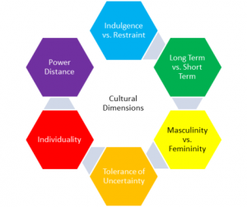

Figure 1.(CULCbulanppa, 2014)

In the Raspberry Pi trustees report (2016) was stated that the organization running ‘Code Club’ have over 4,000 clubs over 100 countries. (Raspberry Pi, 2018)As an example will be using Hosfede 6 comparison value dimensions to compare and analyze how different countries culture in UK and code club communities countries such as Australia, Brazil and Hong Kong. See Figure 2 below with the results. (Hofstede Insights, 2018)

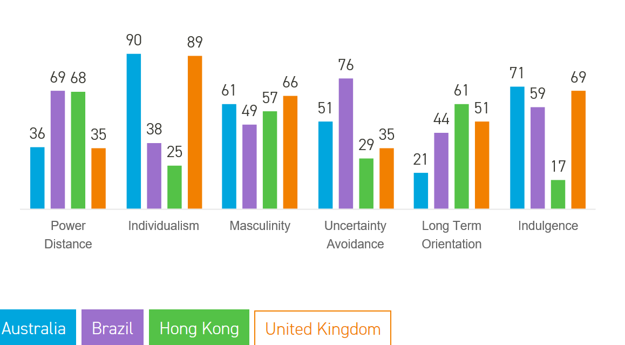

Figure 2.(Hofstede Insights, 2018)

Numbers in Figure 2 show that:
Power Distance dimension the highest number is in Brazil and the lowest United Kingdom. Brazil people believes that hierarchy must be respected and is acceptable differences between people which opposites in UK were people belief that all people should be treated equally.
Individualism dimension the highest number have Australia because of high individualist culture. Australian people expectations to look after themselves, which the lowest Hong Kong is collectivist culture. Hong Kong people performance is not necessary is of they self is more as the group.
Comparing masculinity clearly see that all countries have similar scoring that’s mean that all countries have masculine society which highly driven and very success orientated.
Uncertainty avoidance the highest score have Brazil as society have strong desire for rules to structure their life’s. Because of that Brazilian people very affectionate and passionate as in most people of Latin American societies. For Brazilian people is very important have day to day social life activities. Hong Kong in other hand is opposite people in Hong Kong are comfortable with uncertainty.
Long time orientation the highest score shows that Hong Kong’s culture is absolutely realistic. Hong Kong people believe that truth depends on situation, and time. They have willpower In order to achieve wanted results in life and have skills to adapt traditions with no trouble to changing any conditions. Australia scores very low on this dimension that show that country has a normative culture.in that type society’s people have a strong fear with founding the Truth. They respect traditions, focusing on achieving quick results and don’t have necessity to save for the future.
Indulgence Australia have the highest score in this dimension and that’s show that Australia is an Indulgent country. People in societies who have high score in indulgence usually are very optimistic and have positive attitude .Is very important for them have leisure life style ‘spend money as they wish and act as they please’.
Opposite Hong Kong’s on this dimension. Low score shown that Hong Kong people is more Controlled. People in Societies like that is very pessimistic and restrained. With a low score people in this dimension have a tendency to cynicism and pessimism and have the perception that indulging themselves is wrong and not acceptable by social norms. (Hofstede Insights, 2018)

4. The need of continuous improvements

Raspberry Pi foundation continuously improving and growing internationally in the past years and have many new projects which are successful, however continuous improvement to Raspberry Pi organization is important in order future successful growth of businesses. According to Perimutter (1997) this is main reasons organizations struggling to fine the place in globalize market:
- “unwillingness to update
- Inadequate products
- Vacillating products
- Sending the wrong people
- Selecting the wrong business partners
- Failure to manage stakeholders”.(Maund,2001)

Jolly (1997) recommended that all organizations which is already or going to become global should have certain specifics qualities which one of them is “internationalizing all functions such a research and development and human resources”. (Maund, 2001).Raspberry Pi Foundation HRM should address and put in place strategies in order know how to identify and introduce business abilities in a global organization.
According to Deloltte University press that: “a new model of “high-impact” HR blends globalized talent practices for consistency and mobility with localized flexibility to attract, retain, and manage people appropriately.” (Stephan et al., 2014)
Deloltte University press in 2014 survey which aim was to compare HR readiness between 20 talent practices show that putting into practice of global movement and career programs was more than 40procent lower than the average for all other HR practices and two out of three managers (70 percent) rate their company’s capability to deliver on this need as “weak”. (see Figure 3)
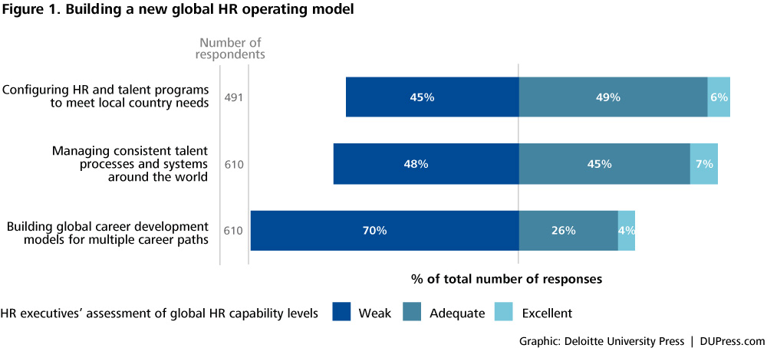

Figure 3.(Stephan et al., 2014)

Deloltte University press research suggested a clear starting improvement points, which can implement Raspberry Pi HRM:
Influence of global technology: Raspberry Pi I could implement new technologies in order to support the global HR organization and introduce new abilities to managers and employees.
Rationalize essential global services: Raspberry Pi HRM can Start implement new essential set of services. That way could learn from local business partners to control important practices in the field.
Encourage country initiatives within global processes: When Raspberry Pi organization international procedures, roles, and expectations are created company should try to expand the team and take in to account of communities of knowledge and let local HR leaders try to create, customize, and deliver local programs.
Create deep specialists: Create in Raspberry Pi HR specialists who be focused on recruiting, organizational development, employee relations and compensation.
Build HR “skill masters”: in order to have continuous improvement in the company Raspberry Pi should invest in training and developing HR team. (Stephan et al., 2014)
5. How to improve employee rewards and work-life balance

According to BusinessDictionary work-life balance is:
“A comfortable state of equilibrium achieved between an employee's primary priorities of their employment position and their private lifestyle. Most psychologists would agree that the demands of an employee's career should not overwhelm the individual's ability to enjoy a satisfying personal life outside of the business environment.”(BusinessDictionary.com, 2018)
There is no difference or company is in the nonprofit sector or private sector, the work-life balance is very important these present days. Caitlin Hotchkiss(2017) suggested ‘11 creative strategies to improve employee work-life balance’:
- “Provide flexible hours including seasonal hours
- Allow employees to work from home
- Less rigid lunch schedules
- Provide laptops and equipment to make working from anywhere possible
- Have a conducive office setup
- Encourage social activities
- Team-building exercises
- Workplace volunteering
- Allow for payroll giving
- Offer perks
- Have an open-door policy.” (Hotchkiss, 2017)
All these points could improve the employee work cycle, however Raspberry Pi organization IHRM before offer any rewards strategy should first take in consideration the differences of a social, cultural, gender, geographic and economic. What HRM approach fits to in one country employee doesn’t mean fits to all. Over all by creating new HR policies to improve Raspberry Pi employees work -balance Company in return will get highly engaged, motivated and dedicated employee.

Conclusion

Analyzing provided information above could clearly see that International HRM have very important role in changing and developing at increasing diverse in the international workforce. Business facing challenges such as globalization, new innovations and technological changes, which could affect negatively business if not implement right IHRM strategies. In order to maintain increasing diverse at work place HRM should analyze culture and cultural and environmental diversity in countries working with. That’s give very clear understanding of countries values and what HMR strategies can implement in order to achieve companies goals. Is crucial need that HRM been involved and focuses on continuous improvement because of fast changing globalization, political and environmental changes. Constantly analyzing and improving IHRM strategies would increase international business success. Findings above show that is very important for HR management to keep the work-life balance of employees. There is many suggestions how to reward employees in order to improve their work cycle, which can be very beneficial for the company success, however as mention above HRM should first research and take in consideration cultural differences to ensure that they offer right type of reward strategy. Overall this research show that HRM should be involve in every aspect of changing and developing role of Raspberries Pi organization to expand and increase international profile.

Bibliography

Anon, (2017). Annual review 2017. [online] Available at: https://static.raspberrypi.org/files/about/RaspberryPiFoundationReview2017.pdf [Accessed 30 Apr. 2018].

Armstrong, M. (2006). A handbook of human resource management practice. London: Kogan Page.

Bradley, D. (2014). Continuous improvement necessary for business. [online] Scotsman.com. Available at: https://www.scotsman.com/news/opinion/continuous-improvement-necessary-for-business-1-3271776 [Accessed 30 Apr. 2018].

Bradley, J. (2018). What Are the Five Main Functions of Global Human Resource Management?. [online] Smallbusiness.chron.com. Available at: http://smallbusiness.chron.com/five-main-functions-global-human-resource-management-61538.html [Accessed 30 Apr. 2018].

BusinessDictionary.com. (2018). What is work-life balance? definition and meaning. [online] Available at: http://www.businessdictionary.com/definition/work-life-balance.html [Accessed 30 Apr. 2018].

BusinessDictionary.com. (2018). Do you know this term?. [online] Available at: http://www.businessdictionary.com/definition/work-life-balancehtml. [Accessed 30 Apr. 2018].

CULCbulanppa. (2014). Let’s Dive in Diversity. [online] Available at: https://culcbulanppa.wordpress.com/2014/06/15/lets-dive-in-diversity/ [Accessed 28 Apr. 2018].

de Waal, A. and Chipeta, K. (2018). The relation between Hofstede’s cultural dimensions and the HPO Framework. [online] HPO Center. Available at: https://www.hpocenter.com/scientific-studie/the-relation-between-hofstedes-cultural-dimensions-and-the-hpo-framework/ [Accessed 30 Apr. 2018].

Ghosh, S. (2017). The creator of a super successful £27 computer said Brexit has been 'rocket fuel' for his business — but also a 'mixed bag'. [online] Business Insider. Available at: http://uk.businessinsider.com/eben-upton-raspberry-pi-interview-2017-6 [Accessed 28 Apr. 2018].

Higginbottom, K. (2016). Forbes Welcome. [online] Forbes.com. Available at: https://www.forbes.com/sites/karenhigginbottom/2016/12/28/challenges-facing-hr-directors-of-global-firms-in-2017/#4df7e8de4f95 [Accessed 28 Apr. 2018].

Hofstede Insights. (2018). Country Comparison - Hofstede Insights. [online] Available at: https://www.hofstede-insights.com/country-comparison/australia,brazil,hong-kong,the-uk/ [Accessed 28 Apr. 2018].

Hofstede Insights. (2018). National Culture - Hofstede Insights. [online] Available at: https://www.hofstede-insights.com/models/national-culture/ [Accessed 30 Apr. 2018].
Hotchkiss, C. (2017). 11 creative strategies to improve employee work-life balance. [online] FrontStream. Available at: https://www.frontstream.com/work-life-balance-strategies/ [Accessed 30 Apr. 2018].
https://ac.els-cdn.com/S1877042816311119/1-s2.0-S1877042816311119-main.pdf?_tid=d331729f-1b9b-4ebc-b791-6afd3f072e3b&acdnat=1524924857_f8d8f2e4c63ca34f25dfcb0ef493802c
Lindblad, M. (2018). List of the Five Dimensions of Culture & How Each Affect Employee Behavior. [online] Smallbusiness.chron.com. Available at: http://smallbusiness.chron.com/list-five-dimensions-culture-affect-employee-behavior-24161.html [Accessed 30 Apr. 2018].

Maund, L. (2001). An introduction to human resource management. New York: Palgrave Macmillan.

Perkins, S. and Shortland, S. (2006). Strategic international human resource management. 2nd ed. London: Kogan Page, pp.59,60,61,62.

Raspberry Pi. (2018). Code Club - Raspberry Pi. [online] Available at: https://www.raspberrypi.org/education/programmes/code-club/ [Accessed 30 Apr. 2018].

Raspberry Pi. (2018). The Code Club International movement - Raspberry Pi. [online] Available at: https://www.raspberrypi.org/blog/code-club-international/ [Accessed 30 Apr. 2018].

Stephan, M., Walsh, B., Vahdat, H. and Walkinshaw, H. (2014). The global and local HR function. [online] Deloitte Insights. Available at: https://www2.deloitte.com/insights/us/en/focus/human-capital-trends/2014/hc-trends-2014-global-and-local-hr.html [Accessed 30 Apr. 2018].

Stephan, M., Walsh, B., Vahdat, H. and Walkinshaw, H. (2014). The global and local HR function. [online] Deloitte Insights. Available at: https://www2.deloitte.com/insights/us/en/focus/human-capital-trends/2014/hc-trends-2014-global-and-local-hr.html [Accessed 30 Apr. 2018].

