Written Report on IHG

Matthew Childs

2128038

Management and Organisational Behaviour

BMIH5004

Charlotte Joyner

Word Count: 2021

Executive Summary

The following report evaluates the International Hotel Group in relation to theories such as Porter's 5 Forces and the Boston Matrix. With a high market share within the hotel industry it is important that IHG remains competitive and aware of any opportunities or threats that arise during operations. With expansion in China it is clear the level of growth possible from spotting trends and entering new markets.

Contents Table

- Introduction
- Boston Matrix for IHG
- Expansion in China
- Competitors in the Market
- IHG Organisational Structure and Culture
- Schein’s Layered Conceptualisation of Culture and Handys Culture Model
- Porter's 5 Forces
- Recommendations
- Conclusion
- Reference List

Introduction

IHG (International Hotel Group) operates 6,363 hotels globally in over 100 countries, employing 345,000 staff members. With 17 brands operated by IHG from luxury of Six Senses and Kimpton to essential brands such as Holiday Inn and Candlewood Suites. IHG boasts a market share of 6.48% as of Q4 2022 with an increase from 5.04% in Q3 of 2022. With an approximate market share of 15.83% in 2024, CSI Market (2024), significant growth has been accounted for with increased locations and investments in new markets such as in Greater China. IHG is a PLC (public limited company) which sells shares via the Stock Market.

Boston Matrix for IHG

The Boston Matrix allows businesses to assess and analyse the numerous brands within their portfolio, assessing brands based on market share and market growth. With IHG having very different brands across their portfolio from six senses to candlewood suites, IHG (2024), it is important to utilise Bostons Matrix in order to monitor success and intervention needed for each brand. Below is a completed boston matrix based on IHG’s brands.
Question Mark  Six Senses  Kempton | Star  Intercontinental  Crowne Plaza
Dog  Even  Voco | Cash Cow  Holiday Inn  Holiday Inn Express

A Star (Intercontinental and Crowne Plaza) has both high market share and high market growth, constantly increasing and providing a stable income for IHG with two of the most recognised brands within their portfolio. Question Mark has high market growth but low market share where Six Senses and Kempton are exclusive hotels and do not saturate the market but provide a solid income for IHG offering a luxury service to visitors of the hotels.

A Cash Cow has high market share but low market growth, these such as Holiday Inn offer a ‘know what to expect’ type approach where quality remains the same in every location and with such a high regarded reputation it is unnecessary for IHG to spend time advertising these when they can keep a high market share without the need for growth. However as new competitors enter the market IHG should be sure to remain competitive and assess the situation for any requirements for change of market positioning. Finally, a Dog is a brand that has low market share and low market growth, these are often seen as time and resource consuming however there are chances to leave this section and become more successful with expansion into new continents for example, with 87 openings in 2023 within Greater China, their fastest growing market. IHG Developments (2024). Showing huge opportunities for declining brands to rejuvenate in a whole new market.

Using Boston's Matrix poses limitations regarding real life use due to the data not available on how each individual hotel is performing therefore the above matrix is based on the data available and reputations of each hotel. In order to critically evaluate the performance of each individual hotel multiple sources of financial data would be required on an individual basis as opposed to a group as a whole.

Expansion in China

As mentioned above IHG took a huge step in 2023 to saturate the Greater China market by introducing 87 new openings and now announcing 134 signings for new properties within China. IHG have recognised the growth of industry and tourism within China and successfully entered the market with numerous different brands from high end luxury of Six Senses to the basic Holiday Inn providing visitors with recognisable brands for their stay. IHG also opened a whole new brand solely focussed on the china market with Hualuxe based only in Greater China, as of December 2023, IHG owned and operated 20 Hualuxe hotels in Greater China mainly marketed towards business clients offering extensive meeting rooms and superfast wifi, IHG (2024).
In 2023, it was reported that IHG’s REVPAR increased by 94% year on year. Thisismoney (2023). This concludes how successful investments in China have become with revenue almost doubling from 2022 suggesting the ever-growing market in China, in comparison to the Americas where REVPAR increased by 11%. This suggests that IHG made the correct business choice in investing in China primarily with almost 180,000 rooms across China.

Competitors in the Market

The Hotel Market is highly competitive with over 1200 hotel brands worldwide. IHG have a large share of the market due to their highly regarded reputation across their 17 brands however they must remain competitive in order to be a guests first and only choice. IHG operates a loyalty scheme across all their 6,363 hotels named IHG Rewards, IHG (2024). The methods of loyalty schemes are a fantastic initiative by hotel brands in order to create brand loyalty from customers where guests tend to not mind paying that little bit extra once they are loyal to a brand.

One of IHG’s largest competitors is Hyatt Group, which operates 28 brands across 70 countries, Hyatt Group (2024). Hyatt is also following the trend of increasing capacity in Greater China with 50 hotels already open and opening soon. With both hotel groups entering the China market more vigorously it is important that IHG remain competitive offering discounted rates for example during opening year or offering room upgrades for example in order to capitalise on the market and increase brand loyalty in China.

IHG Organisational Structure and Culture

IHG is operated by a Board, they claim “The Board is responsible for ensuring leadership through effective oversight and review of the Group's activities. Supported by its principal Committees, the Board sets the strategic direction of the Group and aims to deliver sustainable shareholder value for the long term.” IHG Leadership (2024).

With IHG being a multinational hotel chain with 17 brands the Board of Directors make any major decisions such as expansion into China, with all stakeholders in mind, however mainly shareholders as IHG operates as a PLC therefore a main focus is to increase share price thus increasing company value. However operating a tall hierarchical structure poses both positives and negatives. There is often a clear route of hierarchy where each department will have a specialised supervisor/manager who answers to their own manager who will eventually after a long line of superiors answer to the Board and CEO. However this creates the negative factors of an extremely long chain of command due to the scale of the business, one individual housekeeper within a hotel has a very long chain of command with department manager, hotel manager, regional manager, brand manager then board of directors plus the possibility of more. This creates the issue of a time lag with any commands being passed down and also complaints or queries reaching the board.

There are positives to operating a hierarchical structure over a flat structure for example each member of staff has a clear leader to report to which will take the necessary steps to communicate/ escalate any potential issues. A flat structure would likely see productivity fall as staff fall under the radar with no specialised manager for their department. A Matrix organisational structure may also be operated within IHG where teams report to multiple leaders within the group. This benefits from increased expertise and communication as well as increased support on making informed decisions however there can be potential conflict this way and create confusion with staff as to who they are expected to report to.

Below shows the hierarchical structure within IHG with the board of directors and their subordinates:
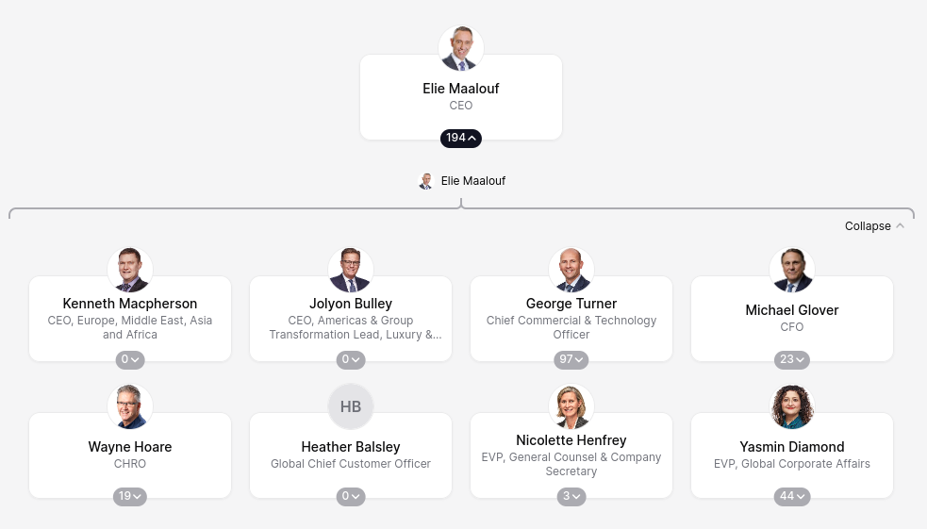
ORG Chart (2024)

Schein’s Layered Conceptualisation of Culture and Handy’s Culture Model

Schein’s model emphasises three layers - “artefacts and behaviours, espoused values, and basic underlying assumptions. Artefacts and behaviours represent the visible aspects of culture, while espoused values are the stated beliefs and ‘norms’. Basic underlying assumptions are deeply ingrained beliefs that shape behaviour”, Think Insights (2024).

In relation to IHG, it is important to use different levels of culture in respect of the large number of nationalities and religions and all levels of ability working across one multinational network. Therefore basic assumptions are that each member of staff is treated equally regardless of geographic location across the group and by introducing a strong level of culture the business is likely to strive by the positive impressions created passed on to guests in a way of happy staff.

Handy (1987) introduced the thought of ‘the way things are done around here’ which emphasises where a business has a low level of culture so employees become custom to a particular way, this culture creates copies of the same employee multiplied where change doesn't occur as the same task is always done the same way. This is often created by lazy and un-inspirational management which creates employees who do not take care or effort in changing how things are done, this causing resistance to change over time.

Porter's 5 Forces

Porter's 5 forces is a tool used to analyse the business environment and threat of competition. As IHG operates in the hotel industry there are numerous barriers to entry, the predominant one being cost. For a new brand to enter the market it would cost millions and become very difficult to compete against the likes of IHG and Hyatt who have a large market share and years of brand loyalty. However new businesses do enter the hotel market and inevitably gain market share as a result of this so IHG must remain aware and competitive with new entrants.

As IHG is multinational and secure in its market position it has high buying powers with suppliers due to the scale of products required bought in large quantities to cover all hotels, a new hotel would struggle to compete on price and profitability due to low buying powers compared to the likes of IHG.

Recommendations

As IHG is a multinational group operating in over 100 countries it is essential that the organisational structure is clear with routes of communications and chain of command shortened, with this in mind it may be an option to have an individual manager assigned to a certain team who directly communicates with senior management but also have a senior management meeting with each team quarterly in order to successfully assess where productivity and morale can be increased. #

With ever-changing trends through social media and personal changes IHG must continue to monitor these trends and take action on entering new markets such as where marriott introduced MOXY hotels. Backpacking is a highly popular tourist choice with South America and Australia being predominant choices. The average age of backpackers is 24, where most are looking for basic and cheap accommodation due to low incomes while abroad. Therefore for the IHG group to target the 10.3 million backpackers in 2021 (compared to 6.6million in 2007) showing a rising trend for backpacking holidays. They should introduce a hostel type hotel within the Australian market offering basic but comfortable and affordable facilities. With the average backpacker being aged 24, this can create brand loyalty for years to come if IHG markets these hostels correctly.

IHG group offers several All inclusive hotels however the vast majority of these are in the Caribbean and South America. With Statistica (2024) reporting that 15% of brits booked an all inclusive holiday in 2022 there is a large section of the market which IHG may be missing out on, holidays from the UK are often within Europe in the likes of Spain, France and Portugal, therefore investing in the European All inclusive market is likely to increase bookings and market share.

Conclusion

In conclusion, IHG has a large market share within a largely competitive market. In order to remain competitive the board must continue to monitor the global market and patterns in order to attract a higher number of guests and loyal customers through the use of their loyalty scheme as well as monitoring trends such as social media trends in order to attract the younger generation and create brand loyalty early. As new patterns emerge such as working remotely during covid, which has become more and more popular in previous years IHG must continue to work on management and organisational structures to ensure they are achieving targets and maximum productivity.

Reference List

Cloudbeds (2024) Hotel Brands Worldwide. Available at: https://www.cloudbeds.com/hotel-business/brands/#:~:text=Hotel%20brands%3A%20Who%20owns%20who%20in%202023&text=It%20wasn't%20long%20ago,brands%20worldwide%2C%20according%20to%20STR. (Accessed: 26 February 2024)

CSI Market (2024) IHG Market Share. Available at: https://csimarket.com/stocks/compet_glance.php?code=IHG (Accessed: 26 February 2024)

CSI Market (2024) IHG 2022 Performance. Available at: https://csimarket.com/stocks/competitionSEG2.php?code=IHG (Accessed: 26 February 2024)

Dälken, F., 2014. Are porter’s five competitive forces still applicable? a critical examination concerning the relevance for today’s business (Bachelor's thesis, University of Twente).

Dream Big Travel Far Blog (2024) Backpackers Statistics. Available at: https://www.dreambigtravelfarblog.com/blog/backpacking-statistics#:~:text=Ever%20wondered%20how%20many%20backpackers,becoming%20more%20popular%20than%20ever. (Accessed: 26 february 2024)

Hualuxe Hotels (2024) Greater China Developments. Available at: https://development.ihg.com/hotel-brands/hualuxe-hotels-and-resorts (Accessed: 26 February 2024)

Hotel Tech report (2022) IHG. Available at: https://hoteltechreport.com/news/ihg-hotel-brands#:~:text=IHG%20brand%20portfolio%20breakdown,about%20this%20portfolio%20of%20brands. (Accessed: 26 February 2024)

Hyatt Group (2024) About Us. Available at: https://about.hyatt.com/en.html (Accessed: 26 February 2024)

Hyatt Group (2024) China Developments. Available at: https://www.hyatt.com/promo/china-hotels (Accessed: 26 February 2024)

IHG (2024) About Us. Available at: https://www.ihgplc.com/about-us (Accessed: 26 February 2024)

IHG Developments (2024) New Developments. Available at: https://development.ihg.com/regions/greater-china (Accessed: 26 February 2024)

IHG Leadership (2024) Our Board. Available at: https://www.ihgplc.com/about-us/our-leadership/our-board (Accessed: 26 February 2024)

IHG (2024) Our Brands. Available at: https://www.ihgplc.com/en/our-brands (Accessed: 26 February 2024)

Mind Tools (2024) Handys Four types of Culture. Available at: https://www.mindtools.com/ass7geb/handys-four-types-of-culture (Accessed: 26 february 2024)

ORG Chart (2024) IHG Heierachial Structure. Available at: https://theorg.com/org/ihg (Accessed: 26 February 2024)

Mind Tools (2024) Porters 5 Forces. Available at: https://www.mindtools.com/at7k8my/porter-s-five-forces (Accessed: 26 February 2024)

Statistica (2024) All-Inclusive Holidays Statistics. Available at: https://www.statista.com/statistics/934103/uk-united-kingdom-all-inclusive-holiday-trend/#:~:text=An%20annual%20survey%20conducted%20among,booked%20an%20all%2Dinclusive%20vacation. (Accessed: 26 February 2024)

Statistica (2024) China Hotel Market. Available at: https://www.statista.com/statistics/1175779/china-market-size-of-hotel-industry/ (Accessed: 26 February 2024)

Tajeddini, K., 2014. The effect of organisational structure and hoteliers’ risk proclivity on innovativeness. Asia-Pacific Journal of Management Research and Innovation, 10(1), pp.1-12.

Thisismoney (2023) Greater China Revenues Soar. Available at: https://www.thisismoney.co.uk/money/markets/article-12383981/IHG-revenues-soar-China-sales-double.html (Accessed: 26 February 2024)

Tutor2U (2022) Boston Matrix Model. Available at: https://www.tutor2u.net/business/reference/boston-matrix-and-product-portfolios#:~:text=The%20Boston%20Matrix%20is%20a,a%20problem%20for%20a%20business. (Accessed: 26 February 2024)

Youtube (2024) Handy’s organisational Culture Explained. Available at: https://www.youtube.com/watch?v=0g201MaiN3k (Accessed: 26 February 2024)

Zhang, H.Q., Guillet, B.D. and Gao, W., 2012. What determines multinational hotel groups’ locational investment choice in China?. International Journal of Hospitality Management, 31(2), pp.350-359.

