Ioan Davies
2115169
ACMA6010
Written Assessment
Designing a race car rear wing: structural design assessment
Structural & Fluid Analysis

Table of Contents
Introduction 2
FEA Optimisation Techniques 2
Rear Wing Baseline Model 4
Optimising Rear Wing Structure 5
Optimise for Manufacture 8
Deformation Prototype Testing 10
Conclusion 12
Bibliography 13

Introduction
This report uses a model of a race car Rear Wing and analyses it using FEA software Genesis Design Studio. The Rear Wing model was optimised with a CFRP structure in Design Studio to meet the technical regulations of the (Fédération Internationale de l'Automobile, 2022) which influenced the optimisation constraints and objective. The optimisation was also refined to ensure that the Rear Wing can be manufactured using 0.1mm plies, implementing discrete design variables. The report also discusses potential physical testing methods to determine the maximum deflection of the Rear Wing using a prototype tool.

FEA Optimisation Techniques
Finite Element Analysis also known as FEA has emerged as a tool that can be used to optimise the design of components and processes. With the intention of designing right first time with minimal design stages and test cycles. (SDC Verifier, 2023) describes optimisation as a function of FEA that allows the most cost-effective structural model to be developed. By defining the best possible design which uses the minimal material quantity, with minimal stress concentrations for a desirable performance.

There are two main approaches to optimisation, parametric and non-parametric. In a Parametric method the structural model is represented using a set number of parameters and their associated boundary values. Therefore, the natural shape can be automatically detected by the software such as the dimensions in a 3D CAD model (Mcdowell, et al., 2010). Non-parametric methods use a defined outer boundary of the structure’s geometry, in which the optimisation process either removes mass without effecting the mesh node location (topology optimisation) or directly manipulates it (shape optimisation) to achieve a desired objective (Hahn & Cofer, 2014).

One common FEA optimisation technique is topology optimisation. This is a mathematical method that spatially optimises the distribution of material within the domain (Rosinha, et al., 2015). The software uses given constraints and minimises a predefined cost function to optimise a structure defining major load paths in the early conceptual design phase. As explained by (Sigmund & Bendsoe, 2004) topology optimisation improves the design process as constraints and performance expectations are factored early in the concept stage reducing the time required to produce a final design. This is because the CAD concept design is entirely based on the topology optimisation results which is based on a CAE model.

Another FEA optimisation technique is shape optimisation. This technique modifies an existing structural design geometry to optimise the shapes performance for given constraints and applied loads (Allaire, et al., 2021). This is most useful when a current structural design exists with some critical features that cannot be adjusted but has other boundaries that can be optimised. Shape optimisation is used to maximise part stiffness and generate a 3D mesh that can guide structural refinement during the design process, according to (AutoDesk, 2023). For example, a beam with circular holes undergoes loading then shape optimisation could be used to optimise the holes geometry to withstand loading in the best possible way and distribute stress more evenly.

In addition, there is topography optimisation. This is an advanced form of shape optimisation in which a specific design region is defined for the part in which shape variable-based reinforcements can be generated (Altair Engineering, 2023). Topography optimisation is commonly applied to thin-walled structures and shells to optimise their reinforcement using beads and swages within the design region.

Size optimisation is another optimisation technique that is widely used once the major load paths have been established (topology optimisation). This technique is used to find optimal solutions for the size of specific features such as cross-sectional thicknesses or the thickness distribution of a shell (Ponginan, 2021). As discussed by (Gerzen, et al., 2016) implementing size optimisation into the design process after a topology study a structures optimal size can be identified using the major load paths. This significantly speeds up the design process and removes the need of developing CAD models from scratch and without relying on knowledge and engineering judgement.

Composite optimisation is another FEA optimisation technique that has been used practically in this report. Composite structures are predominately made of thin plies stacked in layers that are in a different orientation to the previous, also known as a laminated structure (Wang, et al., 2019). Composite optimisation is used to identify the optimal material distribution in terms of orientation and thickness using free-size optimisation where thickness of the plies and fibre direction changes depending on the force applied as explained by (Zhou, et al., 2023). The thickness contour of each fibre orientation can then be obtained.

Historically optimisation was carried out by producing CAD models building tools and then physically testing the parts. Design improvements would be made following test results and new CAD design developed followed by tooling manufacture and physical testing. This process was repeated until the initial design was optimised. With the introduction of CAE software optimisation techniques were implemented in the product lifecycle after an original design had been produced in CAD. The design was then assessed in CAE software and improvements to the structure were made accordingly using CAD. This process would continue until a more robust design was developed. However, as CAE software has advanced an original design can be produced in CAE software and then assessed and optimised using CAE software. A CAD model can then be produced from the basic CAE geometry and assessed again using CAE software before building tools and then testing prototypes physically.

As stated by (Cunningham, 2015) optimisation led design allows you to test designs in a virtual environment and determine the optimal configuration, rather than addressing performance failures in prototype testing and then reverting to the CAD design stage. This helps to save time and money without sacrificing quality throughout the design process. This is because building and testing physical prototypes can be very expensive and time consuming with high manual effort. Optimisation led design reduces the need for multiple prototypes with all optimisation and testing mainly conducted in a virtual environment.

Currently there are restraints in performing high accuracy simulations when optimising designs as due to a lack of computing power simplifications to problems must be made and therefore, reduce accuracy. (BosonQ Psi, 2022) suggests that future development of Quantum computers will overcome this issue and allow optimisations to run with multiple variables and constraints within the entire design space, very quickly and using minimal computing resources. This will allow complex engineering problems to be solved with highly efficient designs at low cost and significantly reducing design times.

Rear Wing Baseline Model
Following research conducted into race car rear wings it is common for organisations to implement restrcitions to the flexibility of rear wings. A large rear wing generates a lot of downforce with the negative effect of producing drag, which reduces the race cars top speed and acceleration. Therefore, the wing design must be balanced correctly to generate optimum downforce with minimal drag. However, if the material of the wing allows for some flex, the downforce at high speeds will rotate the wing so that the planes are flattened against the airflow, lowering the angle of attack, and reducing drag as the car accelerates. As the car slows down into corners the wing will move back to its original position, increasing drag and downforce as explained by (Somerfield, 2021).

To prevent any advantage gained by flexible rear wings the FIA has implemented load test requirements on the rear wings of Formula One cars in its technical regulations. (Fédération Internationale de l'Automobile, 2022) states that “The rear wing mainplane may not deflect more than 6mm along the loading axis and 1.0° in a Y-plane, when two loads of [0, 0, -1000]N each, applied simultaneously to the rear wing profiles”. Therefore, a total load of 2000N in the Z axis direction uniformly distributed was applied across all nodes onto the rear wing.

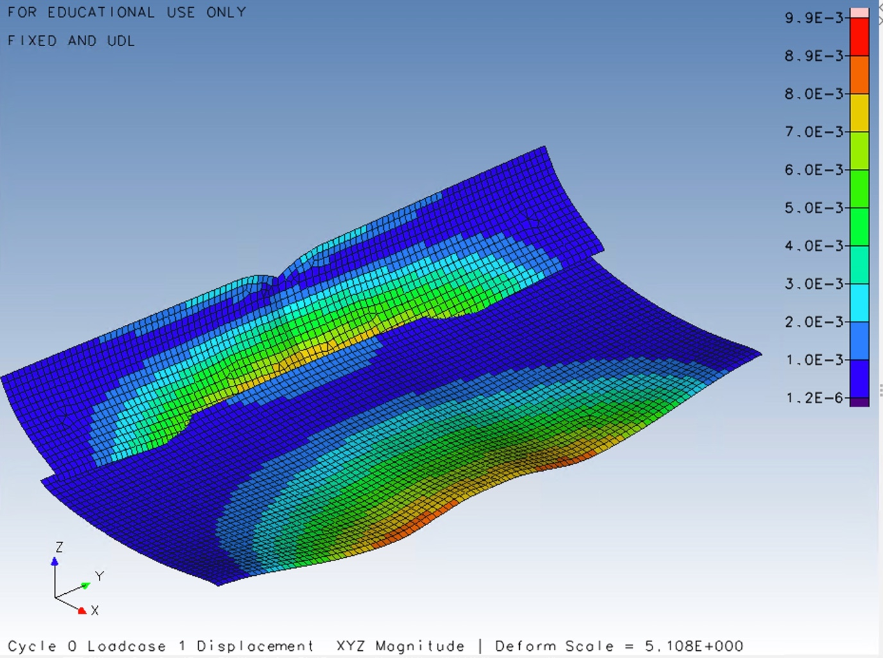
Figure 1: Post analysis deformation colour mesh of the baseline rear wing.

The model in Figure 1 was created in design studio FEA software as a CFRP composite structure with the material properties and plies laid up as specified in the assignment brief. The zero degrees vector direction runs ‘fore to aft’ across the length of the rear wing. A static UDL load of 2000N was applied to the rear wing in the Z axis as specified by the (Fédération Internationale de l'Automobile, 2022) technical regulations. A simulation was run to determine the displacement (deflection) of the rear wing under the specified load. The post analysis results show a maximum displacement of 9.9mm, which can be seen in Figure 1. The key on the right of Figure 1 is displayed in SI unit of metres and reference the colour mesh on the model which help visualise the areas of higher displacement, which as expected is towards the centre of the rear wing.

The stiffness to weight ratio for the baseline CFRP rear wing can be calculated as follows:

$$MASS=1.8829kg$$
FORCE = 2000N
DISPLACEMENT = 9.9mm

$$K= \frac{F}{x}= \frac{2000}{9.9}=202 N/mm$$

$$\frac{STIFNESS}{WEIGHT}= \frac{202}{1.8829 × 9.81}=10.94 N^{2}/mm$$

Optimising Rear Wing Structure
To meet the technical regulations specified by (Fédération Internationale de l'Automobile, 2022) the rear wing displacement must not exceed 6mm of displacement when 2000N load is applied. Therefore, the rear wing will be optimised to limit displacement to a maximum of 6mm while minimising the mass to reduce weight. To optimise the rear wing using Design Studio software design variables, constraints and objectives must be determined. The design variables shown in Table 1, sets the thickness of each layer between 0.1mm (1 ply) and 2mm and are orientated the same as the baseline. The design objective was set as minimal mass, and the constraint was set with a maximum displacement of 6mm.

Variable Name | Initial Value | Lower Bound | Upper Bound
Thickness of Layer 1 | 0.5mm | 0.1mm | 2mm
Thickness of Layer 2 | 0.5mm | 0.1mm | 2mm
Thickness of Layer 3 | 0.5mm | 0.1mm | 2mm
Thickness of Layer 4 | 0.5mm | 0.1mm | 2mm
Thickness of Layer 5 | 0.5mm | 0.1mm | 2mm
Table 1: Optimisation variable for thickness of each CFRP layer.
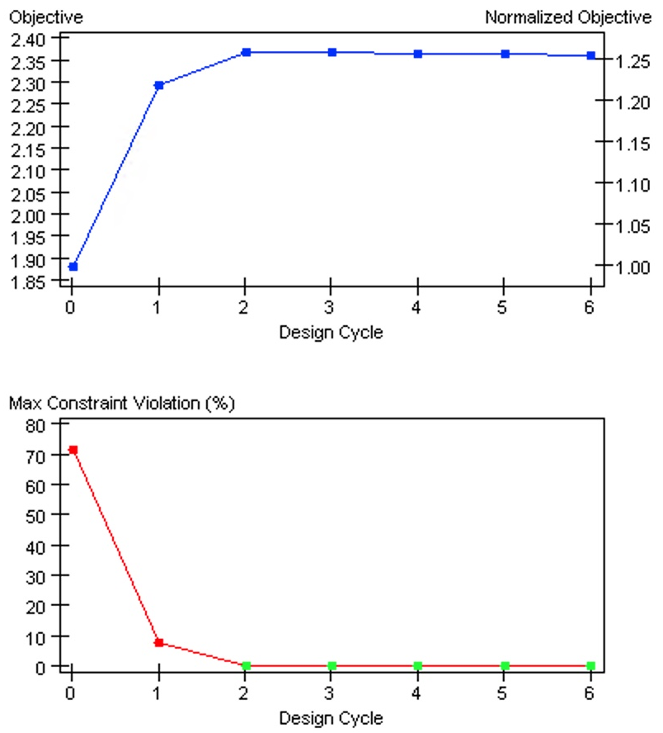

Figure 2: Optimisation design cycle graphs for both objective and constraint.

In Figure 2 at design cycle 0 (baseline) the constraint is being violated by over 70% however, by design cycle 2 there is no violation and therefore, the displacement constraint of a maximum of 6mm has been achieved. By analysing the objective results in Figure 2 the mass was initially 1.88kg at cycle 0 and by cycle 6 it has increased to 2.36kg.
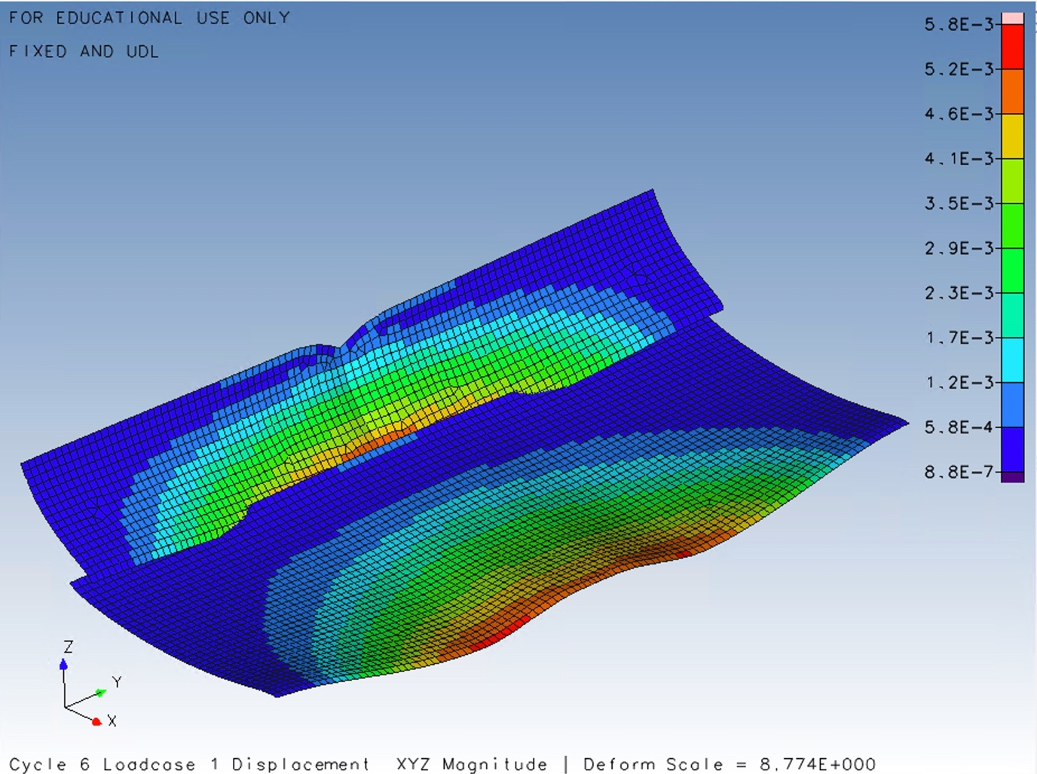
Figure 3: Post analysis deformation colour mesh of the optimised rear wing.

The post optimisation analysis results show a maximum displacement of 5.8mm, which can be seen in Figure 1. The key on the right of Figure 1 is displayed in SI unit of metres and reference the colour mesh on the model which help visualise the areas of the higher displacement. Therefore, design studio has increased the thickness of each layer orientation (with exception to layer 5) to meet the displacement constraint target while minimising the mass.

The stiffness to weight ratio for the optimised CFRP rear wing can be calculated as follows:

$$MASS=2.3625kg$$
FORCE = 2000N
DISPLACEMENT = 5.8mm

$$K= \frac{F}{x}= \frac{2000}{5.8}=344.83 N/mm$$

$$\frac{STIFNESS}{WEIGHT}= \frac{344.83}{2.3625× 9.81}=14.88 N^{2}/mm$$

Following this calculation and comparing the stiffness to weight ratio with the baseline rear wing, the optimised rear wing has increased in mass but has an improved stiffness to weight ratio due to the reduction in displacement.
Design Variable | Value (Thickness) | Number of Plies and Orientation
Layer 1 | 0.62mm | 6.2 at -90 degrees
Layer 2 | 0.66mm | 6.6 at -45 degrees
Layer 3 | 0.69mm | 6.9 at 0
Layer 4 | 0.68mm | 6.8 at 45 degrees
Layer 5 | 0.49mm | 4.9 at 90 degrees
Table 2: Optimised rear wing CFRP layer thickness values from Design Studio history file.

However, it is also important to analyse the manufacturability of the rear wing. Currently it would not be possible to manufacture the rear wing with layer thickness specified from the optimisation. Each layer thickness and the number of plies required can be found in Table 2. This is because the thickness of 1 ply is 0.1mm and therefore, discrete values in increments of 0.1mm must be used to ensure the rear wing is manufacturable.

Optimise for Manufacture
To optimise the rear wing composite structure to be manufacturable the design variables must be defined as discrete values. Discrete design variable values were added from a minimal thickness of 0.1mm (1 ply) to a maximum of 2mm in increments of 0.1mm. The optimisation could then be run again using the same constraint and objective previously defined to obtain a rear wing CFRP layup that is manufacturable using 0.1mm plies.
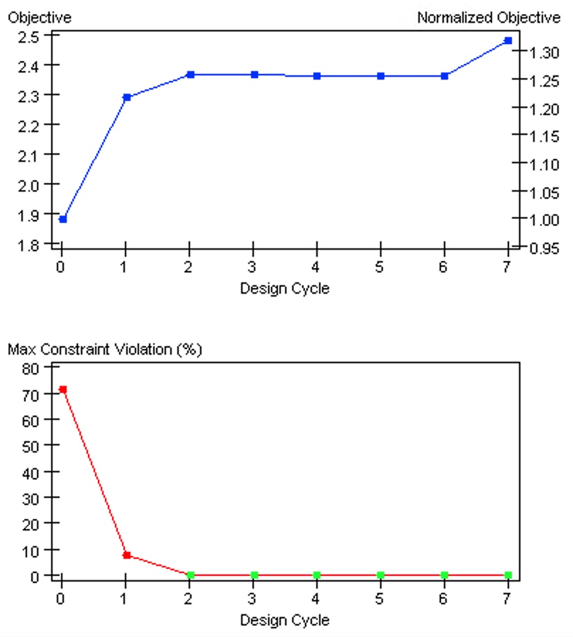

Figure 4: Optimisation for manufacture design cycle graphs for both objective and constraint.
In Figure 4 at design cycle 0 (baseline) the constraint is being violated by over 70% however, by design cycle 2 there is no violation and therefore, the displacement constraint of a maximum of 6mm has been achieved. By analysing the objective results in Figure 2 the mass was initially 1.88kg at cycle 0 and by cycle 6 it has increased to 2.49kg.

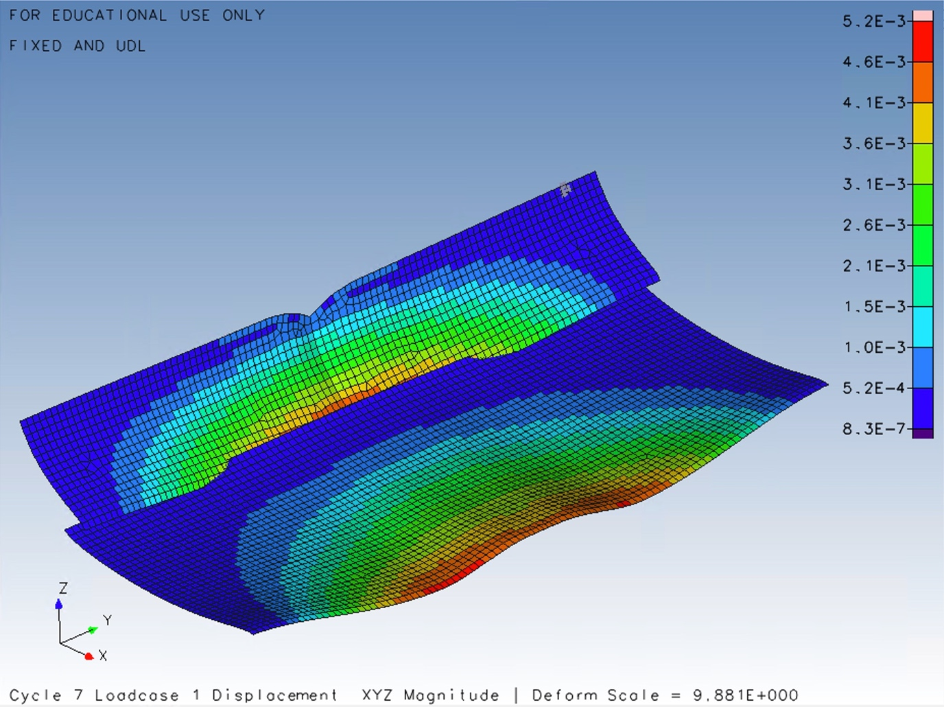
Figure 5: Post analysis deformation colour mesh of the optimised rear wing for manufacture.

The post optimisation analysis results show a maximum displacement of 5.2mm, which can be seen in Figure 1. The key on the right of Figure 1 is displayed in SI unit of metres and reference the colour mesh on the model which help visualise the areas of the higher displacement. Therefore, the rear wing is now stiffer than previous optimisation resulting in less displacement with an increase in mass to accommodate the discrete value ply thickness.

The stiffness to weight ratio for the optimised CFRP rear wing for manufacture can be calculated as follows:

$$MASS=2.4855kg$$
FORCE = 2000N
DISPLACEMENT = 5.2mm

$$K= \frac{F}{x}= \frac{2000}{5.8}=384.615 N/mm$$

$$\frac{STIFNESS}{WEIGHT}= \frac{384.615}{2.4855× 9.81}=15.77 N^{2}/mm$$

Following this calculation and comparing the stiffness to weight ratio with the optimised rear wing, the discrete design variable values has increased the mass but has also slightly improved stiffness to weight ratio due to the reduced displacement.

Design Variable | Value (Thickness) | Number of Plies and Orientation
Layer 1 | 0.7mm | 7 at -90 degrees
Layer 2 | 0.7mm | 7 at -45 degrees
Layer 3 | 0.7mm | 7 at 0
Layer 4 | 0.7mm | 7 at 45 degrees
Layer 5 | 0.5mm | 5 at 90 degrees
Table 3: Optimised for manufacture CFRP layer thickness values from Design Studio history file.

From Table 3 the thickness values of the optimised rear wing with discrete design variable values ensure that each layer can be manufactured using the required number of plies.

Deformation Prototype Testing
To perform a suitable deformation test of a prototype rear wing it is recommended that the flexibility test of the (Fédération Internationale de l'Automobile, 2022) technical requirements to be used. This testing procedure involves applying two loads of 1000N each simultaneously to the rear wing profile in the Z axis direction. According to (Fédération Internationale de l'Automobile, 2022) the loads are to be applied through adaptors that lie between “250mm and 350mm from Y=0”. The adapter would be designed to grip the rear wing at the specific location and then be used to apply the load.

The load could be applied using hydraulic actuators to push down in the negative z axis direction at the required load. One actuator would be placed at the two locations of the rear wing adapter. Sensor pads would be applied to the wings surface at a fixed location in which the magnitude of deflection can be measured. The feedback from these sensors can then be visualised using a computer to monitor the force and deflection which can be plotted onto a graph automatically. The hydraulic actuator could be used in a push or pull motion depending on the orientation and method it was secured to the rear wing. However, pushing down on the rear wing would be the preferable option. Once the maximum load of 2000N is applied the deflection value at this point can be recorded as the maximum. This can then be compared with the simulation optimisation results for maximum deflection.

As suggested by (Boom Supersonic, 2020) once the wing is restrained by a steel fixture at its ends an array of hydraulic actuators can be used to simulate maximum forces that the wing’s structure may experience, using sensors to monitor the magnitude of deflection as shown in Figure 6. (Boom Supersonic, 2020) also suggests that it Is important to conduct the testing incrementally. Therefore, the loading should be applied in incriminates until the desired maximum loading condition has been reached. This avoids any inaccuracies with excessive sudden loading that may not provide accurate maximum deflection results.

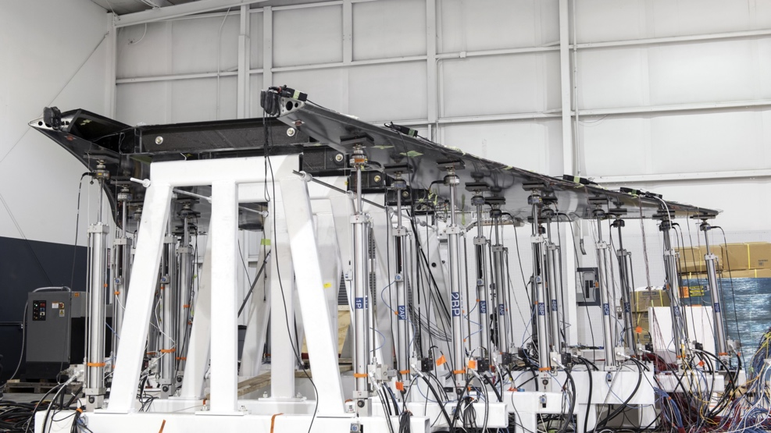
Figure 6: Aircraft wing under loading bend test, using hydraulic actuators (Boom Supersonic, 2020).

Using a basic setup, it would also be possible to gain accurate results again using a steel fixture to secure the rear wing at its ends and the top face of the wing. A bladder can then be inflated using high pressure air to deflect the rear wing with the required load. The required load can be applied to the wing by adjusting the air pressure as shown in Figure 7. The magnitude of deflection can be recorded using a dial indicator set at zero on the surface of the rear wing and manually recording the results as demonstrated by (easycomposites, 2022).

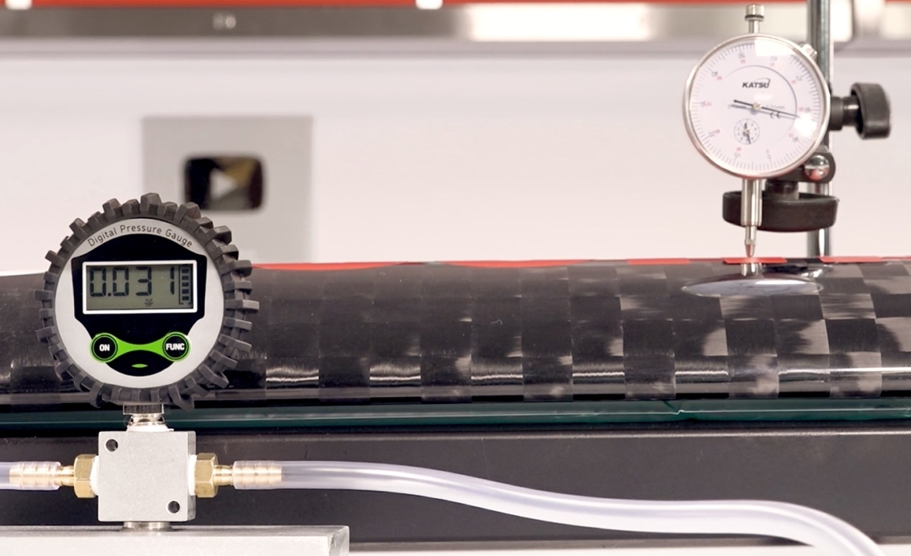

Figure 7: Motorsport rear wing under load testing with air pressure bladder and dial indicator (easycomposites, 2022).

Conclusion
In summary the optimised simulation increased the thickness of the CFRP layers from the baseline Rear Wing model and therefore, increased the mass to reduce the deflection from 9.9mm to 5.8mm when a distributed load of 2000N was applied. Which is below the objective of 6mm maximum deflection. However, even though the mass increased from 1.88kg to 2.36kg the stiffness to weight ratio increased from 10.94 N²/mm to 14.88 N²/mm as shown in Table 4. Therefore, the Rear Wing has been successfully optimised not only to meet the objectives and constraints set but also improving the structures design efficiency.

Run | Material | Thickness  (mm) | Deflection  (mm) | Mass  (kg) | Load  (N) | Stiffness  (N/mm) | Stiffness/Weight (N²/mm)
Baseline | CFRP | 2.5 | 9.9 | 1.88 | 2000 | 202 | 10.94
Optimised | CFRP | 3.14 | 5.8 | 2.36 | 2000 | 344.83 | 14.88
Manufacture | CFRP | 3.3 | 5.2 | 2.49 | 2000 | 384.62 | 15.77
Table 4: Comparison of results from each optimisation run of the Rear Wing.

However, the Rear Wing was optimised for a second time using variables that allow manufacture using 0.1mm plies of CFRP. This was not possible with the first optimisation run as the layer thicknesses were not built in 0.1mm increments. Following this the mass and thickness of layers increased from 2.36kg to 2.49kg which also further reduced the deflection from 5.8mm to 5.2mm as shown in Table 4. The small increase in thickness and mass reduced the deflection, increasing the stiffness of the optimised Rear Wing for manufacture. Therefore, increasing the stiffness to weight ratio from 14.88 N²/mm to 15.77 N²/mm improves the structures design efficiency even further and maintains the ability to manufacture.

Bibliography
Allaire, G., Dapogny, C. & Francois, J., 2021. Chapter 1 - Shape and topology optimization. In: Handbook of Numerical Analysis. Texas: Elsevier, pp. 1-132.
Altair Engineering, 2023. Practical Aspects of Structural Optimization with Altair OptiStruct. s.l.:Altair Engineering.
AutoDesk, 2023. Shape Optimization study. [Online]
Available at: https://help.autodesk.com/view/fusion360/ENU/?guid=SIM-SHAPE-OPTIMIZATION#:~:text=Shape%20Optimization%20provides%20an%20intelligent,to%20guide%20your%20design%20refinement.
Boom Supersonic, 2020. What are wing bend tests and how are they performed?. [Online]
Available at: https://boomsupersonic.com/flyby/what-are-wing-bend-tests-and-how-are-they-performed
[Accessed 8 October 2023].
BosonQ Psi, 2022. Design Optimization: Foundation and the Quantum Future. [Online]
Available at: https://www.bosonqpsi.com/post/design-optimization
[Accessed 19 September 2023].
Cunningham, B., 2015. Simulation-Led Design Is Better and More Accessible than Ever. [Online]
Available at: https://www.comsol.com/blogs/simulation-led-design-is-better-and-more-accessible-than-ever/
[Accessed 28 September 2023].
easycomposites, 2022. Motorsport Rear Wing Destruction Test. [Online]
Available at: https://www.easycomposites.co.uk/learning/motorsport-wing-destruction-test
[Accessed 9 October 2023].
Fédération Internationale de l'Automobile, 2022. 2023 FORMULA 1 TECHNICAL REGULATIONS, s.l.: Fédération Internationale de l'Automobile.
Gerzen, N., Clausen, P. M. & Pedersen, C. B. W., 2016. Sizing optimization for industrial applications and best practice design process. s.l., WIT Conferences.
Hahn, Y. & Cofer, J. I., 2014. Study of Parametric and Non-Parametric Optimization of a Rotor Bearing System. Emerging Methods in Design and Engineering.
Mcdowell, D. L. et al., 2010. Integrated Design of Multiscale, Multifunctional Materials and Products. s.l.:Butterworth-Heinemann.
Ponginan, R., 2021. What is Size, Shape and Free-Shape Optimization?. [Online]
Available at: https://altairuniversity.com/52528-what-is-size-shape-and-free-shape-optimization/#:~:text=Size%20optimization%20is%20widely%20used,choice%2C%20and%20other%20part%20parameters.
Rosinha, I. P., Gernaey, K. V., Woodley, J. M. & Kruhne, U., 2015. Computer Aided Chemical Engineering. 12th International Symposium on Process Systems Engineering and 25th European Symposium on Computer Aided Process Engineering, pp. 1463-1468.
SDC Verifier, 2023. Types of optimization in FEA. Why do you need to optimize your FEA model?.
Sigmund, O. & Bendsoe, M. P., 2004. Topology Optimization. Lyngby: Springer.
Somerfield, M., 2021. Why F1’s flexi wing tricks are a never ending problem for the FIA. [Online]
Available at: https://www.motorsport.com/f1/news/flexi-wings-never-ending-problem-fia/6507093/
[Accessed 23 June 2023].
Wang, M., Guo, L. & Sun, H., 2019. Manufacture of Biomaterials. In: Encyclopedia of Biomedical Engineering. Chapel Hill: Elsevier, pp. 116-134.
Zhou, M., Raphael, F. & Kemp, M., 2023. Optimization of Composite - Recent Advances and Application, s.l.: Altair Engineering.

