

Networks and Cyber Security Essentials
ACCA4024

Synthesize a solution to a potential real life scenario

Student ID – 2432768
Student Name – Jozef Szepesi

Lecturer Name: Muhammad Azeem Abbas

Date: 20/03/2026
Table of Contents
Introduction 2
Organisational Context and Regulatory Requirements 3
Identification of Threats 3
External Threats 3
Internal Threats 4
Security Policies 5
Mitigation Measures 6
Monitoring and Incident Response 8
Staff Training and Awareness Programme 9
Conclusion 10
Appendix A – Board Presentation Slides 11
References 16

Table of Figures
Figure 1: Example of phishing attack process (Source: Cloudflare [6]) 5
Figure 2: Incident response process at HealthPlus Analytics (HPA) 10

Introduction
Cybersecurity has become a serious issue for organisations, especially those working in healthcare. Companies that deal with patient information have a big responsibility because the data they hold is very sensitive. If this information is leaked or stolen, it can cause harm to patients and damage the organisation’s reputation. In recent years, the rise of remote and hybrid working has made security even more difficult to manage. Staff often use personal laptops and mobile phones to access company systems, which increases the risk of cyberattacks.
HealthPlus Analytics (HPA) is a healthcare technology company based in the UK. It processes and stores patient data for hospitals and clinics. Recently, the company suffered from several security problems, including unauthorised access to patient information stored in the cloud and a ransomware attack on its analytics servers. These incidents show that the current security measures are not strong enough. They also raise concerns about compliance with the UK General Data Protection Regulation and the security requirements set by NHS Digital [1][5].
The purpose of this report is to develop a complete data security and governance framework for HPA. The solution will identify the main threats, suggest practical security policies, explain how risks can be reduced, and describe how the company can monitor and respond to incidents. It will also propose a staff training programme to improve awareness and encourage responsible behaviour.

Organisational Context and Regulatory Requirements

HPA operates in a highly regulated environment because it processes special category health data. Under the UK General Data Protection Regulation, health information requires enhanced protection due to its sensitive nature. Any breach involving patient records could result in serious legal penalties, financial fines, and reputational damage. In addition, because HPA provides services to NHS organisations, it must meet the Data Security and Protection Toolkit standards set by NHS Digital [5].
The recent ransomware attack shows that HPA’s current security controls are not strong enough. Unauthorised access to cloud systems suggests weaknesses in identity management and access control. These incidents demonstrate that the company needs not only stronger technical controls but also better governance, clearer policies, and improved employee awareness.
To build an effective solution, this report draws on recognised industry standards such as ISO/IEC 27001 and the NIST Cybersecurity Framework. These frameworks provide structured guidance for managing information security risks and improving organisational resilience.

Identification of Threats
Before analysing specific threats, it is useful to apply a recognised security model to structure the assessment. The McCumber Cube provides a comprehensive framework for analysing information security by considering confidentiality, integrity and availability across different states of information [7]. It also highlights the importance of human, technical and policy-based controls. By applying this model to HPA, it becomes clear that the recent incidents have affected multiple dimensions of security. For example, ransomware impacts availability of stored and processed data, while phishing attacks threaten confidentiality during information transmission. This structured approach helps identify weaknesses more systematically rather than viewing threats in isolation.

External Threats
One of the biggest risks to HPA is ransomware. This type of attack locks access to important systems or files and demands money to restore them. Healthcare organisations are common targets because their services are critical, and attackers believe they are more likely to pay.
Phishing attacks are also a major concern, as attackers attempt to trick employees into revealing login credentials or clicking malicious links.
Another serious issue is cloud security weaknesses. If cloud storage is not set up properly, patient data could be accessed by unauthorised users. Hackers may also use stolen login details to enter systems. In addition, denial of service attacks could overload the company’s servers and make services unavailable to clients.
Phishing is one of the most common cyber threats facing healthcare organisations. In this type of attack, an attacker pretends to be a trusted source and sends a fake email to an employee. The goal is usually to steal login credentials or install malicious software. If an employee clicks on a harmful link, attackers may gain access to sensitive systems and patient data. This type of attack is particularly dangerous because it relies on human error rather than technical weaknesses [6].

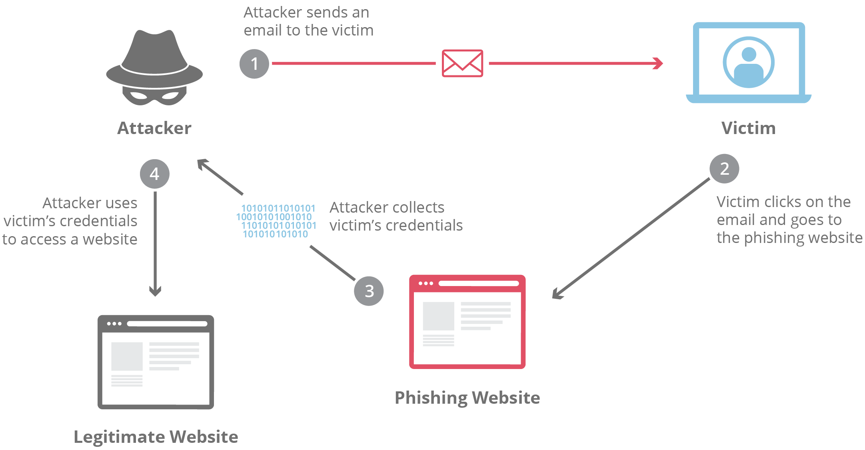
Figure 1: Example of phishing attack process (Source: Cloudflare [6])

Internal Threats
Internal threats are risks that come from within the organisation. These threats may not always be intentional, but they can still cause serious damage. In many cases, security incidents happen because of human error rather than technical failure.
One common internal risk is weak password management. Some employees may use simple passwords or reuse the same password for multiple systems. If one account is compromised, attackers may gain access to other systems as well. Another issue is sharing login details between colleagues, which reduces accountability and increases the risk of unauthorised access.
The use of personal devices for work purposes also creates security concerns. When employees use their own laptops or mobile phones to access company systems, the organisation has less control over security settings. If these devices are lost, stolen, or infected with malware, sensitive patient data could be exposed. This is particularly concerning for HPA because it processes confidential healthcare information.
Insider threats are another serious risk. Although rare, there is always the possibility that a staff member could deliberately misuse their access rights. For example, an employee might access patient records without a legitimate reason or attempt to extract data for personal benefit. Even if such actions are uncommon, the potential impact is significant.
Finally, a lack of awareness or training can increase the likelihood of mistakes. Employees may accidentally send confidential information to the wrong recipient or click on suspicious links. Without proper understanding of security policies, staff may not recognise risky behaviour.
These internal threats show that improving technology alone is not enough. HPA must also focus on governance, access control, and staff awareness to reduce risks effectively.

Security Policies
In order to reduce the risks identified earlier, HealthPlus Analytics (HPA) must introduce clear and practical security policies. Security policies provide structure and guidance for how information should be managed across the organisation. They also ensure that employees understand their responsibilities when handling sensitive patient data. According to the NIST Cybersecurity Framework, organisations should establish clear governance and protective controls to manage cyber risk effectively [2].
Firstly, HPA should implement a comprehensive Information Security Policy. This policy would outline the company’s commitment to protecting confidential information and maintaining the confidentiality, integrity and availability of systems. These three principles are often referred to as the CIA triad and form the foundation of information security management [3]. The policy should clearly define roles and responsibilities, including accountability at senior management level.
An Access Control Policy is also essential. Access to patient records and analytics systems should be granted based on job roles, following the principle of least privilege. Multi-factor authentication should be required for access to cloud services and administrative accounts. Regular audits of user permissions would help ensure that access rights remain appropriate over time. This approach aligns with international standards such as ISO/IEC 27001, which emphasise access management and control procedures [4].
HPA should also introduce a Data Classification and Handling Policy. Under the UK General Data Protection Regulation, health data is considered special category data and requires enhanced protection [1]. By clearly classifying information as confidential, internal or public, the organisation can apply suitable security controls based on risk level.
An Acceptable Use and BYOD Policy is particularly important due to hybrid working arrangements. This policy should explain how employees may use personal devices securely. Minimum security standards, such as device encryption and updated antivirus software, should be required before accessing company systems.
In addition, an Encryption Policy should require that sensitive data is encrypted both at rest and during transmission. This reduces the risk of data exposure in the event of unauthorised access.
Finally, HPA must establish a formal Incident Response Policy. This policy should define how security incidents are identified, reported and managed. Under UK GDPR, certain data breaches must be reported to the Information Commissioner’s Office within 72 hours [1]. Therefore, clear internal procedures are necessary to meet regulatory obligations.
By implementing these policies in alignment with recognised frameworks such as NIST and ISO 27001, HPA can create a structured and accountable security environment while remaining compliant with UK regulations.

Mitigation Measures
While security policies provide direction, they must be supported by practical and realistic mitigation measures. In order to strengthen its security posture, HealthPlus Analytics (HPA) needs to implement both technical and organisational controls.
One of the most important measures is the introduction of multi-factor authentication across all critical systems. This means that employees would need more than just a password to access company platforms. For example, they may also need to enter a code sent to their mobile device. This significantly reduces the risk of unauthorised access if login credentials are stolen through phishing attacks.
HPA should also improve its endpoint security by deploying endpoint detection and response tools on all company-managed devices. These tools continuously monitor devices for suspicious activity and can isolate infected systems before malware spreads further. This would be particularly important in preventing future ransomware incidents.
Network segmentation is another effective control. By separating sensitive systems, such as patient databases, from general corporate networks, the organisation can limit the impact of a breach. Even if attackers gain access to one part of the system, they would not automatically have access to all data.
In addition, regular data backups should be implemented and securely stored. Backups should be encrypted and kept separate from the main network. This ensures that if ransomware encrypts operational systems, the company can restore data without paying attackers. Backup systems should also be tested regularly to confirm that data can be recovered successfully.
Cloud security configurations must also be reviewed and strengthened. Access permissions should be carefully managed, and unnecessary administrative privileges removed. Continuous monitoring tools can help identify unusual behaviour within cloud environments.
From an organisational perspective, HPA should conduct regular risk assessments to identify new vulnerabilities. Data Protection Impact Assessments should be carried out when introducing new systems or processing activities, particularly when handling sensitive health information [1]. This supports compliance with regulatory requirements and reduces legal risk.
Vendor risk management is another important area. Since HPA works with external healthcare providers and cloud service companies, contracts should include clear security obligations. Third-party suppliers should demonstrate that they follow recognised standards such as ISO/IEC 27001 [4].
Finally, software updates and patch management procedures must be improved. Many cyberattacks exploit known vulnerabilities that have already been fixed by software vendors. Ensuring that systems are updated regularly can significantly reduce the likelihood of exploitation.
By combining these technical and organisational mitigation measures, HPA can create a layered security approach. This makes it more difficult for attackers to succeed and ensures that even if one control fails, others remain in place.

Monitoring and Incident Response
Even with strong security controls in place, no organisation can completely eliminate cyber risk. For this reason, HealthPlus Analytics (HPA) must establish continuous monitoring and a clear incident response process. Effective monitoring allows the company to detect unusual behaviour early, while a structured response plan ensures that incidents are handled quickly and professionally.
HPA should implement continuous network monitoring through a Security Information and Event Management (SIEM) system. A SIEM platform collects and analyses logs from servers, cloud systems and user devices. By reviewing this data in real time, suspicious activity such as repeated failed login attempts or unusual data transfers can be identified quickly. This supports early detection and reduces the potential impact of an attack.
In addition to automated monitoring tools, HPA should define clear reporting procedures for employees. Staff members should be encouraged to report suspicious emails, unusual system behaviour or possible data breaches immediately. Creating a simple reporting channel, such as a dedicated email address or internal portal, will improve response time.
When a security incident is detected, the response process should follow clear stages. First, the incident must be identified and recorded. Next, the IT security team should assess the severity of the situation. If necessary, affected systems should be isolated to prevent further damage. This may involve disconnecting devices from the network or temporarily restricting access to certain services.
After containment, the organisation should investigate the root cause of the incident. This may include reviewing system logs and analysing how the breach occurred. Once the issue is resolved, systems can be restored from secure backups if needed. Finally, a post-incident review should be conducted to identify lessons learned and improve future security measures.
The overall monitoring and response approach should align with recognised frameworks such as the NIST Cybersecurity Framework, which highlights the importance of detecting, responding to and recovering from cyber incidents effectively [2].
The process can be summarised in the following flow structure.
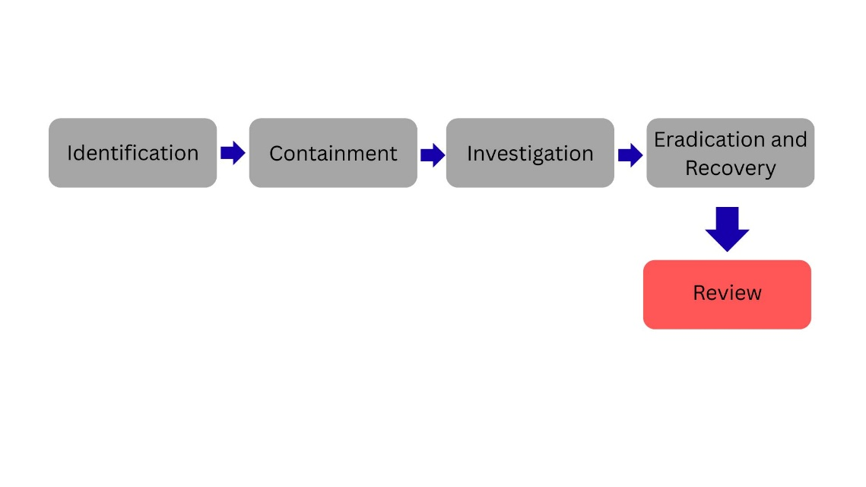
Figure 2: Incident response process at HealthPlus Analytics (HPA)
In cases where patient data is compromised, HPA must also follow legal reporting requirements. Under the UK General Data Protection Regulation, certain data breaches must be reported to the Information Commissioner’s Office within 72 hours [1]. Therefore, having a well-defined incident response procedure is not only a technical necessity but also a legal obligation.
By combining proactive monitoring with a structured response process, HPA can reduce downtime, minimise reputational damage and maintain trust with its healthcare partners.

Staff Training and Awareness Programme
Technology alone cannot protect HealthPlus Analytics (HPA) from cyber threats. Many security incidents happen because of human error, such as clicking on phishing emails or using weak passwords. For this reason, staff training and awareness must be a key part of the company’s overall cyber strategy.
Firstly, all employees should receive mandatory cybersecurity training when they join the organisation. This induction training should explain the importance of data protection, especially because HPA processes sensitive patient information. Employees must understand their responsibilities under the UK General Data Protection Regulation and the potential consequences of data breaches [1]. The training should cover topics such as recognising phishing emails, creating strong passwords, handling confidential information securely and reporting suspicious activity.
In addition to initial training, regular refresher sessions should be provided at least once a year. Cyber threats continue to evolve, and staff need to stay informed about new risks. Short online modules or workshops can help reinforce good security practices without taking too much time away from daily work.
HPA should also introduce simulated phishing exercises. These controlled tests can help measure how employees respond to suspicious emails. If staff members click on a simulated phishing link, they can receive additional guidance rather than punishment. This approach encourages learning and improvement rather than blame.
Role-based training is another important element. Employees working in IT or handling large volumes of patient data may require more advanced training compared to administrative staff. Senior managers should also receive targeted sessions focusing on cyber risk management and decision-making during security incidents.
To strengthen the security culture further, HPA could appoint security champions within different departments. These individuals would act as points of contact for security-related questions and help promote good practices across the organisation.
Finally, the company should regularly communicate security reminders through emails, posters or internal newsletters. Simple messages about password safety, data handling and safe remote working can reinforce awareness in everyday activities.
By investing in continuous training and awareness, HPA can reduce the likelihood of human error and build a culture where cybersecurity is seen as a shared responsibility rather than only an IT issue.

Conclusion
In conclusion, cybersecurity represents a significant risk for HealthPlus Analytics (HPA), particularly because the organisation processes large amounts of sensitive patient information. The recent incidents involving unauthorised cloud access and a ransomware attack have demonstrated weaknesses in the company’s current security controls. These events highlight the need for a structured and comprehensive data security and governance framework.
This report has identified both external and internal threats that could affect HPA’s systems and data. External risks such as ransomware and phishing attacks remain serious concerns, while internal risks such as human error, weak access control and the use of personal devices also create vulnerabilities. Addressing these threats requires more than technical solutions alone.
To strengthen its security posture, HPA must implement clear security policies aligned with recognised standards such as ISO/IEC 27001 and the NIST Cybersecurity Framework [2][4]. Practical mitigation measures, including multi-factor authentication, network segmentation, secure backups and improved cloud configuration, will reduce the likelihood and impact of future incidents. Continuous monitoring through logging and SIEM systems will support early detection of suspicious activity.
The development of a structured incident response process ensures that security incidents are handled quickly and effectively, while also meeting regulatory obligations under the UK General Data Protection Regulation [1]. In addition, investing in staff training and awareness will help create a culture of shared responsibility and reduce the risk of human error.
Overall, the proposed framework provides HPA with a realistic and achievable approach to improving data security, regulatory compliance and organisational resilience. By combining governance, technology and employee engagement, the company can enhance trust with healthcare partners and protect the sensitive data entrusted to it.

Appendix A – Board Presentation Slides

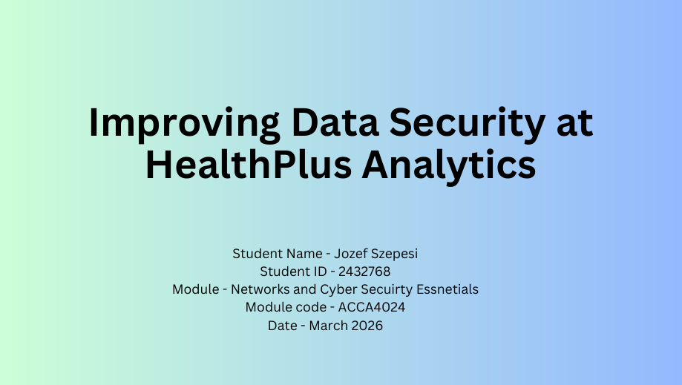

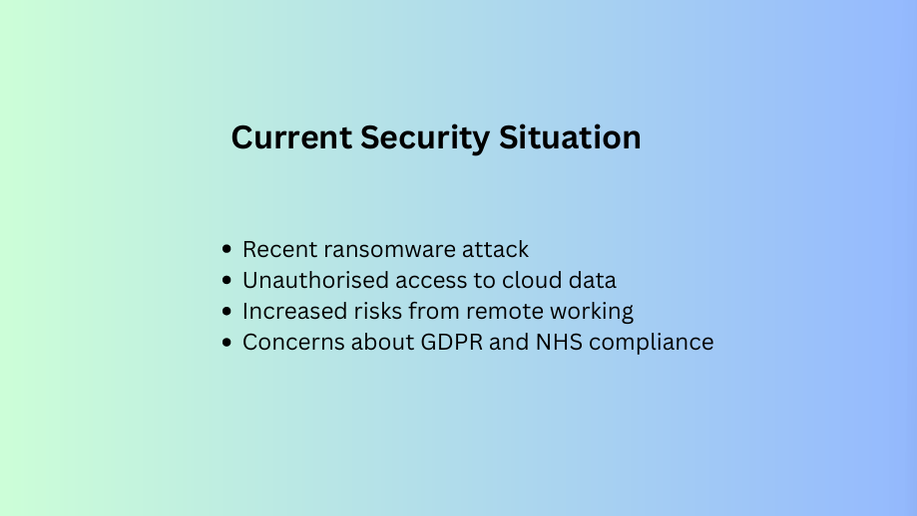

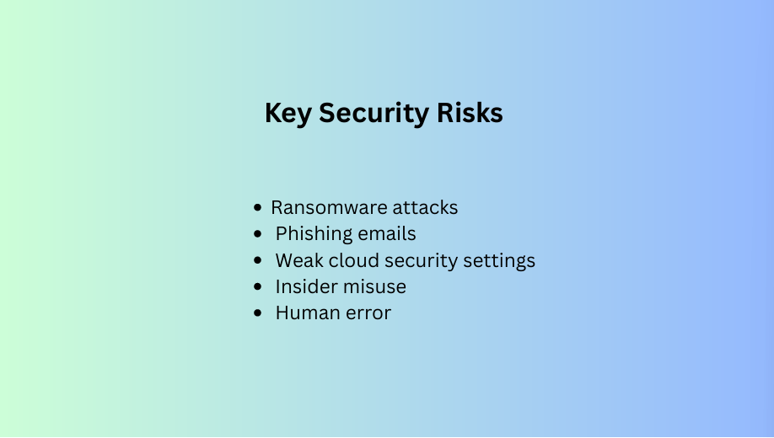

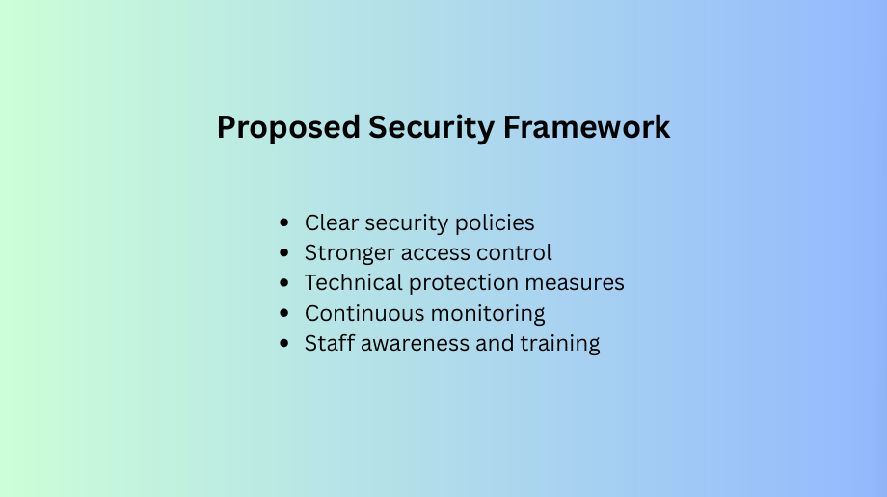

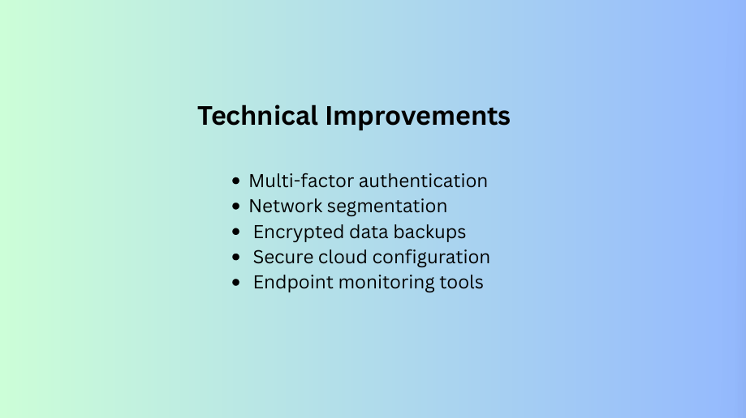

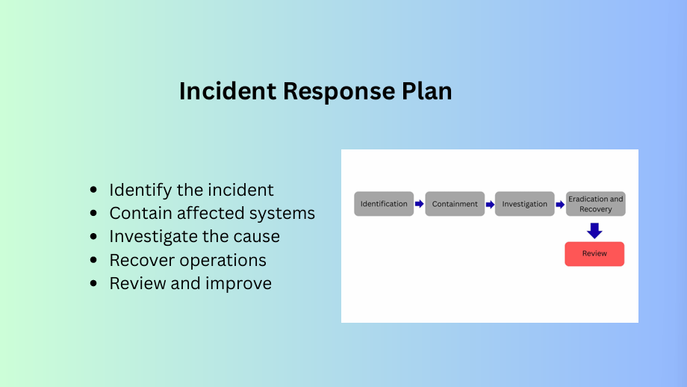

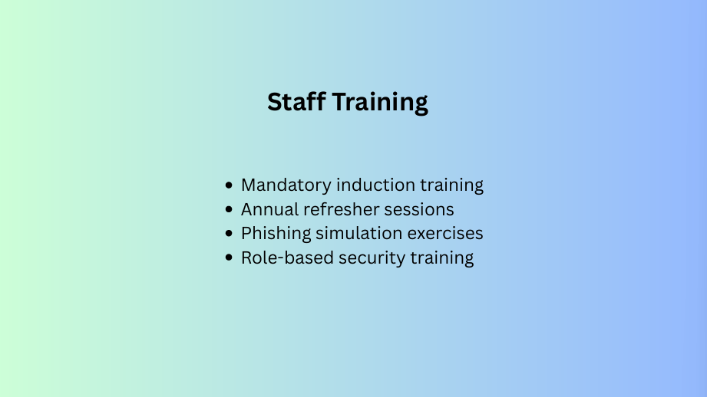

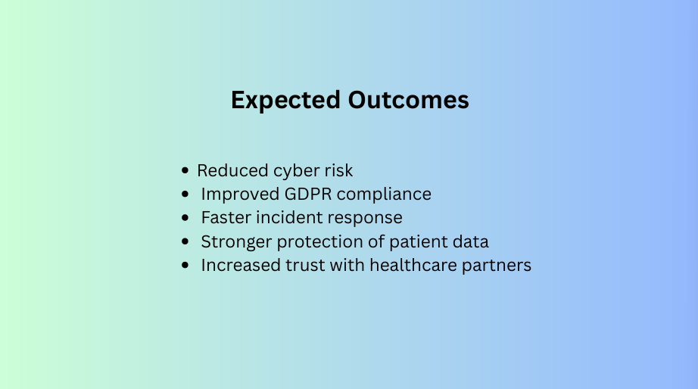

References

[1] M. Limb, “How data protection changes will affect your practice,” BMJ (Online), vol. 361, p. k1764, Apr. 2018, doi: 10.1136/bmj.k1764.
[2] National Institute of Standards and Technology (NIST), Framework for Improving Critical Infrastructure Cybersecurity, 2018. [Online]. Available: https://www.nist.gov/cyberframework [Accessed: 15 February 2026].
[3] R. von Solms and J. van Niekerk, “From information security to cyber security,” Computers & security, vol. 38, pp. 97–102, Oct. 2013, doi: 10.1016/j.cose.2013.04.004.
[4] International Organization for Standardization, ISO/IEC 27001:2022 Information security management systems — Requirements. [Online]. Available: https://www.iso.org/standard/27001 [Accessed: 15 February 2026].
[5] NHS Digital, Data Security and Protection Toolkit Guidance, 2023. [Online]. Available: https://www.dsptoolkit.nhs.uk/ [Accessed: 15 February 2026].
[6] Cloudflare, “What is Phishing?”, 2023. [Online]. Available: https://www.cloudflare.com/learning/access-management/what-is-phishing/ [Accessed: 15 February 2026].
[7] S. Furnell and N. Clarke, “Power to the people? The evolving recognition of human aspects of security,” Computers & security, vol. 31, no. 8, pp. 983–988, Nov. 2012, doi: 10.1016/j.cose.2012.08.004.

