DS 1 Kleban Maryna

My Screenshots

Screenshot 1
Email inbox
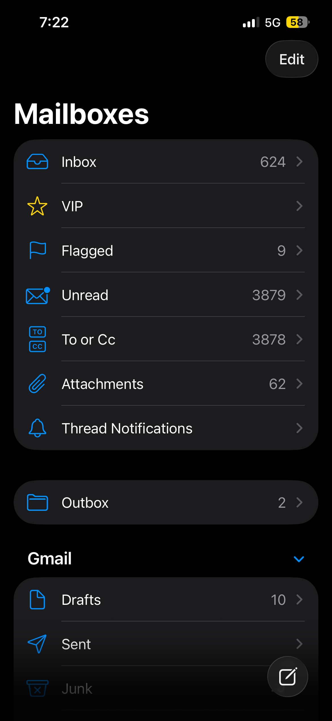
This is my email. I use it every day for work also to receive updates like discounts from different shop.

Screenshot 2
Strava app
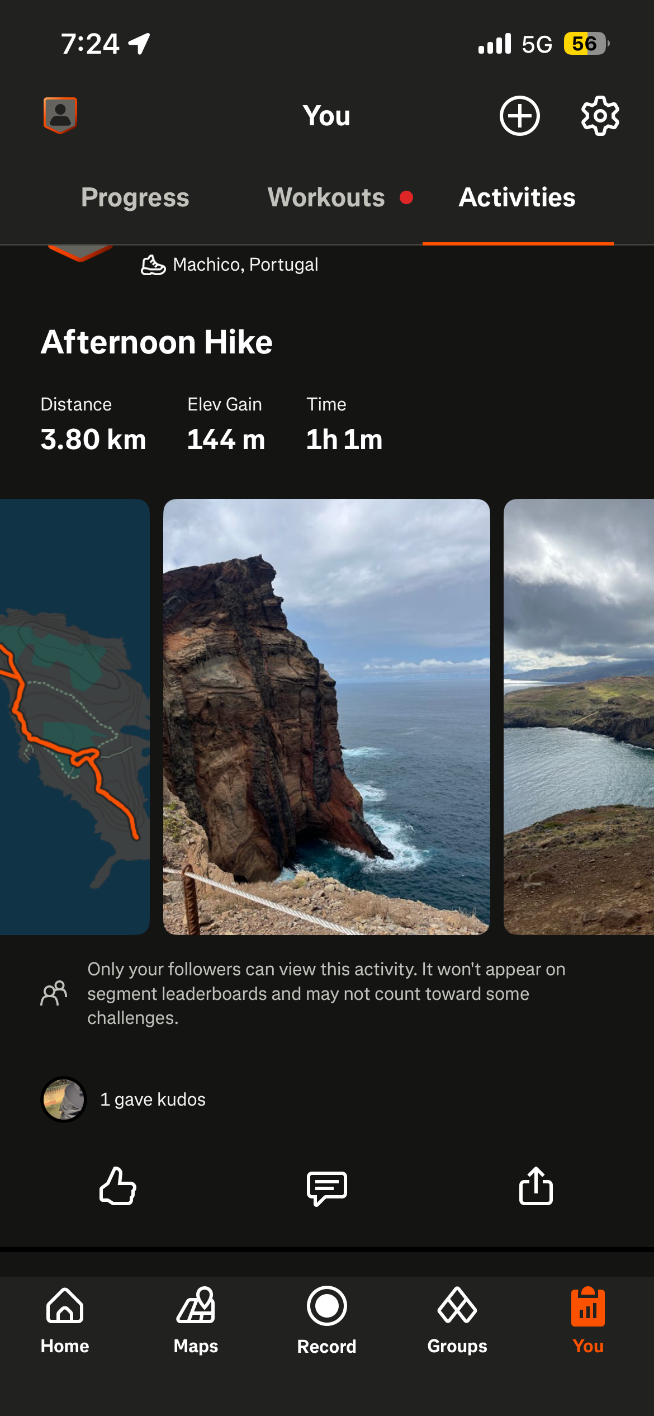
This is my Strava app. I use it to track my runs and monitoring my progress. I also can follow my friends , what make it’s more interesting.

Screenshot 3
Workforce app
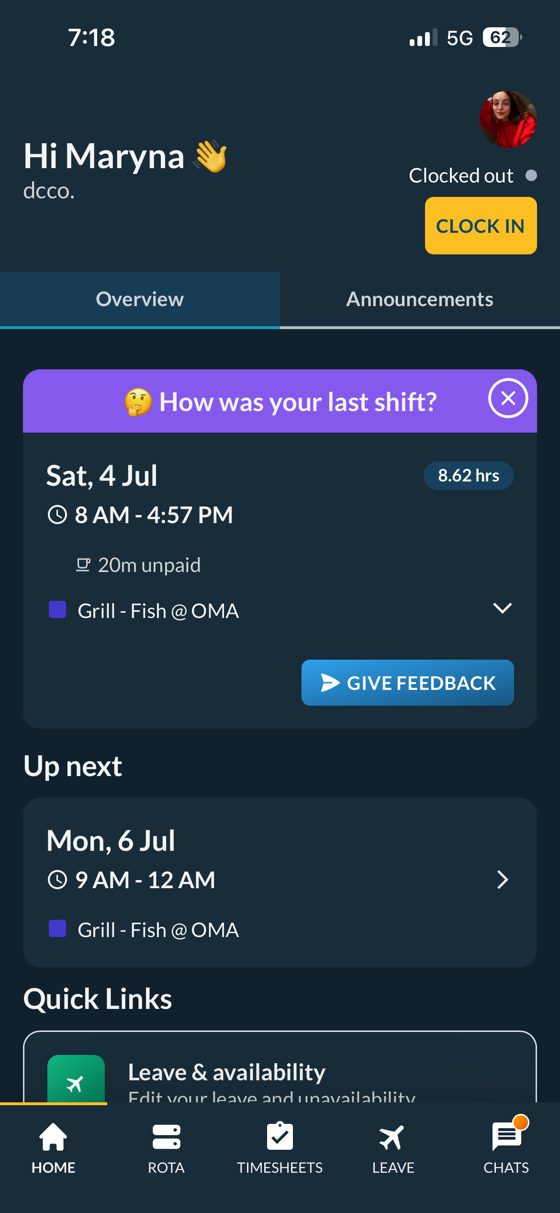
This is my work app.I use it to clock in and clock out, check my work schedule and communicate with my company. I can book my holiday from this app.

Screenshot 4
Health app
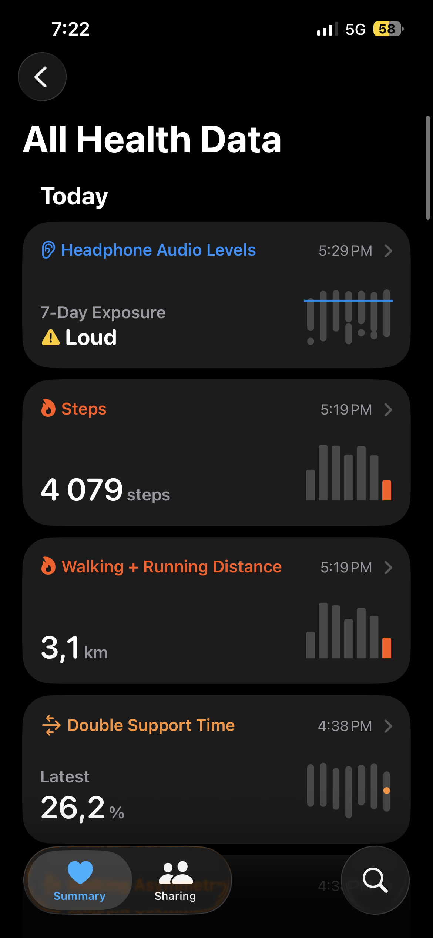

Screenshot 5
Binance app
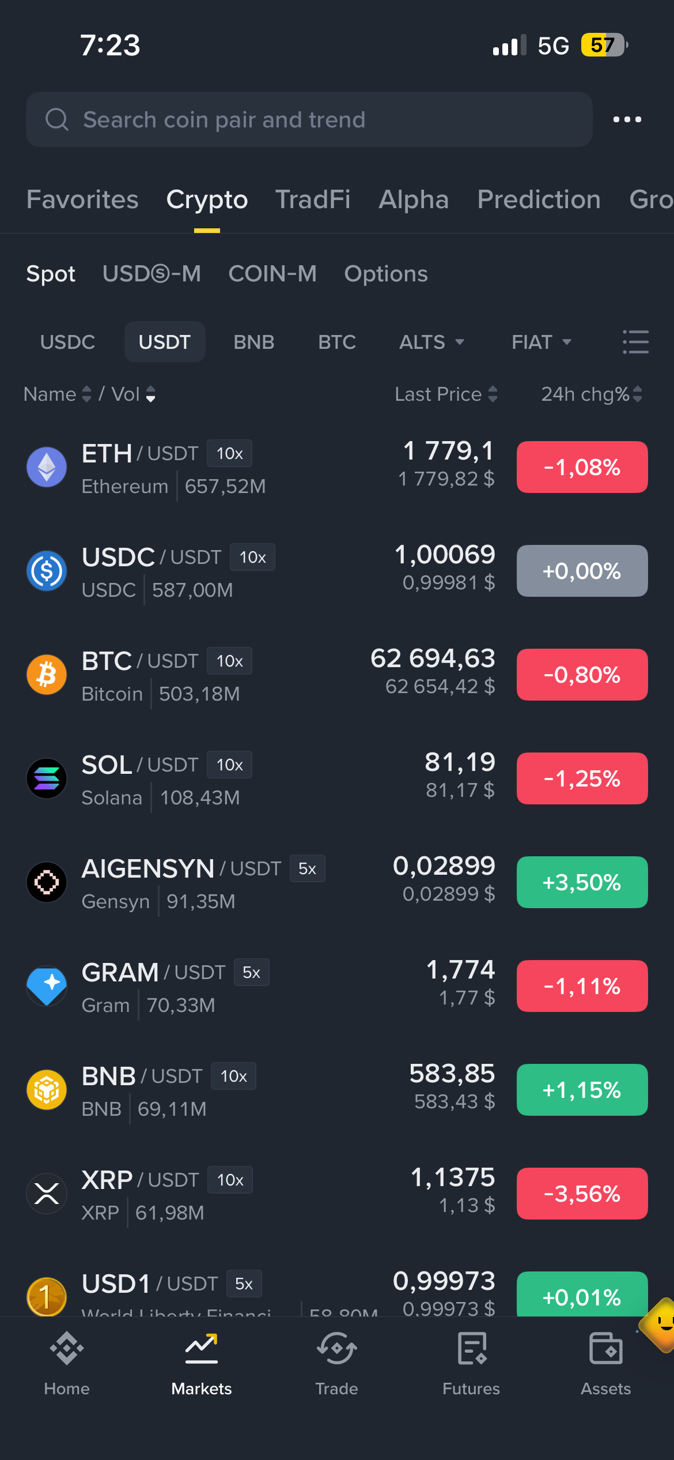
This is Binance app. I use it trade cryptocurrency and monitor prices

Screenshot 6
UWTSD Hwb
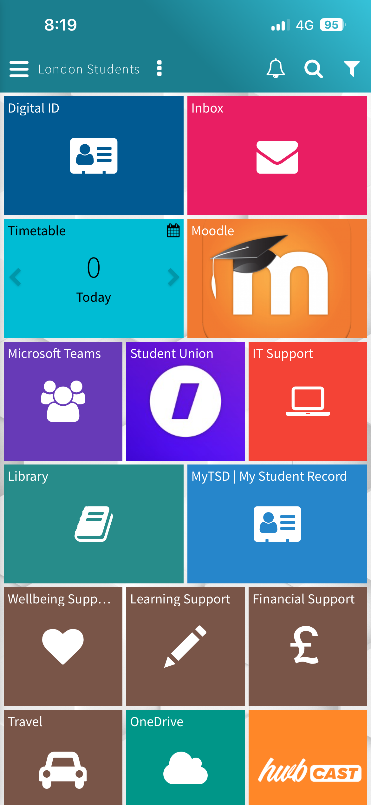
This is my university app. It contains all the information I need for my studies.

My Short Reflection
My digital life is very important for me. I use many different apps for studying, working, communicate and health monitoring. They help me stay more organize and make my daily task more easier. All of them helps me stay more productive. I often use social media like Tik Tok or Instagram. I sometimes feel nervous about I spend to much time in my phone. I want to do more activities but social media take all my free time. I feel confident when I use any digital device. But I’m happy it’s a lot of useful apps that helps make my life better.

Submission Checklist
Before you submit, please check:
​​​ ☐ I added 4–6 screenshots
☐ I wrote short sentences for each screenshot
☐ I wrote my short reflection
☐ My work is my own
☐ My file opens correctly
​​☐ My file opens correctly

