

Effective Team Working and Communication

Student ID: 2128090
Student Name: Ivaylo Georgiev
Submission Date: 17/10/2022
Module code: BMSW4002
Module title: Effective Team Working & Communication
Lecturer’s name: Hafiz Rahmani

Executive Summary
Several different models and theories of team development, including the Tuckman Model, the Belbin Team Roles, and the Wheelan's Team Development model, were analysed and discussed in this research. The Tuckman Model was one of the other available options, which have also been evaluated. Using the Amazon case study as an example, the research looked at not just the many benefits that come with working together as a team, but also the numerous drawbacks that come along with it.

Table of Contents
Executive Summary 2
1. Introduction 4
2. Overview of Team Working 4
2.1. Defining Team and Teamwork 4
2.2. Characteristics of Teamwork 5
3. Models of Team Development 6
3.1. Recognising, Discussing and Justification of the Preferred Model 6
3.2. Recognising, Discussing and Justification of a Second Model 8
4. Team Roles 9
4.1. Recognising the Roles Utilising a Theory 9
4.2. Significance of the Considering Roles for the Team Selection 11
5. Discussion 11
5.1. Discussion of the Advantages of an Effective Team 11
5.2. Discussion of the Barriers to Teamwork Considering Case Study 11
6. Conclusion and Recommendations 12
7. References 13

1. Introduction
As per many pieces of research, the team working is among the most effective tool that can influence the overall success of businesses as well as the overall self-development effectively and efficiently. The collaborative efforts of each and every individual result in improving the overall ability in solving the problems taking place on a regular basis (Reeves,Xyrichisand Zwarenstein,2018). Individuals or any business is willing to take a risk when the team's collaborative effort can result in the calculation of risks that lead to a better overall workplace and the environment as well. There is no denying the fact that working collaboratively always encouragesself-development, increasing overall job satisfaction while also reducing overall stress.
There are many models such as Tuckman’s Model of 1965 where there are 5 stages involving Forming, Storming, Norming, Performing, as well as Adjourning (Jones,2019). In addition, Belbin's 9 team roles include roles that are action, people and thought-oriented. The case study of teamwork in the company of Amazon is also going to be considered for understanding the effectiveness of teamwork.

2. Overview of Team Working

2.1. Defining Team and Teamwork
A team refers to a group of people who are working collaboratively for accomplishing common goals and objectives. The people that are accountable for carrying the goals and objectives of the team needs to have to work must be on the same path for increasing the overall probability of success. People that are not compatible or harmonious with each individual can never result in formation of a successful team. On the other hand, teamwork is an outcome of a team that is filled with compatible people that can work collaboratively for a common cause (Marasi,2019). In simple words, teamwork takes place when the individual work collaboratively for a common purpose and as mentioned, teamwork is an extension of a team that is formed well together (Fosteret al., 2019).Effective teamwork always hugely assists in empowering each and every individual to reach common goals while also having a greater impact which can also influence success.
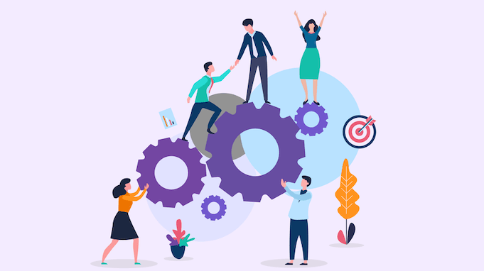
Figure 1: Teamworking
(Source:Marasi,2019)

2.2. Characteristics of Teamwork
There are many characteristics of teamworkand it is also very essential and vital forincreasing the overall effectiveness and efficiency of teamwork. Effective teamwork can be observed by having a clear direction since they engage in setting a clear direction where all the individuals in the team work accordingly since each player in the team has clarity in unifying the group (Sanyal and Hisam, 2018). When each individual has a single goal in mind for carrying the goals and objectives then the team can understand the main purpose behind the existence of the teamwork. In addition, open as well as honest communication is very vital for the formation of a team that is effectively formed where effectively communicating always leads to the building of belongingness between each member of the team (Levitt,2019).Teamwork is also comprised of various roles that are defined to eachindividualcollaboratively working in a team that clearly defined each role and also increases the overall effectiveness of the roles that are being handled and carried by the members of the team for accomplishing the various goals and objectives effectively and efficiently.
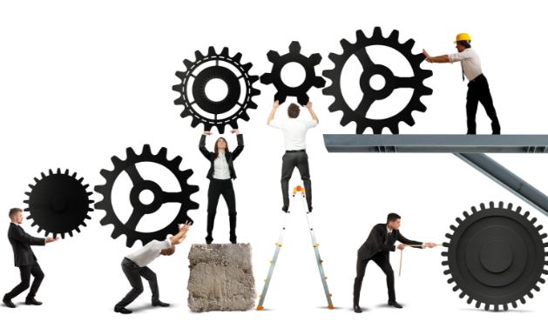
Figure 2: Clear Direction
(Source:Sanyal and Hisam, 2018)

3. Models of Team Development

3.1. Recognising, Discussing and Justification of the Preferred Model
One of the effective models of team development isTuckman’s Model of 1965 which was initially proposed by the psychologist names Bruce Tuckman that involves the necessity of going through 5 stages of development that are forming, storming, norming, performing as well as adjourning (Jones,2019).As per the case study, it is also very crucial that the team Tom Jackson must clear their differences for increasing the overall effectiveness and efficiency of the team in carrying out the various operations of Amazon effectively and efficiently. The Tuckman model can effectively contribute to clearing the differences by simple 5 stages.
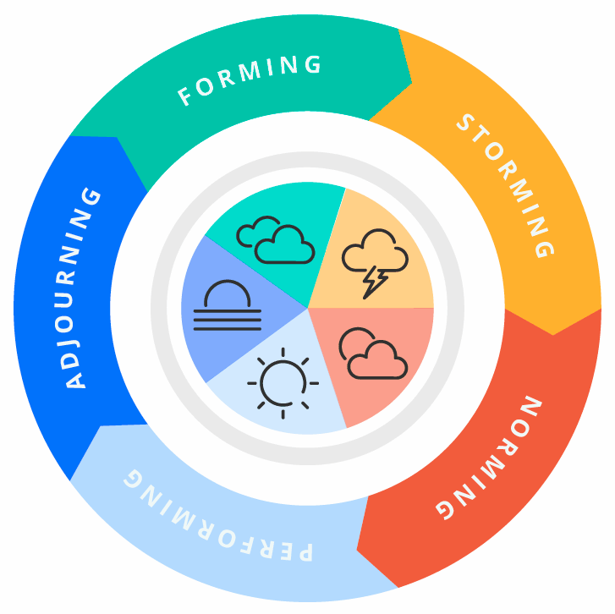
Figure 3: Tuckman’s Group Development
(Source: Jones,2019; Kiweewaet al., 2018; Egolf,2022; DossouKpanouand Kelsey,2021; Hildebrandtand Marr,2020; Dillet al., 2020)
The followings are the five stages of Tuckman’s Model of 1965 and which are:
Forming
This is the first and initial stage that heavily puts emphasis on the dependency on the leaders for the ultimate direction as well as guidance where many individuals meet for the first time but it can also result in providing greater results for the amazon case study (Kiweewaet al., 2018).
Storming
This is the second stage where individuals in the team start pushing various boundaries and also a lot of conflicts take place between the members of the team (Egolf,2022). This is evident in the case study.
Norming
The third stage is Norming where team members start engaging in resolving the various differences while also appreciating the strengths of the other individual while also respectingothers’ authority (DossouKpanouand Kelsey,2021).
Performing
The performing stage is the stage in which the team starts to unlock their full potential with their hard work as well as the structured procedure (Hildebrandtand Marr,2020).
Adjourning
The adjourning stage where all the members of the team start getting disbanded after which the team was formed has been accomplished in the process (Dillet al., 2020).

3.2. Recognising, Discussing and Justification of a Second Model
The second model is Wheelan’s Team Development modelwhich is critically based on the behavioural as well as the psychological factors of the overall team development that can influence the behaviour as well as the perception of the members of the team (Arola,2021).Similarly, there are various phases of Wheelan's Model of Team Development:
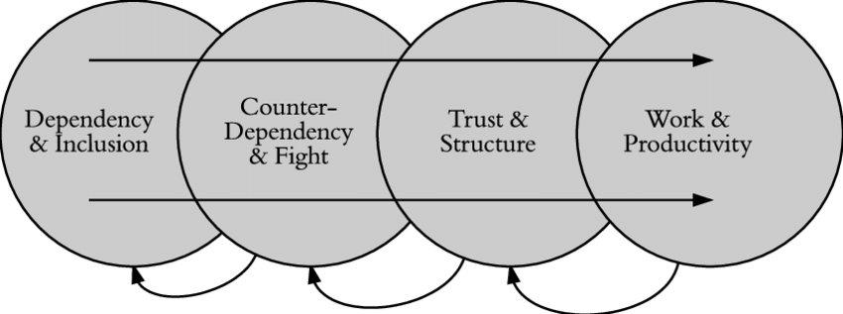
Figure 4: Wheelan’s Team Development Model
(Source:Arola,2021; VAIDAand ȘERBAN,2021; Gwandureand Boshoff,2019; Gren, Goldmanand Jacobsson,2019; Åkerlund,Jacobssonand Tilin,2021)
Inclusion and Dependency
The first stage is the dependency of the members of the team on the leader and the productivity tends to stay very low as per the case study, it can be observed that the individuals in the team are also having many differences and Tom being a leader has to engage in the effective formation of the team (VAIDAand ȘERBAN,2021).
Fighting and Counter-Dependency
The second stage involves having many disagreements and the individuals in the team actively engaging in freely expressing their opinions there is a necessity for the team leader to be able to solve the various interpersonal conflicts and also clarify the goals and work processes (Gwandureand Boshoff,2019). This can be observed as lacking in the case of Tom Jackson from Amazon.
Trust and Structure
The third stage is trust and structure which involves strengthening the overall relationship with each other in a positive manner. Communication in this stage becomes more task-oriented as well as more open and less concentrated on status, influence as well as power (Gren, Goldmanand Jacobsson,2019). There is a lack of trust and structure in the case of the team that is being carried forward by Tom Jackson and applying this model can increase the overall effectiveness and efficiency of the teamwork.
Work
The fourth stage is the work that involves maximisation of the overall effectiveness as well as productivity (Åkerlund,Jacobssonand Tilin,2021). This stage is very similar to the stage ofperforming from Tuckman’s Model. The leaders of the team engage in rewarding the team as well as various individual efforts. This stage needs to be accomplished for increasing the overall productivity of Amazon effectively as well as efficiently in the process.

4. Team Roles

4.1. Recognising the Roles Utilising a Theory
There is no denying the fact that the different roles of the various individuals in the team play a huge role in carrying the various goals and objectives effectively and efficacy. The followings are the nine Belbin's team roles that are:
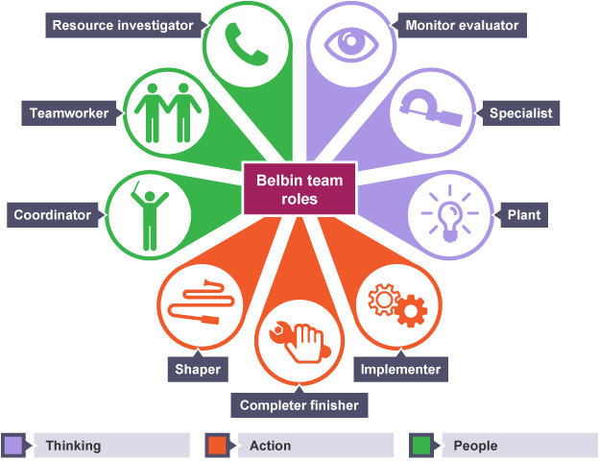
Figure 5: Belbin’s Team Role
(Source:Rahmaniet al., 2021; Bednárand Ljudvigová,2020; Rahmaniet al., 2021)
Action Oriented Roles
There are 3 types of roles in it which are shaper, implementer, and completer/finisher. The shaper is the task leader who aids in guiding the team and the implementer is the individual that aids in turning the decisions into tasks that are manageable by effectively defining as well the process (Rahmaniet al., 2021). The finisher or the completer is the individual that engages in checking every single detail and managing the required changes or adjustments for increasing the overall success probability.
People Oriented Roles
These roles have three components which are coordinator who is a team leader that is natural and it is also more democratic as well. In addition, the team-worker are the people that tend to be very likeable and also the core member of the team (Bednárand Ljudvigová,2020). The third component is the Resource Investigator which involves the liaison officer and diplomat who is always looking for new possibilities and opportunities.
Thought Oriented Roles
The plan is the person who is accountable for new ideas, innovation and creativity, the main objective of the people that are having these roles is to stop any team from engaging in wrong decision-making that can affect the overall project (Rahmaniet al., 2021).

4.2. Significance of the Considering Roles for the Team Selection
Thereis a huge significance for considering the roles like Action Oriented, People Oriented and though oriented roles. With the assistance of the Belbin team role, any company like Amazon as given in the case study can get an adequate drive for making sure that the team is actively moving while not losing any concentration or momentum.

5. Discussion

5.1. Discussion of the Advantages of an Effective Team
As per Coyle (2018), it can be identified that behind the secrets of any groups that are successful are building safety, and sharing the vulnerability while also establishing the purpose. The skills like utilising eye contact as well as body language while also showing attentiveness. In addition,spotlighting the fallibility initially is also among the important skills that can be recognised in any team that is capable. Furthermore, the effective team is comprised of two major components that are diversity and size, each team is unique and varies in size depending on the scale of the project. Diversity in the team is very important and critical because it promotes new insights and learning which can result in increased effectiveness in improving the quality of the business operations.

5.2. Discussion of the Barriers to Teamwork Considering Case Study
From the case study, it can be observed that there were many drawbacks and barriers in the overall team management since the formation of the team was very poorly constituted and not a suitable communication channel for the individuals working in the team to engage in effective communication with each other for carrying the goals and objectives of the business organisation (Raybourn,2020). Two of the members that are Mihaela and Spencer were not working committedly for meeting the objectives of the business. These two members of the team are more interested in attaining personal rewards instead of achieving the goals and objectives of Amazon. In addition, Tom Jackson is not able to guide the team members and due to that, it is also creating complex problems like the teamsfeeling very unmotivated as well as disconnected which can immensely affect the ability of the individuals to work collaboratively.

Figure 6: Barriers to Communication
(Source:Raybourn,2020)

6. Conclusion and Recommendations
The report has come to the conclusion and it has discussed various components of teamwork. The models such as Tuckman Model as well as the Wheelan’s Team Development model are considered for understanding their significance and how the efficiency, as well as the overall effectiveness of the teamwork, can be increased. There are 5 stages as per Tuckman’s model that is forming, storming, norming, performing as well as adjourning. Furthermore, Wheelan’s Team Model consists ofInclusion and Dependency, Fighting and Counter-Dependency, Trust and Structure, and Work. There is a strong requirement for having the right communication channel in place for overcoming any type of problem-related to confusion and misunderstanding between the employees in the team. In addition, effective leadership regarding guiding the members of the team in the right direction is also very important.

7. References
Åkerlund, M., Jacobsson, C. and Tilin, F., (2021). The Legacy of susanwheelan. Small Group Research, 52(1), pp.103-109.
Arola, I., (2021). Building trust step-by-step in virtual project teams; project manager perspective.
Bednár, R. and Ljudvigová, I., (2020). Belbin team roles in a start-up team. In SHS Web of Conferences (Vol. 83, p. 01002). EDP Sciences.
Coyle, D., (2018). The culture code: The secrets of highly successful groups. Bantam.
Dill, L.J., Gousse, Y., Huggins, K., Fraser, M.A., Browne, R.C., Stewart, M., Salifu, M., Joseph, M.A. and Wilson, T.E., (2020). Adjournment in community HIV prevention: Exploring transitions in community–academic partnerships. Health promotion practice, 21(4), pp.544-551.
DossouKpanou, B.M. and Kelsey, K.D., (2021). Exploring the Dynamics of a Long-Term Research Network. Journal of Agricultural Education, 62(3).
Egolf, R.S., (2022). Exploration of Tuckman’s Model of Group Development: Perceived Applications and Prevalence among Adventure Education Practitioners (Doctoral dissertation, Prescott College).
Foster, M., Gilbert, M., Hanson, D., Whitcomb, K. and Graham, C., (2019). Use of simulation to develop teamwork skills in prelicensure nursing students: an integrative review. Nurse educator, 44(5), pp.E7-E11.
Gren, L., Goldman, A. and Jacobsson, C., (2019). The perceived effects of group developmental psychology training on agile software development teams. arXiv preprint arXiv:1911.09057.
Gwandure, C. and Boshoff, E., (2019). Alignment between theory and practice in group development processes in the workplace: an experiential perspective. International Journal of Training Research, 17(3), pp.252-260.
Hildebrandt, A. and Marr, J., (2020). NICK SABAN–A CASE STUDY FOR RECRUITMENT METHODS AND APPLICATION OF TUCKMAN’S MODEL OF TEAM DEVELOPMENT. Global Journal of Business Pedagogy, 4(1), p.214.
Jones, D., (2019). The Tuckman’s Model Implementation, Effect, and Analysis & the New Development of Jones LSI Model on a Small Group. Journal of Management, 6(4).
Jones, D., (2019). The Tuckman’s Model Implementation, Effect, and Analysis & the New Development of Jones LSI Model on a Small Group. Journal of Management, 6(4).
Kiweewa, J.M., Gilbride, D., Luke, M. and Clingerman, T., (2018). Tracking growth factors in experiential training groups through Tuckman’s conceptual model. The Journal for Specialists in Group Work, 43(3), pp.274-296.
Levitt, S.R., (2019). Cultural dialectics in international teamwork dynamics. International Journal of Business Communication, 56(3), pp.326-348.
Marasi, S., (2019). Team-building: Developing teamwork skills in college students using experiential activities in a classroom setting. Organization Management Journal, 16(4), pp.324-337.
Rahmani, F., Scott-Young, C., Tadayon, A. and van der Walt, J.D., (2021). Team composition in relational contracting (RC) in large infrastructure projects: a Belbin’s team roles model approach. Engineering, Construction and Architectural Management.
Rahmani, F., Scott-Young, C., Tadayon, A. and van der Walt, J.D., (2021). Team composition in relational contracting (RC) in large infrastructure projects: a Belbin’s team roles model approach. Engineering, Construction and Architectural Management.
Raybourn, E., (2020). Why we need strategies for working remotely. In Proc. Collegeville Workshop Sci. Softw.
Reeves, S., Xyrichis, A. and Zwarenstein, M., (2018). Teamwork, collaboration, coordination, and networking: Why we need to distinguish between different types of interprofessional practice. Journal of interprofessional care, 32(1), pp.1-3.
Sanyal, S. and Hisam, M.W., (2018). The impact of teamwork on work performance of employees: A study of faculty members in Dhofar University. IOSR Journal of Business and Management, 20(3), pp.15-22.
VAIDA, S. and ȘERBAN, D., (2021). GROUP DEVELOPMENT STAGES. A BRIEF COMPARATIVE ANALYSIS OF VARIOUS MODELS. Studia Universitatis Babes-Bolyai, Psychologia-Paedagogia, 66(1).

