MARKETING FUNDAMENTALS

Analysis and Evaluation
Harvey Nichols

by Anca Ghizela Hotca
(2021006/BABM Level4T1G2/21.03.2021)

Tutor’s name: Tushara Balendran

TABLE OF CONTENTS
Introduction 1
Discussion 2
Conclusion 9
Recommendations 9
References 10

Introduction
Marketing plays a crucial role in modern-day business as it has become much more complex to retain customers and attract them. The below essay includes the essence of marketing and sheds light on the process of marketing. The essay aims to describe the major stages in the process of marketing. The essay also includes the macro-environment analysis through PESTEL in order to analyse the nature of the forces is whether favourable or unfavourable. The essay also includes Porter's 5 forces model and then highlights if the force of that particular element is low, high or moderate. The essay considers the case of Harvey Nichols.

Figure 1: Harvey Nichols
(Source: NME, 2019)

Discussion
Marketing is present everywhere around us; everything like presenting oneself in an interview for a job to selling products involves marketing. The major of the organisation is to make profits which can be attained with the help of marketing of products and services. Marketing helps the venture to earn profits and create demand. Marketing is the function of the organisation and a set of the process of delivering, creating and communicating the value of a product or service to the customer, and for management of the relationship with the customer in a manner that benefits the business and its key stakeholders (Camilleri, 2018).
The organisation known as Harvey Nichols was formed in 1831 and is a chain British luxury department store with a flagship store based in Knightsbridge, London. It sells men and women fashion collections, beauty products, fashion accessories, food and wine. Marketing plays a crucial role in the organisation.
The process of marketing involves ways in which value can be developed for the customer to meet their needs and requirements. It is an endless series of reactions and actions between the companies and the customers, making an attempt to develop value and to satisfy customer's needs. In the process of marketing, the situation is assessed to determine opportunities, the strategies are prepared for an additional value, tactical decisions are made, and the plan is implemented, and then finally, results are assessed. The below process highlights the marketing process in the context of Harvey Nichols (Gurel and Tat, 2021)
Mission Statement: Harvey Nichols is dedicated to making high-quality premium products that have distinctive features and provides the customer with a great sense of satisfaction.
Situational Analysis: Harvey Nichols's competitive advantage is driven by understanding needs of customer and commitment to the same, focusing on services and products that are core to the mission of the organisation fostering a work culture which is collaborative.
Marketing Strategy: Harvey Nichols is usually first to marketplace with new offerings, and the organisation depends on brand loyalty from present customers as a strategy when launching new services and products.
Marketing Mix: Harvey Nichols, while offering a great range of products, values the strategy of premium pricing and depends on rigid distribution guidelines.
Execution and control: Each product of Harvey Nichols is of premium quality, and they exist in one ecosystem, and thus customers are likely to stay with the brand while creating customers who are loyal (Homburg et al., 2016)
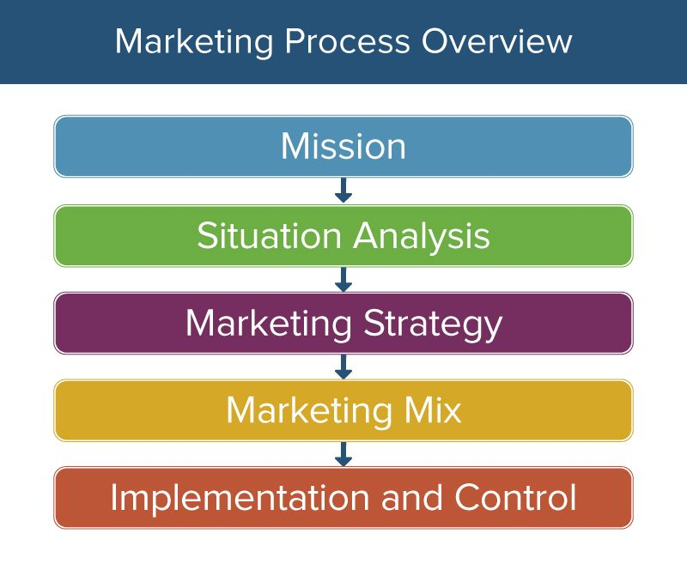
Figure 2: Marketing Process
(Source: Smartsheet, 2018)

PESTLE ANALYSIS
There are various external factors that impact a business, and these factors are needed to be kept in mind before making strategic decisions. In order to assess the external factors in the context of Harvey Nichols, the use of the PESTLE model is considered, and the same is evaluated below.
Political: The organisation is selling a great amount of product sourced from America, Italy or China as their main products are fashion wear, shoes and accessories. After the Brexit, there have been imposed quotas on total import and this cause adverse impact of product import in Harvey Nichols has limited the number of products ventures can sell (Išoraitė, 2016)
Economic: The Harvey Nichols stores are often visited by celebrities and influences. When the economy is in good shape and the average income of the people in the country increases, then it leads to direct benefit for Harvey Nichols as the people then have better confidence and they spend more on luxurious items which are sold at Harvey Nichols.
Social: Fashion keeps on changing, and thus, Harvey Nichols is required to focus on it to stay on top. Modern customers are becoming more impacted by what they observe on the internet or social media, and they look out for reviews before buying. The role of social influencers cannot be neglected in the market of the clothing and cosmetic product industry, and thus venture is required to cover social media influencers promotion of the store.
Technological: Changes in technology has impacted the luxury retail industry. The use of modern-day technology to enhance the customer's in-store and online experience is a focal point for the retail giants in the market. The use of augmented reality in order to provide customers with a real experience at home is helping the retailers to move to the next level.
Environmental: The retailers in the fashion industry are now concerned about sustainability issues more than ever. The customers are concerned about the environment, and they want to see how their clothes are being manufactured and what material is being used in production. The retailers are cutting down on wastage to save the environment.
Legal: The legal compliance factors involves adhering to laws. The organisation is required to comply with various laws like environmental laws, food and beverages law, competition law and consumer protection law. The non-compliance can lead to a serious impact.
The current factors of the Pestle environment are moderately in favour of Harvey Nichols. The political policies are stable and favour the retail market; the economy, on the other hand, has seen a significant decline which has led to lower spending. The social factors are favourable so far as the customers are willing to pay a good amount of money for premium products that Harvey Nichols offers. The organisation has adapted to the use of modern-day technology, which has, in turn, assisted the organisation in attaining growth (Perera, 2017). The venture is focusing on reducing wastage and continuously working on product sustainability hence keeping in mind the environmental concern. The legal factors are in favour as the laws are not very rigid or stringent which are binding the venture from conducting business operations.
Porter’s five forces
In order to assess the forces of the environment, there are different approaches that can be considered. Porter's 5 forces approach is considered to assess the market forces in the context of Harvey Nichols.
Competitive Rivalry: The major department stores based in London are in perfect competition. When it comes to department stores that offers a variety of luxury products like Selfridges, Harrods and Harvey Nichols, the competition is very high. The decrease in price of one's product or additional to existing product diversity impacts the business of others. For instance Selfridges offers discounts often on premium products and that impacts business of Harvey Nichols. The force of competitive rivalry is very high for Harvey Nichols (Ndofirepi et al., 2016)
New entrants threat: The new entrant threat is very low as a newly opened department store in London does not have much impact on established ventures like Harvey Nichols. Any newcomer in the market must prove itself to compete with Harvey Nichols. They also require to have proper finances before going into competition with Harvey Nichols.
Substitution threats: There persists a threat of substitution for Harvey Nichols as the economy is shifting. For example, the premium and luxurious products sold in department stores are sold in supermarkets, discount stores and specialist stores as well but for lower rates and comparatively lesser product attributes. In tough times of economy, consumers are willing to buy products at lower rates. Thus the substitution threat is high for Harvey Nichols (Olson et al., 2018).

Buyers Power:The buyers power in the industry of department stores varies on the basis of consumer loyalty, location and reputation for the store. For example, sellers would be much more interested in selling through Harvey Nichols than Selfridges because of their stock capabilities and greater size. The buyer has a lot of power in the business as they have multiple options, but they do not have bargaining power in front of luxury department stores. The buyers power is low in this force (Pan, et al., 2019)
Supplier’s powers: The department stores products are generally produced by external producers and are sold under one roof where profit margins are covered. Though a few organisations like Harvey Nichols and Harrods offers a range of products which are not there in different other stores. This clearly shows that main priorities of department stores is to sell product successfully and gain loyalty of the customers. The power of such force can said to be low as suppliers wants their presence in stores like Harvey Nichols.
Segmentation, Targeting and Positioning
Segmentation: The business target person of age 18-35 that generally shops online and is influenced by use of social media and is influenced by the opinions of using innovative strategies. Also the age of 36-65 is being targeted that customers can shop mainly in stores and generally cares about the opinions of the peers. The business also target both male and female respondent. Also, the tourist on the local streets would be targeted so that adequate revenues can be attained.
Targeting: The target market is big, Mid and small spenders. This target market spends very frequently at Harvey and has high level of disposable income. Mid spenders spend fairly substantial portion, and these are really brand conscious and generally shop at generally shop at designer stores. And also, the target market is small spenders that can purchase affordable items as these have small level of income.
Positioning strategy: The below table clearly show the positioning strategy of the business in the competitive market. As the business will sell its products on the multichannel platform it will help in achieving the key competitive advantage.
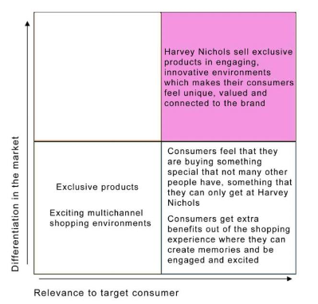
Marketing Mix
Product: The brand is luxury department store that sells fashion collection for men and women, fashion accessories, beauty related products and also wine and food. Also it sells different products of different brands over the website.
Price: Generally, Harvey follows the premium pricing strategiesas the products are generally luxury and generally designer clothes are being sold.
Place: The brand has generally 8 stores location and its sells product over website and therefore generally majorly targets customers through online platform (Jackson and Ahuja, 2016).
Promotion: The brandpromotes products through social media and digital marketing platform so that it attracts millions of the customers. Currently the organisation is focusing on the social media marketing that influence the consumers and help the organisation to retain the interest of the users on social media and communicate with the target groups in an effective manner. The social media allows the organisation to know the target group preferences, trends and taste of the target groups as well. It facilitates the organisation to strengthen the brand value and also allows the organisation to enhance the engagement of the customers and allows retaining the customers for longer period that facilitates to strengthen the competitive edge of the organisation. As shown in the image below the organisation has more than 530K followers that reflect strong brand value of Harvey Nichols. Also the organisation has utilised the social media for facilitating the target group with the prices of the products that can be seen with a simple click on social media page of the organisation.
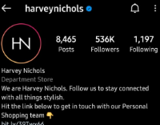
Figure 1 Harvey Nichols’ Social Media


Figure 2 Products of HN

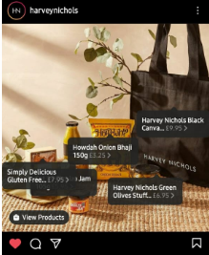
Figure 3Product prices

Conclusion
Marketing has a great role to play in the current market competition as the competition is getting stiff and customers are not easy to be retained. The essay covered the role and process of marketing. This essay covered the stages in the marketing process related to Harvey Nichols. The essay also involved assessment of macro-environment with the use of Pestle to assess the external impact on the organisation. Then an analysis of factors being unfavorable or favourable was covered. The essay also included an assessment of market forces with the help of Porter's model and then assessed whether these forces are of moderate, low or high threat. The essay also included the analysis of SWOT factors to highlight the internal capabilities of Harvey Nichols.

Recommendations
It is necessary for Harvey is to plan regarding effective expansion of the business with ensuring all the customers are digitally connected. Therefore, majority of the customers can be targeted through digital form of advertising and can attract millions of customers. Further, the market research is regularly required to be carried out with respect to analyzing the needs of customers and planning their behaviour.

References
Books and Journal
Camilleri, MA, 2018. Strategic planning and marketing effectiveness audit. In Travel marketing, tourism economics and the airline product (pp. 117-135). Springer, Cham.
Gürel, E. and Tat, M., 2017. SWOT analysis: a theoretical review. Journal of International Social Research, 10(51).
Hanlon, A., 2018. Digital marketing: Strategic planning & integration. Sage.
Homburg, C., Jozić, D. and Kuehnl, C., 2017. Customer experience management: toward implementing an evolving marketing concept. Journal of the Academy of Marketing Science, 45(3), pp.377-401.
Išoraitė, M., 2016. Marketing mix theoretical aspects. International journal of research granthaalayah, 4(6), pp.25-37.
Jackson, G. and Ahuja, V., 2016. Dawn of the digital age and the evolution of the marketing mix. Journal of Direct, Data and Digital Marketing Practice, 17(3), pp.170-186.
Moorman, C. and Day, GS, 2016. Organising for marketing excellence. Journal of Marketing, 80(6), pp.6-35.
Ndofirepi, E., Farinloye, T. and Mogaji, E., 2020. Marketing mix in a heterogeneous higher education market: A case of Africa.
Olson, E.M., Slater, S.F., Hult, G.T.M. and Olson, K.M., 2018. The application of human resource management policies within the marketing organisation: The impact on business and marketing strategy implementation. Industrial Marketing Management, 69, pp.62-73.
Pan, W., Chen, L. and Zhan, W., 2019. PESTEL analysis of construction productivity enhancement strategies: A case study of three economies. Journal of Management in Engineering, 35(1), p.05018013.
Perera, R., 2017. The PESTLE analysis. Nerdynaut.
Online
Nm, 2021 [online][accessed through] https://www.nme.com/discount-codes/harveynichols.com, [18thMarch, 2021]
Smartsheet,2021[online][accessed through]https://www.smartsheet.com/strategic-marketing-processes-and-planning, [18thMarch, 2021]

