

Assignment Title: Assignment 2: “Inclusive Event Planning Masterclass: Designing and Executing Accessible Events”

Module: International Meetings Management for the Hotel Industry

Module code: BMIH6007

Lecturer: Chris wilkin

Prepared by: Md Shiplu Uddin
Student ID: 2209548
Word Count: 2545

Table of Contents
1. Introduction 3
2. The Event Cycle 3
2.1 Application to the Event 3
2.2 Strategic Timeline 4
3. Event Concept 4
3.1 Delegate/Guest Experience 4
3.2 Full Itinerary 5
3.3 Value Proposition 5
4. Aim and Objectives 6
4.1 SMART Objectives 6
5. Event Management 6
6. Event Budget 8
7. Industry Trends, Issues and Impacts 9
7.1 Emerging Trends in the MICE Industry 9
7.2 Challenges in Inclusive Event Planning 10
7.3 Impact on Future Events 10
8. Situational and Cultural Considerations 11
8.1 SWOT Analysis: Internal Factors 11
8.2 PESTLE Analysis: External Factors 12
9. Conclusion 14
Reference List 15

1. Introduction
The Inclusive Event Planning Masterclass gives students, hotel workers, and event planners the tools they need to design events that are both inclusive and easily available. In the MICE sector, inclusion has become increasingly important since it is necessary to satisfy a wide spectrum of participants including people with disabilities, diverse cultural origins, and special needs (Bow Din et al., 2023). This masterclass offers practical workshops, expert panel discussions, and networking chances that support the use of universal design in event planning so addressing these issues.
This event is the result of growing demand for legal, ethical, and commercial inclusion. Following industry norms and accessibility rules is now necessary (Litvinova-Kulikova, Aliyeva, and David, 2023). Inclusive event plans improve audience involvement, brand reputation, and competitiveness beyond mere compliance (Park et al., 2022).
The Vision venue in London is one that meets operational efficiency and accessibility criteria and is accessible. Its proximity to public transportation, assistive technologies, and flexible seating—which Vision Hall, 2025 describes as barrier-free. The site is an excellent choice since its infrastructure supports the variety of the event and the aims for professional learning.

2. The Event Cycle
The event cycle is the process of "imagining, planning, executing, and evaluating an event," as defined by Getz and Page (2019). Brown et al. (2015) provide a rigorous approach to event management meant to improve participant experiences, use resources wisely, and create strategic alignment with event objectives. The Event Management Body of Knowledge (EMBOK) Model (Silvers et al., 2005) consists in initiation, planning, execution, evaluation, and knowledge. These ideas applied in the Inclusive Event Planning Masterclass promotes involvement, risk management, and structure.

2.1 Application to the Event
- Concept Development: The initial phase involved market research, defining event objectives, and identifying industry demand for inclusivity training (Bowdin et al., 2023).
- Planning: This stage included venue selection, budgeting, securing sponsorships, and logistical arrangements, ensuring accessibility and operational feasibility (Jones, 2017).
- Implementation: Focused on executing marketing campaigns, onboarding speakers, and finalizing resource allocations (Rogers and Wynn-Moylan, 2022).
- Event Execution: On the event day, coordination between staff, speakers, and technology teams ensures seamless delivery.
- Evaluation: Post-event feedback collection through surveys, social media insights, and stakeholder meetings assesses the event’s success and areas for improvement (Jones, 2017).

2.2 Strategic Timeline
- Pre-Event (6 Months Prior): Venue booking, sponsorship outreach, marketing strategy development.
- Pre-Event (3 Months Prior): Speaker confirmations, accessibility planning, ticket sales launch.
- Event Week: On-site setup, final technical checks, coordination meetings.
- Event Day: Execution of sessions, real-time monitoring, and audience engagement strategies.
- Post-Event (1 Month After): Feedback analysis, financial reconciliation, and reporting for future improvements.
Following this event cycle helps the Inclusive Event Planning Masterclass improve operational effectiveness, guest satisfaction, and industry influence.

3. Event Concept
Designed to involve, connect, and educate attendees—including hospitality experts, students, and event planners—the inclusive event planning masterclass. Participants in the event are guided on how to plan and conduct inclusive events stressing universal design, diversity, and accessibility (Darcy, 2012).

3.1 Delegate/Guest Experience
Visitors will first come across inclusive and easily accessible surroundings. Visitors to Vision Hall, 2025 have access to digital accessibility tools, assistive listening devices, sign language interpreters, and step-free access. Digital check-in systems and QR codes help to address issues with address accessibility and registration. Keynotes, expert-led panel discussions, practical seminars, and case study presentations will round out the day. Through breakout seminars, attendees can apply ideas to actual event planning environments, therefore helping to retain knowledge and acquire skills (Huggett, 2022). A networking event will round up the program and help to promote industry inclusion and professional contacts.

3.2 Full Itinerary
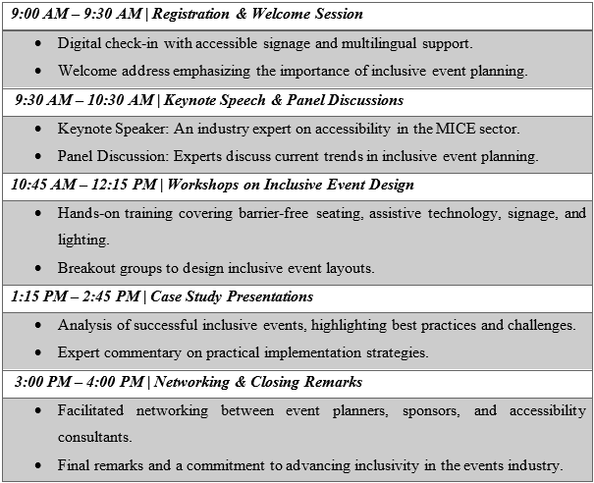

3.3 Value Proposition
The way this event is planned structurally and inclusively distinguishes it. While many conferences debate diversity theoretically, this masterclass gives attendees the chance to create ideas that give accessibility top priority (Rogers and Wynn-Moylan, 2022). Practical insights abound from interactive lectures, case studies, and expert panels. By combining event professionals and accessibility experts, the event helps the sector to undergo long-term change. This masterclass creates a more inclusive MICE business by linking knowledge and implementation (Darcy, 2012).

4. Aim and Objectives
Designed specifically to meet the need in the MICE sector for inclusive event planning, the Inclusive Event Planning Masterclass The event has the following goal –
"To provide event planners and hospitality professionals with practical knowledge and skills to design and execute truly inclusive events."
Legal and ethical responsibilities are driving the sector to gradually highlight in event management accessibility, diversity, and inclusion (Bowdin et al., 2023). By giving participants practical knowledge, the event guarantees accessibility all through the process, so encouraging methodical change in the methods of event design (Finkel and Dashper, 2020).

4.1 SMART Objectives
Following SMART goals has helped to ensure that the event produces measurable results -
- Educate more than eighty attendees on the most efficient ways to organise accessible events, allowing them to incorporate inclusivity into future events.
- Encourage diversity and long-term effect by forming five or more industry partnerships with event technology providers, accessibility experts, and hospitality groups.
- Conduct post-event surveys to ensure that 95% of participants are satisfied with the training's quality, efficacy, and relevance.
The event's aims ensure practical learning, industry partnerships, and attendee happiness. Using articulated goals improves event feasibility and strategy (Darcy, 2012).

5. Event Management
Implementing the Inclusive Event Planning Masterclass calls for an ordered event management approach combining strategic planning, resources, and crucial skills. Good event management assures that the event is financially and operationally feasible, offers a unique experience, and accomplishes its goals (Dowson, Albert, and Lomax, 2022).
Good event management calls for several skills. Logistics, planning, and speaker administration must be taken care of if an event is to go off smoothly (Allen, Harris, and Jago, 2022). Marketing and advertising use the AIDA paradigm—attention, interest, desire, action—to raise awareness and ticket sales (Morrison, 2023). Logistics management must organise transportation, accessibility services, food, vendors, and vendors to ensure successful implementation (Bowdin et al., 2023). Finally, risk management calls for the creation of fallback strategies, the expectation of problems, and the observance of accessibility rules to stop disturbances (Rogers and Wynn-Moylan, 2022). These skills help the event staff to present an inclusive, professional, orderly experience.
Many basic resources at the event guarantee accessibility and efficiency. All attendees of the conference centre can access barrier-free entry, accessible technologies, flexible seating, and Vision Hall, 2025. Accessibility consultants, technical support teams, and event coordinators that want to run effectively need to be sufficiently qualified (Allen, Harris, and Jago, 2022). Not less important are real-time captioning, assistive listening devices, audio-visual systems, hybrid events enabling virtual involvement (Darcy, 2012). Furthermore, improving the experience for every participant will be inclusive communication tactics, sensory-friendly settings, braille materials, and sign language interpreters (Finkel, Sharp, and Sweeney, 2019).
The success of any event depends on strategic preparation (Allen, Harris, and Jago, 2022). Wheelchair-accessible seating, neurodivergent-friendly quiet areas, and clear navigation cues will all be features of the facility. Real-time subtitles, accessible digital materials, and hybrid event activities for remote attendees depend on IT help (Bow Din et al., 2023).
The AIDA approach will direct marketing and promotion towards maximising involvement and reach (Setiawan, Wibisono, and Purwanegara, 2022). Media coverage, search engine optimised website material, and interesting social media will all start the campaign. Target email marketing, speaker interviews, and teaser videos will all help to pique curiosity. Successful inclusive event case studies and guest testimonies distribution will increase curiosity. Finally, basic registration, early bird discounts, and referral rewards will inspire involvement.
Ensuring that an event is inclusive and accessible calls for logistical planning (Doran et al., 2024). The security staff will have the required knowledge to manage large numbers in a respectful and inclusive way. There will be catering from halal, kosher, vegan, allergy-friendly substitutes. Visitors with mobility, sensory, or cognitive needs will have access to easily available support teams.
Strategic planning, the delivery of required resources, and staff training will help to improve operational efficiency, inclusivity, and attendance satisfaction (Bladen et al., 2022). Highlighting easily available and inclusive event management, the Inclusive Event Planning Masterclass is a benchmark for next event planning in the sector (Doran et al., 2024).

6. Event Budget
Financial sustainability and viability of the Inclusive Event Planning Masterclass need for a well-organised budget (Bladen et al., 2022). Using a break-even analysis, this part shows profitability, outlines income and expenses, and points up funding sources.
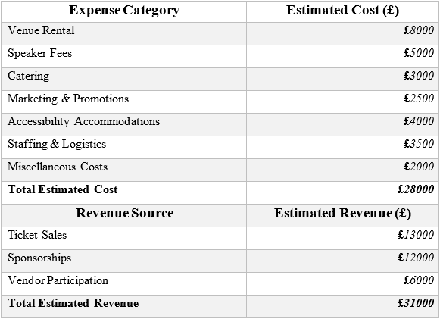
The event budget of £28,000 includes venue rental, speaker fees, catering, promotion, accessible lodgings, and personnel costs. One of the costliest charges is the £8,000 site rental, which must feature flexible seating, assistive equipment, and barrier-free access. The £5,000 lecture fees reflect industry professionals' inclusive event planning abilities. The cost of accessibility facilities, such as assistive listening devices, braille materials, and sign language interpreters, is £4,000, which meets inclusion criteria. Staffing and logistics (£3,500) will be responsible for event staff, while marketing and promotions (£2,500) will focus on digital campaigns based on the AIDA model.
Three key money streams are used to fund the event. The organisation of pricing levels will boost revenue by maximising attendance, with tickets priced at £13,000. The event technology, accessibility consultants, and industry groups will give £12,000 in financial and promotional support. The £6,000 contributions made by inclusive event solutions exhibitors will increase the event's value.
Total Cost (£) | Total Revenue (£) | Net Profit/Loss (£) | Break-even Status
28000 | 31000 | 3000 | Profitable
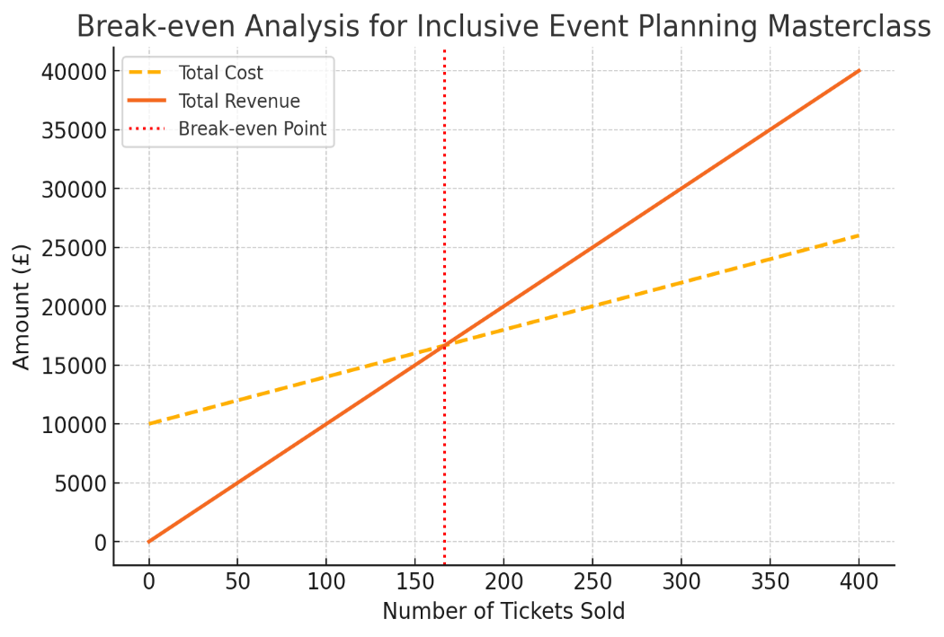
The event is predicted to earn £31,000 in revenue and £3,000 in net profit, according to the break-even analysis. This leads to the event being both profitable and scalable (Bowdin et al., 2022). The event's strong financial prospects make it feasible for future expansion (Getz and Page, 2019). The Inclusive Event Planning Masterclass is financially sustainable and impactful in the MICE sector because it focuses on financial sustainability, cost efficiency, and diversification of revenue streams.

7. Industry Trends, Issues and Impacts
The Meetings, Incentives, Conferences, and Exhibitions (MICE) sector is rapidly changing due to technological advancements, sustainability, and inclusivity (Shalihah, 2024). The Inclusive Event Planning Masterclass focuses on these developments and the underlying hurdles to delivering accessible events.

7.1 Emerging Trends in the MICE Industry
Sustainability and eco-friendly event planning are two major MICE issues. Environmental concerns have led to a surge in demand for carbon-neutral venues, digital event materials, and trash reduction (Mair, 2022). To reduce their environmental impact, a growing number of event organisers prioritise sustainable catering, renewable energy, and carbon offset programs (Jones, 2017). The Inclusive Event Planning Masterclass features sustainable supplier partnerships, reusable supplies, and paperless registration. Another tendency is the rise of hybrid and virtual events, owing to the increased need for digital solutions caused by the COVID-19 pandemic. The greater accessibility and global engagement of virtual and hybrid forms reduces travel expenses and emissions (Mohamed and Sabre, 2022). Real-time captioning, virtual networking, and live-streamed lectures ensure that this event is accessible to a wide range of attendees.

7.2 Challenges in Inclusive Event Planning
Despite rising awareness, implementing fully inclusive events remains difficult. Event planners face challenges in standardising inclusive procedures due to regional accessibility restrictions and regulatory constraints (Darcy, 2012). Finkel and Dashper (2020) observed that sensory-friendly venues, sign language interpreters, and assistive technology can be costly. Certain virtual platforms lack accessibility features such as screen reader support and real-time subtitles (Doran et al., 2024). To overcome these concerns, industry players must invest in inclusive innovations while adhering to industry best practices.

7.3 Impact on Future Events
The Inclusive Event Planning Masterclass can change industry norms by teaching event planners how to organise accessible events. By highlighting the business benefits of inclusivity, such as increased audience reach and brand reputation, this event encourages event planners to incorporate accessibility into all event management. Hybrid event models, as well as sustainability, ensure industry innovation and resilience. This workshop sets a standard for inclusive MICE event planning by connecting academic concepts to practical implementations, driving action.

8. Situational and Cultural Considerations
Strategic planning and execution require an understanding of both the internal and exterior components of the Inclusive Event Planning Masterclass. This part uses SWOT and PESTLE analyses to assess the event's key situational and cultural aspects (Bowdin et al., 2023).

8.1 SWOT Analysis: Internal Factors
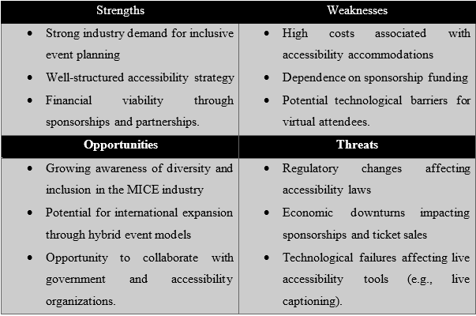
The event is financially sustainable because of the industry's desire for inclusive event design, a well-structured accessibility strategy, and sponsorships and partnerships. Because of these advantages, the event is a leader in MICE accessibility (Finkel, Sharp, and Sweeney, 2019). Sponsorship money and accessibility accommodations are both expensive and risky (Bladen et al., 2023). Technology challenges may have an impact on virtual event components (Mohamed and Sabre, 2022).
The growing understanding of diversity and inclusion in event planning opens new opportunities. Hybrid approaches and accessible organisations could help the event expand internationally. However, the event could be hampered by technological concerns affecting assistive devices, economic downturns affecting sponsorships, and regulatory changes affecting accessibility legislation (Darcy, 2012).

8.2 PESTLE Analysis: External Factors
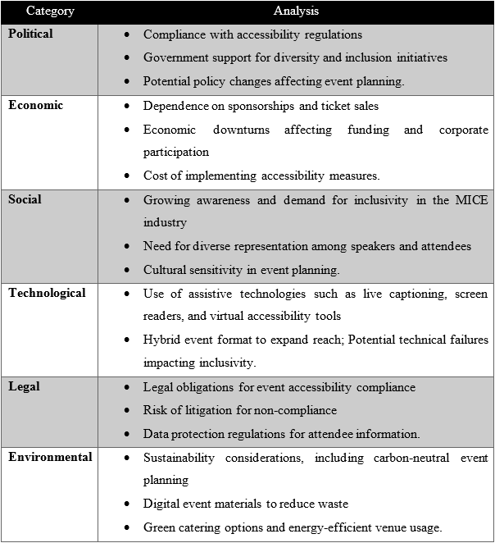
Political considerations influence event compliance (Belden et al., 2022). Government diversity programs and accessibility rules encourage event coordinators to use barrier-free designs and assistive technologies. Failure to meet legal accessibility criteria may result in fines and reputational harm. Economic factors have a considerable influence on event funding (Allen, Harris, and Jago, 2022). Economic downturns or organisational financial constraints may have an impact on sponsorships and ticket sales, which help to fund the event. Inclusive infrastructure and assistive technology can be expensive; thus, it is critical to set a realistic budget. Social considerations include cultural representation and inclusivity. Case studies, multilingual support, and diverse speaker panels are prioritised (Rouse and McBride, 2022). Social inclusion improves credibility, industry relevance, and attendee engagement.
Technological developments like virtual access, assistive technology, and live captioning help to improve accessibility. Platform compatibility and internet connectivity issues are risks linked with technology use (Botelho, 2021). It is critical to follow legal requirements on disability inclusion. The management of attendance data must also comply with data protection standards. Carbon-neutral planning, digital materials, and waste minimisation all contribute to event sustainability (Cavallin Toscani, Vendraminelli, and Vinelli, 2024). By addressing these situational and cultural issues, the Inclusive Event Planning Masterclass improves the MICE industry's strategic feasibility, compliance, and impact.

9. Conclusion
The Inclusive Event Planning Masterclass is financially sound, practical, and industry relevant. The event encourages best practices and addresses industry inequities, and there is a strong demand for accessible and inclusive event planning. Sponsorships, ticket sales, and vendor participation help to fund a sustainable budget with an expected net profit of £6,000. The curriculum encourages information sharing and collaboration by training participants on how to plan and execute inclusive events.
This event is based on a strong strategic purpose. Regulations, corporate social responsibility, and industry standards are all helping to boost the appeal of inclusive event planning. The event's finance plan promotes sustainability by balancing profitability and accessibility objectives. The training also covers long-term MICE market themes, such as digital accessibility, hybrid event models, and sustainability.
It looks promise to grow into hybrid forms and global accessibility programs. Future editions may include AI-driven assistive technologies, virtual reality inclusion training, and multilingual support. By widening its scope, the event has the potential to become a global benchmark for inclusive event management, increasing its long-term industry importance.

Reference List
Allen, J., Harris, R. and Jago, L. (2022). Festival & special event management. John Wiley & Sons.
Bladen, C., Kennell, J., Abson, E. and Wilde, N. (2022). Events management: An introduction. Routledge.
Botelho, F.H. (2021). Accessibility to digital technology: Virtual barriers, real opportunities. Assistive Technology, 33(sup1), pp.27-34.
Bowdin, G.A., Allen, J., Harris, R., Jago, L., O'toole, W. and McDonnell, I. (2023). Events management. Routledge.
Brown, S., Getz, D., Pettersson, R. and Wallstam, M. (2015). Event evaluation: Definitions, concepts and a state of the art review. International Journal of Event and Festival Management, 6(2), pp.135-157.
Cavallin Toscani, A., Vendraminelli, L. and Vinelli, A. (2024). Environmental sustainability in the event industry: a systematic review and a research agenda. Journal of Sustainable Tourism, pp.1-35.
Darcy, S. (2012). Disability, access, and inclusion in the event industry: A call for inclusive event research. Event Management, 16(3), pp.259-265.
Doran, A.L., Dutch, V., Warren, B., Watson, R.A., Murphy, K., Aldis, A., Cooper, I., Cockram, C., Harp, D., Desmau, M. and Keppler, L. (2024). Planning virtual and hybrid events: steps to improve inclusion and accessibility. Geoscience Communication, 7(4), pp.227-244.
Dowson, R., Albert, B. and Lomax, D. (2022). Event planning and management: Principles, planning and practice. Kogan Page Publishers.
Finkel, R. and Dashper, K. (2020). Accessibility, diversity, and inclusion in events. In The Routledge handbook of events (pp. 475-490). Routledge.
Finkel, R., Sharp, B. and Sweeney, M. eds. (2019). Accessibility, inclusion, and diversity in critical event studies (pp. 1-16). Abingdon: Routledge.
Getz, D. and Page, S.J. (2019). Event studies: Theory, research, and policy for planned events. Routledge.
Huggett, C. (2022). The Facilitator's Guide to Immersive, Blended, and Hybrid Learning. Association for Talent Development.
Jones, M. (2017). Sustainable event management: A practical guide. Routledge.
Litvinova-Kulikova, L., Aliyeva, Z., and David, L.D. (2023). MICE tourism: How the pandemic has changed it. Journal of Tourism and Services, 14(26), pp.197-218.
Mair, J. (2022). Sustainability developments at conference centers: A greener future for business events. In The Routledge handbook of business events (pp. 107-116). Routledge.
Mohamed, R. and Saber, S. (2022). Technological Innovation in Tourism and Events industry: A hybrid future of Events. International Journal of Tourism, Archaeology and Hospitality, 2(3), pp.271-286.
Morrison, A.M. (2023). Marketing and managing tourism destinations. Routledge.
Park, J.Y., Perumal, S.V., Sanyal, S., Ah Nguyen, B., Ray, S., Krishnan, R., Narasimhaiah, R. and Thangam, D. (2022). Sustainable marketing strategies as an essential tool of business. American Journal of Economics and Sociology, 81(2), pp.359-379.
Rogers, T. and Wynn-Moylan, P. (2022). Conferences and conventions: A global industry. Routledge.
Rouse, W.B. and McBride, D.K. (2022). Assistive Technologies for Disabled and Older Adults: Models of Use Cases, Market Economics, and Business Cases. In Handbook of Model-Based Systems Engineering (pp. 1-25). Cham: Springer International Publishing.
Setiawan, R., Wibisono, D. and Purwanegara, M.S. (2022). Defining event marketing as engagement-driven marketing communication. Gadjah Mada International Journal of Business, 24(2), pp.151-177.
Shalihah, A. (2024). It Implements in Meetings, Incentives, Conferences, and Exhibitions (Mice) Industry: A Systematic Mapping Study. Journal of Social Research, 3(3), pp.737-750.
Silvers, J.R., Bowdin, G.A., O'Toole, W.J. and Nelson, K.B. (2005). Towards an international event management body of knowledge (EMBOK). Event Management, 9(4), pp.185-198.

