Information operation management system based on SQL database

Catalog
Information operation management system based on SQL database 1
1、 Introduction 2
2、 SQL VS NoSQL 2
2.1 Main differences 3
2.2 Main advantages of SQL vs NoSQL 4
3. Indexes： 5
3.1、 Advantages of indexing 5
3.2、 Disadvantages of index 6
3.3 fields suitable for indexing: 6
3.4 High performance index strategy 6
4 Transaction 7
5 Distributed Database Solution 8
5.1 Establishment of distributed database 8
References 9

Introduction
This paper introduces SQL and NoSQL in detail, analyzes the differences between them, introduces their respective characteristics and advantages, combines with the specific examples proposed in the operation to analyze, design, index, query and other operations, creates the required database, which can meet the needs of abertware technology company. In addition, it designs and analyzes the distributed database, which achieves the goal of function enhancement effect.

SQL VS NoSQL

With the continuous expansion of Internet business, the types of business scope also continue to expand, and various applications appear one after another，So In this era of cloud services, there are more demands for technology, which are mainly from the following four aspects:

1. Low latency reading and writing speed: Quick response can make users have higher satisfaction;
2. Support main information and traffic: for large-scale applications such as search, we must use Pb level data and be able to cope with millions of traffic;
3. Cluster management: system administrator hope that distributed applications can be deployed and It's not complicated;
The consideration of huge operation cost: it managers want the hardware cost, It can reduce a lot of software and labor costs.

SQL (Structured Query Language) database, refers to the relational database - main representatives: SQL server, Oracle, MySQL (open source), PostgreSQL (open source).

NoSQL (not only SQL) generally refers to non relational database - main representatives: mongodb, redis, CouchDB.

"SQL is out of date." "Relational database management system (RDBMS) can no longer meet the data management needs of enterprises." "NoSQL and other new database technologies are the solutions suitable for today's enterprises." Such comments are rampant, both inside and outside the database technology industry. But are these words right? SQL is out of date. Is NoSQL the right solution for the future.

Although relational database plays a very important and crucial role in data storage, it is difficult to meet the previous requirements due to the limitations of everything.

1. Difficult to expand: It is difficult to expand: the multi table query mechanism makes the database expansion more unsatisfactory;
2. Reading and writing information is slow: this happens when the amount of data reaches a large scale. The composition of relational database information is so complex, it is very easy to have concurrency problems such as birth and death lock, so the reading and writing speed of relational database declines very seriously;
3. Expensive: the enterprise level database grant price is very high, and the system scale is becoming larger and larger, more and more information;
4. Poor after-sales support: the existing solutions can not support the explosive growth of data storage;

In order to be able to quickly solve this complex , the industry has launched vsrious of lated types of databases, and in some extend they have lots of differences with the conventional NoSQL database in design, they are referred to as "NoSQL" series databases. In the way, In the process of designing the whole program, the high concurrency of data and how to store massive data are the two most noteworthy points. They are more concise than relational databases in terms of architecture and data model, and add new things in terms of scalability and concurrency.

2.1 Main differences
(1)Type
SQL database is mainly called relational database (RDBMS), while NoSQL database is distributed database. It means non relationship.

- Storage mode
The structure of NoSQL database is dynamic architecture. Data can be stored in multiple ways. It can be document oriented, column oriented, graph based or organized key value storage, which is very flexible. In this way, it can create documents directly. Each document can also be designed as its own structure, and fields can be added at any time.

- Scalability
In the normal use process, the vertical scalable SQL database is in the majority. Then users can add ram, CPU or SSD to increase the load on a single server. In addition, NoSQL database is horizontal and scalable. Then users can slice or add more servers to the library to process more information. It's like building higher in a tall building, rather than building more in a neighborhood. As a result, NoSQL will become more complex and powerful, and the database will have more advantages in the face of large amount of data sets.

- Structure
SQL database is directly related to tables, NoSQL database is graphic database or wide column storage, and is based on key value pair and document. In this way, relational SQL is a better choice for applications that need to process transactions in parallel.

- Follow attributes
SQL database follows acid attributes (atomicity, homogeneity and oligopoly and persistence), while NoSQL database follows the principles of consistency, availability and partition tolerance.

- Support
All SQL databases provided by manufacturers provide strong support. furthermore, There are a lot of personal advisers who can help with large-scale deployment of SQL database, There are some NoSQL databases, you still have to rely on the support of the community, and Only external experts who meet the quantitative requirements can design large NoSQL with these things.

- language
The definition and operation of SQL database are implemented by data structured SQL language with complete functions. SQL is the most common option. In the face of complex large-scale queries, it is a very safe choice at present. But on the other hand, SQL is restrictive, it requires us to use the predefined schema to determine the data structure before using data, and all data must follow the same structure. A lot of preparation makes it impossible for us to change the system easily.

2.2 Main advantages of SQL vs NoSQL
The differences are shown in Table 1：

If your data is growing dramatically, The scalability you need needs to be fast and effective, and NoSQL may be right for you. But The data structure is not added or deleted and The growth curve is smooth and controllable, SQL may be the most reasonable for you.

In the process of project development to solve the service problem of Art Center, the process will face a problem of database selection. When choosing a database type, the most important choice is choosing SQL)or NoSQL structure. Although these two databases are feasible choices, according to the characteristics of the requirements, SQL seems to be a more correct choice.

SQL | NOSQL
Relational database management system（RDBMS） | Non relational or distributed database system
Database with fixed, static and predefined architecture | They have a dynamic architecture
Database not suitable for hierarchical data storage | These databases are most suitable for hierarchical data storage
These databases are most suitable for complex queries | These databases are not suitable for complex queries
Vertically scalable features | Horizontally scalable

Indexes：

Index is a data structure used by storage engine to find records quickly. Index optimization is the most effective way to optimize query performance.
An index can contain the values of one or more columns. If the index contains multiple columns, the order of the columns is also very important, because MySQL can only use the leftmost prefix column of the index efficiently.The structure of the index is shown in Figure 1.
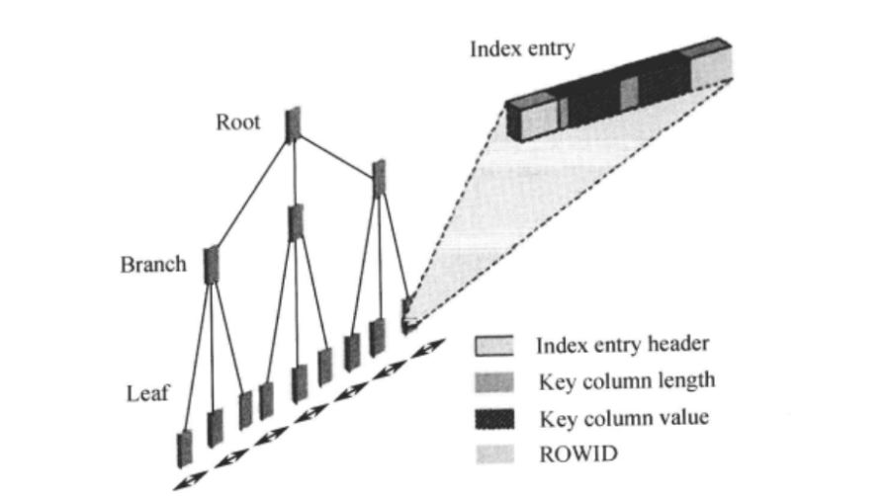
Figure 1:Index structure chart

3.1、 Advantages of indexing
In short, there are two main points:
- As for the way to find data, the index structure of B + tree balances the way of multi-channel search tree, which is fast

- In terms of query consumption, it means that the IO times of accessing data block are less, and then the scanning data block is small and less, so it is naturally faster

3.2、 Disadvantages of index
Although the index gives the query very good efficiency, it can not be abused.
By understanding the structure and principle of index, we can know that:

- Memory:The index is to get the data of the corresponding column into the memory, then arrange it in order, and build it in the free block of the disk, so as to produce the index block, which must occupy the disk space, because there will be ROWID (MySQL is the primary key) in the index, which is used to retrieve the data from the table, indicating that the space occupied by the index is larger than that of a column in the table. If every column has an index, the index will be larger A small meeting is bigger than a watch.

b.Update: after updating a field, you need to go to the index block to update the index, resulting in extra overhead. However, this update only needs to update the field of the index (for the column in the index)
Delete: it's different to delete data. To delete a piece of data, if there are too many indexes, you need to delete the values in each index, resulting in more overhead.

3.3 fields suitable for indexing:
1: Frequent search
2: Frequent sorting
3: It often follows the where statement
4: Small data type
5: Simple data type
6: Try to avoid null in columns

3.4 High performance index strategy
Independent columns:Independent columns are index columns, which cannot be part of an expression or parameters of a function. If the columns in the query are not independent, MySQL will not use indexes.

Prefix index and index selectivity:Sometimes you need to index a long column of characters, which makes the index big and slow. Usually, the characters at the beginning of the index can be indexed, which can greatly save the index space and improve the efficiency of the index. But this will reduce the selectivity of the index.

Multi column index:In MySQL or later versions, the strategy of "index merging" will be used. Queries can scan with two single column indexes at the same time and merge the results. There are three variants of this algorithm
1).Union of or conditions.
2).Intersection of and conditions.
3).Combination and intersection of the first two cases.

Select the appropriate index column order:The correct index order depends on the queries that use the index, and at the same time, we need to consider how to better meet the needs of sorting and grouping.

Cluster index:InnoDB's clustered index actually stores B-tree indexes and data rows in the same structure. Its data is actually stored In the content of the index.
Clustering "means that data rows and adjacent key values are tightly stored together. Because data rows cannot be stored in two different places at the same time, a table can only have one clustered index (primary key index).There is a big difference between clustered index and nonclustered index, that is the fundamental difference between clustered index and Nonclustered index refers to whether the context content of the table record is consistent with that of the index.

Overlay index:If an index contains (or covers) the values of all fields that need to be queried, we call it an "overlay index."

Index and lock:InnoDB locks rows only when they are accessed, and index can reduce the number of rows accessed by InnoDB, thus reducing the number of locks.

To solve this problem, the corresponding secondary index is established, the appropriate primary key value is selected, and the primary key index (including a unique index, null value is allowed) is created. ）Each time you look up the data, find In the node, the primary key value cluster index gets complete record information.

In the most important field to establish an index, from the database as a whole can know, ticket_ The booking table contains many important information, such as the location, number, program number and price of the theater. These information are frequently queried, so a non clustered index is added to the three columns of booking time, company name and theater number. In this way, the primary key value corresponding to the record can be found, and the primary key value can be clustered to the required information.

4 Transaction
This database establishes a ticket_ID Theatre_ Repertaire_ id 、Theatre_ id Customers_ ID_ Card、Ticket_ seat_ number、Ticket_ Cost and other data tables, set different primary keys and foreign keys for each table, and establish the relationship between each table. Set the ticket ID of the ticket table as the primary key of this table. In this table, there are other information such as the contrast ID of the theater, theater ID, theater seat number, consumer ID card, ticket price, etc. In data query, key information such as seat, ticket price and theater name can be found through ticket table, and then the information can be queried through the detailed information established by each table.

The definition of transaction needs to be explained as follows:
- A database transaction can have one or more database operations, which are logical and complete.
2. If the database operation that constitutes the logical whole fails, it will fail.
3. All the operations that make up a transaction either have an impact on the database or have no impact on it. That is to say, the database can always maintain a consistent state regardless of whether the transaction is successfully executed.

A database transaction usually contains a sequence of operations to read or write to the database. It has two purposes
1. It provides a method to recover from failure to normal state for database operation, and also provides a method to keep consistency of database even in abnormal state.
2. When multiple applications are accessing the database concurrently, At the same time, these applications can be isolated to avoid unexpected interference between operations.

Database transaction can solve these two problems: 1. Sometimes the booking of the venue is recorded, However, the specific date required by the production company is not recorded in the system. 2. Customers can book inactive tickets.

If the details of a specific date are not recorded in the system, the submission is not allowed for a long time.
If there are no relevant tickets, consumers can not book tickets.

5 Distributed Database Solution
Distributed cluster can solve the problem of big data storage and access explosion. The key point of distributed system is to make multiple servers work together at the same time to complete complex tasks, especially in the face of high concurrency or large amount of data tasks.
Distributed database is the product of the combination of database technology and network technology. Through the network operation technology, the physically separated databases are connected together to form a huge data aggregation and realize the centralized management and efficient management of the logical layer.

5.1 Establishment of distributed database
1. The space table is used as the basic table to store the important information such as the location and capacity of the theater, which can be divided into different types of venues horizontally. Transverse distribution.
2. Establish a company booking table, which can be vertically distributed.
1. Company information and schedule that the company can book
2. Booking information and related fees
3. Store the ticket information corresponding to the company booking cinema
Realize Booking
4. Horizontal distribution of ticket contents.
Conditions: distinguish the number of tickets purchased
- Price list of activity tickets can be distributed horizontally.

References
- S. Harizopoulos, et. al., "OLTP Through the Looking Glass, and What We Found There," Proc. 2008 SIGMOD Conference, Vancouver, B.C., June 2008.
- M. Stonebraker, et. al., "The End of an Architectural Era (It's Time for a Complete Rewrite)," Proc. 2007 VLDB Conference, Vienna, Austria, Sept. 2007.
[3] B. Cooper et al, "Benchmarking Cloud Serving Systems with YCSB", ACM Symposium on Cloud Computing (SoCC), Indianapolis, Indiana, June 2010.
[4] F. Chang et al, "BigTable: A Distributed Storage System for Structured Data", Seventh Symposium on Operating System Design and Implementation, November 2006.
[5]Liu ziye. Introduction and Enlightenment of major domestic micro databases 〔 J 〕. China Statistics, 2018 (7): 35-37

