Tiegan Hughes
1701231
3D Computer Animation
Contextual Studies ways of perceiving
ADAD4010
Tutor: Scott Smith

Colour, identity and representation
Colour has been used throughout history “to make a statement, create atmosphere or call forth a response” from those that participate (Yeoman, 2019). Areas of society that use colours include fashion, marketing and design, art and culture and everyday life.
This interdisciplinary exhibition explores colours and how they are used across areas within contemporary culture such as social media, music, marketing, fashion and gender identity it also introduces the visitor to the mind of person with disability conditions.
For all the artists involved repetition to hone their work is important, to develop their craft, from a personal perspective repetition is comforting due ASC. Artists selected all use colour or colour effects in a different way, for example Jeffrey Jey has a colour in his song title, but Green Day have a colour in their name. Artists selected have also been chosen for the range of media work, including video, audio, photoshoot and 2D imagery and a prosthetic facial mask.
This exhibition will include two options both physical and virtual so that people with disabilities can access the space; the physical environment, will be within a cube shaped room, there would be a wall for each of the artists who have video or images, the intention is also to display the lyrics as this would be accessible for those with dyslexia, audio processing disorders, autism and hearing loss, this would be put on the remaining wall in big text and a non-white background to be accessible for those with Irlen syndrome. The last artist is Alexis Stone but as I would be displaying his prosthetics that he used when he had his fake plastic surgery they would be in the centre of the room.
On completion of the exhibition, it would continue to be available for people to see, this is also to facilitate if they could not make it or lived far away and this would be in 3D format online maybe for use with virtual reality or 360 photo format.
Fig. 1 Internal exhibition designs1 Fig. 2 Internal exhibition designs 2

Fig. 3 Drawing of exhibition space
Fig. 4 Drawing of exhibition space
Fig. 5 3D model of exhibition space
Fig. 6 3D model of Lyrics Colour Inside Her, Jeffrey Jey

Audio and lyrics available (Jeffrey Jey AKA Gianfranco Randone) Jeffrey Jey is from Italy and was a former member of Eiffel 65 (they still tour as a duo however, he currently is working solo). Most of his songs are in Italian for example Adesso per sempre (2017) and Da quando ci sei te( 2018), however, some of them are in English for example Out of your arms( 2012) and Color inside her( 2013). The lyrics of this song repeat colour for different reasons for example one of the lyrics goes “The color in my sight with colors so bright” and “the color that paints all the things that I am” mostly every line colour represents a different meaning or object.
Similarly another Musical artist was selected but this time it is a band and that’s Green Day even though I will not have their music playing even though they have a song with a colour in the title such as Stop when the Red Lights Flash (2012), I wanted to show something different and that was their band logo on album art. Green day have changed their logo for each album to evolve with the style they where currently in. Green day wouldn’t be used for their music however they have many albums with different logos on and their name also represents a colour and that is green.
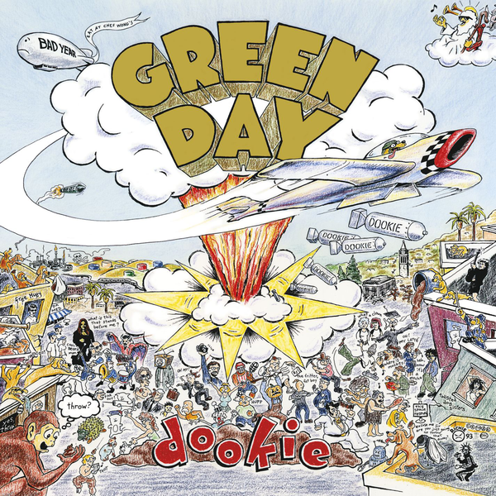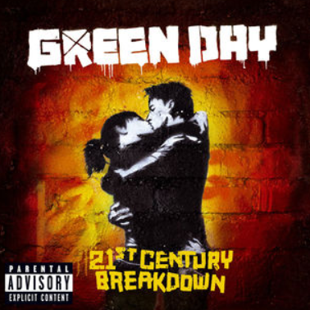
Fig 9 Album cover Art,
21st Century Breakdown
Chris Billheimer,

Fig 7 Album cover Art, Doofie
by Richie Bucher

Fig 8 Album cover Art,
American Idiot,
Chris Bilheimer

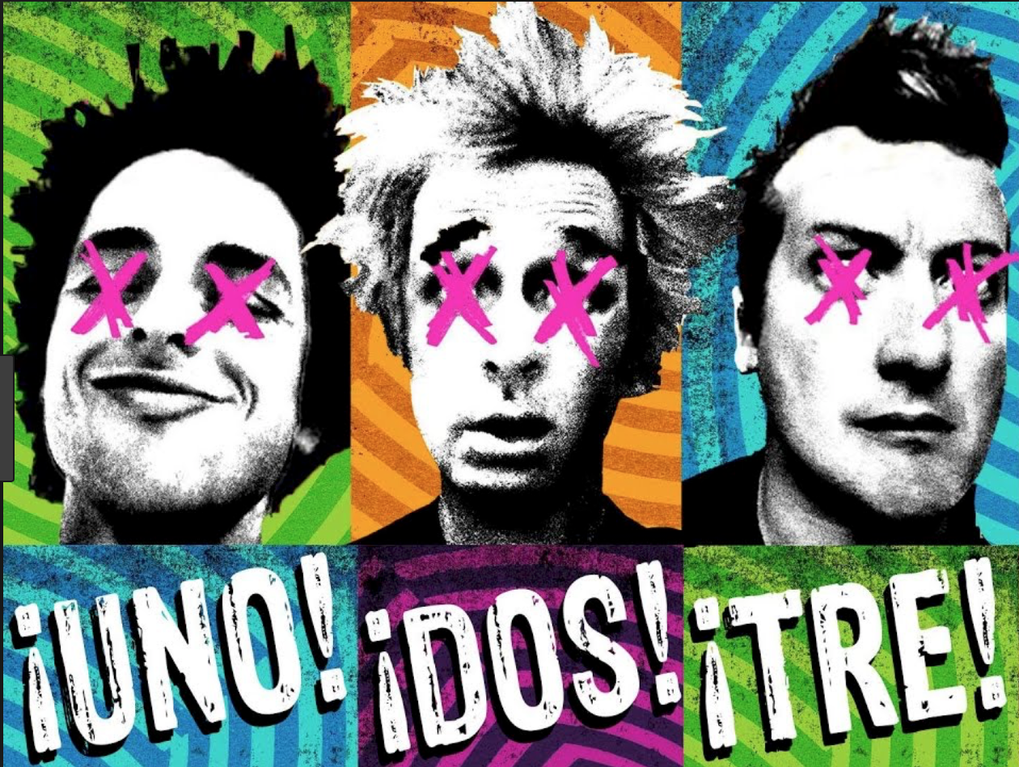
Fig. 10 Album Covers Style, designer Chris Bilheimer
I only chose a few albums as they have 11 albums, so I chose Dookie, American Idiot, 21st Century Breakdown, Uno, Dos and Tre
For the album Dookie their band logo is more detailed than the rest of their albums as it is included within the album art as part of the explosion and underlined by the plane smoke contrasting this is American Idiot which is a simple black, white and red design, however, the logo stands out more as it is white against a black background and the album art is not as busy. This album is also designed by cover artist Richie Bucher. For 21st century breakdown the logo changes but not its colour. The album art is closest to Dookie as it has the graffiti style art, however, there’s less colour as it is only black, white and orange. The band logo is above the album art just like Dookie, however, it is not really tied in. The band logo is also still white, however, it appears spray painted instead of solid text and it is all on one line. It also has an X through the R.
Uno, Dos and Tres are separate albums however, were all released in the same year making them a trio. They have the same band logo as American Idiot however they all have different colours that contrast the colour of the album art.
Following on from Green Day and their always changing logo Jenna Drawing links in to Green Day as they always recreate the same item that has the same meaning. Jenna Re-draws her rainbow haired girl (that is now called Iris) every year to see if there is any improvement in her art style. She is never too sure if she has changed or improved so re-drawing the same thing and then putting it side by side shows the real improvement or turned out worse than the one before. This gives opportunity when a year later you can change that again.
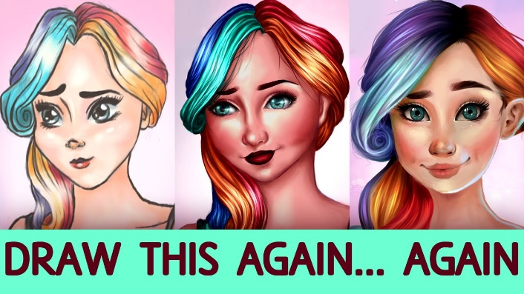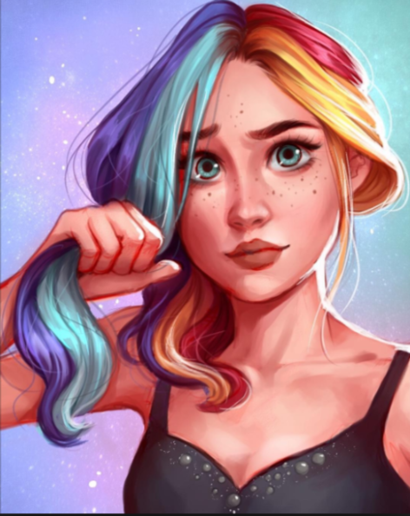
Fig. 11 Jenna Drawing (Jenna Bushell) Rainbow Hair Girl video

Jenna Drawing is 19 years old Jenna Bushell and comes from England. She is currently a student studying 3D computer animation but prefers drawing in 2D. she is well known because of her youtube channel and has a fan base. Every so often she does a “Drawing your OC’s” video where she draws people’s original characters which they have submitted using the “JennaDrawMyOC” tag on Instagram this is used to also critique the persons work and can help them improve.
Similarly, Jeffree Star took his bestselling palette and re-designed it however, this time turning it blue so people with cool undertones can use this palette. Also Jenna’s rainbow haired girl has cool tones one side and warm tones the other side.
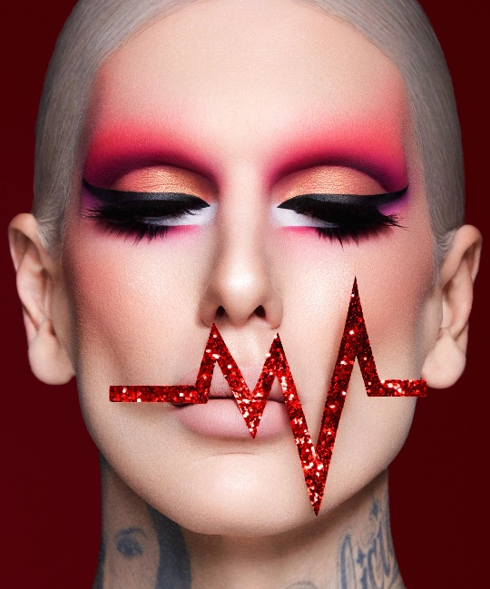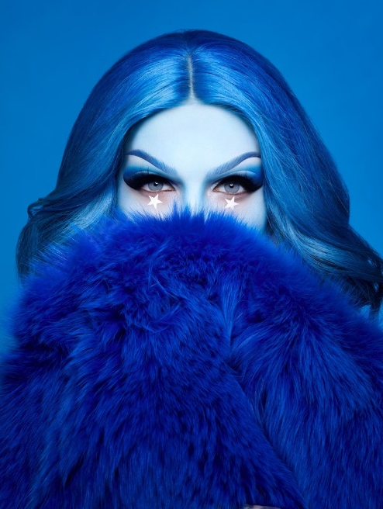
Fig. 12 Blood Sugar (Jeffree Star) Fig. 13 Blue Blood Sugar (Jeffree Star)
The first photo is from his Blood Sugar palette photoshoot and second is from the Blue Blood palette photoshoot
He created a blue version of one of his best-selling palette blood sugar. It was mostly targeted for a smaller audience as neutrals are more popular than blues and cool tones.
Jeffree star and Alexis Stone both link together because they are both Gay men who wear makeup and go against the gender roles by dressing in a “feminine” way, this can also be linked contextually to Queer theory, which first appeared in the early 1990s. According to this theory sexual meanings are inter-dependant on historical sociocultural influences and “inextricably woven in a web of unequal social relations” (Kates, 1999 p.26) that establish one’s self-understanding of gender and sexual identities. According to queer theory the biological male may have a feminine gender identity.
“‘Queer’ in Queer theory refers both to an identity (that of a non-heterosexual person, context, image, or situation) and a positionality that opposes the normal” (Kates, 1999 p.27) so that positions itself against normal conventions.
“It revels in parody, pastiche and spectacle for its playful deconstructive spirit delights in exposing the artificiality of gender” (Kates,1999, p.28) All three descriptive words should be further explained; parody means a deliberate exaggeration or caricature, pastiche is the imitation of another work; and spectacle which is a visually striking performance. Both people also link to the overall title because they use colour in different ways and they also repeat actions and use colour in a different way.
Alexis Stone is best known as a prior drag queen and has a channel where through makeup he transforms into other personalities, in doing so he has gained a huge following in a quote from Beauty Bay, Stone describes his methods which links to parody “Jeffree Star was the most challenging …The trick is to look at someone’s face and dissect their features, almost looking at it as a caricature” (Day, 2018).

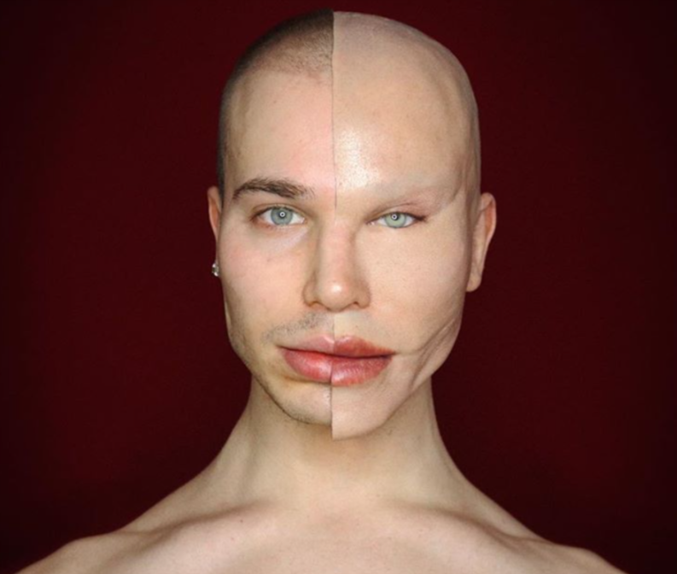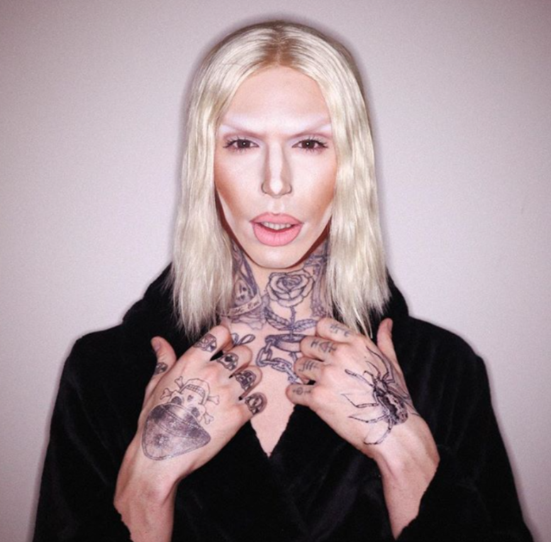
Fig. 14 Alexis Stone before and after

When he had his fake plastic surgery he lost many fans because they were disappointed in what he did to his face, they called him botched and told him he ruined his face and was no longer attractive. When he ripped the face off on New Years Day some of the people tried to come back to support him again. This showed that society saw his looks were more important than his artistry. He worked with David Marti a SFX artist from Barcelona who has worked on many films to create his prosthetics that were inspired by “botched” plastic surgery. He mentions this in his video: The making of Alexis Stone
All these artists share two common traits, the use of colour and constantly improving, however, keeping consistent. They all try again and again, for example Jeffrey Jey had a second try at his music career as Eiffel 65 wasn’t giving him the musical satisfaction he wanted, Jenna re-draws her favourite characters every year as her art style changes regularly, Green day changes their logo every album to suit the style of it, Jeffree star remade his red palette to suit cool toned people and Alexis Stone keeps coming back with original content.
For Jenna I would display the Draw this again drawing and the video she made, for Jeffrey Jey I would have the audio and lyrics available, for Green Day I would add their logos from over the years, Alexis Stone would have the prosthetics he used and for Jeffree star I would have photoshoot images from both blood sugar and blue blood.

Bibliography
Fig.1 Hughes, T. (2019) Internal exhibition Space 1[digital drawing]
Fig.2 Hughes, T. (2019) Internal exhibition Space 2 [digital drawing]
Fig.3 Hughes, T. (2019) Drawing of exhibition space [digital drawing]
Fig.4 Hughes, T. (2019) Drawing of exhibition space [digital drawing]
Fig.5 Hughes, T. (2019) 3D model of exhibition space [digital drawing]
Fig.6 Hughes, T. (2019) 3D model of exhibition space [digital drawing]
Fig. 7 Bucher, R. (1994) Dookie Green Day [album cover] Available at: https://itunes.apple.com/us/album/dookie/1160081985 Accessed: 02/04/2019
Fig. 8 Bilheimer, C American idiot Green Day[album cover] Available at : https://itunes.apple.com/gb/album/american-idiot-deluxe-version/207192731 Accessed: 02/04/2019
Fig. 9 Billheimer, C. 21st Century breakdown Green Day [album cover] Available at: https://itunes.apple.com/gb/album/21st-century-breakdown-deluxe-version/315605291 21st Accessed: 02/04/2019
Fig. 11 Bushell, J. (2018) Rainbow Hair girl Jenna Drawing [video] Available at: https://youtu.be/JT5wIKioqDo Accessed: 28/03/2019
Bushell, J. (2018) Rainbow Hair girl Jenna Drawing [drawing] Available at: https://youtu.be/JT5wIKioqDo Accessed: 28/03/2019
Jey, J. (2013) The Colour Inside Her - Available at: https://youtu.be/TJqPXvUcCR4 Accessed: 13/04/19
Stone, A. (2019) The Making of Alexis Stone [video] Available at: https://youtu.be/U0lUi6YPcqc Accessed: 01/05/19
Kates, S. (2013). Making the Ad Perfectly Queer: Marketing “Normality” to the Gay Men's Community?. Journal of Advertising. 28. 25-37. 10.1080/00913367.1999.10673574. pp.27-28 Accessed: 24/04/19

Day,G. (2018) An Interview With Alexis Stone, The Drag Queen Who Can Transform Himself Into Any Celebrity, Available at: https://www.beautybay.com/edited/alexis-stone-drag-queen-interview/ Accessed: 01/05/19

