Certificate of Higher Education Skills for the Workplace (Health & Social Care)

LCHS4007 - Digital Skills and Research Methods

Title: The use of Excel in health & social care setting

Component 2 – Research Report

Student Name: KEDIJA ALI HUSSEN
Student ID: 2434785
Date of Submission: 19/12/2025

Executive Summary
The healthcare professional uses the MS Excel tool for maintaining patient data and analysing it in an adequate manner. This report has explained the advantages of this tool to optimise the resource allocation process and develop a decision-making procedure. Excel has an integral role in health and social care setting. In relation to data management, accuracy it contribute largely. The health and social care consist various sensitive information of patients, as well as data related to stakeholders, including doctors, investors, and nurses, these have been maintained through Excel. Moreover, and individual can maintain their health routine, diet plan, exercise plan through Excel. The reasons for choosing the secondary qualitative method for collecting data have been evaluated in this report.
Table of Contents
Introduction 3
Main analysis 4
Task 1 - Identification of Research topic 4
Task 2- Research methodologies 7
Task 3- Data collection 8
Conclusion 10
References 11

Introduction
In the present days, most healthcare firms have utilised MS Excel to manage essential data and maintain essential information. In terms of tracking patient data and managing resources, the healthcare professionals have utilised the MS Excel tool (Keating et al. 2021). The R&D department of the healthcare professionals has utilised this tool to manage trial data and analyse findings. This report focuses on the importance of using MS Excel in health and social care services. A brief overview of quantitative and qualitative research evaluates this study with a brief explanation. The main differences between primary and secondary data collection methods and reasons to choose the secondary data collection method evaluates this report.

Main analysis

Task 1 - Identification of Research topic
Problem/issue
Data management and accuracy are one of the major concerns in the health and social care setting, which increases the chances of data inconsistency. This issue can hamper the quality of service delivery to the patient in healthcare. In order to get rid of this difficulty, the use of Excel is necessary for health and social care, which offers high flexibility for data management. The complex analysis of data is required for this setting; in some cases, health and social care organisations fail to do so, which creates dissatisfaction among patients (LaPolla, 2020). The social care or healthcare firms prioritise Excel to analyse complex patient data with visualisation.
Need for the research
The research relating to the utilisation of Excel for health and social care settings is needed as it provides a better understanding of data accuracy and reliability. Excel is versatile and has various limitations to manage large datasets, which also includes complex statistical analysis (Cleverley et al. 2023). This research analyses the accuracy of data entry and the reliability while managing sensitive information of patients. On the contrary, healthcare and social care professionals highly rely on data analysis in order to make informed decisions. This report explores the Excel-driven data analysis of healthcare, which influences decision-making. Moreover, the requirement of this research is high as it handles records of patients, like their demographic information, medical history, as well as treatment plans, and so on. It has the ability to store and analyse data related to the development of drugs, clinical trials, along with the outcome of patients. In relation to resource management, including inventory, employees, and financial management of health and social care, Excel contributes a lot (Hunter et al. 2022).

Three sources for research, explanation, and justification for selection
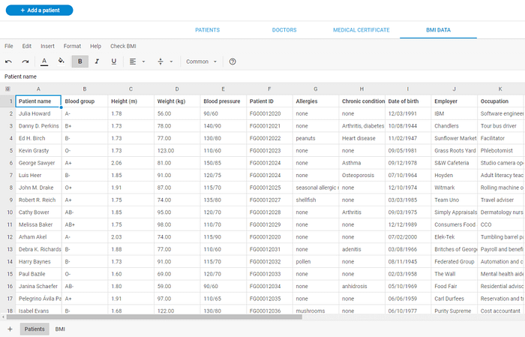
Figure 1: Spreadsheet utilised in recording patient information
(Source: Medium, 2022)
I have selected the source named spreadsheet utilisation in healthcare, because it offers a robust understanding of patient data management. It also sheds light on the use of Excel spreadsheets for medical research. Each of the tasks and functions of healthcare has been maintained through the Excel spreadsheet. This becomes advantageous to collect and maintain information about patients. Further, the hospital personnel track the health status of patients in the hospital through Excel. Besides, the patients' bed allocation, editing, or replacing the patient records are done by the spreadsheet. Moreover, it permits medical assistants in order to collect data with the maintenance of convenience. At the time of record analysis, the health or social care professional syncs the data of patients and applies mathematical formulas to calculate the outcome. For example, healthcare professionals check the BMI of the patients, which provides a minute understanding of the need for extra care. On the contrary, Excel is used by the medical researcher. For instance, the FEMSA Biotechnology Centre uses an Excel spreadsheet while modelling vaccination practices (Medium, 2022). The core aim of this centre is to analyse the significance of vaccination rate in COVID-19 in urban locations, including Mexico, Brazil, and so on.

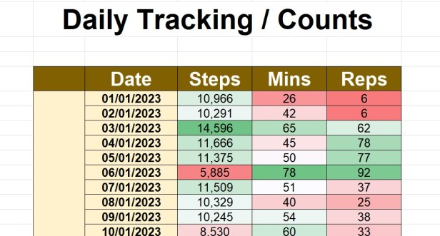
Figure 2: MS Excel used in tracking fitness goals
(Source: Excelattheoffice, 2025)
I have also chosen the website named Tracking of health and fitness goals in Excel. This source consists of the diet plan, exercise plan of an individual through Excel. Excel provides numerous templates as well as tools that become beneficial to track different perspectives of one’s fitness journey. One can use this for their workouts, nutrition, along with weight management. Moreover, Excel supports one to record the progress by using separate tabs (Support. Microsoft, 2024). A person can use the Week 1, Week 2 tabs to log workout data, which can help the individual, to note down weightlifting, reps achieved, along with other relevant details. The people who are in strict diet use Excel for meal planning. They take support from a template to plan for the weekly meals, which specifies the food items, the size of protein, the number of calories, and so on.
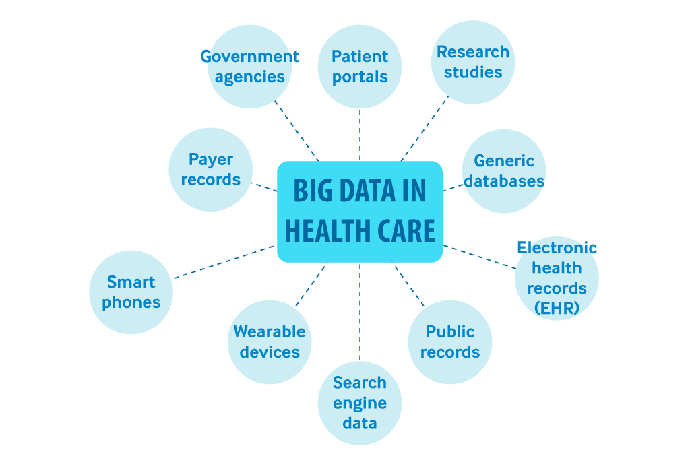
Figure 3: Types of Big Data used in Healthcare
(Source: Catalyst, 2018)
I have selected the journal named Big Data analytics in healthcare, which emphasises spreadsheets. The reason for choosing this book is it describes the Excel Spreadsheet and its importance for data analysis, which is used in healthcare settings. Big data includes cloud computing, which highlights a data-centric ecosystem, and in that, Excel has an integral role (Iyengar et al. 2019). The healthcare system prioritises different stakeholders, like doctors, patients, nurses, and so on. In order to maintain the systematic process of tracking their data, an Excel spreadsheet is integral. The sensitive health-related data need strong technological support, and spreadsheets contribute largely in maintaining those.

Task 2- Research methodologies
Quantitative research
As stated by Kittur (2023), quantitative research is all about a systematic investigation process that is used for collecting numerical data and completing the statistical analysis process. The application of this quantitative research method helps to reduce bias and properly measure results. Furthermore, this research method is efficient for collecting data and optimising the discussion process.

Qualitative research
The qualitative research method involves collecting and analysing non-numeric data for in-depth understanding. Researchers consider this type of research method for understanding complex phenomena and exploring new topics (Thunberg and Arnell, 2022). Furthermore, this type of data collection method has played a crucial role in generating hypotheses and offering flexibility.
Chosen methodology and reasons for choosing
The entire research will be focused on the usage of Excel in health and social care settings. For successfully conducting this research, qualitative research method will be used in this research. This research method can be valuable for collecting a wide range of information on the utilisation of MS Excel in healthcare activities. Furthermore, this method will also be valuable for broadly evaluating the significance of using the MS Excel tool for analysing for managing healthcare data and interpreting them in an appropriate manner. For understanding the complicated phenomena on the research topic, the researcher will follow the qualitative research method (Pyo et al. 2023). Moreover, this research method will be valuable for the researcher to identify the intangible factors about this research topic. The necessary information gathering process will be optimised by following this research method.

Task 3- Data collection
Difference between primary data and secondary data
As stated by Cerar et al. (2021), in the primary data collection method, essential information mainly collected by researchers, whereas in the secondary method, researchers utilises the pre-existing information for conducting the research and fulfilling all the objectives. For completing the primary data collection method, researchers conduct survey, interviews, observations and focus groups. Whereas the secondary data collection method is done by using journals, articles and websites and many more. Research follows the primary method for answering specific questions, gaining insights and testing hypotheses. On the other hand, one of the major purposes of following secondary methods is providing background information and identifying trends.
The chosen data collection method and the reasons for choosing it
The entire research will be focused on the importance of Excel in health and social care settings. In terms of conducting this study, the researcher will follow a secondary qualitative data collection method. Secondary data collection method helps to mitigate the excessive time consumption issue and properly address the research problem (Cheong et al. 2023). In order to collect secondary data collection method, the researcher will utilise relevant journals, articles, and websites. This method can help in giving in-depth information about the significance of MS Excel in the health and social care ventures. It will be valuable for determining the challenges of using this software tool and strategies to mitigate these issues. In terms of gaining a more comprehensive understanding of the effectiveness of Excel in the health care industry, a secondary method will be followed.

Conclusion
Nowadays, most health and social care firms have utilised the modern data management software tools, and MS Excel is one of them. The application of this software tool helps to manage patient data and interpret them in an appropriate manner. For increasing the efficiency of financial tracking, the health and social care firms have utilised Excel. This software application has optimised the decision-making process. The quantitative method gives major priority to collecting numerical data, whereas the qualitative method focuses on collecting non-numerical information. In order to gather several information about the usage of Excel in patient care, the research will consider a secondary qualitative method. Relevant information and essential data will be collected through secondary resources such as authentic websites, articles and journals. This method could be significant in gathering the challenges of using Excel for completing operational activities of this sector, as well as it could be valuable for minimising bias.

References
Catalyst, N.E.J.M. (2018) ‘Healthcare big data and the promise of value-based care’, NEJM Catalyst, 4(1). Available at: https://catalyst.nejm.org/doi/full/10.1056/CAT.18.0290
Cerar, J., Nell, P.C. and Reiche, B.S. (2021) ‘The declining share of primary data and the neglect of the individual level in international business research’, Journal of International Business Studies, 52(7), pp. 1365-1374. Available at: https://link.springer.com/content/pdf/10.1057/s41267-021-00451-0.pdf
Cheong, H.I., Lyons, A., Houghton, R. and Majumdar, A. (2023) ‘Secondary qualitative research methodology using online data within the context of social sciences’, International Journal of Qualitative Methods, 22, pp. 16094069231180160. Available at: https://journals.sagepub.com/doi/pdf/10.1177/16094069231180160
Cleverley, W.O., Cleverley, J.O. and Parks, A.V. (2023) Essentials of health care finance, Jones & Bartlett Learning. Available at: https://books.google.com/books?hl=en&lr=&id=CI7hEAAAQBAJ&oi=fnd&pg=PP1&dq=Excel+for+health+care+book&ots=GLuhlJb6Q-&sig=8Hy433zSJDWqOH0wx1Pwvd1lbGE.
Excelattheoffice (2025) Simple Excel Daily Fitness Tracker. Available at: https://excelattheoffice.com/2023/01/02/simple-excel-daily-fitness-tracker-for-2023/ [Accessed on: August 1, 2025]
Hunter, K.E., Webster, A.C., Page, M.J., Willson, M., McDonald, S., Berber, S., Skeers, P., Tan-Koay, A.G., Parkhill, A. and Seidler, A.L. (2022) ‘Searching clinical trials registers: guide for systematic reviewers’, Bmj, 377. Available at: http://dx.doi.org/10.1136/bmj%3C2011%3E2021%3C2011%3E068791.
Iyengar, S.P., Acharya, H. and Kadam, M. (2019) ‘Big data analytics in healthcare using spreadsheets’, In Big Data Analytics in Healthcare (pp. 155-187), Cham: Springer International Publishing. Available at: https://link.springer.com/chapter/10.1007/978-3-030-31672-3_9.
Keating, P., Murray, J., Schenkel, K., Merson, L. and Seale, A. (2021) ‘Electronic data collection, management and analysis tools used for outbreak response in low-and middle-income countries: a systematic review and stakeholder survey, BMC public health, 21(1), pp. 1741. Available at: https://link.springer.com/content/pdf/10.1186/s12889-021-11790-w.pdf
Kittur, J. (2023) ‘Conducting quantitative research study: A step-by-step process’, Journal of Engineering Education Transformations, pp. 100-112. Available at: https://journaleet.in/index.php/jeet/article/download/290/290
LaPolla, F. W. Z. (2020) ‘Excel for data visualization in academic health sciences libraries: A qualitative case study’, Journal of the Medical Library Association, 108(1), pp. 67–75. Available at: https://doi.org/10.5195/jmla.2020.749
Medium (2022) Using Spreadsheets in Healthcare: Relevant Examples and Their Advantages. Available at: https://dhtmlx.medium.com/using-spreadsheets-in-healthcare-relevant-examples-and-their-advantages-3a261330f312. [Accessed on: August 1, 2025]
Pyo, J., Lee, W., Choi, E.Y., Jang, S.G. and Ock, M. (2023) ‘Qualitative research in healthcare: necessity and characteristics’, Journal of preventive medicine and public health, 56(1), pp. 12. Available at: https://pmc.ncbi.nlm.nih.gov/articles/PMC9925284/pdf/jpmph-22-451.pdf
Support.microsoft (2024) Track your health and fitness goals in Excel. Available at: https://support.microsoft.com/en-us/office/track-your-health-and-fitness-goals-in-excel-322af086-734b-4837-ba4f-410c6bceccd4. [Accessed on: August 1, 2025]
Thunberg, S. and Arnell, L. (2022) ‘Pioneering the use of technologies in qualitative research–A research review of the use of digital interviews’, International journal of social research methodology, 25(6), pp. 757-768. Available at: https://www.tandfonline.com/doi/pdf/10.1080/13645579.2021.1935565

