

Student Name – Salmankhan Ayazkhan Pathan
Student Number - 2433002
Module Name: - Strategic Management
Module Code: - LCMB7003
Lecturer Name: - Jia Miao
Assignment Title: Individual report
Company: - Primark
Term 2

Table of Contents
Introduction 3
Overview of company and country 3
Comprehensive strategic analysis 5
PESTEL 5
Porter five forces 7
Porter Diamond model 8
Strategic development and formulation 9
Ansoff matrix 9
Porter Generic strategies 11
Formulation of market entry strategy 12
Establishing a competitive advantage in a new market 13
Performance evaluation framework 14
References 17

Introduction
Strategic management (SM) is a discipline that mainly describes approach of the company to develop suitable strategy for long-term growth and development and analysis of its strategic environment to attain these goals and objectives. The process typically includes application of different models and framework for evaluating the firm’s performance within the business environment and assessing the future plans and strategy of the brand to move ahead and attain its goals and objectives. The present report is based on analysis of strategic management approach and practice adopted by Primark in the current business environment and its strategic plan to expand its operations in the market of India in the future. The report will involve conducting strategic analysis, developing new strategy for expansion and evaluation of the newly formulated strategy in the long-run using range of SM models and frameworks.

Overview of company and country
Primark is a fashion retailer that has strong presence in the European market and is headquartered in Dublin, Ireland. The England’s head office of Primark is in Reading, England and the brand has very strong presence in the domestic fashion retail market of the UK. Apart from the UK and Europe, the brand has its strategic presence in United States, and also has franchisee stores in Kuwait and Dubai as well. The brand has strong brand awareness and reputation in the domestic market and also has a loyal customer base contributing towards the growth and development of Primark.
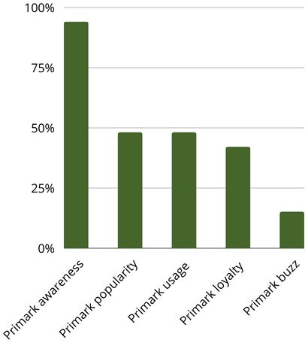
Figure 1: Primark brand value
(Source: Hegart, 2023)
The graph above reflects the strong brand awareness, popularity, usage as well as loyalty of Primark in the market of the UK (Hegart, 2023). This also implies that the brand has very well established market in the UK, and across the Europe, that significantly contribute towards its growth and development in the long-run. Due to the fact that the selected brand has very limited presence outside Europe, therefore, expansion of the brand in any market outside of Europe will be justified. For the purpose of its international expansion, India will be selected as potential country. The key rationale behind selection of India as potential country for expansion will be that it is an emerging economy with massive population and increasing demand of fashion items in the current times.
The apparel and fashion market in India is booming at a rapid pace, with increased demand of trendy fashion items and accessories in the market. The apparel market size in India touched USD 115.6 billion as of 2025 (IBEF, 2025). The growth of this market is supported by increased adoption of e-commerce and online shopping trend in the selected market, as well as rising popularity among trendy and fashionable products among the young consumers in the Indian market.
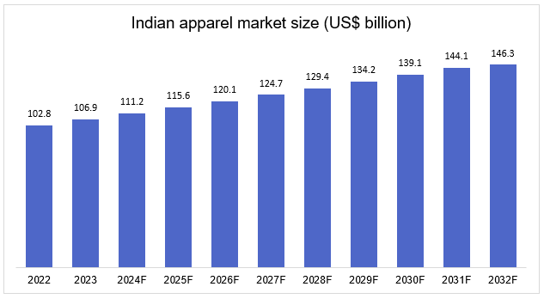
Figure 2: Apparel market in India
(Source: IBEF, 2025)
The graph above illustrates the market size growth of the apparel market in India, where it can be observed that the market is forecasted to reach USD 146.4 billion by the end of 2032 (IBEF, 2025). This also implies that the market is growing rapidly and will be forecasted to grow even quicker in the near future. This is also one of major rationale why expansion of Primark in the market of India will be justified, as result of increasing market growth rate and demand in the market. Also, looking at the strategic considerations, assessing the various factors regarding market viability and strategic fit for the brand to expand is also useful. In the case of selected market, it can be determined that the economic context of India can be one of major reason why it will be selected as market to expand. Since the economy of India is growing rapidly, along with strong population growth rate and increased spending power of the customers in Indian market, the expansion of Primark in the Indian market can be justified.

Comprehensive strategic analysis

PESTEL
The PESTEL analysis lays emphasis on various factors such as political, economic, social, technological, environmental, and legal. In terms of the political factors, it can be observed that there is political stability and an investment-friendly environment in India (Makvandi, 2024). The government has focused on progressive liberalization over the years and has also allowed hundred percent FDI in single-brand retail under the automatic route. This is a significant advantage for control over its operations in the countries. Further, with the implementation of Goods and Services Tax, the organisation has a unified national market where the distribution inefficiencies will also be lower (Kir, 2021). The Make in India campaign will ensure the strengthening of the domestic textile and apparel industry, making it possible for it to become an essential sourcing model for companies.
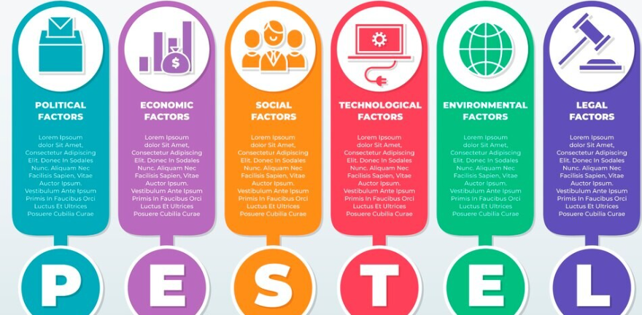
Figure 3: PESTEL Analysis
Source: Abdelrahim Aqqad, 2024
In terms of the economic factors, India is currently one of the world's fastest-growing major economies, with GDP growth that consistently outpaces the Global averages. The demographic structure presents a young population that has rising disposable income and due to this, there is heavy demand in the fashion and apparel sector (Gill et al., 2023). With the expansion of the middle class, there is value-oriented consumption, which is in favour of the cost leadership model of Primark. However, the challenges exist in terms of the fluctuations and currency that have an impact on the cost for fashion retailers, as well as heavy dependence on Overseas Sourcing. Further, the inflationary pressure also has an impact on the purchasing power of consumers, even though the value segment becomes stronger during the economic strain. Even though high economic growth directly gives an advantage to Primark, there is a need for strategic initiative in order to optimise the sourcing models.
In terms of the social factors, fashion consumption is extremely significant in the country. There is increased exposure towards the western fashion brands, leading to the growth of mall culture as well as rising aspiration among the youngsters of tier 2 and 3 city consumers (Kaur, Malik and Singh, 2024). Further variation also exists in terms of the regions where there is cultural diversity, climatic differences, and differences in preferences. The consumers are also becoming conscious of the reputation of the brand and their efforts towards sustainability.
The focus of the organisation on trend-led fashion and low prices functions as an advantage for it in capturing the segment. Due to the social demand for affordable fashion, there is an opportunity for Primark through which it can focus on the localisation of the product lines and thus have the attention of the consumers.
In terms of the technological factors as well, there has been a rapid digital transformation due to the widespread use of smartphones, the expansion of the internet, and government-led digitalisation initiatives (Khadria and Mishra, 2022). Even though Primark has avoided E-commerce, India is technologically advanced in terms of its retail ecosystem and efficient distribution networks. With the rise in digital payments, UPI and Technology adaptation, it is important for Primark to invest in modern retail technology and ensure that it maintains an influential position in the Indian market.
In terms of the environmental factors, it has become extremely important to make sure that focus is laid on the control of textile waste pollution as well as water usage. It is also important to comply with the concerning factors with regard to sustainable manufacturing, waste management and chemical restrictions that are applicable to the apparel companies. The youngsters in India are very aware of the sustainability aspect and focus on associating with such brands that take care of their ethical responsibility (Kaur et al., 2022). The existing initiative of its sustainability program will lead to the strengthening of the trust of the brand as well as differentiation.

Porter five forces
There is significant competitive rivalry in the fashion Retail Industry of India due to established international players such as Zara, H&M, along with domestic retailers such as Reliance Trends and Max Fashion (Sellitto et al., 2022). Further, there also exists price competition in an aggressive manner, due to which it is important for Primark to compete with the same. There are fast fashion cycles as well as the evolution of consumer preferences in a rapid manner.
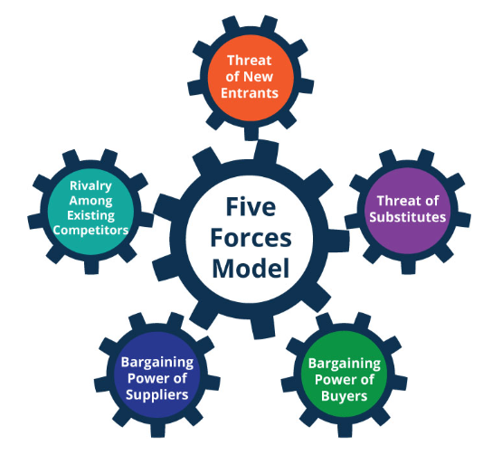
Figure 4: Porter’s Five Forces Analysis
Source: Planium Pro, 2025
There is a moderate threat of new entrants in the country because of the requirements of high capital, as well as the supply chain complexity that exists in the current scenario. The interest of other players continues to increase for expansion in the country, due to which Primark needs to focus on operational efficiency to compete with the new players.
There is low to moderate marketing power of suppliers because it is one of the largest textile and garment manufacturing hubs, which has an abundance of suppliers, leading to low bargaining power for them. However, the high-quality suppliers might have some level of influence on the brand.
The bargaining power of the customers is high because they are price-conscious and have access to various options and alternatives (Çavuşoğlu et al., 2021). With the presence of online platforms in the country, price comparison and quick delivery are also significant factors that play an important role.
The threat of substitutes is moderate because the existence of local retailers, thrift fashion, and Street markets also has an influential position in the country. Due to the low pricing of the street fashion, it is extremely competitive, but the organisation can focus on quality as well as variety to compete with the same.

Porter Diamond model
Element | Key Features in India | Relevance to Primark
Factor Conditions | Skilled labour, textile clusters | Build local sourcing
Demand Conditions | Young population, mall culture | Strong demand potential
Supporting Industries | Logistics, retail tech | Efficient store operations
Rivalry | Competitive markets
  Drives innovation

Factor Conditions
The country has strong factor advantages due to the presence of modern logistics hubs, skilled labour, large-scale textile production and low cost of production. Further, the presence of cotton and synthetic fibre also leads to strengthening potential for the country (Kumar et al., 2022). It can focus on integrating India into the Global supply chain, leading to a reduction in cost. Due to the presence of these factors, the country is a significant choice for various organisations. Through these factors, the emphasis can be laid on higher profit margins with low-cost manufacturing as well as an effective supply chain strategy. The technology can also be effectively leveraged in this country and the emphasis of Primark can be laid on making the right use of E-commerce.
Demand Conditions
Due to the presence of a youth population as well as their preferences in the rising fashion industry, there are evolving lifestyle Trends through which the domestic demand is significant. It can focus on targeting high-volume sales with the rapid inventory cycles (Gill et al., 2023). Due to this growing appetite, Primark can focus on aligning its offerings with the conditions in the market and ensure that the high urban density makes it possible to have long-term results. Further, it is also important to make use of sustainability initiatives for attracting new consumers because it will help in the attraction of these consumers and will also ensure that a long-term relationship is established.
Related & Supporting Industries
The ecosystem of India involves Mall developers, logistics companies and retail technology firms. Due to the interconnection of this industry, there is a strong foundation for retail expansion. The advantage for Primark in this particular scenario is related to the easy availability of support services, which leads to the reduction of operational risk. Further, the IT service providers also support retail analytics and digital payment integrations. With the effective planning and implementation of the strategies, the emphasis can be laid on the right use of the other industries for the enhancement in the case of Primark.
Firm Strategy, Structure and Rivalry
The presence of intense competition forces the leaders to have in place the enhancement of efficiency, innovation, and optimization of the supply chain. With the mastery of the low-cost production, domestic players continue to have a significant position and the global players have also focused on strong branding. With the help of the cost leadership model, it will be possible to compete in the environment and become a significant player with the attention of the consumers (Hossain et al., 2025).
With the help of an effective strategy, the company can make use of all these factors in its favour and ensure that it helps in the achievement of the best possible results. Further, it will also help the organization in becoming a significant player with the compliance of the legal requirements, as well as cost-effective strategies to attract consumers.

Strategic development and formulation

Ansoff matrix
The Ansoff matrix is a strategic planning tool that focuses on the organisational growth options with the help of various pathways such as product development, diversification, market development, and market penetration.
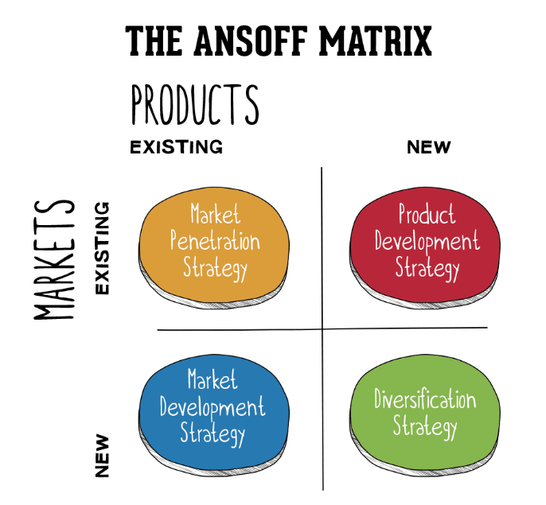
Figure 5: The Ansoff Model
Source: Annmarie Hanlon, 2021
The expansion of Primark in India is a classic case of market development where the company is introducing its existing product in a new geographical market. India has a high growth environment due to the presence of a large youth population as well as rapid expansion in the mall infrastructure. The major advantage lies in the fashionable products that are available at low prices, ensuring an effective fit for the country’s market. Through the strategy, the emphasis will be laid on the selection of optimal entry locations, building brand recognition, and understanding the regional preferences. The Tier 1 cities in the country allow the company to tap into high footfall and affluent urban consumers before expanding into growing Tier 2 markets.
The product development functions as a secondary strategy in the case of Primark because it is important for the company to adapt in terms of the seasonal differences, as well as climate and cultural influences (Zugay and Zakaria, 2023). Due to this, product development is a significant strategy in the case of the company, where breathable fabrics such as cotton should be focused on. Along with this, due to the presence of high festive seasons in the country, it is also important to focus on festive-oriented collection and make sure that this leads to the strengthening of the competitive advantage of the company in this market.
In the current scenario, the market penetration is not applicable because the emphasis is on enhancing the market share in the existing market. However, after the post-establishment of the company in an effective manner, the emphasis can be laid on price promotion, category expansion, and enhancement of the in-store experience of consumers. Another strategy of the metric is related to diversification, where focus is laid on getting into new product categories and sectors where there will be a strengthened brand identity of the company, as well as cost leadership models, which leads to better profitability.

Porter Generic strategies
The Porter's generic strategies Framework lays emphasis on three primary strategies: cost leadership, differentiation, and focus. In the case of Primark, one of the most significant strategies that can be focused on is cost leadership, where the focus can be laid on the enhancement of value perception without any compromise on affordability.
By making cost leadership the primary strategy of the company, Primark can ensure building on the delivery of fashionable and high-volume apparel at the lowest possible price. With the help of tight control over the operational cost, economies of scale, minimisation of advertising expenditure, as well as a globally integrated sourcing network, it will be possible for the company to reduce the cost and ensure that the profitability can be duly enhanced. While entering India, cost leadership becomes even more important because the country has the presence of deeply price-sensitive consumer behaviour as well as significant demand for fashion (Jerab and Mabrouk, 2023). The domestic players in the market, such as Reliance Trends, Max Fashion, and DMart, have also focused on low-cost structures in order to gain a share in the market as well as compete on price competitiveness. The ability of Primark to focus on trending products at a lower price will make it possible to have a better positioning in comparison to the other players, making it possible to grab the opportunities and ensure that the cost efficiency can be used for investments and effective results.
Even though differentiation is not a primary strategy in Primark, it places emphasis on the incorporation of selective differentiation, which will make it possible to enhance customer appeal. In this process, the emphasis needs to be laid on rapid fashion turnover, visually appealing store layouts, and sustainability initiatives. The Indian consumers in tier 1 cities have increasingly focused on ethical sourcing as well as associating with such brands that take into consideration the responsibility towards the environment. With the help of sustainability programs as well, it will be possible to add intangible value and make sure that a sense of trust is built, which attracts both the customers and the investors, making it possible to survive effectively in the competitive landscape of India.
This strategy is appropriate in the case of India due to the presence of high competition, switching costs, and price sensitivity. The presence of the international brands attracts the consumers and the domestic retailers dominate through affordability. With the help of the cost leadership approach of Primark, it will be possible to provide branded products at a reasonable price, making it possible to attract the consumers of India and ensure that strict cost discipline is focused on while also offering fashion trends important for a long-term competitive advantage.

Formulation of market entry strategy
With the help of the formulation of an effective market entry strategy, the emphasis can be laid on the successful establishment of Primark in India. It will be possible to integrate the entry mode selection, supply chain design, as well as effective marketing approaches that align with the Global cost leadership model of Primark.
With the use of the wholly owned subsidiary entry mode, it will be possible for the company to have 100% foreign direct investment, which is the most appropriate entry route for Primark in the current scenario (Bhat et al., 2022). With the help of this, it will be possible to have strategic and operational control, making it possible to have effective brand reputation as well as supply chain governance. Even though a joint venture also comes with significant advantages, there are complexities related to slow decision-making and inconsistency. With the reliance on management, it will be possible to ensure alignment and make sure that a strong long-term presence can be built, which leads to the retention of profit as well as effective investment.
In terms of the geographic location, it is important for Primark to focus on prioritizing Tier 1 cities such as Bangalore, Hyderabad, Mumbai and Delhi due to the presence of mature Mall infrastructure and strong foreign orientation of the people. Through these markets, it will be possible to focus on attracting such consumers who are already familiar with international fast fashion. The establishments will make it possible to emerge into the tier 2 cities such as Pune, Jaipur and Ahmedabad. Due to the growing Mall development as well as scalable future growth in this industry, it will be possible for the organisation to make effective profits, leading to a significant position in the market.
Due to the strong textile and garment production in the country, there is an opportunity for Primark to focus on the adoption of a hybrid Sourcing model through which the imports from the Global network can be combined with the domestic Sourcing (Kohne et al., 2023). The cost leadership strategy of the company will be supported through the local Sourcing and a centralised distribution Centre can also be established near Mumbai or Gujarat. With the help of this, inventory management will be facilitated, making it possible to have an effective supply chain partnership.
Further, in terms of the marketing and brand positioning as well as the model of minimal advertising, it makes it possible to remain suitable for India and make sure that the influence of partnerships, social media visibility and other activities can be focused on. With the highlight of affordability, it will be possible to attract customers and make sure that the sustainability commitments also attract youngsters in the long run (Singh, Chakrabarti and Tripathi, 2025).

Establishing a competitive advantage in a new market
For the long-term success of Primark in India, it is important to emphasize Sustainable competitive advantage. With the leverage of organisational capabilities while adapting strategically to local market dynamics, emphasis will be laid on the combination of cost efficiency, operational excellence, and value creation.
In this scenario, the cost advantage will act as one of the most significant aspects because the leadership model will make it possible for Primark to offer good quality products at lower prices, leading to significant competition for the other players. Due to the price-sensitive retail landscape in India, it is important for Primark to focus on affordability for the consumers, making it possible to give competition to established brands such as Reliance Trends and Max Fashion. Further, the organisation can also focus on outperforming the competitors with the capitalisation of economies of scale. With the use of the extensive textile manufacturing ecosystem in India, it can focus on reducing the logistics cost and making sure that it leads to the price advantages for the company, leading to better profitability (de Aguiar Hugo, de Nadae and da Silva Lima, 2021).
Further apart from low prices, it is also important for Primark to focus on its ability to deliver high perceived value to the consumers in India. With the offering of contemporary fashion and seasonal collections, it will be possible to attract consumers. Further, it should also focus on adapting specific product lines such as cotton clothing, festival and lightweight, leading to brand loyalty in the long run. The large format store experience also works in favour of the company, leading to better engagement with the help of an influential shopping environment.
With the enhanced awareness of sustainability among the youngsters in India, it is important for Primark to make sure that this opportunity is focused on with the help of the Primark Cares program. It can lay emphasis on transparent supply chain, ethical Sourcing as well as recycling of material so that the credibility is enhanced, making it possible to fulfil the expectations of the youngsters. Along with this communication of this commitment, it is also necessary to make sure that long-term trust can be built.
The combination of superior cost efficiency experiences, store formats, and sustainability initiatives will attract consumers and ensure long-term loyalty with affordable and creative products. With the help of this, it will be possible for Primark to achieve a significant position in the Indian market.

Performance evaluation framework
Measuring the performance of the brand or its strategy to move ahead is important consideration in terms of SM. There exist several tools and frameworks that enable the brand to measure the performance of the company in the competitive world of business. In the case of Primark’s expansion in Indian market, it can be justified that the use of Triple Bottom Line can be used as effective strategic model for measuring the performance of the company based on its CSR efforts and approach. The author stated that Triple Bottom Line is effective model that determine three major pillars to measure how well the company is performing based on profitability measures, management of the people, and efforts towards protection of the environment. Social equity, environmental stewardship as well as economic viability are renowned as specific measure for evaluating the performance of the brand as per this framework.
Triple bottom line dimensions | Key performance indicators | Current performance | Expected performance in new market
Social equity | Diversity and inclusion  Investment in community development | Employee engagement, recruiting diverse employees and promoting global colleague network with more than 700 colleagues involved as of now (Primark, 2025). | Increasing employee engagement rate by 10% in new market.  Expanding numbers of colleague to 1000 within its global colleague network initiatives.
Environmental stewardship | Greenhouse Gas (GHG) Emissions  Waste reduction | Reduced carbon emission by -3.9% as of now to achieve aim of net zero emission by 2030 (Primark, 2025).  Reduced 18.31% of textile waste in its operations as of 2024 (Primark, 2025). | Reduce emission by 7% by 2026 and reduction in textile waste up to 25% by 2026 after expansion into new market.
Economic viability | Financial performance | 9.5 billion British pounds in revenue by 2025 (Statista, 2025). | Attain 5% growth in revenue by 2026 though expansion into new market.
As per the TBL framework, it can be determined that the company has strong performance indicators established in the context of social equity, viability in economic aspect and environmental stewardship. In terms of social equity, the brand has strategic focus towards promoting diversity as well as inclusion within its workforce by promoting global colleagues network as its key initiatives to achieve this goal. Additionally, continuous investment into community development programs and encouraging community participation can be seen as most influential approach of the brand to promote social equity and attain the defined objectives in this relation.
The author also stated that caring for environment and advocating for its conservation and prevention is also one of key strategic focus of the brands in the contemporary times. In this regards, the strategic focus of Primark is also inclined towards establishing different metrics to promote environmental stewardship. The metrics mainly involves reducing the textile waste, and reducing the carbon emission from its operations. Considering the current performance, the brand has strong focus over reducing the emissions throughout its value chain to attain the goal of net zero emissions by 2030. This also involves prioritising use of single-use plastic within its packaging and other operations, and also significantly reducing textile waste throughout the operations.
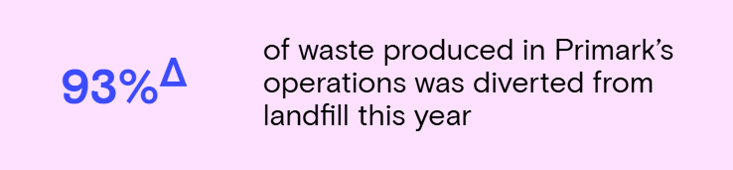
Figure 6: Waste management in Primark
(Source: Primark, 2025)
The figure above represents the insights about the Primark’s approach towards reducing the waste from its operations that was dumped in the landfills. It is found that the brand was able to divert 93% of the waste from landfills in 2025 (Primark, 2025). This implies that the proposed expansion plan will also be directed towards ensuring protection of natural environment and planet.
At last, the author stated that assessing the economic or financial viability is among one of most important indicator to measure the firm’s performance and evaluates its strategic actions. In case of Primark, the economic viability is primarily measured through the use of key indicator such as annual revenue and revenue growth. Considering the current performance of the brand, strong revenue growth is witnessed based on which, the economic and financial performance of the company is seen to be justified. However, looking at its plan to expand in the market of India, the proposed strategy will be proved to be effective in terms of positively contributing towards revenue growth in the new market.
It can further be assessed that the overall impact of the expansion plan of Primark will be highly effectual as it will lead to improve the firm’s profitability and reach in the long-run. On the other side of this, the brand’s global reputation will also be improved as result of this expansion plan. In regards to its progress, establishing short-term and medium-term goals for moving ahead with the plan will be key strategy that will be adopted by the management of the Primark to expand its operations in the new market.

References
https://huuray.com/inspiration/gift-cards/primark-statistics/
https://www.ibef.org/blogs/fashion-forward-an-analysis-of-india-s-growing-apparel-market
https://sr.primark.com/colleagues-inclusion-communities
https://www.statista.com/statistics/383785/primark-revenue-worldwide/?srsltid=AfmBOorii3t3XHuMJRuq8FzdynV8BkD38p-F1Dc0yKDDy9eWi_3nqEBe
https://sr.primark.com/planet
Abdelrahim Aqqad, 2024. PESTEL Analysis. [Online]. Available at;< https://www.linkedin.com/pulse/why-should-internal-auditors-use-pestel-analysis-lx1tf >.[Accessed on:7th December, 2025]
Annmarie Hanlon, 2021. The Ansoff Model. [Online]. Available at;< https://www.smartinsights.com/marketing-planning/create-a-marketing-plan/ansoff-model/ >.[Accessed on:7th December, 2025]
Bhat, M.N., Ikram, F., Rahman, M.N. and Naeem, M.H., 2022. Economic freedom of the world: wholly owned subsidiaries and joint ventures as binary response. Transnational Corporations Review, pp.1-18.
Çavuşoğlu, S., Demirağ, B., Durmaz, Y. and Çıkmaz, G., 2021. The impact of brand image and brand consciousness on perceived price and purchase intention. Transnational Marketing Journal, 9(2), pp.391-407.
de Aguiar Hugo, A., de Nadae, J. and da Silva Lima, R., 2021. Can fashion be circular? A literature review on circular economy barriers, drivers, and practices in the fashion industry’s productive chain. Sustainability, 13(21), p.12246.
Gill, P., Malik, P., Arya, N. and Yadav, N., 2023. Evolving fashion trends and choices of Indian youth: Family approval and disapproval. International Research Journal of Modernization in Engineering Technology and Science, 5(2), pp.503-506.
Gill, P., Malik, P., Arya, N. and Yadav, N., 2023. Evolving fashion trends and choices of Indian youth: Family approval and disapproval. International Research Journal of Modernization in Engineering Technology and Science, 5(2), pp.503-506.
Hossain, K., Alam, M.N., Muwazir, M.R., Alsiehemy, A. and Azizan, N.A., 2025. Deconstructed entrepreneurial orientation and export performance: mediating role of differentiation and cost leadership strategy from the developing country context. International Journal of Emerging Markets, 20(6), pp.2243-2273.
Jerab, D. and Mabrouk, T., 2023. Achieving competitive advantage through cost leadership strategy: Strategies for Sustainable Success. Available at SSRN 4574945.
Kaur, J., Malik, P. and Singh, S., 2024. Generational Cohort Analysis to Purchase Fashion Products in India. In Data-Driven Decision Making (pp. 139-150). Singapore: Springer Nature Singapore.
Kaur, J., Mogaji, E., Wadera, D. and Gupta, S., 2022. Sustainable consumption practices in Indian households: A saga of environment management linked to Indian ethos and generational differences. Society and Business Review, 17(3), pp.441-468.
Khadria, B. and Mishra, R., 2022. Technological transformation in India: the debate between appropriate and frontier technologies. In Handbook of innovation & appropriate technologies for international development (pp. 71-85). Edward Elgar Publishing.
Kir, A., 2021. India's goods and services tax: A unique experiment in cooperative federalism and a constitutional crisis in waiting. Can. Tax J., 69, p.391.
Kohne, Z.A.M., Shahrestanaki, S.K., Parvizy, S. and Shoghi, M., 2023. Concept analysis of adoption: A hybrid model. Journal of Child and Adolescent Psychiatric Nursing, 36(2), pp.155-164.
Kumar, P., Sai Ram, C., Srivastava, J.P., Behura, A.K. and Kumar, A., 2022. Synthesis of cotton fiber and its structure. Natural and Synthetic Fiber Reinforced Composites: Synthesis, Properties and Applications, pp.17-36.
Makvandi, R., 2024. Analysis of the Impact of Macroeconomic Factors on the Development of Financial Products: Application of the PESTEL Model in Identifying Opportunities and Threats. Transactions on Quantitative Finance and Beyond, 1(2), pp.233-246.
Planium Pro, 2025.Porter’s Five Forces Analysis.[Online].Available at;< https://www.planiumpro.com/blog/porters-five-forces-analysis-assessing-the-competitive-environment/ >.[Accessed on:7th December, 2025]
Sellitto, M.A., Valladares, D.R.F., Pastore, E. and Alfieri, A., 2022. Comparing competitive priorities of slow fashion and fast fashion operations of large retailers in an emerging economy. Global Journal of Flexible Systems Management, 23(1), pp.1-19.
Singh, N., Chakrabarti, N. and Tripathi, R., 2025. Factors determining fashion clothing interest and purchase intention: A study of Generation Z consumers in India. Fashion, Style & Popular Culture, 12(3), pp.423-446.
Zugay, B. and Zakaria, R., 2023. Ansoff matrix. SAGE Publications, Inc..

