University of Wales Trinity Saint David
Motorsport Engineering
Engineering Skills Technical Report
Marcus Tenniswood 2501145
07/12/25
Engineering skills ACHA4022A
Word count-1822

Table of contents
Contents
Table of contents 2
Introduction 3
Health and Safety 3
Real life applications 3
Risk assessment 4
Security risk matrix 4
Security threats 4
Security matrix 5
Engineers’ role in society 6
Problem Solving 6
Team Structure 7
Conclusion 8
References 9

Introduction
In this report there will be an outline of all the necessary skills needed to conduct research and experiments as an engineer. To do this an analysis of all relevant risks, legislation and skills for an engineer will be outlined and explained, as the outline has demonstrated, this report is designed to show all the skills required to produce a technical report to a university level standard, whilst also using the appropriate reference citations along the way.

Health and Safety

Real life applications
Throughout an engineer’s career, they will encounter many situations in which health and safety rules and regulations make a large impact. An example of this could be for a motorsport engineer that is conducting an engine strip class in the workshop. To this particular situation many legislations apply. According to the Health and Safety at Work Act 1974, an employer, which in this case applies to the university, must ensure the health and safety of all their employees. Whilst this is a broad range, in the workshop it could apply to maintenance of equipment and appropriate supervision of students, if this is not appropriately taken care of it could lead to personal injury during the operation of machinery. It could also cause injury to others, such as a student operating an engine mount that has not been properly maintained and it could break off and fall and land on a separate student, and in that case the university would be liable. Furthermore according to the Provision and Use of Work Equipment Regulations 1998 all equipment, such as the hand tools and engine mounts for the engine strip, must be fit for use, this could affect the activity of an engine strip because the regular inspection of tools can put time and stress on an already busy technician, but it is essential for safety, although if this is not completed the risk of harm to students is significantly increased.

Risk assessment
Hazard | Who is at risk | Risk | Risk Controls
Oil spills | Technicians and students in the workshop | Slipping and falling | Ensuring cleanup, grippy work boots as the supplied PPE.
Eye injuries | Technicians and students working on the engine | Hitting a tool or breaking loose a part of the engine causing flying objects which could enter eye | Safety goggles, supplied PPE by the HSW act
Loose clothing caught in machinery | Anyone wearing loose clothing in the workshop | A higher chance of getting caught in machinery and damage to clothing or health | Wearing the dust jackets provided, which aren’t loose and contain all clothing.

Security risk matrix

Security threats
Modern vehicles are at serious risk of security compromises; they are ever increasingly part of a connected online network and have features such as self-driving which if compromised could cause serious risk. Below are 4 security threats towards the automotive industry all surrounding types of cyber-attacks that have been highlighted in the paper “A Survey on Cyber-Security of Connected and Autonomous Vehicles (CAVs)”. In this paper it shows a mix of different type of attacks including in-vehicle network attacks (IVN) and vehicle to everything attacks (VtE), these have many different types individually but cover all aspects of the risk of security threats.
- A type of in vehicle attack is a GPS spoofing attack, this would essentially be an outside signal which could either give a false destination or remove GPS assistance entirely
- A type of Vehicle to Everything attack is a DoS, (denial of service), in an autonomous vehicle this could appear as certain services not being available to the driver, this could lead to danger if it were to occur during driving
- Eavesdropping attacks are another VtE attack, this focuses on the user’s private data and identity, the risk of this is more than just surrounding the vehicle but to the person’s physical and potentially financial health.
- An alternate security threat that isn’t just a cyber risk is that certain vehicles rely on cameras for navigation, this can be affected during harsh weather conditions, this could effect the ability of the vehicle to drive successfully, leading to accidents. However most vehicles use Lidar or radar which are more reliable than older methods.

Security matrix
Below is a simple risk matrix, along the x axis is the severity of the risk and along the y axis the likelihood of the risk occurring
 | Low | Medium | High | Very High | Extreme
Rare
Unlikely |  | GPS spoof |  | Weather affected camera interference
Possible | Eavesdrop |  |  | DoS
Likely
Certain

Security Threat | Proposed Response
The highest risk is the Denial-of-Service attack, this is due to reported and real events occurring, whilst there is also limited available data on these events and the serious consequences that came alongside it. | As shown in the article “A novel framework for detection and prevention of denial-of-service attacks on autonomous vehicles using fuzzy logic” using a rule-based fuzzy system has evidence to show that it can accurately and precisely show results of avoiding these and defending them whilst ensuring the safety and continued operations.

Engineers’ role in society
One company that publishes a code of conduct for engineers with a focus on motorsport engineering is the FIA, in respect to Formula 1 (F1). F1 is a global sport with millions of viewers and attendees in person, therefore the company must pay attention to their role within society. Common criticisms of the sport are about the net carbon emissions that are caused by flying across the globe, whilst F1 has comprehensive codes of conduct for staff behavior and due care for the people within their association, there has been a recent focus on sustainability, this includes a net 0 by 2030, which means a non-negative carbon footprint on the environment, this is highlighted in their code of conduct along with sustainability initiatives avoiding modern slavery and inclusivity and diversity within this organization. All of these initiatives and pledges within the code of conduct help the engineers contribute the most to society as a whole.
An organization that has a well-known code of conduct is The Institute of Mechanical Engineers (IMechE), a professional institute of engineers with over 100,000 members both across the UK and globally, it is essential they maintain a high level of professional standards and regarding the environment of the world they occupy. Explained in their code of conduct is a set list of 4 values that they maintain, this includes sustainability, and moral integrity. Focusing on the integrity their guidelines state they must do things such as reject bribes, do not mislead and declare conflicts of interest. This makes members of the IMechE trustful and desirable employees as a member shows all the signs of a valuable employee. They also make a point of diversity within leadership roles, which provides a deep connection to all engineers and does not limit anyone by opportunity.

Problem Solving
For a team that encounters problems during an activity or task there are many methods they could apply to the situation, in the article “Problem Solving: A Structured Approach- University of Strathclyde Glasgow” a method of breaking down the problem, followed by analysis and a deep understanding allows groups of engineers to counter problems and the evaluate themselves. This method could allow an engineering team to circumnavigate any issues they encounter, for example, if they ran into an issue with a compound material not having the responsiveness they desired first, they would, define and break down the problem, really delving deep into figuring out the core issues. This would then be followed by target setting and analysis of the causes. Development and implementation of countermeasures would next take place; this would make for a high level of ensuring the countermeasures have been effective. Finally, there would be evaluation of the end results.
They could use a flow diagram to structure this process; this would allow the team to put this problem-solving plan into a visible medium. Below is an example of a flow chart known as “Engineering Design Process Flow Chart- Jet propulsion laboratory (JPL)”, this essentially shows the problem-solving method.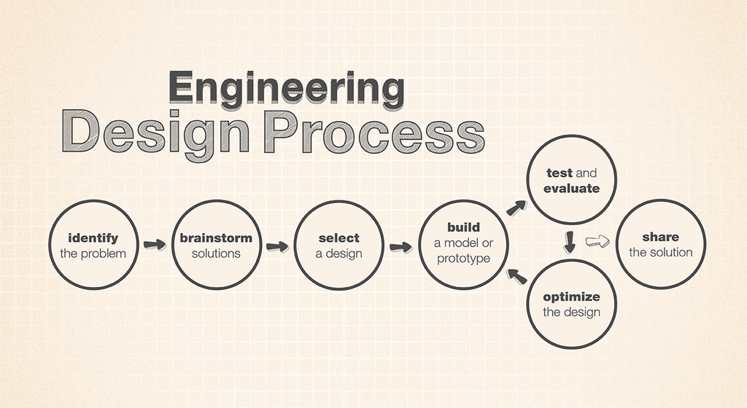

Team Structure
Personally, I have worked in teams a lot during my education as an engineer, one such time was in a year long project to design a robotic arm capable of operation on Mars, this entailed design stages, programming and iteration and then a full presentation of the project. This meant working in a team with dedicated roles and responsibilities. I operated as the project manager which meant I would delegate tasks and activities to the research scientists and experimental technicians that worked alongside myself. I took this as an opportunity to help steer the project in the right direction by working alongside each member of the group individually, rather than being a leader who only delegates. This method of team structure worked very well for the team, we experienced very little issues other than communication, certain members of the team were unavailable during essential moments leading to being behind our set out Gantt charts and left more responsibility on my shoulders to pick up the slack. Positive attributes of this team formation were by my working alongside each member closely to monitor progress, I had a high level of understanding of every attribute of the project, this meant that when issues did arise, I was able to step in and take over right where the other person left off. Another positive was the delegation of tasks and assignment of roles due to personal strengths; I assigned each member of the team a task by their greatest strengths, and this led to a lot of success throughout the project
An alternative type of team structure that may have been more successful could have been the matrix method of structure, this puts all members on the same level, whilst still reflecting a hierarchy and strong team relations. In the image below a matrix team structure is shown, as of the “The 4 Types of Project Organizational Structure”
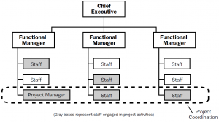
Visible in this image is a more complex view of how this would work, but focusing on the bottom layer it is easy to visualise the team structure for the particular project I worked on, I believe the project may have gone smoother if I lowered myself down to work alongside in a hybrid format and have less delegation and more personal work within the group. This also would have smoothed out any communication issues as when all members feel as though they are on the same level, there is a higher cohesion within the group, rather than social barriers which could lead to confrontation and tension within the group.

Conclusion
In conclusion, this paper has demonstrated all attributes of engineering skills, with particular highlights towards area such as an engineer’s responsibility to sustainability and also with layered personal experience. It has comprehensively shown all of the skills needed to write and produce a technical report to a high level and shown reference citation all along the way.

References
Health and Safety at Work etc. Act 1974 (HSW Act)- available at:
https://www.legislation.gov.uk/ukpga/1974/37/section/2 (accessed: 07/12/25)
Provision and Use of Work Equipment Regulations 1998 (PUWER)- available at:
https://www.hse.gov.uk/work-equipment-machinery/puwer-overview.htm (accessed: 07/12/25)
A Survey on Cyber-Security of Connected and Autonomous Vehicles (CAVs)- available at:
https://ieeexplore.ieee.org/abstract/document/9447840
A novel framework for detection and prevention of denial of service attacks on autonomous vehicles using fuzzy logic- available at:
https://www.sciencedirect.com/science/article/pii/S2214209624000160 (accessed:07/12/25)
F1 Code of Conduct- available at:
https://media.formula1.com/image/upload/v1701969109/content/dam/fom-website/manual/Misc/f1_code_of_conduct/F1_Code_of_Conduct_7_December_2023.pdf (accessed: 07/12/25)
IMechE code of conduct- available at:
https://asf.imeche.org/about-us/imeche-governance/governance-and-finance-reviews/code-of-conduct-explained (accessed: 07/12/25)
Problem Solving: A Structured Approach- University of Strathclyde Glasgow
https://www.strath.ac.uk/workwithus/trainingconsultancy/continuousimprovementforyourorganisation/ourblogs/problemsolvingastructuredapproach/ (accessed: 07/12/25)
Engineering Design Process Flow Chart- Jet propulsion laboratory- available at:
https://www.jpl.nasa.gov/edu/resources/image/engineering-design-process-flow-chart/ (accessed: 07/12/25)
The 4 Types of Project Organizational Structure- project engineer -Available at:
https://www.projectengineer.net/the-4-types-of-project-organizational-structure/ (accessed: 07/12/25)

