Bethan Woolley (2523031)
Learning in the digital era
Computing (Data systems)

Contents
Task 1 – Self-evaluation. 2
Task 2 – PDP 5
Task 3 – Unit 4 topic summary 7
Presentation link (YouTube): 9
Full Screenshots of Presentation: 9
Reference List 12

Task 1 – Self-evaluation.
- PowerPoint screen shots:
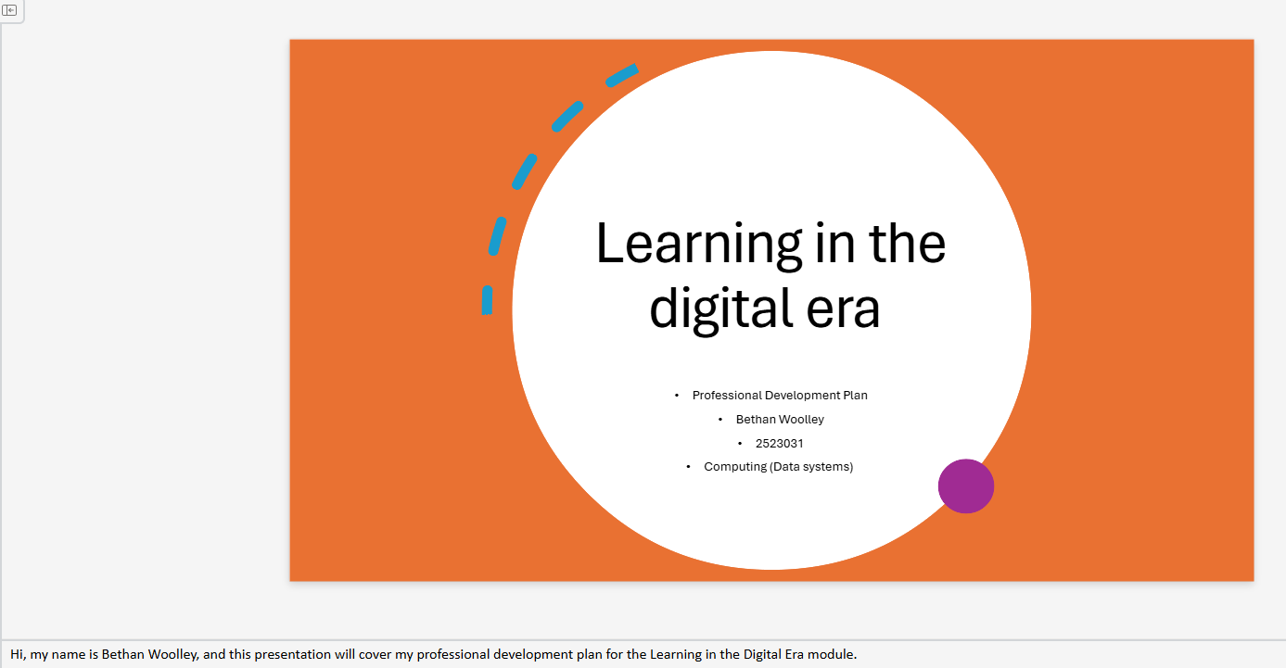
Slide 1 notes - Hi, my name is Bethan Woolley, and this presentation will cover my professional development plan for the Learning in the Digital Era module.

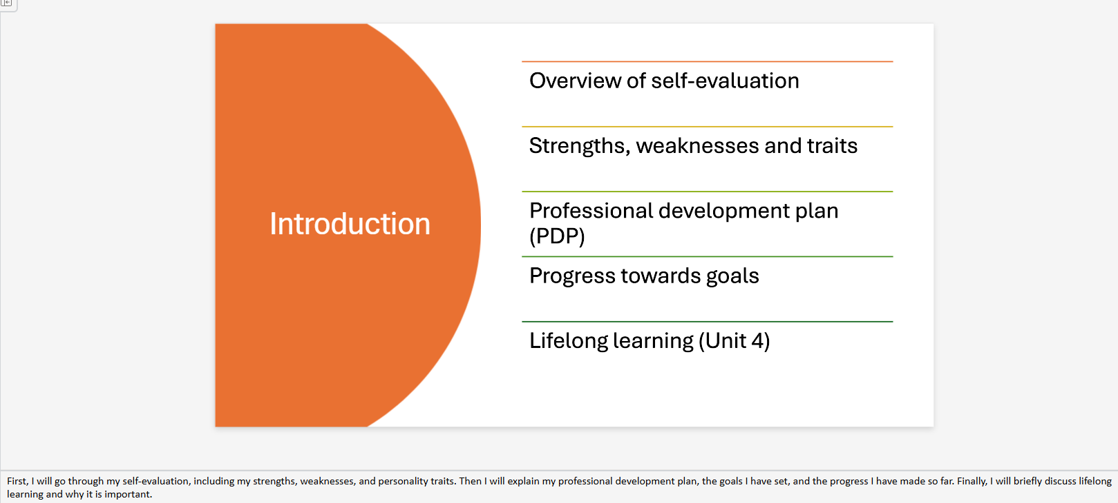
Slide 2 notes-
First, I will go through my self-evaluation, including my strengths, weaknesses, and personality traits. Then I will explain my professional development plan, the goals I have set, and the progress I have made so far. Finally, I will briefly discuss lifelong learning and why it is important.

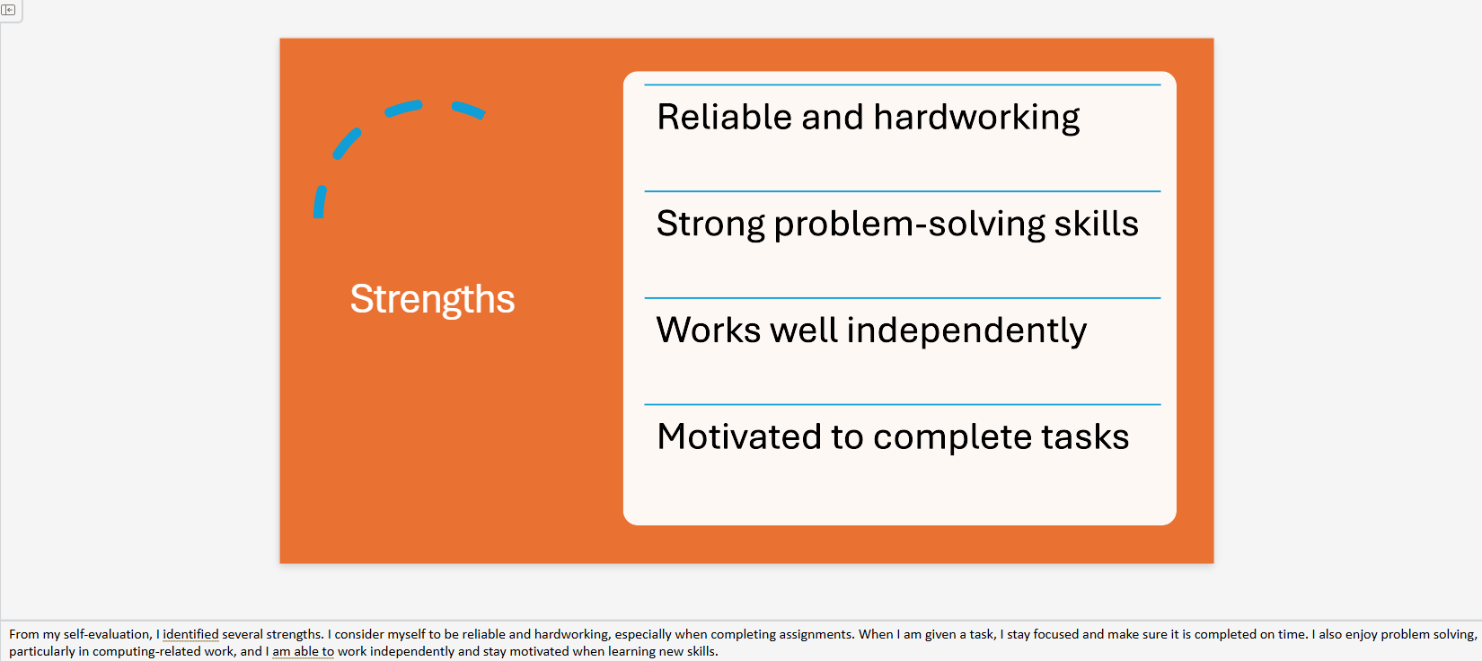
Slide 3 notes- From my self-evaluation, I identified several strengths. I consider myself to be reliable and hardworking, especially when completing assignments. When I am given a task, I stay focused and make sure it is completed on time. I also enjoy problem solving, particularly in computing-related work, and I am able to work independently and stay motivated when learning new skills.
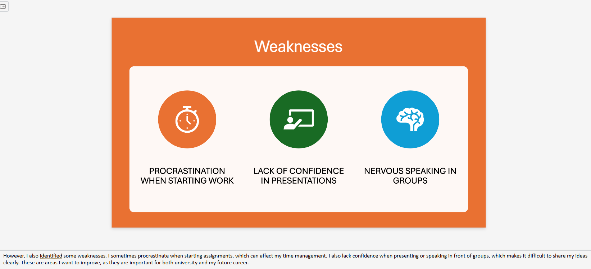
Slide 4 notes- However, I also identified some weaknesses. I sometimes procrastinate when starting assignments, which can affect my time management. I also lack confidence when presenting or speaking in front of groups, which makes it difficult to share my ideas clearly. These are areas I want to improve, as they are important for both university and my future career.

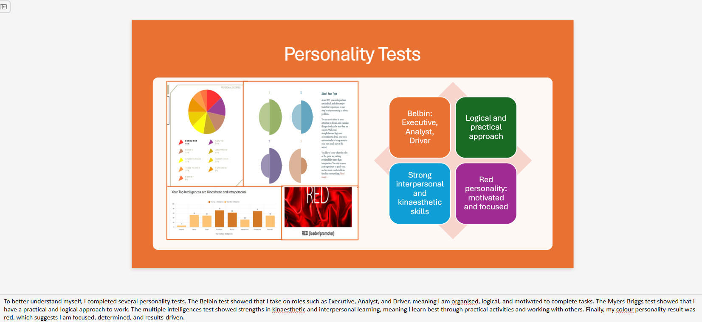
Slide 5 notes- To better understand myself, I completed several personality tests. The Belbin test showed that I take on roles such as Executive, Analyst, and Driver, meaning I am organised, logical, and motivated to complete tasks. The Myers-Briggs test showed that I have a practical and logical approach to work. The multiple intelligences test showed strengths in kinaesthetic and interpersonal learning, meaning I learn best through practical activities and working with others. Finally, my colour personality result was red, which suggests I am focused, determined, and results driven.

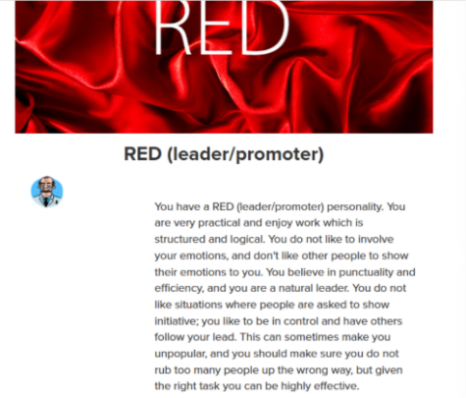
- Personality test individual screenshots:

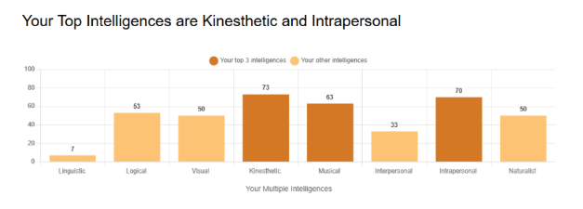
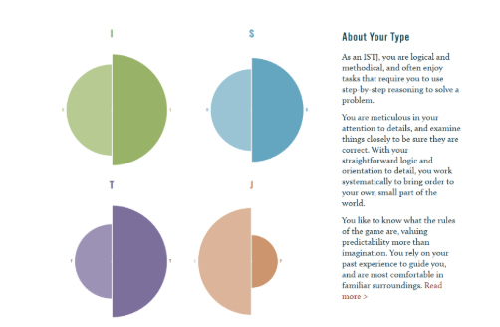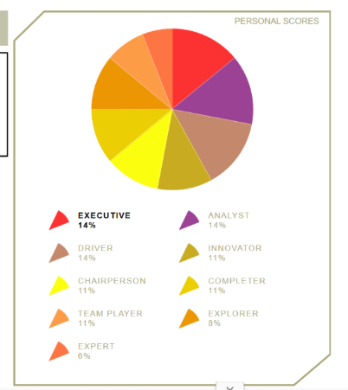

Task 2 – PDP

- PowerPoint screen shots:

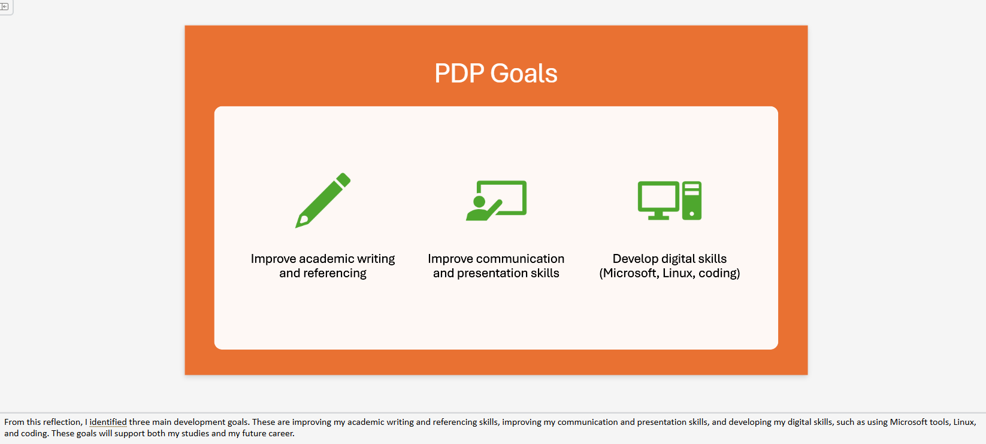

Slide 6 notes- From this reflection, I identified three main development goals. These are improving my academic writing and referencing skills, improving my communication and presentation skills, and developing my digital skills, such as using Microsoft tools, Linux, and coding. These goals will support both my studies and my future career.

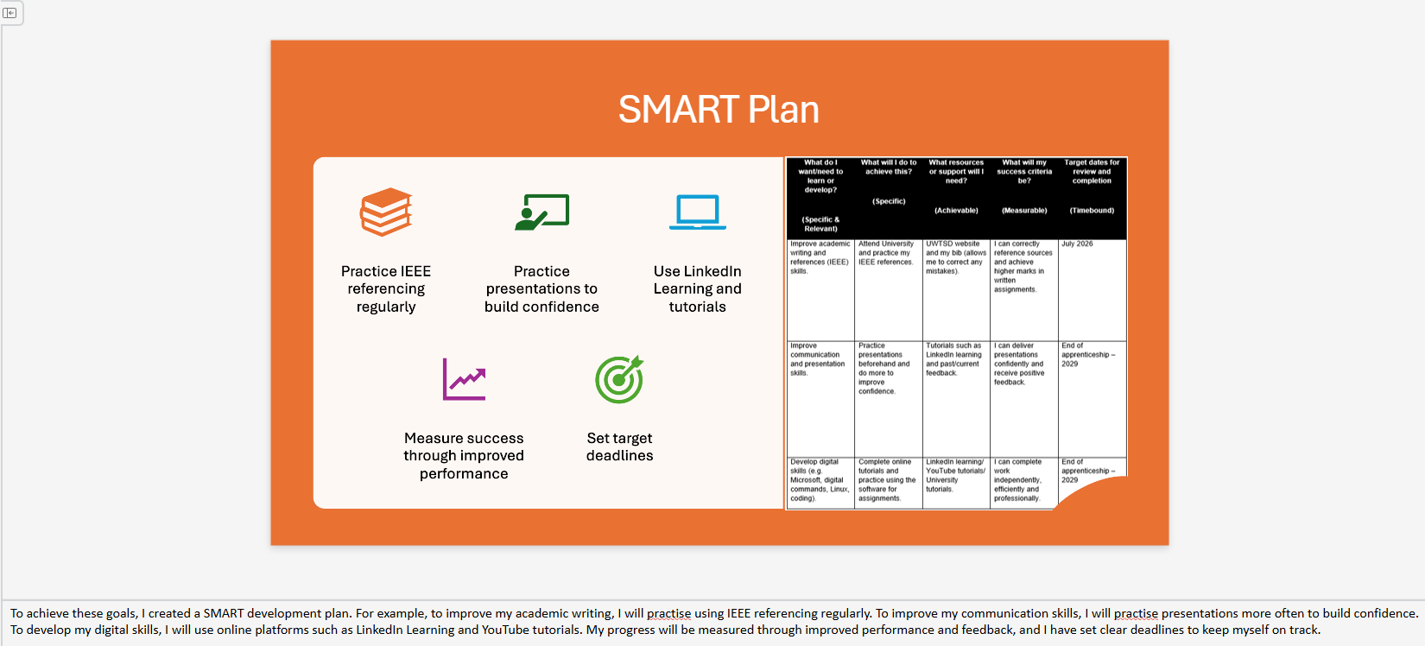
Slide 7 notes - To achieve these goals, I created a SMART development plan. For example, to improve my academic writing, I will practice using IEEE referencing regularly. To improve my communication skills, I will practice presentations more often to build confidence. To develop my digital skills, I will use online platforms such as LinkedIn Learning and YouTube tutorials. My progress will be measured through improved performance and feedback, and I have set clear deadlines to keep myself on track. [1],[2],[3].

- Link to PDP: Task 2 - Example PDP Template.docx

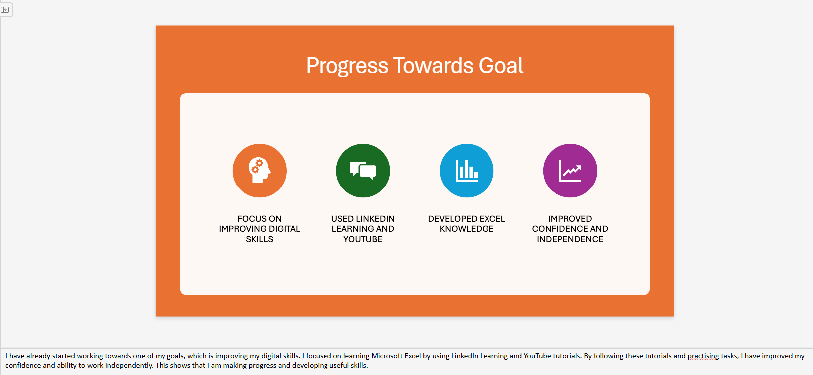
Task 8 notes - I have already started working towards one of my goals, which is improving my digital skills. I focused on learning Microsoft Excel by using LinkedIn Learning and YouTube tutorials. By following these tutorials and practicing tasks, I have improved my confidence and ability to work independently. This shows that I am making progress and developing useful skills.
- Progress towards goal screenshots (LinkedIn Leering and YouTube):
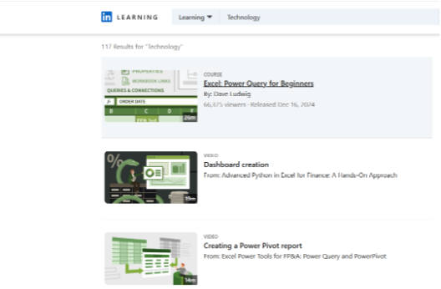
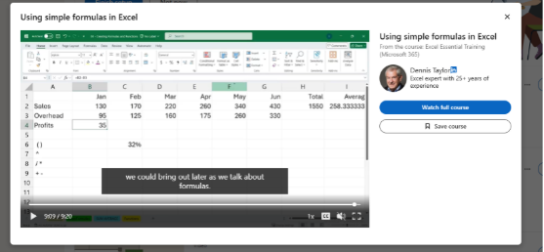
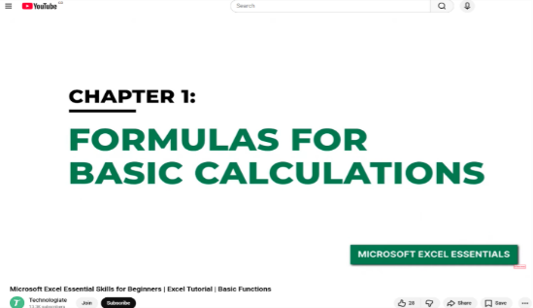 [4],[5].

Task 3 – Unit 4 topic summary
- PowerPoint screen shots:
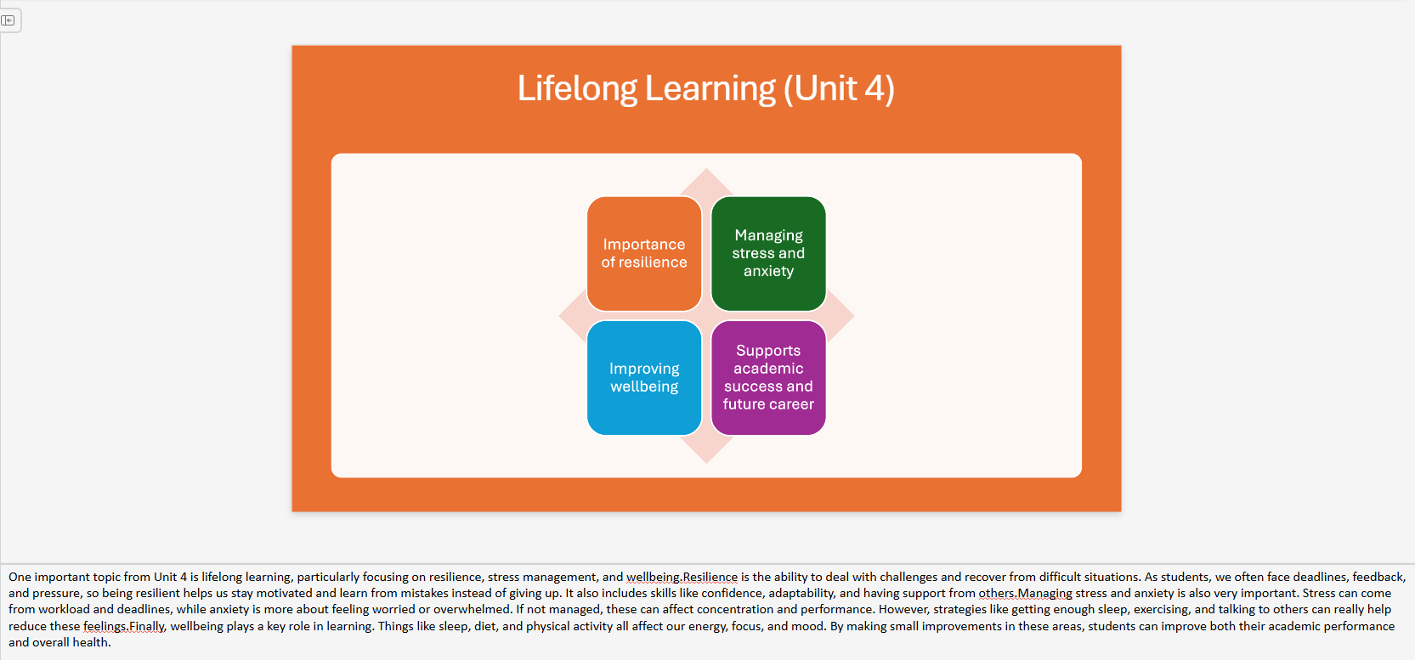
Slide 9 notes- One important topic from Unit 4 is lifelong learning, particularly focusing on resilience, stress management, and wellbeing. Resilience is the ability to deal with challenges and recover from difficult situations. As students, we often face deadlines, feedback, and pressure, so being resilient helps us stay motivated and learn from mistakes instead of giving up. It also includes skills like confidence, adaptability, and support from others. Managing stress and anxiety is also very important. Stress can come from workload and deadlines, while anxiety is more about feeling worried or overwhelmed. If not managed, these can affect concentration and performance [7], [9]. However, strategies like getting enough sleep, exercising, and talking to others can really help reduce these feelings. Finally, wellbeing plays a key role in learning. Things like sleep, diet, and physical activity all affect our energy, focus, and mood. By making small improvements in these areas, students can improve both their academic performance and overall health [8]. [6].

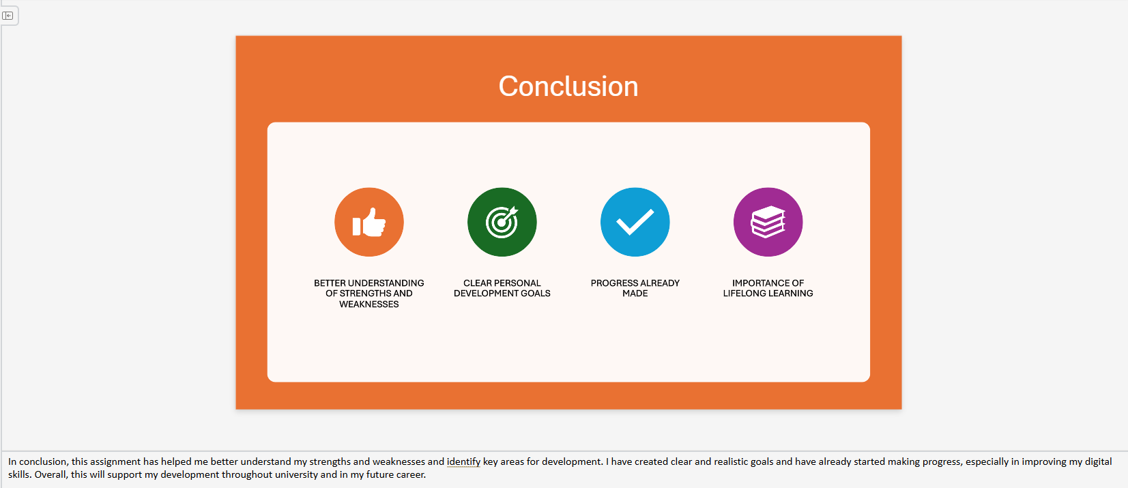
Slide 10 notes- In conclusion, this assignment has helped me better understand my strengths and weaknesses and identify key areas for development. I have created clear and realistic goals and have already started making progress, especially in improving my digital skills. Overall, this will support my development throughout university and in my future career.

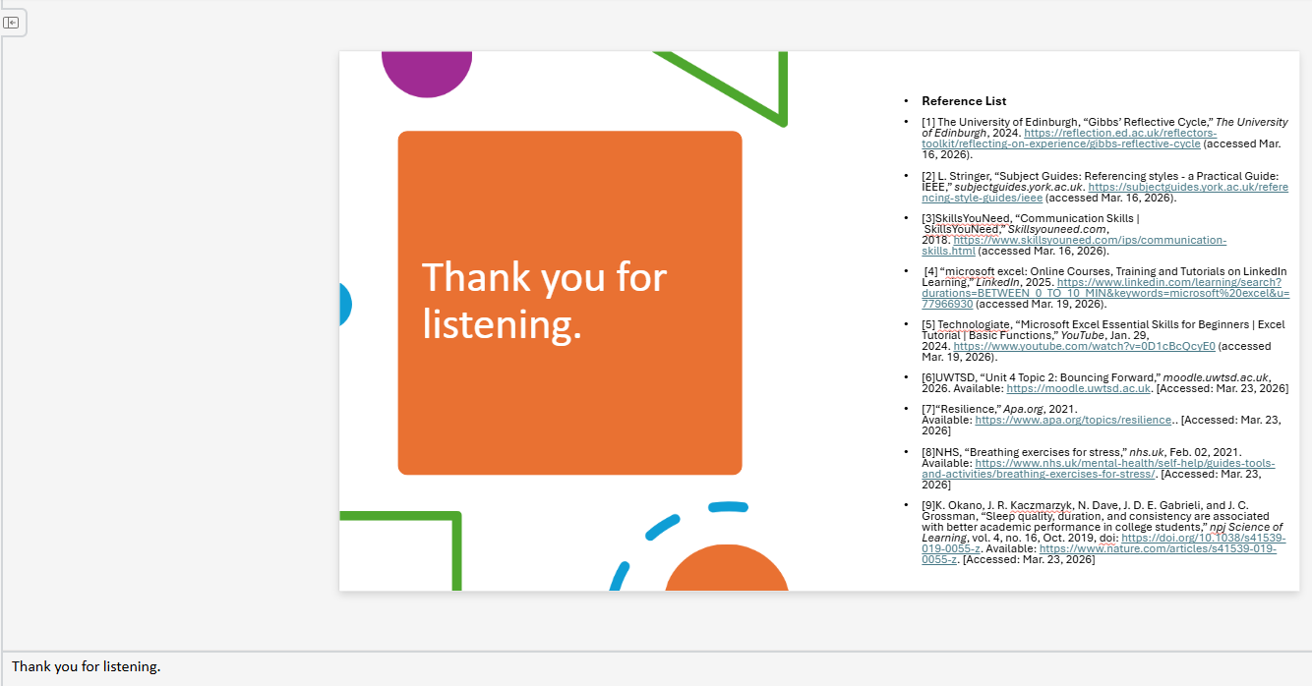
Slide 11 notes - Thank you for listening.

Presentation link (YouTube):
https://youtu.be/CGefiWBqWZE

Full Screenshots of Presentation:

Reference List
[1] The University of Edinburgh, “Gibbs’ Reflective Cycle,” The University of Edinburgh, 2024. https://reflection.ed.ac.uk/reflectors-toolkit/reflecting-on-experience/gibbs-reflective-cycle (accessed Mar. 16, 2026).
[2] L. Stringer, “Subject Guides: Referencing styles - a Practical Guide: IEEE,” subjectguides.york.ac.uk. https://subjectguides.york.ac.uk/referencing-style-guides/ieee (accessed Mar. 16, 2026).
[3]SkillsYouNeed, “Communication Skills | SkillsYouNeed,” Skillsyouneed.com, 2018. https://www.skillsyouneed.com/ips/communication-skills.html (accessed Mar. 16, 2026).
[4] “microsoft excel: Online Courses, Training and Tutorials on LinkedIn Learning,” LinkedIn, 2025. https://www.linkedin.com/learning/search?durations=BETWEEN_0_TO_10_MIN&keywords=microsoft%20excel&u=77966930 (accessed Mar. 19, 2026).
[5] Technologiate, “Microsoft Excel Essential Skills for Beginners | Excel Tutorial | Basic Functions,” YouTube, Jan. 29, 2024. https://www.youtube.com/watch?v=0D1cBcQcyE0 (accessed Mar. 19, 2026).
[6]UWTSD, “Unit 4 Topic 2: Bouncing Forward,” moodle.uwtsd.ac.uk, 2026. Available: https://moodle.uwtsd.ac.uk. [Accessed: Mar. 23, 2026]
[7]“Resilience,” Apa.org, 2021. Available: https://www.apa.org/topics/resilience.. [Accessed: Mar. 23, 2026]
[8]NHS, “Breathing exercises for stress,” nhs.uk, Feb. 02, 2021. Available: https://www.nhs.uk/mental-health/self-help/guides-tools-and-activities/breathing-exercises-for-stress/. [Accessed: Mar. 23, 2026]
[9]K. Okano, J. R. Kaczmarzyk, N. Dave, J. D. E. Gabrieli, and J. C. Grossman, “Sleep quality, duration, and consistency are associated with better academic performance in college students,” npj Science of Learning, vol. 4, no. 16, Oct. 2019, doi: https://doi.org/10.1038/s41539-019-0055-z. Available: https://www.nature.com/articles/s41539-019-0055-z. [Accessed: Mar. 23, 2026]

