BMSW4001

Academic and Employability Skills

Student name: Dionisie Andrei Tiron
Student ID: 2130488

Table of Contents

Introduction 4
Task-1 6
Discuss your inert and acquired skills pertaining to your field of interest 6
Identify those requiring improvement for practically succeeding in the chosen field 10
Demonstrate an understanding of that chosen field 12
Task-2 14
Reflective Report 14
Conclusion 17
References 19

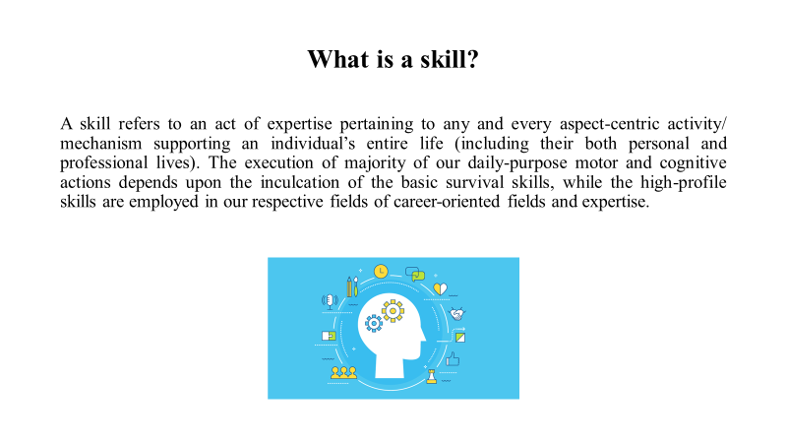

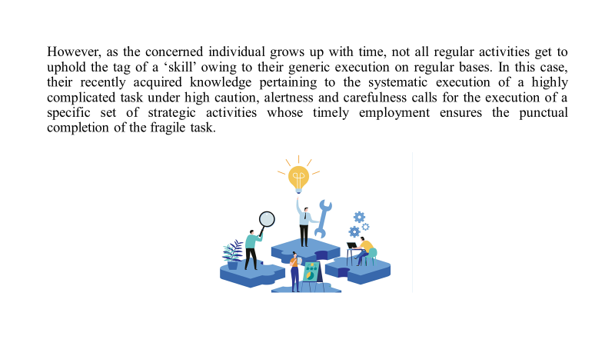

Introduction
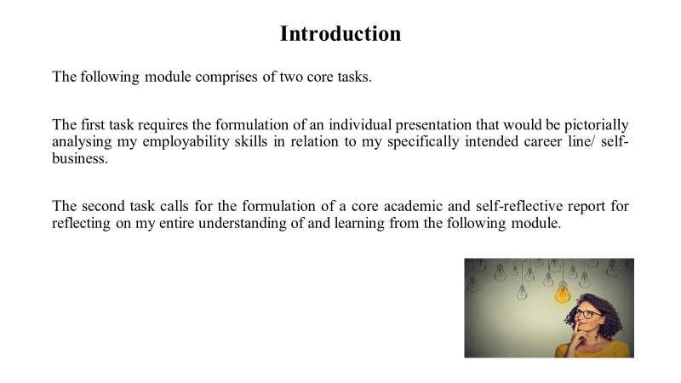

The following module comprises of two core tasks, which are individually subdivided into other variant tasks, whose accomplishments would be meeting the entire module’s core academic goal.

The first task requires the formulation of an individual presentation that would be pictorially analysing my employability skills in relation to my specifically intended career line/ self-business. Prior to that, its support theoretical report would be formulated; wherein both of my previously possessed inert and acquired skills would be identified along with those requiring executive improvement and future acquirement for practically succeeding in the respective professional field. My chosen aspirational field would be well-identified and demonstratively analysed through theoretical elucidation. Furthermore, it would be providing an in-depth understanding of that specific field through practically valid and relevant approaches pertaining to its supportive activity environment by referring to published literature. The following file’s core content (based on my personal interests and perspectives) would be supported through SWOT Analysis, Time Management tools and PDP.
Meanwhile, the second task calls for the formulation of a core academic and self-reflective report reflecting my entire understanding of and learning from the following module, by resorting to a prominent reflective model; which would be explained in details further ahead.

As per task one’s requirements, I careeristically aspire to manage a leading global MNC’s core operations in the long-run; owing to which I’m academically inclined towards Business Management and Studies.
As per the provided topics pertaining to task two, the three topics chosen from the list provided in the brief (apart from ‘public speaking’ with respect to verbally presenting a presentation) are ‘time management’, ‘organising study’ and ‘paraphrasing’.

Task-1

Discuss your inert and acquired skills pertaining to your field of interest
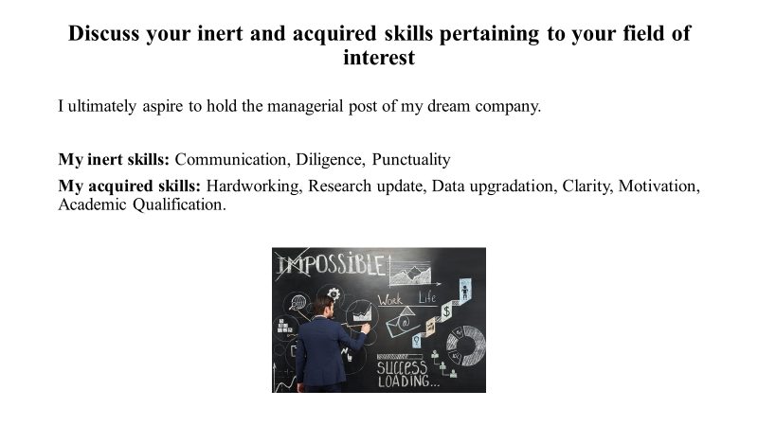

A skill refers to an act of expertise pertaining to any and every aspect-centric activity/ mechanism supporting an individual’s entire life (across their functional executions and orientations) (Ward et al., 2018). This implies that an individual’s both personal and professional lives depend on the timely execution of the most appropriate skill for achieving the exact targets of these tasks as per their executive desirability. Since birth, these exclusive acts are continuously acquired and mastered by individuals through external trainings (imparted by their family members, teachers, relatives, friends and every other beings inhabiting within their spatial vicinity within the concerned environment). Their inculcation depends upon the concerned individual’s motor and cognitive developmental pace and its current state, which helps in identifying their overall stability, which ultimately validates the inculcation of a specific skill especially at that specific point of time (Alnoori, 2019). Not just that, the execution of particular skills involves its permanent memorization for driving the concerned task’s repeated execution based on its frequency of recurrence. Rather, the execution of majority of our daily-purpose motor and cognitive actions (from brushing our teeth right after getting up from bed to going to bed at 10 PM post-dinner and involving every other actions’ chronological execution in-between) calls for their executive memorization. This process further develops individual habits and imparts a sense of good and bad mannerisms to them through their continuous execution, based on which the habitual execution of certain actions can be restricted to certain events or mostly avoided for posing harm to other individuals within and/ or beyond their spatial vicinities (Adriaensen et al., 2019).
However, as the concerned individual grows up with time, not all regular activities get to uphold the tag of a ‘skill’ owing to their generic execution on regular bases. In this case, their recently acquired knowledge pertaining to the systematic execution of a highly complicated task under high caution, alertness and carefulness calls for the execution of a specific set of strategic activities whose timely employment ensures the punctual completion of the fragile task (Werner, 2022). This act now gets promoted as the individual’s new skill for bearing an exclusive executive approach, for performing non-recurrent activities. Also, their systematic inculcation and execution for meeting the concerned task’s deliverability standards depends upon the continual development of that individual’s maturity as well as its level/ status at that point of time, when the task’s execution has been offered to them. These skills boost their executive confidence and practically reflect their qualification and sense of responsibility towards ensuring the concerned task’s timely accomplishment. The more they ace at employing the exact knowledge during skill execution, the more they reflect their efficiency in managing both time and energy for accomplishing that particular task. Furthermore, their vast knowledge procurement across various disciplines can also empower them to resort to the locally and cheaply available tools and elements aiding the task’s quick execution, based on which they can even lower its executive budget. This pattern of executing exclusive genre-specific skill(s) fall under its ‘domain-specific’ category (like those pertaining to the fields of core-engineering. technical, music (both vocal and instrumental), art, craft, handling of electrical tools/ gadgets; and more) (Schoevers et al., 2020). The ability of handling team work involves leadership, which is again an executive skill which falls under its domain-general category for being executable across various functional departments pertaining to the same and/ or a different activity field. Skills like teamwork, time management, communication, self-motivation and more also fall under the latter category (Bustamante et al., 2018).

As mentioned above, I ultimately aspire to be hold the managerial post of my dream company.

Accordingly, I’m elucidating on my inert skills:

- Communication: As an extrovert, I’ve always succeeded in effortlessly interacting with strangers and new people, despite which I make sure not to harm their inert faith/ beliefs as I acknowledge a cosmopolitan setup’s intermingling of diversified ideas, lifestyles, ethnicities, languages and more. Owing to these complications, currently I strictly prefer sticking to the national/ universal mediums of communication (mostly English), since every individual bearing multiple socio-cultural dynamics can understand this one relevantly used medium in its extremely simplified form (Radovic Markovic et al. 2018).

- Diligence: I get engrossed deeply while executing a project/ assignment demanding my prior attention based on two key factors; my interest pertaining to the given topic and its allotted deadline. As a perfectionist, I try to ensure my work’s ultimate finesse through its appeal and factual relevance.

- Punctuality: Being prone to anxiety attacks regarding the late submission of tasks, I try to wrap up my pending works prior to their given deadlines for making room to indulge in other recreational activities.

Elucidating on my acquired skills:

- Hard worker: I hustle hard to level-up my productivity standards while executing a given assignment as I’ve inculcated the need for excellence with time for sorting out my long-term dream as soon as possible.

- Research work: I conduct an in-depth research for procuring a wide-variety of knowledge pertaining to my field of prior interest. Accordingly, I browse through multiple online sites for gathering the exact material pertaining to the current scenario. Additionally, I visit libraries for gathering relevant references bearing archival knowledge, which can enable its comparison with the latest information for asserting its practical relevance.

- Data update: Apart from doing assignment-based researches, I like to keep myself updated regarding every universal as well as local events (irrespective of their significances’ intensities) as it helps me to broaden my own horizon on life with a progressive attitude, since the world is also changing daily.

- Clarity: Previously, owing to the undergoing through unnecessary harassments related to spread of miscommunication amongst group members which negatively affected out team work’s outcome, I prioritise learning about the assignment’s core objective right when the brief arrives, before executing the final task. This way, I get to convey the core message to my teammates with a more clarified approach, which helps to keep everyone on the same page.

- Motivation: My inert urge of ensuring my diligent productivity cannot be achieved without the employment of motivation, which I had to inculcate within myself for ensuring the concerned task’s desirable completion within its given deadline. Motivation boosts my executive discipline and tones down my anxiety.

- Academic qualification: Once I developed an aspirational interest towards controlling the management mechanism of a concerned organisation wherein I’ll be getting placed, I immediately looked up for the exact academic courses and streams that would strategically guide me to my dream’s path. Identifying the same (BBA and MBA streams), I searched for the leading business schools and universities throughout the world, claiming whose graduation certificate cannot just boost my career’s future, but also ensure that I was exposed to the perfect academic premises for enabling the inculcation of high-end executive skills/ knowledge and further develop my inert skills’ practical exclusivity.

Identify those requiring improvement for practically succeeding in the chosen field
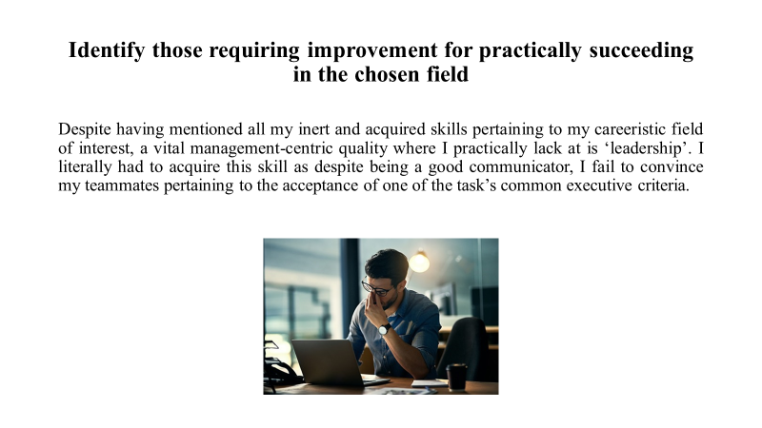
Despite having mentioned all my inert and acquired skills pertaining to my careeristic field of interest, a vital management-centric quality where I practically lack at is ‘leadership’. I literally had to acquire this skill as despite being a good communicator, I fail to convince my teammates pertaining to the acceptance of one of the task’s common executive criteria. Their recessive attitude prompts me to take a backseat so I’m still working on this skill.

Conducting a SWOT Analysis of my inert and acquired skills to check their executive compatibility with my concerned long-term career stream and identify the existing weaker skills to boost their executive quotient accordingly.

Strengths | Weaknesses
- I execute clarified communication between peers, authorities and amongst team members by resorting to the most understandable medium of communication through a simplified appeal.  - I ensure my performatory diligence while executing an assignment through disciplinary motivation and executive perfectionism. This way, I qualitatively enhance my productivity and get done with it before their respectively allotted deadline.  - I resort to abundant support files, facts and references (from libraries and the internet) for ensuring my output’s relevant precision. | - I suffer from anxiety issues for bearing the fear of not performing up to the organization’s expectations. This drives my executive hypertensity for meeting the given task’s deadline, owing to which I’m constantly subjected to intra-team criticisms.  - The same reason drives my superiority complex with me believing in the submission of an excellent file, whose quality is way better than my peers’; owing to which I degrade their respective productivities.  - Despite being an extrovert with good communication skills, I fail at gaining strategic control while interacting with my team members or asserting my minimal authority as the team lead.
Opportunities | Threats
- I’m meditating on daily bases to release my performatory stress and boost my self-motivation for achieving my prior life-goal, by combatting against all odds with a calmer approach.  - Staying at-par with current affairs on daily bases boosts my IQ’s tenacity in updating myself with the world and accepting things the way they are.  - Executing simplified root-level communication with my team members with a clarified approach can help me overcome my leadership hurdles. | - The existence of a highly diversified cosmopolitan group within my work setup freaks me out as clashes in ideologies prevail, which prevents my potential productivity’s honest reflection.

Demonstrate an understanding of that chosen field
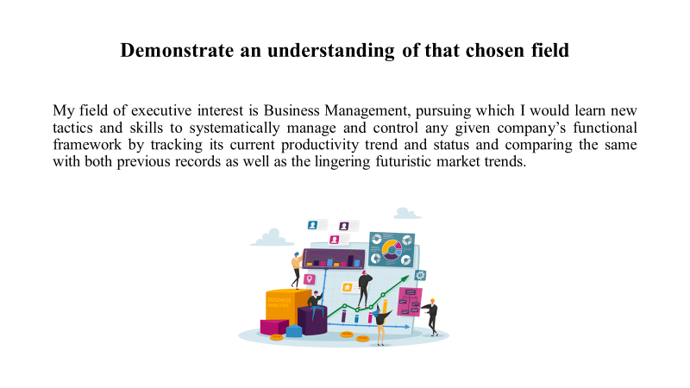

My field of executive interest is Business Management, pursuing which I would learn new tactics and skills to systematically manage and control any given company’s functional framework by tracking its current productivity trend and status and comparing the same with both previous records as well as the lingering futuristic market trends, depending upon whose insights I would be empowered to drive fresh business-centric enhancements, amendments and/ or alterations; if and when needed. I have always been fascinated by the operational mechanism of every firm’s functional framework with respect to each department’s hierarchical positioning based on their respective objective accomplishment’s prior requirement, which further governs the entire firm’s systematic and chronological functioning. Also, the mode of high-end infrastructures employed to smoothen the pace of their technical operations along with driving clarified and simplified intra-organizational communication amid their corporal engagement, that too without interfering the executive course of a single department’s operation(s) has also garnered my attention.

Lastly, the importance of these strategic functional course-aided framework’s practical incorporation and execution within every single organization across their diversified participatory activities and productivity targets also assert the importance of executing managerial activities for every task, irrespective of their personal/ professional orientations.

Task-2

Reflective Report

Since its inception, this assignment has been reflecting on the various corporal skills that were present in or were eventually acquired by me through my gradual mental, motor and cognitive developments as well as age-centric maturity. Moreover, these executive skills must align with my long-term career goal (which happens to be ‘Business Management’, that too as an aspirant for a leading MNC’s managerial post); for ensuring its final accomplishment in the long-run. After having conducted my SWOT Analysis for identifying the corresponding strengths, weaknesses, opportunities and threats pertaining to my career field of interest.

As per this report’s requirement, I have to reflect my executive calibre pertaining to the three domains of ‘Time management’, ‘Organising study’ and ‘Paraphrasing’ (that were selected from the list of other executive domains that were provided within the given brief); and the last domain of ‘Public speaking and giving presentations’, whose involvement has been mandated within the same brief itself. Now, as an academic candidate, the practical reflection of my managerial skills are restricted to the institution-level assignments/ team works/ group projects and related other institutional communities; wherein I just don’t get to showcase my excellent diligence with respect to delivering the given task’s highly precise and relevant outputs, but also get to showcase my communication skills within a team setup to win everybody’s mutual confidence pertaining to a judicious executive idea, which further enhances their overall participatory engagement within the concerned setup for effectively meeting its required final objectives. The more fruitful my communication skills turn out to be through its convincing quotient, the more I would gain every single group member’s validation in their acceptance of voting me as the team leader and further abiding by my executive instructions for procuring its best outcomes. In return, I would be taking down their feedback and suggestions pertaining to their executive and participatory limitations and discomforts, based on whose valid generosity (with respect to the concerned organization’s expected participatory standards and regulations) I would be introducing improvised and enhanced functional patterns accordingly, that too from time to time.

However, before practically proceeding to this stage of careeristic promotion, I need to build up my leadership traits and the quality of their practical execution within my current institutional setup. For achieving the same, I priorly need to step up as a BA candidate by working on my other academic skills (pertaining to the same field) and enhancing their individual productivities as well.

Currently, for bearing a priorly-required submission-oriented assignment in my kitty (whose execution is still untouched), I would be ensuring its timely completion with a high qualitative approach (by incorporating relevantly authentic information and data pertaining to the topics of concern). However, for proceeding with the same, I need to analyse my inert and acquired skills pertaining to its systematic execution right from its inception to conclusion. This is why I would be analysing my potential pertaining to the fulfilment of certain aspects regarding driving the given assignment’s execution and punctual completion (in a more or less chronological format). These aspects were already provided in this assignment’s brief, out of which I selected the three execution-centric aspects of ‘Time management’, ‘Organising study’ and ‘Paraphrasing’; for identifying my potential in ensuring their strategically qualified fulfilment within limited time spans. The fourth executive aspect pertaining to the same assignment was already mentioned in the brief, which happens to be ‘Public speaking and giving presentations’; which would be reflecting my presentational appeal and vocal skills which actively drive the concerned presentation’s appealing formulation and an enhanced demonstration through a clarified approach.

Elucidating on these four assignment-execution aspects individually:

- Time management: As mentioned before, I worry a lot with respect to maintaining the consistency of my punctuality’s quotient within institutional setups, with respect to ensuring a given task/ assignment’s timely completion within the given time boundary without contemplating on its compromised qualitative attribute. This fear constantly drives my sense of punctuality by treating the assignment’s completion as my sole priority. Since the moment I receive the brief, as a team leader, I check out all the provided tasks, sub-tasks and their adjacent questions; which I align with each member’s interest and expertise areas pertaining to their inert and procured skills and knowledge. This smoothens labour division and I punctually track their progress status from time to time to check whether they are meeting their respective targets on time or not. Once done, I collect their individual outputs, make the necessary amendments and then chronologically compile the tasks into a single assignment document. Based on this compiled file’s punctual completion, we get to save some extra time for formulating its corresponding presentation and ensure its high-end productivity through enhanced diagrams and visuals, for boosting the content’s visual appeal.

- Organising study: As per the topics divided amongst every single member, they are required to conducted detailed research on the same by resorting to either physical or virtual documents like (e-)newspapers and magazines, government and academic journals, blogs, topic-related official sites and more. I often provide extra reference documents to them or suggest some new site’s names for boosting their research-centric participation as well as the assignment’s final productivity status.

- Paraphrasing: This is a serious issue in hindering any assignment’s relevant authenticity, based on which no assignment can ever hold a public utility or a reliance value as despite being flashy and extremely appealing, its information/ data ain’t authentic for relying upon glitched/ morphed procuration sources. Hence, I always ensure every information source’s authentic background, depending on which I validate each team member’s executive progress based on the same. Also, I strictly proof-read through their final outputs for limiting all scopes of information copy-pasting (which might not be applicable for the headlines, numerical data and legendary quotes). Our team’s files’ mostly reflect a plag-percent less than 8. Lastly, I ensure my teammates mention the sources of their information procuration in the Bibliography/ Reference section (Fitria, 2021).

- Public speaking and giving presentations: While presenting its corresponding presentation before the entire class, I ensure the high-end enhancement of its pictorial representation for boosting its visual appeal, based on which the viewers don’t find it very boring. Additionally, interesting graphics and transitions can be added for imparting special effects while changing slides. Every member must be well-versed with their participatory portions for confidently orating the same forth the entire class. Everybody speaks clearly in simplified English to make the matter of concern understandable for all (Gallego et al., 2022).

Conclusion
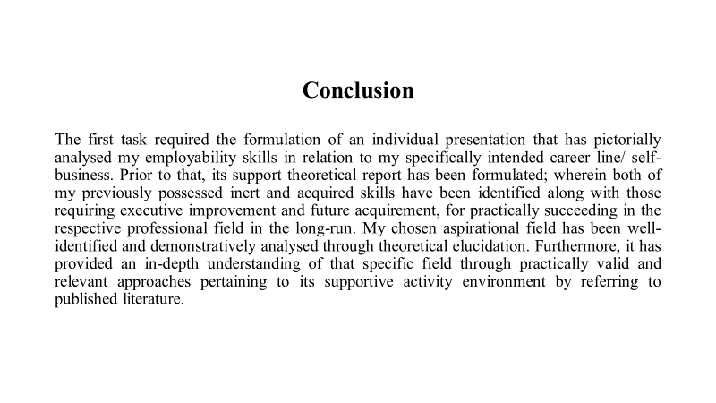

The following module comprised of two core tasks, which were individually subdivided into other variant tasks, whose accomplishments met the entire module’s core academic goal.

The first task required the formulation of an individual presentation that has pictorially analysed my employability skills in relation to my specifically intended career line/ self-business. Prior to that, its support theoretical report has been formulated; wherein both of my previously possessed inert and acquired skills have been identified along with those requiring executive improvement and future acquirement, for practically succeeding in the respective professional field in the long-run. My chosen aspirational field has been well-identified and demonstratively analysed through theoretical elucidation. Furthermore, it has provided an in-depth understanding of that specific field through practically valid and relevant approaches pertaining to its supportive activity environment by referring to published literature. The following file’s core content (based on my personal interests and perspectives) has been supported through SWOT Analysis, Time Management tools and PDP.
Meanwhile, the second task has formulated a core academic self-reflective report, that has reflected my entire understanding of and learning from the following module, by resorting to a prominent reflective model; which has been explained in details further ahead.

As per task one’s requirements, I careeristically aspire to manage a leading global MNC’s core operations in the long-run; owing to which I’m academically inclined towards Business Management and Studies.
As per the provided topics pertaining to task two, the three topics chosen from the list provided in the brief (apart from ‘public speaking’ with respect to verbally presenting a presentation) are ‘time management’, ‘organising study’ and ‘paraphrasing’.

References
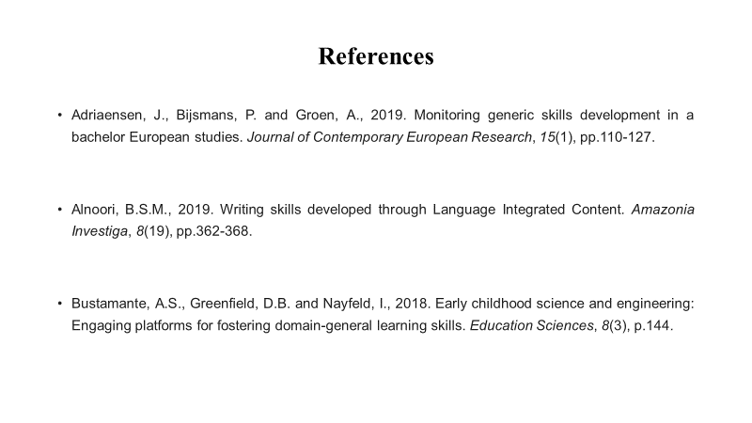

Adriaensen, J., Bijsmans, P. and Groen, A., 2019. Monitoring generic skills development in a bachelor European studies. Journal of Contemporary European Research, 15(1), pp.110-127.

Alnoori, B.S.M., 2019. Writing skills developed through Language Integrated Content. Amazonia Investiga, 8(19), pp.362-368.

Bustamante, A.S., Greenfield, D.B. and Nayfeld, I., 2018. Early childhood science and engineering: Engaging platforms for fostering domain-general learning skills. Education Sciences, 8(3), p.144.

Fitria, T.N., 2021. QuillBot as an online tool: Students’ alternative in paraphrasing and rewriting of English writing. Englisia: Journal of Language, Education, and Humanities, 9(1), pp.183-196.

Gallego, A., McHugh, L., Penttonen, M. and Lappalainen, R., 2022. Measuring public speaking anxiety: self-report, behavioral, and physiological. Behavior Modification, 46(4), pp.782-798.

Radovic Markovic, Mirjana, and Aidin Salamzadeh. "The importance of communication in business management." In Radovic Markovic, M., & Salamzadeh, A.(2018). The Importance of Communication in Business Management, The 7th International Scientific Conference on Employment, Education and Entrepreneurship, Belgrade, Serbia. 2018.

Schoevers, E.M., Kroesbergen, E.H. and Kattou, M., 2020. Mathematical creativity: A combination of domain‐general creative and domain‐specific mathematical skills. The Journal of Creative Behavior, 54(2), pp.242-252.

Ward, P., Gore, J., Hutton, R., Conway, G.E. and Hoffman, R.R., 2018. Adaptive skill as the conditio sine qua non of expertise. Journal of applied research in memory and cognition, 7(1), pp.35-50.

Werner, D., 2022. Athletics and Disabilities Are Not Mutually Exclusive. Sport Social Work Journal, 2(1).

