ECEY6006

Supporting Children with Additional Learning Needs

Contents Page – Page 1

Poster – Page 2

Agenda – Page 3

Poster reference list – Page 4 – 8

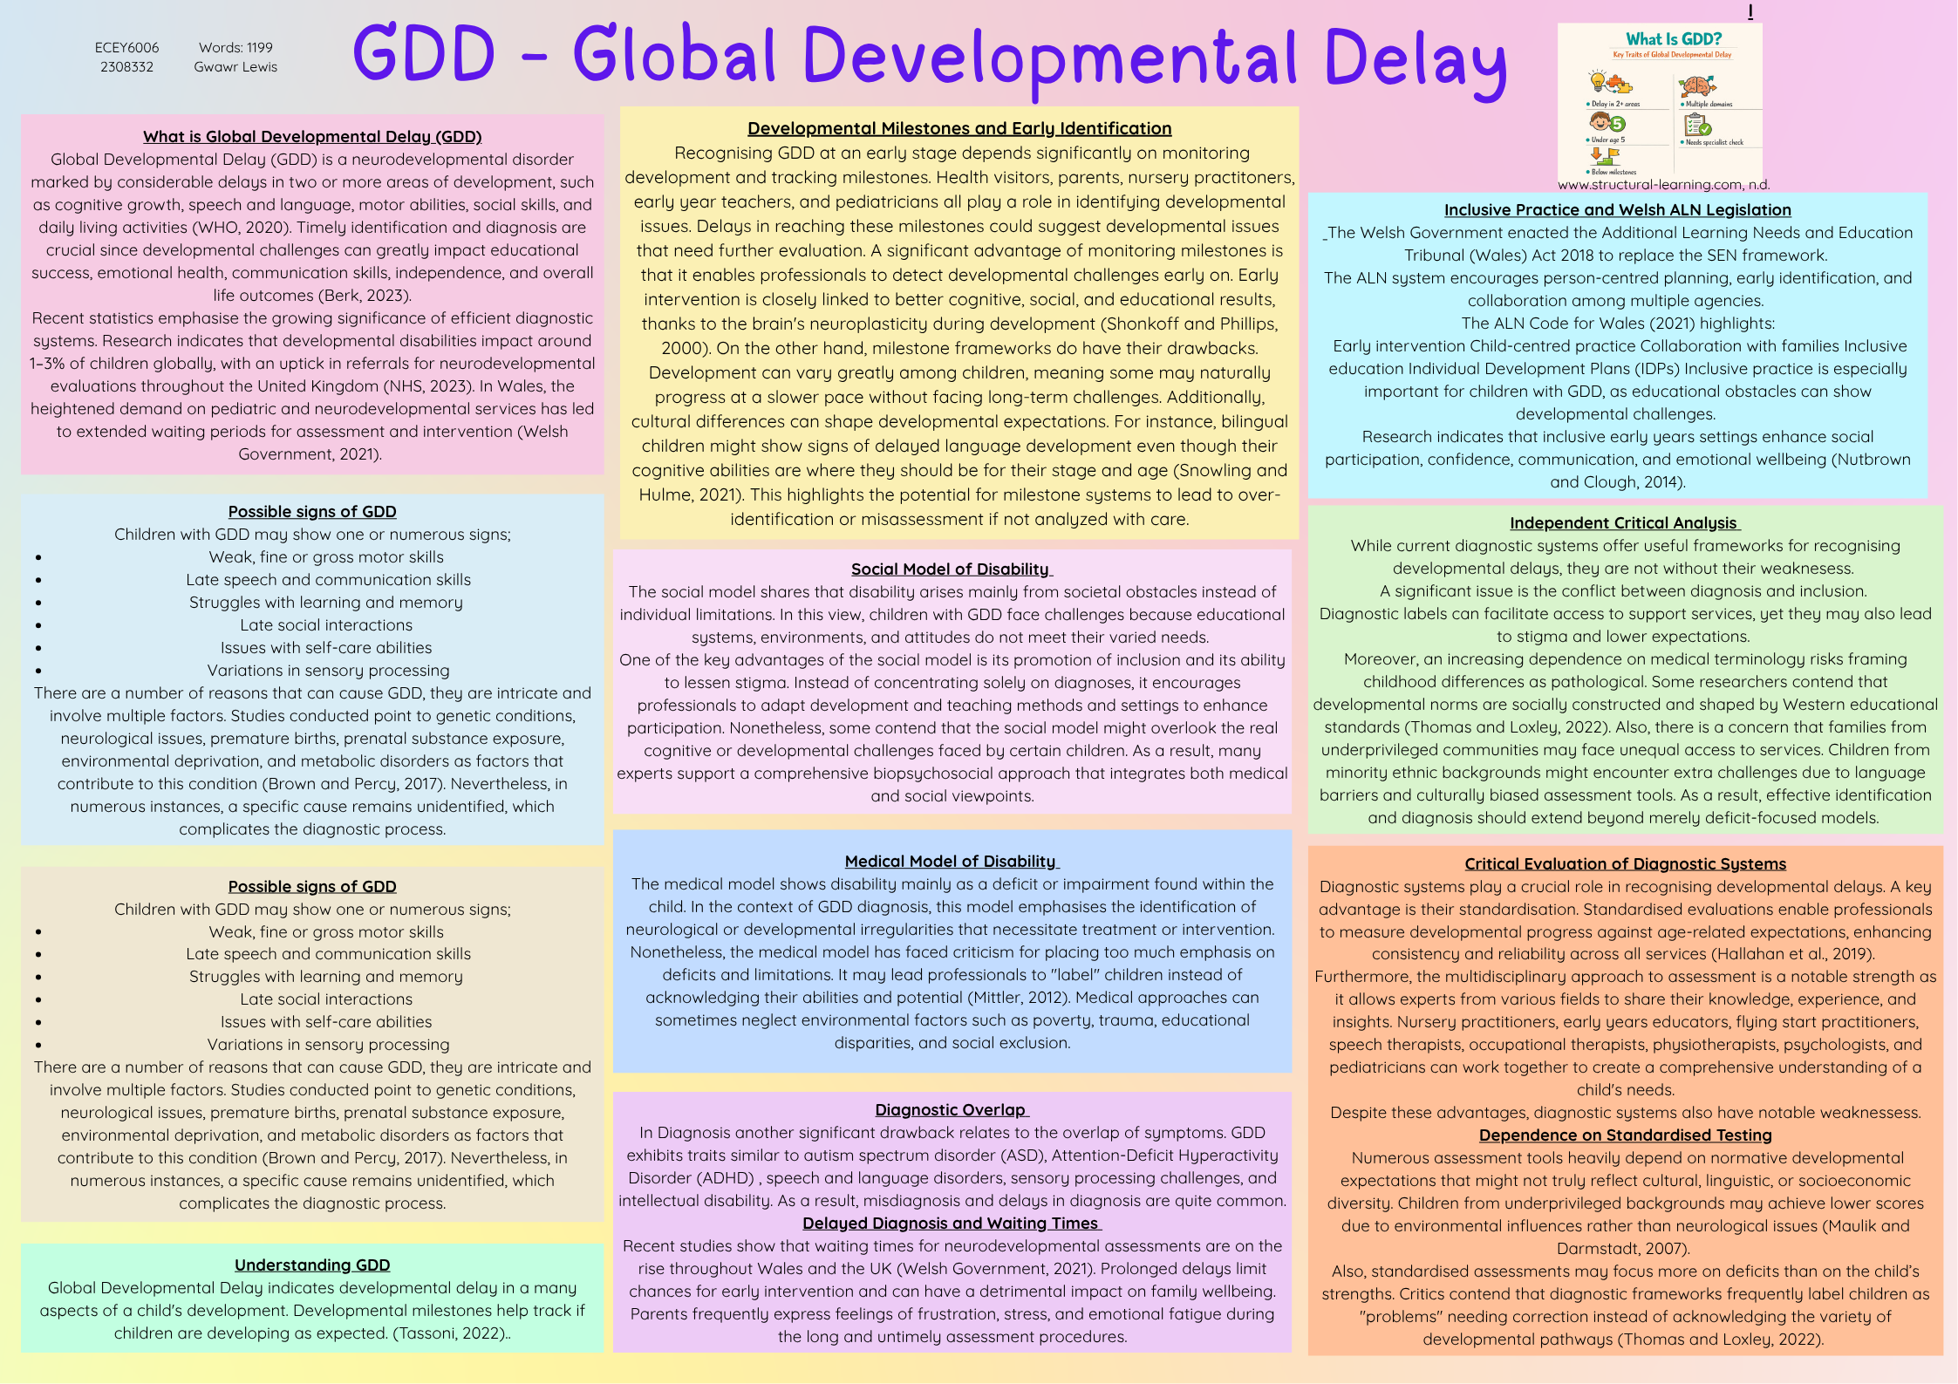
ALN WEBINAR AGENDA

Additional Learning Needs webinar scheduled to start at 5pm on Monday 11th 2026,
Webinar Introduction – Gwawr

ADHD poster and presentation, followed by question and answers – Gemma

Dyslexia poster and presentation, followed by question and answers – Cody

Bobbie poster and presentation, followed by question and answers – Down Syndrome

Joelle poster and presentation, followed by question and answers – Autism

Gwawr poster and presentation, followed by question and answers – Global delay

Webinar closure – Gwawr

Allen, K. and Cowdery, G. (2015) The Exceptional Child: Inclusion in Early Childhood Education, 8th edition

American Psychiatric Association (2022) Diagnostic and Statistical Manual of Mental Disorders

Anning, A., Cullen, J. and Fleer, M. (2019) Early Childhood Education: Society and Culture. 3rd edition

Atkinson, M., Jones, M. and Lamont, E. (2007) Multi-Agency Working and Its Implications for Practice.

Bailey, D. and Wolery, M. (2015) Teaching Infants and Preschoolers with Disabilities.

Bandura, A. (1977) Social Learning Theory

Bee, H. and Boyd, D. (2019) The Developing Child; 14th editions

Berk, L. (2023) Child Development, 11th edition

Blackburn, C. (2016) Policy-to-Practice in the Early Years. Maidenhead

Blamires, M. and Moore, J. (2014) Socially Inclusive Teaching: Strategies for Supporting Children with Emotional and Behavioural Difficulties

Bowlby, J. (1988) A Secure Base: Parent-Child Attachment and Healthy Human Development

Bronfenbrenner, U. (2005) Making Human Beings Human

Brown, T. and Percy, M. (2017) Developmental Disabilities in Infancy and Childhood

Carpenter, B., Egerton, J., Cockbill, B. and Bloom, T. (2015) Engaging Learners with Complex Learning Difficulties and Disabilities

Charman, T. and Stone, W. (2018) Social and Communication Development in Autism Spectrum Disorders

Children’s Commissioner for Wales (2022) Disabled Children and Young People in Wales

Department for Education (2015) Special Educational Needs and Disability Code of Practice: 0–25 Years

Department of Health (2021) Healthy Child Wales Programme

DfE (2022) Early Years Foundation Stage Framework

Doherty, J. and Hughes, M. (2009) Child Development: Theory and Practice 0–11

Donaldson, M. (2012) Children’s Minds

Dunst, C. and Espe-Sherwindt, M. (2016) Family-Centred Practices in Early Childhood Intervention

Feldman, R. (2020) Development Across the Life Span, 9th edition

Fletcher-Campbell, F. (2013) Supporting Children with Additional Need

Frederickson, N. and Cline, T. (2015) Special Educational Needs, Inclusion and Diversity; 3rd edition

Garcia Winner, M. (2013) Social Thinking and Me. California

Glascoe, F. (2018) Collaborating with Parents

Goldbart, J. and Caton, S. (2010) Communication and People with the Most Complex Needs

Goswami, U. (2015) Children’s Cognitive Development and Learning. York

Guralnick, M. (2017) Early Intervention for Children with Intellectual Disabilities

Hallahan, D., Kauffman, J. and Pullen, P. (2019) Exceptional Learners; 14th edition

Healthy Children Organisation (2019) Developmental Delays in Early Childhood.

Heward, W. (2018) Exceptional Children: An Introduction to Special Education; 11th edition

Hobson, P. (2014) Autism and the Development of Mind. Hove

Hodkinson, A. and Vickerman, P. (2016) Key Issues in Special Educational Needs and Inclusion

Hornby, G. (2014) Inclusive Special Education

Izard, C. (2010) The Many Meanings of Emotion Definitions, Functions and Activation

Jones, C. (2021) Supporting Inclusion in the Early Years.

Kail, R. (2020) Children and Their Development; 8th edition

Lindon, J. (2016) Understanding Child Development; 3rd edition

Lindsay, G. (2007) Educational Psychology and the Effectiveness of Inclusive Education

Locke, J. (2013) An Essay Concerning Human Understanding

Maulik, P. and Darmstadt, G. (2007) ‘Childhood disability in low- and middle-income countries’, Paediatrics,

Mittler, P. (2012) Working Towards Inclusive Education

Moore, A. (2021) Teaching and Learning: Pedagogy, Curriculum and Culture

Morrison, G. (2018) Early Childhood Education Today. 14th edition

National Institute for Health and Care Excellence (2017) Developmental Follow-Up of Children and Young People Born Preterm

NHS (2023) Developmental Delay in Children

Nutbrown, C. and Clough, P. (2014) Inclusion in the Early Years; 2nd edition
Odom, S., Horner, R., Snell, M. and Blacher, J. (2012) Handbook of Developmental Disabilities

Open University (2019) Inclusive Practice in Early Childhood

Parsons, S. and Lewis, A. (2010) The Home-Education of Children with Special Needs or Disabilities in the United Kingdom

Parton, N. (2014) The Politics of Child Protection

Piaget, J. (1952) The Origins of Intelligence in Children

Pound, L. (2019) How Children Learn. 3rd editions

Raver, S. (2013) Early Childhood Special Education

Rogers, S. and Dawson, G. (2010) Early Start Denver Model for Young Children with Autism

Rogoff, B. (2003) The Cultural Nature of Human Development

Shonkoff, J. and Phillips, D. (2000) From Neurons to Neighbourhoods

Skinner, B. (1974) About Behaviourism

Slee, R. (2018) Inclusive Education Isn’t Dead, It Just Smells Funny

Snowling, M. and Hulme, C. (2021) The Science of Reading

Sroufe, L. (2005) The Development of the Person

Tassoni, P. (2022) Child Development and Education

Thomas, G. and Loxley, A. (2022) Deconstructing Special Education and Constructing Inclusion. 3rd edition

Trawick-Smith, J. (2022) Early Childhood Development: A Multicultural Perspective. 8th editions

UNESCO (2020) Global Education Monitoring Report: Inclusion and Education

UNICEF (2019) Children with Disabilities

Vygotsky, L. (1978) Mind in Society.

Welsh Government (2018) Additional Learning Needs and Education Tribunal (Wales) Act 2018

Welsh Government (2021) Additional Learning Needs Code for Wales

Welsh Government (2023) Neurodivergence Improvement Programme

WHO (2020) International Classification of Diseases

Wolfendale, S. (2018) Special Needs in the Early Years

Wood, D. (2013) How Children Think and Learn

www.structural-learning.com. (n.d.). Developmental Global Delay. [online] Available at: https://www.structural-learning.com/post/developmental-global-delay. [Accesses May 3rd, 2026]

Yell, M. (2019) The Law and Special Education. 5th edition.

Young, S. and Smith, J. (2017) Supporting Communication in Early Childhood

‌

