The evaluation of budgeting methods and the importance within a company 2018-2019



Module NAme: Management accounting (m5x00854)
Student Name: Phils Muobike
student number: 1706873
lecturer name: Manjit biant

Table of contents
1. Executive Summary 2
2. Introduction 2
3. Types of budgeting 2
4. Main Findings 4
4.1 Evaluation of the Traditional Budgeting method 4
4.2 Identification and disadvantages of Annual Budgeting 5
4.3 The importance of Beyond Budgeting 7
4.4 Barriers 8
5. Conclusion and Recommendations 9
6. References 10

List of figures
Figure 1 Traditional Budgeting (Hope and Fraser, 2003) 4
Figure 2 Beyond Budgeting (Tian, Ni, Hao and Wu, 2015) 7

Executive Summary

This report includes a short introduction, which will explain the aim of this report. In the following section, there will be a description of various types of budgeting approaches and definitions made by scholars and academics. Evaluation of the Traditional Budgeting method will be discussed where the main disadvantages of this system will be mentioned. Annual Budgeting will be analysed and examined. The modern budgeting approach known as Beyond Budgeting will be discussed and the advantages of this approach will be explained. In the final section, there will be a brief conclusion and some recommendations as to how Traditional Budgeting could be implemented along with the modern approaches and why companies should move to Beyond Budgeting.

Introduction

This report will focus more on the Beyond Budgeting model in contrast with the traditional method, and there will be a detailed explanation of the usefulness of the Beyond Budgeting model. There will be a description and a brief evaluation of Annual Budgeting methods, and how they are utilised in a company, and the weaknesses of this approach will be discussed. The modern budgeting method including the Beyond Budgeting method is going to be mentioned in the report because they are effective systems which could resolve various issues, which the traditional system has been causing in recent years (Réka, Ştefan and Daniel, 2014).

Types of budgeting

There are various definitions of budgeting given by scholars and academics. As stated by Drury (2013), budgeting is when financial objectives are set, and forecasts of the future are made in order to prevent any action that affects the accomplishment of the objectives and the management of initial plans made by a company. Radonić (2018) believes that budgeting has been having a big influence in controlling the performance of a company.
Budgeting is a very important process to build a strategy on how to spend money and it helps to balance expenses and income. Budgeting could also have an enormous impact on managerial behaviour, and could motivate managers and other experts within a company to perform and achieve their objectives efficiently. According to Tilanus (2012), the budget is a quantitative term for a plan for a specific period of time. The budget could also include revenues, sales, costs, expenses, cash flows and many other financial elements (Anderson, 2016).
Harris and Mongiello (2012) consider that budgeting has had a significant change over the years and that it developed from the traditional system where the budget was increased to a new strategy based on the present needs that offer more flexibility with a driven approach (Miller, 2018). There are various types of budgeting methods such as the traditional method, Zero-based Budgeting, Beyond Budgeting, Activity-based Budgeting, Balance Scorecard and many more (Radonić, M., 2018).
In the traditional system, the budget of the previous year is utilised and creates assumptions for the budget of the following year. This traditional method is used by decreasing or increasing the amount of money that indicates the changes that could happen in the future. The traditional method is considered a quantitative approach, while, Balanced Scorecard Budgeting is a qualitative approach because it has four phases of implementation. As described by Kaplan and Norton (2007) Translating the Vision, Communicating and Linking, Business Planning and Feedback and Learning are the four essential stages in the Balance Scorecard budgeting system.
Zero-based Budgeting is a transparent way of creating a budget (Chinniah, 2013). This method of budgeting starts from zero every year in order to eliminate any unnecessary cost and create an accurate forecast (Miller, 2018). It requires all managers to adjust the individual financial statement items in the budget (Chinniah, 2013). CIMA (2007, cited in Goode and Malik 2011) stated that Zero-based Budgeting is time-consuming and expensive. Initially, companies gather and calculate all the information needed; it takes time to understand all the activities and they try to analyse all the expenditures (Miller, 2018).
Activity-based Budgeting is a method which does not consider the previous year to arrive at the present year’s budget (Börjesson, 1997). The costs acquired are researched and analysed, and then the resources are assigned in an activity. Activity-based Budgeting is made to justify cost drivers (Hansen, 2011). According to Drury (2013), the Activity-based Budgeting is to approve the supply that is vital to performing activities needed to reach the budgeted production and the number of products sold by the company.
The traditional budgeting method has been used as the default method of budgeting for many years (Bogsnes, 2016). Various companies still utilise the Traditional Budgeting system and this does not allow them to accomplish their full potential and their objectives (Olesen, (2015). The following section will discuss the weaknesses of Traditional Budgeting.

Main Findings

4.1 Evaluation of the Traditional Budgeting method
There has been a significant transformation in the business environment from when Traditional Budgeting was first adopted as a method to have hierarchical control of a company.
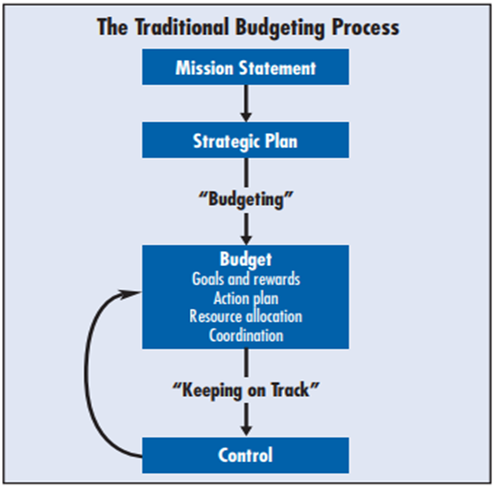
Figure 1 Traditional Budgeting (Hope and Fraser, 2003)

Moreira (2018), argued that Budgeting is something expensive and time-consuming, due to the fact that most of the money and time are invested to reduce costs. It is believed that budgets are considered by accountants to be a fiscal exercise where strategy is not considered (Anderson, 2018). Traditional Budgeting systems have more disadvantages than benefits; organisations could have difficulty adapting to any unexpected change (Norkowski, 2012). Businesses are becoming less flexible; and flexibility is one of the most essential elements which could determine the success of a company (Radonić, 2018). In the current business climate, where the environment is quite unpredictable, this traditional way of budgeting has been considered an ineffective system of managing and administrating business activity. As reported by Atrill and McLaney (2014), Traditional Budgeting is not having the impact that it should, due to the lack of long term conceptual and strategic thinking, and using the budget in an improper way which was not planned by the organisations.
According to Hope and Fraser (2003), the main disadvantages are time and cost consumption; it is expensive for a business activity to create a budget annually because it is a procedure that takes between four to six months to complete (Norkowski, 2012). Many businesses start their budgeting process between June and July until December. When a Traditional Budget is made, it requires the consent of the shareholders and it could take more time and cost more due to the fact that it is very detailed. Another disadvantage could be the inability to be flexible and to adapt to changes in the marketplace (Anderson, 2018). There are many things that could affect the economy in positive or negative ways; new investors or competitors could arise (Hope and Fraser, 2003). The conditions within the industry and or the market could change (Moreira, 2018). There could be many more changes that could affect a company, but Traditional Budgeting focuses only on the things that happened in previous years (Morris and Barsky, 2016).
As reported by Daum (2002), the Scandinavian Bank, the Svenska Handelsbanken has been using Traditional Budgeting since it was founded, and the bank had no budgets and no objectives. In 1979, the Swedish bank abandoned the Traditional Budgeting method and adopted the Beyond Budgeting system, and this upgrade made by the banks provided better flexibility and clearer objectives (Goode and Malik, 2011). Since they adopted the Beyond Budgeting method, the bank had considerable growth in Scandinavia, and started to be considered one of the most efficient banks in Europe (Hope and Fraser, 1997). This demonstrates the ineffectiveness of the Traditional Budgeting method previously used, which had prevented the company from achieving its objectives and full potential (Réka, Ştefan and Daniel, 2014).
Furthermore, it should be mentioned that Traditional Budgeting systems are concentrated on business functions such as Human Resources, Marketing, Information Technology, Finance which lead companies to fail to meet customer’s needs efficiently (Drury, 2013). According to Moreira (2018), in the modernised environment and economy, a company should have an acceptable level of customer service in order to challenge its competitors.

Identification and disadvantages of Annual Budgeting
Annual Budgeting for a company is planned just for a year and it is based on the previous year (Collier, 2015). Annual Budgeting could be considered as a system which is not able to perform in an efficient way and it is time-consuming (McWatters and Zimmerman, 2015). In an environment which changes quickly, the Annual budget could be perceived as unnecessary due to the fact that there could be environmental and economic changes which the company would be unable to adapt (Atrill and McLaney, 2009). As discussed in the previous section, Traditional Budgeting is planned for a year and it normally takes a considerable amount of time to create. It has been argued by various authors and scholars that budgets need a constant update, and this is not applied in Annual Budgeting (Zeller and Metzger, 2014).
According to Jensen (2003), there is another issue when it comes to budgeting regarding the performance of the employees and their rewards. Annual Budgeting systems create a habit of manipulating and producing creative accounting (Perrin, 1998). On the other hand, it could be argued that this creative accounting is also applied in the modernised budgeting methods (Collier, 2015). In most cases, incremental thinking is utilised to acquire the necessary information to create the annual budget, which gives no flexibility and adaption to any unexpected environmental change (McWatters and Zimmerman, 2015). Hope and Fraser (2003) argue that Annual Budgeting is an inconvenient process that uses a huge amount of time but creates a short-term plan, which has a negative effect on the ambition of the manager of a company (Drury, 2013).
According to Hope and Fraser (2003), managers and the other shareholders focus more on increasing sales, persuading customers to order the company’s products and achieve their financial target by any means possible. Managers spend less time concentrating on the level of performance, creating an effective strategy for the team to achieve their objectives efficiently or building a powerful team (Atrill and McLaney, 2009). This is the reason why Annual Budgeting motivates employers of a company to set their objectives on financial targets, rather than building up an efficient team to achieve the company’s purposes (Drury, 2013). When Annual Budgeting is utilised in a company, the managers are considered as a ‘watch person’ while the other members are obligated to dissociate themselves from the company’s structure (McLaney and Atrill, 2014).
According to Bogsnes (2016), the Annual Budgeting method should not be abolished but it should be remodelled into the new approach, although the values should remain the same. In this theory, it was stated that the Annual Budgeting and the Activity-based Budgeting could be combined in order to include Annual Budgeting with the other modern approaches (Bogsnes, 2008).

The importance of Beyond Budgeting
As stated by various academics, Beyond Budgeting is an innovative system where modernised management models are the only feasible competitive tool for all companies (Beyond Budgeting Institute, 2019).
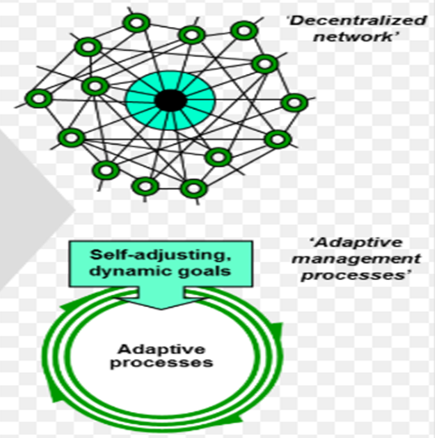
Figure 2 Beyond Budgeting (Tian, Ni, Hao and Wu, 2015)

Beyond Budgeting is helpful to simplify the bureaucratic aspect of budgeting and reduce the responsibilities of the people in the organisation during the control system. It also enables the workers of a company to increase and improve their performance by applying their workplace skills. Bogsnes (2016) argues that Beyond Budgeting provides flexibility in order to increase the trend of innovation and encourage people to make decisions by seeking permission from their managers. The author also stated that Beyond Budgeting should be used instead of the Annual Budgeting and Traditional Budgeting methods (O’Grady, Akroydand and Scott, 2017).
Beyond Budgeting has various features such as updating the budget monthly which is generally updated every four months. This method of budgeting is very convenient because it takes very few days to complete, and this demonstrates that the Beyond Budgeting takes less time to finish and is very efficient when it comes to improving the performance of the company. For example, FoodCorps switched from the Traditional method to the Beyond Budgeting approach in 2003 and the company stated that this enabled them to improve the performance through many factors and not only with the Key Performance Indicator (KPI), (Sandalgaard and Nikolaj Bukh, 2014).
Statoil is a Norwegian energy company which operates in more than 30 countries worldwide (Bogsnes, 2016). In 2005, Statoil moved from the Traditional Budgeting method to the Beyond Budgeting approach and stated that performance is improved through actions, strategy, plans and allocation of resources; while the Traditional Budgeting focuses more on the KPI. This modern method helped Statoil to achieve its financial targets and improve its dynamic forecasting model (Olesen, 2015).
Alfa Laval is the dominant global supplier of products such as heat exchangers and oil separators (Prohnitchi and Cadri, 2018). In 1998, Alfa Laval eliminated Traditional Budgeting and adopted a new method of budgeting. Conflicting roles of budgeting and the lack of flexibility to adapt to changes are the reason why Alfa Laval switched to Beyond Budgeting (Olesen, 2015).
Beyond Budgeting has so far been successfully used in a number of different companies (Franz Röösli and Santhosh Kaduthanam, 2018). Managers have to be aware of what they have to do to satisfy the expectations of the company. Most of the managers that have been using the traditional budgeting try to avoid taking risks (Virtanen, 2016). Beyond Budgeting is still considered a new approach and there has not been made enough research into its weaknesses.
Most managers still find it hard to understand that companies need a decentralised control and coordination (Franz Röösli and Santhosh Kaduthanam, 2018). When companies decide to move to the Beyond Budgeting system, they will often encounter some challenges. To begin utilising the modern method could be time-consuming and expensive if this system has not been automated previously (Hansen, 2011). Accountants will require specific training, and their tasks within the company will increase if the business adopts the Beyond Budgeting. The company will also look for another way to calculate and monitor performance because it would be evaluated at various times throughout a year (Libby and Lindsay, 2010).

4.4 Barriers
Traditional Budgeting has been considered inadequate by the Government and some business activities, although they are not prepared to adopt a modern method of budgeting (McCarthy and Lane, 2009). There are various barriers such as the difficulty to accept change and abandoning their “comfort zone”. Many companies agree that Traditional Budgeting should be improved but not be eliminated because it allows company leaders to have more control (Wienhold, 2015).
Companies that are using Traditional Budgeting and considered using modern approaches have to replace their traditional costs to activity-based costs (Pietrzak, 2013). Organisations that have utilised this method stated that it helps them to allocate costs accurately into specific departments and expected sales (Pietrzak, 2013). On the other hand, there are other companies that did not switch to a modern system of budgeting and argued that there are various disadvantages. The first reason is that it could be difficult to analyse the cost drivers and the overheads which could affect the company (Yakhou and Sulzen, 2010). Another reason could be the cost because it is time-consuming, so businesses prefer utilising the Traditional Budgeting because it is simple to use (Yakhou and Sulzen, 2010).

Conclusion and Recommendations

Traditional Budgeting has many disadvantages but there are other new methods. Traditional Budgeting has been in existence for over 80 years and has it has never been developed since then (Niven, 2010). Beyond Budgeting is one of the best new approaches because it is based on the current needs and objectives of the departments of a company rather than utilising information from previous years (Sandalgaard and Nikolaj Bukh, 2014).
Annual Budgeting has various barriers but it still has an important role in a company’s management. It should be combined with Activity-based Budgeting in order to enable a company to maximise the profit and catch up with the modern budgeting approaches (Bogsnes, 2016). Although budgeting has various weaknesses, it is still an important element for companies; it provides control and coordination of the company and it also helpful for performance management (Franz Röösli and Santhosh Kaduthanam, 2018).
The Traditional Budgeting approach could help an organisation to receive finance from investors or banks. Investors and lenders always want to see the financial plans and projections before capital can be invested. With this method of budgeting, companies can show investors their forecast and explain their reasons referencing the budget of the previous year (Hope and Fraser, 2003). Managers can also maintain control, and coordinate and monitor the performance management within the organisation (Franz Röösli and Santhosh Kaduthanam, 2018).
The Beyond Budgeting method enables companies to develop more co-operative behaviour between managers. Normally, managers manipulate outcomes in order to reach their targets (Perrin, 1998). This method helps companies to adapt to unexpected changes from internal and external factors. The flexibility of this method enables organisations to successfully face new situations (Miller, 2018).
The drawbacks of the two budgeting methods have been mentioned above. In order to meet the needs of modern businesses, it could be said that Traditional Budgeting could be made flexible, whilst still utilising the previous year’s budget which can be updated every four or six months in order to able to face upcoming challenges.

References
Anderson, B., (2016). Budgeting for Disasters.
Atrill, P. and McLaney, E., (2009). Management accounting for decision makers. Pearson Education.
Barsky, N.R. and Morris, J.T., (2016). Corporate budgeting: Perceptions of a next generation of corporate leaders. Management Accounting Quarterly, 17(4), pp.1-1.
Beyond Budgeting Institute (2019) Are you aware of the benefits of Beyond Budgeting? Let me enlighten you … [Online]. Available from: https://us7.campaignarchive.com/?u=33069b15098259cee2f42cf2b&id=f16ba1363b&e=1934b736d1. [Accessed 4 April 2019]
Bogsnes, B., (2008). Implementing beyond budgeting: Unlocking the performance potential. John Wiley & Sons.
Bogsnes, B., (2016). Implementing beyond budgeting: Unlocking the performance potential. John Wiley & Sons.
Börjesson, S., (1997). Activity-Based Budgeting. Journal of Cost Management, 10, pp.7-18.
Chinniah, A., (2013). An Assessment of Zero-Based Budgeting to Protect the Leakage of Finance in Government and an Organizational Development. CLEAR International Journal of Research in Commerce & Management, 3(5).
CIMA (2007). Beyond Budgeting. [Online] Available from: http://www.cimaglobal.com/Documents/Student%20docs/P1sept07fmarticle.pdf. [Accessed: 30 Apr 2019]
Collier, P.M., (2015). Accounting for managers: Interpreting accounting information for decision making. John Wiley & Sons.
Daum, J.H., (2002). Beyond budgeting: a model for performance management and controlling in the 21st century. Controlling & Finance, 5, pp.33-34.
Drury, C.M., (2013). Management and cost accounting. Springer.
Goode, M. and Malik, A., (2011). Beyond budgeting: the way forward?. Pakistan Journal of Social Sciences (PJSS), 31(2).
Hansen, S.C., (2011). A theoretical analysis of the impact of adopting rolling budgets, activity-based budgeting and beyond budgeting. European Accounting Review, 20(2), pp.289-319.
Harris, P. and Mongiello, M., (2012). Accounting and Financial Management. Routledge.
Hope, J. and Fraser, R., (1997). Beyond budgeting... breaking through the barrier to the third wave'. MANAGEMENT ACCOUNTING-LONDON-, 75, pp.20-23.
Hope, J. and Fraser, R., (2003). Beyond budgeting: how managers can break free from the annual performance trap. Harvard Business Press.
Kaplan, R.S. and Norton, D.P., (2007). Using the balanced scorecard as a strategic management system. Harvard business review, 85(7-8), pp.150
Libby, T. and Lindsay, R.M., (2010). Beyond budgeting or budgeting reconsidered? A survey of North-American budgeting practice. Management accounting research, 21(1), pp.56-75.
McCarthy, G. and Lane, A., (2009). One step beyond: is the public sector ready to let go of budgeting?. Journal of Finance and Management in Public Services, 8(2), p.26.
McLaney, E.J. and Atrill, P., (2014). Accounting and finance: an introduction. Pearson.
McWatters, C.S. and Zimmerman, J.L., (2015). Management accounting in a dynamic environment. Routledge.
Miller, G., (2018). Performance-based budgeting. Routledge.
Moreira, R., (2018). Budgeting process (Doctoral dissertation).
Niven, P.R., (2010). Balanced Scorecard Step-by-Step: Maximizing Performance and Maintaining Results. John Wiley and Sons.
Norkowski, M., (2012). THE BEYOND BUDGETING CONCEPT AND MULTIFACETED CRITICISM OF TRADITIONAL BUDGETING. Research Papers of the Wroclaw University of Economics/Prace Naukowe Uniwersytetu Ekonomicznego we Wroclawiu, (263).
O’Grady, W., Akroyd, C. and Scott, I., (2017). Beyond budgeting: distinguishing modes of adaptive performance management. In Advances in Management Accounting (pp. 33-53). Emerald Publishing Limited.
Olesen, A., (2015). The Case for Moving Beyond Traditional Budgeting. Beyond Budgeting Institute.
Perrin, J., (1998). Resource accounting and budgeting: from cash to accruals in 25 years. Public Money and Management, 18(2), pp.7-10.
Pietrzak, Ż., (2013). Traditional versus activity-based budgeting in non-manufacturing companies. Social sciences, 82(4), pp.26-37.
Prohnitchi, E. and Cadri, J., (2018). Viability of Budgets in Uncertain Environments. A multiple-case study of budgeting practices.
Radonić, M., (2018). Beyond budgeting-gaining competitive advantage through strategic changes in budgeting processes. Megatrend Revija Megatrend Review, p.141-158.
Réka, C.I., Ştefan, P. and Daniel, C.V., (2014). TRADITIONAL BUDGETING VERSUS BEYOND BUDGETING: A LITERATURE REVIEW. Annals of the University of Oradea, Economic Science Series, 23(1).
Röösli, F and Kaduthanam, S (2018) Beyond Budgeting as a mindset and a framework for action [Online] Available from: https://bbrt.org/wpcontent/uploads/2018/06/R%C3%B6%C3%B6sli_Kaduthanam_Beyond-Budgeting-as-a-mindset-and-a-framework-for-action.pdf. [Online: 2 Apr 2019]
Sandalgaard, N. and Nikolaj Bukh, P., (2014). Beyond Budgeting and change: a case study. Journal of Accounting & Organizational Change, 10(3), pp.409-423.
Tian, J., Ni, Q.L., Hao, Q. and Wu, D., (2015). The Application of the Beyond Budgeting to Organisations-An Example of Application of Borealis Company. Modern Management Science & Engineering, 3(1), p.65.
Tilanus, C.B. ed., (2012). Quantitative methods in budgeting. Springer Science & Business Media.
Virtanen, T., (2016). Finland: Active reformer looking for more centralisation and horizontal coordination. Public administration reforms in Europe: The view from the top, p.129.
Wienhold, M., (2015). Better Budgeting methods: a comparative effect analysis on traditional budgeting problems (Doctoral dissertation).
Yakhou, M. and Sulzen, K., (2010). Changes in Budgeting. Corporate Ownership & Control, 7(3), pp.465-469.
Zeller, T.L. and Metzger, L.M., (2013). Good Bye Traditional Budgeting, Hello Rolling Forecast: Has the Time Come? American Journal of Business Education, 6(3), pp.299-310.

