2019
Alicia Hiles
1707152
11/23/2019
Strategic Travel & Tourism Management
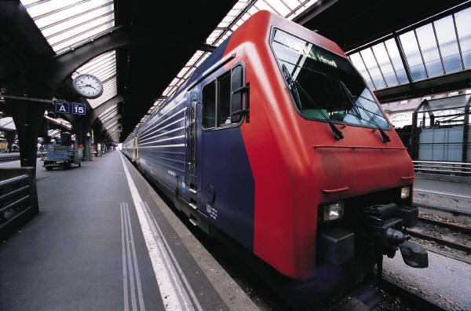

Executive summary
The Heart of Wales Line is up against many competitors; however the line is one of a kind and offers beautiful scenery along the route. After comparing to other competitors it is believed that the Heart of Wales Line promotion could be developed more as their online websites are much improved and have vital information for the guests. There are many attractions and events occurring in the rural communities but the Heart of Wales line have not got involved and this could be something they can improve on in the future. Although it could improve advertising to the tourists, the line is still very popular with the locals and the strategic plan for 2022 to increase the capacity of guests and bring in bigger and better trains will be amazing.

Introduction
A report will be completed to discuss the Heart of Wales line and to understand what the organisation has planned for the future whether it is beneficial for the communities and rural areas. As part of the strategic plan for 2022, Transport for Wales are introducing larger trains which will enable the train to hold more passenger capacity meaning that they would like to fill the seats and there’s lots of opportunities in which they can do this. Many strategic recommendations will be made to enable the key stakeholders to understand what can be done and developed to attract the tourists. Transport Wales was owned by Arriva Wales, however they did not have enough money and it was taken over by Keolis Amey in October 2018. Research will be undertaken to understand whether it has improved.

Main Body
The Heart of Wales Line
The Heart of Wales Line is a remarkable rural railway running between Swansea and Shrewsbury. The train service is operated by Transport for Wales and the line is much loved by day trippers and walkers. The line consists of 30 different stations, however most of them are request stations meaning people can request a stop (see appendix 1- map of the line) and also the line offers a vital transport connection for lively rural communities and towns across Mid Wales and the Borders, benefiting tourists and the people living/working nearby. The line is set for an expansion from 2022 as part of the strategic transport plan; Transport for Wales would like to double the passenger capacity offering an opportunity for additional tourism along the route. The line provides access to great walking trails and offers the chance to walk direct routes between stations. A group called the ‘Rail Ramblers’ organises guided group walks usually taking the train out from Shrewsbury. A book called ‘The heart of Wales Line Trail’ and the ‘Great Walks from the Heart of Wales Railway’ display the different walking routes and they’ve also been published with the aim to encourage larger number of individuals to use the train to go walking.
The Heart of Wales line is there to attract many visitors as possible. A brilliant scheme they have attracting for the over 60’s is that they provide free travel, however this is only in from October to March. After looking at an article on the Guardian its created a judgment that the line does attract all ages, “On board, there were usually walkers like us; teenagers… a large Scandinavian family carrying camping kit… day-trippers getting as immersed in bucolic wonderment as they could before returning home.” Harris, J (2019). The Heart of Wales line has disabled access and a designated place where wheelchair uses are able to go and also offers assistants with before your journey, during and even after.
Since Keolis Amey has taken over the organisation in 2018, he “has introduced new services, increased capacity, improved stations and created new jobs as part of an ambitious 6 billion-euro contract” in Wales and is planning many more developments to improve rail transportation which will be undertaken over the next 15 years. Keolis (2019. Transport for Wales has recently just published their sustainability development plan, they’d like “electricity for stations and overhead wires on the Core Valley Lines which will come from 100% renewable energy, with at least 50% sourced in Wales”. They’d also like to encourage customers to make healthier choices and reduce air pollution by walking or cycling. The sustainable development manager, Natalie Rees stated that “We want to ensure that sustainable development becomes a part of the culture at TfW and is evidenced in all our activities. We want a transport network in Wales that is sustainable for future generations.” Holden, M(2019).
In Wales, bus blending/integration has been slow, however, Visit wales have created three different routes providing tourists with direct links to some of the best attractions. They are determined to show how the routes can be traversed by rail, Cymru Coastlner and TrawsCymru. The next move is to produce “integrated timetables and tickets for the development of long distance public transport. This will make both rail and bus travel more attractive and could form the basis of further intergration.” Cole, S (2019).
The ScotRail website is much more developed and they’ve promoted their local attractions, hotels and restaurants. Tourists are able to access current offers, explore the scenic rail journeys and plan what they are able to do before the trip. They are even able to look at different blogs from other tourists to gain knowledge of the area and take on board any recommendations that have been made. According to the A-B magazine, “Combining bikes and trains can be a uniquely efficient means of getting around” in which ScotRail have done this and allow individuals to travel with their bikes, however it is recommended that individuals reserve a space as their trains can usually only ‘accommodate up to 4 bikes’. McAredle, H (2016). Merseyrail has been another railway company that has been identified for being ‘bike friendly’ not only do they allow bikes on trains but also individuals are allowed to secure their bikes at stations for free. Another factor that the Scotsrail offer unlike The Heart of Wales is a journey known as the ‘ The Ultimate Outlander Itinerary’ which is a planned itinerary revolved around the Outlander film. “From Fife to South Queensferry, Inverness to Glencoe, Outlander has been filmed right across the country, and the Spirit of Scotland travel pass is the only ticket you’ll need to experience the show’s mysterious world.” Scotland’s Railway (2019). See appendix 2 for an itinerary that the Heart of Wales Line could put together.
In a place like Llandovery, bikes would be much more appropriate as the roads are narrow and small, it can also become very congested in the summer quite easily meaning long queueing times. Bikes would be a much more sustainable way of getting around. Unfortunately, the Heart of Wales Line do not have bike access, however it would make a big impact if they allocated space for bicycles.
Freeman (2004) states that stakeholders are “those groups who are vital to the survival and success of the corporation”. The heart of wales line rely on many stakeholders to attract tourists to use the line and it’s important that the organisations work together to create better tourist statistics. See appendix 3 for vital stakeholders that the heart of wales line rely on.
Twr Y Felin, also known as the ‘best hotel in Wales’ is located in Britain’s smallest city St Davids. To attract guests the hotel offers free transfers from the ferry terminal and train station and even free shuttles to the beach. The online website also provides great methods of getting around which is beneficial for the tourists. The hotels near the heart of wales line and stations could offer this type of service to guests as it’s beneficial and makes it so much easier for guests. The four stars Cawdoe hotel is set in the historic town Llandeilo, in order for them to gain more business it is a great opportunity for them to connect and there are lots of facilities that are perfect for the Heart of Wales line tourists. As they are one of the best hotels in Llandeilo it’d be beneficial if they benchmarked towards the Twr y Felin and offer transport to guests to and from the railway station.
It’s important for the rail industry to build a partnership with tourism sectors for the following factors: sharing best practise, Greater awareness, financial benefits, sharing tourism knowledge, to provide a high-quality experience. Community Rail (2017) state that “Effective partnerships can play an important part in encouraging visitors to travel along your line. Once initial contact has been made you may find this opens future opportunities to promote your line to a tourism audience on an ongoing basis.” There are many popular attractions along the Heart of Wales Line including: Pembrey Country Park, National Waterfront Museum, The Gower, Dinefwr Castle, The National Botanical Gardens, Llandovery Markets, The Garden of Wales, award winning restaurant ‘The Drovers Rest Restaurant, Wyeside Arts Centre, National Cycle Museum, Castell Collen, Knighton Market town, Stokesay Castle and finally the town of Shrewsbury which has many attractions. To persuade individuals to get off the train, the heart of wales line and the attractions could build a partnership and offer deals like 2 for the price of 1 with a valid train ticket. Many festivals and events happen along the line throughout the year; however the heart of wales line could get involved and promote the festival; in return this could mean more passengers and guest filling the capacity of the trains. The Royal Welsh show that runs for 4 days in July is very popular and attracts hundreds, instead of the guests leaving after the festival it’s a way of promoting the other rural communities. Helping the growth of local businesses is important and by working as a partnership it’ll create more tourism and more money will be going towards the local businesses i.e hotels, local produce, shops, restaurants. (See appendix 5 for the Porters Five forces).
There are many strengths and weaknesses that are stated above and some opportunities they can undertake. See Appendix 4 for a SWOT Analysis.

Recommendations

- A recommendation for the Heart of Wales Line is to produce audio stream where tourists are able to gain knowledge of the places they are passing. The line is very historical and it’d be really good if guests were able to learn about the history. This is also a way of the Heart of Wales Line could promote other businesses, attractions and events.
- The 2022 strategic plan aims to develop the capacity numbers; however it’d be excellent if the trains offered bike spaces for guests as it also makes it a much sustainable way of getting around the towns. Recently ‘MerseyTravel has invested £3.5 million’ to make cycling a healthier and sustainable option. This is something Transport for Wales could look into
- Build partnerships with local attractions. For an example Scotland’s Rail has a top quality website and offers many deals with local attractions from: 2FOR1 attractions, Kids go free, Money off, Free Taxi’s to the attraction/ Restaurants, Kids eat free.
- To develop a better website and promoting as many guests do not know the attractions around the line and will have to undertake their own research which can take a lot of time for them.
- To promote the walking trail, could even put an itinerary together for ramblers using the local hotels/ B&B’s

Conclusion
To conclude, it is believed that Transport for Wales is offering a beautiful railway service called the Heart of Wales Line however it needs to be promoted more as many do not know about the line. To reach this development it is essential that they improve their website as there is not much information about the railway line or walking trail. The line is beneficial for the rural communities as it does bring in money but with a better marketing scheme that identifies the different attractions and events that is going on, it is guaranteed more guests would visit.

Bibliography
A to B Magazine. (2010), ‘Bikes on Trains’, A to B, Issue 78, p32-38. 7p.
Acorp. (2017), Developing partnerships with the tourism sector, [Online]. Available at: https://communityrail.org.uk/wp-content/uploads/2018/02/Tourism-partnerships-guidance-2017.pdf, [Last accessed: 28.11.2019]
Caffyn, A and Lumsdon, L. (2016), The Heart of Wales Line Trail, [Online]. Available at: https://llanrhydithon.files.wordpress.com/2017/03/heart-of-wales-line-trail-report-final.pdf, [Last accessed: 24.11.2019]
Cole, S. (2019), ‘Balanced blend of transport ti refresh Wales’ tourism appeal- PROFESSOR STUART COLE WALES IN MOTION’. Western Mail Cardiff, ed 1, page 19.
Expedia. (2019), Twr Y Felin Hotel,[Online]. Available at: https://www.expedia.co.uk/Haverfordwest-Hotels-Twr-Y-Felin-Hotel.h11871255.Hotel-Information, [Last accessed: 24.11.2019].
Fontaine, C& Et al. (2006), The stakeholder theory, Edlays Education: Semantics scholar.
Harris, J. (2019), Want to see the future? Take a trip on Wales’ model railway, [Online]. Available at: https://www.theguardian.com/commentisfree/2019/aug/19/railway-heart-of-wales-line-social-rail, [Last accessed: 24.11.2019].
Holden, M. (2019), Transport for Wales launches Sustainable Development Plan, [Online]. Available at: https://www.railadvent.co.uk/2019/11/transport-for-wales-launches-sustainable-development-plan.html, [Last accessed: 28.11.2019]
Keolis. (2019), KeolisAmey Wales marks first year anniversary in transformation of the Wales and Borders network, [Online]. Available at: https://www.keolis.com/en/media/newsroom/latest-news/keolisamey-wales-marks-first-year-anniversary-transformation-wales-and, [Last accessed: 24.11.2019]
McArdle, H. (2016), Campaigners warn over cuts in bike capacity on ScotRail’s West Highland and Edinburgh-Glasgow routes, [Online]. Available at: https://www.heraldscotland.com/news/14388363.campaigners-warn-over-cuts-in-bike-capacity-on-scotrails-west-highland-and-edinburgh-glasgow-routes/, [Last accessed: 24.11.2019].
MerseyTravel. (2019), Cycling, [Online], Available at: https://www.merseytravel.gov.uk/getting-around/cyclingandwalking/Pages/Cycling.aspx, [Last accessed: 24.11.2019].
Ramblers. (2019), Rail Rambles, [Online]. Available at: https://www.ramblers.org.uk/go-walking/group-finder/areas/shropshire/rail-rambles.aspx, [Last accessed: 24.11.2019]
Scotland’s Railway. (2019), The Ultimate Outlander Itinerary, [Online]. Available at: https://www.scotrail.co.uk/blog/ultimate-highlander-itinerary, [Last accessed: 24.11.2019].
The Heart of Wales Line. (2019), THE HEART OF WALES LINE, [Online]. Available at: https://www.heart-of-wales.co.uk/, [Last accessed: 24.11.2019].
Transport for Wales. (2019), Accessible Travel, [Online]. Available at: https://tfwrail.wales/AssistedTravel/, [Last accessed: 24.11.2019]
Transport for Wales. (2019), Concessionary Travel, [Online]. Available at: https://tfwrail.wales/ways-to-save/concessionary-travel, [Last accessed: 27.11.2019].
Twr Y Felin. (2019), Twr Y Felin Hotel,[Online]. Available at: https://www.twryfelinhotel.com/, [Last accessed: 24.11.2019].
UKEssays.(2018), Environmental Impact Of Transportation In London Environmental Sciences Essay, [Online]. Available at: https://www.ukessays.com/essays/environmental-sciences/environmental-impact-of-transportation-in-london-environmental-sciences-essay.php?vref=1, [Last accessed: 24.11.2019].

Appendix
Appendix 1- Map of the Heart of Wales Line
Appendix 2- Itinerary – Scotland’s Railway Itinerary
Appendix 3- The Stakeholders
Appendix 4- Swot Analysis
Appendix 5- Porter’s Five Forces

Appendix 1- Map of the Heart of Wales Line
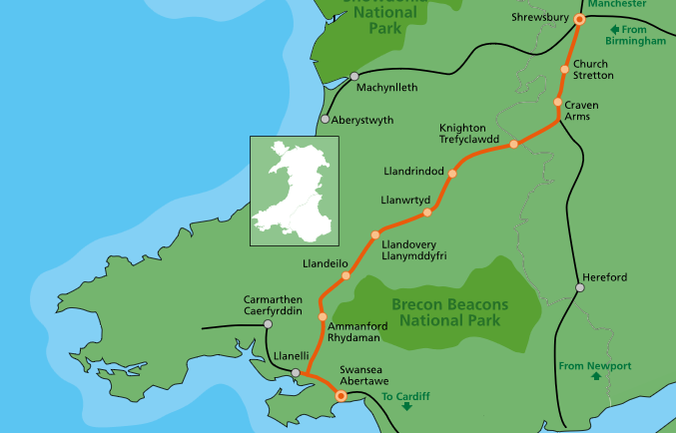

The heart of wales Line (2019)

Appendix 2- Itinerary
The Castle tour
Swansea | The tour starts off at Swansea where you can visit the oyster mouth castle and then time to relax- see mumbles  A night at a hotel i.e B&B mumbles, Premier Inn
Llandeilo  Llandovery | After a night stay in Swansea, the heart of wales line will take you to the next attraction which is the Dinefwr Castle, after time at the Dinefwr Castle you will depart Llandeilo railway station to arrive at Llandovery where the castle will be visited and time to explore the beautiful town. A night stays at the Castle hotel in Llandovery.
Knucklas  Shrewsbury | After a night stay in Llandovery, the next attraction is in Knucklas which again you will be catching the Heart of Wales Line to arrive and then you can visit the remains of the 12th century castle. After spending the morning at Knucklas, you will then depart for Shrewsbury where you will be able to see the last attraction which is Shrewsbury Castle.
This is a basic itinerary to visit all the Castles along the Heart of Wales Line.
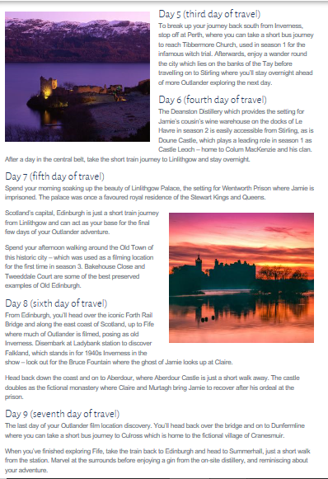
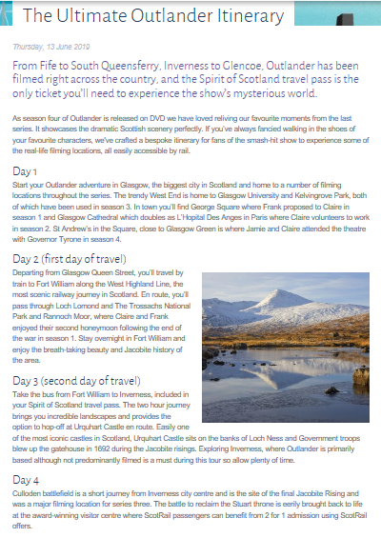

This is a screenshot off the Scotland’s Railway website promoting ‘The Ultimate Outlander Itinerary’ they’ve put together. Scotland’s Railway (2019)

Appendix 3 –the Main Stakeholders
The heart of Wales development
Transport for Wales
Arriva Wales Trains
Rail Ramblers
Local Authorities- Powys council, Carmarthenshire council, Swansea Council
Visit Wales
National trust- Protected landscape associations
Accommodation- Cawdor Hotel
Swansea | Three cliffs bay(Gower), The Dylan Thomas centre, Glynn Vivian Art centre, Celtic cycling Trail, National waterfront museum
Llanelli | Millennium Coastal Park, Pembrey Country Park, Water sport centre, National Wetlands Centre
Llandeilo | Dinefwr National Park, Newton House, Dinefwr Castle, Castle woods wildlife reserve
Llandovery | Markets, heritage centre, bookshops, Llandovery castle, Tywi Valley
Sugar Loaf | The Garden of Wales-historic castle. This is an ideal starting point for the walking trail
Llanwrtyd Wells | Award winning restaurants, hosts events all year round including ‘bog snorkelling’
Llangammarch Wells | Known for high class hotel& a real ale pub
Cilmeri | Where the last native Prince of Wales was killed in battle in 1282. Memory stone is found close to the station
Builth Wells | Host the Royal welsh show, many fairs, sporting facilities and the Wyeside Arts Centre
Llandrindod Wells | Heyday festival in the summer, National Cycle Museum, Castell Collen, the Beast Fountain.
Four Spa Towns | Historical architecture that dates from the 1860’s – 1930’s
Knucklas | Remains of a 12th century castle. Beautiful village and valley.
Knighton | Market town, Offa’s Dyke earthworks, fashionable development
Craven Arms | Stokesay Castle, Shropshire Hills discovery centre, Onny meadows
Church Stretton | Good cycling and walking tracks, antique centres
Shrewsbury | Severn Way national footpath, museums, galleries, castle, markets

Appendix 4 – SWOT Analysis
Strength | Weakness
- Customer service- offering many request stops enabling customers to choose.  - Beautiful scenery  - Tourists spending money at local businesses  - Line is a 150 year old rural railway- historical  - Many local volunteers and communities helping out with the line(non-paid meaning more money for the organisation- making facilities& trains better)  - Suitable for all age markets.  - Environmental friendly (encouraging individuals to travel by train instead of cars) | - Up against organisations like Scotland’s Rail which is well promoted  - Marketing  - Look into connecting with local hotels, restaurants and attractions to advertise& even could create an itinerary  - Better facilities could be added to the trains (space for bikes)
Opportunity | Threats
- Increasing the capacity of trains which is on the strategic plan for 2022  - Due to climate change , individuals may decide to travel by public transport to reduce heavy traffic and pollution/fossil fuels  - Promoting tourism in Wales  - Put on offers with local attractions (2 for 1)  - Links with other transportation | - People go to alternative places –Scotland’s Rail (well developed)  - Better facilities on trains  - Pricing

Appendix 5 – Porter’s Five Forces
 | Opportunities | Threats
Competitive rivalry- competitors | Advertise, good reviews, deals, beautiful landscape | Scotland’s Railway, Great Scenic Railways
The threat of entry- new comers | Better knowledge of industry, loyal customers | Other service may offer deals, packages i.e attractions, hotels&travel.
Buyer (customers) power- their bargaining power | Price-special offers (2 for 1?), promote- stunning scenery along the heart of wales line. | Individuals may decide to go to a different country/ line because what they are offering/ scenery.
Suppliers’ power- their bargaining power | Reducing trains in less busy times i.e winter to save money. Raise prices at peak times | Better service- more customers. Individuals using cars to commute
Threats of Substitutes- any substitutes? | Capacity of trains, affordable prices (low fares), More trains/ availability | Better service and quality from other services. Better special offers& cheaper. Product differentiation.

