Assignment Title: Human Resources Management
Name: Ramandeep Kaur – 2218846


Module Code: LCMB7000
Instructor Name: Dr Gladius Kulothungan

Table of Contents

1.0 Introduction of Labour Market 4
1.1 Developed Countries' Labor Markets 4
1.2 Labour Market in UK: 5
1.3 Employment: 5
1.4 Recent Changes in the UK Labour Market 6
MAIN BODY 7
2.0 Kinds of Employment 7
2.1 Foreigners Working in the UK 7
2.2 MOTIVATION 8
2.3 PROS AND CONS DISCUSSION 8
2.4 Sustained Joblessness: 9
2.6 Young People Not Working 9
2.7 Inequality of Income 9
2.8 Earnings Disparities Between Women and Men 10
3.0 THEORIES AND TOOLS 10
3.1 MBO (Management by Objective) 10
3.2 The Stages of The Management By Objectives Method 11
1. Establish the Organization's Aims: 11
2. Establishing Employee Goals: 11
3. Continuous Evaluation of Output And Development 11
4. Analysis Of Performance 12
5. Feedback: 12
3.3 PESTLE ANAYSIS 12
1. Political Factors - 12
2. Economic Factors: 13
3. Sociological Factors 13
4. Technological Factors: 13
5. Legal Factors: 13
6. Environmental Factors: 14
4.0 CONCLUSION 15
References 16

EXECUTIVE SUMMARY
London's economy and labour sector are being severely impacted by the COVID-19 outbreak. Early in the COVID-19 epidemic, the capital of the UK emerged as one of the nation's hotspots by February 7, 2001, London had recorded more than 7,60,000 cases and 13,000 fatalities. London has seen a severe economic decline in addition to the human consequences. In 2020, it is anticipated that its economy will have decreased by more than 10%, with decreases of 20–30% in industries like Tourism, Entertainment, Hospitality.
London already had labour market issues before COVID-19, therefore there was a need for a strong adult learning system. however, the situation has increased the value of adult education. Although London has high educational levels in comparison to other OECD metropolises, part because Regarding the migration of professionals, labour output the past flat since the financial crisis in 2009. Because London's workforce's present talents are not being utilised to their full potential and because local labour market demands are not being met, there has been less-than-ideal productivity growth. By working in a position that is either below or above their degree of education, 37% of employees in London are insufficiently qualified. Employers in London suffer directly as a result of skill shortages and mismatches.

1.0 Introduction of Labour Market
The Employment market, usually referred to as the labour market, is concerned with the supply and demand of labour, with employers filling demand and employees providing supply. It plays a crucial role in every economy and is closely related to the markets for commodities, financial products, and services (Times, 2022). At the macroeconomic level, factors such as globalization, population size, and educational attainment as well as supply and demand are influenced by both domestic and global market dynamics. On a microeconomic level, workers are dealt with by various businesses in terms of hiring, firing, and changing compensation and hours (KENTON, 2022). Demand and supply of labour determine how the labour market in an economy works. In this market, labour supply is the labour that employees are willing to provide for their employers. The market's supply and demand for labour are impacted by shifts in bargaining power.

1.1 Developed Countries' Labor Markets
The Essential characteristics of developing nations include high inflation rates, erratic growth rates, a shaky banking system, low labour productivity, high income inequality, a sizable public sector, wage áexibility, and poorly functioning labour markets. These markets fail to function well due to a number of economic inadequacies or subpar government interventions. Developing countries frequently implement macroeconomic stabilisation programmes and structural reforms connected to the scale, financial, or real sectors to address these issues and sustain macroeconomic stability. Due to structural considerations, traditional fiscal or monetary policy alone cannot accomplish the necessary goals. For this reason, stabilisation initiatives are frequently accompanied by a package of structural changes. The rate of labour force participation is among the most significant characteristics of labour markets in general. (Fields, 2010).

1.2 Labour Market in UK:
The UK labour market has recently appeared to be extremely healthy from a macroeconomic perspective. We give the pasts of unemployment, inflation, inflation expectations, and real wage growth just to put the current state of affairs into historical perspective. The following significant elements have emerged since 2021. As of the writing of this article, unemployment was at its lowest point in a generation. The rate of inflation has remained unusually low, and important wage-bargaining groups' expectations of inflation have been steady during this time.

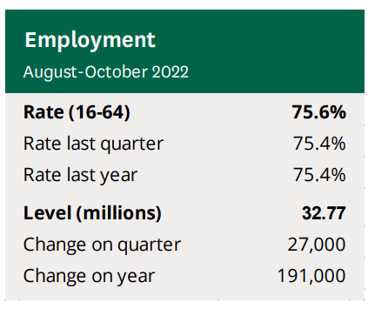
1.3 Employment:
Full employment today is defined as "employment opportunity for everybody." In the UK, there were 32.77 million persons in employment from August to October 2022. There were

75.6% of people between the ages of 16 and 64 who were employed. Before the coronavirus epidemic began in 2013, the employment rate gradually increased. The highest level ever recorded since records began keeping track in 1971, it peaked at 76.6% in early 2020. Compared to a low of 70.1% following the recession between July and Sept 2010, this is higher.

1.4 Recent Changes in the UK Labour Market
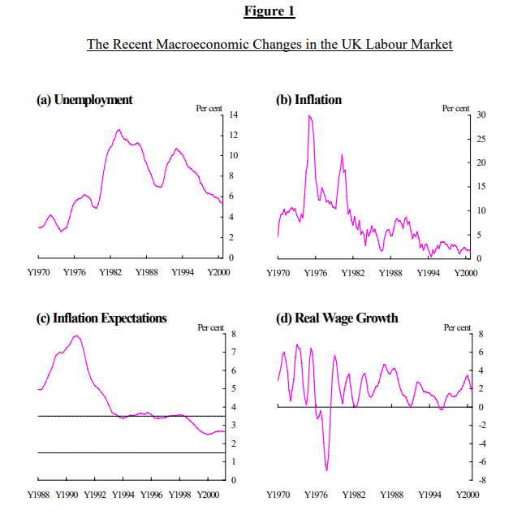
If we have some sense of the recent history of British unemployment, it helps to set the stage before going into depth regarding recent variations in equilibrium unemployment. Using the conventional ILO definition which states that an unemployed person is someone who is
Recent Changes in the UK Labour Market

not working but is actively looking for work and is available to accept a job—we depicted the trajectory of unemployment since 1970 in Figure 1a. Individual behaviour takes time to adapt to shifts in the economic environment, so the effect of changes of the kind indicated above on the equilibrium rate will often manifest itself gradually over a period of years. (Nickell, 2022).

MAIN BODY

2.0 Kinds of Employment
Over the past 10 years, full-time employees have been responsible for the rise in employment levels. After the pandemic broke out, there was a substantial decline in part-time employment while the number of full-time employees continued to rise.
- Part Time and Full Time: The most typical type of job is full-time. Employees who are employed full-time have regular work schedules and complete leave privileges. If they are over 18 and make more than $450 per month (before taxes); or if they are under 18 and make more than $450 per month and work more than 30 hours per week, their wage package includes superannuation. In the event that a public holiday falls on a regular workday, full-time employees are also entitled to public holiday pay. Those who work part-time typically have open-ended contracts as well. They share the same rights and obligations as full-time employees. Additionally, they put in a consistent amount of time that falls short of a full-time job. They might simply have set hours or unpredictable shifts, like part-time nurses and shop employees. Parents, students, and others with health concerns who find it challenging to work full-time hours are frequently better suited for part-time work.

2.1 Foreigners Working in the UK
The information in this briefing focuses about how immigrants integrate into the labour market and the types of employment they have in the UK. Additionally, it provides information on the employment and unemployment rates, professional status, pay levels, and types of contracts for migrants.
- In the UK, there will be about 19% foreign-born workers in 2021.
- In 2021, immigrant’s employment rates among men will be higher than those of UK-born people (85% vs. 78%), but immigrants' employment rates among women will be lower (68% vs. 74%).

2.2 MOTIVATION
The UK's labour market is a crucial case to examine since, despite being a member of the EU, it has long been seen as the most "American" of the European labour markets. In Europe, UK workers have by far the weakest employment protection. Only a small number of nations, including the US, Canada, and New Zealand, provide less protection for employees worldwide. The UK has traditionally been a desirable location for immigration of both low- and high-skilled workers due to its unique linguistic landscape. (Rens, 2018).

2.3 PROS AND CONS DISCUSSION
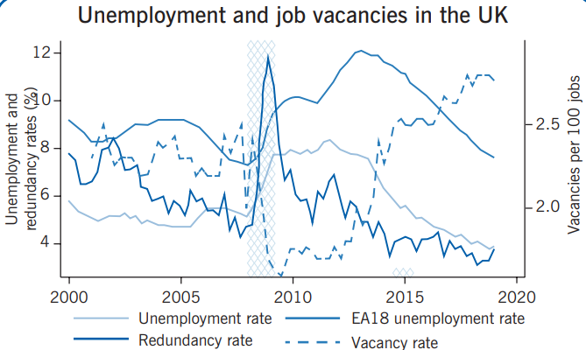
- Unemployed People Overall: The seasonal adjustment of the unemployment rate from 2000 to 2019 is depicted in the illustration on page 1. The Great Recession in the UK started

beginning in the second quarter of 2009 and continuing for five quarters, as shown by the darkened region. During the second quarter of 2010, The jobless rate went up to 5.4% to 7.8%. Following that, it remained elevated at little under 8% before starting to decline in 2011.

2.4 Sustained Joblessness:
The Emergence of long-term unemployment is a key worry for both economists and policymakers. High rates of long-term unemployment may be an indication of fundamental issues with labour market institutions and, therefore, may lead to the need for reform, whereas short-term unemployment is a necessary byproduct of the reallocation of talent within the labour market. Long-term unemployment also has significant social repercussions since a disproportionate amount of a recession's cost falls on a small number of people.

2.6 Young People Not Working
It is especially concerning when young employees are unemployed since it could portend higher unemployment rates in the future. High unemployment among this demographic may also be a sign of lower future wages because young unemployed persons don't go to school or gain work experience.

2.7 Inequality of Income
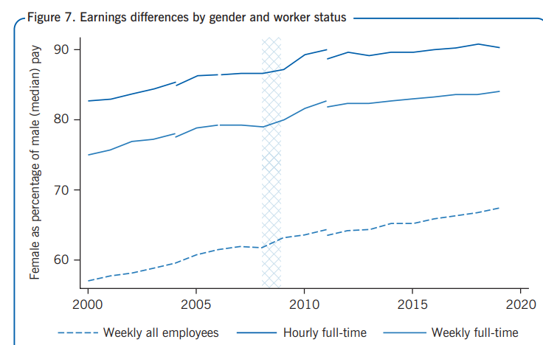
In the UK, a two-decade rapid rise in income disparity came to an end in 2000 and has just begun to decline. Using the gross weekly earnings of full-time employees as a starting point, Figure 6 displays various indicators of income disparity.
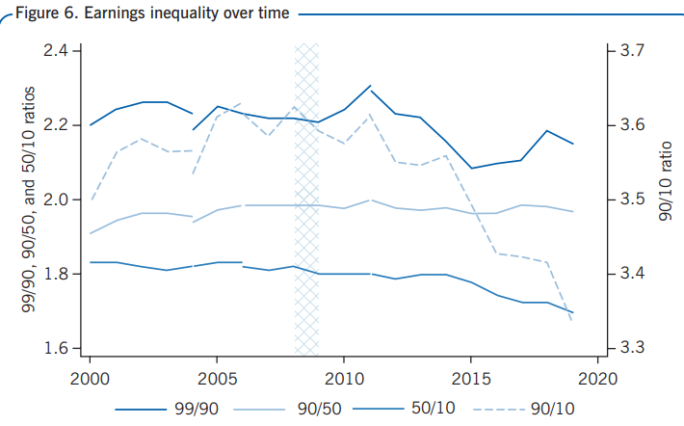

2.8 Earnings Disparities Between Women and Men
In the UK, paying men and women differently for the same work has been prohibited since the Equal Pay Act was implemented in 1970. The gender pay gap has, nevertheless, taken a while to reduce. The good news is that major advancements have been made after 50 years. The median female wage is shown in Figure 7 as a percentage of the median male wage.

3.0 THEORIES AND TOOLS

3.1 MBO (Management by Objective)
An organisation can perform better by using the Management by Objectives (MBO) strategy approach. It is a procedure whereby the management clarifies the organization's goals and communicates them to the staff in an effort to meet each aim. The MBO approach includes a crucial step of tracking and assessing the output of each worker advancement pertaining to the predetermined objectives. Employees are more likely to carry out their responsibilities if they are actively involved in formulating objectives and choosing a course of action (Team, 2022).

3.2 The Stages of The Management By Objectives Method
- Set the Organization's Goals in Place: The process of establishing objectives has several benefits. functions and is essential to any company's success. When establishing goals, it must involve a variety of management. Based on an assessment of what the company can and should do in a certain period of time, the supervisors have set provisional goals for the organisation.
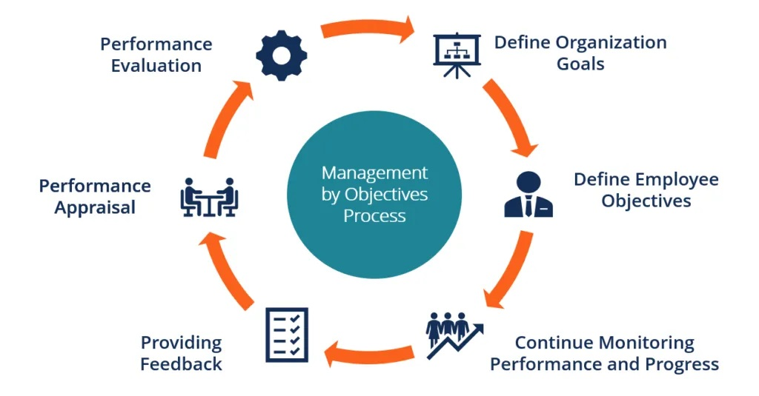
- Establishing Employee Goals: The managers can begin working with their subordinates on developing their own objectives once they have given the employees a briefing on the overall objectives, plan, and techniques to be used. The managers and subordinates will have a one-on-one conversation during which the latter will learn about the former's targets

and the latter's knowledge of the latter's goals and the resources and timeframes they can devote to achieving them. They can then discuss some flimsy ideas around what objectives the company or division would find doable.
- Continuous Evaluation of Output And Development: The MBO approach is essential for increasing managers' effectiveness., but It is essential for monitoring each person's growth as well within the Organisation.
- Analysis of Performance: The managers involved in the performance evaluation participate in it under the MBO framework.
- Feedback: The continual feedback on results and targets is the most crucial phase in the management by objectives approach since it enables the staff to monitor and adjust their actions. Regular formal evaluation meetings that allow superiors and subordinates to discuss how well they are doing in achieving goals serve as a supplement to continuous feedback and result in additional feedback.
Although the impact of Covid-19 on employment has been extensively discussed practises and HRM and what that implies for certain behaviours, the majority of the information and commentary on these subjects is typically of a general nature, presenting observations and/or suggestions that attempt to specify what the "new normal" would be. As an illustration, that flexible working hours is likely to prevail or that remote work will increase in frequency. Although this may actually be the case, as Covid-19 is a global epidemic, we need to comprehend how it will affect working conditions, overall health, and human resource management in particular situations. There will probably be numerous modifications that apply to all country situations, but we should also anticipate localized variations due to institutional differences. Our ongoing research in Australia has revealed some significant findings through a survey of and interviews with managers and other individuals with responsibility for people management.

3.3 PESTLE ANAYSIS
Despite having its origins in marketing, PESTLE analysis is a powerful tool for planning HR and personnel management.
- Political Factors - These are a result of governmental policies, and they have an impact on organisations and businesses to the same extent as any changes made as a result of them do. In terms of HR, examples include modifications to tax laws or employment regulations as well as the introduction of new legislation that businesses must abide by.
- Economic Factors: These are related to the overall regional, national, and, in certain cases, global economic situations. Brexit is a recent example of this, which has had a different impact on different businesses. These can involve the price of raw materials or the feasibility of dealing internationally. In terms of HR, staffing is the glaring example, particularly in sectors like hospitality and agriculture that primarily rely on workers from abroad.
- Sociological Factors: Sociological considerations take into account a company's workforce's attitudes, changing perspectives, and demands. Understanding people and spotting any patterns that may affect their involvement and attitude towards an employer are the main goals of this PESTLE analysis component. For example, the COVID pandemic has led to an increase in flexible and hybrid working methods, which are currently anticipated to become the standard and are highly regarded by both employees and prospects in several industries. (Hardy, 2022)
- Technological Factors: Technology is being adopted and used by more companies than ever before to increase productivity and gain a competitive advantage. Instead of using time-consuming manual processes and procedures, this. Business management tools, such as the HR software from Breath, automate HR administration and free up staff members' time so they may engage in other profitable activities.
- Legal Factors: Political factors and human resource management have some overlap in this case. HR professionals need to be aware of how changes to the law will impact company policies and procedures as it changes over time. A recent illustration is the declaration by IKEA and a number of other businesses that they want to lower Statutory Sick Pay (SSP) for unvaccinated personnel who must isolate themselves. From a legal and HR viewpoint, this presents a lot of issues that need to be considered and require careful planning. (Hardy, 2022)
- Environmental Factors: These have to do with how an organisation affects the environment and leaves an ecological footprint both locally and globally. A rising amount of research indicates that employees place a high value on sustainability and corporate social responsibility (CSR), which is a priority for firms of all sizes. People like to work for organisations that practise social responsibility, and human resources departments must demonstrate these principles to both existing employees and potential new hires.

4.0 CONCLUSION
The UK labour market is undergoing a major upheaval. Nearly three million people are collecting unemployment benefits, according to official numbers released on Tuesday, while more than 600,000 people have stopped working for pay and more than 100,000 have stopped being self-employed since the lockdown began. With hiring collapsing and pay falling in real terms, job openings reached a record low in May. The employment has not decreased much more dramatically as a result of the crisis thanks primarily to the job retention programme. The ONS reported that average working hours were down about 9% quarter over quarter, and this has been the primary factor behind the precipitous decline in those hours. The programme, coupled with fewer incentives, contributed to the decline in average total pay, which fell 0.8% in real terms between April and May after falling 1.5% the previous month. Furloughed employees receive 80% of regular pay, unless their employers top up salaries. The towns and localities that already had significant levels of destitution and insecure labour markets saw the biggest rises in the claimant count at the beginning of the lockdown. However, there are already noticeable pockets of unemployment in southern England's wealthier regions, particularly in those that may be particularly vulnerable to a long-term structural decline in certain industries, including aviation and auto manufacturing.

References
Fields, G. S. (2010, Augest 25). Labor Market Analysis for Developing Countries . Retrieved from www.ecommons.cornell.edu: https://ecommons.cornell.edu/bitstream/handle/1813/74735/Fields214_Labor_Market_Analysis.pdf?sequence=1
Hardy, N. (2022, January 12). What is a PESTLE analysis and why is it important to HR? Retrieved from www.breathehr.com: https://www.breathehr.com/en-gb/blog/topic/performance-and-productivity/what-is-a-pestle-analysis-and-why-is-it-important-to-hr
KENTON, W. (2022, March 30). Labor Market Explained: Theories and Who Is Included. Retrieved from www.investopedia.com: https://www.investopedia.com/terms/l/labor-market.asp
Nickell, S. (2022, FEB, 15). The Recent Performance of the UK Labour Market. The Recent Performance of the UK Labour Market, pp. 15-28.
Rens, B. H. (2018, may 25). The labor market in the UK, 2000–2019. Retrieved from www.wol.iza.org: https://wol.iza.org/uploads/articles/524/pdfs/the-labor-market-in-the-uk.pdf
Team, C. (2022, november 26). Management by Objectives (MBO). Retrieved from www.corporatefinanceinstitute.com: https://corporatefinanceinstitute.com/resources/management/management-by-objectives-mbo/
Times, T. E. (2022, december 20). The Economic Times. Retrieved from www.economictimes.indiatimes.com: https://economictimes.indiatimes.com/definition/labour-market

