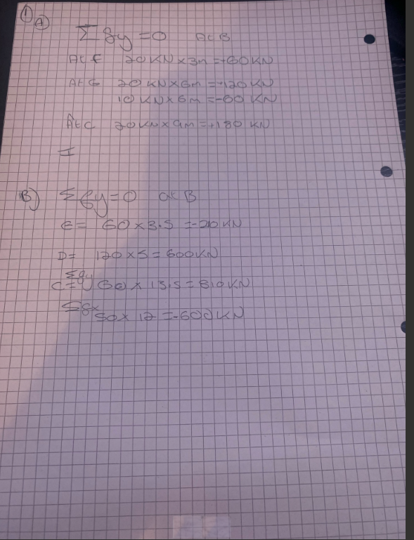

Maths equations
This is the maths equations section of the assignment showing shear forces and bending moment equations as well as equilibrium.


