1/12/2022
Mariya Kalcheva

Software Development
ACCA 4002
Software Development
ACCB4017
Assignment 1
Mrs. Renuga Jayakumar
University of Wales
Trinity Saint David
Mariya Kalcheva
Ref. number: 2106299
12 January 2022

Table of Contents

- Part One (Understanding)
- “List” and “Variable” definitions in Python……………………………………………….3/4
- User-defined functions in Python………………….4
- Part Two (Implementation)
- Exercise One……………………………………….5
- Exercise Two………………………………………6
- Exercise Three…………………………………….7/8
- Exercise Four……………………………………..9/10

Part One (Understanding)
“List” and “Variable” definitions in Python

Variables in Python are used to store data and use it later. The data hold by the variables is called value, and this value has three types: integer, float, and string. Integers refer to numbers, float refers to decimal, and string – to letters. It is important to use simple and understandable names when creating variables.
Variables can only start with letter or underscore, and can only consist of such, including numbers. Although variables contain numbers, they cannot start with one. Variables are case-sensitive and cannot have any special characters such as <,?,!,%,$, etc.
Also, there are certain words that can’t be used as variables. These words are represented by key words – if, while, else. Example: my_phone=123456, and the variable is “my_phone”.
List is one of the most popular data structures in Python. It is an ordered container, and its elements are placed between square brackets, and are separated by commas. Unlike variables, lists can contain any type of data. In order to access items from the list, one must use an index, and the first value will have an index equal to 0.
Although, variables can be added together, lists have built-in functions. It can be easily updated with the help of the following functions: insert, append, remove, sort, reverse, count, etc.
Examples:
- Sort – sorts the elements in alphabetical order
- Insert – inserts a new element in position with index 1
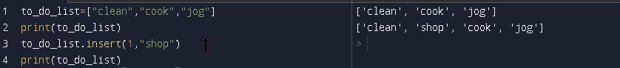
- Remove – removes a selected element from the list
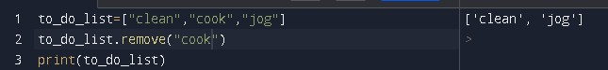

- Append – inserts a new element at the end of the list
- Reverse – reverse all items in opposite order
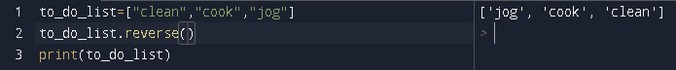

User-Defined Functions
Functions which are defined by the user are functions that hold certain code and do specific tasks, that will be used repeatedly in the program. They are called user-defined, because are written by the program developers, and are not built-in in Python. Unlike looping, they may not be used in a consecutive way, but whenever it is needed and can be used as many times as necessary.
User-defined function are an easy way to organise and maintain the program even from more than one developer. Functions can even be saved as an external file and imported to different programs if possible. But it is very important to remember that their syntax is just like the one for loops – there is a special tab for the function’s content. It is optional, but very helpful, especially if a program is being developed by more people, to add # and explain the purpose of the function, so others don’t get confused.
In order to create a function, one must use the key word – def, followed by the name of the function and parentheses, and a colon. Different parameters can be added inside the parenthesis, but it is not mandatory. For example: def generate_random(). Same function was used in exercise 4 to generate random numbers.
Example:
Here I created a function – def schedule(), that contains information about the working hours of my shop.
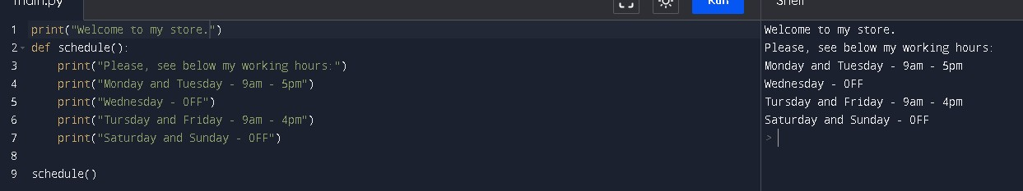

Exercise 1

- Python code
# User enters input values for selected variables
carmake=input("Enter the brand of your current car: ")
carmodel=str(input("Enter the car model: "))
doors=input("How many doors does it have? ")
mileage=float(input("How many miles have you done? "))
# All values are then included in a list and printed
list=[carmake, carmodel, mileage, doors]
print(list)
# Values included in a statement and printed
print("Your current car is", carmake,",model ", carmodel,"and it has", doors,"doors. You drove", mileage,"miles with it.")

- The output
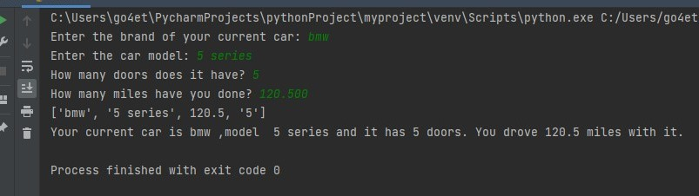

- Validation
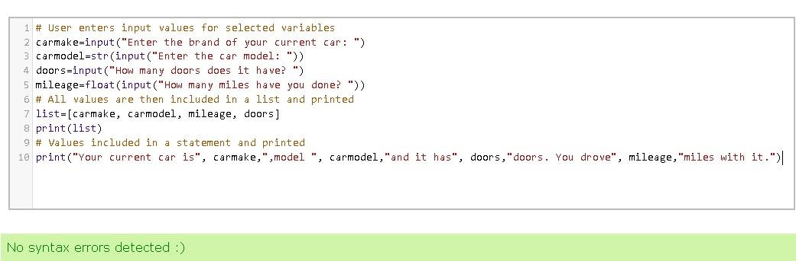

Exercise 2
- Python code
print("Let's calculate the area of the circles: ")
rad1=float(input("Enter a value for R1. Consider that R1<R2<R3. "))
Pi=3.14
red=Pi*(rad1*rad1)
print("The area of the red circle is:", red)
rad2=float(input("Enter a value for R2: "))
black=Pi*(rad2*rad2)
print("The area of the black circle is:", black)
rad3=float(input("Enter a value for R3: "))
blue=Pi*(rad3*rad3)
print("The area of the blue circle is:",blue )
blueregion=blue-black
print("The blue region of the circle is:", blueregion)
blackregion=blue-(blueregion+red)
print("The black region of the circle is:", blackregion)

- Output
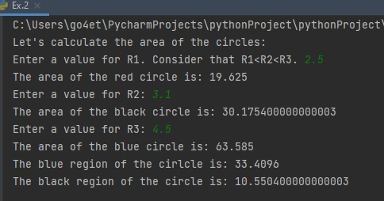
- Validation
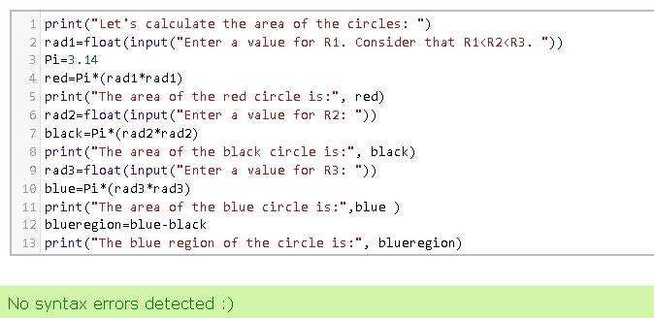
Exercise 3
- Python code
- #Created empty list for each category
name_list=[]
age_list=[]
gender_list=[]
salary_list=[]
count=0
# Included "for" loop function to ask the user the same questions 5 times
# All input then is included in the proper list with ".append"
for count in range(0,5):
name=input("Enter employee's name: ")
name_list.append(name)
age=int(input("Enter employee's age: "))
age_list.append(age)
gender=input("Enter employee's gender: ")
gender_list.append(gender)
salary=int(input("Enter employee's salary: "))
salary_list.append(salary)
# Print all lists with included input
print(*name_list, sep=" ")
print(*age_list, sep=" ")
print(*gender_list,sep=" ")
print(*salary_list, sep=" ")
# Simple arithmetic functions
male_average_age=(30+35+20)/3
male_average_salary=(2000+2500+5000)/3
female_average_age=(25+32)/2
female_average_salary=(3000+3300)/2
# Print statements with the above results
print("The average age of the males is ", male_average_age,"years and their average salary is ", male_average_salary,".")
print("The average age of the females is", female_average_age,"years and their average salary is ", female_average_salary,".")

- Output
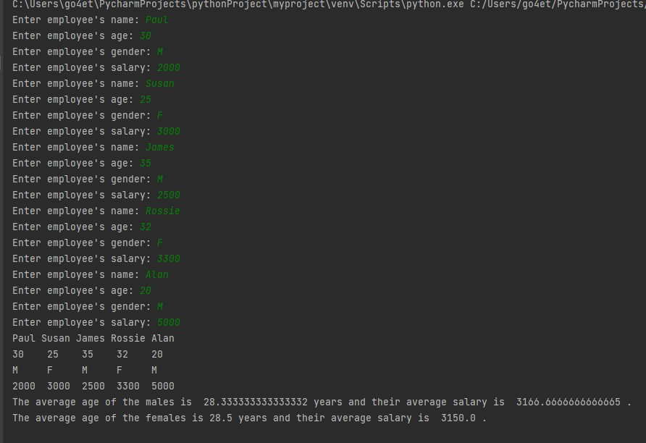

- Validation
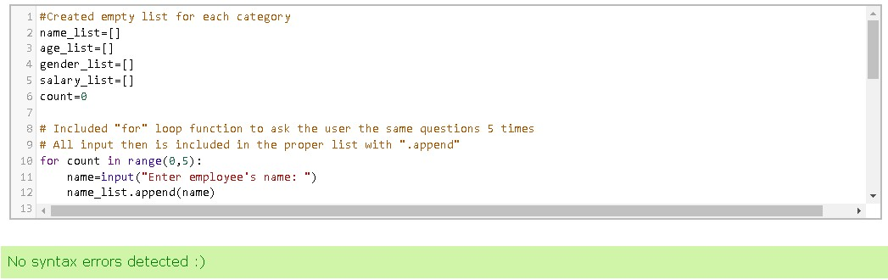

Exercise 4
- Python code
- print("Let's play a game.")
# Importing random function
import random
def generate_random():
return(random.randint(0,5))
choice="yes"
# Creating a loop with few conditions
while choice=="yes":
random1=generate_random()
random2=generate_random()
random3=generate_random()
print(random1,"",random2,"",random3,"")
if random1==5 and random2==5 and random3==5:
print("Jackpot! You won 2000 points!")
elif random1==random2 and random2==random3:
print("Good job. You won 20 points.")
elif random1==random2 or random1==random3 or random2==random3:
print("Very good. You won 10 points.")
choice = input("Would you like to continue? yes/no ")
if choice=="no":
print("Goodbye.")

- Output
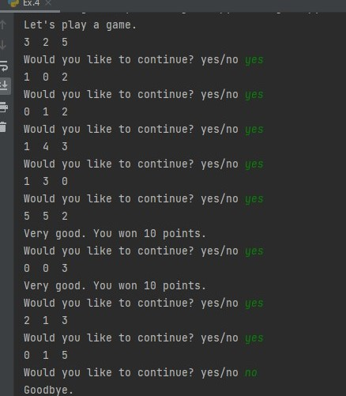
- Validation


