Problem
Analysis and Solution
Development

Module Name: Analysing and Solving Problems
Module Code: ACCA 4019
Student Name: Giuseppe Palumbo
Student ID: 2335642
Group:3
Lecturer’s Name: Dr Redhwan Al-amri

Table of Contents
Table of Contents 2
1. Introduction 3
2. Deconstruct the Problem 3
MoSCoW Technique explanation 4
2.1 MoSCoW Technique Requirement 5
1.1 Variables Identification 6
2. Proposed Solution 7
2.1 Flowchart 7
2.2 Flowchart Explanation 8
3. Reflection and Justification 11
3.1 Abstract thinking 11
3.2 Sub-dividing 11
3.3 Justification of solution 11
3.4 Limitation 11
3.5 Assumption 12
4. Conclusion 12
References 13

Introduction
Classroom allocation is an important task in colleges and universities. If classrooms are not organised properly, it can cause problems such as overcrowded rooms, empty unused spaces, timetable clashes, and students or staff being late due to moving between rooms.
This report focuses on solving the classroom allocation problem in a local college. The aim is to create a system that assigns classrooms efficiently, reduces movement time between classes, and avoids scheduling conflicts.

To achieve this, the problem will first be broken down into smaller parts. Then, a solution using a flowchart will be proposed and explained. Finally, the report will reflect on the methods used and justify the solution with support from academic sources.

Deconstruct the Problem
The classroom allocation problem can be broken down into smaller parts to make it easier to understand and solve. The main issues include assigning the right classrooms, avoiding timetable clashes, and reducing the time students and staff spend moving between rooms.

This problem can be divided into three key areas. The first is classroom allocation, where classes must be matched with suitable rooms based on size. The second is scheduling, which ensures that no classes overlap for the same students, teachers, or rooms. The third is movement optimisation, which focuses on reducing the distance between consecutive classes.

MoSCoW Technique explanation

The MoSCoW Method is a widely used prioritisation technique in project management and systems development. It helps organisations classify requirements based on their level of importance, ensuring that critical features are delivered first while less important ones are addressed later.
The term MoSCoW stands for Must Have, Should Have, Could Have, and Won’t Have. These categories help structure decision-making and ensure efficient allocation of resources [1].
The “Must Have” requirements represent essential features that are necessary for the system to function. Without these, the system would fail. “Should Have” requirements are important but not vital; the system can still operate without them, although performance may be reduced. “Could Have” requirements are desirable features that enhance the system but are not necessary. Finally, “Won’t Have” requirements are those that are intentionally excluded from the current scope, helping to control project complexity and prevent scope creep [2].
The MoSCoW technique is particularly useful in complex systems such as classroom allocation, where multiple requirements must be balanced. By prioritising tasks, it ensures that critical constraints, such as avoiding timetable clashes and meeting room capacity, are addressed first. This structured approach improves decision-making, resource management, and overall system efficiency [3].

MoSCoW Technique Requirement

Must have
- All classes must be scheduled
- No timetable clashes (rooms, students, or lecturers)
- Room capacity must be equal to or greater than class size
- Each classroom must only be used by one class at a time
- Accurate timetable must be generated
- Classes must be assigned within available time slots

Should have

- Minimise travel time between consecutive classes
- Improve overall room utilisation (avoid empty rooms)
- Keep classes for the same group close together
- Balance room usage across the college
- Reduce gaps between classes where possible

Could have
- Allow lecturer room preferences
- Allocate specialised rooms (e.g. labs, IT rooms)
- Provide alternative room suggestions
- Generate reports on room usage
- Allow minor timetable adjustments

Won’t have
- Real-time automatic timetable updates
- Fully personalised schedules for every student
- Integration with external systems (e.g. transport, apps)
- Predictive analytics for future scheduling

Variables Identification
Several variables are involved in this problem. These include the number of classrooms, room capacities, number of classes, class sizes, available time slots, and room locations.

There are also constraints that must be followed. A classroom cannot be assigned to more than one class at the same time, and the room capacity must be equal to or greater than the class size. In addition, students and teachers cannot be in two places at once. The distance between rooms must also be considered to reduce movement
time.

Variables: | Description: | Data Type
Number of classrooms | Number of available classrooms in the college | Integer
Room capacity | Maximum number of students each classroom can hold | Integer
Number of Classes | Total number of classes that need to be scheduled | Integer
Class Size | Number of students in each class | Integer
Time Slots | Available time periods for scheduling classes | Integer/Time
Room Location | Location of each classroom (building, floor, etc.) | String

These variables are important for solving the classroom allocation problem. The number of classrooms and their capacities determine how many students can be accommodated. The number of classes and class sizes affect how rooms should be assigned. Time slots are used to schedule classes without conflicts, while room locations help reduce movement time between classes.

Proposed Solution

Flowchart

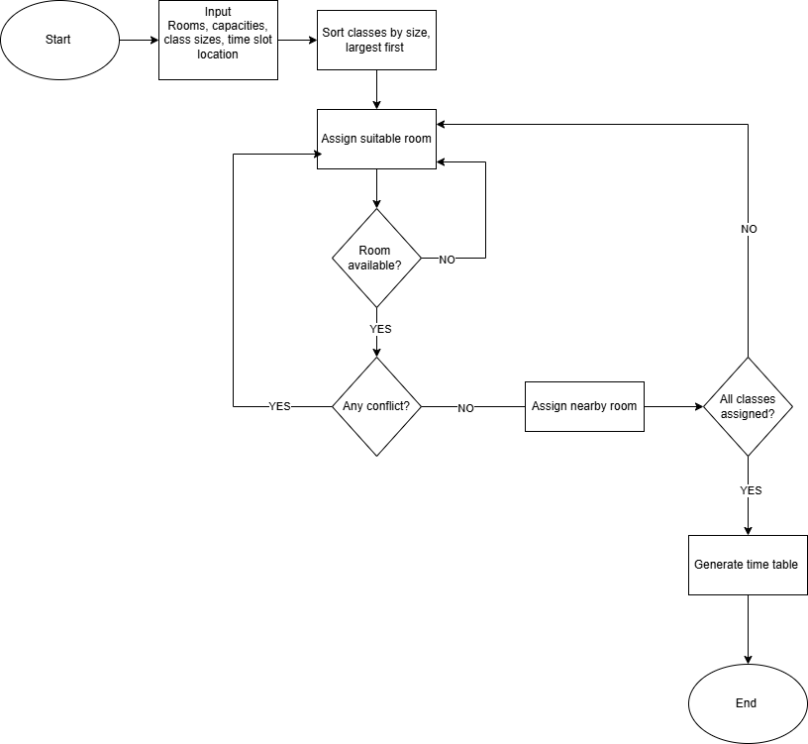

Flowchart Explanation
The flowchart illustrates a structured process for optimising classroom allocation within the college. It follows a step-by-step algorithm to ensure efficient room usage, minimise movement time, and avoid scheduling conflicts.
The process begins with the input of data, where all relevant information is collected. This includes classroom capacities, class sizes, available time slots, and room locations. Accurate input data is essential to ensure the system works effectively.

Next, the system sorts of classes by size in descending order, meaning larger classes are handled first. This approach is based on a greedy algorithm, which prioritises the most constrained tasks to improve allocation efficiency [4].
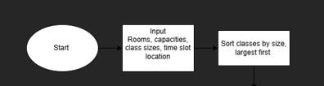

After sorting, each class is assigned to a suitable classroom. The system selects the smallest available room that can accommodate the class size. This ensures efficient use of space and avoids wasting larger rooms on smaller classes.

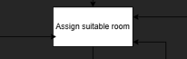

The system then checks whether the room is available. If the room is already in use during the selected time slot, the system reassigns the class to a different room. This step ensures that no classroom is double-booked.

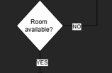

Following this, the system checks for scheduling conflicts. This includes verifying that students and lecturers are not assigned to more than one class at the same time. If a conflict is detected, the system reassigns the class to another room or time slot. Conflict checking is a key part of timetabling systems and helps ensure a valid schedule [5].

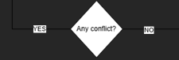

Once conflicts are resolved, the system performs location optimisation. It assigns classrooms that are close to each other for consecutive classes. This reduces travel time for students and staff, helping to ensure that classes start on time.

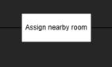
The system then checks whether all classes have been assigned. If not, the process repeats until all classes are successfully scheduled. This iterative process ensures that all constraints are satisfied.

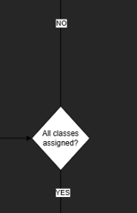
Finally, the system generates the final timetable, which includes all classroom allocations and schedules. The process ends once a complete and conflict-free timetable is produced.
Overall, this algorithm ensures efficient use of classrooms, minimises movement between classes, and eliminates scheduling conflicts. It reflects principles of optimisation and scheduling commonly used in operations research [6].

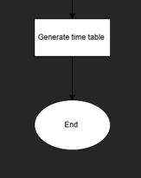

Reflection and Justification

Abstract thinking
Abstract thinking was used to focus on the most important elements of the problem, such as classroom capacity, time slots, and room location. Unnecessary details, such as classroom design or furniture, were ignored. This helped simplify the problem and made it easier to develop an effective solution.

Sub-dividing
The problem was divided into smaller parts, including classroom allocation, scheduling, and movement optimisation. This made the problem easier to understand and allowed each part to be solved step by step. Breaking the problem into smaller sections also helped in designing a clear and logical flowchart.

Justification of solution
The proposed solution is appropriate because it uses a structured and logical approach to solve the problem. The use of a greedy algorithm ensures that larger classes are allocated first, reducing the risk of allocation failure. The system also includes decision points to check room availability and scheduling conflicts, which ensures accuracy.

In addition, the iterative process allows the system to continuously adjust allocations until all classes are successfully scheduled. This improves efficiency and ensures that all constraints are satisfied. The solution also reduces movement time by assigning nearby rooms, which improves the overall learning experience.

Limitation
Despite its effectiveness, the solution has some limitations. The greedy approach does not always guarantee the most optimal solution, as it focuses on immediate decisions rather than the overall best outcome. The system also assumes that all data is accurate and does not account for real-time changes, such as last-minute room changes or class cancellations.
Furthermore, the movement optimisation is simplified and does not consider factors such as accessibility or crowd movement.

Assumption
Several assumptions were made when developing this solution. It is assumed that all classroom data, including capacity and location, is accurate. It is also assumed that time slots are fixed and do not change. Additionally, it is assumed that students and staff follow the timetable without delays, and that room distances are known and consistent.

Conclusion
In conclusion, this report analysed the classroom allocation problem and proposed a structured solution using a flowchart-based approach. The system improves room allocation efficiency, reduces movement time, and prevents scheduling conflicts. Although there are some limitations, the solution provides a practical and effective method for managing classroom allocation in a college environment.

References
[1] D. Clegg and R. Barker, Fast-track: A RAD approach. Wokingham, England ; Reading, Mass.: Addison-Wesley Pub. Co. ; Berkshire, Uk ; Redwood Shores, Ca, Usa, 1994.

[2] C. Larman, Agile and Iterative Development : a manager’s Guide. Boston: Addison-Wesley, Cop, 2004.

[3] I. Sommerville, Software engineering, 10th ed. Harlow: Pearson Education, 2015.

[4] K. R. Baker, Introduction to Sequencing and Scheduling. John Wiley & Sons, 1974..

[5] P. I. Cowling, G. Kendall, and E. Soubeiga, “A Hyperheuristic Approach to Scheduling a Sales Summit,” pp. 176–190, Jan. 2001, doi: https://doi.org/10.1007/3-540-44629-x_11

[6] H. A. Taha, Operations research: An Introduction, 10th ed. Harlow, Essex: Pearson Education Limited, 2017.

