Assignment 2

Learning in the Digital Era

Module Name: Learning in the Digital Era
Module Code: ACCA 4025
Student Name: Francisca Lerka Fernandes
Student ID: 2510888
Group: 2
Lecturer’s Name: KOUSHIK MODAK

Video Link: francisca^

UNIVERSITY OF WALES TRINITY SAINT DAVID
LONDON CAMPUS

Contents
Learning in the Digital Era 1
Introduction 3
Main Body 3
Video Link: 3
Slide 1: COVER PAGE 3
Slide 2: CONTENTS 4
Slide 3: INTRODUCTION 4
Slide 4: MAIN BODY 6
Slide 5: GIBB’s REFLECTIVE MODEL 6
Slide 6: SELF EVALUATION 7
Slide 7: TRAITS GAINED FROM THE SELF EVALUATION 7
Slide 8: PROFESSIONAL DEVELOPMENT PLAN 8
Slide 9: UNIT 4 TOPIC SUMMARY 8
Slide 10: CONCLUSION 9
Slide 11: REFERENCES 9
Conclusion 10
References 10
TASK 1: SELF EVALUATION 11
TASK 2: PROFESSIONAL DEVELOPMENT PLAN (PDP) 11
TASK 3: TOPIC SUMMARY 12
TASK 4 PRESENTATION 12
Link to the Video in its cloud platform (e.g. YouTube) 12
Screenshot of the Video in its cloud platform (e.g. YouTube) 12

Introduction
This assignment is dedicated to such three parts as a self-assessment, a professional development plan, and a summation of Unit 4 Topic 2, Bouncing Forward. It will analyze my strengths, weaknesses, and personal characteristics and provide SMART goals that will help to achieve academic and professional development. The summary of the topic covers the subject of resilience, managing stress and anxiety, and ways to maximize well-being to learn effectively. On the whole, this assignment emphasizes my learning experience of reflection throughout the module Learning in the Digital Era.

Main Body

Video Link: francisca^

Slide 1: COVER PAGE
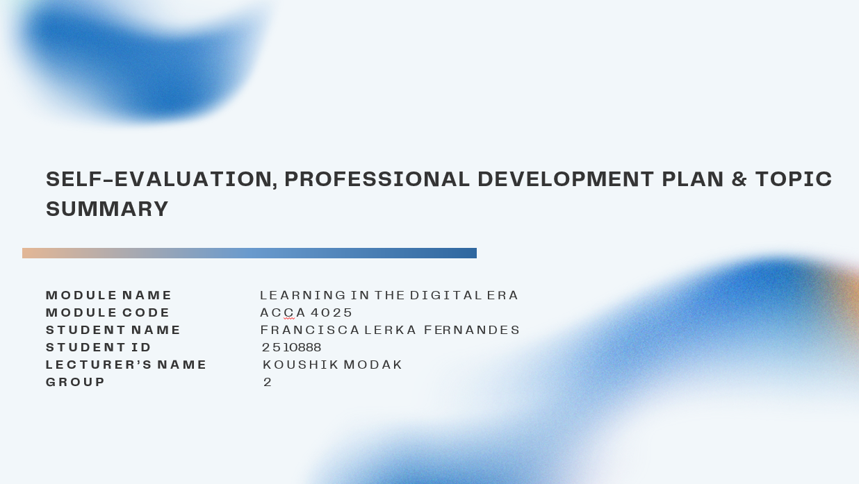

Brief Explanation: Good Morning all, In this presentation, I am going to give myself evaluation, my Professional Development plan (PDP) and a brief overview of my chosen Unit 4 topic. These aspects, combined, display my learning process, self-growth, and knowledge of major concepts provided in this module.

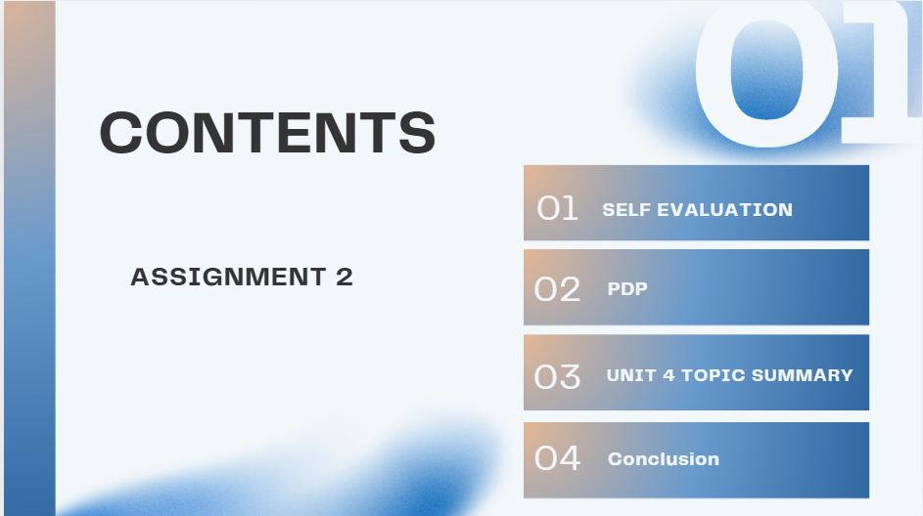
Slide 2: CONTENTS

Brief Explanation: The following slide gives a rough outline of all the key activities in the presentation. It provides the list of the Self-Evaluation, Professional Development Plan (PDP), Unit 4 Topic Summary and the Conclusion, such that the audience can know how the presentation is organized.

Slide 3: INTRODUCTION
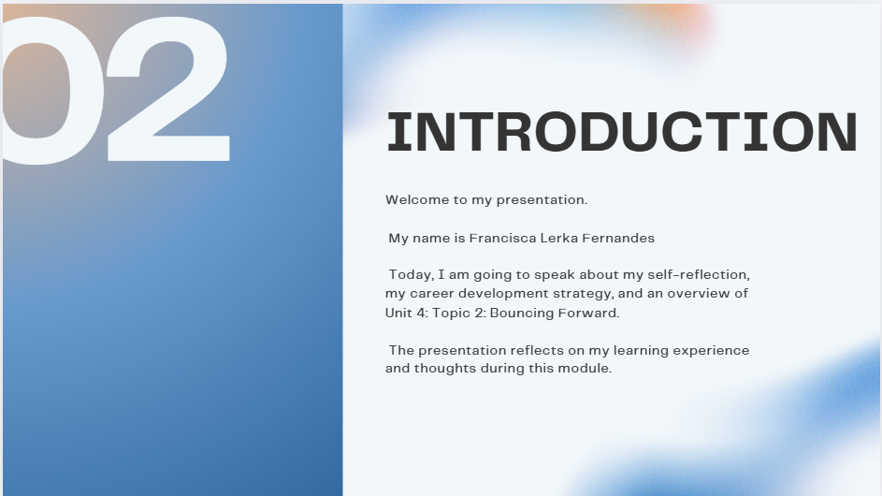

Brief Explanation: This slide presents the presenter and in a brief manner, it describes what the presentation entails. It has a welcome message and it outlines that the presentation is going to speak on self-reflection, the PDP and the chosen topic of Unit 4, which is Bouncing Forward.

Slide 4: MAIN BODY
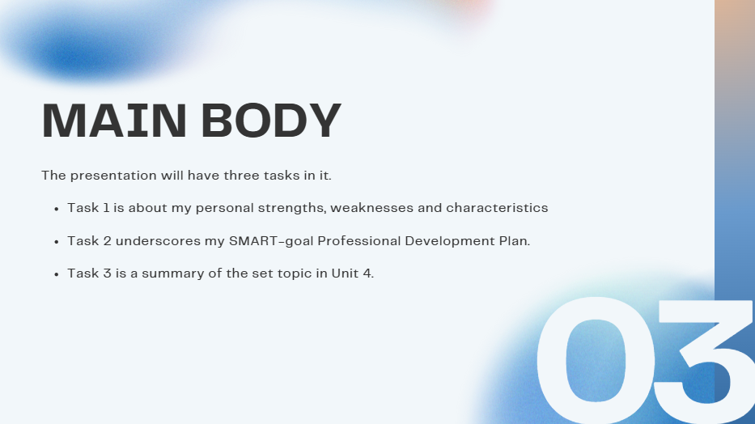

Brief Explanation: This slide describes the fact that there are three key tasks in the presentation. It emphasizes that Task 1 discusses the self-evaluation, Task 2 is the SMART-goal Professional Development Plan, and Task 3 is a summary of the given Unit 4 topic.

Slide 5: GIBB’s REFLECTIVE MODEL
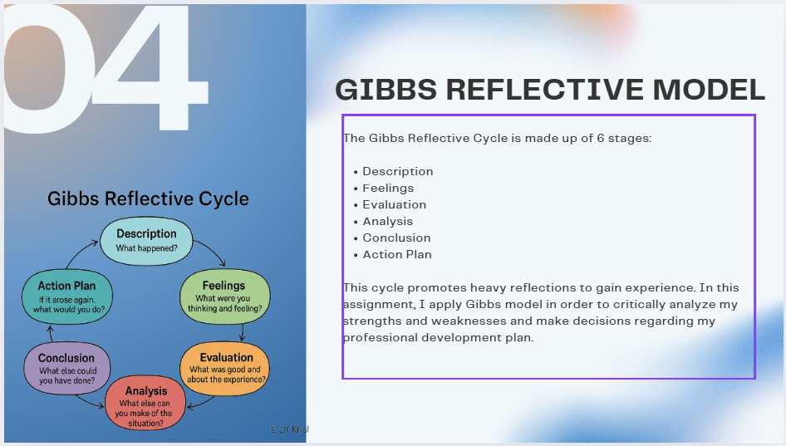

Brief Explanation: This slide describes the Reflective Cycle used by Gibbs and a diagram of the model is provided. The text explains the way the six stages facilitate a structured reflection. I as well describe how I applied this model in my self-evaluation plan and personal development plan [1].

Slide 6: SELF EVALUATION

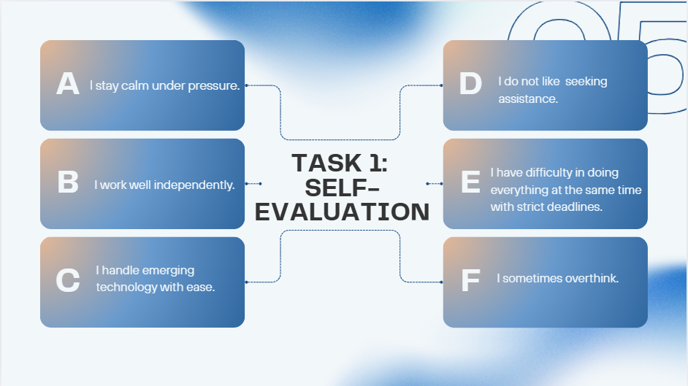

Brief Explanation: This slide shows my strengths and weaknesses in terms of self-analysis and SWOT. The explanation talks in little detail how this assessment has enabled me to know the capabilities that I now have and the areas that I require to work on in order to grow professionally.

Slide 7: TRAITS GAINED FROM THE SELF EVALUATION
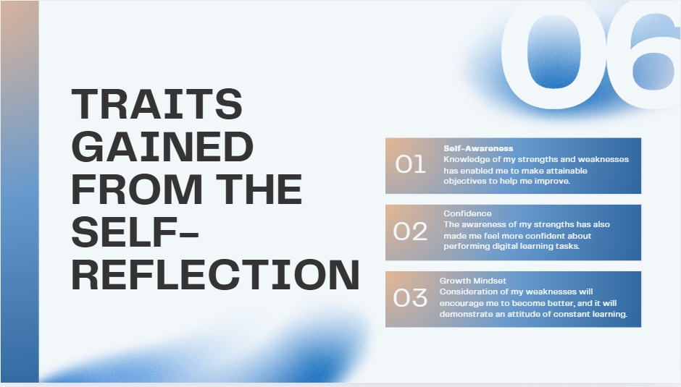

Brief Explanation: This slide determines the major features which I have learned during the reflection process. The short description goes further to explain how these qualities, including self-awareness, confidence and positive attitude towards growth, have helped me grow as a learner and a future professional [4].

Slide 8: PROFESSIONAL DEVELOPMENT PLAN
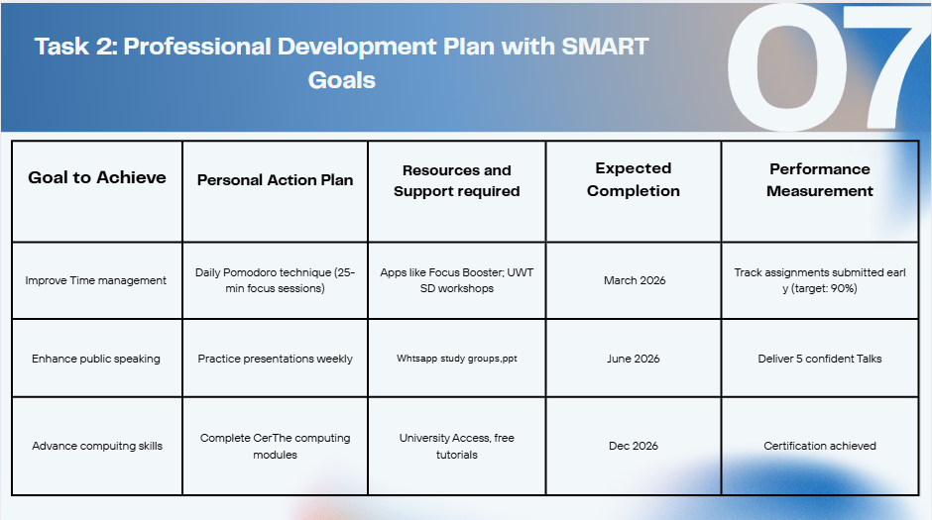

Brief Explanation: My SMART goals and development plan are presented in this slide. The description emphasizes the fact that every goal is quantifiable and attainable, and the plan will assist with my personal and professional development in the long-term perspective.

Slide 9: UNIT 4 TOPIC SUMMARY
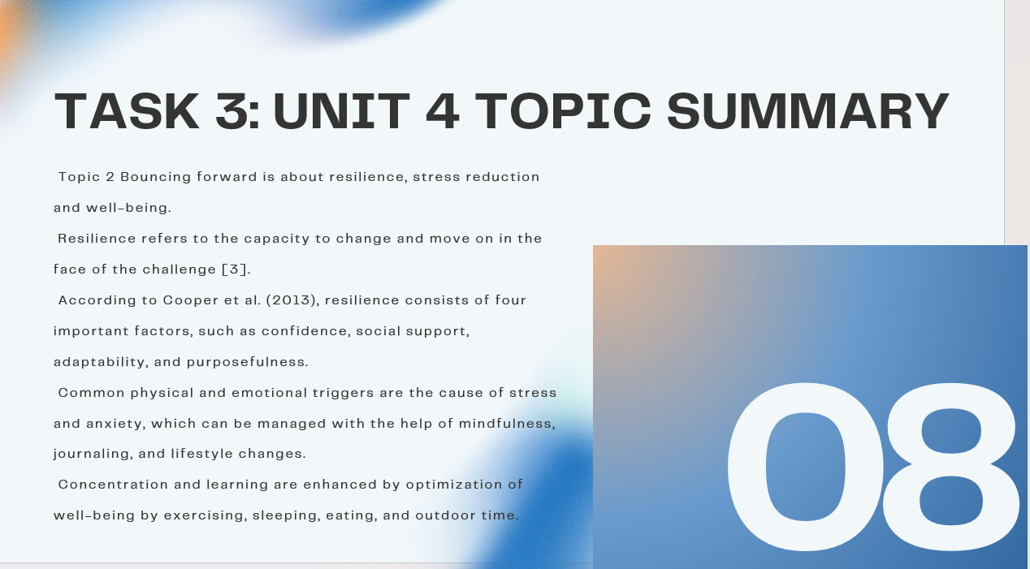

Brief Explanation: It is an overview of Unit 4 Topic 2: “Bouncing Forward in the form of this slide. It touches on the notions of resilience, stress and anxiety and well-being. The discussion highlights the significance of these skills to learning and employ-ability [3].

Slide 10: CONCLUSION
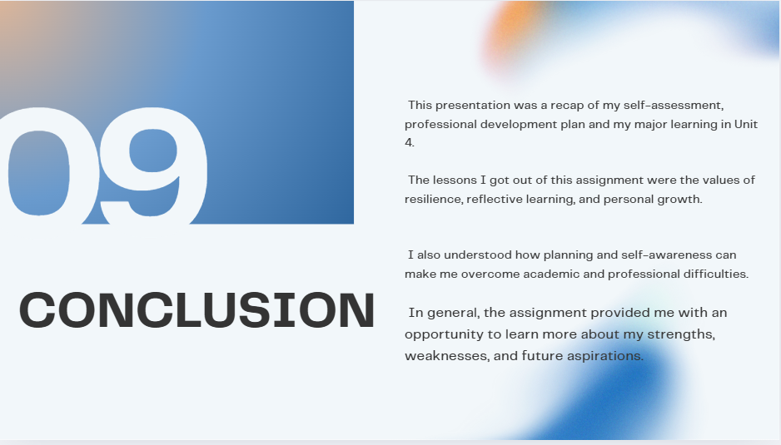

Brief Explanation: This slide will be my general summary of the presentation. The description explains what I have learned in the process of completing each activity and what the assignment provided me with the awareness of my strengths and areas of future development.

Slide 11: REFERENCES

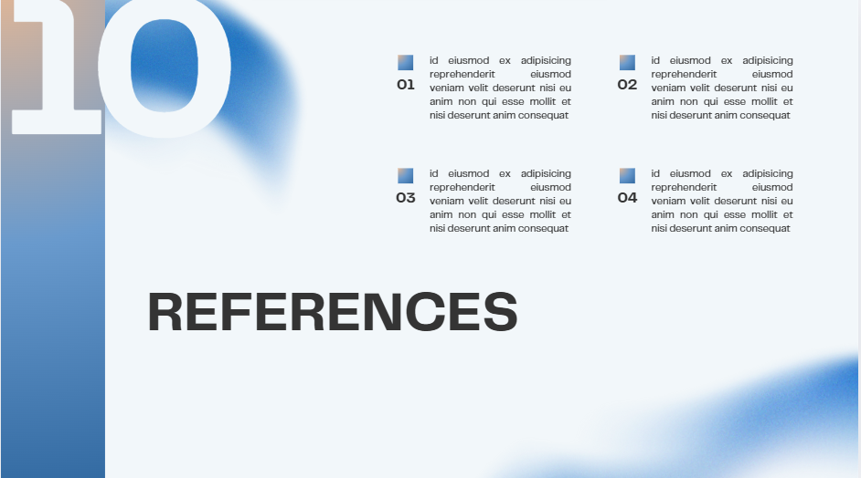

Conclusion
To sum up, this assignment enabled me to practice a good self-reflection, determine my strengths and weaknesses and develop a systematic plan of my personal and professional growth. The Unit 4 topic summary also helped me to develop a better conceptualization of resilience, stress management and well-being. This assignment has helped enhance my abilities in reflecting and becoming more conscious of the ways of learning academically, emotionally, and professionally in the online learning context.

References
[1]S. McLeod, “Gibbs Reflective Cycle,” Simply Psychology, 2025. https://www.simplypsychology.org/gibbs-reflective-cycle.html
[2]K. Cherry, “How to boost your self-awareness,” Verywell Mind, May 09, 2024. https://www.verywellmind.com/what-is-self-awareness-2795023
[3]Zlata Grygorenko and H. Naidionova, “THE CONCEPT OF ‘RESILIENCE’: HISTORY OF FORMATION AND APPROACHES TO DEFINITION,” Public Administration and Law Review, vol. 14, no. 2, pp. 76–88, Jun. 2023, doi: https://doi.org/10.36690/2674-5216-2023-2-76-88.
[4] J. Hreha, “What is a growth mindset and how to develop it in 9 steps,” Persona, Aug. 16, 2023. https://www.personatalent.com/development/how-to-cultivate-a-growth-mindset/

TASK 1: SELF EVALUATION

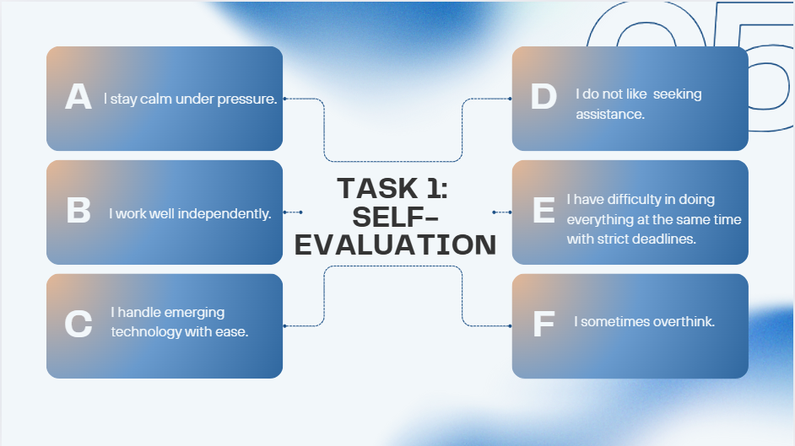
TASK 2: PROFESSIONAL DEVELOPMENT PLAN (PDP)
francisca^

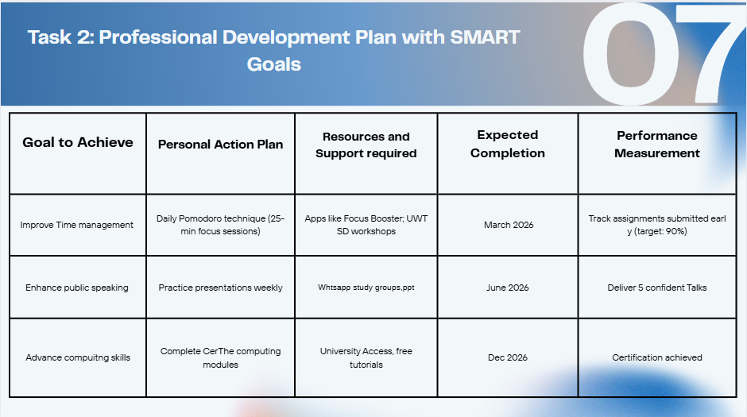

TASK 3: TOPIC SUMMARY
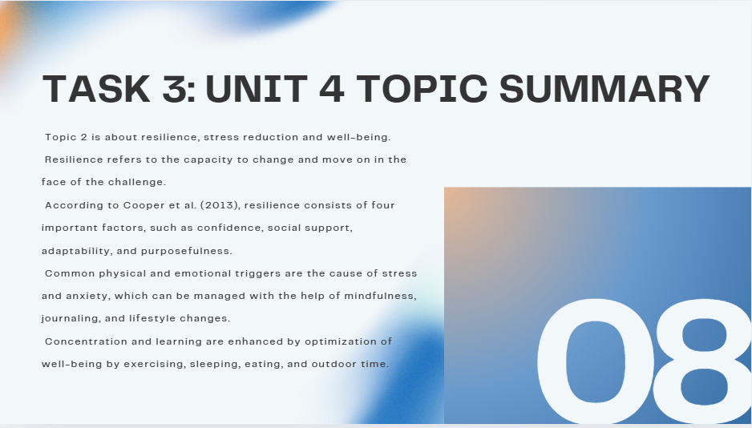

TASK 4 PRESENTATION

Link to the Video in its cloud platform (e.g. YouTube)
https://youtu.be/DvC_74fCwIw?si=1UYn4b3oujfqrZHM

Screenshot of the Video in its cloud platform (e.g. YouTube)



