Business Report – Comparison of Corinthia Hotels and Ibis Hotels

Student name:
Roberto-Alexandru Stere
Student ID:
2214492

Module name:
Financial Management for the Hotel Industry
BMIH5007

Lecturer name:
Jaliya de Silva

Word count:
1946

Executive summary:
This report provides a thorough analysis and comparison between Corinthia Hotels and Ibis Hotels in terms of their financial management strategies and practices. The assessment covers critical areas such as total revenue, market position, growth potential and financial commitment to CSR. The findings aim to provide insight into the financial performance and sustainability of both hotel groups.

1. Total revenue:
Corinthia Hotels: Corinthia Hotels, synonymous with opulence, has consistently demonstrated solid total revenue figures. The main sources of revenue encompass a spectrum of services including luxury room bookings, hosting extravagant events and providing a range of ancillary services. The brand's reputation for luxury and attention to detail contributes significantly to its premium image, attracting a demanding and affluent clientele. While this focus on exclusivity results in higher revenue per customer, there is a potential vulnerability to economic downturns as demand for luxury travel tends to be more sensitive to economic fluctuations.
Corinthia's commitment to maintaining a premium brand image is reflected in its pricing strategy, which allows for higher profit margins per transaction. In addition, strategic partnerships with luxury brands and exclusive collaborations further contribute to revenue diversification.
Ibis Hotels: Ibis Hotels, positioned as an economical option in the hospitality landscape, relies heavily on achieving high occupancy rates and operational efficiency. Most of its revenue comes from room bookings, with auxiliary services playing a relatively smaller role. The brand's affordability and standardised offerings attract a broader customer base, making it less susceptible to economic downturns that could affect luxury travel.
While Ibis excels in achieving stability through volume, it faces challenges in maintaining profitability due to lower profit margins per transaction. The brand's success depends on operational efficiency, cost-effective measures and economies of scale. In addition, Ibis emphasizes loyalty programs and partnerships with online travel agencies to drive bookings and increase its market reach.
Comparison:
Corinthia excels in revenue per customer, taking advantage of its premium positioning to charge higher prices. However, this strategy makes the brand more vulnerable to economic fluctuations. Ibis, on the other hand, focuses on volume and affordability, offering stability in variable economic conditions. The key factor influencing their revenue dynamics is the economic environment and consumer preferences.
In a dynamic market, understanding the delicate balance between luxury and affordability is crucial for sustained success. Both Corinthia and Ibis must continually adapt their strategies to align with changing consumer expectations and economic conditions.
2. Market position:
Corinthia Hotels: Corinthia establishes and maintains a prestigious position in the market, with a focus on luxury, exclusivity and a commitment to high quality amenities and personalized service. The brand's focus on offering an opulent and unparalleled experience is aimed at an affluent clientele seeking premium accommodation. While the perception of the Corinthia brand is highly favourable, exclusivity can limit the potential customer base. The challenge is to strike a delicate balance - maintaining an aura of exclusivity while exploring ways to broaden appeal without diluting the premium brand image.
Strategic collaborations with renowned designers, exclusive partnerships and innovative marketing approaches can help extend Corinthia's market reach. Using digital platforms for targeted marketing and personalised experiences can also enhance brand appeal.
Ibis Hotels: Ibis is positioning itself in a wider market, targeting especially budget travellers. The brand identity is associated with simplicity, efficiency and affordability. Ibis achieves significant market share by targeting the mass market segment looking for cost-effective accommodation. The challenge for Ibis is to differentiate itself from other budget competitors in the crowded hospitality market. While affordability is a strength, it can also pose a risk of being perceived as generic or lacking distinctive features.
To overcome this challenge, Ibis can focus on enhancing guest experiences through unique design elements, localized offerings and value-added services. Emphasising sustainability practices and engaging with the local community can also contribute to positive brand differentiation.
Comparison:
Corinthia's exclusive positioning offers a niche market, attracting a specific segment of luxury travellers looking for luxury and personalised service. The challenge is to expand this market without compromising exclusivity. Instead, Ibis' wider appeal is aimed at budget travellers, banking on affordability to capture a larger market share. However, the key challenge for Ibis is to stand out in a competitive budget segment where differentiation is crucial.
3. Growth potential:
Corinthia Hotels: Corinthia's growth potential is closely linked to strategic expansion into emerging luxury travel markets. By identifying and entering markets with growing demand for premium accommodation, Corinthia can capitalise on its reputation for luxury and exclusivity. Collaborations with luxury brands and the introduction of unique experiences can further distinguish Corinthia from competitors, attracting a wider audience. However, the luxury travel segment is sensitive to economic uncertainties and Corinthia needs to be agile in adapting to market fluctuations.
To mitigate economic challenges, Corinthia could consider diversifying its offerings, such as introducing more affordable packages, without compromising on quality. In addition, focusing on sustainable wellness and luxury experiences aligns with evolving consumer preferences and can contribute to long-term growth.
Ibis Hotels: Ibis' growth potential lies in leveraging its successful business model by expanding into untapped markets, particularly in regions with a growing middle-class population. Targeting emerging markets can provide ample opportunities for Ibis to take advantage of a growing demand for affordable but quality accommodation. The challenge for Ibis is to sustain growth in a budget segment characterised by fierce competition.
To stand out, Ibis should prioritise constant innovation in its offerings. This could include incorporating technology for enhanced guest experiences, introducing unique amenities and adopting sustainable practices to attract eco-conscious travellers. Strategic partnerships with local businesses and cultural initiatives can also contribute to Ibis' growth.
Comparison:
Corinthia should leverage its exclusivity and premium positioning for strategic expansion into emerging luxury travel markets. This requires a balance between maintaining the brand's luxury image and adapting to the preferences of a wider audience. In turn, Ibis' growth relies on innovative strategies to differentiate itself in the competitive budget segment. The key for Ibis is to continually evolve its offerings and stay ahead of changing consumer expectations.
4. Financial commitment to CSR:
Corinthia Hotels: Corinthia Hotels demonstrates a commitment to corporate social responsibility (CSR) by integrating sustainable practices into its luxury offerings. These practices can include energy efficient technologies, waste reduction initiatives and responsible sourcing of materials. While Corinthia has made progress in incorporating sustainability into its operations, there is room for improvement in community engagement initiatives. Strengthening ties with local communities, supporting social initiatives and engaging stakeholders in CSR programs can enhance Corinthia's positive impact. In addition, improving transparency in the reporting of these initiatives is crucial to build trust among consumers and stakeholders with environmental concerns.
Ibis Hotels: Ibis Hotels focuses on CSR through green practices, aiming to minimize its environmental footprint. These practices can involve energy saving measures, waste reduction and initiatives to promote local biodiversity. Despite these efforts, Ibis faces a challenge in effectively communicating its CSR initiatives to improve brand perception. Engaging customers through various channels, such as digital platforms and on-site communications, can help highlight the brand's commitment to sustainability. In addition, transparency in reporting is essential to provide clear evidence of the positive impact of these initiatives.
Comparison:
Both Corinthia and Ibis demonstrate a commitment to CSR, recognising the importance of aligning their operations with social and environmental responsibility. However, both face challenges specific to their market positions.
Corinthia, which is part of the luxury segment, needs to increase its community engagement initiatives and improve its transparency in reporting to enhance credibility. Luxury consumers are increasingly considering a brand's ethical and social values when making choices.
For Ibis, the challenge is to effectively communicate its green practices to a budget-conscious consumer base. Using accessible and relatable communication channels such as social media and in-room materials can bridge the gap between brand efforts and customer awareness.
In conclusion, both organisations can benefit from refining their CSR strategies to align with their target audiences and increase transparency in communicating their positive contributions to society and the environment. This not only strengthens their brand image but also contributes to the overall sustainability of the hospitality industry.
Recommendations:
Corinthia Hotels:
1.Strengthen community engagement initiatives: Corinthia should focus on strengthening its community engagement initiatives to further improve its CSR perception. This may involve actively participating in local community projects, supporting social causes and fostering meaningful relationships with stakeholders. By aligning with the values and needs of the communities in which Corinthia operates, the brand can demonstrate a genuine commitment to social responsibility, contributing positively to its overall image.
2. Explore strategic partnerships: To attract a broader customer base, Corinthia should explore strategic partnerships with high-end brands and influencers. Collaborations can offer unique and exclusive experiences, differentiating Corinthia in the competitive luxury hospitality landscape. These partnerships can not only enhance brand appeal, but also create new avenues for revenue generation. It is essential to carefully select partners that align with Corinthia's values and resonate with its target audience.
Ibis hotels:
1. Improve communication of CSR initiatives: Ibis should focus on improving the communication of its CSR initiatives to raise brand awareness among consumers. Implementing a comprehensive and accessible communications strategy, including social media, website content and in-room materials, can effectively convey the brand's commitment to green practices and community involvement. Transparency in reporting the impact of these initiatives will build trust and resonate with environmentally conscious travelers.
2. Invest in technology and innovation: In the budget segment, staying competitive requires continuous innovation. Ibis should invest in technology to improve customer experiences and operational efficiency. Implementing user-friendly mobile apps for reservations and guest interactions, incorporating smart room technologies and adopting sustainable practices through technology solutions can position Ibis as a forward-thinking and customer-centric brand. Embracing innovation will not only attract budget travelers, but will also contribute to long-term cost savings and sustainability.
Additional considerations for both:
- Sustainability certification: Both Corinthia and Ibis should consider obtaining recognized sustainability certifications such as LEED (Leadership in Energy and Environmental Design) or Green Key. These certifications can serve as independent validations of their commitment to environmental and social responsibility, enhancing credibility in the eyes of environmentally conscious consumers.
- Employee training: Implementing comprehensive employee training programmes on CSR initiatives is essential for both brands. Well-informed and engaged staff can effectively communicate brand commitment to guests, creating a positive impact on customer perception and loyalty.
By implementing these recommendations, Corinthia and Ibis can further strengthen their positions in their respective market segments, fostering positive brand perceptions and contributing to their long-term sustainability and growth.

Conclusion:
In conclusion, this comprehensive analysis of Corinthia Hotels and Ibis Hotels highlights critical aspects of their financial management strategies and practices, shedding light on their strengths, challenges and growth potential. The recommendations offered are intended to serve as strategic guidelines for both organizations, addressing specific areas that can contribute to their sustained success in the dynamic hospitality industry.
Corinthia Hotels has established itself as a beacon of luxury with a focus on exclusivity and premium offerings. The brand's consistent demonstration of robust total revenue figures demonstrates its effectiveness in catering to the high-end market. The recommendation to strengthen community engagement initiatives aligns with the evolving expectations of socially responsible consumers.
On the other hand, Ibis Hotels has carved out a niche in the low budget segment, achieving stability through high occupancy rates and operational efficiency. The recommendation to improve communication of CSR initiatives recognises the importance of effectively conveying the brand's commitment to sustainability.
As the hospitality industry evolves, Corinthia and Ibis should remain vigilant in monitoring market trends, consumer preferences and emerging technologies. By continually adapting their strategies to the ever-changing landscape, these organisations can navigate challenges, capitalise on opportunities and strengthen their position as leaders in their respective market segments.

References:
Hotels, C. (no date) About Corinthia: Corinthia Hotels International, Corinthia. Available at: https://www.corinthia.com/en-gb/our-story/ (Accessed: 30 January 2024).
Hotels, C. (no date b) The corinthia standard, Corinthia. Available at: https://www.corinthia.com/en-gb/development/ (Accessed: 30 January 2024).
Hotels, I. (no date) Ibis Hotels - feel good at a great price., ibis.accor.com. Available at: https://ibis.accor.com/discovering/ibis-hotel/index.en.shtml#section-whyibis (Accessed: 30 January 2024).
Hotels, I. (no date) Accor - discover ibis, Descover Ibis . Available at: https://group.accor.com/en/brands/economy/ibis (Accessed: 30 January 2024).
Investments, M. (2023) corinthia group of companies, FINANCIAL ANALYSIS SUMMARY. Available at: https://www.corinthiagroup.com/wp-content/uploads/2023/06/IHI_Financial-Analysis-Summary-2023.pdf (Accessed: 30 January 2024).
IBISWorld - industry market research, reports, and Statistics (2023) IBISWorld Industry Reports. Available at: https://www.ibisworld.com/us/bed/government-consumption-investment/381/ (Accessed: 30 January 2024).
Total revenue: Definition, how to calculate it, and examples (2023) BEONx. Available at: https://www.beonx.com/knowledge/articles/total-revenue-definition/ (Accessed: 30 January 2024).
Cocks, P. (2022) Corinthia to target 4-star space under new brand to be launched by 2023, BusinessToday.com.mt. Available at: https://www.businesstoday.com.mt/business/business/1849/corinthia_to_target_4star_space_under_new_brand_to_be_launched_by_2023 (Accessed: 30 January 2024).
ReviewPro (2020) How Corinthia Hotels provides 5-star service on the social web, ReviewPro. Available at: https://reviewproblog.shijigroup.com/corinthia-hotels/ (Accessed: 30 January 2024).
Bhasin, H. (2024) Marketing mix of Ibis Hotel and 4Ps (updated 2023), Marketing91. Available at: https://www.marketing91.com/marketing-mix-of-ibis-hotel/ (Accessed: 30 January 2024).
Accorgroup (2019) Ibis family reaches over 1,700 hotels and pursues its pioneering revolution: Accor – newsroom, Accor. Available at: https://press.accor.com/la-famille-ibis-depasse-les-1-700-hotels-et-poursuit-sa-revolution-pionniere_5714_5714/?lang=en (Accessed: 30 January 2024).
Corinthia Hotels (2023) Corinthia Hotels is pleased to welcome three new industry leaders to spearhead their hotels opening in 2024., Corinthia. Available at: https://www.corinthia.com/en-gb/latest-news/corinthia-hotels-is-pleased-to-welcome-three-new-industry-leaders-to-spearhead-their-hotels-in-rome-new-york-and-brussels/ (Accessed: 30 January 2024).
Newman, E. (2019) Corinthia hotels adapting to changing luxury demands, Hotel Management. Available at: https://www.hotelmanagement.net/own/corinthia-hotels-international-adapts-to-changing-luxury-demands (Accessed: 30 January 2024).
WiT (2014) Accor makes economy all about ibis, and puts more money into Accor brand, WiT. Available at: https://www.webintravel.com/accor-makes-economy-ibis-puts-money-accor-brand/ (Accessed: 30 January 2024).
Cheng, J. (2019) Research and suggestions on declining market shares of Ibis Budget Hotels, SCIRP. Available at: https://www.scirp.org/journal/paperinformation?paperid=97885 (Accessed: 30 January 2024).
Overview of our recent CSR activities (2021) Corinthia Group Overview of our recent CSR activities Comments. Available at: https://www.corinthiagroup.com/insider/overview-of-our-recent-csr-activities/ (Accessed: 30 January 2024).
Hospitality On (2022) Ascott residence trust strengthen its commitment to sustainability, Hospitality ON. Available at: https://hospitality-on.com/en/csr/ascott-residence-trust-strengthen-its-commitment-sustainability (Accessed: 30 January 2024).
Accorgroup (2017) Accorhotels takes its corporate responsibility to the next level with bold new CSR commitments looking: Accor – newsroom, Accor. Available at: https://press.accor.com/accorhotels-takes-its-corporate-responsibility-to-the-next-level-with-bold-new-csr-commitments-looking/?lang=en (Accessed: 30 January 2024).
Gutterman, A.S. (2023) LinkedIn login, sign in, LinkedIn. Available at: https://www.linkedin.com/pulse/developing-csr-commitments-alan-s-gutterman-ydxfc/ (Accessed: 30 January 2024).
Accorgroup (2017) Accorhotels takes its corporate responsibility to the next level with bold new CSR commitments looking: Accor – newsroom, Accor. Available at: https://press.accor.com/accorhotels-takes-its-corporate-responsibility-to-the-next-level-with-bold-new-csr-commitments-looking/?lang=en (Accessed: 30 January 2024).
Hospitality On (2022) Ascott residence trust strengthen its commitment to sustainability, Hospitality ON. Available at: https://hospitality-on.com/en/csr/ascott-residence-trust-strengthen-its-commitment-sustainability (Accessed: 30 January 2024).
Burton, E. (2021) 5 tips for improvement if you’re in the Hotel Industry, Typsy Brand. Available at: https://blog.typsy.com/5-tips-for-improvement-if-youre-in-the-hotel-industry (Accessed: 30 January 2024).
Elphick, D. (2023) Hotel strategy: Examples to boost your business, SiteMinder. Available at: https://www.siteminder.com/r/hotel-strategy/ (Accessed: 30 January 2024).

Appendix
Corinthia Hotels: 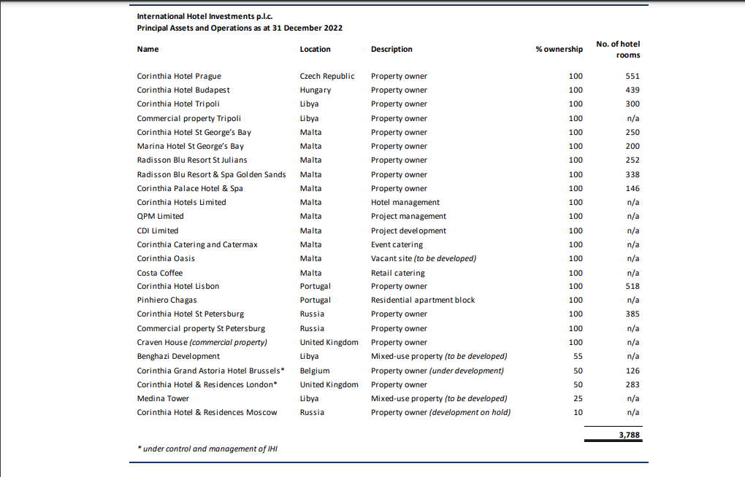
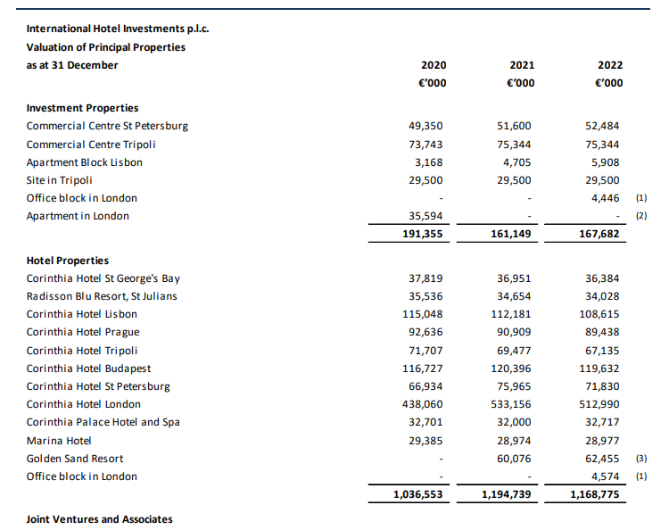
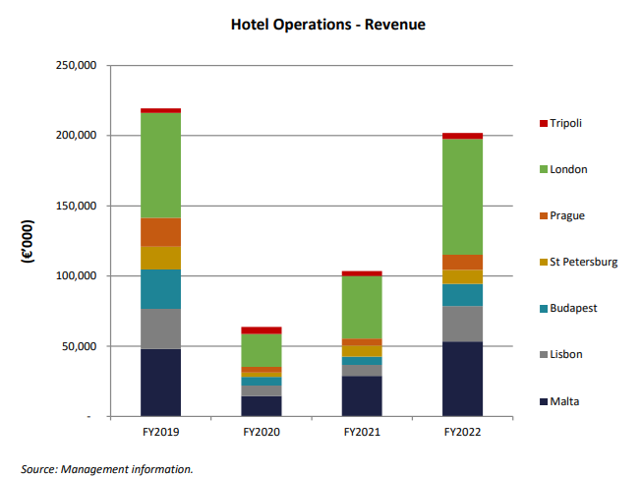

Ibis Hotels:


