John Muir Award – Max Leech & Lucas Seers & Matthew Hilyer

Activity – Beach Clean-up.
Outcome: Connect with and care for the environment.
I can’t be part of the actual John Muir awards process as nominations are now closed as they update the award for next year. New nominations can be accepted from 1st March 2025.
John Muir – Proposal (4 Aspects to cover):
- Discover a Wild Place: Find a natural area to explore and understand its unique features.
- Register with Surfers Against Sewage – be part of ‘Million Mile Clean” (this is the Partner organization).
- Register a individual or group clean: Register a clean - Surfers Against Sewage and they will provide us with free kit to complete the clean-up.
- TARGET = Pembery or Llansteffan Beach – about 15 miles away from UWTSD is maybe a good target beach to clean-up 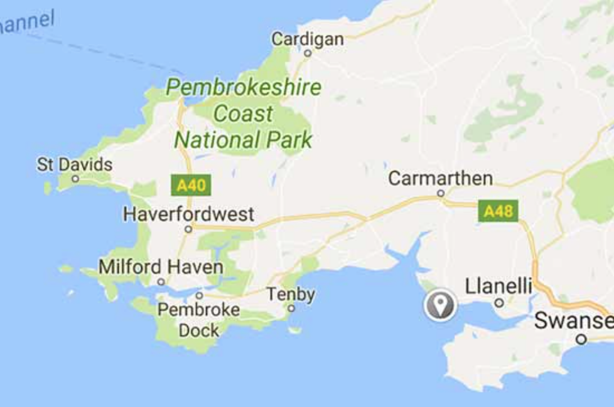

- Explore Pembry OR Llansteffan Beach: Spend time in the wild place, engaging your senses and learning about its biodiversity and natural history.
- Take photos/videos of the beach
- It has sand and sand dunes
- Research about this beach

- Conserve it by doing a beach clean-up activity: Take action to care for the wild place, such as participating in clean-up activities or habitat restoration.
- Complete beach clean-up with my team on either Saturday 9th or Saturday 16th November
- Include clean-up with my group - Matthew, Izzy & Lian and Lucas.
- The nearest litter picking hub to Carmarthen is the Llanelli Rural Council Litter Picking Hub. It's located in Llanelli, which is about 15 miles (24 kilometers) from Carmarthen. This hub provides all the necessary equipment for litter picking, including litter pickers, hi-vis vests, rubbish bags, and hoops to keep the bags open in breezy conditions. You borrow the litter pick up kit free and return it after. Open hours 8.45am-4pm (Mon-Fri).
- Book a Thursday or Saturday or Sunday to individually or with a group (maybe with my flat) to go gather rubbish and do a full beach clean-up.

- Share My Experience: Tell others about your adventures and what you've learned, celebrating your achievements.
- Post on social media about my clean-up.
- Submit the evidence of all the plastic and rubbish collected on the beach clean-up (how many miles covered and KGs of rubbish collected). To the Surfers Against Sewage site as part of ‘Million Mile Clean’.
- Share the brands with most rubbish as part of the The Brand Audit also on the Surfer Against Sewage site.

References:
Engagement Initiative | John Muir Award
John Muir Award | Resources | National Improvement Hub
Litter Picking Hubs - Keep Wales Tidy - Caru Cymru

