

MODULE CODE: Digital Skills for Personal Development and Business Growth BMSW4008

ASSESSMENT COMPONENT
PORTFOLIO

STUDENT NAME: Marie Sugarova

STUDENT NUMBER: 2531376

LECTURER: Manjit Biant

DATE: 15.03.2016
Contents
Task 1 3-8
Assessment of Digital Skills 3-5
References 5-6
Digital Badges………………………………………………………………………………………………..6-8
Task 2 9-14
LinkedIn Learning Certificates for Office365 9-14
Task 3 15-19
Essay on Relevance of Excel in professional and personal life. 18-17
References 18-19
Task 4 19-20
7 Minute Reflective Presentation 19
References 20

AI Statement
I confirm that I have not presented any AI generated materials as my own work.
I confirm that I have copies of my drafts, notes, and other resources I used, which I
may be asked to provide in evidence.

Task 1

Assessment of Digital Skills

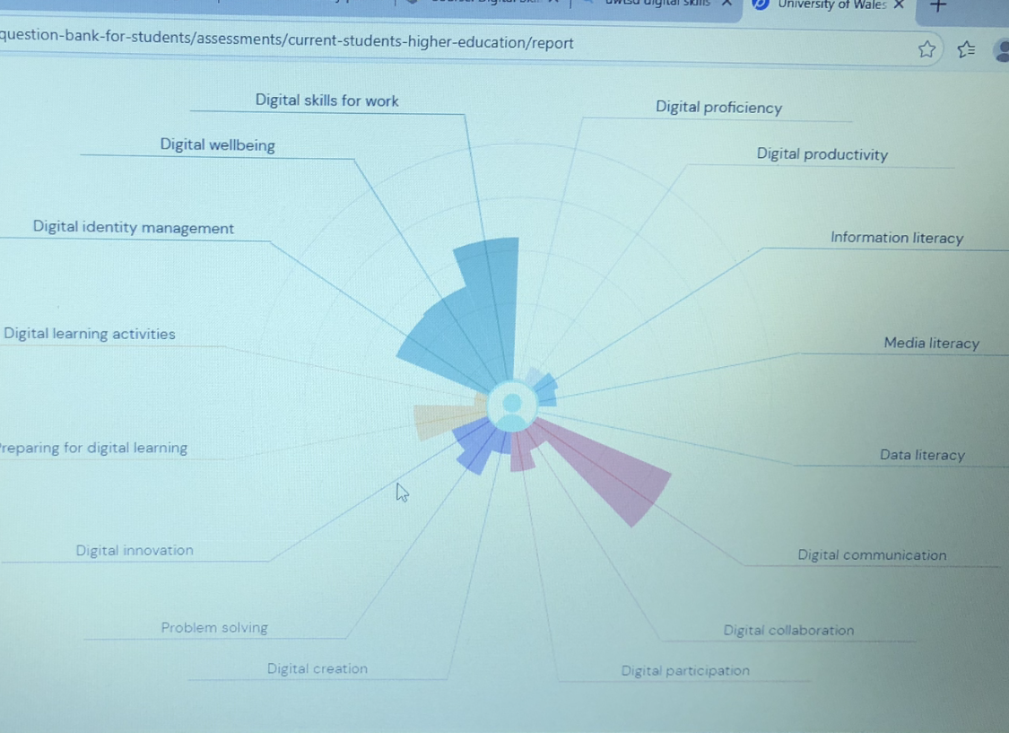
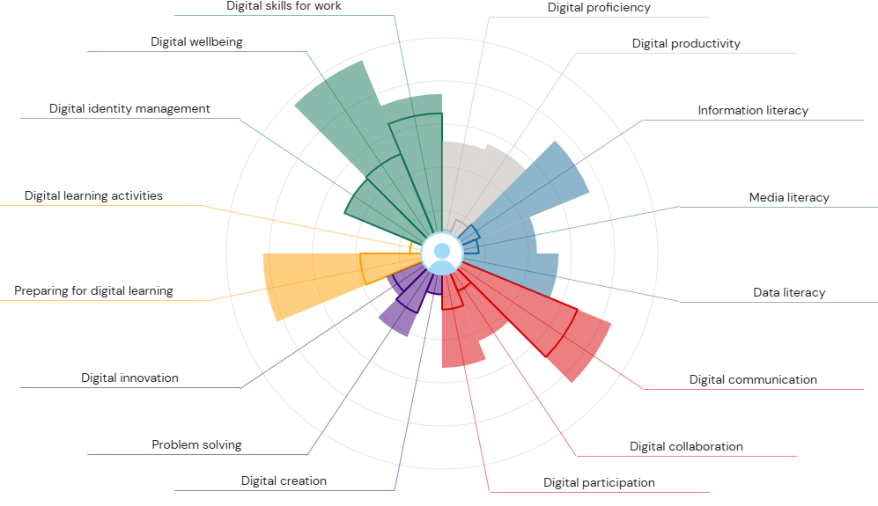
I’m writing this essay to outline all the new knowledge that I have gained in the first semester. This new step in my life is very challenging, but exciting at the same time. I have gained basic understanding of some features that Microsoft 365 has. I’m aware that there is a wide range of features for me to explore and learn moving forward.
Fully motivated to discover the digital world starting with Jisc. Article Read (2012) explain the importance of the organisation Jisc give students better understanding of the digital tools and navigate students where to improve their digital skills. My first step was to completed Essential digital skills the Jisc questionnaire to assess my digital technology understanding then again now to clearly see my progress in digital skills. Comparing my first week to now, I have moved past the basics. I feel much more comfortable using Microsoft 365 to stay organised and manage my data. I still have a long way to improve specially with Digital creation and Problem solving I’m positive that I will success in those areas and many others my plan it’s to continue using LinkedIn learning tutorial videos at my free time which is every Sunday afternoon for hour at least. I learned how to write professional email correctly including all key factors. Finally, I know how to attach a file right way. Pinto (2024) describes Microsoft 365 like a key to work more efficiently using Outlook calendar to manage time better and stay organise. Learning about Microsoft Outlook I was overwhelmed at a beginning with all the possible feature I can use. Students know how to use technology like social media but found it difficult with educational tools (Ng, 2012). I’m developing my digital skills it’s starting to have a positive effect on me which makes me very happy. Manage my inbox using colours and different categories helps me to clearly see important emails. Also feature snooze keeping my inbox neat, I can set date, time when the email will appear at the top of my inbox ready for me. According to Cottrel (2024), it’s essential to understand digital tools well to be successful at university. Staying organised is vital for my studies Outlook calendar helps me to stay organised and update with all responsibilities. It is very simple to schedule, arrange and rearrange events. Individuals can book appointments, meetings etc. Microsoft teams it’s my favourite platform that combines communication through private, groups, and video calls chat also access to Word, Excel and PowerPoint. Teams are widely known for create a channel when working on a task. Allows me to upload, edit and share my work on teams Makes it easier for me to communicate. Each member of the chat can create and share work on the same specific task e.g. add, amend or erase when needed. LinkedIn site plays the most important part on my academic journey, helping me to learn all about digital technology. Creating profile, making professional connections and exploring all the materials are provide by tutorials videos. Resent study Hazzam et al. (2024) found that LinkedIn learning helps students to gain better learning habits and be more prepared for work. Using PowerPoint for presentation, opens a creating side of me various image, videos, add my own audio is bit hard for my to do because I don’t like my voice recorded doesn’t sounds like me, but I will work on the uncomfortable feeling. In Chen (2023) article he points out that PowerPoint helps students to get their idea out more clearly using various images, picture by presenting slide show. Recently discovered Canva, I’m starting to feel like I can create anything poster and business card the possibilities are endless. I use Microsoft Word to type my essays, amending documents, Bencsik (2017, p.137) recommending putting ideas into Word document helps businesses build team collaboration. Spelling checks its great feature helping me to improve my writing skills.
In conclusion I have gained confidence in Microsoft 365. I have explored more features of Microsoft 365 and started making use of it. There is still so much to learn, I’m actively using LinkedIn and learning from it. Expanding my digital technology knowledge even further.

References
Bencsik, A. (2017) Knowledge management initiatives and strategies in small and medium enterprises. Edited by A. Bencsik. Hershey, Pennsylvania: Business Science Reference. https://doi.org/10.4018/978-1-5225-1642-2.
Chen, C.W. (2023) “PowerPoint as a multimodal retelling tool: students’ slide design, collaboration, and goal-setting,” Innovation in language learning and teaching, 17(1), pp. 1–14. https://doi.org/10.1080/17501229.2021.1895801.
Cottrell, S. (2024) ‘’The study skills handbook’’, Sixth edition, London: Bloomsbury Academic.
Hazzam, J. et al. (2025) “The drivers and outcomes of postgraduate students’ adoption and use of LinkedIn learning,” Innovations in education and teaching international, 62(3), pp. 851–866. https://doi.org/10.1080/14703297.2024.2346549.
Ng, W. (2012) “Can we teach digital natives digital literacy?,” Computers and education, 59(3), pp. 1065–1078. https://doi.org/10.1016/j.compedu.2012.04.016.
Pinto, R. (2024) Mastering Microsoft 365 and SharePoint Online : A Complete Guide to Boosting Organizational Efficiency with Microsoft 365’s Real-World Solutions, 1,ed. Birmingham, England: Packt Publishing Ltd.
Read, M. (2012) “The JISC,” Alexandria (Aldershot), 23(3), pp. 45–49. https://doi.org/10.7227/ALX.23.3.8.
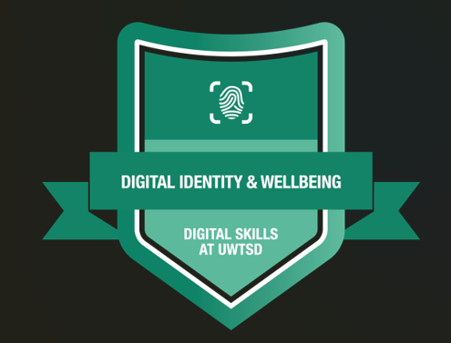
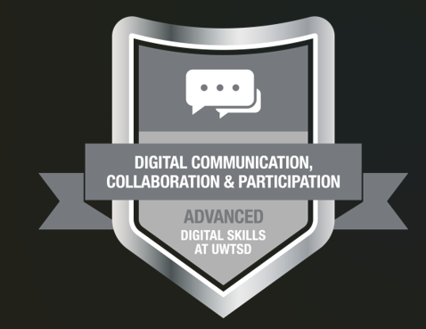

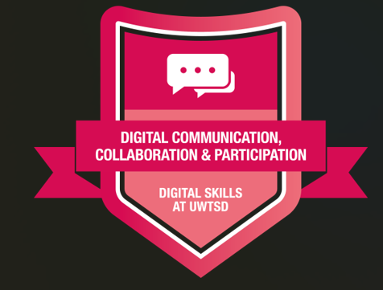

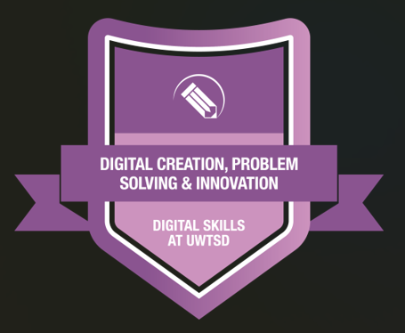

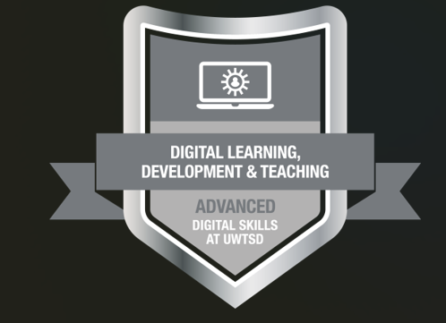

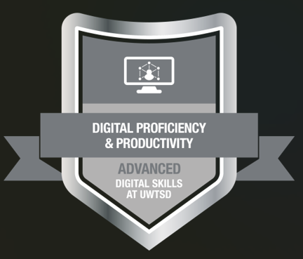

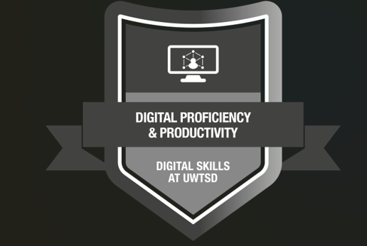

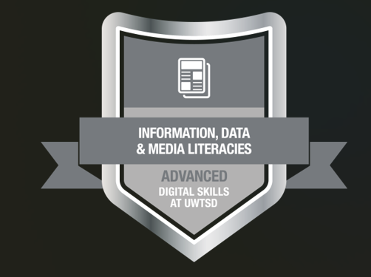

Task 2

LinkedIn Learning Certificates for Office365

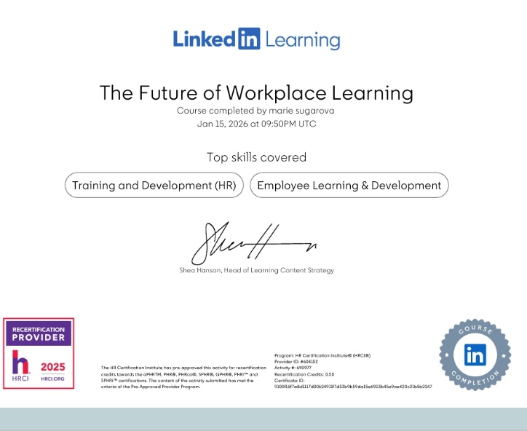


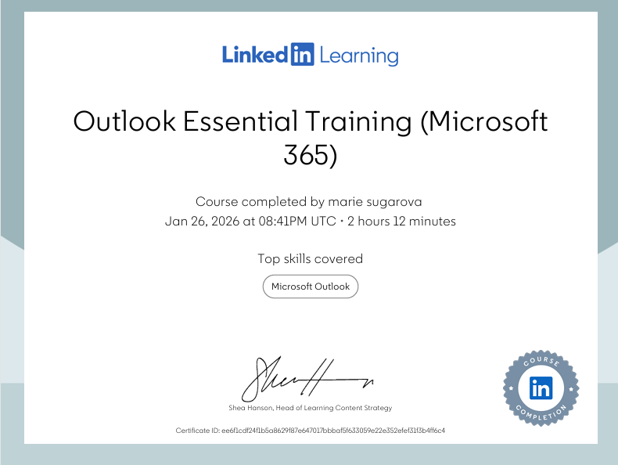
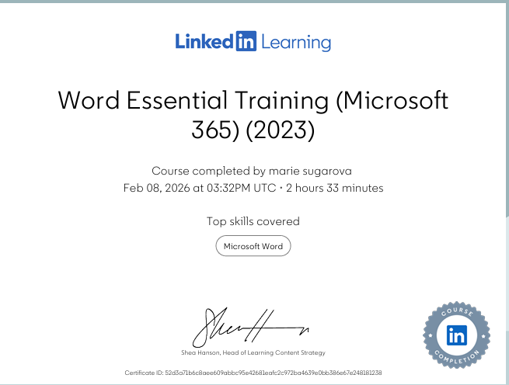

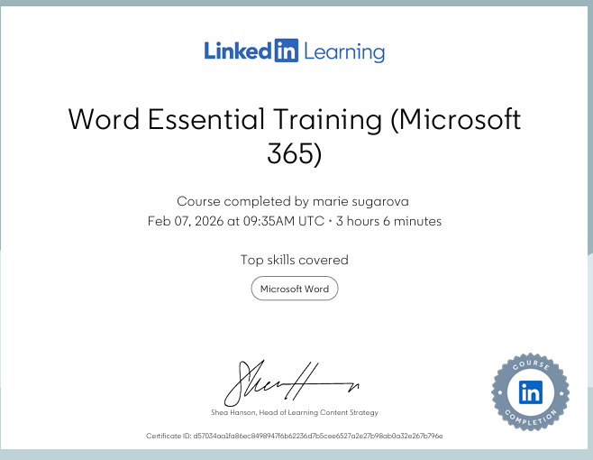


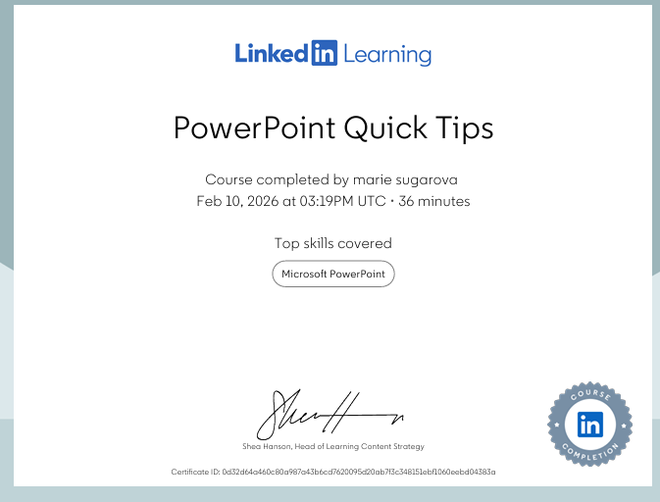

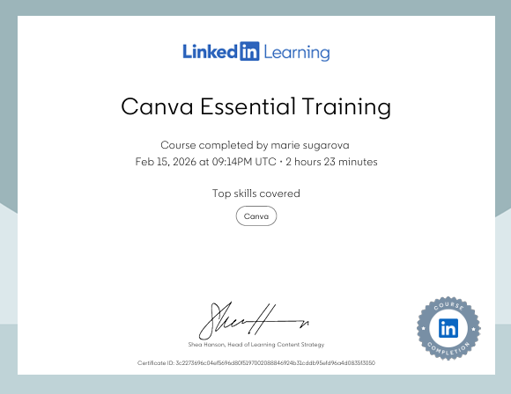
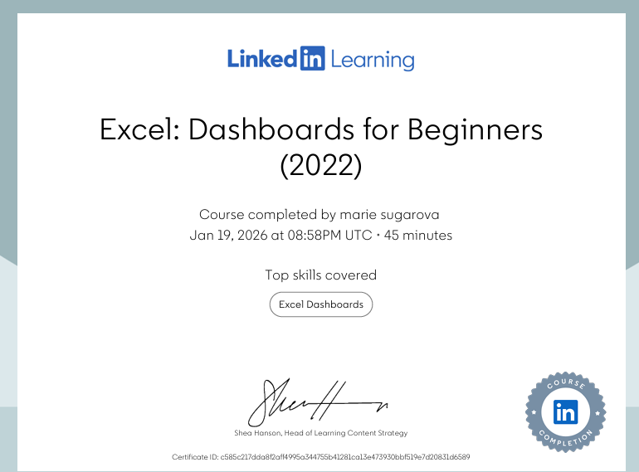

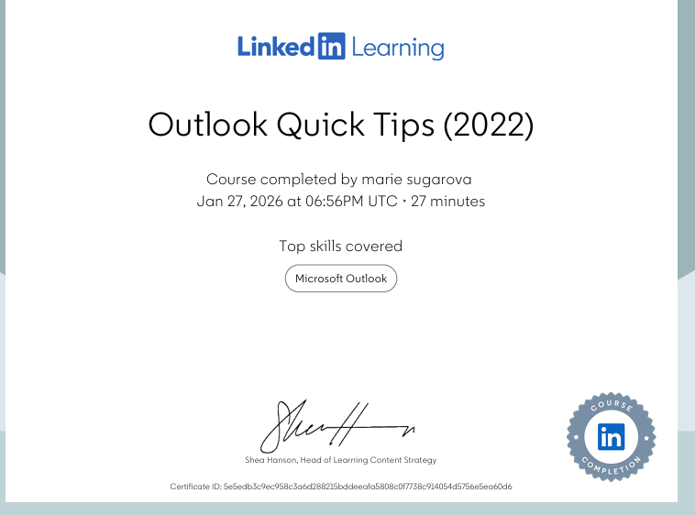
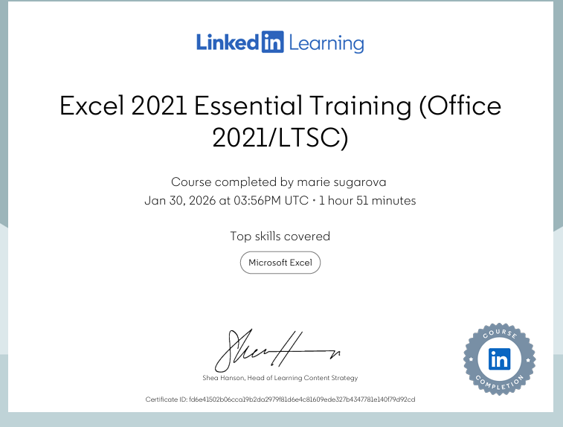

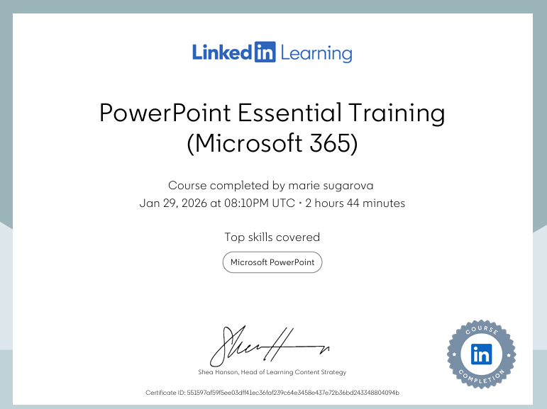

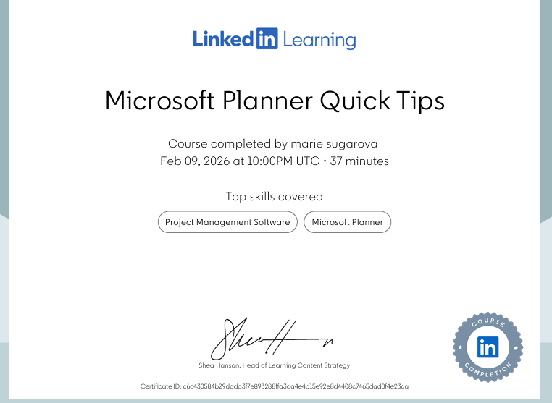

Task 3

Essay on Relevance of Excel in professional and personal life.
In the digital world we are living today, numbers are everywhere. Whether we are checking a water bill or trying to save up for a summer trip we are dealing with data. This essay will explain the importance of Microsoft Excel by showing how family of four can make budget spreadsheet and track all their incomes and outcomes.
Microsoft Ecxel is the main tool students use to handle all information’s. For student who just starting out, Excel can look scary at first large sheet with empty boxes. Developing Excel knowledge, it’s a great way to learn how to think clearly and solve problems (Abraham at el., (2021). Understanding the whole story what numbers trying to tell as and how numbers can be transformed to charts and graphs (Prodromou, 2017). Learning features that Microsoft Excel provides it one of the most practical skills for students, mastering fundamental spreadsheet skills early in university is a major advantage, students will find it much easier dealing with data (Rubin et al. 2025). Excel it’s a spreadsheet with columns which goes up and down and rows going side to side. For example, think of columns like my shopping list and rows the price to pay for each item. According to Bertaud (2018), the layout we use for each element is important to Excel system working right. When a row and column meet, they create a cell just like a puzzle need every peace to complete the whole picture also Excel need all cell information to be correct. Sorting family finance can be frustrating especially if their money coming in from multiple sources, staying on top of all family bills can be very challenging task to do. In situation like this one it’s ideal to find the truth about family of four finance using Excel spreadsheet. When applying something as sensitive as family budget using scenario manager found within the what if analysis tools on the data ribbon give a family the ability to find the exact capacity of their budget, showing them exactly how much ups and downs their can afford before it happens (Bates and Johnson, 2021). If one of family incomes increase or decrease simply change the one box in Excel, and instantly Excel will automatically create new calculations of yours saving and incomes. This helps families to have clear visual knowledge, improve their decisions by make better choices not just guessing anymore. Many studies (Van Borkulo et al.,2023) found that using spreadsheets helps families to see how different parts of their daily lives are connected by data information. Excel can even help families to guess what might happen in a future this feature calls predictive analytics (Brusco, 2020). Family can look at how much they spend last winter on gas and use Excel forecast sheet tool to know how much they need to save for next winter. In medical field Taylor et al. (2021) explains how rows and columns are used to analyse different treatments and found the best value for money of different medicine. Whether beginner learner or student in higher education learning about basic accounting (Cathey and Smith, 2020) or a doctor, Excel will give simple guidance to professional knowledge how to solve a problem (Brusco, 2022). In this family project on budget Excel will be using the same principles of rows columns to manage household resources. Instead of just a simple list of cost Excel lets as viewed the budget as a structured layout for the future. Each column represents different categories of spending like housing, food and savings. While each row tracked monthly progress. By organising finances, students can evaluate spending habits more clearly, Byrd (2021, p.1) proved that using digital tools to process information is a key skill. There is no need to use calculator any more instead using the SUM formula. It added everything up, then when needed to see how much money family have left each month simple use minus formula. It’s straightforward this method is called the Net Balance (Lantushenko et al.,2018). Changing the amount spend on food, the whole year’s budget updates itself. Just a long list of numbers is boring and hard to understand. Excel charts is an additional help to see expenses going up or down in a clearer view. Article by Miller (2014) argues that there is a strategic reason when we are choosing right tools between table which is use when need it to see exactly number, charts are used to see project going up or down. Pie chart shows all spending as a slice and can easily see that the biggest slice was rent and childcare. Seeing spending in a bright colours chart gives better understand where the money is going. Teacher uses similar graphs to help students learn how to read data (Bagley and Sheridan, 2021). The research by Kakegawa (2024) explains that Excel is essential it creates principle of linked data using practical recipes. This connects scattered spending into a financial clarity. In this family project it means that every cell was linked, they can simulate different financial futures by changing just one row of date. Moncada (2025) argues that the process of data cleaning transform messy numbers into intellectual capital, this allows doctors, managers and professionals to maintain data integrity and make trustworthy decisions. Excel is a friendly and practical choice for organising incomes and outcomes, using rows and columns we can turn spending records into a clear finance picture.
In conclusion Microsoft Excel it, more than just rows and columns. It’s a powerful tool helping as achieve much better control and deeper understanding, ability to predict the future when it’s come to budgeting, spending and so much more. Microsoft Excel skills are extremely important wherever on student journey to success in studies or employment career to achieve higher position in their profession. Even for a beginner using Excel gives able to use the same skills experts use to analysing data and making visual report. Digital technology is the future become an expert is essential.

Income | Amount per month £££ | Expenditure | Amount per month £££
Wage 1 |  | Rent/Mortgage
Wage 2 |  | Council tax
Trust Funds |  | Electric
Stocks/Share payouts |  | Gas
Universal credit |  | Water rates
Student Finance |  | Food
Other |  | Car insurance
 |  | Car Tax
 |  | Fuel
 |  | Child Care Costs
 |  | Loans/credit cards
 |  | Other eg Birthdays/savings/holidays

References

Abraham, J. et al. (2012) ‘Simple Analysis in Spreadsheets with Excel’s Analysis Tool’, Journal of Education, 10(2), pp. 45-56.

Bagley, S. and Sheridan, K. (2021) ‘Graphing Activity for the First Semester Chemistry Lab Session to Introduce Data’, Journal of Chemical Education, 98(4), pp. 1200-1205.

Bates, M. and Johnson, M. (2021) ‘Removing Accounting and Debt’, Journal of Accountancy, 231(5), pp.30-35.

Brusco M. (2022) ‘Logistic Regression via Excel Spreadsheets: Mechanics, Model Selection, and Relative Predictor Importance’, Informs Transactions on Education, 23(1), pp. 1-11.
Byrd, L.S. (2021) Cultivating Entrepreneurial Changemakers Through Digital Media Education. 1st ed. Hershey: IGI Global Scientific Publishing.https://doi.org/10.4018/978-1-7998-5808-9.

Cathey, A. and Smith, B. (2020) ‘SAP Solutions: Data Analysis Cases for Introductory Accounting Date’, Journal of Emerging Technologies in Accounting, 17(1), pp. 15-22.

Kakegawa, Y. (2024) ‘Polars cookbook: Over 60 Practical Recipes to Transform, Manipulate, and Analyse Your Data Using Python Polars 1.x.’, Birmingham, England: Packt Publishing.
Lantushenko, V., et al. (2018) “Teaching basic spreadsheet skills with peer tutoring,” Managerial finance, 44(7), pp. 885–901. https://doi.org/10.1108/MF-06-2017-0234.

Miller, A. (2014) ‘Application of Excel Pivot Tables and Pivot Charts for Efficient Library Data Analysis and Visualization’, Journal of Library Administration, 54(3), pp. 234-246.
Moncada, M. (2025) ‘Should we use NVivo or Excel for qualitative data analysis?,’Bulletin de méthodologie sociologique, 165–166(1–2), pp. 186–211. https://doi.org/10.1177/07591063251317084.

Prodromou, T. (2018) ‘Data visualization and statistical literacy for open and big data’, T. Prodromou. Hershey, PA: Information Science Reference,https://doi.org/10.4018/978-1-5225-2512-7.
Rubin, S.J. and Abrams, B. (2015) “Teaching Fundamental Skills in Microsoft Excel to First-Year Students in Quantitative Analysis,” Journal of chemical education, 92(11), pp. 1840–1845. https://doi.org/10.1021/acs.jchemed.5b00122.

Taylor, R.A. et al. (2021) ‘Extensions of Health Economic Evaluations in Microsoft Excel: A Tutorial for Incorporating Heterogeneity and Conducting Value of Information Analysis’, Pharmaco Economics, 39(1) pp. 1-13.

Van Borkulo, S.P. et al. (2023)’Spreadsheets in Secondary School Statistics Education: Using Authentic Data for Computational Thinking,’ Digital experiences in mathematics education, 9(3), pp. 420–443. https://doi.org/10.1007/s40751-023-00126-5.

Task 4

7 Minute Reflective Presentation

References
Arya, M. and Azma, S. (2021) “Little-Known Tips for Using Microsoft Word for Clear Writing,” American Medical Writers Association AMWA journal, 36(2), p. 79. https://doi.org/10.55752/amwa.2021.20.
Hartman, W. (2025) “Optimize your meeting calendar in Outlook,” Journal of Accountancy, 236(8), pp. 1–7.
Healy, M. et al. (2023) “LinkedIn as a pedagogical tool for careers and employability learning: a scoping review of the literature,” Education & training (London), 65(1), pp. 106–125. https://doi.org/10.1108/ET-01-2022-0004.
Hughes, N. (2023) “Student engagement, pedagogical imaginaries and the future of arts and humanities teaching and learning in higher education,” Arts and humanities in higher education, 22(1), pp. 81–99. https://doi.org/10.1177/14740222221125623.
Olson, J. and Segovia, J. (2021) “Linkedin Learning: A Valuable Resource For CPE Credits,” Journal of business strategies, 38(1), pp. 62–71. https://doi.org/10.54155/jbs.38.1.62-71.
Rosener, W.J. (2024) “Comparative Analysis of Google Sheets and Microsoft Excel: A Discussion Case in Spreadsheet Software,” Journal of cases on information technology, 26(1), pp. 1–21. Available at: https://doi.org/10.4018/JCIT.351672.

