Assessment Component 2
Individual report
Student Name: Mariana Acris
Student Number: 2239619
Lecturer Name: Ejike Robert Udeogu
Module Name: LCBB5000
Data Handling & Business Intelligence

Table of Contents
1. Introduction 3
2. Descriptive Statistics and Interpretations. 4
2.1. Price & SQFT_Living: 4
2.2. Bedrooms & SQFT_Lot: 5
2.3. Bathrooms: 7
3. Graphs: relationships between house price and other factors: 8
3.1. Price vs Bedrooms: 8
3.2. Price vs Bathrooms: 9
3.3. House Price vs Square footage of living space (sqft_living). 10
4. Corelation USA housing dataset: 11
Part 2: Tool Comparison and Data Mining Cycle Explanation 12
2.1. Comparison of Excel and SPSS 13
2.1.1. Advantages of SPSS Over Excel 13
2.1.2. Disadvantages of SPSS Compared to Excel 14
2.2. The Data Mining Cycle 15
4.2. Conclusion 17
References 18

Introduction
The USA housing market is complex and influenced by a range of factors, from property size to location and amenities. In this report, we analyse a comprehensive dataset from a research institute that focuses on understanding the dynamics of house prices across key U.S. cities. The dataset includes a variety of property characteristics, such as price, square footage, number of bedrooms and bathrooms, lot size, and year built, providing valuable insights into the factors that drive property values.
As a data analyst intern, the role is to examine this dataset in detail using both Microsoft Excel and SPSS, each offering distinct advantages for data analysis. Excel has been the institute's primary tool for basic data processing and visualization, while SPSS has recently been introduced for more sophisticated statistical analyses (Simmons, 2023). The report leverages both tools to provide a thorough understanding of the relationships between housing prices and key features, aiming to identify patterns and trends that may guide potential homebuyers in their decision-making process.
By analysing variables such as the square footage of living space, lot size, and number of bedrooms, this study seeks to discover which characteristics most significantly impact house prices. Through descriptive statistics, data visualizations, and correlation analysis, we aim to provide data-driven recommendations for those seeking affordable housing options or valuable property investments (LHS, 2024). The report will contribute to the research institute’s broader objective of offering reliable, actionable insights into the housing market, benefiting both the research team and the homebuying community.

Descriptive Statistics and Interpretations.

2.1. Price & SQFT_Living:

Fig.1.

- For Price:
- Mean:
The mean property price is 553,062.88, demonstrating the central price. However, it is influenced by extreme values.
- Median:
The median price is 460,000, indicating that half of the properties are priced below this amount and half above. The significant difference between the median and mean suggests the existence of high-priced outliers.
- Standard Deviation:
With a standard deviation of 583,686.45, property prices exhibit a high level of variability.
- Range:
The price range is 26,590,000, with values spanning from a minimum of 0 to a maximum of 26,590,000. The extremes, such as a price of 0 or unusually high amounts, point to possible data variances or outliers.
- For SQFT_Living:
- Mean:
The mean living area size is 2,143.64 square feet, requiring a useful indication of the typical property size.
- Median:
The median size is 1980,0 square feet, which is slightly lower than the mean, suggesting that a few big properties are pushing the average up.
- Standard Deviation:
The standard deviation is 957.48 square feet, indicating a considerable range of variation in the sizes of living areas.
- Range:
The range spans 9,670 square feet, from a minimum of 370 square feet to a maximum of 10,040 square feet, showing that the data includes both very small and very large properties.

Bedrooms & SQFT_Lot:

Fig.2.

- For Bedrooms:
- Mean (Average):
The average number of bedrooms is 3.4, advising that most properties have between 3 and 4 bedrooms. The presence of some properties with more bedrooms slightly raises the average.
- Median:
The median number of bedrooms is 3, meaning half of the properties have 3 or fewer bedrooms, and half have 3 or more. Since the median equals the mode (3), it indicates that the majority of properties have a similar bedroom count.
- Standard Deviation:
The standard deviation is 0.9, showing that the number of bedrooms doesn’t vary significantly. Most properties have between 2 and 4 bedrooms, with a few exceptions for larger homes.
- Range:
The range is 8, with the minimum at 0 bedrooms and the maximum at 8. This suggests a relatively narrow distribution, as most properties have a bedroom count within a smaller range.
- For SQFT_Lot:
- Mean:
The average lot size is 14,697.64 square feet, suggesting that properties typically have large lots. However, the presence of significantly larger lots is elevating the average.
- Median:
The median lot size is 7,676 square feet, meaning half of the properties have smaller lots, and half have larger ones. The lower median compared to the mean indicates that a few very large lots are influencing the average.
- Standard Deviation:
The standard deviation of 35,876.84 square feet reflects substantial variation in lot sizes. Some properties feature much larger lots, adding to this wide spread.

- Range:
The range is 1,073,580 square feet, from a minimum of 638 square feet to a maximum of 1,074,218 square feet. This demonstrates significant variability in lot sizes, with both very small and extremely large lots.
In summary, the data indicates that the number of bedrooms is fairly consistent, with most homes having approximately 3 bedrooms. In contrast, lot sizes show considerable variation, with a small number of properties having much larger lots compared to the rest.

Bathrooms:
Fig.3.
- Mean:
The average number of bathrooms is 2.16, suggesting that most properties have around 2 bathrooms, although some have more or fewer.
- Median:
The median number of bathrooms is 2.25, meaning that half of the properties have fewer than 2.25 bathrooms, and half have more. The median being slightly higher than the mean indicates that there are more properties with fewer bathrooms, which lowers the average.

- Standard Deviation:
The standard deviation is 0.78, showing that the number of bathrooms varies moderately across properties. Most properties likely have between 1.5 and 3 bathrooms, with fewer homes having much more or less.
- Range:
The range is 6.75, from a minimum of 0 bathrooms to a maximum of 6.75 bathrooms. This indicates a broad range of bathroom counts, with a few properties having far more than the majority.
In summary, the majority of homes in the USA dataset have between 2 and 3 bathrooms, with a few properties featuring significantly more. The data shows a slight rightward skew, suggesting that there are more properties with fewer bathrooms. However, the distribution remains fairly balanced and is not largely affected by extreme outliers.

3. Graphs: relationships between house price and other factors:

- The graphs make it easier to identify trends, outliers, and variability in price and sqft_living.
- Central tendency metrics (mean and median) give a sense of the "typical" price or size of homes, while dispersion metrics (range and standard deviation) reveal how diverse or consistent the data is (Frost, 2024).
- These visualizations help in making informed decisions, such as pricing strategies or understanding the distribution of home sizes in a given market.

3.1. Price vs Bedrooms:

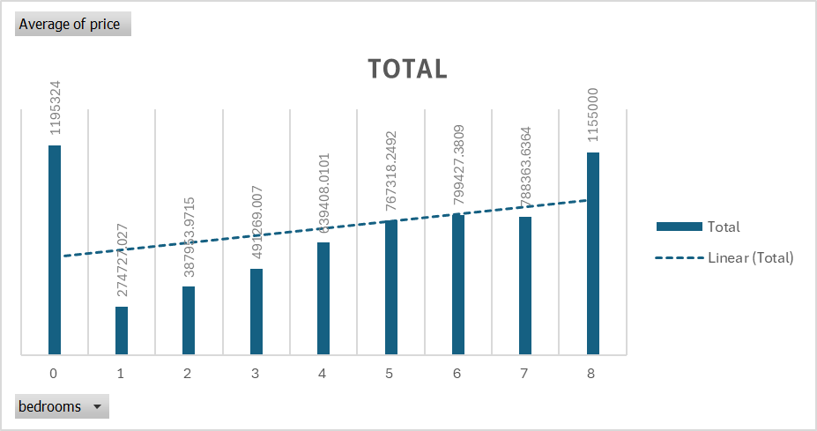
Fig.4.
The general trend shows that as the number of bedrooms increases, the property price also increases. However, the rate of increase is not linear, and there are diminishing returns as the number of bedrooms rises.
The graph indicates that the number of bedrooms is positively correlated with property price, particularly for properties with up to 6 bedrooms. However, after 6 bedrooms, the price increase slows down, and 7-bedroom properties have a slightly lower price than 6-bedroom properties, possibly indicating diminishing returns. The increase in price at 8 bedrooms suggests that very large properties (luxury homes or estates) represent a unique and higher-priced segment of the market. The high price for 0 bedrooms indicates an anomaly, potentially representing non-residential or mixed-use properties.

3.2. Price vs Bathrooms:

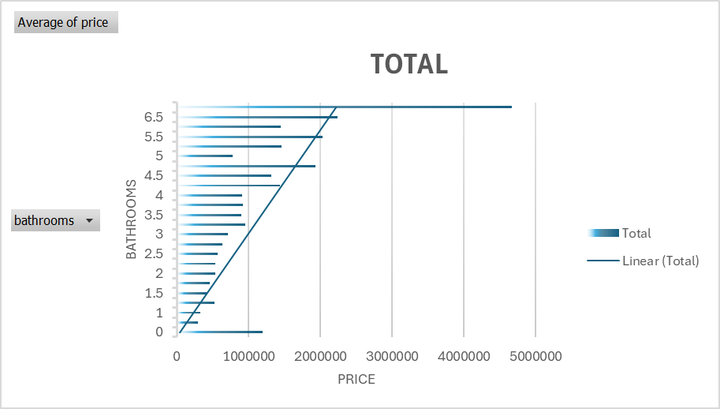
Fig.5.
As the number of bathrooms increases, the associated property value (price), tends to increase as well. This suggests that properties with more bathrooms generally have higher values. However, the increase isn't strictly linear and seems to have a more significant rise as you move past 4 bathrooms.
The graph shows that the number of bathrooms plays a significant role in determining property values, but the impact becomes much more pronounced for properties with more than 4 bathrooms. For homes with up to 3 bathrooms, the property values increase moderately, while homes with 4 or more bathrooms, especially those with 5 or more, exhibit a more dramatic increase in value. The highest-value properties, having 6.75 bathrooms, suggest luxury estates that are significantly more expensive than typical homes.

3.3. House Price vs Square footage of living space (sqft_living).

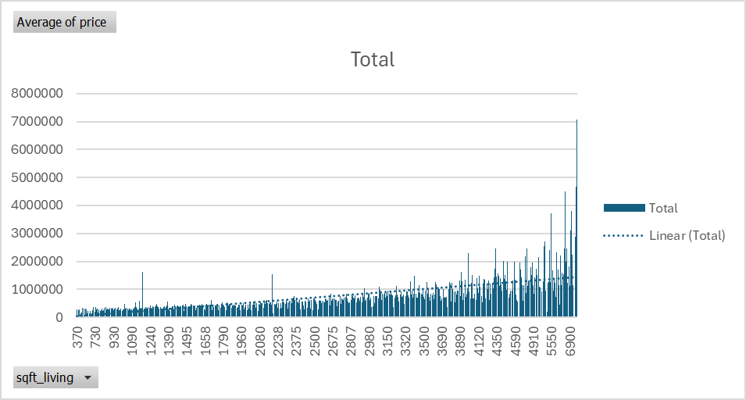
Fig.6.
Positive Correlation: Generally, as the square footage of a property increases, so does the price. Larger homes tend to be more expensive. This positive trend is expected in real estate, where more living space typically adds more value to a property.
From the chart, we can observe the following trends:
Larger properties (more square footage) generally tend to have higher prices, indicating a positive correlation. There are some outliers where smaller properties have unexpectedly high prices, possibly reflecting unique factors like location or property features that are not captured by square footage alone.
This visualization helps in understanding how square footage can impact property prices, though additional factors may also play a significant role.

  - House price / Year the house was built.

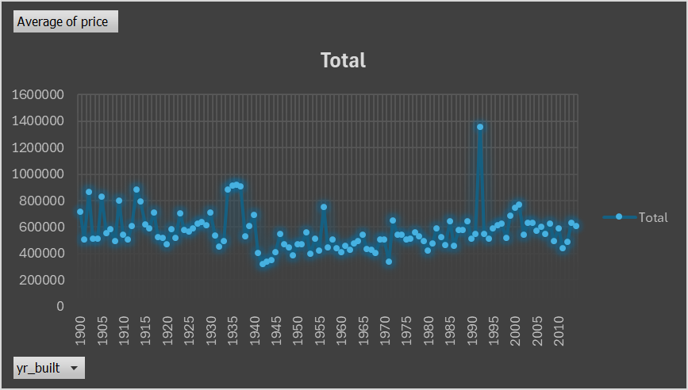
Fig.7.
This chart shows the average price of houses in USA, based on the year they were built. It appears to represent data over a time period from 1900 to 2010. The trendline fluctuates, with some spikes around definite years, such as 1990, indicating possibly outlier values or special cases in housing data. Between 1940 and 1970, the prices seem relatively stable, with smaller fluctuations compared to other periods.

Corelation USA housing dataset:

Fig.8.
- Price vs. Square Footage:
- Strong positive correlation: larger living areas often lead to higher prices since they provide more usable space.
Weak correlation with sqft_lot: Lot size might have less impact unless it is significantly large or in prime locations.
- Price vs. Number of Bedrooms/Bathrooms:
- Moderate correlation: More bedrooms or bathrooms generally increase the house price, but only to a point. Very large homes with excessive bedrooms might not always fetch proportionally higher prices.
- Price vs. Floors:
- Likely moderate correlation: Houses with multiple floors might be valued higher, depending on the design and location.
- Bedrooms vs. Bathrooms:
- Strong correlation: More bedrooms often come with more bathrooms.
- Bedrooms/Bathrooms vs. Square Footage:
- Strong correlation: larger living spaces tend to accommodate more rooms.

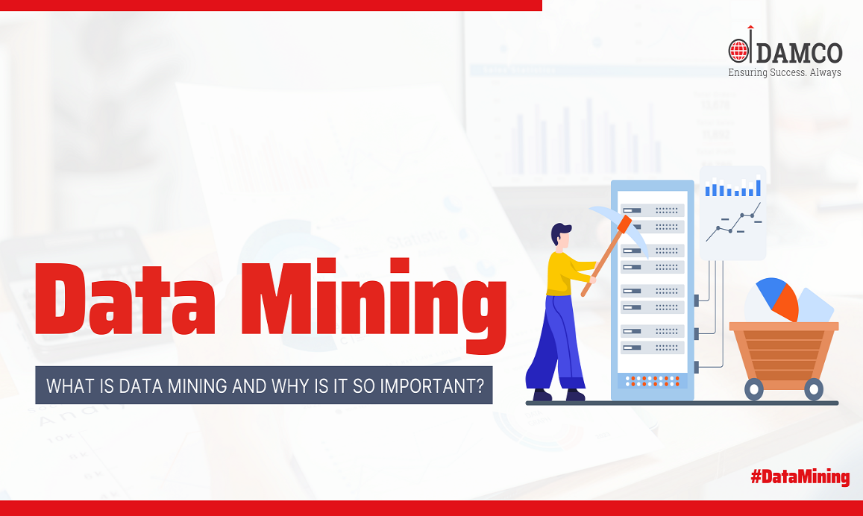
Part 2: Tool Comparison and Data Mining Cycle Explanation
Fig.9.
Data mining is a powerful technique for analysing large datasets to identify hidden patterns, relationships, and trends that can resolve business problems and inform strategic decisions. By leveraging advanced mathematical, statistical, and analytical tools, data mining allows companies to forecast future trends and optimize decision-making (Twin, 2024). It is commonly associated with marketing for understanding demand, customer behaviour, and the effects of product changes, promotions, or pricing on sales.

2.1. Comparison of Excel and SPSS
In today’s data-driven environment, organizations rely on data analytics to uncover insights and support informed decision-making. While Excel has long been a go-to tool for data handling and basic analytics, it’s not tailored for the more advanced, robust analytics needed by organizations aiming to stay competitive (Stodder, 2015). IBM SPSS Statistics, however, was developed specifically for sophisticated statistical analysis, making it a powerful alternative to Excel.

2.1.1. Advantages of SPSS Over Excel

Advantages | SPSS Strength | Excel Limitation | Example
Specialized Statistical Capabilities | Designed with data science and statistics in mind, SPSS includes an extensive suite of analytical tools, from regression analysis and ANOVA to machine learning techniques like neural networks. It supports complex statistical methods not easily accessible or available in Excel. | Excel, though versatile, only offers basic statistical tests and functions, making it difficult to conduct in-depth analysis. For example, while Excel can perform simple linear regression, it lacks advanced statistical modelling options such as logistic regression or factor analysis. | For a research centre analysing house prices, SPSS can be used to develop predictive models for price forecasts, which Excel cannot handle with the same sophistication.
Data Visualization | SPSS provides diverse and customizable data visualization options tailored for advanced data presentations. It allows users to create high-quality charts, plots, and graphs that communicate complex insights clearly. | Excel offers basic charting capabilities suitable for simple data displays but struggles with complex visualizations and lacks customization options for in-depth analysis. | When presenting findings on housing data, SPSS can create layered and sophisticated visualizations, such as scatterplots with trend lines and clustered bar charts, making it easier to convey statistical insights to stakeholders.
Data Preparation and Transformation | With features like automated data cleaning, missing value handling, and data validation, SPSS streamlines data preparation, a critical phase in data analytics projects. | Excel’s data cleaning tools are limited and often require complex formulas and manual handling, which can be time-consuming and prone to error. | In a dataset with missing values or outliers, SPSS allows analysts to clean and pre-process data more reliably, reducing the risk of analysis errors caused by inconsistent or inaccurate data.
Automation and Reproducibility with Syntax | SPSS syntax enables users to automate repetitive tasks and document analysis steps for future use, making workflows efficient and reproducible. | Excel lacks an equivalent scripting language for automation (other than VBA, which is complex and limited in its analytical applications). | For repeated analyses, such as quarterly housing data updates, SPSS syntax can automate calculations and visualizations, saving time and ensuring consistency. Excel users would need to repeat steps manually or use complex VBA scripts.
Predictive Analytics and Advanced Modelling | SPSS is equipped with machine learning algorithms and predictive analytics features, allowing users to build models for forecasting and decision-making. | Excel does not support machine learning algorithms, limiting its predictive capabilities. | A data scientist can use SPSS to create predictive models, such as predicting housing market trends based on historical data. In Excel, this type of analysis is not feasible without additional software or plugins.

2.1.2. Disadvantages of SPSS Compared to Excel
Disadvantages | SPSS Limitation | Excel Advantage | Mitigation
Cost | SPSS is more expensive, with licensing fees that may be cost-prohibitive for some organizations. | Excel is included in the Microsoft Office suite and is widely available without additional costs. | IBM offers various pricing options for SPSS, including short-term subscriptions, making it accessible for specific projects.
Ease of Use | SPSS has a learning curve, especially for users new to statistical analysis, while Excel is more intuitive for general users. | Excel’s user-friendly interface and extensive support resources make it accessible for users with minimal technical expertise. | SPSS offers a range of training options, tutorials, and support resources that help users become proficient in the tool. Additionally, organizations may consider targeted training for employees.
Flexibility for General Tasks | SPSS is specialized for analytics and lacks the general-purpose flexibility that Excel provides, such as word processing, simple data tracking, and creating basic reports. | Excel is versatile for various tasks beyond data analysis, making it a convenient tool for day-to-day business functions. | Organizations can continue using Excel for basic tasks while leveraging SPSS for complex analytics, maximizing the strengths of both tools.
While Excel is highly versatile and cost-effective, it’s not designed for advanced analytics. SPSS offers a range of specialized features that make it ideal for handling large datasets, performing complex statistical analyses, and creating sophisticated visualizations. By adopting SPSS, organizations can extract deeper, more reliable insights from their data, supporting data-driven decision-making and gaining a competitive advantage (Juden, 2022). Although SPSS comes with higher costs and a steeper learning curve, these challenges are offset by its robust capabilities in advanced analytics, making it a valuable investment for organizations committed to maximizing their data potential.
Ultimately, organizations should choose tools based on their specific needs. For advanced data analytics, SPSS is better suited to handle complex, high-stakes analyses, while Excel remains a reliable option for simpler, routine tasks.

2.2. The Data Mining Cycle
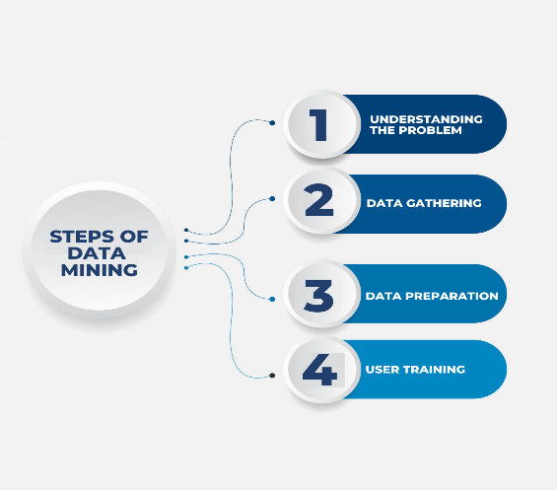
The Data Mining Cycle is a structured approach to extracting meaningful insights from raw data. This cycle involves several key steps, each designed to ensure that data analysis is focused, accurate, and useful for decision-making. The approach varies depending on the questions being asked, the nature of the data, and how it’s organized. Below are the essential steps in the Data Mining Cycle, along with explanations, importance, and examples (Pokhriyal, 2023).
Fig.10.
1. Understanding the Problem
- Meaning: The first step is to define the core problem or objective clearly. Decision-makers need a deep understanding of the business domain, key questions, and relevant internal and external data.
- Importance: Clear problem definition keeps the analysis focused and ensures the results will be relevant and actionable.
- Example: A retail business aims to identify factors contributing to customer churn. By understanding the problem, the team can focus on relevant data, such as purchase history and customer service interactions, to develop a targeted analysis.
2. Data Gathering
- Meaning: The stage involves collecting data from internal systems and external sources, then consolidating it into a data warehouse or database. This data may include customer records, social media insights, or industry trends (Tremblay, 2023).
- Importance: Comprehensive data collection allows a holistic view of the problem, ensuring the analysis incorporates all relevant factors.
- Example: A bank gathering customer transaction records, demographic data, and credit scores from multiple databases to assess credit risk. External economic data may also be included for a more accurate model.

3. Data Preparation (Data Wrangling)
- Meaning: In this stage, data is cleaned, organized, and formatted to ensure accuracy and consistency. It may involve removing duplicates, correcting errors, and handling missing values (Bingham, 2024).
- Importance: Properly prepared data is crucial for accurate results; poor-quality data can lead to flawed conclusions and misguided decisions.
- Example: A healthcare provider cleans patient records by removing duplicates and standardizing formats (e.g., date and time fields) to improve the reliability of analysis on patient outcomes.
4. User Training
- Meaning: As data mining tools can be complex, it’s important to train users, giving them hands-on experience with the tools and techniques they’ll be using. Initial training is followed by ongoing education to help users advance their skills.
- Importance: Training ensures that analysts can use the tools effectively, allowing for efficient data exploration and minimizing errors.
- Example: A telecom company provides initial training to its analytics team on using data mining software to detect customer churn patterns, followed by advanced training in predictive analytics to enhance future analyses.
Each of these steps in the Data Mining Cycle is essential for transforming raw data into insights that can drive informed decision-making. This structured approach ensures that data mining efforts are comprehensive, accurate, and aligned with the organization’s goals.
Data mining’s popularity stems from its ability to unlock commercial opportunities through its descriptive and predictive capabilities. By identifying patterns in large datasets, data mining supports businesses in understanding customer behaviours, which helps in creating effective marketing strategies, reducing costs, and increasing sales. Web data mining companies, for instance, use specialized software to analyse vast amounts of online data, enabling businesses to personalize campaigns and optimize customer targeting (Pokhriyal, 2023).
Additionally, data mining empowers data scientists to quickly assess massive data volumes to build risk models, enhance product safety, and detect fraudulent activities. This predictive power allows organizations to forecast future trends, make proactive decisions, and ultimately, drive profitability. Through these applications, data mining has become an invaluable tool for businesses seeking to leverage data for strategic advantage.

Conclusion

This report has highlighted the importance of data mining in understanding the relationships between key factors such as price and property features, enhancing decision-making for homebuyers and real estate stakeholders. The application of tools like Excel and SPSS has demonstrated how descriptive statistics, correlation analysis, and visualizations can turn raw data into meaningful insights, guiding practical recommendations for decision-makers (Cooksey, 2020).
Moreover, data mining’s ability to integrate external factors like demographics and economic trends provides a broader context for understanding internal performance, making it an invaluable asset for businesses aiming to stay competitive in a data-driven world.
In conclusion, data mining not only addresses immediate business inquiries but also fosters long-term strategic planning and innovation. Its effectiveness grows with the quality and volume of data, as well as with the experience of its users, making it a critical component of modern analytics. By adopting data mining, organizations can unlock the full potential of their data, optimize operations, and adapt to evolving market demands, ensuring sustained growth and success.

References
Bingham, D., 2024. Data Wrangling vs Data Cleaning: Know What They Mean & Their Key Differences. [Online]
Available at: https://www.cdata.com/blog/data-wrangling-vs-data-cleaning
[Accessed 5 june 2024].
Cooksey, R. W., 2020. Illustrating Statistical Procedures: Finding Meaning in Quantitative Data.. Descriptive Statistics for Summarising Data, May.
Frost, J., 2024. statistics by Jim:Mean, Median, and Mode: Measures of Central Tendency. [Online]
Available at: https://statisticsbyjim.com/basics/measures-central-tendency-mean-median-mode/
Juden, R., 2022. Unveiling the Ultimate Statistics Solution - SPSS vs Excel: SPSS vs Excel: Which Tool is The Best One For Statistics. [Online]
Available at: https://vocal.media/education/unveiling-the-ultimate-statistics-solution-spss-vs-excel
LHS (2024) Local Housing Solutions-Data visualization: Transforming local housing data into engaging visual narratives.
Pokhriyal, R., 2023. customerthink:What Is Data Mining and Why Is It So Important?. [Online]
Available at: https://customerthink.com/what-is-data-mining-and-why-is-it-so-important/
[Accessed 25 March 2023].
Simmons, B., 2023. Why SPSS is a much better choice than Excel for data analytics. [Online]
Available at: https://www.sv-europe.com/blog/why-spss-is-a-much-better-choice-than-excel-for-data-analytics/
Stodder, D., 2015. Visual Analytics for Making Smarter Decisions Faster : Applying Self-Service Business Intelligence, s.l.: TDWI RESEARCH.
Tremblay, T., 2023. How to Create an Enterprise Data Strategy. s.l.: kohezion.
Twin, A., 2024. What Is Data Mining? How It Works, Benefits, Techniques, and Examples. Investopedia.

