  Programme: CertHE Computing Skills for Workplace  Module:Software Solutions for Business  Module code: ACCA4026  Student name: Cleverson Da Silva  Student ID number: 2510156  Tuitor: Kwame Assa-Agyei | 

Cover Page
Table of Contents
Task 1. (e-Commerce Website builders or software solutions) 1
1.1 (Shopify) 1
1.2 (E-commerce) 2
BENEFITS OF E-COMMERCE 2
Task 2. (Mind-map of contemporary software applications) 4
2.a (Mind mapping and explain the benefits of using mind mapping in business operations) 4
2.b (Create a mind map of contemporary software applications) 6
Task 3. (Office Application) 7
3.a Four office software solutions for business operations 7
3.a.1 (MS Word) 7
3.a.2 (MS PowerPoint) 8
3.a.3 (MS Excel) 10
3.b (Practical demonstration of Two Office Features) 14
3.b.1 (Mail Merge) 14
3.b.2 (If Statement) 17
Task 4. Communication and Collaboration applications 17
4.a.1 One contemporary Communication and one Online Collaboration applications/tools 17
Gmail 17
Gmail Step by Step on How to Send an Email Including Screenshots 20
4.a.2 22
a. One feature of a freely available Communication (1) and one feature of a Collaboration (1) application 22
Skype 22
Conclusion 28
References 29

Introduction

In today’s business environment, technology software solutions play a critical role in supporting organizational efficiency, innovation, and competitiveness. This assignment aims to demonstrate the practical understanding and application of a range of contemporary digital tools that can enhance business processes and workplace productivity. By exploring different categories of software including e-commerce platforms, mind-mapping systems, office applications, and communication/collaboration tools. This work will highlight how these technologies can support areas such as workflow optimization, data driven decision making, improved communication, and streamlined operational management. Through both descriptive research and simulated practical demonstrations, this assignment will not only discuss how such software contributes to business performance but also provide evidence of hands-on engagement with selected applications.

Task 1. (e-Commerce Website builders or software solutions)

1.1 (Shopify)
Shopify: Creation and How It Helps Business

Shopify was founded in 2006 in Ottawa, Canada, by Tobias Lütke, Daniel Weinand, and Scott Lake. The founders initially created an online snowboard retail store named Snowdevil but found that existing e-commerce solutions were inadequate for their needs. In response, Lütke, who possessed extensive programming expertise, developed a bespoke software system to operate the store effectively. This software eventually served as the foundational architecture for what later became the Shopify platform [1, p. 227]
Shopify is a leading e-commerce platform that empowers businesses to create and operate fully functional online stores. Developers and merchants using Shopify can build bespoke storefronts via themes, leveraging existing web-development technologies like HTML, CSS, and JavaScript, together with Shopify’s own templating language [1, p. 227]. The platform is especially valuable because, as described in The Definitive Guide to Shopify Themes by Gavin Ballard, it supports a robust workflow for developing, deploying and customizing themes, giving businesses flexibility, scalability, and an ability to translate web design into profitable online retail experiences [1, p. 227].
Online behavioural stores offer significant opportunities for experimental research, allowing realistic manipulations and observation of participant behaviour while maintaining both construct and external validity (Dolifka, 2023) [2].These stores can support a variety of research designs, from simple survey additions to full-scale field experiments. Recent developments in third-party Shopify applications enable researchers to create functional online stores within a single day without coding expertise, providing flexibility in designing experiments. Best practices include creating a generic storefront stocked with products adaptable to multiple research questions. Preliminary logistical considerations, such as store naming, management, and fees, are important even for stores not intended for actual sales [2]
Low-code tools like Shopify have changed how e-commerce startups are launched and grown. With these tools, people without technical skills can set up full-featured online stores, including payment processing, marketing, shipping, and customer engagement, without writing any code. Startups using Shopify often begin with fewer employees and less funding than traditional e-commerce businesses, but they can achieve similar levels of success, generating high value per employee and strong returns for investors [3, Vol. 16]
E-commerce is well-suited for this approach because founders can identify profitable opportunities without needing to be technical, and the sector provides a lot of data on how businesses operate online. Overall, low-code tools make it easier to start and scale a business efficiently, allowing non-technical founders to compete successfully in the e-commerce space [3, Vol. 16].

1.2 (E-commerce)


What is e-commerce? Electronic commerce or e-commerce refers to a wide range of online business activities for products and services. It also pertains to "any form of business transaction in which the parties interact electronically rather than by physical exchanges or direct physical contact[4]. E-commerce is usually associated with buying and selling over the Internet or conducting any transaction involving the transfer of ownership or rights to use goods or services through a computer-mediated network[4].
Though popular, this definition is not comprehensive enough to capture recent developments in this new and revolutionary business phenomenon. A more complete definition is E-commerce is the use of electronic communications and digital information processing technology in business transactions to create, transform, and redefine relationships for value creation between or among organizations, and between organizations and individuals[4]

BENEFITS OF E-COMMERCE
Transaction costs. Business-to-business (B2B) e-commerce significantly lowers expenses in three main areas:
Reduced search costs. Buyers no longer must rely on numerous intermediaries to gather details about suppliers, products, or prices, as they would in a traditional supply chain. The Internet offers a faster, more efficient, and more cost-effective way to access information[4].

Lower transaction-processing costs. Activities such as handling invoices, purchase orders, and payments become faster and less costly because B2B systems automate these tasks. This automation enables quicker execution compared to traditional channels like phone or fax. Online auctions in B2B marketplaces also improve the efficiency of trading and transaction handling [4].
Improved inventory and logistics management. Processing transactions online enhances the monitoring and control of inventory and the movement of goods[4].
Disintermediation. B2B e-marketplaces allow suppliers and buyers to communicate and conduct transactions directly, reducing the need for traditional intermediaries and distributors. However, new types of intermediaries are emerging—e-markets themselves can act as middlemen because they sit between suppliers and customers in the supply chain[4].
Greater price transparency. One of the clear advantages of e-markets is the increased visibility of prices. When many buyers and sellers participate in one online marketplace, pricing and transaction information becomes openly available. The Internet makes it easy to publish details about individual purchases or transactions so all participants can access them.
Higher transparency tends to narrow price variations in the market, giving buyers more time and information to compare options and make smarter purchasing decisions [4].
SUPPLY CHAIN MANAGEMENT
Supply Chain Management (SCM) refers to the oversight of materials, information, and financial resources as they move through the stages from supplier to manufacturer, then to wholesaler, retailer, and finally the consumer. It involves coordinating and integrating these flows both within a company and across multiple organizations. The primary aim of an effective SCM system is to deliver goods or services promptly to the next link in the chain, ultimately minimizing inventory levels at each stage [4].
SCM consists of three major flows:
Product flow: the physical movement of goods from suppliers to customers, including returns and service-related shipments.
Information flow: the communication of orders and updates regarding delivery status.
Financial flow: the handling of credit arrangements, payment terms, consignment details, and ownership transfers.
Many SCM solutions rely on open data models that permit information-sharing across an “extended enterprise,” which includes key suppliers, manufacturers, and final customers. The shared data may be stored in various databases or data warehouses distributed across multiple locations and companies. Exchanging this information both upstream (with suppliers) and downstream (with customers) helps SCM tools accelerate product time-to-market, reduce expenses, and enable all members of the supply chain to manage their resources more effectively and prepare for future demands [4].

Task 2. (Mind-map of contemporary software applications)
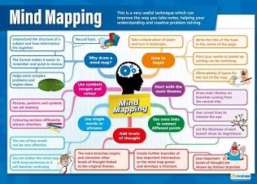

2.a (Mind mapping and explain the benefits of using mind mapping in business operations)
Mind mapping refers to a visual method of laying out ideas and showing how they connect to one another, reflecting the mental structures people use to store and associate knowledge. In these diagrams, meaning is conveyed mainly through conceptual links, which is why mind maps are often described as semantic networks. Some researchers argue that this form of mapping resembles the organization of information in long-term memory. Humans process visual symbols very efficiently as seen in our quick recognition of arrows, road signs, logos, maps, and icons which demonstrates how strongly visual recall is embedded in our cognition. These diagrammatic representations also support a fuller, more interconnected understanding than written text alone, because they allow viewers to see the overall picture along with its component parts simultaneously, rather than in a step-by-step linear sequence [5].
Over time, many computer-based mind-mapping tools have been created. Strong mapping software allows students to work with ideas at an appropriate level of depth and detail. Within science education, mind mapping has been widely promoted and incorporated for multiple purposes. It helps teachers and students build systematic knowledge structures within a subject or specific topic and serves as a technique for evaluating students’ existing understanding. It has also supported the design of science curricula and the review of teaching practices aimed at improving conceptual learning. Unlike traditional written notes, mind maps organize information in a way that aligns with the brain’s natural processing patterns. The activity engages both creativity and logic at once. Mind mapping is useful for tasks such as taking notes, generating ideas, problem solving, studying and memory, planning, conducting research, blending information from diverse sources, presenting ideas, and clarifying complex issues [5].
Mind maps
Tend to be more flexible and personal than concept maps.
Are used to slice and dice the map’s central topic or concept in multiple ways.
May contain images and colour, to make them more visually stimulating
Methods of Mind-Mapping
Mind mapping is a visual strategy for organizing ideas by showing how concepts connect to one another in a structure resembling how the brain stores and processes knowledge. These visual networks are often compared to long-term memory because they express meaning through linked ideas rather than linear text. Humans process visual symbols quickly, as demonstrated by our ability to easily recognize icons, signs, and logos. Because of this, visual mapping supports a broader understanding of information by presenting the whole picture and its components at the same time, rather than in a step-by-step format [5].
With the rise of technology, many digital mind-mapping tools have emerged. The most effective ones support an appropriate level of detail and complexity so that students can explore ideas fully. In educational settings, especially in science, mind mapping has been widely used to help learners build structured knowledge in a topic and to assess their existing understanding. It has also supported curriculum planning and evaluation of teaching techniques aimed at improving conceptual learning. Unlike conventional notetaking, mind mapping reflects how the brain naturally forms associations. It engages creativity and analytical thought simultaneously and is useful for tasks such as notetaking, brainstorming, studying, planning, synthesis of information, presentation, and interpretation of complex topics [5].
Mind maps are generally more adaptable and personal than standard concept maps, allowing the central idea to be expanded in multiple directions and enriched with colour and imagery for greater engagement [5].
Modern mind mapping was popularized in the late 1960s as a technique designed to activate both hemispheres of the brain. The approach encouraged people to move away from rigid linear notes and toward a format that mirrors natural cognitive processes. Mind maps enable users to organize, reorganize, and compare ideas dynamically, often leading to new insights. They function as a structured brainstorming and thinking tool intended to make full use of mental capacity [5].
Research shows that mind mapping supports thinking and learning by encouraging connections and enhancing memory. Various educational studies have examined the method across age groups. Many students consider mind mapping enjoyable, stimulating, and motivating, and some prefer working individually so they can express their own interpretation of ideas [5].
Constructivist learning emphasizes active participation and the linking of prior knowledge to new information. Mind mapping aligns with these principles by engaging the learner, activating prior understanding, and using both visual and verbal modes of processing. Because of its cognitive and creative benefits, mind mapping is viewed as an effective tool for organizing knowledge, encouraging deeper thinking, and promoting meaningful learning [5].
Benefits of Mind Mapping
Mind mapping is important, effective and useful for students to structure their understanding of environmental concepts in a way which can help the students to be effective. Note takers and which can generate new ideas and associations that they have not thought of before. Graphics organizers assist learning by providing an opportunity for visual, stimuli, brainstorming, recording information in none leaner fashion, assessment, checking understanding, problem solving, elaboration, creating analogies, note taking, summarizing, illustrating sequence of events and other creative ways of instruction. [5]

2.b (Create a mind map of contemporary software applications)

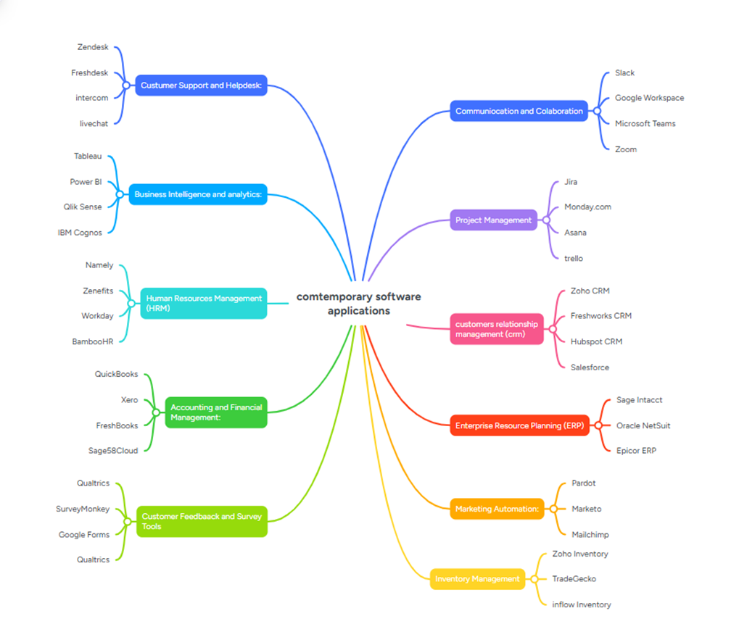

Task 3. (Office Application)

3.a Four office software solutions for business operations

3.a.1 (MS Word)


The rapid growth of technology brings new momentum to the world of education. Although its impact is highly positive, the results ultimately depend on how effectively teachers and learners make use of it while continuously improving their knowledge and digital skills. Technology can be understood as a set of tools and systems designed to support human needs, enabling convenience, efficiency, and continuity of work[6].
Computers, for example, have become essential in almost every organization, including both public and private institutions. Their use not only simplifies data storage but also significantly speeds up operations and services. Technology plays a crucial role in education: from the rise of digital and electronic media as learning resources, to the development of new teaching methods that allow learning to happen without requiring physical, face-to-face interaction[6].
By utilizing technology, tasks such as data transfer and information processing become much easier. Organizations benefit from improved ability to capture, interpret, and manage information in a more practical way. One tool that supports this is Microsoft Word, a widely used word-processing application. It allows users to write, edit, and format documents in numerous styles and structures. In addition, it includes various intelligent features designed to increase speed and efficiency when working with documents. It also incorporates security options to protect the information contained within a file[6].
Understanding these features is useful for those who may not yet be aware of how to automate searches, manage references, or apply document security when preparing written work. This knowledge makes the document-creation process more efficient, accurate, and secure [6].
Information and communication technologies (ICT) include digital tools such as computers, laptops, networks, and online platforms that enable communication, learning, and the exchange of information. ICT has transformed many aspects of life, especially education, by shaping how students learn and how teachers deliver content. Both educators and students now require continual digital skill development to use technology effectively for problem-solving, collaboration, and creative communication[7]
In modern education, ICT supports hybrid or blended learning environments, where students can access materials, communicate with instructors, and learn both synchronously and asynchronously. This flexibility improves student engagement and supports language development, especially in English learning, as students practice communication, vocabulary, grammar, and writing[7].
Microsoft Office 365 is one example of a digital ecosystem that supports education. Tools such as Microsoft Word can help students and teachers create and edit text, check spelling and grammar, and develop writing skills more efficiently. These technologies can motivate learners and foster curiosity by making language learning more interactive and accessible[7].
However, the use of ICT also presents challenges. Many teachers lack sufficient digital training or ICT-integrated teaching strategies, particularly in places where access to professional development is limited. Some educators are unfamiliar with available tools or do not know how to integrate them effectively into classroom practice. Training and continuous development are necessary to help teachers succeed in blended and digital learning environments[7].
Overall, ICT has a strong impact on students’ ability to develop 21st-century skills, including digital literacy, communication, collaboration, and critical thinking. When effectively used, tools like Microsoft Word can contribute to improved writing ability and language acquisition. This study reviews previous research to analyse both the advantages and disadvantages of using Microsoft Word as an ICT tool in English language learning, with the goal of understanding how it affects students’ writing and learning outcomes[7].

3.a.2 (MS PowerPoint)

Ms PowerPoint benefits And Features
Microsoft PowerPoint is widely used in educational settings due to its ability to deliver visually structured and engaging presentations. The software includes features such as customizable slide templates, bullet structuring, built-in design themes, transitions, animations, and the ability to embed images, audio, video, hyperlinks, and screenshots. These functionalities allow instructors to present information in a clear and visually stimulating manner, helping students grasp key concepts more effectively [8, p. 32].
PowerPoint supports multiple learning styles through its multimodal capabilities. Visual learners benefit from charts, diagrams, and text-image integration, while auditory learners can benefit from embedded narration or instructional audio. This flexibility enables instructors to present material in varied formats, contributing to deeper comprehension and improved knowledge retention [8, p. 32].
The software helps maintain student attention and motivation by breaking lectures into manageable segments using slides rather than continuous verbal explanation. The ability to highlight and emphasize key points—through bolding, color-coding, or animation—ensures that the main ideas are easily identifiable. Additionally, the linear slide-based structure helps guide lecture flow, making the instructional message more coherent and easier for students to follow[8, p. 32].
PowerPoint also functions as a student-centred learning tool. Students can actively use the software to create their own presentations, supporting development of communication, organization, and digital literacy skills. In language and communication-oriented courses, this process encourages student participation, confidence, and autonomy in expressing ideas[8, p. 32].
Furthermore, when used alongside traditional whiteboard instruction, PowerPoint forms part of a balanced and interactive teaching environment. The combination of visual projection, verbal explanation, and optional written board-based annotation enhances student engagement and provides multiple pathways for processing information[8, p. 32].

Ms PowerPoint Limitations

This study explored medical students’ perspectives on the drawbacks of using PowerPoint as a lecture tool. The research involved undergraduate medical students at a medical college in Saudi Arabia, using a questionnaire that collected demographic information as well as opinions related to PowerPoint-based teaching methods. A total of 110 students voluntarily participated, and their responses were analysed using statistical software[9].
The findings revealed that a large majority of students perceived PowerPoint presentations as having several limitations that can hinder learning. More than half of the participants identified the excessive number of slides as the primary source of boredom during lectures. Additionally, over half of the group indicated that dim lighting used to accommodate projector visibility was a major distraction. Other students reported being distracted by animated transitions or moving text within slides, which drew attention away from the instructional content [9].
Regarding optimal presentation structure, most students agreed that a range of twenty to thirty slides per hour is appropriate for maintaining engagement. However, a significant portion of students reported that lectures frequently exceed this number, sometimes presenting more than forty slides within the same timeframe, which they found overwhelming. Furthermore, a majority indicated that limiting each slide to approximately six bullet points contributes to clearer communication and stronger comprehension[9].
An important observation from the data is that students Favor a blended instructional approach over reliance on PowerPoint alone. Most respondents stated that combining PowerPoint with traditional teaching methods such as using a whiteboard or direct verbal explanation—creates a more effective and interactive learning environment.
In summary, the students’ responses suggest that while PowerPoint is a widely used teaching tool, it can become ineffective when overused or poorly structured. Integrating PowerPoint with more interactive and traditional teaching techniques appears to enhance student engagement, improve understanding, and support a more dynamic educational experience[9].

3.a.3 (MS Excel)

Ms Excell benefits And Features
Microsoft Excel is a widely used tool for performing benefit-cost analysis due to its versatility, accessibility, and computational capabilities. Its ability to organize data across multiple worksheets allows users to separate assumptions, calculations, raw data, and results, ensuring clarity and structured analysis. Excel also provides built-in formulas and functions for arithmetic, statistical, and financial calculations, including net benefits, total costs, discounting future values, and benefit-cost ratios. This functionality ensures accurate and efficient computation, which is essential for informed decision-making[10].
The software enables scenario and sensitivity analysis, allowing users to model different assumptions, such as varying discount rates or project timelines, and observe their impact on overall results. Charts, graphs, and tables can be generated to visualize trends, compare costs and benefits, and highlight key outcomes, enhancing understanding and communication of results. This visual capability supports both instructors and stakeholders in interpreting complex data effectively[10].
Excel’s cell-based structure provides transparency, enabling reviewers or collaborators to trace formulas, verify assumptions, and replicate analyses. This feature promotes reliability and accountability, reducing the risk of errors. Additionally, Excel can handle both recurring and non-recurring costs and benefits, allowing comprehensive evaluation of complex projects with multiple variables over time. Users can aggregate data into tables to track cumulative impacts and trends, facilitating strategic planning and decision-making[10].
The accessibility and user-friendly interface of Excel make it a cost-effective tool for organizations, educators, and researchers, requiring no specialized software or advanced programming knowledge. By combining visual, numerical, and scenario-based capabilities, Excel supports efficient, accurate, and transparent benefit-cost analysis, enhancing the quality of decision-making and enabling users to evaluate projects systematically. Its integration of computational power and usability makes it a fundamental tool for evaluating the efficiency and effectiveness of investments and interventions[10].

Ms Excell Limitations

Microsoft Excel is widely used for data analytics in healthcare and other sectors due to its accessibility and ease of use. However, despite its advantages, several limitations exist when applying Excel for complex enterprise resource planning and healthcare data management. Excel is primarily a standalone application and lacks robust integration capabilities with other enterprise systems, which can hinder seamless data exchange between multiple platforms such as clinical, insurance, and patient record management systems. This limitation can result in inconsistencies, duplication of data, or incomplete datasets when information flows across different systems[11].
Another limitation is that Excel is prone to human error. Manual data entry, formula mistakes, and improper handling of large datasets can compromise the accuracy of analyses. Additionally, Excel struggles with scalability; handling very large volumes of data or complex multi-dimensional analytics may slow processing, increase the risk of crashes, and reduce overall efficiency. Excel also provides limited built-in audit and control mechanisms, making it challenging to enforce data validation, maintain compliance with regulatory standards, or ensure confidentiality in sensitive healthcare information [10].
Furthermore, Excel lacks advanced automation features and workflow management capabilities present in specialized enterprise software. While it is useful for analysing transactions and monetary impacts, it cannot fully enforce business rules or track operational procedures in real time, which are critical in environments such as healthcare service and insurance management. Training and user expertise also significantly affect the effectiveness of Excel, and resistance or unfamiliarity with the tool can lead to underutilization or errors in analysis[11].
In summary, while Microsoft Excel is a flexible and accessible platform for quantitative analysis, it has limitations related to system integration, scalability, error-proneness, regulatory compliance, and real-time process management. These constraints make it less suitable as a comprehensive solution for enterprise-level healthcare data management and highlight the need to complement Excel with more specialized systems or integrated tools for reliable and efficient operations[11].

3.a.4 (MS Access)

Ms Access benefits And Features
Microsoft Access is a versatile database management system that offers a wide range of features suitable for both educational and business applications. One of its primary features is the Query by Example tool, which allows users to construct queries using a graphical interface without the need for advanced SQL knowledge. This makes Access accessible to students and professionals who are not familiar with complex coding. Access also supports crosstab queries, enabling detailed transactional data to be aggregated into meaningful summaries for analysis. In addition, the software offers pivot tables and pivot charts, which allow interactive visualization and summarization of data, enhancing decision-making processes[12].
Another significant feature is primary key management, which ensures that each record in a database has a unique identifier, while also allowing for adjustments to support realistic modelling scenarios. Microsoft Access integrates seamlessly with Excel, allowing the import of large datasets for processing and analysis. It supports structured data dimension handling, including fact tables and dimension tables, which are essential for constructing data warehouses and performing advanced business intelligence exercises. Access also facilitates automated data processing through macros and scripts, supporting the extraction, transformation, and loading of data efficiently[12].
The benefits of Microsoft Access extend to both learning and practical applications. The user-friendly interface reduces the technical barriers for database creation and querying, enabling users to focus on data analysis and interpretation. The software allows the handling of large fact tables, providing opportunities to work with realistic datasets that closely resemble real-world business scenarios. Integration with Excel enhances analytical capabilities and streamlines data modelling and visualization. Access supports both relational and dimensional data models, offering flexibility for different types of data management tasks. Automation features reduce repetitive tasks such as data cleaning and importing, saving time and minimizing errors[12].
For educational purposes, Microsoft Access provides hands-on experience with data warehousing concepts, business intelligence, and database management. Users can create detailed simulations, aggregate data meaningfully, and generate actionable insights, supporting managerial decision-making and strategic planning. Overall, Access is a powerful tool that combines ease of use, analytical capability, and flexibility, making it suitable for both academic instruction and practical business applications[12].

Ms Access Limitations
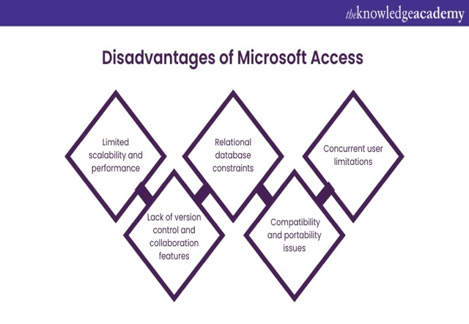
Microsoft Access is a versatile desktop database tool, but it has limitations. It is not designed for full web applications, and the Jet Engine struggles with many simultaneous users. Deployment can be tricky, requiring the correct Access version on each desktop, and updates are not centralized. Security and data integrity are weaker than enterprise systems like SQL Server, and databases are limited to 2 GB. The user interface is basic, and advanced multi-document applications cannot be created[13].
Despite these constraints, Access excels as a rapid application development tool. It bridges the gap between spreadsheets and large-scale databases, allowing solutions to be built quickly with minimal coding. Many real-world databases are well within Access’ capacity, making it ideal for small to medium data needs. Its low cost and ease of use enable organizations to implement practical, effective database solutions and gain a competitive advantage[13].

3.b (Practical demonstration of Two Office Features)

3.b.1 (Mail Merge)

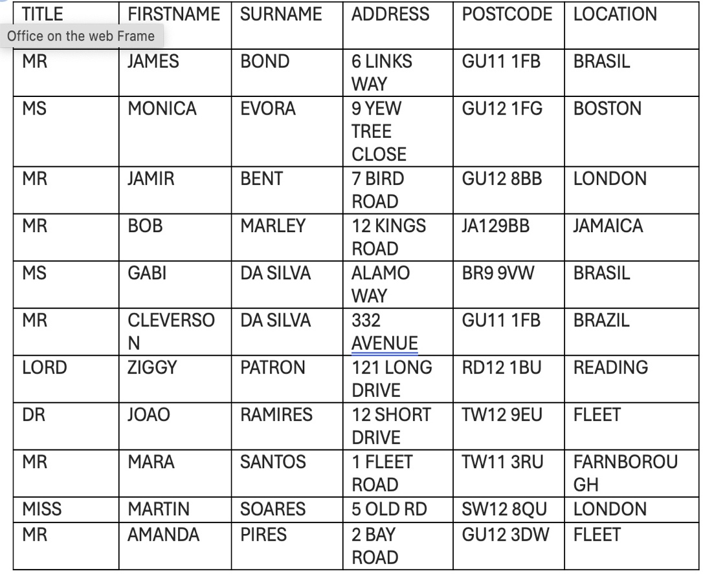

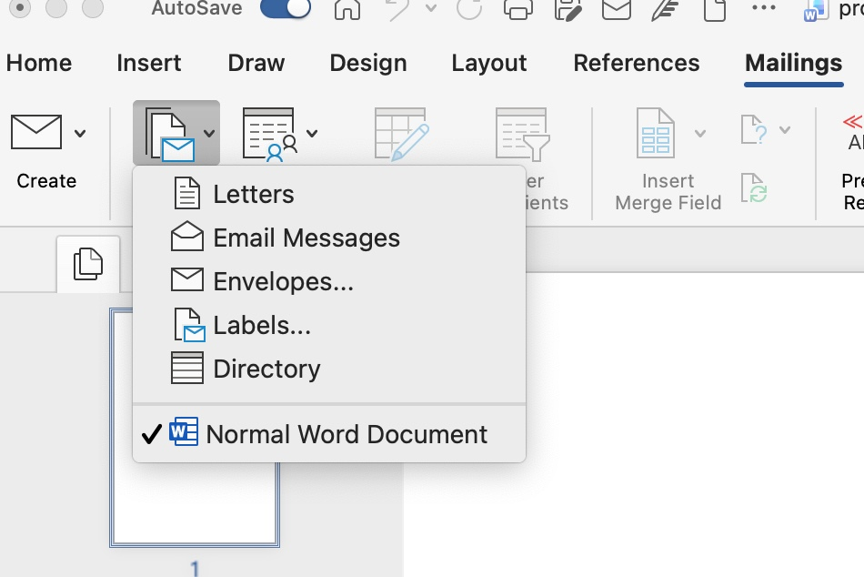

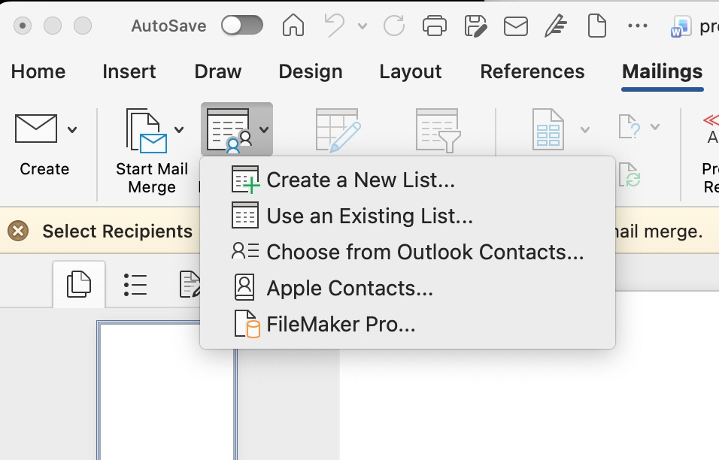

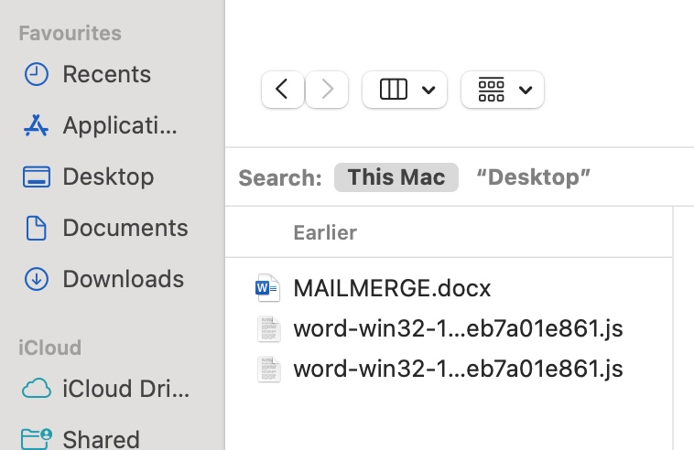
My contacts were saved as
MailMerge

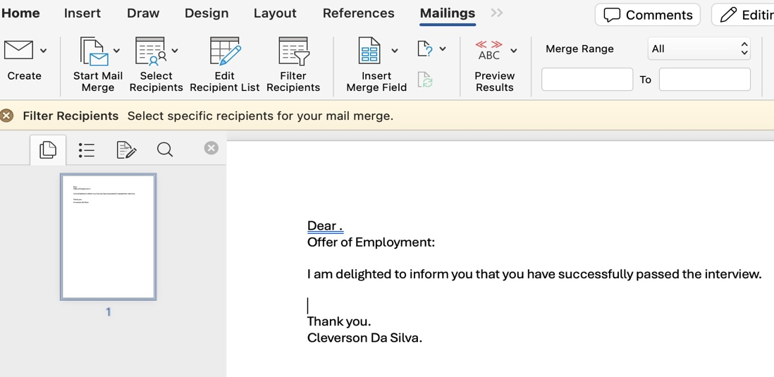

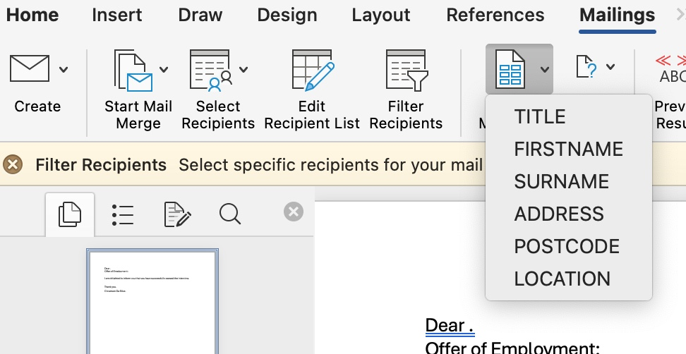

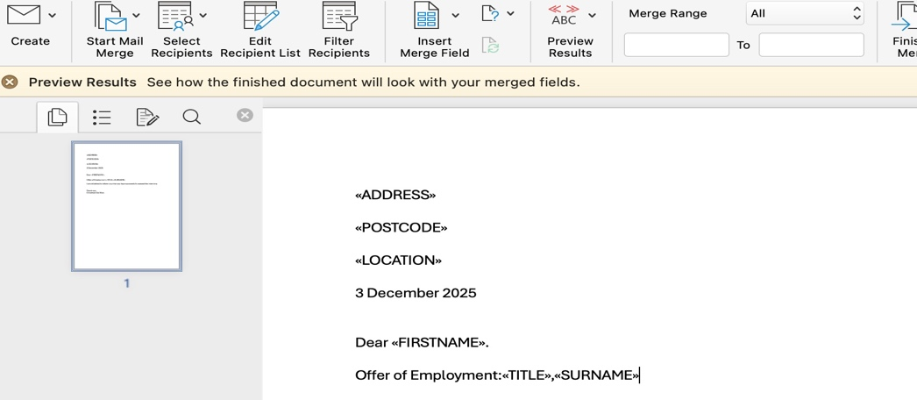

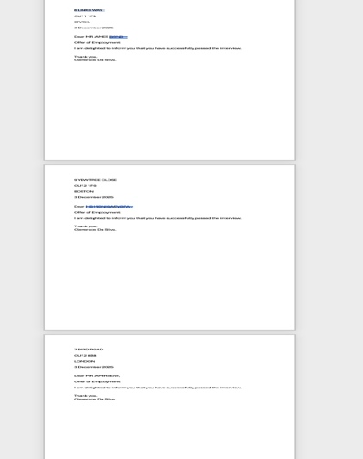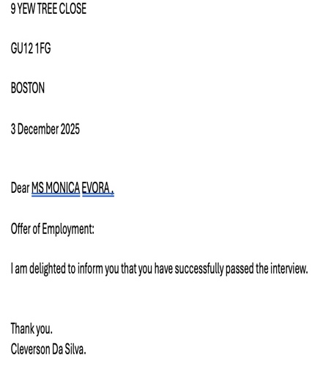

3.b.2 (If Statement)
<Insert screenshots with captions>


This is my Excell Output

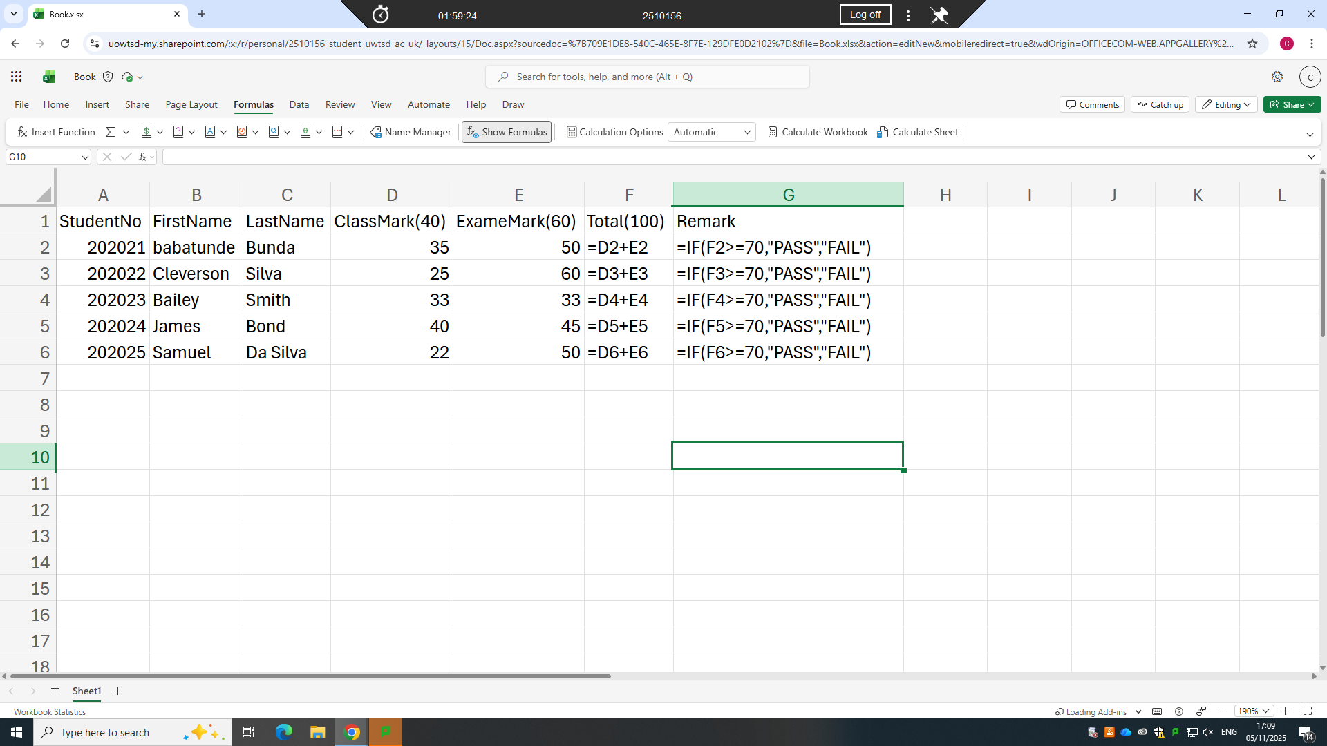
This is my Formula

Task 4. Communication and Collaboration applications

4.a One contemporary Communication and one Online Collaboration applications/tools

4.b One feature of a freely available Communication (1) and one feature of a Collaboration (1) application


4.a.1 (Gmail)

In the modern digital environment, email marketing continues to serve as a central approach for organisations seeking to communicate with consumers. Gmail, as one of the most widely used email services, provides distinctive opportunities for promotional activities. The incorporation of advanced data analysis into marketing practices has reshaped the ways in which businesses interpret consumer behaviour and refine their promotional strategies. This study investigates the effectiveness of promotional activities conducted through Gmail and examines the crucial role of data driven analytical methods in enhancing marketing decisions[14].
Using a quantitative research method, the study evaluates survey responses collected from a varied group of Gmail users. The aim is to determine how characteristics such as age, occupation, and income influence the degree of consumer engagement with promotional messages. The results indicate noticeable differences in email usage across occupational categories. Full time employees predominantly use email for professional reasons, while part time workers and individuals who operate independently show a more balanced pattern of personal and professional use [14].
The findings further reveal that sectors such as fashion, electronics, and sports demonstrate strong utilisation of email marketing, while areas such as fast moving consumer goods and travel are steadily expanding their adoption of this approach. A clear link is observed between income levels and engagement with promotional messages. Higher income participants tend to receive tailored promotions for more costly products, whereas lower income groups are primarily targeted with more affordable alternatives [14].
In addition, the study highlights the significance of personalised promotional messages, which greatly enhance consumer interaction and purchasing behaviour. The research concludes that sophisticated data analysis is vital for improving promotional activities conducted through Gmail, as it enables marketers to design targeted strategies that reflect consumer preferences and adapt effectively to changing market conditions. These findings offer practical guidance for marketers who aim to strengthen the impact of their email marketing through evidence-based methods [14].
In the current digital climate, email marketing has become an essential method for enterprises seeking to build meaningful connections with consumers. Among the numerous email providers available, Gmail is particularly prominent due to its large user base, advanced features, and connection with other services offered by Google. As of the year two thousand and twenty-three, Gmail has accumulated more than one and a half billion active users globally, making it a valuable platform for marketers wishing to access a broad and diverse audience. The capacity to send personalised and relevant content directly to users provides significant opportunities to increase customer engagement and stimulate sales [14].
The success of email marketing activities, especially those carried out through Gmail, is increasingly shaped using contemporary data analysis techniques. This refers to the substantial amounts of information generated by consumer actions across different digital spaces. When examined thoroughly, this information offers important insights into consumer behaviour, preferences, and developing trends. Through the use of advanced analytical tools, marketers can make informed decisions that improve the effectiveness of their promotional efforts[14].
The value of analytical data processing in marketing decisions is considerable. It enables businesses to divide their audience into meaningful groups, adjust their messaging with precision, and enhance their campaigns as new information becomes available. For example, predictive analysis can estimate future consumer behaviour and allow marketers to anticipate preferences before they fully emerge. This forward-looking approach not only improves customer satisfaction but also increases the probability of successful conversions [14].
Although the importance of data driven marketing is widely recognised, there is still limited academic work that directly assesses its influence on promotional activities conducted through Gmail. Previous research has examined email marketing and data analysis separately, but few studies have combined these areas to offer a complete understanding of how they function together. This research aims to address this gap by reviewing studies that explore Gmail based promotional activities, with a specific focus on how analytical data practices influence marketing decisions [14].
The objectives of this study are three in number. First, to assess the effectiveness of promotional activities conducted through Gmail that incorporate data centred analysis. Second, to identify important patterns and strategies that contribute to improved campaign outcomes. Third, to provide practical recommendations for marketers seeking to apply data informed techniques in their email marketing work. By drawing together evidence from various studies, this paper aims to contribute to a deeper understanding of how analytical approaches can be used to enhance promotional activities on Gmail and improve broader marketing performance [14].
This paper provides an in-depth examination of the connection between Gmail based promotional activities and modern data analysis practices. As organisations continue to confront the challenges of digital marketing, understanding how to utilise data centred strategies will be essential for achieving lasting success in engaging consumers and supporting higher conversion rates [14].
Gmail offers several advantages for promotional campaigns. Its large and diverse user base allows businesses to reach many different groups of consumers. The platform also supports detailed data analysis, which helps marketers understand user behaviour and tailor their messages more effectively. Personalised content is another benefit, as it increases engagement and encourages consumers to respond to promotional emails. Gmail also allows campaigns to be adjusted in real time, which improves their overall performance. Many industries already make good use of Gmail for marketing, and the platform works well for both premium and budget-oriented promotions. In addition, new technologies such as artificial intelligence and machine learning have the potential to further improve the accuracy and impact of Gmail based campaigns [14].
Despite these advantages, there are also challenges. The amount of data generated through Gmail can be overwhelming, making it difficult for marketers to identify useful insights without advanced tools and skills. Privacy concerns and strict data protection regulations add another layer of difficulty, as companies must ensure they are handling user information responsibly. It can also be challenging to turn raw data into practical actions, since this requires careful analysis and planning. The process of making decisions based on data, which involves several detailed steps, can be demanding for organisations, especially smaller ones. Advanced marketing models that combine technology and data analysis can be helpful, but they often require specialised knowledge. Finally, while data driven marketing has been widely researched, there is still limited work focusing specifically on Gmail promotional campaigns, which means there are fewer established guidelines for marketers to follow [14].

4.a.2 (Gmail Step by Step on How to Send an Email Including Screenshots)

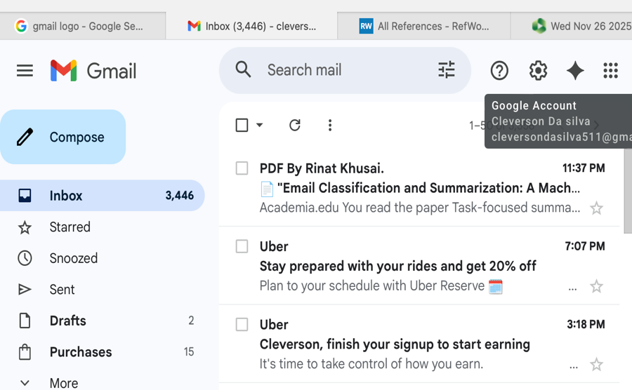
Click on Compose to Edit New Email

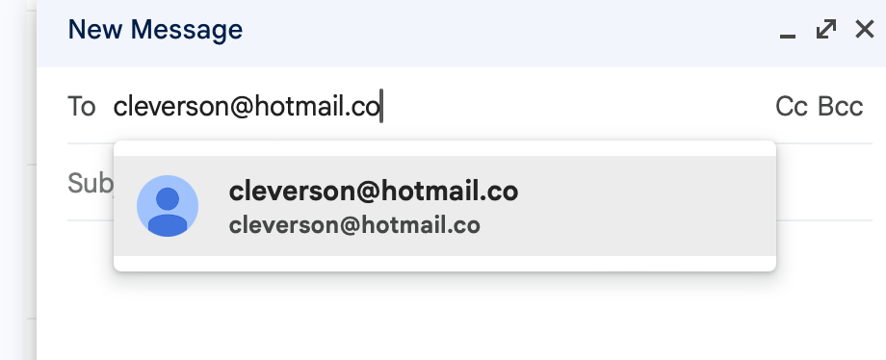
Insert Recipient

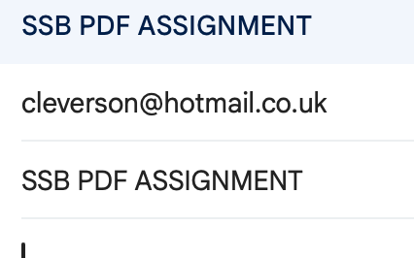
Add subject


Click
on
Link

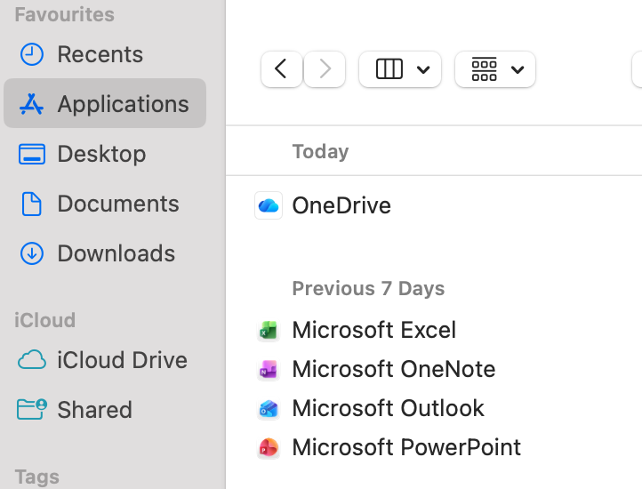
Click on Application to Upload the
Document

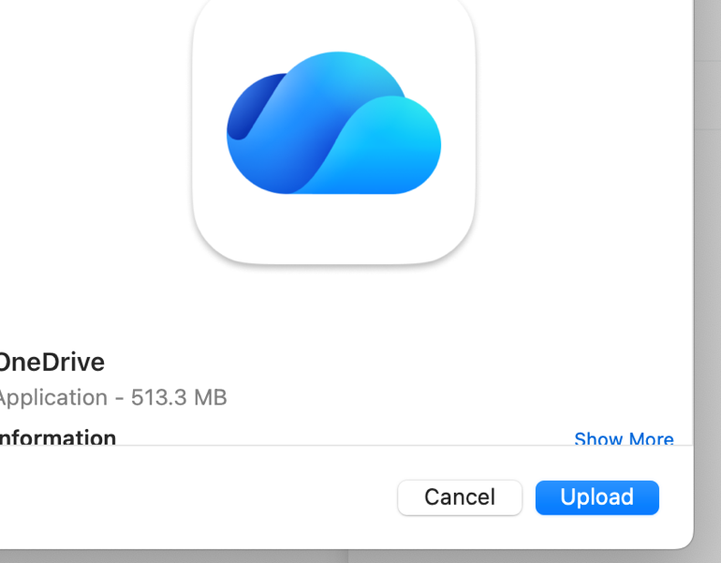
Upload
Document


Finally Send Your Email

4.b1 (Skype)

Skype has become an important resource for qualitative researchers as internet-based communication continues to grow in everyday life. Voice over Internet Protocol technologies allow interviews to take place through real time audio and video, giving researchers a practical way to speak with participants without needing to meet in person. Skype is especially useful because it combines visual and verbal interaction in a single platform, making it possible to capture many of the dynamics that appear in face-to-face conversations [15, p. 103].
One of the strongest advantages of using Skype is the ability to reach a wide and diverse range of participants. Researchers who study topics that cross borders or cultures, such as dance traditions or the experience of navigating different environments, can connect with people in many locations with ease. This removes the need for travel and reduces both time and financial pressures. As a result, research becomes more accessible and flexible, allowing scholars to gather rich and varied data while working within realistic constraints [15, p. 103].
There are, however, important considerations when relying on Skype for interviews. Building rapport can feel slightly different compared to meeting in person. Although video makes it possible to observe facial expressions and some gestures, the full depth of nonverbal communication may not be completely visible on a screen. Even so, many participants appreciate being interviewed in a familiar setting, which can help them feel more relaxed and willing to share their experiences. This environment can create new forms of openness that might not arise in more formal spaces [15, p. 103]
Ethical responsibility is another key element. Privacy and data protection must be ensured, especially when interviews are recorded through additional software such as EVAER which captures both voices and images. Clear explanation of the process and careful storage of recordings help maintain participants trust and safety [15, p. 103].
In conclusion, Skype may not entirely replace traditional in person interviews, but it offers an effective and valuable alternative. It expands the reach of qualitative research, supports cost efficient data collection, and offers a practical solution for connecting with people across distances. When used thoughtfully, it becomes a powerful tool that enhances the possibilities of contemporary research [15, p. 103].
Advantages
- Greater access to diverse and international participants, since Skype removes geographical barriers and allows researchers to speak with individuals who might otherwise be unreachable.
- Supports a more democratic research process by lowering barriers linked to travel, cost, and location, which encourages broader participation across different cultures.
- Saves time and reduces financial costs, as neither researchers nor participants need to arrange transport or rent a venue.
- Flexibility in interview location, allowing participants to speak from familiar and comfortable surroundings, which can sometimes encourage openness.
- Increasing adoption of technology, with many older adults now comfortable using internet communication tools, reducing concerns that age might prevent participation.
- Possibility of building rapport effectively, with some studies showing that online rapport can develop quickly, especially when email exchanges occur before the interview.
Disadvantages
- Unequal access to the internet and technological devices, which limits participation for some groups who do not have stable connectivity.
- Differences in technological ability and willingness, as some people may be reluctant or unsure about using Skype.
- Potential difficulty in building rapport during interviews that involve highly sensitive or emotional topics, where participants may feel hesitant about video communication.
- Risk of technical problems such as weak connections or audio delays, which can interrupt conversations and affect the flow of the interview.
- Concerns about privacy and the use of video recording, which may make some participants uncomfortable and influence the depth of their responses.

4.b2 (Skype Step by Step)
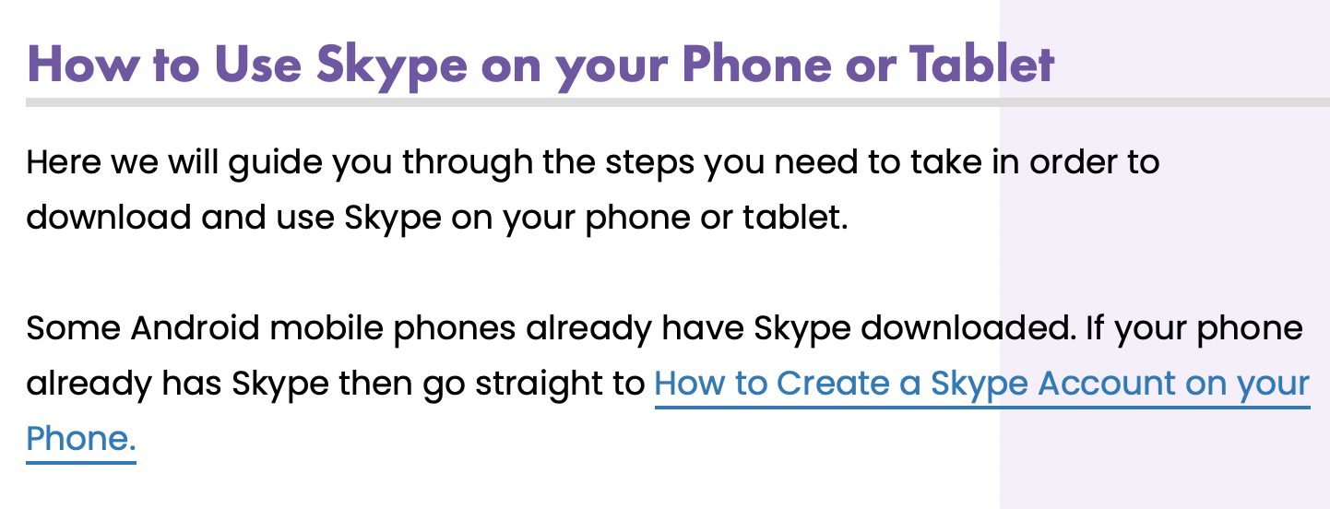\

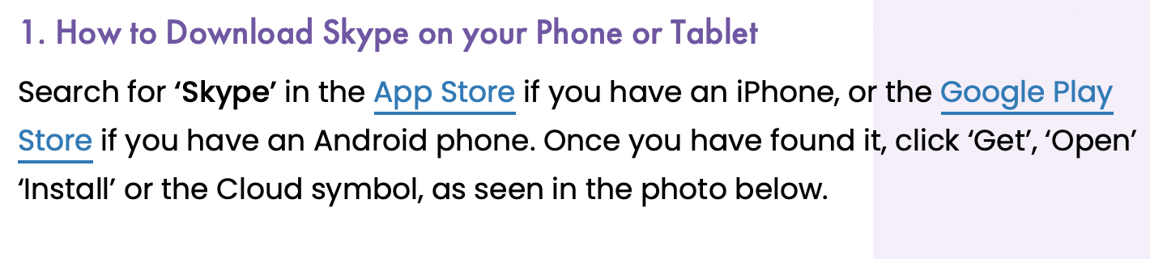

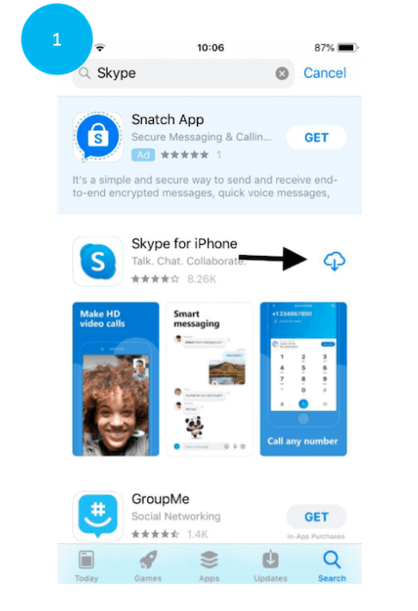

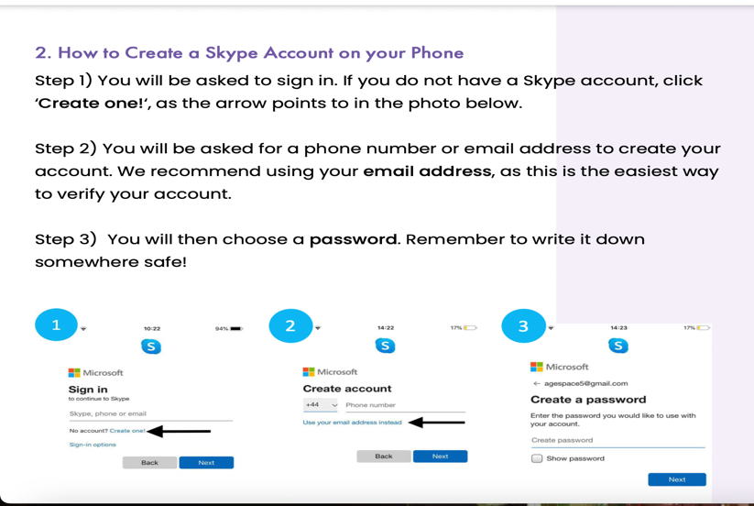

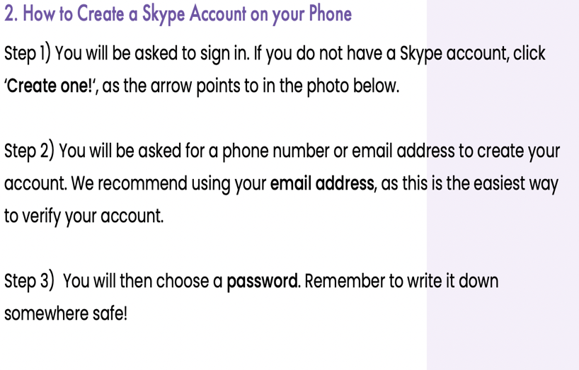
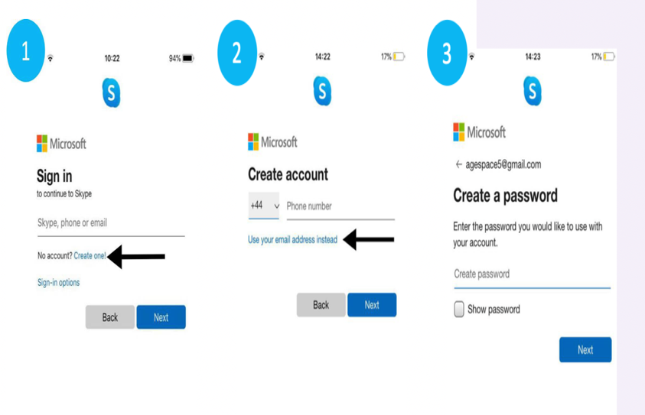

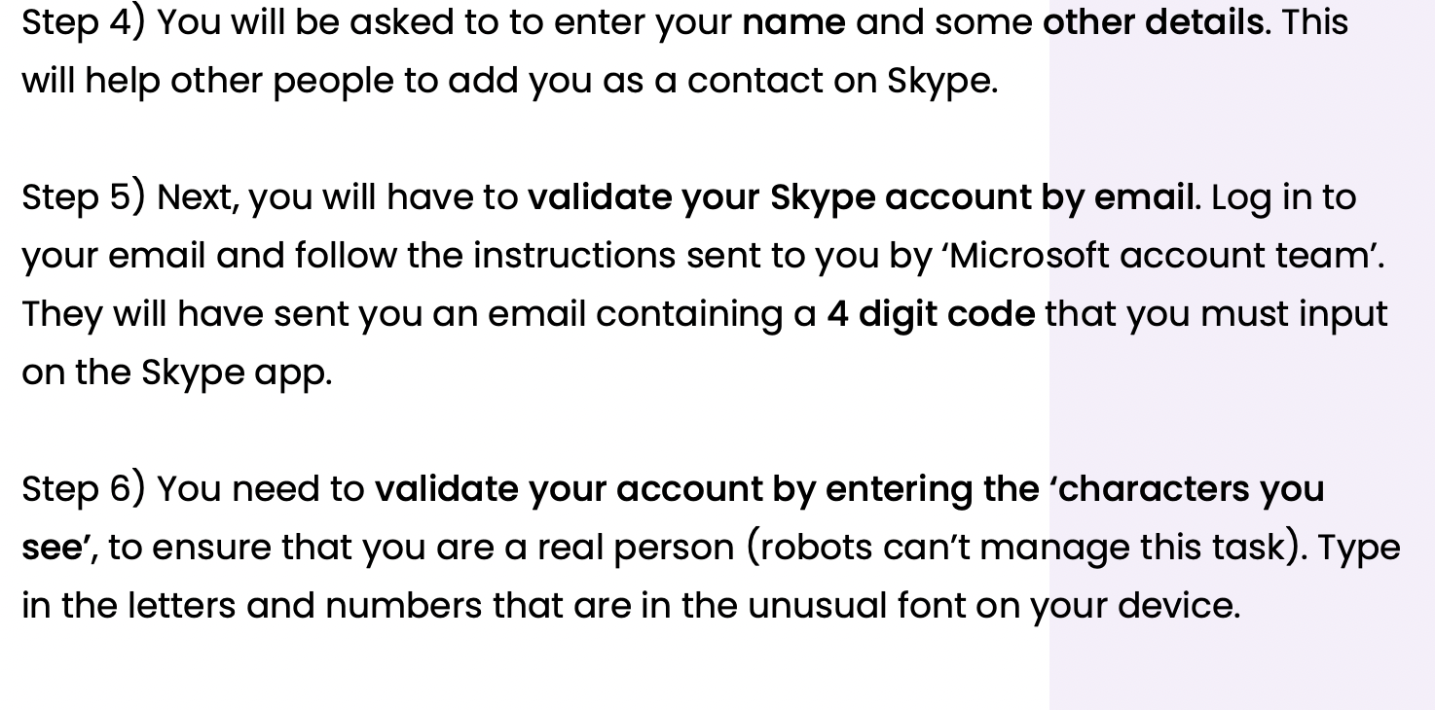
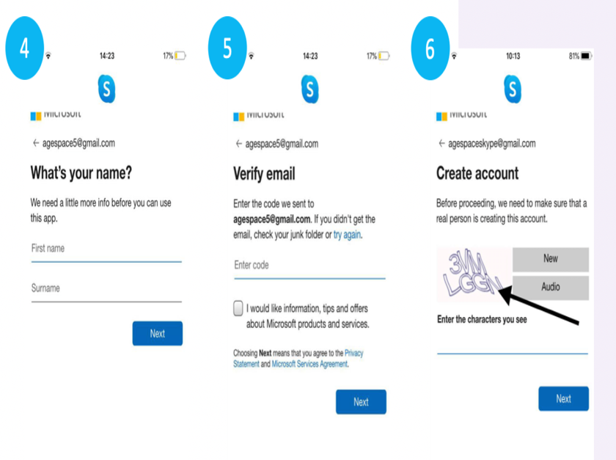



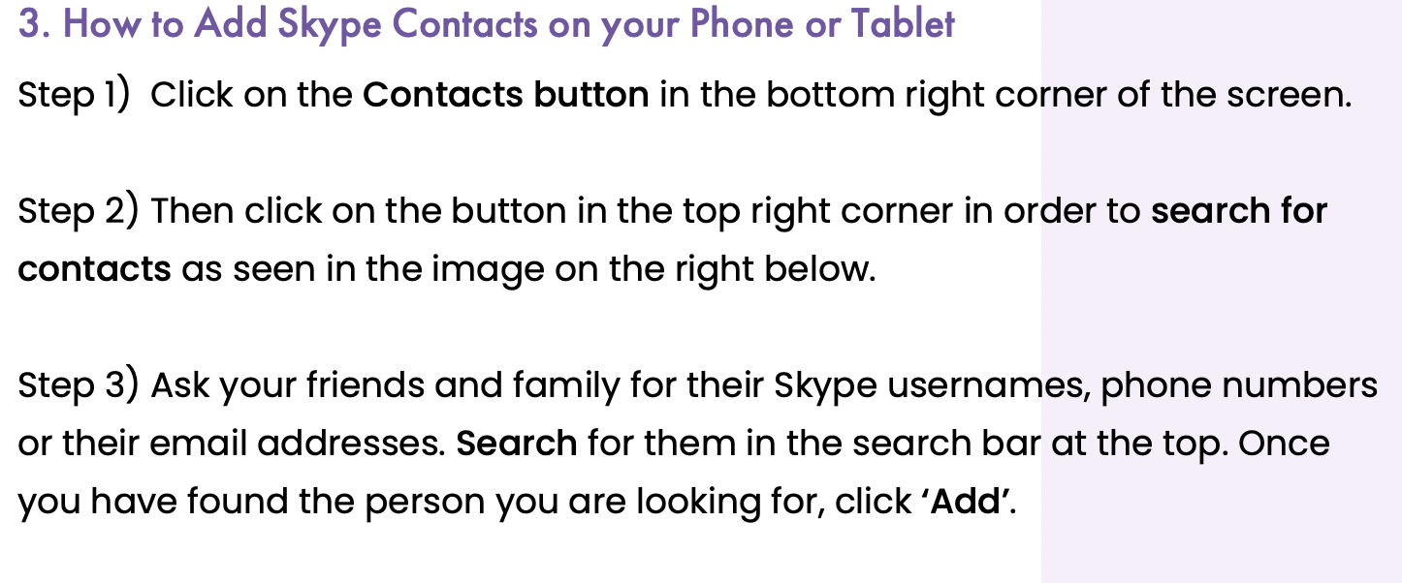

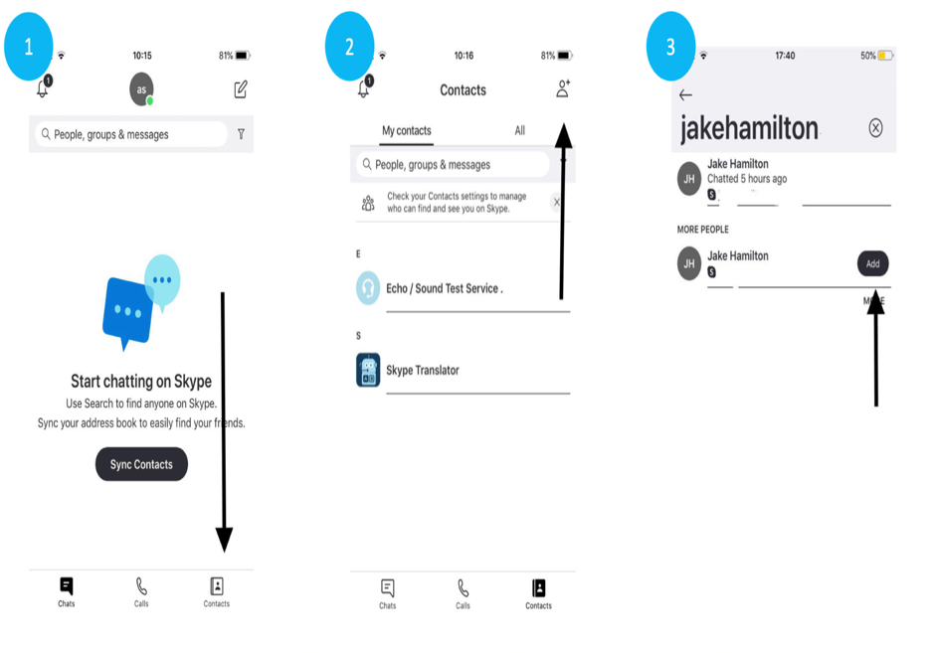

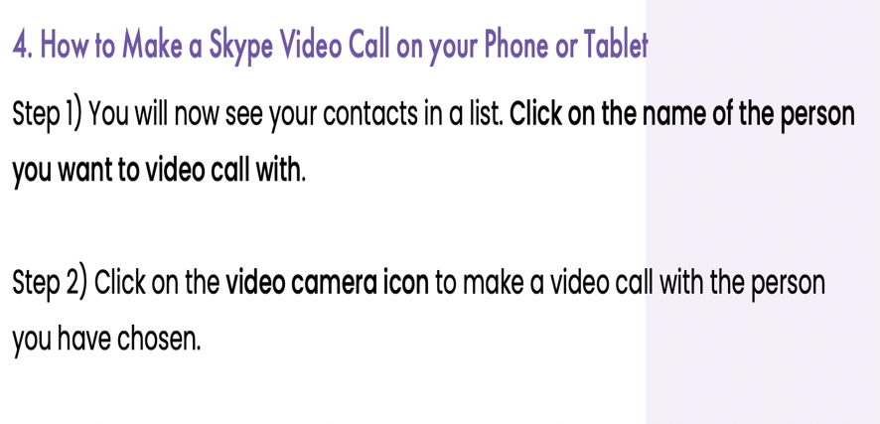

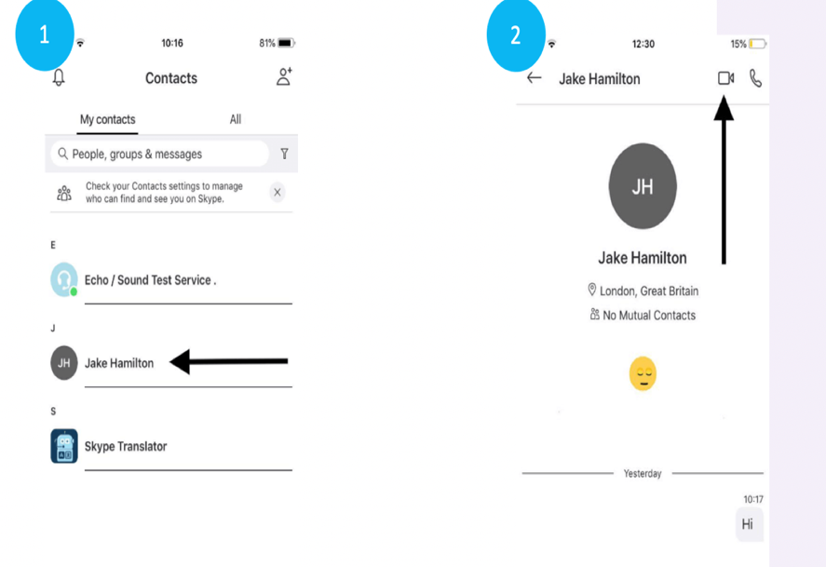

Conclusion
This assessment has explored a wide range of digital tools and software applications that support modern business operations. By examining contemporary e commerce website builders, the work highlighted how accessible platforms now make it possible for organisations to create professional online stores with minimal technical expertise. The discussion of mind mapping demonstrated how visual thinking techniques enhance planning, creativity, and organisational efficiency, supported by a practical mind map of software commonly used in day-to-day operations.
A detailed evaluation of key office applications, including Microsoft Word, PowerPoint, Excel, and Access, showed how essential these tools are for creating, storing, analysing, and presenting information in a business environment. Through hands on testing of Excel features, the assessment also provided practical evidence of how such tools support data driven decision making.
Finally, the analysis of communication and collaboration applications highlighted the central role that digital interaction now plays in professional contexts. By reviewing their core features and testing specific functions, the assessment demonstrated how these tools improve teamwork, streamline communication, and support remote or hybrid work models.
Overall, this assessment reflects the growing importance of digital literacy in the modern workplace. Through research, analysis, and practical demonstrations, it shows how a wide range of software solutions contribute to efficient, flexible, and effective business operations.

References

[1]
Y. S. Ng and A. T. Ranti, “The Effects of MS PowerPoint on Students at a Malaysian University in the English for Professionals (EFP) Classrooms,” vol. 13, no. 4. in AsiaCALL Online Journal, no. 13, vol. 13. Asia Association of Computer Assisted Language Learning, p. 32, Aug. 10, 2022. doi: 10.54855/acoj.221343.
[2]
A. Jalil et al., “Literature Review: Exploration of Features Microsoft Word.”
[3]
V. Lo Iacono, P. Symonds, and D. H. K. Brown, “Skype as a Tool for Qualitative Research Interviews,” vol. 21, no. 2. in Sociological Research Online, no. 21, vol. 21. SAGE Publications, p. 103, May 31, 2016. doi: 10.5153/sro.3952.
[4]
D. Dolifka, “Conducting Experimental Research on Shopify: An Initial Discussion and Guide to Getting Started.” May 16, 2023.
[5]
M. Cunningham, P. Cunningham, M. Kiula, and C. Chege, “Identification of the Limitations of Healthcare Service/Insurance Industry ERPs on Data Flow using QlikView and MS Excel.”
[6]
G. Ballard, The Definitive Guide to Shopify Themes, 1st ed. Apress Berkeley, CA, p. 227. doi: https://doi.org/10.1007/978-1-4842-2641-4.
[7]
“ANALYSIS OF GMAIL DRIVEN PROMOTIONAL CAMPAIGN-ROLE OF BIG DATA ANALYSIS IN MARKETING DECISION MAKING.”
[8]
M. A. King, “A Realistic Data Warehouse Project: An Integration of Microsoft Access ® and Microsoft Excel ® Advanced Features and Skills.”
[9]
A. B. Abusharib, I. H. Nourein, M. A. Huneif, A. M. Abdelrahman, and M. A. Elshaikh, “Limitations and Pitfalls of PowerPoint Presentations: Najran University Medical Students’ Point of View.”
[10]
E. Pricilia, “admin,+350-356.”
[11]
A. Gupta, “E-COMMERCE : ROLE OF E-COMMERCE IN TODAY’S BUSINESS.”
[12]
S. O. Adodo, “Effect of Mind-Mapping as a Self-Regulated Learning Strategy on Students’ Achievement in Basic Science and Technology.” in Mediterranean Journal of Social Sciences. Richtmann Publishing, July 01, 2013. doi: 10.5901/mjss.2013.v4n6p163.
[13]
G. Dushnitsky and B. K. Stroube, “Low-code entrepreneurship: Shopify and the alternative path to growth,” vol. 16. in Journal of Business Venturing Insights, no. 16, vol. 16. Elsevier BV, May 18, 2021. doi: 10.1016/j.jbvi.2021.e00251.
[14]
L. Chung, “Database Evolution: Microsoft ® Access within an Organization’s Database Strategy.”
[15]
“11595133421Excel_Guidebook_V7-2.”

