Visual Branding:

First Logo:
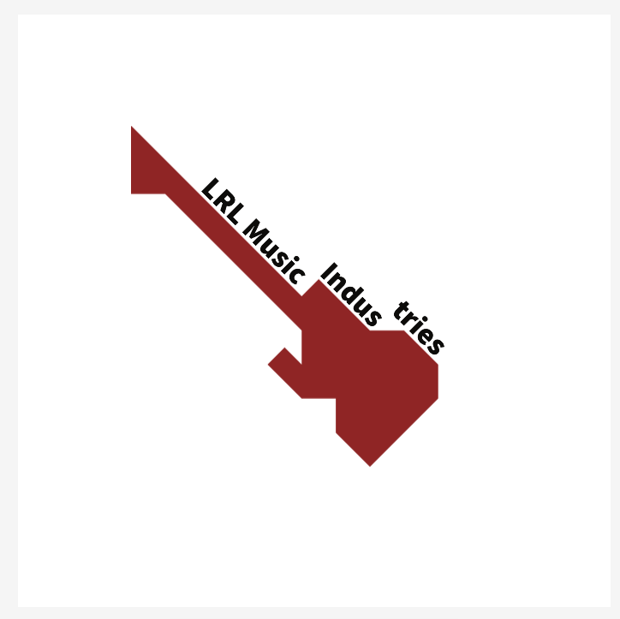
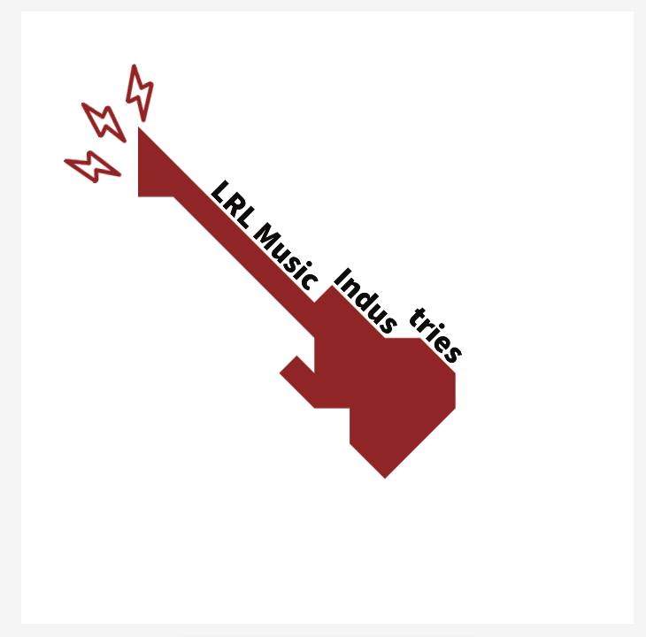
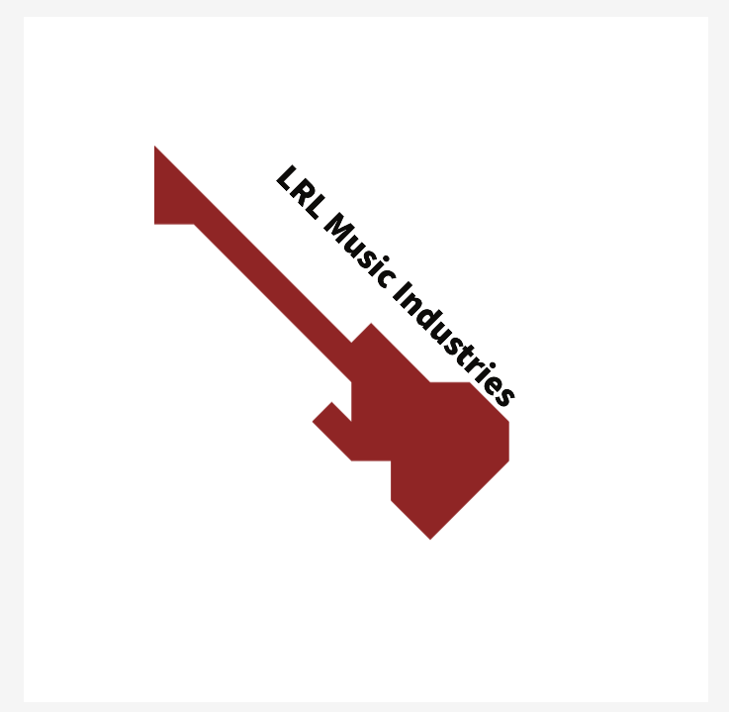
To make my logos I used Adobe Express because of the fact that it has so much potential and many different varieties of templates and shapes meaning my logo won’t look similar to many other artists and/or producers. For my first logo I wanted to use something that I really enjoy playing, so firstly, I ended up looking through some different guitar shapes and eventually found a futuristic looking electric guitar. Secondly, I thought about what my company name would be. After a lot of ceiling staring, I finally came up with the name “LRL Music Industries.”The reason I used the letters LRL is because they are my initials, Liam Rhys Lewis. However, when I put it next to the guitar it looked out of place so by looking at the shape of the guitar I ended up chopping the name up into bits so that it would slot into the gaps. Finally, to make the logo more noticeable I placed a few little lightning bolts at the head of the guitar to make it pop out at people.

Second Logo:
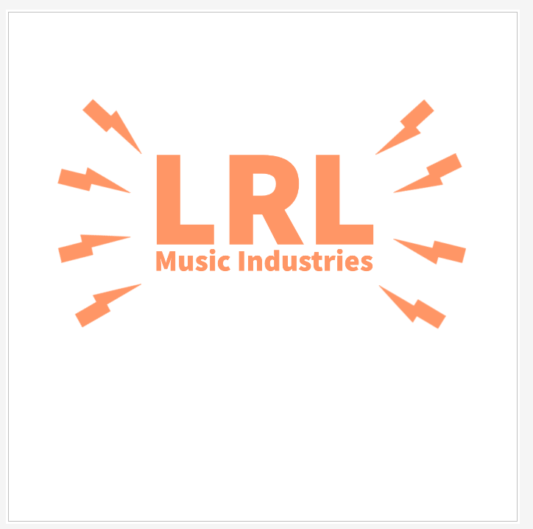
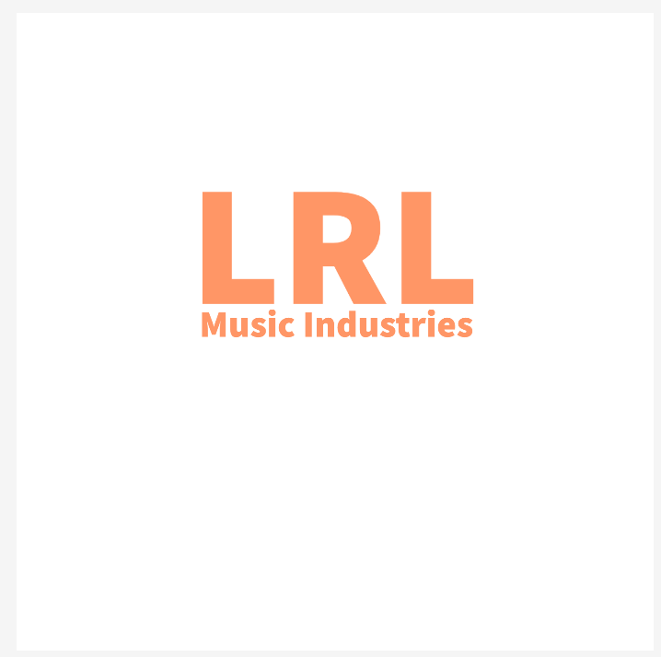
For my second logo I wanted to make something more professional, so I used the same name as I used in my first logo which is “LRL Music INdustries.” This time I made my initials bigger so it stands out more, and then placed Music Industries underneath to represent what I do. I also used lightning bolts for this logo because I think it looks cool, but I did change up the way the lightning bolts look. Finally, I changed the background to plain black because the white background made the orange look horrible.
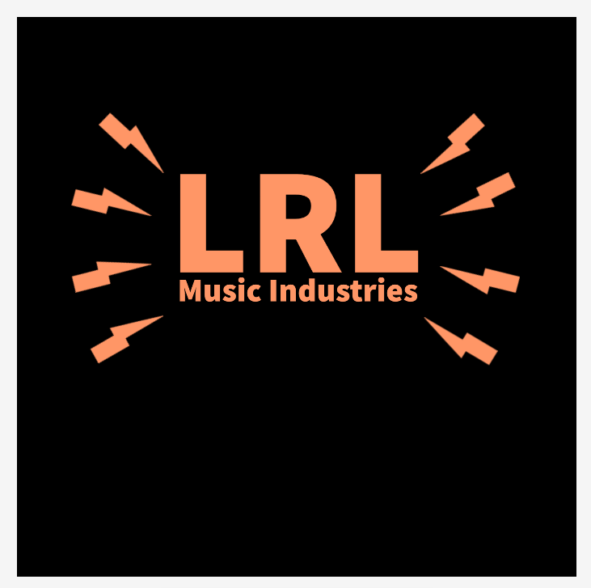

Choosing a Logo:
Going forward I will be using my second logo because of the fact that it looks more professional and when people are interested in my music, they will take me more seriously.

Choosing a video for the logo:
For the video, I used a website called pexels which allows me to pick any royalty free video or photo. When I was choosing a video I searched up music, but there were too many options so I tried to narrow it down by searching guitar, I then came across a video by Deniz Bostanov that also had its original audio so I decided to use it.

Video by Deniz Bostanov from Pexels: https://www.pexels.com/video/a-guitarist-member-of-a-band-playing-the-electric-guitar-3345545/

Pexels website: https://www.pexels.com/

Putting it all together in Premiere Pro:
After collecting the logo I created and the video and audio, I then booted up Premiere Pro to mix them all together. Firstly I dragged in the video and audio and then added a volume effect so that the video wouldn’t just cut off. Instead it fades out, I also added a blur so that viewers can see the logo more clearly when it comes in. Overall, I think the visual branding video came out really well. If I had to do this again I would probably use an AI to see what would come out and then make some adjustments. I would also try and have a few lessons on Premiere pro to get to grips with it and so that I can use it more effectively.

Final version of visual branding - Visual Branding with video.wmv

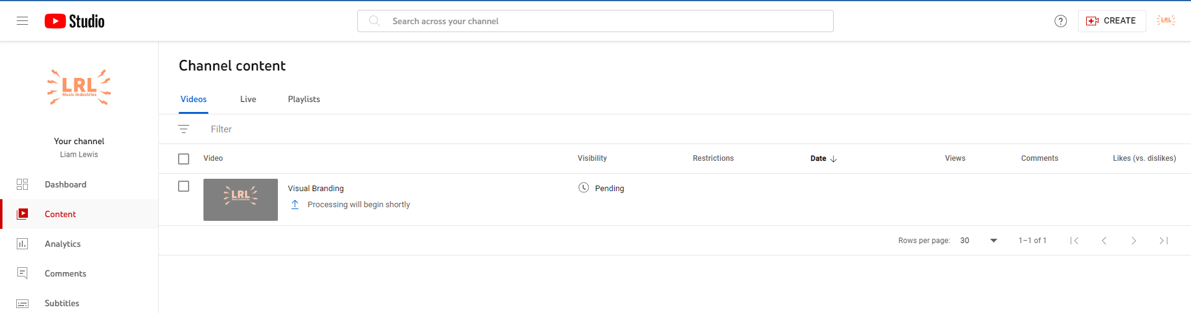
I have made a youtube channel and added this video in. However, it won’t publish because it won’t go through the process.

Collaborative Composition:
In my group there were a total of 6 of us; me, Louie, Tom, Steff, Luke and Paul. The first week we got together and just spoke about what music we liked and what kind of genre we all play, along with what instruments we played. After discussing everything we all decided to try and make a liquid DnB track mixed in with a bit of alternative rock.
When looking for some inspiration Tom suggested looking into Hybrid Minds and trying to feel how we should lay out our drums https://www.youtube.com/watch?v=fnFd3eYhzOk.

After looking into Hybrid Minds we started creating some drums. We looked into different types of sound and found a drum sound with a punchy kick and snare, however, because they are software drums they don’t sound the same as recorded drums.

Next, we decided to add a guitar riff and Luke made the guitar distorted to see what it would sound like alongside the drums. Surprisingly, it sounded alright seeing it was plugged straight into a DI.

I then took the wheel and tried adding a bassline to the guitar and at first I came up with a potential bassline. I then realised that one of the notes wouldn’t mix with the guitar so it took me a while to find the right note, with a little bit of help from Paul we finally found the missing note.

In the second week, there was only me and Tom working on the project and the only addition we made to the composition was adding a DnB section to the track. I then had to leave early because work called me in.

For the next few weeks no one showed up to lectures because they were either working, leaving early or not even showing up to lectures. In the end I spoke to my lecturer asking for advice and he said that if people aren’t showing up then take what I have and finish it off on my own. The next week I took another look at the composition and saw that the others made some additions and after listening to it I honestly thought it wasn’t good so I emailed my tutor asking if I can redo it and his response was to use the elements of the composition and make something new.

The original group project - Group Project - Liquid DnB new.wav

In the end, I went home and made a new composition with one of my friends outside university. We ended up using Ableton because my friend knew Ableton more than Logic. After creating a composition I exported it onto my hard drive and took it home. I then put it into Logic and added Lukes guitar riff and put some effects onto it.

My version of the group project - Group Project - Dave.wav

Virtual Collaboration:
In this project I teamed up with Sam, Joel and Mike and we had to make an original piece of music and after a discussion we decided to make a story based piece of music and we each had to make a part which lasts about 1 minute and 30 seconds. Joel decided to make a romance part, then Mike had to do a war section. Sam had to make a section to represent grief and I had to create a part to end the song so we decided to end on a high note. So I had to do a triumph part to end the piece. After addressing who’s doing what, we spoke about what the main riff would be, so we put Joel on a piano and recorded a few takes of some different riffs we could use, and in the end we decided one that we all liked.

It took me a while to get started, but in the end I had some help from friends outside university and eventually made something that fits into the category of triumph and once Joel shared his riff with us I slotted it into my section. I then emailed my part to everyone and we stitched it all together.

My part of the virtual colab - Triumph.wav

When we sent each other our parts we each stitched them together and we all went onto discord and we decided that Joel was going to be the one to mix and master it. So he shared his screen and we all had a discussion about how the song should be mixed. In the end it took us about 3 hours to get through the entire song and master the whole thing and it came out pretty well.

The final version of the composition - Virtual Collaboration Piece.wav

Biography:
Liam Lewis grew up on the edge of a small town called Llanelli and lived with both of his parents and his brother, his first introduction to music was by humming every song that he and his brother played on Guitar Hero, and eventually started playing the guitar instead of humming the songs. Ever since he started playing Guitar Hero he got more and more intrigued how music was actually made. When he went into secondary school he instantly wanted to take music lessons and asked his music teacher if he could start learning piano lessons because he thought that it was the easiest way to learn how to make songs. Unfortunately, there were no piano teachers at the school so the music teacher offered him to play the double bass. At first, the double bass was very daunting to say the least but Liam gave it a go and started having double bass lessons and quickly developed his sight reading skills, he also started playing in the school orchestra. After a few months of playing the double bass Liam thought to himself, “what if I could play Guitar Hero with a real guitar?” After that he asked if he could have guitar lessons as well as double bass lessons, and the music teacher approved. Liam instantly fell in love with the guitar and played everyday, each day learning something new.
A year went by while Liam was learning both guitar and double bass, when suddenly both instrument teachers asked if he wanted to join the Carmarthenshire Music Service. By joining it he would be playing with the junior orchestra and junior guitar group and performing in front of multiple audiences an academic year. The music service also supplied him with an acoustic double bass to take home and practise at home. Not long after, one of the teachers in the junior orchestra offered him a place in a big band and said if he joined they would give him an electric double bass. Without a doubt, Liam took the offer and joined the Carmarthenshire Big Band. Throughout Liam’s time in the Carmarthenshire Music Service his playing skills developed immensely, and eventually Liam started taking exams to have proof of his skills. Liam quickly climbed the grading ladder with both instruments, and so far he has gotten grade 5 on both guitar and double bass.
While being in the Carmarthenshire Music Service Liam has been to many different places and has had extraordinary experiences such as, going Birmingham and playing in the Birmingham Hall on multiple occasions, he’s also gone to Cardiff to play with many other double bass players from around the UK, while being conducted by a professional violinist who has travelled the world. He has also played in front of the Duchess of Cornwall along with Wynne Evans, better known as the Go Compare guy in Carmarthen with the Big Band. More recently, Liam almost went to New York with the Carmarthenshire orchestra however, because of Covid-19 he was unable to go as there were too many cases in America and the flight was cancelled.
Even though Liam played in an orchestra, guitar group and big band, his music taste was very wide to say the least. He doesn’t really have a favourite genre to listen to because his music taste can go from Disney music all the way to heavy metal, so when he listens to music you can’t really predict what type of music he’s listening to.
Whenever Liam talks about his future he always goes back to talking about how he wants to be a music teacher to inspire young people to make and play music, because it is scientifically proven that music can help an individual’s mental health and can also be used for relieving stress. So by inspiring more young people to develop their musical skills they have the skills to take some control of their own mental health.
Up until now Liam has achieved so much in life so far and is continuing to grow his musical skills and hopefully he may get the chance to go to New York with the Carmarthenshire orchestra and could also start a new chapter in his life alongside his dream of becoming a music teacher. You never know, he could start a band and even become famous.

Pitch Proposal:
For my solo composition I wanted to get out of my comfort zone by creating something I don’t usually listen to, for instance techno or drum and bass. I do have some friends that listen to rap songs and techno music so I have some sort of insight to how a techno beat should sound, but other than that I am going into this blind folded. For the visual accompaniment I am thinking of doing a club and having people dancing and a few shots of a DJ to really have that techno feel to the song.

