Project Proposal
Analysis of Transparency in Deferred Rendering.
Student: David James (1704050)
Project Supervisor: Andrew Baker
Module: Project Management & Research Methods (ACDA5004)
Lecturer: Dr. Mabrouka Abuhmida

Table of Contents
1. Introduction: 2
1.1. What Is Rendering? : 2
1.2. Forward Rendering: 3
1.3. Deferred Rendering: 3
1.4. Critical Review 4
1.5. Aims & Objectives: 4
1.6. Deliverables & Outcomes: 4
2. Research Methodology: 5
2.1. Introduction: 5
2.2. Research Philosophies: 5
2.2.1. Positivism: 5
2.2.2. Phenomenology: 5
2.2.3. Strategy: 5
2.3. Data Collection: 5
2.4. Conclusion: 5
3. Development Methodology: 6
4. Resources & Planning: 7
5. References 8

Figure 1 - Graphics Pipeline 2
Figure 2 - Rasterization Process 2
Figure 3 - Multiple Render Targets. 3
Figure 4 - Deferring Rendering Overview. 3
Figure 5 - FDD Lifecycle 6
Figure 6 - Task List 7
Figure 7 - Gantt Chart 7

Introduction:

The project will involve research and development into the theory and practice of how to efficiently render lighting within a 3D scene using a technique called “deferred rendering”. The primary focus of this project will be to analyses and review the issue this technique introduces with transparent and semi-transparent objects and produce a solution to solve this problem.

The project will primarily take place at the University of Wales Trinity Saint David and will utilize the Games Lab as a place to conduct research and experiment. Hardware and software are readily available through personal means to complete the project, with no dependability on the hardware or software provided by the University.

What Is Rendering? :

Rendering is a large topic within computer graphics, at a high level it’s a procedure that takes some input data, and transforms it into a 2D image for displaying on a screen [1]. The process relies on a strict pipeline that has several steps which describe the sequence of how data is transformed from the CPU to the GPU [2].

Certain steps of the pipeline are programmable through small programs that are executed on the GPU known as shaders. Shaders provide a level of control where the input data can be manipulated [3].

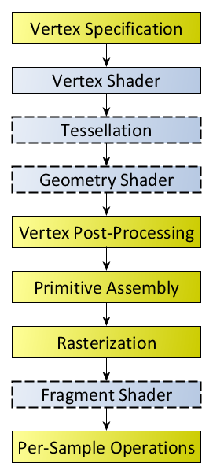
Figure 1 - Graphics Pipeline
Briefly stepping through the significant parts of the pipeline, the first stage is to send 3D data to the GPU, the GPU would then compute the data to produce geometric primitives [4]. Each primitive is then processed at the rasterization stage, this is where any generated primitives are transformed to output fragments which correspond to certain pixels on the screen, fragments hold depth information along with other data such as position, colour [5].

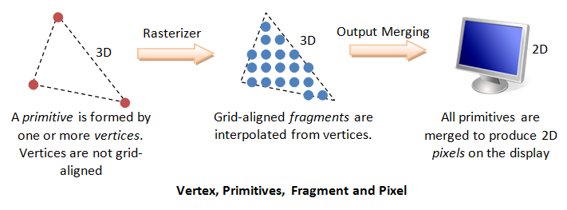
Figure 2 - Rasterization Process

Further processing is done to correctly colour each fragment via the fragment shader, once completed the fragments are then submitted through a series of tests, one of the most common being a depth test [6]. The entire pipeline is iterated over for all 3D data to lastly produce the final render of a 2D image [7].

Forward Rendering:

Up until recent years forward rendering has been a very popular rendering technique in real-time graphics.
The process is very straight forward, 3D data for a single object is processed through the pipeline to produce geometric primitives. Geometric primitives are then rasterized returning fragments, the resulting fragments are then processed for lighting calculations. The rendering pipeline is traversed entirely from start to finish, performing each step per object for every light in the scene [8]. A common problem with this process is that scenes with many light sources would result in poor performance due to multiple lights potentially affecting a single object, this would result in the object being passed down the pipeline multiple times to be rendered correctly [9].

Deferred Rendering:

Deferred rendering is a technique in real-time graphics that focuses on improving the speed of rendering lighting in a 3D scene [10]. This technique works by splitting the geometry and lighting stages in to two passes known as the geometry pass and the lighting pass. All 3D data for every visible object is processed and is passed down the pipeline, the resulting data is then stored into textures that are known as MRT (multiple render targets).

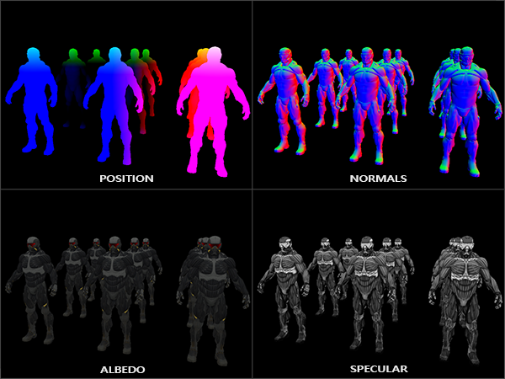
Figure 3 - Multiple Render Targets.
These are textures that describe information of geometry such as position, colour, specular intensity, etc. The textures are stored in the memory of the GPU within a G-buffer (geometry buffer) [11]. Using the textures within the G-buffer, lighting calculations are then performed in a second pass where each fragment of the data within the buffer is sampled to calculate the lighting [12].

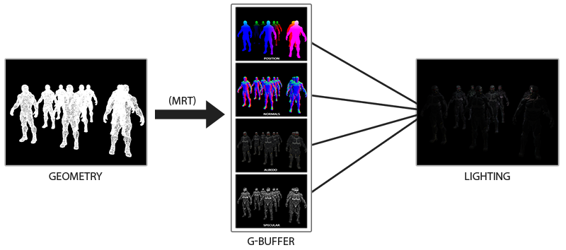
Figure 4 - Deferring Rendering Overview.

Critical Review

Looking at the implementation of deferred rendering technology from Shishkovtsov for the game S.T.A.L.K.E.R [13]. The implementation was mainly due to the design choices of the game, Shishkovtsov expresses in his research that the goal was to have rich visual quality with high polygon objects and complete dynamic lighting and shadows. This is one implementation where quality and performance were the main characteristics to focus on.

A lot of assumptions are made at the start of the chapter “9.2. The Myths” where Shishkovtsov provides explanation towards some expectations against the deferred rendering technique, whilst these assumptions are described and evaluated it leaves the reader having to agree with the content as opposed to providing reassurance through data or other sources [13].

In the paper “Deferred Rendering, J. Thaler” [14], an overview is provided of the entire technique along with insight towards the disadvantages and advantages. Measuring the information against Shishkovtsov [13] a slightly biased opinion against deferred rendering can be implied as Thaler provides concise information about these advantages and disadvantages. This is understandable as Shishkovtsov has good reason to ignore these disadvantages due to the nature of his implementation being focused on performance rather than memory management.

Aims & Objectives:

The main aim of the project will be to research and implement an efficient solution for rendering transparent objects using deferred rendering techniques. A focus on efficiency and performance will be the adjudicated factor that will permit if the project is successful.

In order to achieve this the following objectives will be targeted:

- Research to gain new knowledge in deferred rendering techniques.
- Research algorithms and methods in rendering transparent objects using deferred techniques.
- Analyses and evaluate collective algorithms and methods to uncover which is the most efficient.

Deliverables & Outcomes:

The expected outcome of the project will be to have a clean and well-structured codebase of a working deferred renderer that can render transparency via a chosen method found through research that is efficient in terms of performance and implementation.

A report will be produced to record each step of the project and describe any document review, software development and research development methodologies that are chosen for the project. Along with specification documents for planning the system of how the software will be built.

Research Methodology:

Introduction:

This section will review and concentrate on the research and development methods chosen for the project. A brief explanation of the research philosophies, approaches and strategies will be reflected on before concluding which will best suit the project.

Research Philosophies:

An important part of research is to understand the approach needed for dealing with the knowledge that is gained. Without an underpinning philosophy any research performed really has no context. Choosing a philosophy will provide guidance on how knowledge from research should be perceived and how it will influence further research [15].

Positivism:

The principles of positivism are more aimed towards the belief that credible knowledge can only be gained if the source of that knowledge provides results that are based from fact rather than feeling or influence [16]. In most cases positivism has aims where research should primarily provide an explanation and results should be judged through a logical and quantifiable approach. [17].

Phenomenology:

Phenomenology could be viewed as the opposite of positivism. Phenomenology could be defined as allowing interpretation and opinion of the resulting research, this leads to qualitative results. Phenomenology allows to build knowledge through researching and evaluating a phenomenon based on personal experience or through various other people’s experiences [18].

Strategy:

It is important to provide at least three strategies when forming a methodology for research. The triangulation technique can provide a way to validate the research through two or more sources [19]. Using this technique will supply a broader understanding of the circumstances.

Data Collection:

A comprehensive document review will be performed in order to identify the appropriate areas that are needed to build a deferred rendering system and to analyses the most efficient way to render transparent objects using deferred techniques.

Conclusion:

When deciding on the methodology to apply to the project the appropriate philosophy would be positivism as new knowledge gained will be quantifiable, giving no opinion on the results of the sources found. Strategies will involve software development as the overarching aim of the project is to have a deferred rendering system that effectively renders transparent objects, this will result in a complete render software which makes a software development strategy applicable.

To obtain the knowledge required to implement a rendering system and also analyses various techniques for transparency in a deferred system, a document review strategy is required. Research that will be considered as good sources will follow a criteria such as author credibility, data validity, peer reviewed and the material should be published.

Development Methodology:

With the nature of the project surrounding software development, to provide structure and organization a development methodology would be a good fit for planning development.
Various development methods are available, some belong to categories such as agile, where there are a set of frameworks under the agile umbrella.
Agile is one of the most popular development methods in software development as it has a heavy focus on adapting to changes in development, which cater very well for big projects [20].
A framework that resides in the Agile family is feature-driven development. This provides an iterative approach to software development where the primary focus is to develop the software with the type of features in mind. This provides some structure to development, when all features are planned and agreed a feature list is then compiled.
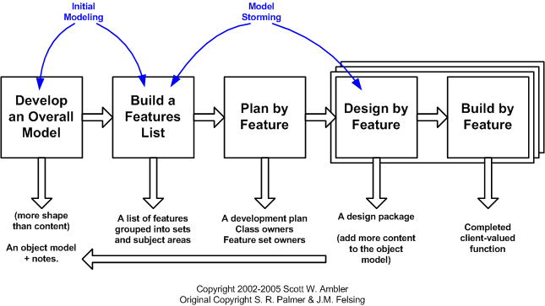
Figure 5 - FDD Lifecycle
Features are better understood as user stories which is another technique for recording particular aspects of a software’s design through the perspective of the user, as an example a feature could be along the lines of “complete login system”.

This approach best suits the project as there are many beneficial tradeoffs, the iterative approach accommodates changes to the project but also provides a logical timeline by breaking up the features allowing a structured approach on where development can be guided to ensure progression.

Development is easily managed for a single person as features can be broken down into more manageable chunks allowing for a single person to work on each feature or a single member of a team to work on multiple features simultaneously.

Resources & Planning:

In this section a description of the resources required to complete the project will be listed. Project management will be described and visualized via a Gantt chart that will record the strategy and tasks that will be performed to reach successful completion of the project.

The required resources:

- PC/Laptop – Hardware which will have a dedicated GPU for development.
- Literature/Books in the subject area – Learning material sourced from University library or purchased.
- Visual Studio – Software used as a development environment.
- OpenGL – C/C++ graphics API that will be used for programming purposes.
- GLUT/GLFW – Potential API’s that will be used to interface with the OpenGL library.

To ensure project success and guidance a Gantt chart has been produced to provide detail on the appropriate tasks that the project will involve. The tasks are split into 3 sections, background research, learning path, software design and development.

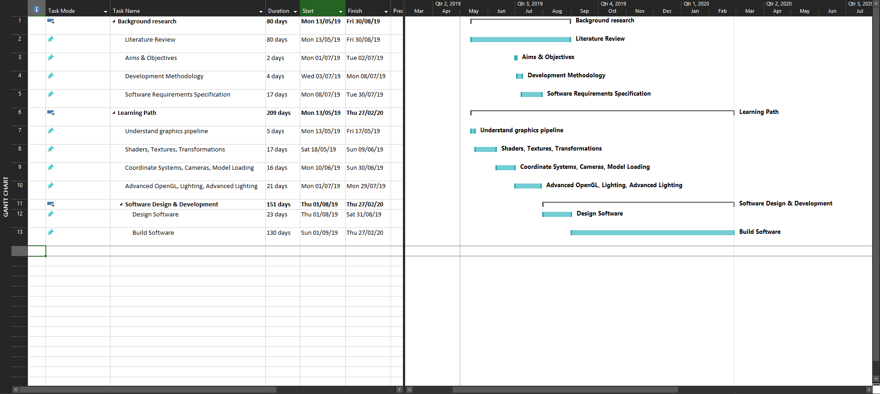
Figure 6 - Task List

Figure 7 - Gantt Chart

References

[1] | Unity 3D, "Real-time Rendering in 3D," [Online]. Available: https://unity3d.com/real-time-rendering-3d. [Accessed 2019 April 29].
[2] | PC Magazine, "Encyclopedia," PC Magazine, [Online]. Available: https://www.pcmag.com/encyclopedia/term/43933/graphics-pipeline. [Accessed 28 April 2019].
[3] | J. X. Chen, "Rendering in computer graphics," WIRE's Computational Statistics, vol. II, pp. 124-125, 2010.
[4] | D. Eck, "Introduction to Computer Graphics, Glossary," January 2016. [Online]. Available: http://math.hws.edu/graphicsbook/glossary.html. [Accessed 28 April 2019].
[5] | MDN Web Docs, "Explaining basic 3D Theory," [Online]. Available: https://developer.mozilla.org/en-US/docs/Games/Techniques/3D_on_the_web/Basic_theory. [Accessed 28 April 2019].
[6] | T. Munzner, "Visibility: Z-Buffering," University of British Columbia, British Columbia, 2003.
[7] | B. Evangelista, "AltDevBlog," [Online]. Available: http://jahej.com/alt/2011_01_18_forward-vs-deferred-rendering-whywhen-forward-rendering-still-matters.html. [Accessed 28 April 2019].
[8] | A. Polisciuc, "Performance of Deferred and Forward Shading under Different Lighting Conditions," Eastern Mediterranean University, Gazimaǧusa, 2013.
[9] | M. H. Shawn Hargreaves, "Nvidia Corporation," [Online]. Available: http://download.nvidia.com/developer/presentations/2004/6800_Leagues/6800_Leagues_Deferred_Shading.pdf. [Accessed 28 April 2019].
[10] | M. Ferko, "Real-time Lighting Effects using Deferred Shading," in The 16th Central European Seminar on Computer Graphics, Bratislava, 2012.
[11] | T. T. Takafumi Saito, "Comprehensible Rendering of 3-D Shapes," Computer Graphics, vol. 24, no. 4, p. 198, 1990.
[12] | W. A. H. Christopher A. Burns, "The Visibility Buffer: A Cache-Friendly Approach to Deferred Shading," Journal of Computer Graphics Techniques, vol. II, no. 2, pp. 55-56, 2013.
[13] | O. Shishkovtsov, "Deferred Shading in S.T.A.L.K.E.R.," NVIDIA, [Online]. Available: https://developer.nvidia.com/gpugems/GPUGems2/gpugems2_chapter09.html. [Accessed 28 April 2019].
[14] | J. Thaler, "Deferred Rendering," Vienna University of Technology, 2010.
[15] | P. L. A. T. Mark Saunders, "Understanding Research Philosophies & Approaches," in Research Methods For Business Students, Pearson, 2015, p. 126.
[16] | Research Methodology, "Positivism Research Philosophy," [Online]. Available: http://research-methodology.net/research-philosophy/positivism/. [Accessed 29 April 2019].
[17] | S. Rahman, "The Advantages and Disadvantages of Using Qualitative and Assessment” Research: A Literature Review," Journal of Education and Learning, vol. 6, no. 1, p. 106, 2017.
[18] | Stanford Encyclopedia of Philosophy, "Phenomenology," 16 December 2013. [Online]. Available: https://plato.stanford.edu/entries/phenomenology/. [Accessed 29 April 2019].
[19] | US National Library of Medicine National Institutes of Health, "The use of triangulation in qualitative research.," 2014. [Online]. Available: https://www.ncbi.nlm.nih.gov/pubmed/25158659. [Accessed 28 April 2019].
[20] | Agile Alliance, "Agile 101," [Online]. Available: https://www.agilealliance.org/agile101/. [Accessed 29 April 2019].

