2312419
University of Wales Trinity Saint David

ECAD6007
A critical evaluation and the identification of next teaching and learning steps focusing on a case study of an individual learner or a group of learners, based on an observed critical incident.

Word Count - 4043

Appendices
- Critical Incident Observation/Field Notes
Date and time, year group:
Year 4 class, date and time recorded unclear, witnessed by me in an immersive classroom on 22nd December 2023.
Where and when?: Context of the observation – subject/AOLE, general classroom context:
Year 4 class, approx. 22 pupils with one class teacher and one teaching assistant. Lesson subject was ‘inferences’, coming under the Language, Literacy and Communication Area Of Learning Experience.
What happened?: a detailed description of the critical incident
The incident itself is split up into two sub-incidents throughout the immersive video where the CT (class teacher) is in communication with the pupil with Additional Learning Needs (ALN).
- At 2:16 in the video (Immersive Learning Space Primary Classroom Video. 2023) where the CT was asking for a few pupils to explain inferences they saw from a still scene on the interactive whiteboard. The pupil with ALN raises their hand to answer the question and immediately the CT picks them to answer and even says ‘I’m so glad you’ve got your hand up!’ encouraging their participation.
- At 14:27 in the video (Immersive Learning Space Primary Classroom Video. 2023) that as soon as the task has been set by the CT for the pupils to come up with as many inferences as possible within eight minutes, the CT immediately approaches the pupil with ALN. The CT seems to be confirming the pupil with ALN can see the whiteboard, giving them some sentence starters to get them going and also offering them some encouragement about the task.
Areas of possible exploration: what do you think could be ‘under the hood in these incidents?
- Is there any provision in place currently to aid the child with ALN (aside from the obvious visual aid they have)?
- Does the CT and more broadly, the school, have regular communication with the ALN child and their family/guardian(s) in order to determine what is the best provision for the learner?
- Are the school well versed and knowledgeable about what they can do to improve the ALN child’s learning experience?
- Does the ALN child have any particular concerns about how their learning is affected and what can be offered to aid them?
Notes: any details you can note?
- The class is relatively busy, quite possibly due to the nature of the task being rather interactive with the introduction of various types of shoes.
- There are lots of different types of learners, with very diverse backgrounds and therefore probably very diverse skill levels, representing a challenge for the class teacher.
- Some children constantly have their hands up and some never put their hands up at all showing potential confidence differences.

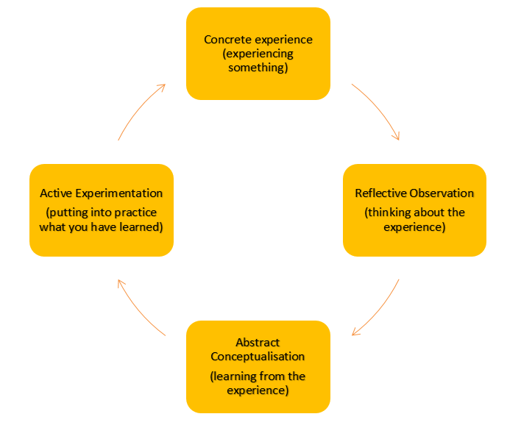
- Kolb’s Model of Reflection (1984)

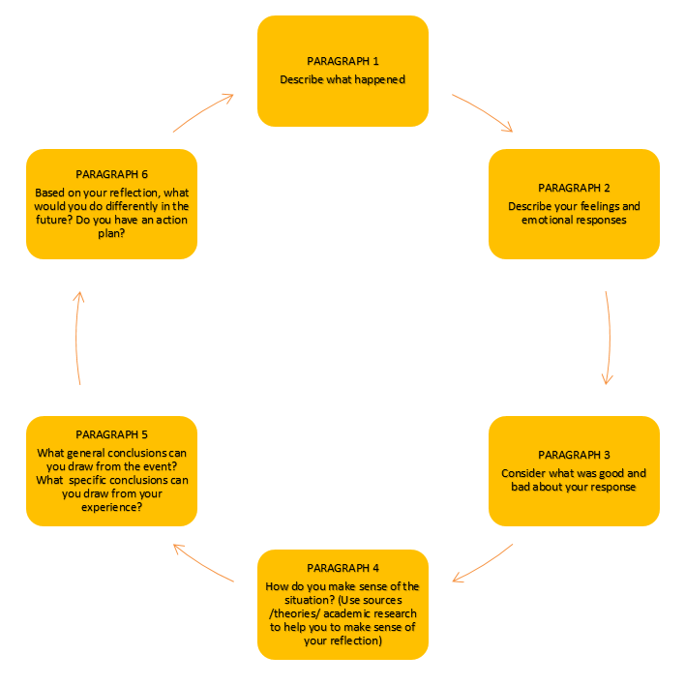
- Gibbs’ Model of Reflection (1988)

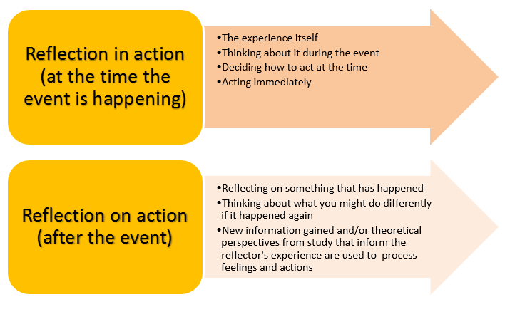
- Schön’s Model of Reflection (1983)

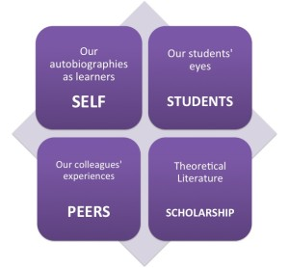
- Brookfield's Model of Reflection (2002)

