Welcome to My Academic Portfolio

Table of Contents
Task 1: IEEE Referencing & Summary on Essential Academic and Employment Skills 3
Part A: 3
Part B 4
Reflection on Similarity Score and Self-Assessment: 4
Bibliography 5
Task 2: Collaborative Teamwork and Professional Academic poster (A3 Poster): 6
Activity: ‘Life is a Team Sport’ introductory activity 7
Task 3: Automatic Referencing Tool. 8
Overview of Virtual Collaboration. 8
Educational Implications of MyBib. 9
Bibliography 11
Task 4: E-Portfolio creation and review: 12

Task 1: IEEE Referencing & Summary on Essential Academic and Employment Skills

Part A:
Title: Key Academic and Professional Skills for Modern Career Development
Acquisition of effective academic and employment skills will be at the centre of the professional development in the long terms. There are several of the core competencies that lead to high performance and employability in any line of business.
Communication Skills:
Effective teamwork and engagement with the clients is supported by clear written and spoken communication. Effective communicators are able to express ideas in a positive manner, minimise conflicts, and engage in fruitful working relations [1].
Time Management:
With proper planning and prioritisation individuals can be able to handle their workloads without creation of needless pressure. Organising activities and ensuring the timely delivery of tasks, professionals increase their reliability and general productivity [2].
Critical Thinking and Problem-Solving:
The ability to reason analytically and make creative decisions is what helps a professional to come out of complex issues. The critical thinkers are able to transform the challenges into opportunities and come up with viable solutions in the dynamic environments [3].
Flexibility and Information literacy:
The fast technological evolution in the environment necessitates flexibility of the employees and their ability to use digital tools. Digital competence facilitates collaborative efforts remotely, working with data, and having a functional presence in the technologically driven work areas [4].
Team Collaboration:
It is possible to work within different groups and open new horizons and new results. This inclusive teamwork has the effect of enhancing cohesion, promoting sharing of ideas as well as helping towards positive organisational culture [5].
Together, the skills raise the competitiveness of industries. To illustrate, effective communication is enabling me to improve my interaction with clients and colleagues, whereas the digital capability allows me to utilise contemporary tools to simplify the work and increase its efficiency.

Part B

Reflection on Similarity Score and Self-Assessment:
The Turnitin similarity rate was 8 percent and this means that I have done most of my work with authentic ideas. In order to keep or minimise the similarity in further tests, I will choose to work on paraphrasing of ideas as much as possible and present the selected information in my own format instead of using structure of the source. I will also take care of citing all the external ideas utilising exact IEEE citation. Besides, it will be possible to incorporate more personal reflection and interpretation to prove originality. Such practises will help in hosting academic freedom and enhancing originality of my assignments.

Bibliography
[1]
None Soid, None Muhammad Fatih, None Nanang Fauzi, and N. E. Norman, “Effective Communication in Building Healthy and Productive Relationships,” MES Management Journal, vol. 4, no. 1, Jan. 2025, doi: https://doi.org/10.56709/mesman.v4i1.631. Available: https://www.researchgate.net/publication/387724975_Effective_Communication_in_Building_Healthy_and_Productive_Relationships. [Accessed: Nov. 28, 2025]
[2]
F. Vizeshfar, M. Rakhshan, F. Shirazi, and R. Dokoohaki, “The effect of time management education on critical care nurses’ prioritization: a randomized clinical trial,” Acute and Critical Care, vol. 37, no. 2, pp. 202–208, May 2022, doi: https://doi.org/10.4266/acc.2021.01123. Available: https://pmc.ncbi.nlm.nih.gov/articles/PMC9184972/. [Accessed: Nov. 28, 2025]
[3]
S. PRAKONG, “The Role of Critical Thinking in Enhancing Students’ Problem-Solving Abilities in Higher Education,” Journal of Education, Humanities, and Social Research, vol. 1, no. 1, pp. 10–16, Dec. 2024, doi: https://doi.org/10.70088/scx8x622. Available: https://www.researchgate.net/publication/386516803_The_Role_of_Critical_Thinking_in_Enhancing_Students'_Problem-Solving_Abilities_in_Higher_Education. [Accessed: Nov. 28, 2025]
‌[4]
K. Abhari, “Employee Participation in Digital Transformation: From Digitalization Sentiment to Transformation Predisposition,” Information & Management, vol. 62, no. 8, p. 104212, Dec. 2025, doi: https://doi.org/10.1016/j.im.2025.104212. Available: https://www.sciencedirect.com/science/article/pii/S0378720625001156. [Accessed: Nov. 28, 2025]
‌[5]
I. Ahmed, H. H. Khan, N. U. Zaman, W. Ahmed, and S. Nabeel ul Haq, “Effect of Deep-Level Workforce Diversity on Group Cohesion: The Moderating Role of Team Leadership,” Research Journal for Societal Issues, vol. 5, no. 1, pp. 255–273, Mar. 2023, doi: https://doi.org/10.56976/rjsi.v5i1.73. Available: https://www.researchgate.net/publication/369762257_Effect_of_Deep-Level_Workforce_Diversity_on_Group_Cohesion_The_Moderating_Role_of_Team_Leadership. [Accessed: Nov. 28, 2025]
‌

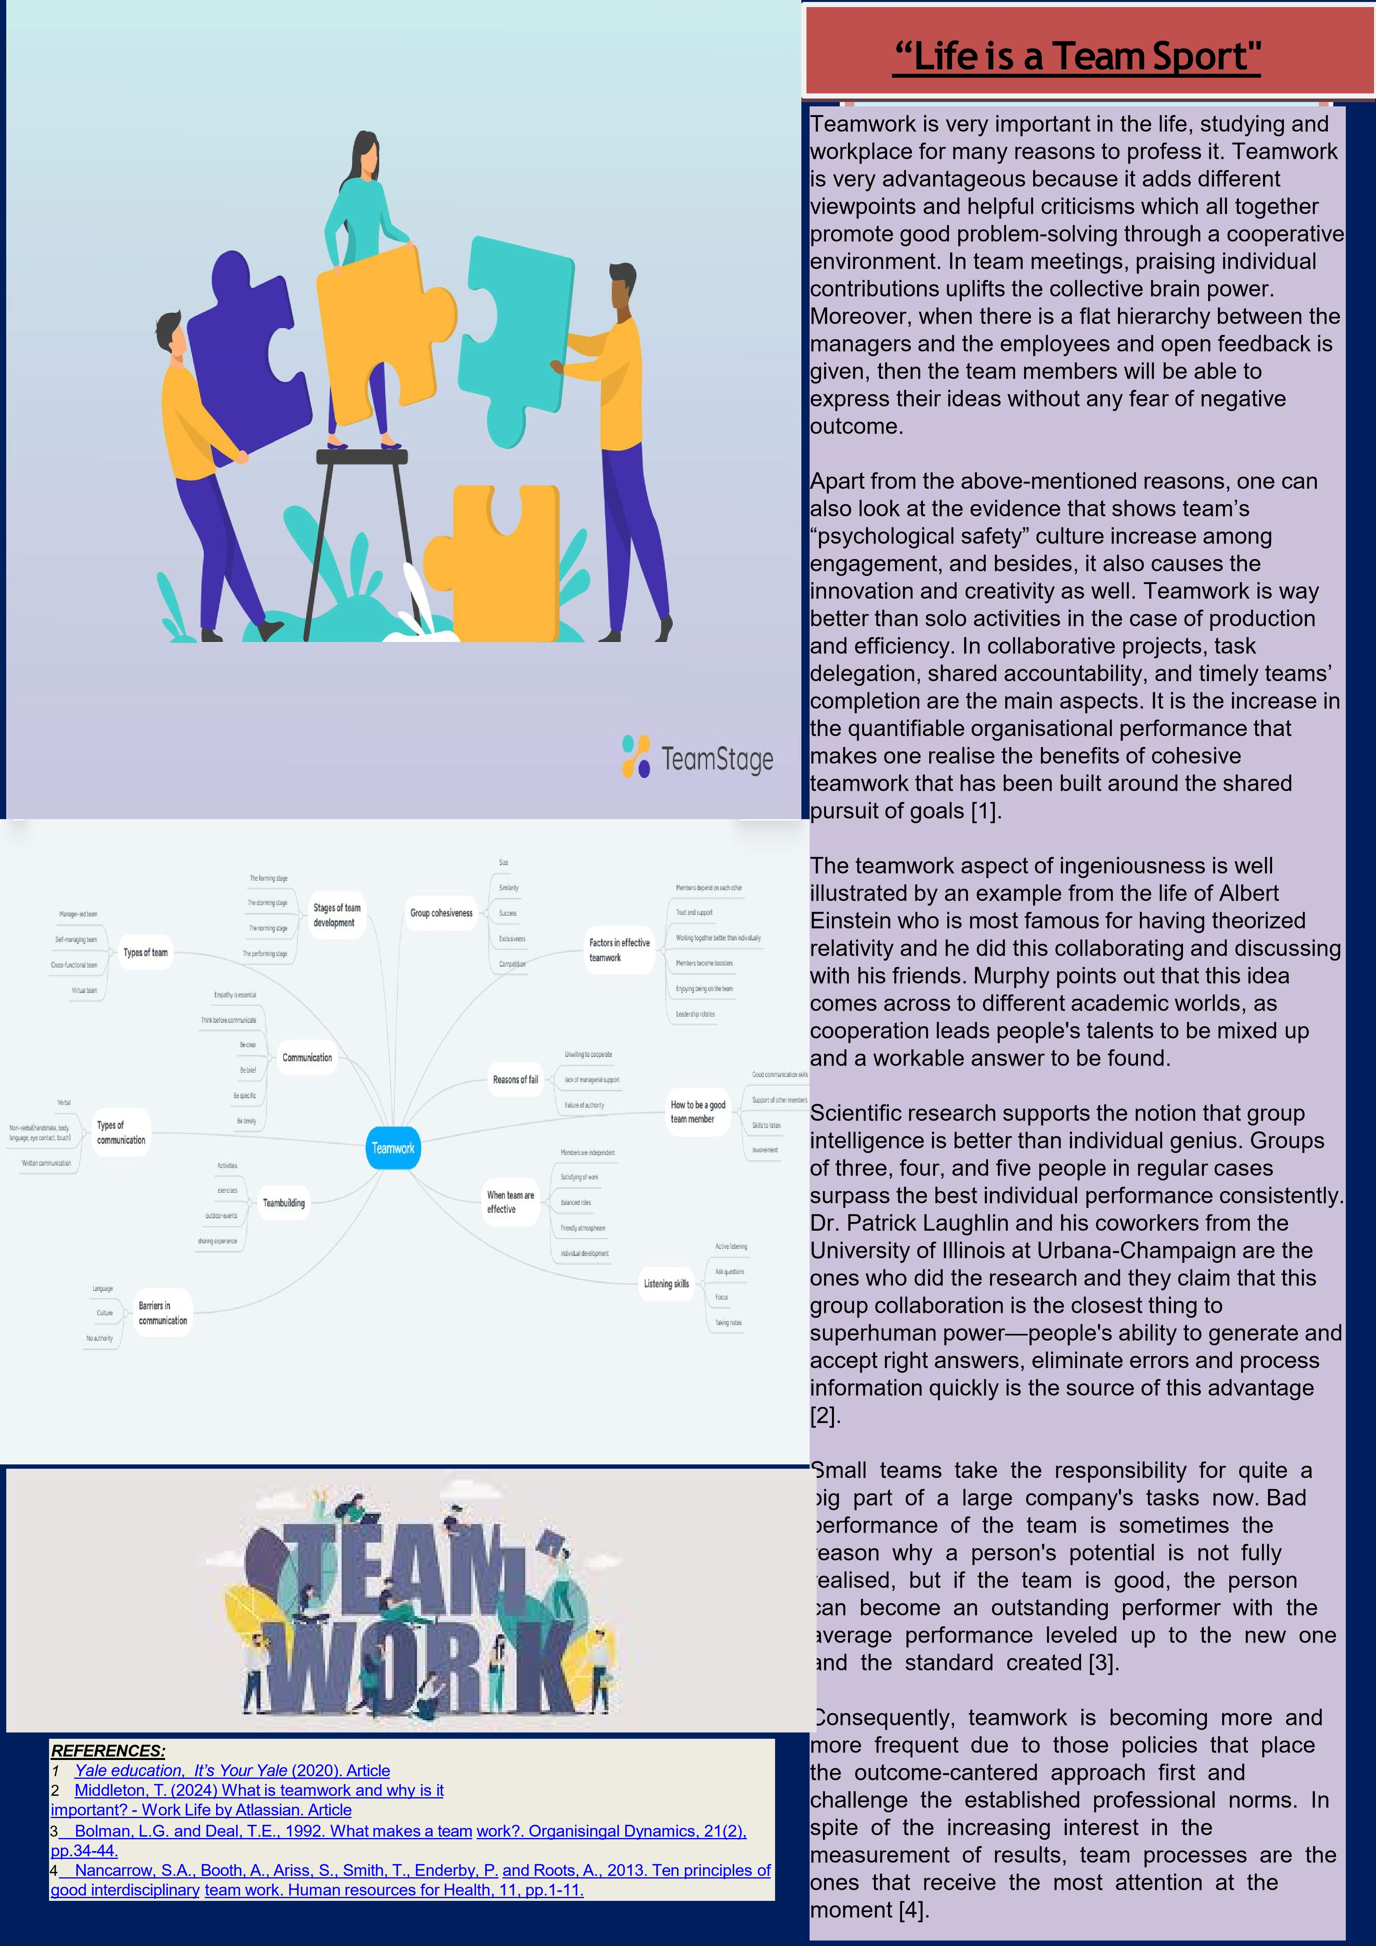
Task 2: Collaborative Teamwork and Professional Academic poster (A3 Poster):

‌
‌

‌

Activity: ‘Life is a Team Sport’ introductory activity
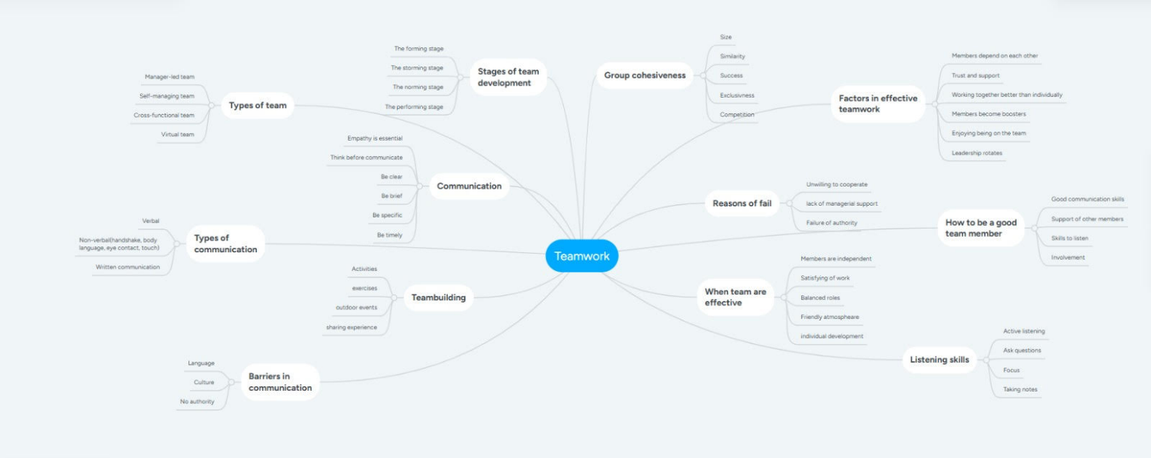

Task 3: Automatic Referencing Tool.
In this case, I learnt how to seek an automatic referencing tool (like MyBib) that would help me to add some relevant IEEE citation and to build a reference list. In the case of the Topic, I selected one of the topics of Moodle Unit 3′ under Virtual Collaboration and recapped its main ideas with the backing of citations. Not just was this exercise a learning exercise which has brought touch base on the subject of anatomy to a larger extent, but it also demonstrated that correct citing and dealing with citations are so much a part of the academic integrity of my work, and how I can make my work process easier.

Overview of Virtual Collaboration.
In the contemporary life, i.e. when we experience connectivity, we need virtual cooperation. Among the reasons why virtual collaboration is important are remote work and the need to have an online project management. Specifically, virtual teamwork entails: significance of communication; establishing trust in virtual organisations; application of technology in virtual teamwork. Among the other factors that get hard with virtual teams is the collection of the time zones difference, the absence of non-verbal communication and the possibility of a miscommunication as a result of being physically not there. That is why it is critical to make sure effective communication methods are put into place and digital tools, such as video conferencing, and the usage of shared task boards, sharing files via the cloud are applied to the virtual collaboration [1].
To cope with such obstacles, virtual leaders make sure to engage members, give feedback, and make them feel like part of the team. It is also critical to understand cultural diversity within the virtual team since the approach to communication and conflict resolutions will depend on the cultural differences. Virtual collaboration in organisations can be enhanced by means of digital literacy and cross-cultural understanding which can be advanced using the help of training programmes [2].
To conclude all of this I have used the MyBib to organise my citations effectively. The specific references I have used are outlined below and which I concur display that the importance of citing academic references in the construction of academic work is significant.
During the creation of this summary, I applied MyBib to organise my references in an effective way. The following are the major references that I made that show that I understand the need to use academic sources to reinforce academic works.

Educational Implications of MyBib.
To support this task, I needed to have IEEE style citations and to create a reference list with the help of MyBib. In case you want to, MyBib could have simplified the process by giving you the option of importing references available in the internet databases and creating the absolute correct in-text citations. These are my screen shots on how I have used MyBib to reference, add citations in my summary and lastly put up the reference list as my final output. The practical experience complemented my requisite knowledge on citation management, which will be applicable in other academic tasks and work projects.
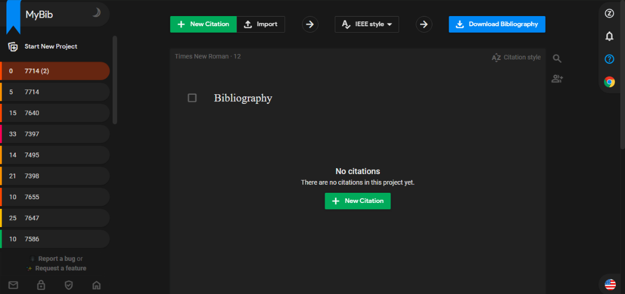
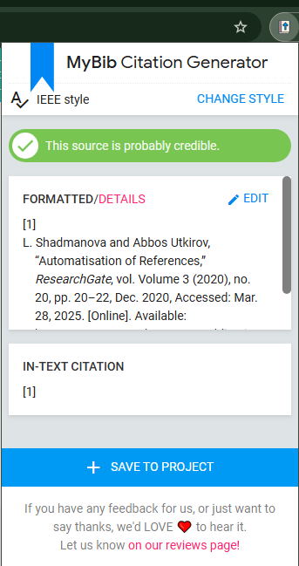
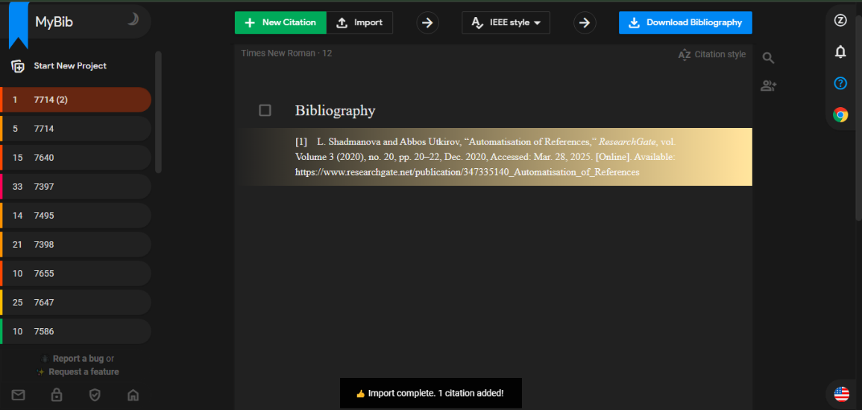

Bibliography
[1]
L. Shadmanova and Abbos Utkirov, “Automatisation of References,” ResearchGate, vol. Volume 3 (2020), no. 20, pp. 20–22, Dec. 2020, Accessed: Mar. 28, 2025. [Online]. Available: https://www.researchgate.net/publication/347335140_Automatisation_of_References
[2]
S. Alkoud, D. Zainudin, and S. Mhd Sarif, “Challenges, Barriers, and Obstacles Facing Virtual Teams: a Conceptual Study,” International Journal of Academic Research in Business and Social Sciences, vol. 13, no. 4, Apr. 2023, doi: https://doi.org/10.6007/ijarbss/v13-i4/16723. Available: https://www.researchgate.net/publication/370356184_Challenges_Barriers_and_Obstacles_Facing_Virtual_Teams_a_Conceptual_Study
‌

Task 4: E-Portfolio creation and review:
https://sites.google.com/view/academicskillse-portfolio/home

