Barbara Newborough student number 1804312
Museums, Heritage and Representation
HPHE6008
Report on St Fagan’s National Museum of History – specifically focusing on The Tollhouse and St. Teilo’s Church.

1. Introduction to the ethos of St Fagans and the exhibits chosen for this report
2. The Aberystwyth Tollhouse and its place in history
3. St Teilo’s Church and its ‘resurrection’
4. Further general reasons for and against
5. Summary

To answer question 3- In the light of one of your visits, examine the arguments for and against removing monuments/artifacts OR buildings from their sites in the landscape to the safekeeping of the museum.

- Introduction to the ethos of St Fagans and the exhibits chosen for this report
St Fagans National Museum of History is part of the National Museum of Wales, which consists of seven museums with a variety of interests. It was originally set up by Royal Charter on the nineteenth of March 1907.
St Fagans became part of this group when it was opened in 1948 and was originally called the Welsh Folk Museum. In a paper published by I C Peate in 1965, in the Journal of the Folklore Institute, Peate says the future aim of the Museum is to recreate a past, ‘almost unknown to a rapidly changing society in the second half of the twentieth century’
This was at a time when rebuilding following World War two was beginning to sweep away the old and bomb-damaged buildings for new ‘’prefabs’’, of which there is an example at St Fagans. The nineteen fifties saw this gather momentum and many buildings which we would preserve today, were demolished to make way for blocks of high-rise flats, many of which today have also been destroyed. Saving some of these was part of the remit, which they fulfilled. A Redundant miners institute, quaint old-fashioned shops and a bakery, all show how we lived before being swept aside by the modern day.
Iorwerth C Peate, according to The Dictionary of Welsh Biography entry, states he was a former student at Aberystwyth University. He was highly influential in setting up a Welsh Folk Museum, where he became Keeper in Charge, and later Curator of the Welsh Folk Museum in 1948. He retired in 1971 and in 1982 after his death, his ashes were buried at St Fagans Capel Pen Rhiw as he had requested The ethos of the Museum has always been to save and recreate the past and I have chosen two buildings.
The first choice is the Aberystwyth Tollhouse because there is no remnant of its site in the current Aberystwyth road system, although since researching photographs and pictures of this, it is now understandable why it is an unusual junction to the south of the town and why this part is called Southgate.
The second choice is St. Teilo’s church because of its medieval origins; and because of the decisions made during reconstruction which included interior wall paintings and newly carved wooden decorations.

2. The Aberystwyth Tollhouse and its place in history
The Tollhouse built in 1771, began collecting tolls in 1772 The site has disappeared from today’s landscape on the edge of Aberystwyth, because like many towns, Aberystwyth has increased in size since it was dismantled in 1962 Therefore, its original place would no longer be on the edge of the town. There is a link to a film here, showing its position well; Watch Southgate Tollhouse, Aberystwyth and Aberarth online - BFI Player
Reasons against moving the tollhouse
- The aforementioned film shows how the road system has altered due to the growth of the town as a whole. It is disappearing from modern day memory as the decades go by, as there is no physical plaque to commemorate its place in the history of Aberystwyth. Nor is there a space where it once stood. Were it not for the re-siting of it at St. Fagans, many of the younger generations who visit the site on school trips would not know it had ever existed.
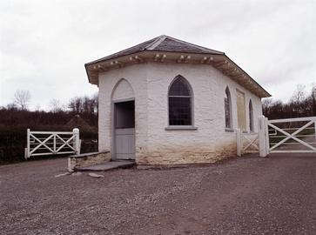
From St Fagan’s Museum website
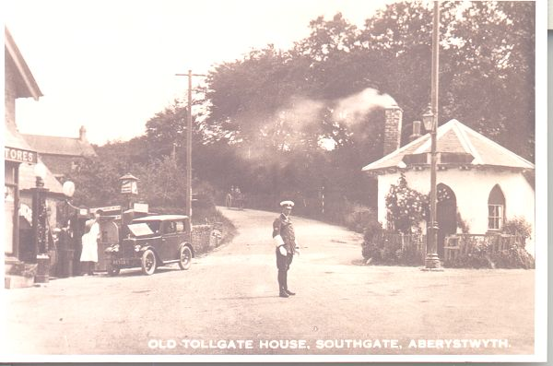
The Tollhouse renamed

Reasons for moving the tollhouse

- The Tollhouse has been re sited at the Museum and the website tells us that though it was built in 1771 and dismantled in 1962, it has been ‘furnished in the style of 1843’. The reason for this, is to tell the historical account of the Rebecca Riots which were very much associated with Tollgates and turnpikes. Though the Rebecca’s as they became known were also a symbol of the poor versus the rich landowners, an extension of the original goal of the protests, for those who studied Welsh history of the period. Colonel Powell of Nanteos, only a short distance from the Aberystwyth Tollgate, was a magistrate at this time and Lowri Ann Rees’ paper paternalism and rural protest: the Rebecca riots and the landed interest of South West Wales gives a good account of the history of absentee landlords and the effect on the poor during this period of dissent The Museums reasoning is sound and fits with the goals of the museum to teach Welsh history. However, to the casual museum visitor, it could associate Aberystwyth with the burning of the Tollgates during the Rebecca riots.

3. St Teilo’s Church and its ‘resurrection’
St. Teilo’s church was offered to St. Fagan’s in 1984 after becoming redundant in 1970. Rather than continuing to be the object of further vandalism, the museum dismantled the building in 1985 and removed it to the museum. It began the reconstruction process in 1997. Elen Philips in her article in Material Religion tells us that the reconstruction was the first of its kind to be moved to an open-air museum in Britain As such, the museum decided to have the reconstruction on full view to the public.
Reasons against moving the church
- The reconstruction though was not as it had been prior to its removal. It was decided to alter it to suit the museums aims – the museum already had another religious building. This surely alters its authenticity, though the public may indeed enjoy the enhancements made to it.
- Wall paintings; which would have been familiar to our medieval ancestors, were found during the dismantling process by the archaeologists. These have been painted on the newly constructed walls in the twenty first century. In another five hundred years, will these be classed as authentic?
- The interior and windows have had the same treatment. A beautiful reconstruction of what was likely to have been there during the period chosen
by the museum rather than its original agreed construction date.
- As a medieval historian, this is a loss to its original landscape.
Reasons for moving the church
- as discussed in the introduction to this section, being in a remote location and having been subject to vandalism, its relocation ensured its survival. This has been explored in much more detail in section four.
- educational purposes: It was decided by the Museum that the public should be able to watch the renovation of the Church being reconstructed in traditional ways; to monitor its progress. Much like the craftspeople, a blacksmith, a leatherworker, a spoon maker, also available to watch at St Fagans, as Peate had planned in his
original ideal Museum.
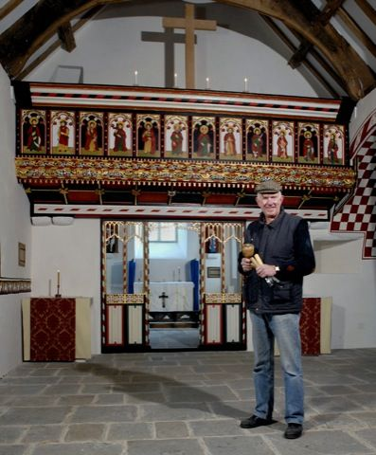
Information below the photograph from St. Fagan’s website –
Here's Ray Smith, Head Carpenter at our Historic Buildings unit, standing in front of the screen he made. The tools in his hand are what were used to make it — a hammer and chisels

4. Further general reasons for and against
For:
- Environmental benefits of all of the monuments in one place – visiting one location and experiencing thousands of years of history.
Against:
- A monument as part of the community and culture
- Demographics: those who go to museums can afford to travel. The St. Fagans Museum is in open countryside of circa 100 acres and as such is not easily accessible by people without transport. The main entrance is from the A4232, a dual carriageway from the M4. This is a suitable route for those arriving in a coach party or by car. There is also a public bus service from Cardiff for people without their own transport. This presumes that people have sufficient disposable income for the cost of travelling there as the museum entry is free. There is a charge for car parking though.
- It is also interesting to note that six of the seven sites which make up the National Museum of Wales are in the south of Wales; the slate museum at Llanberis being the odd one out. It is approximately four hours by car from north to south Wales and it would be interesting to see how many people make this journey; adding a day for travel to any time spent in the south. Indeed, the south Wales sites are nearer to a large population of England more than mid to North Wales.
- Accessibility – As the previous point makes, the distance to the museum is a barrier for many. However, accessibility in the historic sense, is also important to mention here. During our Museums and heritage module, we have learned that from the earliest collector antiquarians such as John Tradascant the Elder and his son John the younger who bequeathed their treasure to the Ashmolian museum, there has been the philanthropic notion that these collections should be available to all. We have seen how the British Museum opened late in the evening to allow the working class to view the artefacts on display. We have also seen how modern-day studies of flow of people try and understand how best to organise a museum space.
In the latter part of the twentieth century, Accessibility has become a regulation to ensure a fully inclusive audience to all places. This is not fully met at St Fagans as far as mobility is concerned due to the size of the site and the layout of the buildings. A point that, in 1948 at its inception, the museum may not have considered to be a barrier.
Though people have many forms of legal transport to use on the site, there are still some people unable to take advantage of all that is on offer. Though installing lifts would not be a sensible option, the distance between buildings will be a factor in whether to visit it or not. If the Tollhouse were still in situ in Aberystwyth, a visitor could brave the traffic and walk to it from their vehicle. Although, if the Church had not been moved, it is understood that its siting was difficult to access which was the reason it had been vandalised. Moving it to its present location was therefore a better option for the building.

Summary:
The arguments for and against moving two of the buildings; The Aberystwyth Tollhouse and St. Teilo’s Church, have been explored here from personal knowledge of the site albeit from my last visit, pre lockdown. The local history and place in the landscape discussed as well as the reasons for removing the buildings versus leaving them in place. The accessibility of these historic buildings and their connection to history have also been explored.
St Fagans is home to many buildings and the visitor is encouraged to choose those they are most interested in due to this. It should be a place that everyone visits at least once. It is after all, Britain’s first open air museum.

Bibliography
National Museums Wales. 2008. “St Teilo’s,” National Museum Wales <https://museum.wales/articles/1168/St-Teilos/> [accessed 3 October 2021]
———. [n.d.]. “Search the Website,” National Museum Wales <https://museum.wales/search/?q=tollhouse> [accessed 3 October 2021]
Old Tollgate House, Southgate, Aberystwyth. 2021. Westwales.co.uk <https://westwales.co.uk/graphics/southgate.jpg> [accessed 27 September 2021]
Owen, Trefor M. 2009. “PEATE, IORWERTH CYFEILIOG (1901-1982), Curator of the Welsh Folk Museum, 1948-1971, Scholar and Poet | Dictionary of Welsh Biography,” Biography.wales <https://biography.wales/article/s6-PEAT-CYF-1901#?c=0&m=0&s=0&cv=11&manifest=https%3A%2F%2Fdamsssl.llgc.org.uk%2Fiiif%2F2.0%2F1465872%2Fmanifest.json&xywh=1199%2C1899%2C1415%2C1224> [accessed 3 October 2021]
Peate, Iorwerth C. 1965. “The Welsh Folk Museum,” Journal of the Folklore Institute, 2.3: 314–16 10.2307/3814151>
People’s Collection Wales. [n.d.]. “Aberystwyth Tollhouse,” Peoples Collection Wales <https://www.peoplescollection.wales/collections/547736> [accessed 3 October 2021]
Phillips, Elen. 2006. “Reconstructing St Teilo’s Church,” Material Religion, 2.2: 258–59 10.2752/174322006778053690>
Rees, Lowri. 2011. “Paternalism and Rural Protest: The Rebecca Riots and the Landed Interest of South-West Wales*,” Agricultural History Review, 59.1: 36–60 <https://bahs.org.uk/AGHR/ARTICLES/59_1_3_Rees.pdf> [accessed 28 September 2021]

Peate, Iorwerth C. 1965. “The Welsh Folk Museum,” Journal of the Folklore Institute, 2.3: 314–16 10.2307/3814151>
Owen, Trefor M. 2009. “PEATE, IORWERTH CYFEILIOG (1901-1982), Curator of the Welsh Folk Museum, 1948-1971, Scholar and Poet | Dictionary of Welsh Biography,” Biography.wales <https://biography.wales/article/s6-PEAT-CYF-1901#?c=0&m=0&s=0&cv=11&manifest=https%3A%2F%2Fdamsssl.llgc.org.uk%2Fiiif%2F2.0%2F1465872%2Fmanifest.json&xywh=1199%2C1899%2C1415%2C1224> [accessed 3 October 2021]
People’s Collection Wales. [n.d.]. “Aberystwyth Tollhouse,” Peoples Collection Wales <https://www.peoplescollection.wales/collections/547736> [accessed 27 September 2021]
ibid
National Museums Wales. [n.d.]. “Search the Website,” National Museum Wales <https://museum.wales/search/?q=tollhouse> [accessed 3 October 2021]
Old Tollgate House, Southgate, Aberystwyth. 2021. Westwales.co.uk <https://westwales.co.uk/graphics/southgate.jpg> [accessed 27 September 2021]
Rees, Lowri. 2011. “Paternalism and Rural Protest: The Rebecca Riots and the Landed Interest of South-West Wales*,” Agricultural History Review, 59.1: 36–60 <https://bahs.org.uk/AGHR/ARTICLES/59_1_3_Rees.pdf> [accessed 28 September 2021]
Phillips, Elen. 2006. “Reconstructing St Teilo’s Church,” Material Religion, 2.2: 258–59 10.2752/174322006778053690>
National Museums Wales. 2008. “St Teilo’s,” National Museum Wales <https://museum.wales/articles/1168/St-Teilos/> [accessed 3 October 2021]

