Tesla's Social Media Marketing Strategy
Challenges and Responses

MODULE NAME ：Marketing Management-BMMB7012
STUDENT NAME : Yuanjun Peng
STUDENT NUMBER : 2232843

TABLE OF CONTENTS
Executive Summary - 1 -
1.Introduction. - 2 -
1.1 Brief Overview of the Organization - 2 -
1.2 Social Media Marketing Effect - 2 -
2. Analysis of Tesla's Social Media Marketing Strategy - 3 -
2.1 External Environment Analysis-Threats and Opportunities - 3 -
2.2 Internal Environment Analysis-Weaknesses and Strengths - 4 -
3. The Micro Environment Analysis-Porter's Five Forces Analysis - 5 -
4. Conclusion - 8 -
5. Recommendations - 8 -
5.2 Recommendation 1: Internal Marketing - 10 -
5.3 Recommendation 2: Integrated Marketing - 10 -
5.4 Recommendation 3: Performance Marketing - 10 -
5.5 Recommendation 4: Relationship Marketing - 11 -
6. References - 13 -

Executive Summary
Tesla Incorporation is globally known for the manufacture of electric vehicles. Tesla attained success in the automotive industry where its social media marketing strategies played a crucial role(Tesla, 2023). This article utilizes the SWOT and Porter's Five Forces models to evaluate Tesla's social media marketing strategy. The SWOT framework provides an extensive analysis of Tesla's internal and external environment, while Porter's Five Forces framework assesses the marketing strategy of the company from an industry perspective. The article identifies the issue which is the excessive reliance on social media and Elon Musk's impact on social media. To address this problem, Tesla should adopt a holistic marketing strategy, such as restructuring the internal marketing department,integrating marketing channel resources, implementing unified brand performance marketing,and implementing relationship marketing. Additionally, it is suggested that fostering alliances to establish a healthy competitive landscape and achieve mutually beneficial outcomes.

1.Introduction.

1.1 Brief Overview of the Organization
Tesla Inc. which began as Tesla Motors in 2003 aimed to create a revolution in the automobile industry by producing electric vehicles that are consumer friendly while increasing the transportation industry’s sustainability(Wu, 2022). In 2008, the company named Elon Musk as its CEO and commenced its portfolio expansion by moving to the production of clean energy, the creation of electric vehicles and solar panels. Through its innovative creation, the incorporation has been successful in this area. Musk believes that Tesla does not advertise or pay for endorsements. Instead, we use that money to make the product great. Therefore, Tesla's marketing expenses are minimal, primarily relying on Musk's personal marketing, the product itself, social media, and word of mouth.However, the company recently announced that it would try a little advertising as in its marketing strategy(Sriram and Jin, 2023).

1.2 Social Media Marketing Effect
It is well-known that Tesla has a zero-dollar marketing budget，despite it being listed as the most valuable automotive firm in the globe，which is worth once approximately 1.3 trillion dollars. Its vision is "To create the most compelling ," which has been attained, and according to the 2022 global EV sales ranking, Tesla's Model Y and Model 3 take the top two spots (Motionlab, 2023). Musk is a charming public figure who has over 130 million Twitter followers. In addition, Tesla has over 20 million Twitter fans, making it the most followed car brand on the platform. Its official YouTube channel also has more than 2.2 million subscribers, surpassing Ford. The huge number of fans makes Tesla has significant influence on social media. For instance, in 2019, Tesla released a video about the new model-Cybertruck, which received 1.8 million reservations, but the new model will not be manufactured until the end of 2023.
In conclusion, Tesla attained success where its social media marketing strategies played a crucial role. But it can also be found that Tesla is overly dependent on social media marketing and Musk ’s personal marketing for Tesla (Thomas and Maine, 2019).

Analysis of Tesla's Social Media Marketing Strategy
SWOT analysis is a business tool used by companies to identify their flaws and realize their competitive advantage in the market and will be used to identify issues at the company (Jiang, 2022).
 | Helpful | Harmful
External Environment | Opportunities:  1.Supportive policies for new energy sources  2.Strong corporate social responsibility image  3.Decision to explore advertising | Threats:  1.Economic recession impacting sales  2.Traditional automakers entering the EV market, posing competition  3.Negative reports leading to potential decline in consumer loyalty
Internal Environment | Strengths:  1.Strong brand presence  2.Compelling social media content  3.Wide coverage of social media campaigns: | Weaknesses  1.Overreliance on social media and Elon Musk's influence  2.Controversial topics associated with Elon Musk  3.Ineffective response to public relations events
Figure 1:SWOT analysis

2.1 External Environment Analysis-Threats and Opportunities
Threats
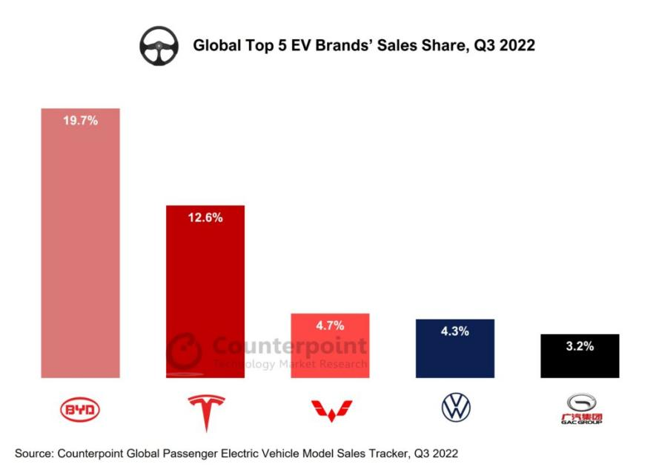

Figure 2:Global top 5 EV Brands' Share,Q3 2022 (Mukherjee,2023)
With the global recession by the COVD-19 Pandemic,Potential consumers may hesitate to purchase electric vehicles (Guénette, 2022).Giant traditional automakers’ entry into the electrical vehicles industry such as Hyundai, Ford, Kia and Chevrolet has made intensified competition.Although Tesla was the first company to capture the public market on electric vehicles with its leading technology and successful social media marketing,according to Figure 2, it is evident that Tesla has begun to lose its dominant position in the industry, and BYD has surpassed Tesla's market share to be NO.1, it is questionable how long Tesla can maintain its competitive advantage .More so,there have been many negative reports about Tesla on news websites and social media.,which cause consumer dissatisfaction with the product has leveled up and the availability of cheaper alternatives to the product poses a threat to Tesla (Merlo et al., 2018). For instance, accidents caused by Tesla’s autopilot(a driver-assist system)will be closely reported, and favorable reports on its expansion projects will be less. Furthermore, Elon Musk's acquisition of Twitter has made consumers doubtful about Tesla's promotion on the platform (Phillips and Pohl, 2022). a move that may affect the effectiveness of his social media marketing strategy.
Opportunities
According to Reimers (2021), Tesla has long benefited from the incentive policies of the US government. Additionally, China has extended its new energy vehicle purchase subsidy until the end of 2023. This is expected to contribute to the global growth of passenger electric vehicle sales, including Tesla's. On the other hand,its strategy has consistently combined technological innovation with environmental sustainability. For instance, Tesla designs and constructs superfactories that use less water and consume less energy.In recent years, as consumer preferences shift towards greener technologies like electric vehicles, batteries, and solar roofs, the company has cultivated a sustainable corporate social responsibility image through social media. This positioning allows its products to possess attributes of sustainable development that has been able to attract a loyal customer. Sustainability serves as Tesla's Unique Selling Proposition (USP), distinguishing the company from the competition in the industry (Jahroh et al., 2023).

2.2 Internal Environment Analysis-Weaknesses and Strengths
Strengths
Tesla often uses unique content to promote on social media, such as bundling marketing with Space X, which has achieved huge marketing effects (Kuokka, 2021). At the same time, the company consistently identifies new focal points, like the distinctive design of the Cybertruck model and continuous and special marketing content has the opportunity to attract more attention (Mangram, 2012). Additionally, the company have partnered with the gaming social platform "Stream" to establish a new marketing channel. Especially in the United States, you will notice that the Cybertruck is well-known among students because many Tesla models are featured on the Stream platform game. Currently, the Stream platform is integrated into the car system, allowing you to enjoy the enjoyable experience of charging your vehicle while playing games. This partnership offers the company the opportunity free marketing.
Weakness
Tesla’s marketing strategy has various limitations as it is overly dependent of social media and its CEO, Elon Musk influence in reaching the target market. Musk often publishes controversial remarks on Twitter, which damage Tesla's brand image and the interests of stakeholders (Šević, Stakić and Stakić, 2023)，For example, causing the stock price to fall. In addition, Tesla's marketing expenses was closed to 0,while its rival Ford has spent $2 billion in 2022.This indicates that Tesla did not engage with mainstream media. This might explain why Ford faces less negative news.Also, Tesla disbanded the US public relations marketing team, resulting in ineffective response to the public relations crisis, for instance, it did not launch a official response for the Super Bowl incident, where other electric car manufacturers advertised to ridicule Tesla’s autopilot function.This will misunderstand consumers who do not understand the true.

3. The Micro Environment Analysis-Porter's Five Forces Analysis
Porter's Five Forces is a framework for analyzing the competitive environment of a company's industry and its potential profitability, According to Magretta (2012), if our profitability is consistently higher than that of our competitors (including rivals, suppliers, potential new entrants, substitutes, buyers), then we have a competitive advantage,Therefore, this section will be based on the above method to evaluate Tesla's competitive environment and social media strategy.
Threat of New Entrants
The threat of new entrants is strong. According to Porter's Five Forces Analysis, the electric vehicle (EV) industry faces significant barriers from external forces, including substantial economies of scale, high costs of conducting business, and high costs of brand creation (Chen, 2022). However, these barriers are relatively lower for traditional automobile manufacturers.Therefor Tesla faces competition from traditional automobile manufacturers such as Ford who are changing to manufacture electric vehicles, emerging electric vehicle producers, and automobiles dependent on petroleum and gasoline (Hoelzlhammer, 2018). Traditional automakers like BMW, Mercedes-Benz, and Ford are well-known brands with strong financial capabilities that can withstand high cost of conducting business and cost of conducting business,which dominate the industry in Europe and the United States of America (Yang, 2022),and with low brand development costs.
Competitive Rivalry
The threat of new entrants is high means that the number of companies in the electric vehicle market is increasing, and the competition in the electric vehicle market is becoming more and more fierce, and even leading to price wars. China is one of Tesla's largest sales markets. Chinese companies such as Li Auto and NIO Auto pose significant competition to Tesla in the Chinese electric vehicle.These companies have high aggressiveness of firms, and even Using marketing methods to attack rivals, for example, Polestar, an electric brand jointly owned by Geely and Volvo, spent $7 million on a Super Bowl advertisement titled "Uncompromising," which mocked Tesla.
Bargaining Power of buyers and Threat of Substitutes Products or Service
The Bargaining Power of buyers and Threat of Substitutes are strong. Buyers have a large impact on the companies in the automotive industry, solar panels and batteries. (Saxena and Vibhandik, 2021). The bargaining power of buyers is influenced by the availability of substitutes, switching costs and the purchase volume. Low switching costs decrease the barriers to cars other providers purchasing by Tesla buyers.For example, consumers are influenced by the negative reviews, and he may substitute brands and models, unless they thinks that Tesla's price reduction is attractive enough, so this will increase the bargaining power of buyers.According to Alanazi(2023),substitutes such as public transportation, fossil-fuel-powered vehicles and cheap electric vehicles provide the consumer market with affordable alternatives to purchasing a Tesla vehicle.So many Substitutes provide consumers with more choices, thereby increasing the bargaining power of buyers and causing a decline in company profits (Kaleb, 2023).Consumers can easily and flexibly to switch brands and vehicle types based on their preferences.
Bargaining Power of Suppliers
The Bargaining Power of suppliers is low.Tesla electric vehicles are dependent on the reliability of the suppliers (Han, 2021)，Tesla has established a powerful brand presence through its social media marketing, attracting top suppliers who seek to collaborate with the company.The profit margin of suppliers can be squeezed to obtain low prices when ensuring product liability, which means greater profits can be achieved.For example, in 2022, Tesla announced the introduction of a game library on the in-vehicle system. As a result, numerous game platforms will vie to become its suppliers and potentially offer complimentary services. This is because Tesla's strong social media influence brings benefits to suppliers, such as enhanced brand image and generating substantial traffic.
To sum up, Tesla is facing a challenging industrial environment, which will squeeze Tesla's corporate profits. The free social media marketing strategy that Tesla has been implementing has not only created a strong brand influence for Tesla, but also created objective profits. However, in the face of the paid marketing strategies employed by new entrants, like General Motors has a US$1.35 billion advertising expenditure in the United States alone, it is obviously that Tesla’s social media marketing strategy is not insufficient. Secondly, facing the marketing attack strategies of competitors As well as the fake news on social media, there may be authoritative problems in replying only through social media. Therefore, it is very necessary for Tesla to adjust its free marketing strategy on social media.

- Conclusion
Based on the analysis of Tesla's social media marketing strategy and its competitive environment, several key points emerge. Firstly, Tesla has achieved remarkable success through its social media marketing efforts, leveraging the personal influence of Elon Musk and cultivating a large and engaged following on platforms like Twitter and YouTube. This strategy has allowed Tesla to gain significant visibility and attract a loyal customer base.However, The emergence of strong competition from traditional automakers and new entrants in the electric vehicle market presents challenges to Tesla's market dominance.Thereby,It is important to acknowledge that Tesla's heavy reliance on social media marketing and Musk's personal influence poses certain risks. Negative reports and controversies surrounding Musk's Twitter activity have the potential to damage Tesla's brand image and investor confidence. On the other hand, Tesla's weaknesses include its overdependence on social media and the absence of mainstream media engagement. The lack of response to public relations crises and the disbandment of the U.S. public relations marketing team have limited Tesla's ability to effectively address negative news and challenges.
In conclusion, it is necessary for the company to utilize holistic marketing strategy to adjust and diversify its marketing approach. From a strategic perspective, Tesla's sustainability-focused positioning and its ability to combine technological innovation with environmental responsibility sholud be seen as its most unique selling points and attract new customers.Integrating marketing channels, implementing paid advertising, and engaging with mainstream media can help counter competitors' marketing efforts and mitigate the risks associated with excessive reliance on social media and Elon Musk's personal brand.Furthermore, addressing public relations crises promptly and effectively is crucial for maintaining Tesla's reputation and stakeholder trust.
- Recommendations
Holistic marketing has been confirmed to be a quality tool for conducting effective marketing activities of companies in modern market conditions.(Belova and Dunin, 2023).Many successful activities of companies are based on integrated marketing, internal marketing, relationship marketing, and social responsibility marketing.According to the above conclusion,
According to the conclusion, Tesla’s marketing activities heavily rely on social media and the influence of Elon Musk's presence on social media platforms. It is evident that Tesla is also aware of this(Sriram and Jin, 2023), although Musk has always expressed his “hatred for advertising” on social media , But at the Tesla shareholder meeting in 2022, Musk announced that "We'll try a little advertising and see how it goes" . At the same time, he tweeted that "advertising is awesome and everyone should do it." This indicates that Tesla is also desire to diversify and enhance its marketing strategy.
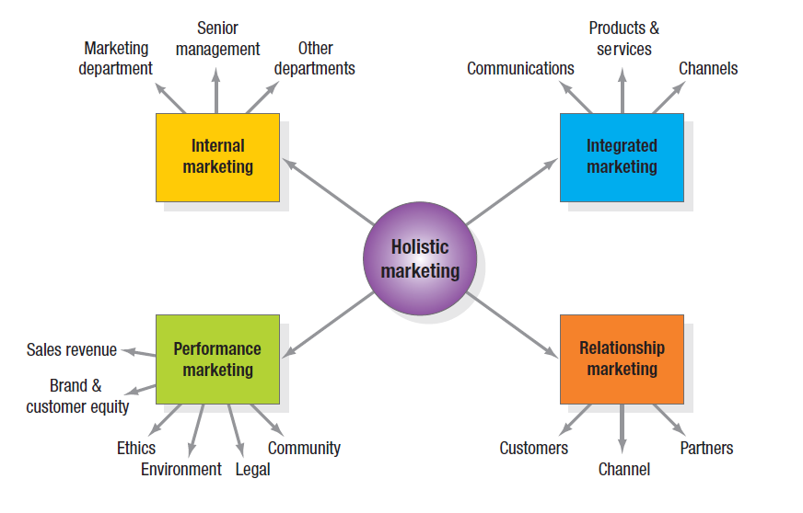

  - Feasibility Analysis of Holistic Marketing

Figure 3:Holistic Marketing Dimensions(Winata, 2020)
Holistic marketing enables businesses to be viewed as unified entities,considering all aspects and components as a whole.By taking a holistic marketing approach and aligning various business processes,the businesses can provide a consistent and seamless customer experience across all of the channels (Winata, 2020).Apple is an illustration of a company that heavily relies on holistic marketing principles in its operations.It is evident that Apple successfully implements this strategy as it ensures that every aspect ,from customer centric product development to the stores being branded in a recognizable in innovation and humanities,providing extremely prompt efficient ,and polite customer service.Apple could be considered a master in utilizing holistic marketing.
Tesla and Apple share striking similarities when it comes to their brand image and the impact of their founders. In the eyes of the public, Apple is often associated with Jobs, but its marketing acitvitives do not rely no Jobs.On the other hand,it continues to allocate significant funds towards advertising on various social media platforms such as television channels, Twitter, and YouTube. Therefore, applying Reasoning By Analogy, it is feasible that Tesla, while benefiting from Musk's influential presence, leverages a comprehensive marketing strategy to establish a similarly powerful brand image.

5.2 Recommendation 1: Internal Marketing
It is necessary to re-establish a professional marketing department that embraces the core values of the company. Marketing organization is the interface of the firm with its markets and where the work of marketing gets done(Dajah, 2022).It enables the seamless coordination of all facets involved in implementing the social marketing strategy, thereby enhancing the effectiveness of strategy execution. On the other hand, it should strive to create top brand marketing content, directing consumer attention towards Tesla's products and its social responsibility initiatives, thus cultivating a strong and distinctive brand identity, and gradually reducing the reliance on Musk's influence within Tesla.

5.3 Recommendation 2: Integrated Marketing
Integrating marketing channels can expand brand awareness to more customers. Companies like Samsung enhance their global brand presence through an integrated approach that appeals to a wide range of customer segments(Zebal,2019). Tesla can also adopt a similar approach by integrating diverse social platforms that attract customers who are interested in gaming and sports and others.
Additionally, allocating resources to traditional advertising can further enhance credibility,because it has a broader reach and is supervised to regulations, making it effective in dispelling consumer concerns regarding features such as autonomous driving.In summary, integrating marketing channels reduces reliance on social media while reaching a broader audience, thereby contributing to sustained sales.

5.4 Recommendation 3: Performance Marketing
The core of performance marketing is to build a stronger brand image. Tesla should implement corporate-level social responsibility strategy and embrace the positioning of sustainable development, combine technological innovation and and leverage the fusion of technological innovation and environmental responsibility as compelling selling points for its products.By ingraining the brand as "innovative and environmentally conscious" in the hearts of consumers, Tesla can reduce Musk reliance on personal influence. In addition, Big Data Analytics can enhance marketing efforts and strategies, leading to improved accuracy and efficiency(Singh, 2016).On one hand, it enables the collection of a substantial volume of data for marketing performance analysis to evaluate the effectiveness of current marketing strategy，and on the other hand,it beneficial to analyze the users preferences,enabling targeted communication of Tesla's environmentally friendly initiatives to environmentally conscious individuals. gaining potential consumers and cultivating the loyalty of Tesla consumers.

5.5 Recommendation 4: Relationship Marketing
The prupose of the relationship marketing strategy is to establish sufficient connections among key stakeholders,By cultivating excellent relationships, ,The business has valuable opportunities to enhance its prospects for success in the targeted markets. (Pluta and Rudawska, 2016).It is important to deal properly with customers, the media, and even competitors(Ibrahim and Harrison, 2020).Firstly, companies can no longer ignore criticism and customer indifference,instead,utilizing the company's marketing methods to adress various public crises, rather than using internal communication.which will helps protect the brand image. In the case of the rights protection incident that occurred at the Shanghai Auto Show in China in 2021, the executives responded inappropriately, leading to an official apology from Tesla as the ultimate outcome. It is essential to promote through mainstream media platforms. Because of Musk's "delayed" advertisements, the relationship between Tesla and the traditional media sector has suffered, resulting in a multitude of negative advertisements from the traditional media sector. Investing more in paid advertising is one way to improve relationships and gain resources.Lastly, it is imperative for Tesla to persist in establishing mutually beneficial collaborations with its competitors to achieve a win-win situation(Suprun, Petrishina, and Vasylchuk, 2020). The company should uphold its corporate social responsibility, prevent from utilizing aggressive marketing skills or other similar strategies, and encourage all electric automobile manufacturers to prioritize competition based on product performance. Reference made to the "Letter of Commitment to Maintain a Fair Market Order in the Automobile Industry" which has been signed by Tesla, along with other manufacturers, in China in the year 2023.

- References

Alanazi, F. (2023) ‘Electric Vehicles: Benefits, Challenges, and Potential Solutions for Widespread Adaptation’, Applied sciences, 13(10), p. 6016–.

Available at: https://doi.org/10.3390/app13106016.
Belova, T. and Dunin, M. (2023). "Evaluation of Enterprise Activity on the Basis of Holistic Marketing." Market Infrastructure.

Available at: https://www.researchgate.net/publication/369456622
Chen, F. (2022) ‘Analysis of key factors for Tesla’s success’, Proceedings of the 2022 2nd International Conference on Enterprise Management and Economic Development (ICEMED 2022). Dalian, China, 27-29 May. Paris: Atlantis Press, pp. 758-763.

Mukherjee, A. (2023). BYD Widens Gap with Tesla in Q3 2022, Leads Global EV Market.

Available at: https://www.counterpointresearch.com/global-ev-sales-q3-2022/
(Accessed 16 July 2023).
Dajah, S. (2022) ‘Holistic Marketing in Human Resources’, Journal of business & retail management research, 17(1).
Available at: https://doi.org/10.24052/JBRMR/V17IS01/ART-05.
Ibrahim, E.B. and Harrison, T. (2020) ‘The impact of internal, external, and competitor factors on marketing strategy performance’, Journal of Strategic Marketing, 28(7), pp. 639-658.Available at: https://doi.org/10.1080/0965254X.2019.1609571
Hoelzlhammer, A. (2018) A strategic audit of Tesla. Honors theses. University of Nebraska-Lincoln. Available at: https://digitalcommons.unl.edu/honorstheses/6/ (Accessed: 7 July 2023).
Han, J. (2021) ‘How does Tesla motors achieve competitive advantage in the global automobile industry?’, Journal of Next-Generation Convergence Information Services Technology, 10(5), pp. 573-582.
Available at: https://doi.org/10.29056/jncist.2021.10.09
Jiang, T. (2022) ‘A business model to analyze the Tesla based on SWOT analysis and POCD’, in Li, C.G., Lin, J.J., Huang, T., Abedin, M.Z. and Ahmed, S. (eds.), Proceedings of the 2022 7th International Conference on Financial Innovation and Economic Development (ICFIED 2022). Virtually online, 14-16 January. Paris: Atlantis Press, pp. 2896-2899.
Available at: https://doi.org/10.2991/aebmr.k.220307.471
Jahroh, S., Kamilah, K., Abdullah, A., Indrawan, R. D., & Sulistyo. (2023) Sustainability Business Model Tesla Motor, in Proceedings of the 1st International Conference on Innovation in Information Technology and Business (ICIITB 2022). Dordrecht: Atlantis Press.
Kuokka, J. (2021). The effect of social media activity on the market : case Elon Musk, evidence from the US. School of Business and Management, Kauppatieteet. Available at: https://urn.fi/URN:NBN:fi-fe202201209499.
Strawhecker, K. (2023) Tesla energy division strategic audit. Undergraduate honors thesis. University of Nebraska-Lincoln.
Available at: https://digitalcommons.unl.edu/honorstheses/616/ (Accessed: 7 July 2023).
Mangram, M.E. (2012) ‘The globalization of Tesla Motors: a strategic marketing plan analysis’, Journal of strategic marketing, 20(4), pp. 289–312. Available at: https://doi.org/10.1080/0965254X.2012.657224.
Mangram, M.E. (2012) ‘The globalization of Tesla Motors: a strategic marketing plan analysis’, Journal of strategic marketing, 20(4), pp. 289–312. Available at: https://doi.org/10.1080/0965254X.2012.657224.
Magretta, J. (2012) Understanding Michael Porter : the essential guide to competition and strategy. Boston, Mass: Harvard Business Review.
Merlo, O. et al. (2018) ‘The benefits and implementation of performance transparency: The why and how of letting your customers “see through” your business’, Business horizons, 61(1), pp. 73–84.
Available at: https://doi.org/10.1016/j.bushor.2017.09.007.
Motionlab Marketing. (2023). Tesla places two models in the world top 10 best-selling vehicles in 2022. JATO. Available at: https://www.jato.com/tesla-places-two-models-in-the-world-top-10-best-selling-vehicles-in-2022/
Pluta, A. and Rudawska, A. (2016) ‘Holistic approach to human resources and organizational acceleration’, Journal of Organizational Change Management, 29(2), pp. 293-309.
Available at: https://doi.org/10.1108/JOCM-11-2014-0210.
Phillips, P.J. and Pohl, G. (2022) Entrepreneurial decision and the strange behavioural economics of Elon Musk.
Available at : https://doi.org/10.2139/ssrn.4253679(Accessed: 7 July 2023)
Reimers, P. (2021) ‘The subsidized green revolution: the impact of public incentives on the automotive industry to promote alternative fuel vehicles (AFVs) in the period from 2010 to 2018’, Energies, 14(18), p. 5765.

Available at: https://doi.org/10.3390/en14185765.

Singh, A. (2021) Big data analytics for improved accuracy, efficiency, and decision making in digital marketing. Edited by A. Singh. Hershey, Pennsylvania: IGI Global. Available at: https://doi.org/10.4018/978-1-7998-7231-3.
Suprun, A., Petrishina, T. and Vasylchuk, I. (2020) ‘Competition and cooperation between fintech companies and traditional financial institutions’, E3S Web of Conferences, 166, p. 13028.

Available at: https://doi.org/10.1051/e3sconf/202016613028.
Saxena, N. and Vibhandik, S. (2021) ‘Tesla’s Competitive Strategies and Emerging Markets Challenges’, IUP Journal of Brand Management, 18(3), pp. 57–72.
Šević, J.S., Stakić, N. and Stakić, A.J. (2023) ‘Impact of Twitter on stock market performance: evidence from Elon Musk and Tesla’, in Bacanin, N. and Shaker, H. (eds.), Proceedings of the 1st International Conference on Innovation in Information Technology and Business (ICIITB 2022). Muscat, Oman, 9-10 November. Paris: Atlantis Press, pp. 47-52.

Sriram, A. and Jin, H. (2023) ‘Analysis: Elon Musk’s embrace of advertising at Tesla grabs marketers’ attention’, Reuters, 18 May. Available at: https://www.reuters.com/business/autos-transportation/elon-musks-embrace-advertising-tesla-grabs-marketers-attention-2023-05-17/ (Accessed: 7 July 2023).
Thomas, V.J. and Maine, E. (2019) ‘Market entry strategies for electric vehicle start-ups in the automotive industry – Lessons from Tesla Motors’, Journal of cleaner production, 235, pp. 653–663.
Available at: https://doi.org/10.1016/j.jclepro.2019.06.284.
Tesla. (2023). Impact Report. Available at: https://www.tesla.com/ns_videos/2022-tesla-impact-report-highlights.pdf
Winata, I.G.K.A., Sanjaya, N.M.W.S.,and Astana, I.G.M.O. (2020). Entrepreneurship Orientation and Holistic Marketing Mix in Creating Competitive Advantages Bumdes. Journal of Business on Hospitality and Tourism, 6(2), p.237.
Available at:doi.org/10.22334/jbhost.v6i2
Wu, A. (2022). Tesla’s Got the Keys: A History of Its Success.
Available at:https://www.investopedia.com/articles/personal-finance/061915/
story-behind-teslas-success.asp(Accessed 13 July 2023).
Yang, X. (2022) ‘Research on Tesla’s market—based on Porter’s five forces and ratio analysis model’, Proceedings of the 2022 2nd International Conference on Enterprise Management and Economic Development (ICEMED 2022). Dalian, China, 27-29 May. Paris: Atlantis Press, pp. 773-777.
Available at:https://doi.org/10.2991/aebmr.k.220603.125
Zebal, M., Ferdous, A., and Chambers, C. (2019). An integrated model of marketing knowledge – a tacit knowledge perspective. Journal of Research in Marketing and Entrepreneurship.
Available at: https://doi.org/10.1108/jrme-03-2018-0018

