Nursing Portfolio
Nikkeia Lewis
1703735

Contents Page
Introduction………………………………………………. Page 3
Reflection…………………………………………………. Pages 3 – 5
Personal Statemen…………………………………………Pages 6 – 7
Curriculum Vitae…………………………………………. Pages 8 – 10
Certificates………………………………………………… Pages 11 – 16
Disclosure Barring Services certificate……………………. Pages 17 – 19
Evidence…………………………………………………… Pages 20 – 21
Smart Action Plan…………………………………………. Pages 22 – 24
References…………………………………………………. Page 25

Introduction
I am a student currently studying Nursing studies and Health at University of Wales Trinity Saint David. After my one-year course and gaining my higher education certificate in Nursing studies and Health I am hoping to gain a place in Swansea University to become a qualified Midwife. I enrolled on this higher education course to improve my chances of gaining a place in university for Midwifery. Currently I am working as a health care assistant for HC-One and am working towards my level two NVQ. I have gained many certificates during training, such as, manual handling and medicine management. I undertook five weeks of training in preparation for starting my job as a healthcare assistant. This training allowed me to gain multiple certificates within care and shows my employability for future references within the nursing role.
Reflection
To reflect on my work experience, I will be using Gibbs reflective cycle. This involves 5 stages;
- Description of the event.
- Feelings on the event.
- An evaluation on the event.
- Conclusions on the event.
- Actions to be taken if the event was to occur again.
The best learning is done through experience. The best way to do this is to reflect on experience and how it could be done better in the future. This is where Gibb’s reflective model becomes useful to help to make sense of the situation, to gain a better understanding of what went well and what could be done to better improve the experience (Mind Tools 2019).
Before starting my job as a health care assistant, I undertook five weeks of training. This consisted of e-training using an online software called touchstone. This is used by the HC-One company for all new members of staff in order to gain certificates within care to become more appropriate for the role. After completing several modules for my e-training I had six shadow shifts within the nursing home to prepare me for the job. During my shadow shifts I was given a list of tasks that I needed to complete to show my capability within the role. During this I was paired with a senior member of staff that was allocated the role of training me in everything that was required of me throughout the day. After five weeks of training I was able to be confident in starting alone. I decided to apply for this role as it would give me the experience, I needed in order to become more employable for the future.
Before my training I felt very anxious as I was unsure of what to expect as this was a very new experience for me. Feeling anxious can be characterized by extreme uneasiness of the mind or a brooding fear of something to come (Merriam-Webster 2019). During training I felt very stressed as it was a lot to take in within a short space of time, as defined by Medicine Net Inc. (2018) stress involves factors such as physical, mental, or emotional which may cause bodily or mental tension. There are many symptoms of stress, one symptom that I experience was tension and feeling irritable throughout the day. However, I was reassured by the team that this was normal for all new members of staff. Once my training was completed, I felt relieved as I was able to start the job with all the correct certificates. I feel that this training helped me to better understand what was is expected of me in a health care assistant role. This will allow me to work better within the company as I have full understanding of the knowledge needed.
The positives of this situation was that I was gaining several certificates within healthcare to improve my employability within the healthcare sector. I feel it also shows my dedication to any job that I pursue as I was able to continue with my studies at University whilst training for a new job role. As well as the positives I feel that whilst studying and training for my new role it caused a lot of stress and may have affected the quality of my work. However, I feel that I was able to keep a health balance between the two and continue in completing assignments to the correct deadlines.
If a similar situation was to occur again, I would manage my time better and balance my work life and my University life with a bit more consideration as to what is the most important and what thing need to be completed first. This will improve on the quality of my work overall.
For this to be a more positive experience I feel that I could have scheduled my training for after I have completed my Nursing studies and Health certificate, this was I would have been able to focus solely on my assignments and then on my training afterwards. To be able to handle this type of situation better in the future I believe I need to develop my time management skills. Time management is referred to managing time effectively for the right time to be allocated to the right activity (Management study guide 2019). Time management is important for students as it allows to develop the skills needed to prioritize work and to allocate the time needed to complete any work (Learning works 2019).
Within my personal statement I have mentioned that I have empathy skills. Having empathy is defined as the ability to understand and share feelings of another (Greater good magazine 2019). This is an important skill to possess within the healthcare sector and will benefit me in a career in Midwifery as I will be able to empathize with all the patients which will allow them to feel less anxious. I have also mentioned my communication skills; this is the ability to communicate effectively with others (The balance careers 2019). This will be essential when working as a Midwife as I will not only be communicating with the patients but also other healthcare professions. Communication is a key skill to have within the healthcare sector as this is essential when making good diagnosis’ and helping all patients feel safe with the healthcare they are receiving.
Within my Curriculum Vitae (CV) I have mentioned that I am highly motivated, this is defined as someone having an interest or enthusiasm for something (Cambridge Dictionary 2019). This is a desirable skill within the healthcare sector as it will show my keen interest in becoming a Midwife. Alongside this I have also mentioned that I am highly dedicated, dedication is defined as devoting or setting aside for a particular purpose (Merriam Webster 2019). This is a good skill to have when working as a Midwife as it shows confidence in the job. It also portrays that I am willing to dedicate my time and effort to the job and am willing to work to the highest potential. As well as dedication I have mentioned that I am a highly caring individual, this is a highly important skill to have in the healthcare sector. This is important as it is the core of the profession as a Midwife and will help for the patients to feel as though they are having the best possible care.
I have included my Disclosure and Barring Services (DBS) in my nursing portfolio as this is essential to have when working as a Midwife or any other healthcare profession. This certificate shows that I am suitable to work with vulnerable adults and children within the healthcare services and will not be dangerous to the patients or any others that I encounter. The use of a DBS is so that employers can make safer recruitment choices and prevent unsuitable people from working within the healthcare sector. Having a DBS will show if the individual has any criminal records or are on any barring lists which may raise concern when working with vulnerable people (Educare 2016).
Gaining evidence of the hours that I have done so far as a healthcare assistant was difficult as I was not yet a fully enrolled employee. This means I was still in training and was not logging the hours officially to receive a pay slip. Alternative to this was a written letter from the manager of the nursing home, however after trying to get into contact multiple times the manager was unable to complete a formal letter in time. This was due to the high demands of the nursing home as several members of staff were taking ill all at once and caused a strain for all workers.

Personal Statement
Nikkeia Lewis
UCAS number: 1277902705
Working within Midwifery is the only profession I have ever wanted to have. I feel ready to start my journey in working towards achieving this and I am very much looking forward to starting my studies in something that interests me immensely. I feel I now possess the skills and qualities needed to study Midwifery. After spending two years studying A levels I decided to work as a carer to gain some clinical experience. This required me to take care of the elderly and gave me an insight into what it may be like caring for others daily. This is where my passion for gaining a career in Midwifery grew as I gained several skills that I think would help me in my studies.
During my time as a care worker I gained good communication and empathy skills, I feel these would be essential when working within Midwifery and are very important skills to have when caring for others. When working within Midwifery you inevitably come in to contact with family member as well as the patient, I was able to do so when working as a career, therefore conveying my communication skills further. During my time as a carer I was able to familiarize myself with the correct terminology used when working in a care setting which can then be transferred when studying for Midwifery.
When working in Midwifery you have the responsibility to assess the condition of the patient that you are caring for and make an informed decision based on your knowledge, I am able to reflect on my experience as a career and although not on the same scale, I am able to assess the patient in my care and make an informed decision even in stressful situations where I am required to stay calm and use my training to take care of the patient.
As a carer I have previously administered medication, advised and educated my patients as to the choices they must make to allow them to lead a better life at home. As well as this I have accurately recorded notes of each visit to allow for early detection of any problems that may arise also, I have logged mediations using an MAR chart, all skills that are transferable in maternity care.
Whilst working as a carer I decided I wanted to further my studies and start working toward my dream career. In order to do this, I decided to start studying Health and Nursing at UWTSD. I am currently in the middle of my studies and discovering a real love of learning, particularly in physiology. This course requires that I maintain a healthy work life balance, I am disciplined enough to study at home whilst having a part time job. During this course I have gained excellent organisational and time management skills as I have had to manage several assignments and ensuring that they are all completed to the correct deadlines. Whilst studying maternity care I will utilize my organisational and time management skills by working shifts as a career whilst also managing my studies.
So far during my time at UWTSD I have learned the process of evaluation and critical analysis, this will allow me to implement research in to practice when working in clinical settings. I am aware of the demands of the Midwifery programme and am looking forward to the experience and starting my journey in this career.
I appreciate the opinions of others as I will be working with a wide range of diverse cultural communities, it is important to understand the positive outcomes when working together as a team. I am a very compassionate and supportive person when caring for others, I believe this is very important when caring for all patients.
Employment in costumer services has helped me to enhance my ability to communicate effectively with others. It is inevitable that I will face challenging situations therefore this skill will help me to develop good relationships with women and their families to keep them at ease. I understand that working within maternity care is physically demanding when working long hours with the provision of 24-hour care. I am fully committed to my studies and am looking forward to expanding my knowledge on Midwifery.

Curriculum Vitae (CV)
Nikkeia Lewis.
72 Parkfields Road,
Bridgend,
CF31 4BJ
E-mail: nikkeia.lewis@hotmail.co.uk
Mobile: 07580531822 Date of birth: 11/02/1999
Key Achievements
Personal Profile
I am an enthusiastic, caring and highly motivated individual who is very keen to take on new challenges and skills. I understand and value the qualities that are required of a reliable and committed member of staff.

I have worked as a Waitress at The Haywain pub and restaurant for the past four years, and during that time I have gained several different skills. Throughout my time at The Haywain I have gained confidence in meeting and greeting customers as front of house and have also gained experience in how to serve customers behind the bar.
In the past four years I have acquired many different skills, which include expanding my knowledge in hospitality. I have been given several different responsibilities as a waitress, such as promoting and preparing desserts during Sunday service, which can be very busy and challenging. I have also been given the responsibility of front of house numerous times during my time working as a waitress, this has given me more confidence and taught me how to correctly seat tables and ensure that everything runs as smoothly as possible.
I have gained experience in customer service and am able to take control and manage various situations, such as organization of staffing and customer complaints, with efficiency and confidence.
I have also gained some experience in care work which was very rewarding and help me to improve on my interpersonal skills as I was required to take care of other and ensure that they were comfortable in their own home.
I have a full driving license.
EDUCATION
2018 – Present
Certificate in Health and Nursing at University of Wales Trinity Saint David – Pending results.

2015 – 2017
A Levels at Brynteg Comprehensive School Bridgend.
Welsh | D
Psychology | C
Welsh Baccalaureate | C

2013 – 2015
GCSE’s at Brynteg Comprehensive School Bridgend.
Physics | B
Sociology | B
Biology | B
Chemistry | A
Welsh | A
RE | A
Double Health and Social | B
English Literature | B
English Language | B
Maths | C
Welsh Baccalaureate | PASS

Employment History
April 2014 – April 2019 September 2017 – December 2017
Waitress Healthcare assistant
The Haywain Allied Healthcare

April 2019 – Present
Healthcare Assistant
HC-One Glanffrwd care home.
References
Kate St Claire Rob James
43 FRON HEULOG BRIDGEND The Haywain
CF31 4RP Coychurch Road, Bridgend
07473188166 CF31 2AP
katestclaire@hotmail.co.uk 01656 669945

In this section I have included my certificates for my role as a healthcare assistant. These will help me in my career as a Midwife as they show that I have gained many skills and attributes that are required to work in the healthcare sector. I have also included the qualifications that I posses relevant to health and social care.

Certificates
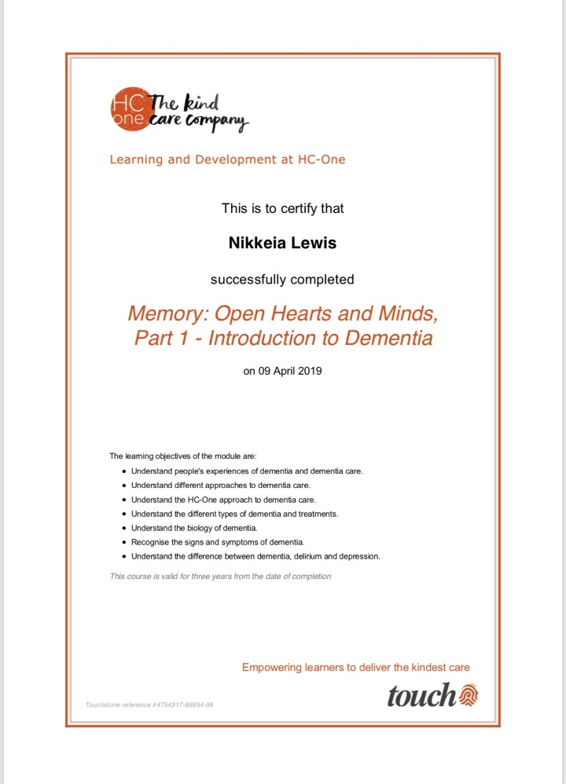

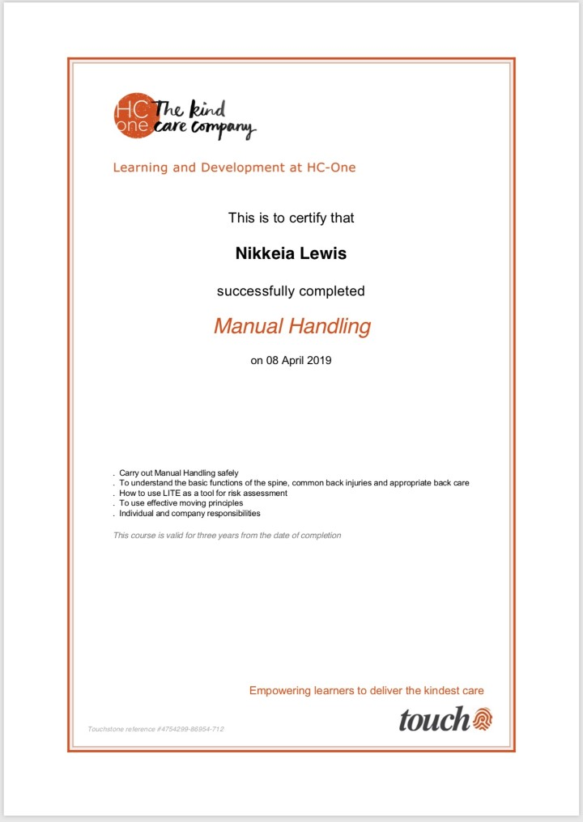

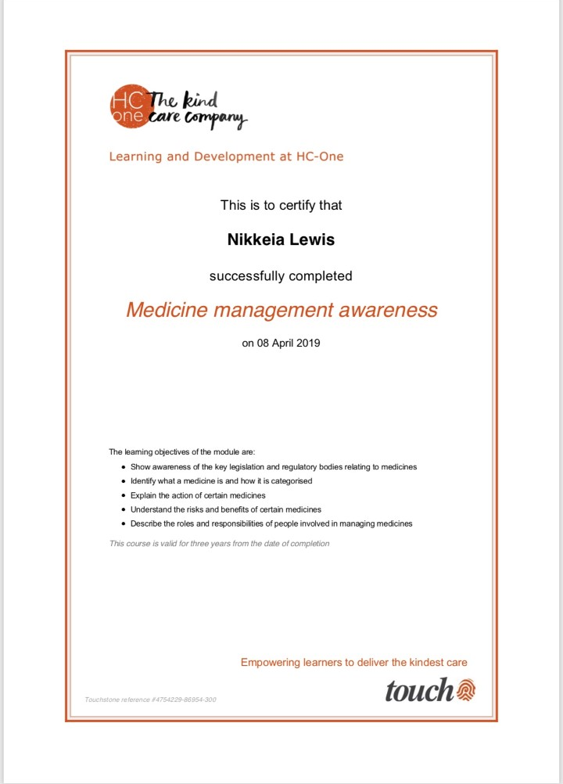

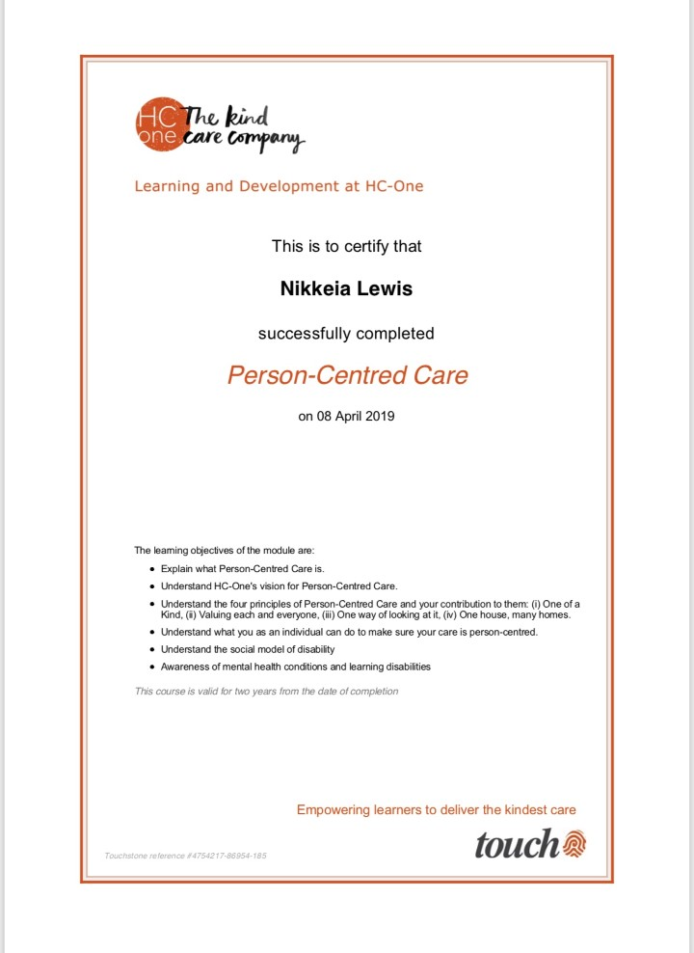
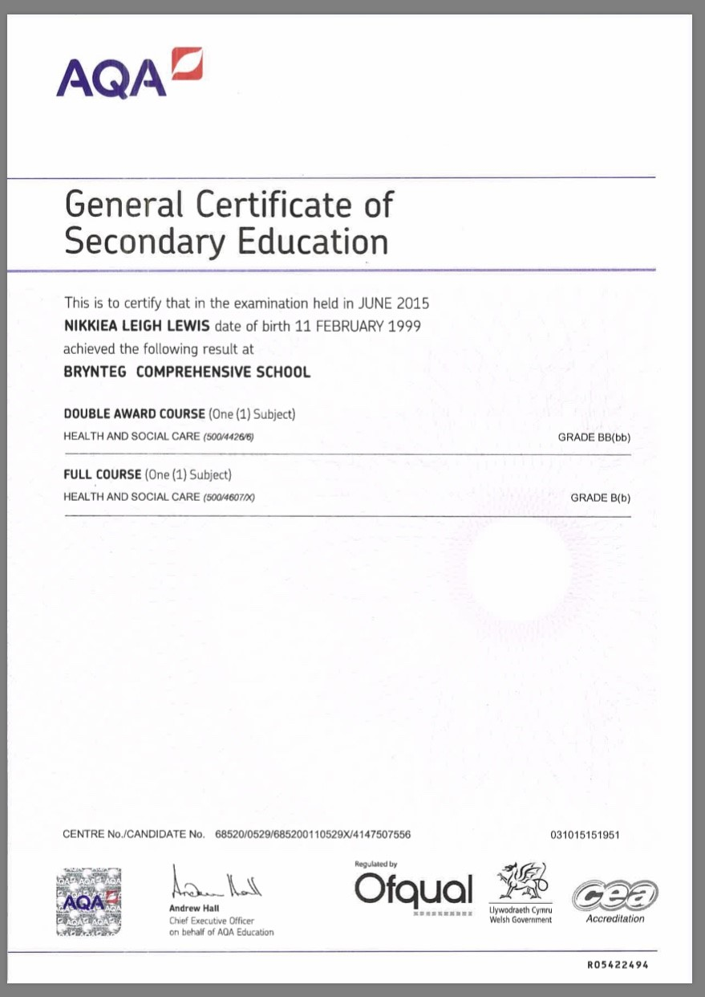

In this section I have included my DBS certificate. This is important for any healthcare profession as it shows that I can work with a diverse group of people.

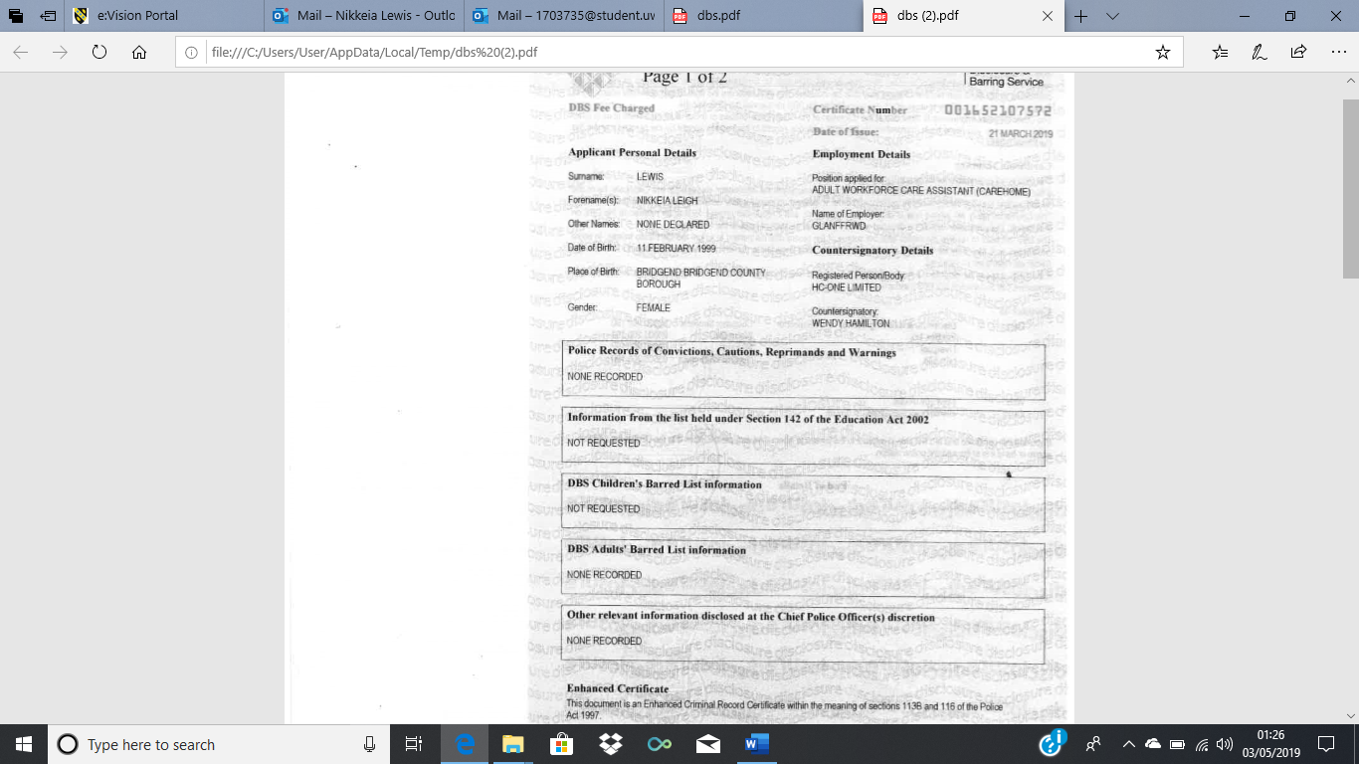

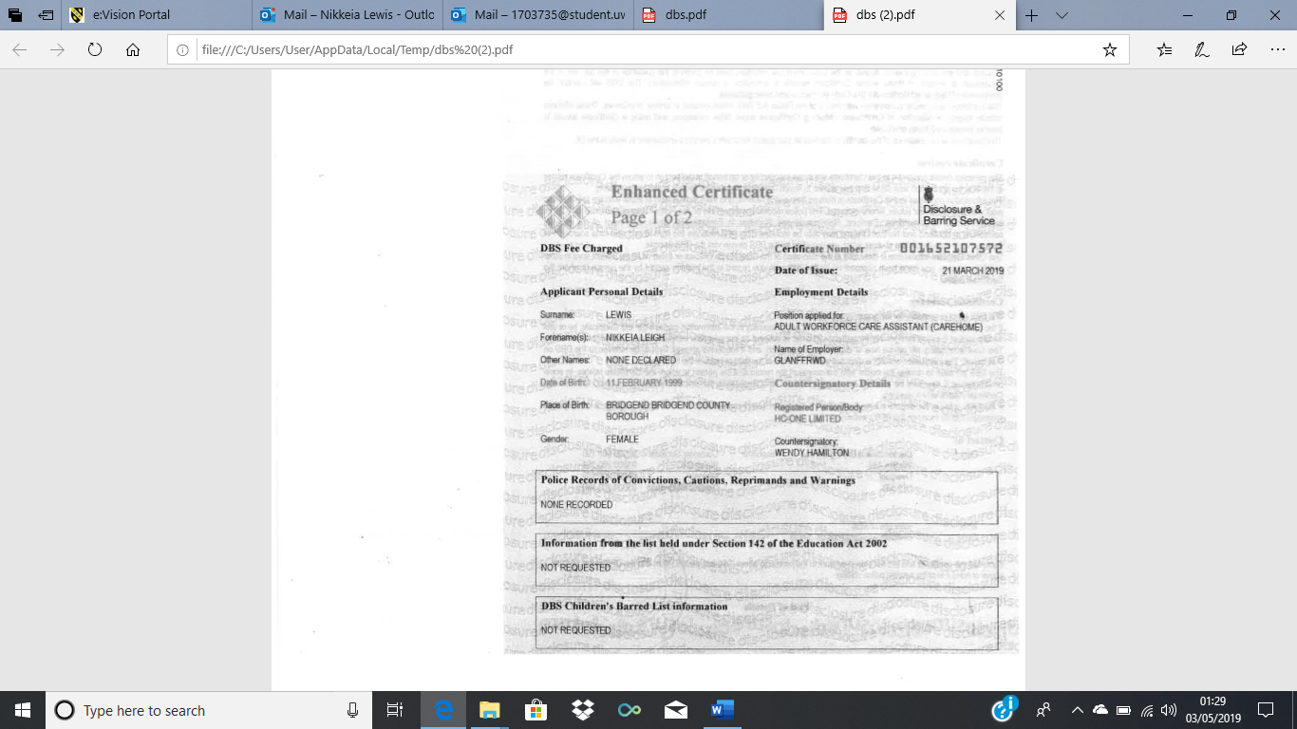

In this section I have included evidence of communication I have received for my job as a healthcare assistant.

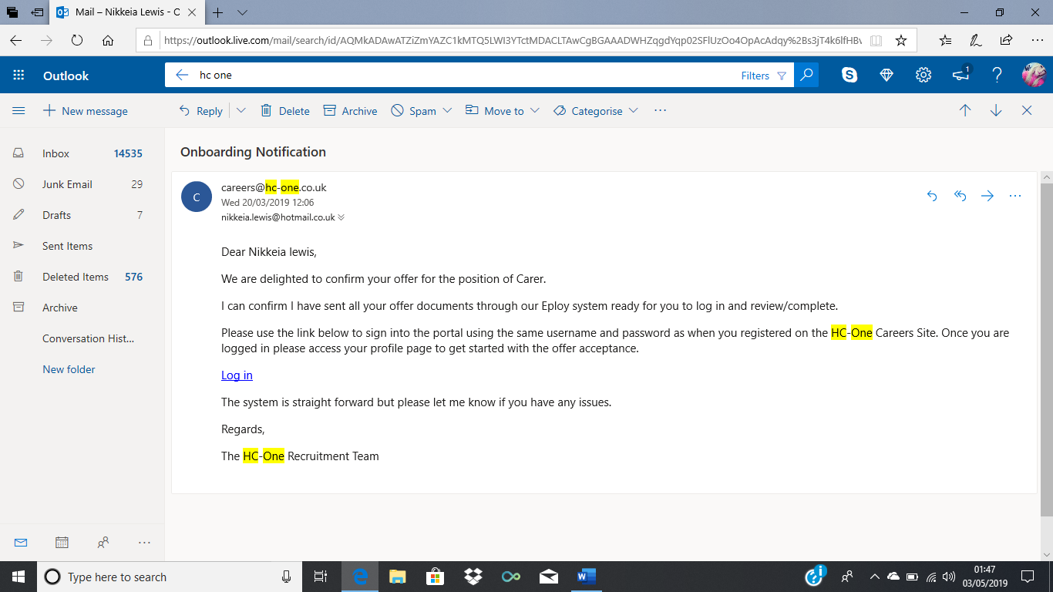
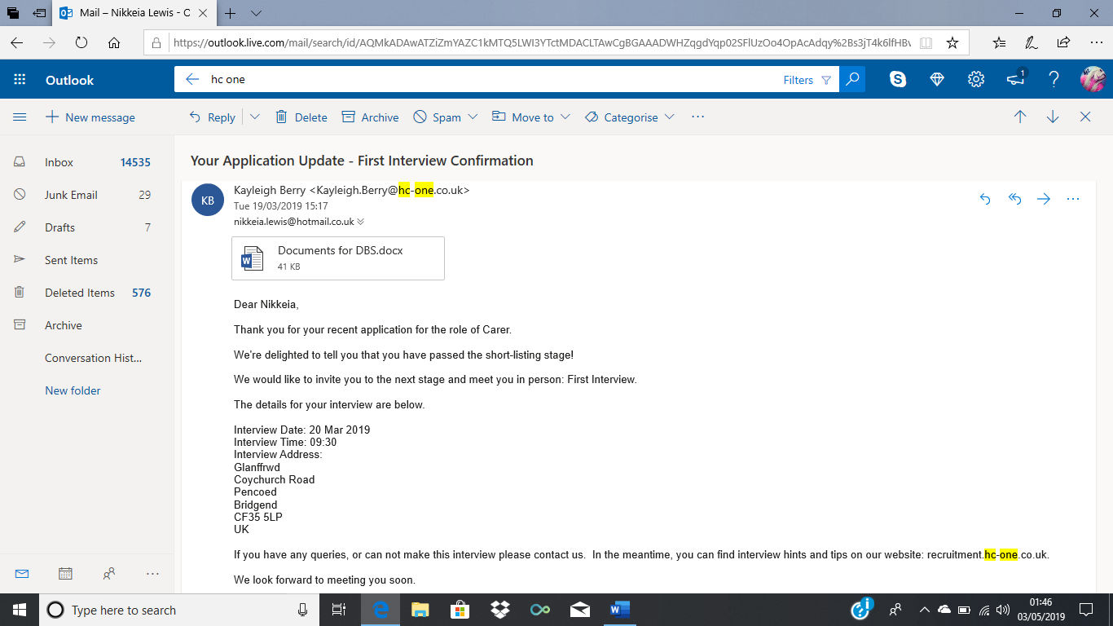

Action Plan
Long Term Goal | Deadline for completion
Become a qualified midwife | 5 years

Short Term Goals (SMART)

Goal 1: Pass my Health and Nursing course.
Specific | I will aim to pass my Health and Nursing course and University of Wales Trinity Saint David (UWTSD) and gain my certificate after graduation. This is important as it will improve my chances of gaining a place on a midwifery course in the future. To ensure I pass I will make sure all my assignments are completed to a high standard and I will also ensure that I revise thoroughly for all exams to ensure high results.
Measurable | The outcome of this goal is to graduate with a certificate in Health and Nursing. I will know I have achieved this goal once I have successfully completed all assignments and exams to a high standard and gained my certificate at graduation. The evidence I will have to show I have achieved this goal is my grades I will receive at the end of the course.
Achievable | To achieve this goal, I will need help from my lecturers to ensure I completely understand what is being asked of me, this will help me to complete all my assignments to a high standard. For me to pass my assignments and exams I will use all relevant books from UWTSD library, I will also use google books as a resource to ensure I have the best references within my assignments. I will also use Moodle on the UWTSD website as this will give me relevant guidance from all lecturers. All these resources will help me to complete my work to the best standard. Potential barriers to achieving this goal is that I may feel under pressure when given several assignments at one time. This may cause a lot of stress and may affect the standard of my work. To overcome these barriers, I will ensure assignments are completed before deadlines given, ensuring they are all complete in order of importance.
Realistic | This goal is relevant to my long-term goal as it will improve my chances of gaining a place on a midwifery course in the future. This goal is achievable for me as I have a lot of support in passing the course. This goal is realistic to me as I can use many resources in order to help me.
Timescale | The time frame to achieve this goal is a year as that is the length of the course. I will check my progress regularly every term to ensure that I am on track to gaining my certificate. The target deadline for this goal will be May of 2019 as this is when the course ends.

Goal 2: Getting a place on a midwifery course at university.

Specific | I want to gain a place on a midwifery course at university to become a fully qualified midwife. This is important as this will help me to achieve my long-term goal of becoming a midwife. I will do this by successfully passing my Health and Nursing course and gaining a place on the maternity care course which will again improve my chances of gaining a place on a midwifery course as this will give me more experience and more relevant knowledge. After this I will apply through UCAS for midwifery and hope for interview offers.
Measurable | The outcome of this goal is to start a midwifery course at university. I will know I have achieved this goal after a successful interview and receiving an offer for midwifery. This will show when I have accepted any offers I receive.
Achievable | I will be able to achieve this goal with successful result from my Health and Nursing course as this will improve my chances of gaining a place on a midwifery course. I will need help from my lecturers to ensure my results show my potential, I will also need help to produce a personal statement in order to portray myself the best I can. I will also need help in improving on my confidence as this is essential to being successful in interviews. I have a lot of resources to help me to achieve this goal, for example, the UWTSD library where I can find books on how to produce the best personal statement. Potential barriers to achieving this goal is that I may not have the relevant experience to gain a place on a midwifery course. As this is a very competitive course, I will need to ensure I have as much experience as possible, I will need to contact hospitals and offer to volunteer on maternity wards to ensure I show how committed I am to become a midwife. I can get the best advice from lecturers and career advisors on what is the best way for me to gain relevant experience.
Realistic | This goal is relevant as it will allow me to become a qualified midwife. This will help me to achieve my long-term goal as it will give me the correct qualifications to do so. This goal may be difficult to achieve as midwifery is a very competitive course and it may take some time to gain a place. However, this goal is achievable as I am currently studying a course that will help to improve my chances on gaining a place on a midwifery course. This course will give me the foundations to carry on in my education and will help me to show my potential.
Timescale | The timescale of this goal is up to four years as midwifery is a three-year course and it may take some time to gain a place on this course. I’m hoping to gain a place on a midwifery course in 2021 after successfully completing the maternity care course.

Goal 3: Completing a midwifery course at university.

Specific | I want to become a qualified midwife after completing a three-year course at university. Completing a course on midwifery is important as this will help me to achieve my long-term goal.
Measurable | The outcome of this goal is to graduate after three years on a midwifery course and become a fully qualified midwife. I will know I have achieved this goal once I have completed my degree in midwifery. The evidence I will have that I have achieved this goal is graduating after three years with a midwifery degree.
Achievable | I will be able to achieve this goal with help from my lecturers to ensure that I fully understand what is being asked of me and to ensure I am on track to passing and being able to graduate at the end of the course. Potential barriers that may delay me achieving this goal is the competitiveness of the course, to overcome these barriers I will need to gain as much experience as possible in order to portray my commitment to the course. I will be able to have help from lecturers as they will be able to advise me on the best placements in order to ensure I am getting the most relevant experience.
Realistic | Completing three years on a midwifery course is relevant to my long-term goal as it will allow me to become a fully qualified midwife. This goal may be difficult to achieve as the midwifery course is very demanding and requires a lot of independent learning and many clinical shifts with long hours. This goal may be difficult to achieve; however, it is achievable as I am fully committed to becoming a qualified midwife and I am ready to commit to full time learning.
Timescale | The timescale to achieving this goal is up to four years due to the competitiveness of the course and how long it may take to gain a place on a midwifery course.

References
Cambridge Dictionary (2019). Meaning of motivated in English. Available at: https://dictionary.cambridge.org/dictionary/english/motivated (Accessed 2nd May 2019).
Educare (2016). Safer Recruitment: The Importance of DBS Checks within the Health & Care Sector. Available at: https://www.educare.co.uk/news/safer-recruitment-importance-of-dbs-checks-within-health-care-sector (Accessed 2nd May 2019).
Greater good magazine (2019). What is empathy? Available at: https://greatergood.berkeley.edu/topic/empathy/definition (Accessed 2nd May 2019).
Learning Works (2019) Why time management is important for student success at school. Available at: https://learningworksforkids.com/2013/11/why-time-management-is-important-to-your-childs-success-at-school/ (Accessed 2nd May 2019).
Management study guide (2019). Role of managers in inculcating time management skills in employees. Available at: https://www.managementstudyguide.com/time-management-in-corporates.htm (Accessed 2nd May 2019).
Medicine Net, Inc. (2018) Medical definition of stress. Available at: https://www.medicinenet.com/script/main/art.asp?articlekey=20104 (Accessed 29th March 2019)
Merriam-Webster (2019). Anxious. Available at: https://www.merriam-webster.com/dictionary/anxious (Accessed 2nd May 2019).
Merriam-Webster (2019). Dedication. Available at: https://www.merriam-webster.com/dictionary/dedication (Accessed 2nd May 2019).
Mind Tools (2019) Gibbs reflective cycle helping people learn from experience. Available at: https://www.mindtools.com/pages/article/reflective-cycle.htm (Accessed 2nd May 2019).
The balance careers (2019). Communication skills for workplace success. Available at: https://www.thebalancecareers.com/communication-skills-list-2063779 (Accessed 2nd May 2019).

