Component 2 – Research Report
  - Zerron Williams-Hankey
  - 2028383
  - Nauman Ali
LCHS4002_BIRM
Digital Skills and Research Methods

Table of Contents
1. Introduction 3
1. Research design 3
1.1. Research question 3
- Which digital tool is most used by students at UWTSD to Collaborate? 3
1.2. Method 4
Ethical Considerations 4
Results 4
2. Discussion. 8
References 10

Introduction
Within this report are researched findings of the most used and technology students can use to collaborate, asking inquiries to better the use of how and why the technology is employed at university. Some researchers have found that to include instructional technology into education for university students to be bold this can become quite challenging, (Hershock and lavaque-Manty, 2012). Using Ethical research to justify the means to the knowledge and data sourced, using the code of conduct to form and visualise plans and structures when trying to figure out how to extract and paraphrase secondary findings within academic and professional backgrounds, statistics showing students’ knowledge and skills of how the employment of digital tools has improved implementing digital tools in everyday activities , each technology application has its own unique purpose for when collectively collaborating (Kusano, et al., 2016)

Research design
Is a straightforward framework of assorted structural research methods and techniques, usually a set of knowledge and data accustomed to create a hypothesis that may increase relevant and ethical findings during a structured and productive way, combining the utilization of mixed methods identifying the most problems sourcing and researching using quantitative and qualitive data analysis to substantiate the complex nature of the information, a design helps give the first person better understanding , from different areas of study to hold out ethical research, (Creswell & Clark, )
  - Research question

- Which digital tool is most used by students at UWTSD to Collaborate?
. MS teams and Moodle are the most popular used digital tools students use when communicating with one another, UWTSD has platforms that help student collaborate with peers using digital tools such as Ms teams, Ms Excel, Ms Word, Moodle, and OneDrive, allowing students to have extended access to exceptional resources, students can create questionnaires that’s others can answer instantly through links and QR codes, the data collection from in-class questionnaires in keeping the questions relevant to the research question , , asking students for a response to collect and analyse the quantitative data ,inputting the information then into a spreadsheet on Ms Excel, students learn the way to use coding formulars that make quantitative data charts and graphs. In dong show shows they are able to confidently sources ethically.

  - Method
This research consisted of collecting data using quantitative research methods. relevant to the topic in question, how students used digital skills to collaborate at UWTSD, each class, students are taught how to use the digital tools collectively to extract and input data, also how to cross reference and analyse , during week 7 students were shown how to create a questionnaire using MS forms, using the resources provided by the university , the data collected by each student at one of UWTSD’s campuses based in Sparkhill, Birmingham, had to choose from a set of questions to create their own individual questionnaire using the different types such as closed questions, Likert, and ranking, being able to use the different types of question styles shows competence when using the applications ,after collecting responses from peers, students then imported and formulated data using the correct formats on Ms Excel
All evidence that is theoretical must be assessed within the real world, purely for ethical reasons, this refers to enquiry supported actual real-world evidence, review in this book it answers important topics like what does one research about? How does one collect sound evidence? And why it is important to gather factual evidence, (Wood, 1986), (Baron, 1997)
Other studies how who looked at research conducted first by a guy called Charles Booth one of the first social surveys, published in 1891 and 1903, his survey consisted of understanding the extent of poverty among the people working in London, (Spicker, 1990) and (Kimball, 2006) he collected primary and secondary data, took time to analyse the data to confirm the findings to be ethical, using different technique to collect his data. Such as survey graphs and charts where he asked over 100 people to participate.

Ethical Considerations
When conducting research, it is very important that the researcher is using the right codes of conduct, ensuring the participants engaging aren’t subject to any harm In any way, by obtaining full consent before proceeding with any practices or studies. Treating people fairly with respect, the knowledge gathered should be transparent and unbiased, providing sufficient information and assurance to the participants involved, fully informing is any implications that may occur, (Ramos, 1989) following the info protection act (1998) Research has shown that to find out from history researchers are more willing to incorporate the people being studied within the recordings of the projects. (Bell and Bryman).

Results
In groups of two, research was conducted to search out how accessible each software application is, by observing all accessible digital tool for collaboration, students can find resources for collaboration ideas in numerous sections on the appliance, using MS forms a questionnaire was created using Multiple choice, Ranking, Likert an rating questions, gained responses from other peers, identifying which applications were best suited to every person’s preferences, students used MS Excel to transfer the info into a workbook spreadsheet to analysis and understand the findings, learning a way to use formatting icons to regulate the data to confirm its accurate, using the information to form graphs to point out the statistical differences within the software and the way it’s used.

Understanding how the university can supply the best resources available, ready for collaboration, students to be included in the decisions of how and what applications are more helpful and efficient enough to use, makes them feel more valued, for students to feel confident in being able to plan research and analyse data effectively.
looking for ways that have proven to be efficient to an academic standard, using different research methods using the six principles as explained in the text above when extracting and cross-referencing books, journals and articles, ethical considerations such as being un-biased and open minded, thoroughly identify and linking the main key points to the research question could be, ensuring that the correct style of formatting is inserted, only including the data that was originally collected during the time of the survey, these are all important when conducting an academic report.
Below are graphs showing the responses collected in from the questionnaire created from using quantitative data methods such as creating surveys and forms to collect substantial amounts of responses to conduct quantitative research from how the data can be used? who the data can be collected from and what the information tells us? (Patton, 1980).
From theses graphs you can see how using primary resources following all ethical considerations can help address shared challenges students face when studying, and how best to see what can possibly be done to make the learning more beneficial for everyone’s needs.

  - Result Graphs
Is MS Teams helpful when communicating on group collaboration task?
Figure 1 a chart to show the responses to Q 1
Majority of students said yes MS teams is helpful when communicating with others when asked why they expressed that it is a straightforward application to use and navigate around, it also helps to interact instantly with peers.

- Do you use OneDrive more than other Digital tools to Collaborate with other peers?
Figure 2 a chart to show the responses to Q2
This graph shows the responses to the question 2, OneDrive being more often used than other digital tools, as they can store all work and collected data in one place, this makes is easier to access work.
- Rank these applications in order according to which ones is more beneficial for collaboration.
Figure 3 A graph that shows students reposes to Q3
All participants had to rank from first to last they would use when collaborating, this graph shows which applications they deemed as being more benificial for their own individual needs, Moodle being the most selected by students as it has everything nessacary for perfect collaboration and to access resoures to complete moduls, OneDrive being the least used in terms of being benificual as mentioned before OneDrive is a storgae application used to help keep all files and docuents in one place to be easlily retrieved.
- Moodle helps students have resources to Collaborate.
Figure 4 a chart that show students responses to Q4
Students were asked if Moodle helps when collaborating, majority said strongly agree, this shows students feel confident when using Moodle while others just agreed, nobody disagreed which shows that Moodle is an effective Digital tool
- Are you able to confidently use MS Teams to Collaborate?
Figure 5 a chart that shows the responses to Q5
This graph shows the common responses taken from the questionnaire; for question five, More than half of the responses were yes and only one said no.

Discussion.
During the 10 weeks, each session, students have learned how to co-operate and collaborate amongst themselves. Creating group presentations as part of component 1, where they had to explain how students use technology to collaborate at UWTSD showing competence in completing the work, using the guided help, when researching, the importance of following the code of conduct of formal rules such as transparency and flexibility with information and data, ensuring that good ethics and cultivating reflection can be used, being able to argue, why how and when, as in one article talks about being sensitive in the social process towards honest and ethical findings (Badham & Zanko, 2014).
This paper focuses on the fundamentals such as improvement of academical studies and how technology can be improved, this is done by firstly collecting data to have an idea of opinions, searching for facts and evidence to prove the points using quantitative research methods to quantify data , creating spreadsheets containing graphs and charts that simplify the popular interest that has been recorded, then formulated and converted from the responses received, by respondents who have participated on the questionnaire or, (Curry, et al., 2009)
Considering Charle booths research methods of adhering correct protocols when conducting research shows that ethics can be found if research is done properly, allowing students to have their own input when working alone, and with others like peer, staff, or lecturers at the university, this ensures that more students are able to confidently access and complete work more efficiently

Conclusion.

Looking at all the evidence and research methods, sourcing and collecting an efficient amount of information to give purpose and create findings to support the evidence, ensuring all primary and secondary sources are dependable and trustworthy, for the research to be conducted.
Both chapman and booth tend to follow the same approach when considering quantitative research methods such as the collection of data following ethical considerations when gathering the information through chosen methods, asking the right questions, this is somewhat dynamic for the growth in the educational industry when helping students to reach their full potential.
The way students use technology to collaborate is by understanding the assignments briefs but also extending the use of all software and resources on and offline to keep themselves knowledgeable to complete work to the university’s academic level. with the right teaching and guidance following the correct research styles using ethical considerations when creating the research design can provide better understanding of the module’s requirements. Asking for help and guidance when needed.

References
Anon., . Charles Booth (1840-1916) - a biography (Charles Booth Online Archive). [Online]
Available at: http://booth.lse.ac.uk/static/a/2.html#iv
[Accessed 5 8 2022].
Anon., . Qualitative vs Quantitative Research » Snap Surveys. [Online]
Available at: http://www.snapsurveys.com/qualitative-quantitative-research/
[Accessed 9 8 2022].
Badham, R. & Zanko, M., 2014. Ethics-in-practice in collaborative management research. [Online]
Available at: http://ro.uow.edu.au/cgi/viewcontent.cgi?article=1433&context=buspapers
[Accessed 11 8 2022].
Baron, D. N., 1997. Dictionary of Scientific Units, 6th edn. By H. G. Jerrard and D. B. McNeill. (Pp. ix+255; £19.99 paperback; ISBN 0 412 46720 8.) London: Chapman & Hall. 1992.. Journal of Anatomy, , 191(3), pp. 477-478.
Creswell, J. W. & Clark, V. L. P., . Designing and Conducting Mixed Methods Research. ed. (): SAGE Publications.
Curry, L. A., Nembhard, I. M. & Bradley, E. H., 2009. Qualitative and Mixed Methods Provide Unique Contributions to Outcomes Research. Circulation, , 119(10), pp. 1442-1452.
Hallman, S. K., Wright, M. C. & Conger, A. J., 2016. Development and Assessment of Student Creativity. TLTC Paper No. 2. CRLT Occasional Paper No. 33.. [Online]
Available at: https://eric.ed.gov/?id=ed573966
[Accessed 9 8 2022].
Kimball, M. A., 2006. London through Rose-Colored Graphics: Visual Rhetoric and Information Graphic Design in Charles Booth's Maps of London Poverty.. Journal of Technical Writing and Communication, , 36(4), pp. 353-381.
Kusano, S. M., Conger, A. J. & Wright, M. C., 2016. Development and Assessment of Collaboration, Teamwork, and Communication. TLTC Paper No. 4. CRLT Occasional Paper No. 35.. [Online]
Available at: https://eric.ed.gov/?id=ed573981
[Accessed 9 8 2022].
Patton, M. Q., 1980. Qualitative research and evaluation methods. [Online]
Available at: https://amazon.com/qualitative-research-evaluation-methods-michael/dp/0761919716
[Accessed 11 8 2022].
Ramos, M. C., 1989. Some ethical implications of qualitative research. Research in Nursing & Health, , 12(1), pp. 57-63.
Spicker, P., 1990. Charles Booth: the examination of poverty. Social Policy & Administration, , 24(1), pp. 21-38.
Wood, E. J., 1986. Dictionary of Scientific Units (5th Edition): By H G Jerrand and D M McNeill, pp 222. Chapman and Hall, London. 1986. £18 or £8.95 (pbk) ISBN 0-412-28090-6 or 0-412-28100-7 (pbk). Biochemical Education, , 14(4), pp. 176-176.
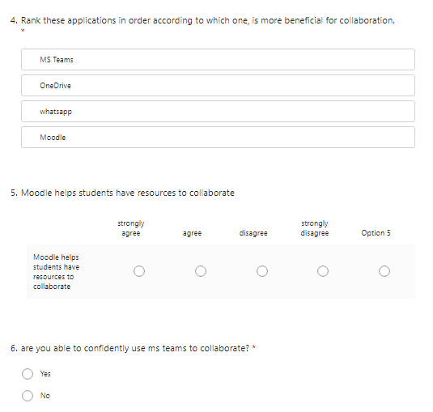
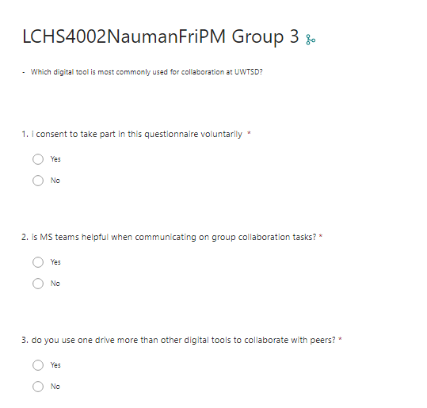
Appendix A – A blank copy questionnaire.

