ERMIYAS KIDANE ENDALE 1908586
PROBLEM SOLVING AND DECISION MAKING

Contents
Introduction: 2
The complex problem in the workplace: identifying problems, scopes and impact: 2
Alternative solutions to these problems: 3
Decision-making techniques to evaluate the solutions and identify the appropriate option: 4
Developing a plan for implementing the solution: 5
Communication plan: 5
Monitoring and reviewing the technique of implementation: 6
References: 7

Introduction:
For every business, it is more important to run a strong employee relationship that leads to employee satisfaction with the management. It also ensures better communication and helps to make a decision and run the proactive approaches to reach the further growth of the business. there is some specific reason that makes employee dissatisfaction like underpaid, overloaded work, less motivation and acknowledgement of work, poor management, limited growth of career, less opportunity to explore own skills and some others. So, it is important to identify these issues and make an effective solution by applying proper decision making and solving process to ensure strong and effective run of the business. This report describes the complex problem in the workplace and the best way to make a solution to this by evaluating the decision-making techniques.

The complex problem in the workplace: identifying problems, scopes and impact:
There are different internal and external issues that increase the scopes that raising the problem in the workplace and having impact into it. Different external issues that increase the complex problem in the workplace like- Brexit is the political issues that are having a high impact because Brexit causes the changes in legislation policies and also the tax issues. So, all the European workers need to count more tax to work in the UK that is having a direct impact on the business cost and employee-management relations. Different multinational companies employees have become dissatisfied with the Brexit decision but they have to maintain the decision and these issues increase the job dissatisfactions. Globalization is the biggest issues that are having an impact on the employee satisfaction level in the business. Globalization increases the chance of getting the job from anywhere in the world and even can perform different duties online that increase the job insecure issues between employees. There are different social and age groups people are in danger to lose their job because of their less updated skills. Using high technology, a new generation is using more updated technology that helps to reduce the manual work and mostly aged employees are seeking much insecure situation for this. Also, there are different changes in labour law also impact to the employee's satisfaction level because changes of labour law sometimes go again the traditional facility of employees that makes impact and reason of dissatisfaction of employees (Wilson, 2005).
There are different internal issues also increase the dissatisfaction of employees. Poor management shows poor relation and communication of employees in the business with management. So, employees cannot share their issues with the management directly that increases the chance of conflicts. Also, underpay are the biggest issues that management needs to consider the living costs, skills and performance to set the salary structure (Ali & Hadi, 2012). Poor management increases the scopes of this conflict and dissatisfactions too. Poor management reflects the less performance management that causes skilled employees are not getting much promotion and acknowledgement as per their skills. It causes highly dissatisfaction too that impact on their productivity in the business too.

Alternative solutions to these problems:
After identifying different issues that the root cause of employee dissatisfaction it is important to identify the proposed solutions of these problems before going to apply the full form of decision-making technique. Underpay, less motivation, poor management, labour law caches, Brexit, different internal and external issues are the root cause of employee dissatisfaction. There are different solution that can be applied by the management to increase the satisfaction level of employees
Management can provide efficient training to their employees about new technology that will help to increase the potentials and productivity of all employees. So, aged and semi-skilled employees will become more satisfied by getting the opportunity to learn the working process and they should feel more secure in their job after finishing the training.
Management needs to run with more efficiency. It is important to make changes in the organizational culture. Management should promote more performance management, acknowledgement of their higher-skilled employees. They should offer promotions, Pay rise to the high performed employees that will increase the positive challenges between other employees. So, it will lead to more productivity and engagement of employees with the business. So, according to the situation, the business needs to change its policies and process (Holloway & Lewis, 1995).
It is also important to take feedback from employees and make strong communication with employees. Management should make the working environment with fun that will increase more interest of employees and satisfaction level of them (Brinda & Bureau, 2016).
Job rotation is another reproach that management can choose. Working in the same field and approach for a long time can cause of boredom of employees. So, it is important to do job rotation and increase experiments of employees that will increase positive ideas and approaches of these employees too/

Decision-making techniques to evaluate the solutions and identify the appropriate option:
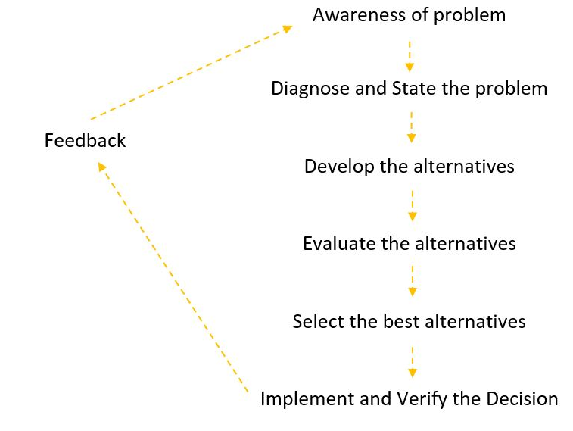
Image: decision-making techniques.
In the beginning, it identifies the cause of employee dissatisfaction like underpaying, poor management, fewer skills, globalization, political issues, technological progress and some other internal and external causes. Also, there are some alternatives of solution that shows as provide efficient training to increases skills of employees change the organizational culture to identify the demand of employees, job rotation, increase communication etc.
All of these are important but on the decision-making time, it is important to choose the best approach first and can make the priority list of using the other possible practices inputs in the organization to increase employee satisfaction (Kelly, 2019). Indeed, it is important to change the poor management concept and should update the management concept of most of the business hey should allow the benefits, pay rise, proper performance management, provide acknowledgement of employees skills, provides training and development program as per their employee needs and make strong and positive communication between employees to management in the business. Changes of the management view and approach can increase potentials of employees by providing training, boost up their motivation and confidence level, increase attachment with the business goal, give the proper direction of work, make acknowledgement of their work and run strong and effective communication.

Developing a plan for implementing the solution:
Development plan directly relates to the management, leadership, employees, performance, employee relation, culture, attitudes, motivation, reward and other related issues in the business. The development plan should show the current position and the future expectation by approaching with the successful plan, direction and monitoring. It is important for management to have a key idea about the complex problem first. This report shows that, poor management that causes the dissatisfaction of employees in the business. Different impact of poor management that increase the boredom of employees because employees are working the same duty for a longer period. They are not getting acknowledgement according to their performance that causes dissatisfaction too. Providing less raining and make updated of employees with the new technology that increases the fear of losing the job of mostly semi-skilled employees. So, these are the present situation at most of the business is having. So, development plan forecast is to increase the management approaches to provide training to their employees to make them skilful. Management needs to do effective performance management to acknowledge the performance and activity of each employee. Management needs to concern over the employee's rights and should evaluate the internal and external factors to increase the strong communication between employees.
The second phase of the development plan is the process consultation. Business needs to avoid unnecessary confirmation and approval from top management and should make immediate decisions. Management should run strong performance management and they can evaluate different performance management tool that will help to identify the individual performance in the business. So, they can use it as the guideline to provide the necessary training to their semi or unskilled employees. It will increase the productivity of these employees and reach a higher satisfaction level. Different employees might have different lacking so it is important to identify these and mostly business can provide on-work training to these employees that will increase their attachment with the business (Furnham, 2004). It is also important for management to make the decision to make changes and improve the overall culture of the organization. They should acknowledge the activities of employees like proved the reward as promotion, pay rise, benefits according to the performance of their employees that increases satisfaction level. It is also important to make the communication plan and monitoring plan in the development process to reach the goals and objectives of the whole development plan

Communication plan:
Communication plan helps to define the actions and timeline for the strong communication in the development plan. There are different reports and progress need to monitor and should communicate to implement the development plan. So, it is important to list out the stakeholder in groups, individuals and using the end-users of the whole activity. Sponsors, senior management also comes under this stakeholder lists. To define the monthly progress of the business there are different report need to send to the end-user as the senior management in the business so, these issues need to clarify. It is important to identify that who will receive the information, how the communication can be processed, the process to getting feedback and make the solution, team responsibility, sharing ideas and make effective monitoring and recording to ensure effective improvement (Lisa, 2016).
It is more important to provide different training about updated technology to employees in the business. so, the stakeholder in here is the employees of the business, top management, trainer, training institute if the business provides any external training, sponsors. Management needs to do performance management and identify the potentials of each employee according to their responsibilities. So, if this report shows the lack of experiment or knowledge about the change management concept or using the updated technology management should provide the training to these employees. So, management needs to make direct communication with these employees and ask for the training. They should give prior direction and arrange the training. If they are running the internal training they can hire a trainer or use their own trainers to run the training. There are different components that need to provide like the place, training equipment, time and other miscellaneous on the training time. So, management needs to link up with a trainer, trainees, sponsors, purchase team, finance and another responsible department in the business. There is a certain cost does the training program is having and management should evaporate the turnover of the training to the finance to get the fund for the training program (Chaplowe, 2008).
There should be a certain chain of triaging where employees should ask for training by management. Employees should report to the trainer according to the time period and process that set by the trainer. The trainer should update the report about the progress of employees to the management. Also, management needs to concern and communication with the finance and purchase team to get the incentives and necessaries of training on time. They can use email communication for reporting that will show the strong official document (Armstrong & Barton, 2004). Also, the trainer should provide the feedback in written format about the whole training and measure the performance of individual employees. So, management needs to keep this report as a monitoring and feedback log of the overall training.

Monitoring and reviewing the technique of implementation:
It is important to draw a proper plan for monitoring and reviewing. First of all, selecting the reporting is the key issues as communication plan shows the reporting system already. Trainers should report to the top management about the progress of employees in the business according to their performance (McPhee, 2006). Different stakeholders that identify like management, purchase team, finance department, trainer and others. So, it is important to ensure the clear communication between all the stakeholder that helps to get the right time delivery of components, promoting the right training, selecting the right trainers etc. it is important to track the progress systematic way and deliberate manner. It is important to do effective data collection to the monitoring policy and advice the best during the data collection process and make an effective composition of all the works to reach sustainable growth. Also, it is important to do regular reviewing and evaluate the outcome with more control in the whole system

References:
- Brenda, D & Bureau, E (2016). 5 ways to deal with dissatisfaction in the workplace. [Online]. Accessed from: https://economictimes.indiatimes.com/jobs/5-ways-to-deal-with-dissatisfaction-at-the-workplace/articleshow/55675474.cms?from=mdr accessed at [27th August 2020]
- McPhee, I (2006), ‘Evaluation and performance audit: close cousins or distant relatives?’, address to the Canberra Evaluation Forum, Canberra
- Furnham, A. (2004), Performance management systems, European Business Journal,
Vol. 16, Nr. 2, 83-94
- Armstrong, M & Baron, 2004, Managing performance: performance management in
action, CIPD, London\
- Holloway, J., Lewis, J. and Mallory, G. (Eds) (1995). Performance Measurement and Evaluation, Sage, London.
- Lisa, B (2016). Communication Plan. UCSC
- Chaplowe S. (2008) Monitoring and Evaluation Planning.” American Red Cross/CRS M&E Module Series. Washington, DC and Baltimore, MD. American Red Cross and Catholic Relief Services
- Wilson, J. P. (Ed.). (2005). Human resource development: learning & training for individuals & organizations. Kogan Page Publishers
- Ali, M., & Hadi, A. (2012). Surveying and identifying the factors affecting successful implementation of business strategies in companies of Fars province industrial towns (case study: companies of food industries). International Journal of Business and Social Science, 3(1), 265-272.
- Kelly, B (2019). Common workplace problems and how to deal with them. Harmony.



