

An Examination of How the “Early Help” System Is Signposted to UK Families by Local Authority Websites

Name: Abeer Al Qadhi
Student Number: 2410956
Course Name: Protecting and Supporting Families in Health and Care
Class Group: G2
Course Code: (BMHP5021_BIRM)
Lecturer Name: Gillian Weaver
Contents
Introduction 2
Explanation of the Early Help System 2
Explanation of Multi-Agency Working 3
Evaluation of Three Local Authority Websites 5
Leicestershire County Council 5
Leeds City Council 5
Southwark Council 6
Comparative Analysis of Strengths and Weaknesses 7
Conclusion and Recommendations 8
Reference List 10
Images Reference list 11

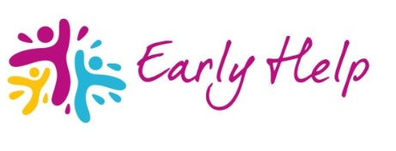
(Calderdale Council, 2025)

Introduction
Early Help is a key aspect of safeguarding in England, providing timely support to children, young people, and families as soon as difficulties emerge. By offering voluntary, proportionate, and supportive assistance, Early Help aims to prevent concerns from escalating to the point where statutory child protection or social care intervention is needed (Department for Education, 2022). National safeguarding guidance emphasises that early intervention can improve outcomes for children, reduce long-term harm, and strengthen family resilience (HM Government, 2023).
Local authorities are responsible for both providing Early Help services and ensuring that families can easily access clear, understandable information about the support available. Nowadays, local authority websites are frequently the first place families turn to for advice or assistance. Research indicates that the clarity, accessibility, and presentation of online information can significantly affect whether families seek help promptly or delay engaging with services, potentially increasing the risk to children (Munro, 2011)
This report assesses and compares how three local authorities: Leicestershire County Council, Leeds City Council, and Southwark Council, use their websites to signpost Early Help information. These authorities were selected to represent a range of geographical and demographic contexts. The report uses The Early Help System Guide and Working Together to Safeguard Children 2023 as key frameworks to guide the analysis where relevant. This report begins by explaining the Early Help system and the role of multi-agency working, followed by an evaluation of each website. A comparative analysis is then presented, before concluding with recommendations and a summary of key findings.

Explanation of the Early Help System
As defined in The Early Help System Guide, early help is support given to children, young people, and families as soon as concerns arise. This preventative approach focuses on identifying needs early and providing suitable, proportionate support to improve outcomes, rather than waiting until problems worsen or require legal intervention (Department for Education, 2022).
The primary aim of Early Help is to address difficulties before they escalate, thereby preventing the need for statutory child protection or social care intervention (HM Government, 2023). Early Help is a voluntary service, built on collaborative partnerships with families. It ensures that consent is obtained and that families actively participate in identifying their needs and agreeing on appropriate support. Early Help assessments are used to develop a comprehensive understanding of the child's situation, considering factors such as health, education, emotional well-being, parenting capacity, and family circumstances (Department for Levelling Up, Housing and Communities and Department for Education, 2022). Support provided may include parenting programmes, assistance with school attendance, mental health services, domestic abuse support, or guidance relating to housing and finances.
National initiatives, such as the Supporting Families Programme, emphasise the importance of early identification of family needs and the provision of coordinated support to prevent problems escalating into crisis or statutory intervention (Department for Education and Department for Levelling Up, Housing and Communities, 2022a).
Early Help forms part of the safeguarding continuum described in Working Together to Safeguard Children (2023). Through multi-agency collaboration and information sharing, it supports early intervention to reduce harm and promote children's welfare, and addresses concerns at the appropriate level before statutory intervention is required.
Given that Early Help is dependent on coordinated support from various services, effective multi-agency collaboration is vital to ensure families receive timely, integrated, and suitable assistance.

Explanation of Multi-Agency Working
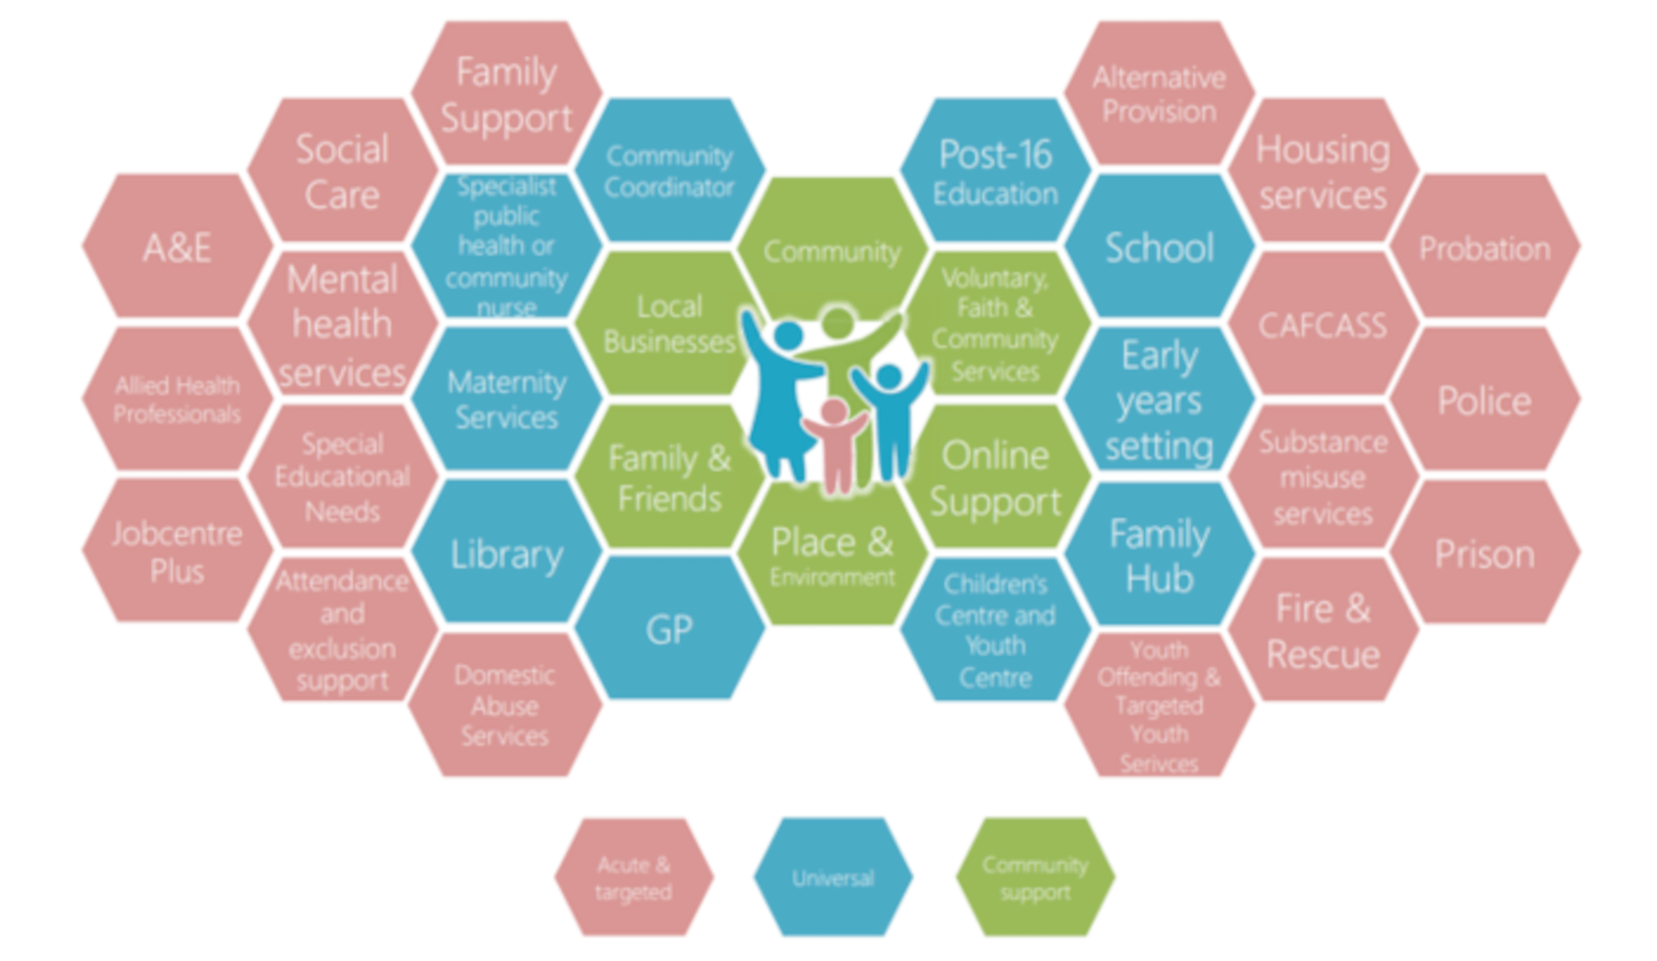
(Spinks, 2023)
Multi-agency working involves different organisations and professionals collaborating to safeguard children and support families. This is achieved through sharing information, coordinating interventions, and delivering integrated services. Within the Early Help system, multi-agency working is essential because families often face multiple, interconnected needs that a single service cannot effectively address alone (Walker, 2021).
Working Together to Safeguard Children 2023 emphasises that safeguarding is a shared responsibility, and that early intervention is most effective when agencies collaborate to identify concerns and provide timely support. The guidance highlights that multi-agency working enables professionals to respond to emerging needs at the earliest stage, thereby reducing the likelihood that concerns will escalate to statutory child protection intervention. As part of this wider safeguarding framework, Early Help operates below statutory thresholds, while remaining focused on protecting children's welfare.
In practice, multi-agency collaboration within Early Help involves professionals from various sectors, such as social work, education (schools), health (health visitors and general practitioners), and voluntary organisations. For instance, schools might identify early concerns regarding a child's attendance, behaviour, or learning and collaborate with Early Help services to provide support to both the child and their parents. Similarly, health professionals may identify physical or mental health concerns and share relevant information to ensure families receive appropriate support. Social workers and Early Help practitioners often coordinate this support, acting as the lead professional to ensure consistent and coordinated service delivery (Devon Safeguarding Children Partnership, 2026).
Effective multi-agency working helps to ensure families receive holistic support, rather than fragmented services. By sharing responsibility and expertise, professionals can collaborate to promote children's well-being, support families, and reduce the need for statutory intervention. This approach aligns with the preventative aims of the Early Help system (Cheminais, 2009).
Similarly, the Supporting Families Programme promotes a whole-family approach where local authorities and partner agencies collaborate to provide coordinated support for families experiencing multiple disadvantages (Department for Education and Department for Levelling Up, Housing and Communities, 2022b).
Given the importance of multi-agency collaboration in Early Help, it is essential to examine how effectively local authority websites communicate this support and direct families to the appropriate services.

Evaluation of Three Local Authority Websites

Leicestershire County Council
Leicestershire County Council provides information about Early Help within its Children and Family Services section. Early Help is defined as support for families facing challenges that do not meet the threshold for statutory social care intervention. This definition aligns with The Early Help System Guide and clarifies the preventative role of Early Help.
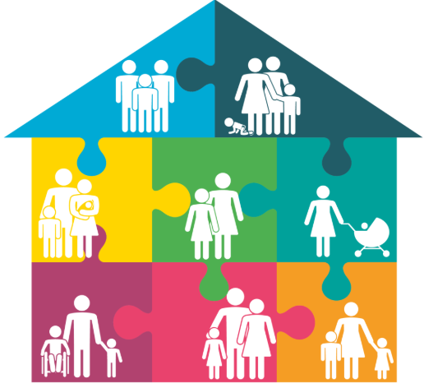
( Leicestershire County Council, 2026)
Early Help information is difficult to find on the website. It is not immediately visible from the homepage and requires several steps to locate. This may present a challenge for families unfamiliar with the website or those seeking support during stressful times. Furthermore, the formal and professional language used may be unclear to some families. Key terms such as 'thresholds' and 'assessments' are included, but without clear explanations, potentially reducing understanding (Sidebotham et al., 2016).
The website provides comprehensive information, particularly for professionals, outlining referral pathways and describing available services. However, information aimed specifically at families is less prominent. In terms of presentation, the website is largely text-based, with limited use of visuals or downloadable resources that might help families understand the Early Help process more easily.
Although clear contact details are provided, instructions on how families can self-refer are not prominently displayed. Overall, the website's main strength is its accurate and in-depth information. However, key weaknesses include limited accessibility for families due to complex navigation, professional language, and a lack of visual or user-friendly presentation.

Leeds City Council
Leeds City Council presents information about Early Help in a clear and family-centred way, incorporating it within a wider framework of "Families" and "Early Support". Early Help is explained in plain language, emphasising the provision of early support to prevent the escalation of problems, which aligns with national safeguarding guidance.
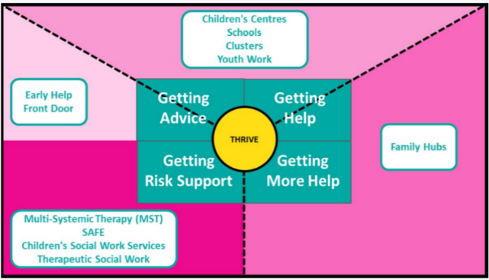
(Leeds City Council, no date)
Early Help information is easy to access via the family services section, which uses clear headings and a logical page structure. This enables families to quickly find the information they need. The use of straightforward language, avoiding unnecessary professional jargon, is a key strength, making the content accessible to a wide audience (Local Government Association, 2019).
The website offers extensive information about Early Help, explaining what it is, when it's suitable, and what families can anticipate after making initial contact. It also connects Early Help with other family support services, like parenting programmes and emotional wellbeing support. The website is well-structured with a clear layout, although it makes limited use of videos or other visuals.
Clear contact details and visible self-referral options encourage voluntary engagement and empower families to seek help directly. Overall, the Leeds City Council website is strong in its accessibility, clarity, and family-friendly design. A minor weakness, however, is the limited use of visual or multimedia resources, which could further enhance understanding.

Southwark Council
Southwark Council's Children and Families section provides detailed information about Early Help. This information, which includes safeguarding processes, assessments, and referral pathways, closely aligns with the guidance outlined in Working Together to Safeguard Children.
Early Help information is available, but its accessibility is limited because it is spread across multiple pages and sections. Families may have to navigate safeguarding content before finding the Early Help information they need, which could be a barrier. Furthermore, the professional and procedural language used may be difficult for families unfamiliar with safeguarding systems to understand (NSPCC Learning, 2023).
The website is comprehensive, offering detailed explanations of processes, the roles of different professionals, and available services. While this level of detail may be helpful for professionals, families might find it overwhelming. In terms of presentation, the website relies heavily on text, with limited visuals or simplified guides to aid understanding.
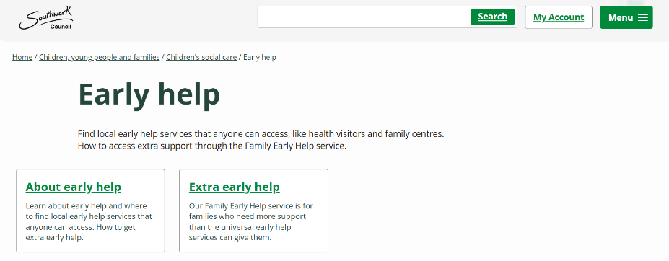
(Southwark Council, 2024)
While clear contact details and referral routes are provided, instructions for families on how to seek help independently are not always prominently displayed. The Southwark website's main strength is its detailed information, which aligns well with policy. However, its key weakness is a lack of family-friendly presentation, potentially hindering early engagement.
Overall, the evaluation indicates that, while all three local authority websites provide Early Help information in accordance with national safeguarding guidance, their effectiveness differs. Leeds City Council exhibits the strongest practice, presenting Early Help information in a clear, accessible, and family-friendly manner that encourages early engagement. Conversely, Leicestershire County Council and Southwark Council offer accurate and comprehensive information but place greater emphasis on professional processes, complex navigation, and less accessible language, potentially limiting usability for families. These findings underscore the importance of clear communication, intuitive website design, and a supportive tone in promoting early access to Early Help services.

Comparative Analysis of Strengths and Weaknesses
A comparison of the three local authority websites reveals distinct variations in how effectively they communicate Early Help information to families. While all three councils provide information aligned with national safeguarding guidance, there are considerable differences in accessibility, clarity, and overall user experience.
Leeds City Council exhibits the strongest overall approach. Its website presents information about Early Help in a clear, accessible, and family-friendly manner. Navigation is straightforward, the language is simple, and unnecessary professional jargon is avoided. Self-referral options and contact details are clearly visible, which supports voluntary engagement. This reflects best practice guidance, emphasising that clear and welcoming information encourages families to seek help early on. Furthermore, the integration of Early Help within a wider family support framework helps to normalise help-seeking and reduce stigma.
In contrast, while Leicestershire County Council provides accurate and comprehensive information, it places a greater emphasis on professional processes. Consequently, Early Help information is more difficult to find, and the use of terminology such as "thresholds" and "assessments" – without clear explanation – may reduce understanding for families unfamiliar with safeguarding systems. Improving navigation and simplifying the language used would enhance accessibility and the user experience.
Southwark Council provides the most detailed information, demonstrating strong compliance with statutory safeguarding frameworks. However, the complex website structure and extensive use of procedural language may overwhelm families seeking quick, clear guidance. Although comprehensive, the presentation could hinder early engagement.
Overall, this comparison highlights the importance of clarity, easy navigation, and family-focused language in supporting early intervention. Websites could be improved by reducing professional jargon, providing step-by-step guidance, and making self-referral routes more prominent. Prioritising user experience alongside policy compliance is essential to ensure that Early Help information is both accessible and effective for families.

Conclusion and Recommendations
This report examined how Early Help information is signposted to families through the websites of three local authorities. The evaluation and comparative analysis showed that, while all three councils provide information that aligns with national safeguarding guidance, there are notable differences in accessibility, clarity, and overall user experience. Leeds City Council was identified as the most effective website due to its clear navigation, simple language, and visible self-referral options, which support families in understanding and accessing Early Help at an early stage. In contrast, Leicestershire County Council and Southwark Council provide accurate and comprehensive information but rely more heavily on professional language and complex website structures, which may reduce accessibility for families.
Based on these findings, several practical recommendations can be made. Local authorities should ensure clear signposting to Early Help information from their homepage, using family-friendly terminology. They should prioritise plain language, clearly explaining key terms such as 'assessments' and 'thresholds'. To encourage voluntary engagement, self-referral routes and contact details should be prominently displayed. Furthermore, the use of step-by-step guidance, summaries, and simple visual aids could help families to better understand the Early Help process (Andrulis and Brach, 2007).
Clear, accessible online information is vital for supporting early intervention. When families can easily find and understand information about Early Help, they are more likely to seek support promptly. This contributes to improved outcomes for children and families, and supports the preventative goals of safeguarding practice.

Reference List
Andrulis, D.P. and Brach, C. (2007) ‘Integrating Literacy, Culture, and Language to Improve Health Care Quality for Diverse Populations,’ American journal of health behavior, 31(1), pp. S122–S133. Available at: https://doi.org/10.5993/ajhb.31.s1.16.
Cheminais, R. (2009) Effective multi-agency partnerships : putting every child matters into practice. 1st edn. London: Sage.
Department for Education (2022) The Early Help System Guide. Available at: https://assets.publishing.service.gov.uk/media/628de13be90e071f5f7e1bd2/Early_Help_System_Guide.pdf (Accessed: 20 February 2026)
Department for Education and Department for Levelling Up, Housing and Communities (2022a) Guidance Chapter 1: Introduction and objectives. Available at: https://www.gov.uk/government/publications/supporting-families-programme-guidance-2022-to-2025/chapter-1-introduction-and-objectives (Accessed: 21 February 2026)
Department for Education and Department for Levelling Up, Housing and Communities (2022b) Guidance Chapter 2: Delivering Supporting Families. Available at: https://www.gov.uk/government/publications/supporting-families-programme-guidance-2022-to-2025/chapter-2-delivering-supporting-families (Accessed: 21 February 2026)
Department for Levelling Up, Housing and Communities and Department for Education (2022) Early Help System Guide. Available at: https://assets.publishing.service.gov.uk/media/628de13be90e071f5f7e1bd2/Early_Help_System_Guide.pdf (Accessed: 21 February 2026)
Devon Safeguarding Children Partnership (2026) A guide to being an Early Help Lead Practitioner. Available at: https://www.devonscp.org.uk/early-help/early-help-information-for-workers/a-guide-to-the-right-for-children-system/a-guide-to-being-an-early-help-lead-practitioner/#:~:text=The%20lead%20practitioner%20is%20the,child's%20needs%20being%20met%20earlier. (Accessed: 21 February 2026)
HM Government (2023) Working Together to Safeguard Children. Available at: https://assets.publishing.service.gov.uk/media/6849a7b67cba25f610c7db3f/Working_together_to_safeguard_children_2023_-_statutory_guidance.pdf (Accessed :21 February 2026)
Local Government Association (2019) Early Help resource pack. Available at: https://www.local.gov.uk/sites/default/files/documents/15.66%20Early%20Help%20resource%20pack_May%202019.pdf (Accessed: 22 February 2026)
Munro, E. (2011) The Munro Review of Child Protection: Final Report A child-centred system. Available at: https://assets.publishing.service.gov.uk/media/5a7b455ee5274a34770ea939/Munro-Review.pdf (Accessed: 20 February 2026)
NSPCC Learning (2023) Early help and early intervention. Available at: https://learning.nspcc.org.uk/safeguarding-child-protection/early-help-and-early-intervention#:~:text=%3E%20Read%20our%20Why%20language%20matters,prepare%20them%20for%20adult%20life. (Accessed: 23 February 2026)
Sidebotham, P., Brandon, M., Bailey, S., Belderson, P., Dodsworth, J., Garstang, J., Harrison, E., Retzer, E., Sorensen, p. (2016) Pathways to harm, pathways to protection: a triennial analysis of serious case reviews 2011 to 2014. Department for Education
Walker, G. (2021) Working together for children : a critical introduction to multi-agency working. 2nd edn. Zed Books

Images Reference list
Calderdale Council (2025) Early Help Pathway. Available at: https://new.calderdale.gov.uk/schools-and-learning/parental-support/early-intervention/early-help-pathway (Accessed: 22 February 2026)
Leeds City Council (no date) One minute guide: Early help. Available at: https://www.leeds.gov.uk/one-minute-guides/early-help (Accessed 20 February 2026)
Leicestershire County Council (2026) Help for children and families. Available at: https://www.leicestershire.gov.uk/education-and-children/social-care-and-supporting-families/help-for-children-and-families (Accessed: 22 February 2026)
Southwark Council (2024) Early help. Available at: https://www.southwark.gov.uk/children-and-families/childrens-social-care/early-help (Accessed 29 February 2026)
Spinks, S. (2023) Supporting Families: Early Help. Available at: https://ssslearning.co.uk/safeguarding-articles/earlyhelp?srsltid=AfmBOopSnDN0Xn_1L42Ah00ee61DWh5TyO07JimAYRis6G1_bJ5TaIRI (Accessed: 25 February 2025)

