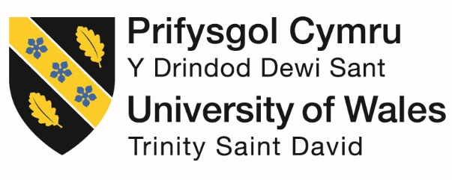



Name: Roxana Pesu

Student number: 2243649

Module Title: Management and Organisational Behaviour

Module Code: BMIH5004

Lecturer Name: Antoinette Milne

AI Declaration
To check the grammatical errors and proofread my report, I took the help of Grammarly on 17th February. However, I acknowledge that no AI-generated content being used in the report, and I have done the whole report.

Executive summary
This report aims to find out where Marriott International stands in the global hospitality business by looking at its environmental strategies, organisational structure, and planning. To respond to local markets while keeping things consistent around the world, Marriott uses a matrix structure that combines functional and regional models. Great customer service, new ideas, and environmental care are essential to the company's mindset. The main goals are to improve the Marriott Bonvoy loyalty program, test sites for environmental compliance, and lower the amount of carbon emissions they produce. As the report explains, Marriott's plan mainly focuses on going digital and caring for the environment. The last part of the report recommends how to get a competitive edge in the field by better training staff in ethics and personalising technology.

Table of Contents
Executive summary 2
Introduction 4
Organisation Structure, Culture, and Goals 5
Recent Change Initiatives 8
Strategic Direction 10
Conclusion 11
References 12

Introduction
Overview of Marriott International: Marriott International Inc. is a world leader in the hospitality industry. It owns or runs well-known hotels, restaurants, and timeshare vacations, such as Courtyard, The Ritz-Carlton, and JW Marriott. The company offers many travel services, such as booking hotels, holiday packages that include flights and car rentals, and timeshares. Its other job is to operate the Marriott Bonvoy program. Marriott operates in North America, Europe, Africa, the Caribbean, Asia-Pacific, and Latin America. The company has its main office in Bethesda, Maryland, and employs about 148,000 people. After making 5.8% more money to $23.7 billion the previous year, Marriott reaffirmed its position as the world's biggest hotel chain in 2024.
Aim: To determine how Marriott International plans to reach its long-term goals and affect the hospitality industry, this report will examine its strategies, organisational structure, corporate culture, and sustainability strategies.
The report will look at everything about Marriott, such as its structure, management styles, company culture, goals (both corporate and individual to units), and the results of recent change initiatives to change things. It will also investigate Marriott's long-term goals, such as its strategies to protect the environment, become more digital, and get better recommendations to improve its reputation in the hospitality business.

Organisation Structure, Culture, and Goals
Organisation structure: The organisational system at Marriott International is a mix of functional and matrix elements. This structure makes it possible for the business to connect with local markets while maintaining a stable presence worldwide (Djurayeva, 2024). Marriott is organised through a grid that combines functional sections with regional oversight. This makes it easier for authority to flow both horizontally and vertically. Regional leaders oversee significant areas of the world, such as Greater China, the Caribbean, Latin America, and Asia Pacific, and submit any problem solutions to Anthony Capuano, the company's CEO. To keep operations running smoothly, each section has its functional structure, and each area has its functional divisions. The Ritz-Carlton JW Marriott are all examples of Marriott brands that use this decentralised approach to meet the needs of customers.
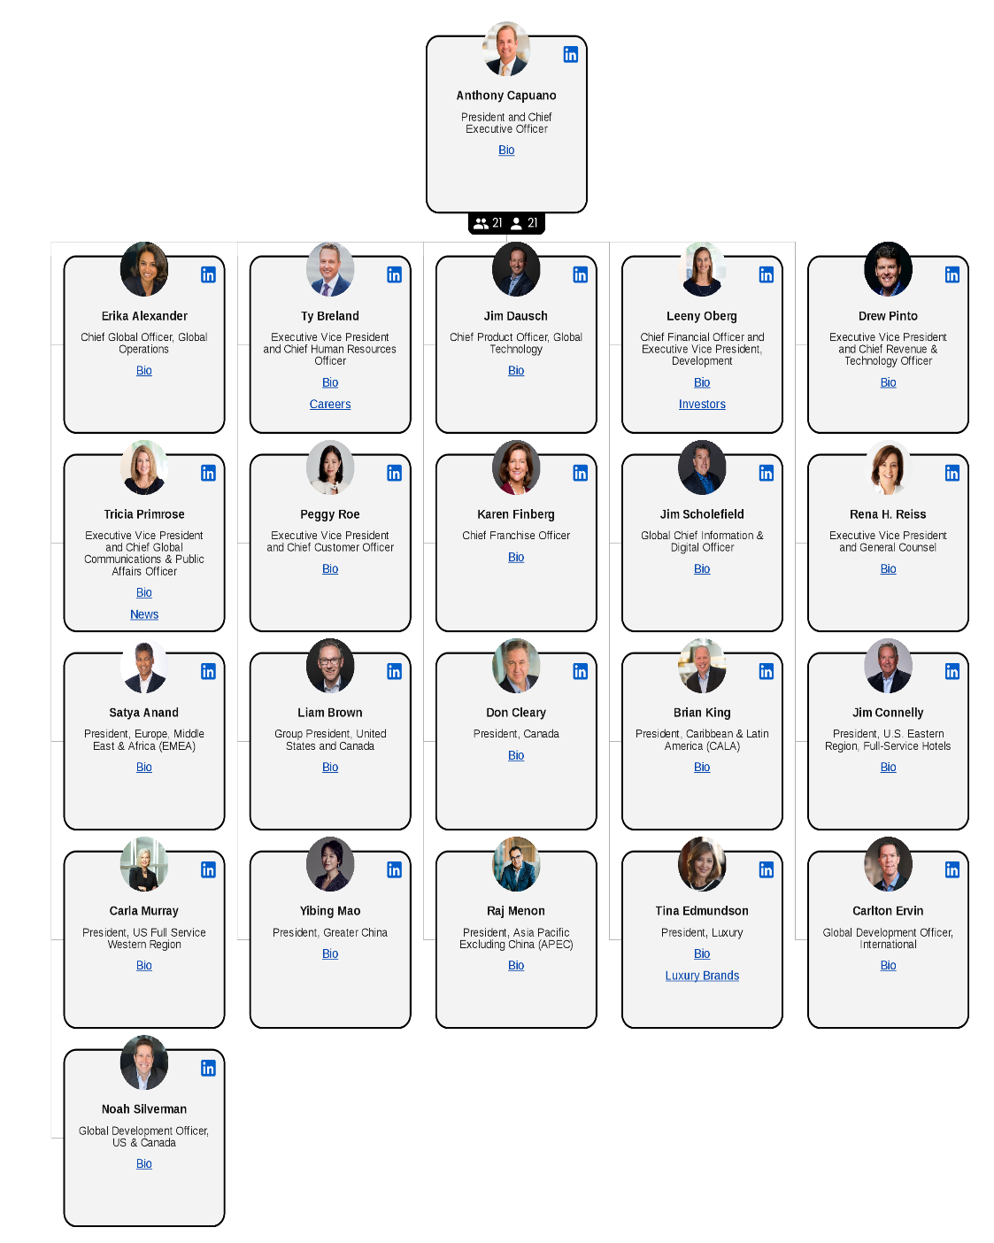
Figure 1: Organisation structure (Marriott Organizational Structure, 2023)
Corporate culture and its influences
An organisation's operations and interactions with stakeholders, customers, and employees are shaped by its corporate culture, which comprises shared values, beliefs, attitudes, and behaviours. It covers all aspects of the work environment, such as management theory, ethics, and communication methods. A strong company culture significantly impacts how engaged, collaborative, and innovative employees are, improving the firm's overall success (Lepeley et al., 2021). The organisation's leadership, rules, customs, and goals can all have an effect. People may lose interest in their work and be less productive if the company culture is weak. On the other hand, a strong culture encourages trust, inclusion, and productivity.
Leadership and management style: A company's ethos, its principles, and the way its employees act are all set by managers. These actions all add to the growth of corporate culture. Transformational leadership theory says that good leaders give their teams a sense of purpose and motivation by setting a common goal and creating an atmosphere where people can share ideas, trust each other, and work together (Murari and Mukherjee, 2021). A customer-centred culture is created in companies with transformative leaders, like Marriott International, emphasising employee participation and empowerment. Higher morale and more work get done when strong leaders create a supportive workplace.
Employee behaviour and work environment: How people in a business interact, what motivates them, and how well they do their jobs all significantly affect its culture. According to Hofstede's Cultural Dimensions Theory, national and organisational cultures affect how people act at work in ways like power distance, individuality versus collectivism, and avoiding uncertainty (Alieva and Powell, 2022). In a highly independent culture, people value their accomplishments more than those of others. In a collectivist culture, people value working together and getting along with others more. The fact that Marriott focuses on diversity and teamwork in all its global locations shows how important it is for companies to adapt their culture to different regional work environments.
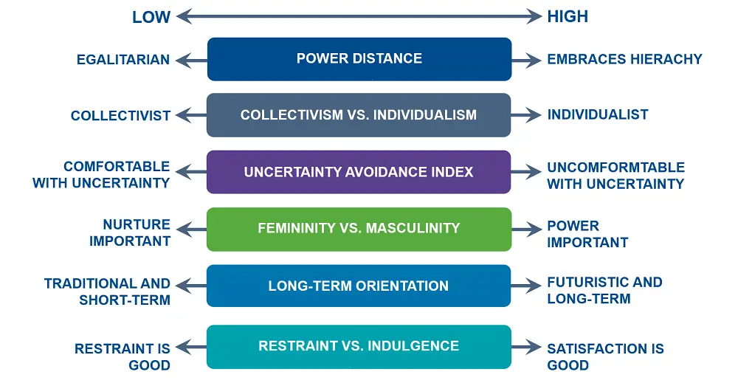
Figure 2: Hofstede's Cultural Dimensions Theory (Batheories, 2024)
Goals of the organisation
Corporate unit levels: To reach their vision, purpose, and long-term goals, corporations develop detailed strategic aims. Key to these goals is financial success, market growth, long-term viability, and happy customers (Mullins and Dossor, 2013). Marriott International wants to grow its business worldwide, improve its rewards program, Marriott Bonvoy, and develop new ways to provide service. The company's goal is to run its business legally, increase the value of its shares, and keep its strong brand image (Baranova et al., 2021). Businesses are also trying to be more sustainable by lowering their carbon footprint, focusing more on eco-friendly processes, and increasing their corporate social responsibility (CSR). The company's departments make choices that align with the corporate plan.
Individuals' unit levels: At the regional, departmental, or property level, goals are more transparent and more manageable for each unit. For example, local Marriott hotels and other business units set performance goals based on company guidelines and the needs of their markets. Some goals could be to improve training programs for staff, keep costs under control, make visitors happier, and get more rooms occupied (Shaddiq and Fahmanadie, 2024). Each specialised area, like operations, marketing, and human resources, has its own goals to help the business succeed. For instance, one team might oversee increasing business bookings, while another might get employees more involved and keep them there.
Recent Change Initiatives
Marriott's recent change initiatives
Reduce carbon intensity: Sustainability and business responsibility are at the core of Marriott International's Serve360 Goals for 2025, which the company has been working hard to reach. The goal of the world's effort to fight climate change is to cut carbon intensity by 30% (Rahman, Sultana and Velayutham, 2022). The company is on track towards this goal by putting money into green energy, environmentally friendly building methods, and running its business using less energy. To have less of an effect on the environment, Marriott has implemented eco-friendly practices such as water-saving systems, advanced HVAC technologies, and LED lights in all its buildings (Mullins, 2023).
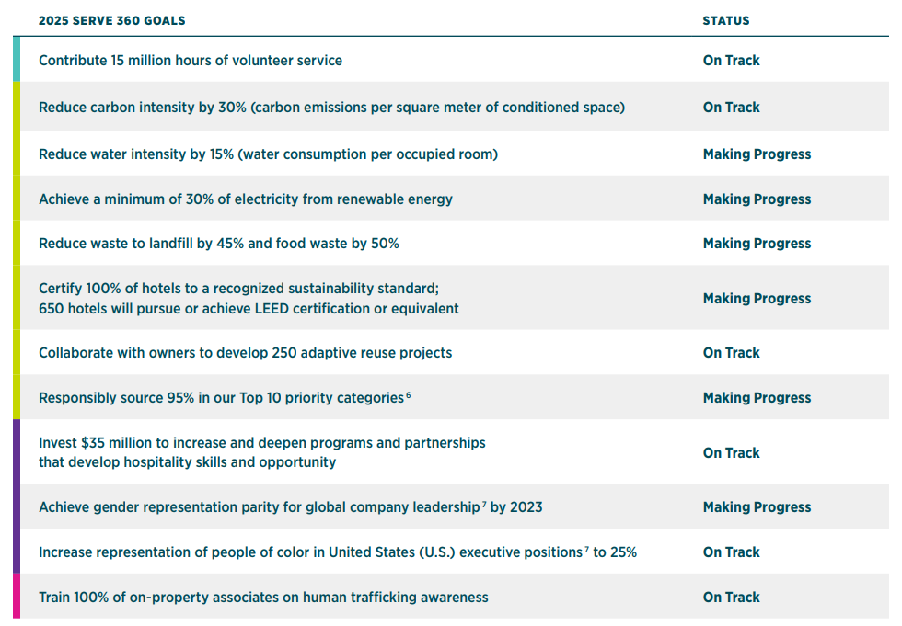
Figure 3: Marriott International goals for 2025 (Marriott International, Inc., 2024)
Certify hotels to a recognised sustainability standard: As part of Marriott's Serve360 plan, one of the main goals is to get all its hotels certified to a recognised sustainability standard, and they are making progress in it. Marriott is working hard to obtain certifications like Leadership in Energy and Environmental Design (LEED) to ensure that all its hotels meet environmental standards that are known worldwide. The company works with its suppliers and other companies in the same field to find safe sources of materials and cut down on waste (Legrand, Chen and Laeis, 2022). By advancing its sustainability certifications, Marriott is proving superior in sustainable hospitality. This is to protect the environment better, keep up with changing government rules, and attract eco-friendly travellers.
Impact of initiatives
Reducing carbon footprint: The hospitality industry, especially Marriott International, feels the effects of the company's promise to cut carbon intensity by 30%. Marriott is working to reduce its environmental impact by using environmentally friendly building methods, making its buildings more energy efficient, and investing in clean energy sources (Youssef and Zeqiri, 2022). These projects help people worldwide act on climate change while lowering costs because they use less energy. Marriott's strategies to reduce carbon emissions improve the company's image and bring in customers who care about the environment, which fits the growing demand for eco-friendly travel (Mullins, 2019). To stay strong as laws, change, Marriott is placing itself as a leader in ethical business practices.
Strengthening hotel sustainability standards: By certifying all its hotels to a well-known green standard, Marriott is trying to do more to protect the environment worldwide. By getting certifications like LEED, Marriott ensures its buildings meet strict environmental standards. These include using ethically sourced materials, saving water, and reducing waste (D’Souza et al., 2021). These methods allow hotels to handle problems in the surroundings better while still running efficiently. Many tourists and business travellers who care about the environment choose green hospitality. Certified sustainable hotels service this business while reducing their environmental impact.
Managing changes: Because of how Marriott International handles its 2025 Serve360 Goals, significant improvements have been made in these critical areas. They are progressing towards a 30% decrease in carbon intensity with the hard work and foresight of the dedicated team (Huczynski and Buchanan, 2019). Marriott has lessened its environmental impact by focusing on energy efficiency, using green energy, and taking steps to offset its carbon emissions. It is still impossible for all its hotels to be certified under a green standard everyone accepts.
Strategic Direction
Marriott strategic direction: Marriott International's strategy is to grow its global footprint, make its operations more environmentally friendly, and give customers the best experiences possible. To get a wide range of customers, the company focuses on using its wide range of brands to appeal to different market segments, such as luxury and exceptional services (Boddy, 2017). To improve its guest services, Marriott is adding to its reward program, Marriott Bonvoy, which helps keep customers and bring in more money. Sustainability is an essential tool, as shown by its Serve360 Goals, which include projects to lower carbon intensity, certify hotels to sustainability standards, and use eco-friendly methods in all parts of operations.
Implemented strategies
Sustainability and environmental initiatives: To reach its long-term goals, sustainability and caring for the earth are important to Marriott International. The Serve360 Goals for 2025 set by the company align with world trends in sustainability and corporate social responsibility. The goals include lowering carbon emissions by 30% and ensuring that all business hotels meet a certified sustainability standard (Armstrong, 2021). All of Marriott's hotels use a comprehensive method that provides technologies that use less energy, renewable energy sources, and programs that cut down on waste. Conserving water, buying environmentally friendly products, and reducing carbon emissions exemplify the company's dedication to sustainability.
Digital transformation: Marriott has prioritised digital transformation and technology innovation as keyways to reach its long-term goals. Marriott is using new technology to improve the customer experience in the fast-paced travel and hospitality business. This includes changes to the Marriott Bonvoy reward program and new ways to book that focus on using phones (Adair, 2009). With digital technologies like personalised guest services and mobile check-in, Marriott is making customers happier and more loyal. These technological improvements help Marriott reach its long-term growth goals by letting it adapt to an industry that changes quickly, attracting travellers who are good with technology, and making operations run more smoothly.

Conclusion
As a significant hospitality company worldwide, Marriott International is known for its dedication to protecting the environment, developing new technologies, and ensuring customers are happy. Marriott is committed to running a responsible business. Its Serve360 Goals and focus on environmental certifications are helping it lower its carbon footprint. The digital change at Marriott is making customer service better and increasing loyalty. However, problems still need to be fixed, especially when it comes to meeting the goals for complete sustainability certification. There is no doubt about Marriott's long-term goals: growth, business efficiency, and meeting customer needs.
Recommendations
Employee training and development: Marriott could improve its position by giving more money to training programs that help employees reach its sustainability and customer service goals. All levels of Marriott can work towards a mindset of environmental stewardship by teaching employees how to use sustainable methods in their daily work. To make this happen, the HR department could work with the sustainability teams to give training and certifications in all its offices worldwide. By 2026, Marriott should try to have all its workers complete training in customer service and sustainability.
Enhance technological transformation: Adding AI-driven customising to Marriott's services could help the company become more digital. Predictive customer service, personalised choices for lodging, and custom holiday packages are all examples of this. Marriott's marketing and technology teams could put this into action by 2025, making sure that key brands have AI technologies. In the same way that Hilton improves its customers' experiences with digital connections and personalised suggestions, Marriott may use big data to learn about its customers' likes and dislikes and create unique experiences for customers.

References
Adair, J. (2009) The Inspirational Leader (2nd Ed), London: Kogan Page
Alieva, J. and Powell, D. J. (2022) The significance of employee behaviours and soft management practices to avoid digital waste during a digital transformation. International Journal of Lean Six Sigma, 14(1), 1-32. [Available at: https://www.emerald.com/insight/content/doi/10.1108/ijlss-07-2021-0127/full/pdf]
Armstong, M. (2021) Armstrong's handbook of performance management (7th Ed), London: Kogan Page
Baranova, V., Kulinich, T., Dutchak, O., Zvonar, V. and Denyshchenko, L. (2021) Development of Corporate Social Responsibility in Business as a Factor of Fiscal Decentralization. Journal of Eastern European and Central Asian Research (JEECAR), 8(3), 411–424. https://doi.org/10.15549/jeecar.v8i3.760
Batheories (2024) Hofstede’s Cultural Dimensions Theory - BA Theories (Business Administration & Management). https://www.batheories.com/hofstede-cultural-dimensions-theory/?noamp=mobile (Accessed: February 16, 2025).
Ben Youssef, A. and Zeqiri, A. (2022) Hospitality industry 4.0 and climate change. Circular Economy and Sustainability, 2(3), 1043-1063. https://doi.org/10.1007/s43615-021-00141-x
Boddy, D. (2017) Management: An Introduction (7th Ed), Harlow, Pearson
D’Souza, C., Apaolaza, V., Hartmann, P. and Brouwer, A. R. (2021) Marketing for sustainability: Travellers’ intentions to stay in green hotels. Journal of Vacation Marketing, 27(2), 187-202. https://doi.org/10.1177/1356766720975063
Djurayeva M.S. (2024) “ORGANIZATIONAL STRUCTURE OF A MODERN ENTERPRISE”, Ethiopian International Journal of Multidisciplinary Research, 11(12), pp. 222–227. Available at: https://www.eijmr.org/index.php/eijmr/article/view/2262 (Accessed: 16 February 2025).
Huczynski, A. and Buchanan, D. (2019) Organisational Behaviour (10th Ed), Harlow: Pearson
Legrand, W., Chen, J. S. and Laeis, G. C. (2022) Sustainability in the hospitality industry: Principles of sustainable operations. Routledge. [Available at: https://thuvienso.hoasen.edu.vn/bitstream/handle/123456789/8505/Contents.pdf?sequence=3&isAllowed=y]
Lepeley, M. T., Morales, O., Essens, P., Beutell, N. and Majluf, N. (2021) Human Centered Organizational Culture. Routledge. [Available at: https://www.researchgate.net/profile/Sergio-Morales-Inga-2/publication/347925240_Assessment_of_the_theoretical_evolution_of_organizational_culture_Pending_need_for_human_focus/links/624252b87931cc7ccf019b15/Assessment-of-the-theoretical-evolution-of-organizational-culture-Pending-need-for-human-focus.pdf]
Marriott International, Inc. (2024) 2024 SERVE 360. https://serve360.marriott.com/wp-content/uploads/2024/07/2024ESGProgress.pdf (Accessed: February 16, 2025).
Marriott Organizational Structure (2023) https://research-methodology.net/marriott-organizational-structure-overview/ (Accessed: February 16, 2025).
Mullins, L (2019) Organisational Behaviour in the Workplace (12th edition) Harlow: Pearson
Mullins, L and Dosser, P. (2013) Hospitality Management and Organisational Behaviour (5th Ed) Harlow, Pearson.
Mullins, L. (2023) Management and Organisational Behaviour (13th edition) Harlow: Pearson
Murari, K. and Mukherjee, U. (2021) Role of authentic transformational leadership for managerial excellence and sustainability. Psychology and Education, 58(4), 3612-3628. [Available at: https://www.researchgate.net/profile/Krishna-Murari/publication/351745375_Role_of_Authentic_Transformational_Leadership_for_Managerial_Excellence_and_Sustainability/links/60a73c7892851ca9dcd38498/Role-of-Authentic-Transformational-Leadership-for-Managerial-Excellence-and-Sustainability.pdf]
Rahman, M. M., Sultana, N. and Velayutham, E. (2022) Renewable energy, energy intensity and carbon reduction: Experience of large emerging economies. Renewable Energy, 184, 252-265. https://doi.org/10.1016/j.renene.2021.11.068
Shaddiq, S. and Fahmanadie, D. (2024) The Influence and Controlling of Industry 4.0 on Work Behavior and Employee Productivity in Start-Up Technology Companies. https://doi.org/10.56444/mia.v21i2.2008

