

Strategic Travel and Tourism Management
Exam Resit Assignment
Is the Expansion of the Cruise Ship Industry Environmentally Sustainable?
Submitted to Mike Davies

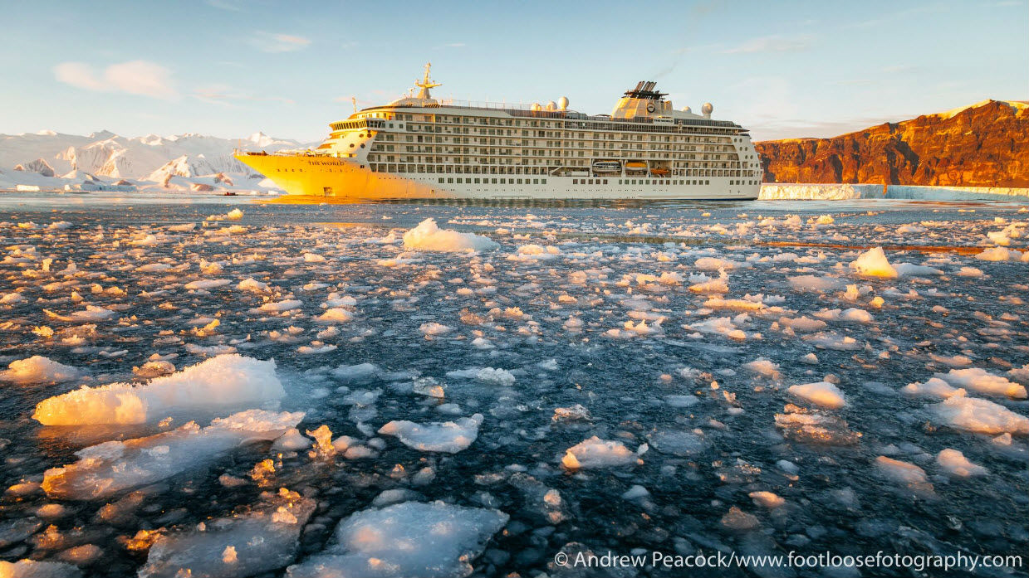

Contents
- Introduction
- Background
- Green Tourism
- Conclusion
- Bibliography

- Introduction
The cruise ship industry is continuously expanding year on year and in order to continue this trend, certain Cruise Ship companies such as Hurtigruten Cruises are broadening their horizons by offering ‘bucket list’ experiences to their customers by giving them the opportunity to travel further into Antarctica than ever before. ‘Roald Amundsen recently crossed the Antarctic Circle and kept going, reaching 70º south, the furthest any Hurtigruten ship has gone.’ (Anne Kalosh, 2020).
Cruise ships are giant vessels and the largest can accommodate up to 7000 people as well as a crew of around 2200. Not only do cruise ships continue to grow but they are improving their services by equipping vessels with more and more state-of-the-art leisure facilities to accommodate wider audiences. ‘Since 2009, cruise ship passengers have grown from 17.8 million to 30 million, an annual growth rate of 5.4%. More significantly, cruise industry revenues have grown even faster, from approximately 15.7 billion in 2010 to an estimated 31.5 billion in 2020, a compounded rate of growth of 7.2%.’ (Joseph Micallef, 2020) As the largest sector of growth in the tourism industry it is understandable why the industry are looking for innovative ways to accommodate wider audiences, however as the industry continues to grow and offer new further destinations, so does the risk these ‘floating cities’ pose to the environment. It is estimated that a single cruise ship can ‘Emit as much pollution as 700 trucks and as much particulate matter as a million cars.’ (James Ellsmoor, 2019).
With much of this knowledge being brought to light, the cruise ship industry has been under fire in the public eye for some time as a result. ‘On the other hand, of course, the rapid growth and global spread of tourism has been accompanied by no less a rapid increase in the number of commentators drawing attention to the potentially negative or destructive consequences of tourism development on destination environments and societies.’ (Richard Sharpley, 2009, p. 24)
The following report aims to investigate just how detrimental the cruise ship industry is towards the environment and how it can be made more environmentally sustainable. In order to do this the report will systematically evaluate contemporary strategic tourism planning issues and the relationship between tourism development and the environment, whilst reviewing and evaluating management planning techniques and their role in effecting sustainable tourism development.

- Background
Cruise ships are harmful to the environment in more ways than one:
Air Pollution:
Perhaps the more obvious method of pollution the cruise ship industry is responsible for is the significant air pollution from the vast amounts of fuel they burn in order to power the ship and despite there being more environmentally conscious alternatives to the traditional diesel which is particularly heavy with sulphur and pollutants, unfortunately not all cruise ship companies choose to use them due to them being more expensive. ‘Fundamentally, all cruise ships today burn fossil fuels in a diesel engine that generates electrical energy to power the ship. This includes the propellers, lights, casino games, and even the environmental systems such as desalinization. In the past, cruise ships, like freighters used Heavy Fuel Oil (HFO) because it is as much as 30% cheaper compared to alternatives. Most cruise ships still do in various parts of the world, though many use a blend in their diesel engines. HFO - also referred to as bunker fuel in it's lowest quality form, is terrible for the environment but it is cheap, stable, and plentiful. It is essentially a tar-like byproduct of what remains after other petrol products are removed during distillation such as kerosene, diesel, and gasoline.’
‘Emissions from cruise ship engines include NOx, SOx, CO2, and diesel PM, the microscopic soot that is so damaging to human health.’ (Friends of the Earth, 2020)
Even when cruise ships are docked the engines continue to burn fuel as they provide the electrical power throughout the ship and as a result these emissions can contribute to serious health problems for the locals in the towns they dock. ‘Among other health and environmental impacts, these emissions contribute significantly to serious cardiovascular problems, premature death, acid rain, habitat destruction, and climate change. According to the EPA, each day an average cruise ship is at sea it emits more SOx than 13 million cars and more soot than 1 million cars.’ (Friends of the Earth, 2020)
In recent years there have been steps taken towards reducing the emissions produced by cruise ships ‘In U.S. waters ships are required to use cleaner fuel and a few cruise lines have adopted technologies that reduce dirty air emissions from cruise ships. Cold ironing technology allows cruise ships at dock to plug in to shoreside power and receive electricity to operate their refrigeration, cooling, heating, and lighting systems without having to burn dirty fuel in ship engines. Cruise ships have installed scrubbers to reduce smokestack emissions but while they reduce air pollution most discharge contaminated wastewater--trading one pollution source for another. Using cleaner fuel and adopting shore power are the best options.’ (Friends of the Earth, 2020)
Cruise Sewage:
Considering cruise ships accommodate and cater for thousands of passengers and crew there is a massive amount of waste produced by them. ‘The U.S. EPA estimates that a 3,000-person cruise ship generates 150,000 gallons of sewage per week — enough to fill 10 backyard swimming pools. This adds up to more than 1 billion gallons of sewage a year for the industry.’ (Friends of Earth, 2020) As long as the cruise ships are more than three nautical miles from shore, this sewage is often dumped into the ocean whilst the cruise ships sail along their route. This sewage is full of harmful pollutants which are both harmful the aquatic life and human health.
Companies such as Norwegian Cruises and Hurtigruten Cruises have banned single use plastics to reduce the waste they produce and develop a ‘green’ image amongst their customers. ‘The European cruise operator has been working hard to eliminate single-use pastics from its ships, and this latest news will see Norwegian eliminate plastic bottles. Instead, they will replace them with paper cartons developed by environmentally focussed brand JUST Goods Inc, founded by Jaden Smith and his family. It is hoped that the move will see the cruise liner save more than six million single-use plastic bottles annually.’ (Aimee Robinson, 2019)
Tourists:
Cruise ships offer dock towns and cities along their routes great economic opportunity which they usually would not have available to them as a result of the mass of tourists and crew aboard who can bring expenditure into these areas. Without cruise liners areas of Antarctica would not usually be exposed to tourist expenditure as they aren’t easily accessible destinations for tourism and don’t have much accommodation, as a result when the cruise liners dock in these communities they boost the local economy. ‘Tenerife, one of the Canary Islands which collectively comprise one of Spain’s 17 politically autonomous regions, is highly dependent upon tourism; the local tourism economy contributes some 65 per cent of the island’s GDP (Sharpley, 2007, page 117) compared with a ﬁgure of around 10 per cent for Spain as a whole.’ (Sharpley, 2009, Page 31)
However, when passengers and crew onboard the cruise ships spill into these dock cities and towns they usually have a negative effect on these areas environmentally as many tourists will be more concerned with how they experience the area than they will be about preserving it as they naturally flock to the most picturesque scenes and exciting experiences available. Some of the effect’s tourists can have on these towns and cities are:
- Invasive species - accidentally bringing in insects or seeds on boots, clothes, in food, cargo etc.

- Impact on local species – Marine life and birds can be made anxious by influxes of tourists and can cause them to leave the area if they are regularly disturbed. The general voluntary code is that visitors should not go closer than 5m to any wildlife however this cannot be enforced.

- Erosion or disturbance of fragile environments – Influxes of tourists travelling through fragile environments can result in the destruction of them.

- Oil spills from ships and boats - there may be a spill due to hitting ice and rupturing a holding tank, or if the vessel sinks, all the polluting fluids will eventually escape.

In 2009 the International Maritime Organization approved an amendment to the Marine Pollution- International convention for the prevention of pollution from ships ‘banning the use and carriage of heavy and intermediate fuel oils for all shipping in the Antarctic Treaty Area. This ban mainly affected large cruise ships that operated "cruise-only" tourism without landings, these ships carry 500+ passengers. As a result of this overall tourism numbers fell from the then peak of 47,225 in 2006-2007, with the difference due largely to the large passenger ships leaving the Antarctic market.’ (Cool Antarctica, 2020)
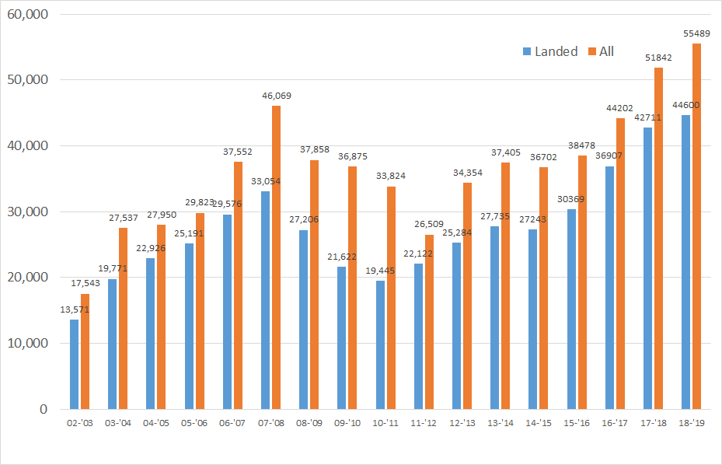
In 2008 Tourist numbers in Antarctica peaked and resulted in a call for tourist numbers to be limited as the number of tourists had risen 14% on the previous year and this rise was not considered environmentally sustainable. In 2018/019 tourist figures in Antarctica have exceeded the 2008 peak figures and the trend has continued.
(Cool Antarctica, 2020)
- Green Tourism
‘According to the World Tourism Organization, green tourism accounts for 7-20% of the total tourist services.’ (Maria Plotnikova, 2018)
In order to avoid being presented badly in the media, Cruise liners are investing in becoming more environmentally responsible both financially and politically in environmentally aware initiatives so that they are able to engage a new generation of tourists who demand more sustainable travel options.
“With opportunity comes responsibility, and we are working as an industry to meet those responsibilities.” “The cruise sector represents 2% of the overall travel industry, we are a small part of the 1.5 billion individual trips made per year, but we need to play a leadership role in sustainable tourism.” (Adam Goldstein, 2019)
Measures have been taken to preserve Antarctica’s environment and wildlife. Some of these include:
- ‘No Antarctic bird or mammal can be killed or captured without a permit - granted only for validated scientific reasons.
- Measures must be taken to minimize harmful interference with wildlife and control the introduction of non-native species - animal or plant. To the point of not taking soil or growing compost to Antarctica as it may contain plant seeds, fungal spores or adults, eggs or larvae of any number of soil-dwelling invertebrates.
- The establishment of specially protected areas to protect sites of outstanding scientific interest and designate specially protected species.
- Seals in particular are covered by a 1972 convention designed to prevent the resumption of sealing, killing of both Ross and Antarctic fur seals is totally prohibited and catch limits are set deliberately at low levels for other species. All six seal species that breed in the Antarctic are covered.
- The discharge into the sea within the Antarctic Treaty Area of all toxic and noxious chemicals, oil and oily wastes, plastics and other forms of non-biodegradable rubbish, is prohibited. The discharge of other wastes (such as sewage from ships and bases) is strictly regulated.’ (Cool Antarctica, 2020)
Each of these efforts are at risk of coming undone as a result of cruise tourism increasing in popularity in Antarctica. Aside from the copious amounts of fuel burned by the ships and massive amounts of waste produced; Cruise tourism means influxes of tourists which will ultimately interfere with the environment and wildlife when the cruise liners dock and when the cruise liners are sailing these massive vessels intimidate the marine life and often drive them away from the areas they frequent.
Green technologies are being incorporated into newly built ships and are sometimes retrofitted onto older ones. Solar panels are being used to reduce the amount of fuel burned to produce electricity, exhaust scrubber systems are systems designed to minimize the emissions produced by the ships, advances in ship hull design have been made so that ships are able to cut through the water more efficiently and cooking oil conversion systems and energy-efficient appliances are now fitted in many ships. Some cruise lines also collaborate with non-profit organizations and government agencies to collect data about the ocean's health and climate changes so that they can monitor the results of the changes they make.
- Conclusion
With Cruise tourism increasing in popularity year on year, it is likely this trend will follow with Antarctic cruises. In order to become environmentally sustainable there would have to be changes made in order to reduce the fuel burned and waste produced by the cruise liners and further efforts must be made at the tourist destinations to preserve the environment.
In order to ensure that the environments are protected from tourists there needs to be further limitations on both the size of the ships which sail through the Antarctic and how many cruise liners can travel there. The more the popularity of these Antarctic cruise liners increases it is likely the size of the ships will also increase in order to accommodate the growing market; this will eventually result protected areas becoming overrun with tourists. In order to avoid this tourist numbers in these areas must be limited.
There is a variety of methods being utilised by Cruise Liners in recent years to reduce the negative effect they have on the environment. The ‘green technologies’ which have been incorporated into newly built ships and retrofitted onto older ones such as: solar panels, exhaust scrubber systems, advances in hull design, cooking oil conversion systems and energy efficient appliances are all steps in the right direction. The expansion of cruise tourism into the Antarctic will certainly require all cruise liners to be equipped with any available green technologies in order to be considered environmentally sustainable and in order for them to keep waste minimal, laws and legislations need to be introduced so that all cruise liners adopt single use plastics.
The expansion of the cruise industry in Antarctica is definitely a threat to the environment and although there are safeguards and green technologies which can reduce the threat and make these more sustainable, it does seem as though the risk in this case is greater than the economic reward. Antarctica is the largest unspoiled wilderness area left on the planet, most of it is completely untouched and remains in pristine condition. Influxes of tourists will likely erode the natural environment and intimidate the local wildlife which can result in them pushing them further and further away from their natural habitat. Antarctica is so unspoiled making it ideal for scientists and their laboratories, they are able to assess critical changes in matters such as global warming including using ices cores whilst in complete isolation from the effects of man and an increase in tourism in Antarctica will no doubt disrupt this.

- Bibliography

The Maritime Executive, 2017- Cruise Ship Sets Antarctic Record
Available at:https://www.maritime-executive.com/article/cruise-ship-sets-antarctic-record

Anne Kalosh, 2020- Roald Amundsen goes further south than any Hurtigruten ship ever Available at: https://www.seatrade-cruise.com/expedition/roald-amundsen-goes-further-south-any-hurtigruten-ship-ever

Joseph V Micallef, 2020- State Of The Cruise Industry: Smooth Sailing Into The 2020’s
Available at: https://www.forbes.com/sites/joemicallef/2020/01/20/state-of-the-cruise-industry-smooth-sailing-into-the-2020s/#7c3acc7e65fa

Friends of the Earth, 2019- Cruise Ship Report Card
Available at: https://1bps6437gg8c169i0y1drtgz-wpengine.netdna-ssl.com/wp-content/uploads/2019/06/Cruise-Ship-RC-2019-FINAL.pdf
Windstar Cruises, 2020- How much fuel a Cruise Ship Uses
Available at: https://www.windstarcruises.com/blog/how-much-fuel-cruise-ship-uses/

MI News Network, 2019- 8 Ways Cruise Ships Can Cause Marine Pollution
Available at: https://www.marineinsight.com/environment/8-ways-in-which-cruise-ships-can-cause-marine-pollution/

Maharaj Vijay Reddy, Keith Wilkes, 2015- Tourism in the Green Economy
Available at:https://pureportal.coventry.ac.uk/en/publications/tourism-in-the-green-economy

Cool Antarctica 2020- Antarctica Tourism - Human Impacts Threats to the Environment
Available at:
https://www.coolantarctica.com/Antarctica%20fact%20file/science/threats_tourism.php

Maria Plotnikova, 2018- GREEN TOURISM DEVELOPMENT IN SMART COMMUNITIES
Page 204
Available at:http://www.baltijapublishing.lv/index.php/issue/article/view/444/pdf

Julian Turner, 2019- Waste away: exploring sustainability initiatives on-board cruise ships
Available at: https://www.ship-technology.com/features/sustainable-cruise-ships/

Richard Sharpley, 2009- Tourism Development and the Environment: Beyond Sustainability?
Page 24
Available at: http://www.istta.ir/upload/file/sustainableTourismBook2.pdf

James Ellsmoor, 2019- Cruise Ship Pollution Is Causing Serious Health And Environmental Problems
Available at: https://www.forbes.com/sites/jamesellsmoor/2019/04/26/cruise-ship-pollution-is-causing-serious-health-and--problems/#25ba34437db3

Richard Sharpley, 2009- Tourism Development and the Environment: Beyond Sustainability?
Page 31
Available at: http://www.istta.ir/upload/file/sustainableTourismBook2.pdf

Aimee Robinson, 2019- Norwegian Cruise Lines goes green as it bans single-use plastic
Available at: https://www.express.co.uk/travel/cruise/1185620/Cruises-Norwegian-Cruise-Lines-green-single-use-plastic-ban-news

Richard Sharpley, 2007- Tourism and Development in the Developing World
Page 117
Available at: https://books.google.co.uk/books?id=qTSAAgAAQBAJ&printsec=frontcover&dq=Sharpley,+2007+tourism+and+development&hl=en&sa=X&ved=0ahUKEwiq9NLZz-rpAhUmURUIHS7IDdwQ6AEIKDAA#v=onepage&q=Sharpley%2C%202007%20tourism%20and%20development&f=false

