

Postgraduate/Distance Learning
Assignment coversheet & feedback form

THIS SHEET MUST BE THE FIRST PAGE OF THE ASSIGNMENT YOU ARE SUBMITTING (DO NOT SEND AS A SEPARATE FILE)
For completion by the student:
Student Name: Whitney Hill
Module code: HPCA7027  Module title: Cosmology, Magic, and Divination | Student ID number:  2209673 |  |  | Educational support needs:  Yes/No
Module tutor: Dr Dorian Greenbaum and Dr Dawn Collins

Assignment due date: 22 April 2025
If your module has multiple submissions please indicate which piece of work this is.

1st 2nd 3rd 4th 5th 6th
I confirm that this is my original work and that I have adhered to the University policy on plagiarism.
Signed ………Whitney Hill……………
Email submission: if you are submitting this form via email, please tick this box □
(as a substitute for your signature) to confirm that you agree to the above declaration.
Assignment Mark
1st Marker’s Provisional mark
2nd Marker’s/Moderator’s provisional mark
Agreed Internal Mark:

External Examiner’s mark (if relevant)
Final Mark

NB. All marks are provisional until confirmed by the Final Examination Board.

For completion by Marker 1:
Comments:

Marker’s signature: |  |  | Date:
For completion by Marker 2/Moderator:

Comments:

Marker’s Signature: |  | Date:
AGREED INTERNAL MARK (where necessary):

Comment on process of arriving at agreed mark:

External Examiner’s comments (if relevant)

External Examiner’s Signature: |  | Date:

Cosmology and Divination in Hellenistic Astrology
Possible Influences of the Ancient Egyptian Decans on the Eighth and Second Astrological Houses
Introduction
This essay examines the roles of and relationship between cosmology and divination within Hellenistic​ astrology, with a focus on how ancient Egyptian cosmology may have influenced the meanings assigned to parts of the astrological chart.
Astrology is an ancient practice with roots in Babylonian, Egyptian, and Greek astronomical, cosmological, and philosophical practices and beliefs. With regard to the Egyptian contribution, Dorian Gieseler Greenbaum and Micah T. Ross write that the use of the Ascendant in an astrological chart originates with the ancient Egyptians, and that:

‘The association of the decans with the zodiac, which occurred in Egypt in the third century BCE, constitutes an important and necessary intermediate step in the development of the astrological ascendant from rising decans and the derivation of the mid-heaven from transit decans.’

Given the role of the decans in determining these two important points in a given astrological chart, this paper briefly explores whether there is room to consider other influences the original Egyptian decans may have had on the development of meaning, both cosmological and divinatory, in astrological charts by assessing the original meanings and use of the decans alongside their use in Hellenistic astrology. The eighth and second astrological houses are the main focus.

Egyptian Decanal Cosmology and Hellenistic Astrology
Cosmology is how humans create meaning from the sky. Dorian Greenbaum says, ‘Cosmology is literally the ordered ways of looking at the world or the heavens, or the arrangement of the heavens, because the word “cosmos” means both “world” and “order”.’ In this regard, astrology has a direct connection to cosmology; it is a system in which humans observe the sky and create ordered sets of rules for what different elements of it would portend for a ruler, nation, individual, or event. Further, Nicholas Campion describes astrology as ‘the practical implementation of cosmological ideas in order to understand the past, manage the present, and forecast the future, in a range of cultures, past and present.’ When it comes to Hellenistic astrology, Greenbaum and Ross write that the cosmological ideas involved come from a blend of cultures: Egypt, Babylon, Greek, and possibly others such as Persia. Assessing the order and meaning conveyed in Hellenistic astrology therefore requires some background understanding of the various parts contributed to the system by each culture. One of these parts is the decans.
The decans were originally selected stars or asterisms used by the ancient Egyptians to tell the hours of the night, with Juan Antonio Belmonte and José Lull noting that measuring hours of day and night was a task of temple astronomers ‘in order to mark with precision the times at which certain rituals should be performed’. O. Neugebauer and Richard A. Parker identify five main families of decanal stars plus a few miscellaneous lists, reflecting shifts over the long period when lists were in use between the 15th century BCE to the 1st century CE. While there is debate around what modern stars or asterisms actually defined each ancient Egyptian constellation and decan (perhaps most notably covered in the recently published work of Belmonte and Lull), for the purposes of this paper it is sufficient to know the basic concept of how they worked functionally, which is covered in a later section.
Additionally, Anne-Sophie von Bomhard writes that in their original mytho-cosmological concept the decanal stars are considered the ‘guides of the sun’ with the responsibility to ‘watch over the entire cosmos’ and specifically to protect Egypt and the pharaoh. The decans as timekeeping mechanisms and as protective deities represent a significant difference in how this system of dividing the sky was adapted for astrological use in the Graeco-Roman period, particularly in how the decans are used by modern practitioners of Hellenistic astrology.
With regard to the decans as used in astrology, Greenbaum and Ross write that

‘Shortly after the zodiac came into Egypt from Babylon in the Hellenistic period, the decans were aligned with it. Eventually each of the zodiac signs contained three decans of 10 degrees each, and the system passed into horoscopic astrology.’

They also note that the decans as used in horoscopic astrology ‘were far removed by this time from their earlier origins, yet the de facto families of rising and transit decans were still employed’, reflecting the gap between the concept of the decans von Bomhard presents and the stripped-down later usage of ten degrees of sky represented in an astrological chart. This information encourages a deeper look at the practical and cosmological usage of the decans and where—despite being heavily adapted to fit a more regularized model—the decans may still show an Egyptian influence on Hellenistic astrology as a divinatory tool in the process of being converted for use.

Hellenistic Astrology as Divination
Divination as defined by Michael Loewe and Carmen Blacker is ‘the attempt to elicit from some higher power or supernatural being the answers to questions beyond the range of ordinary human understanding.’ Astrology has served this purpose from its earliest days in the form of Mesopotamian ‘sky-omens’, which Tamsyn Barton says may be from as early as the second millennium BCE and largely—but not exclusively—focused on events of note for the king and country. Using the sky as a source of divinatory information was therefore often an attempt to gain guidance from the gods to support the management of the country.
In considering the decans and their original usage, von Bomhard also notes this generalized, population-based consideration of astrology, and additionally says that statements about the influence exerted by the decanal stars ‘are affirmative rather than predictive, leaving no room for escape.’ For example, part of a passage from Decade 9 on the left wall of the Naos of the Decades reads: ‘The Great God at the Beginning; it is he who causes massacres, who brings war, carnage, fury and turmoil.’ Such a passage could answer the question of what the gods might be expected to bring about during the ninth decade (ten-day period) of the year, thus guiding an appropriate human response from priests or the pharaoh for the best and most efficacious management of the state or its defense against enemies.
The use of celestially derived divination expands over time from interpreting the will of the gods for the head of state to more personal or individualized applications. Moving into the Graeco-Roman era, Campion writes that Plato ‘is the formative influence in Western attitudes to the heavens’ and that part of Platonic thought focused on ‘the whole question of what he called “better” and “worse” births’ from a moral perspective, i.e., those who would grow up to be ‘upright, virtuous citizens’ with hints that ‘it would be possible to breed such citizens’. In this regard, we can see where astrology would have been considered a useful divinatory tool for the lives of individuals, but also toward supporting and upholding the state. To this end, perhaps Plato’s desire to ‘create a mathematical astronomy which could provide an accurate basis for astrology’ and thereby predict more ‘desirable’ births was an influence in the sanitization and regularization of the original Egyptian decans. Regardless, this demonstrates one way Hellenistic astrology may have developed as a divinatory practice: to assess nativities and predict impacts to not only the individual, but to the state, carrying on, in a way, the Mesopotamian and Egyptian objectives in a new iteration.
The use of the decans in divination also shifted over time, not only in becoming evenly divided slices of sky, but also in conceptualization and usage. Chris Brennan writes that in Hellenistic natal astrology, they were used to make general predictions about a chartholder or describe the physical appearance of that person—a much different concept than either timekeeping or divination as affirmation of the gods’ will. Predictions were related to the zodiacal sign a decan was associated with or the planet said to rule it, for example this from Rhetorius:

‘In the first decan of Aries it makes dangers, plots, fluctuations; in the second, rich, honored persons, but dying early; and in the third, maladies, groans, ill health in youth, but cheerfulness in old age.’

Note the difference between this and the earlier description of Decade 9 on the Naos of the Decades; the naos lays out a statement of what the gods will bring the nation, while Rhetorius’s delineation predicts inclinations or events in an individual’s life. While the decans of Hellenistic astrology are perhaps functioning as a shade of the ancient Egyptian decans or their associated gods, the divorce of the original function of the decans with their use in Hellenistic astrology makes it difficult (if not impossible) to say for certain.
Despite this, there may still be connections between the original function of the decans and the development of certain house names or interpretive concepts in Hellenistic astrology. Von Bomhard writes that ‘An established relationship between the presence of certain stars in the sky and the occurrences of celestial events goes back to the most remote antiquity’ so understanding the ancient Egyptian perception of what was going on above may shed light on interpretative frameworks of what was divined as happening on the Earth below.

Linking Cosmology and Divination in Hellenistic Astrology
Practicalities of the Ancient Egyptian Sky
The first task in reconciling astronomy, cosmology, divination, and Hellenistic astrology is understanding, at a basic technical level, what was going on in the sky as conceptualized by the ancient Egyptians.
Using the system of culminating or transit decans, Neugebauer and Parker’s interpretation of when a star or asterism began work as a decan star, was working by telling the hours, and ended work and thus died or began to die before going into the Duat tells us the following:

- A star spent 80 days ‘in the east’ before beginning its work
- The star would then spend 120 days in culmination, doing work telling successive hours of the night, from twelfth to first
- When it told the first hour of night after sunset, it had reached the end of its work and thus died over the next 90 days
- The star goes through a period of invisibility and is believed to be in the process of purification in the Duat for 70 days

The five epagomenal days in the Egyptian calendar were not included in this calculation in the original work, and they continue to be omitted here for simplicity.
If the period of visibility is 290 days and the assumption of flat plane from which to work is taken, some rough geometry may approximate what this might have looked like in practice. Eighty days is 27.6% of the 290-day period, 120 days is 41.4%, and 90 days is 31%. Taking these as the proportions of a fully visible sky—or of the top half of a circular astrological chart—gives us an altitude or culminating point of 50° for when a star begins work as a decanal hour-indicator, and an altitude of 56° when it tells the first hour of the night and therefore stops its work, with 74° of the half-circle remaining to serve as a ‘work’ period.
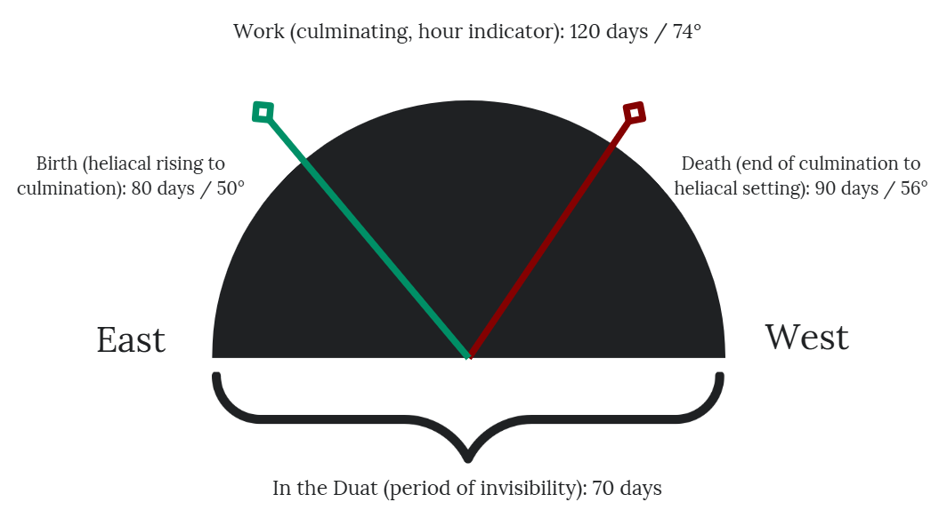
Figure 1: Approximate degrees of altitude at which a culminating decanal star or asterism would start or end "work" as a timekeeper. Created by Whitney Hill.

Practitioners of astrology may notice that Figure 1 above is effectively the top or ‘southern’ half of the circle charts used for astrological charts. This orientation may have connections to Egyptian mythology around the decanal stars. Drawing on an ancient Egyptian work, The Fundamentals of the Courses of the Stars, von Bomhard writes that when the decanal stars are visible at night, they ‘are under the command of the god Shu’ which raises them up on the east wind and has them culminate on the south wind—the east being the place of the astrological Ascendant, and the culminating point being that of the Midheaven in an astrological chart. While it makes sense that the Ascendent or place of rising is in the east where the sun rises, this cosmological belief about the winds of Shu could help further explain why an astrological chart is oriented on a flipped axis to how modern astrologers are accustomed to viewing a map i.e. with north at the top.
This figure is, of course, a very rough way of looking at the possible technical astronomical application of the decans. In practice, features of the natural or built landscape may interfere with this clean and admittedly oversimplified presentation. However, the goal is to get a possible starting point for how the original ancient Egyptian conception of the decans and the passing of time may have influenced the later development of Hellenistic astrology, particularly natal chart astrology in its divinatory capacity.

Connections Between Decanal Hours and the Eighth Astrological House
Astrologers may also note the ending of work and beginning of the ‘death’ of the star starting in the approximate location of the astrological ninth house (using whole sign houses), with the actual ‘dying’ of the star occurring largely through the eighth house. Figure 2 shows this overlaid on an astrological chart for 2:52am on April 5, 2025 in Alexandria, Egypt, laid out using the whole sign system of calculating house boundaries (both to keep boundaries consistent and because it is, according to Holden, ‘the original system of houses.’)

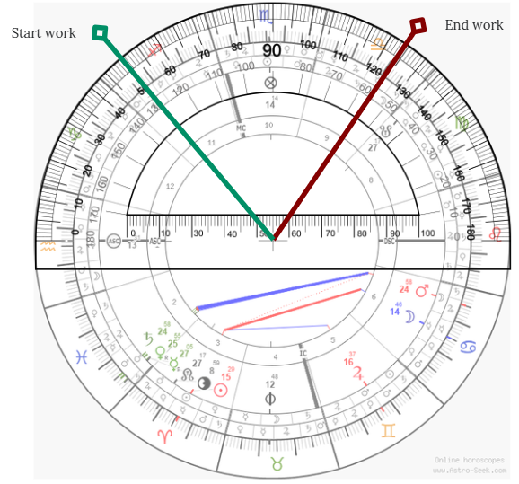
Figure 2: Demonstrating the "work" start and end points on an astrological chart, 50° above the eastern horizon and 56° above the western horizon. Created by Whitney Hill, chart graphic courtesy of Astro-Seek.com.

The eighth house signifies, among other things, death according to Hellenistic astrologers Vettius Valens in the second century CE, Julius Firmicus Maternus in the fourth century CE, and Rhetorius in the sixth century CE. Some of these astrologers, including Rhetorius, comment that the reason for the eighth place signifying death is because ‘It is the sign that is turned away from the ASC [Ascendant]’, but technically there are four such places—the eighth, second, sixth, and twelfth—which do not ‘see’ the Ascendant by Ptolemaic aspect (60° or sextile, 90° or square, 120° or trine, and 180° or opposition). As such, there is room to consider the possibility that the meaning of the eighth house in particular may have come from the original use of the decans and the associated Egyptian cosmology and mythology, and was lost over the time between the decans passing out of usage as star-clocks and into usage as indicators of a person’s ‘spirit’ or disposition, as outlined by Porphyry in the third century CE.

Connections Between Decanal Hours and the Second Astrological House
Although Chris Brennan notes that some astrological house names or topics appear to be based on the system of planetary joys, we may also see some further connections between the hours marked by the decanal stars and cosmology around the sun’s rebirth or return from the Duat. Neugebauer and Parker say that ‘a specific moment is mentioned at which the withdrawal from the Duat towards the earth begins, namely the “9th hour”’ before Re’/the sun ‘goes forth as a child of increasing strength’ noting that this is found in P. 50 and P. Carlsberg I, II, 9-10. If estimates applying the clima and hour lengths for the same date, time, and place as used in Figure 2 are applied to the method of planetary ‘hours’ as described in EAT I, the ninth hour of the night is found to begin at 1:55am and end at 2:52am (from 7 hours and 33 minutes to 8 hours and 30 minutes into a 11-hour, 22-minute night, or 66-75% through the night), as shown in Figure 3 below.

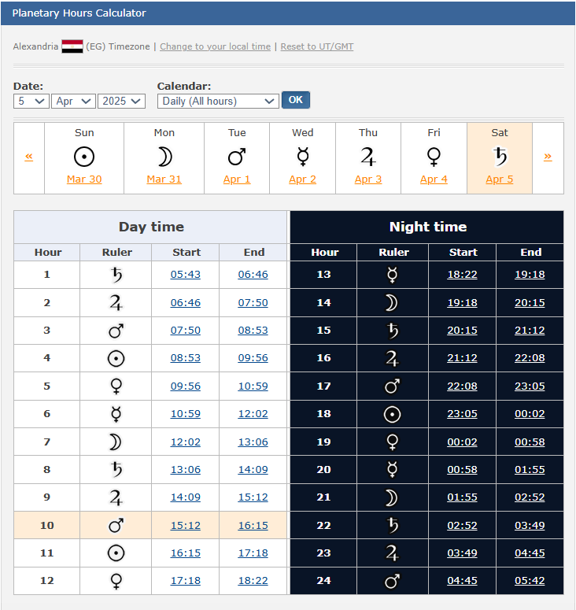
Figure 3: The planetary hours of the night of April 5, 2025, in Alexandria, Egypt with the ninth hour of the night outlined in red. Image of table courtesy of Astro-Seek.com; used with permission.

Taking 66% and 75% of the 180 degrees below the horizon comes to a range of about 119-135 degrees, with the later degree, taken from the Descendant/sunset as the starting point, giving a point on the cusp of the second astrological house using the whole sign house system.

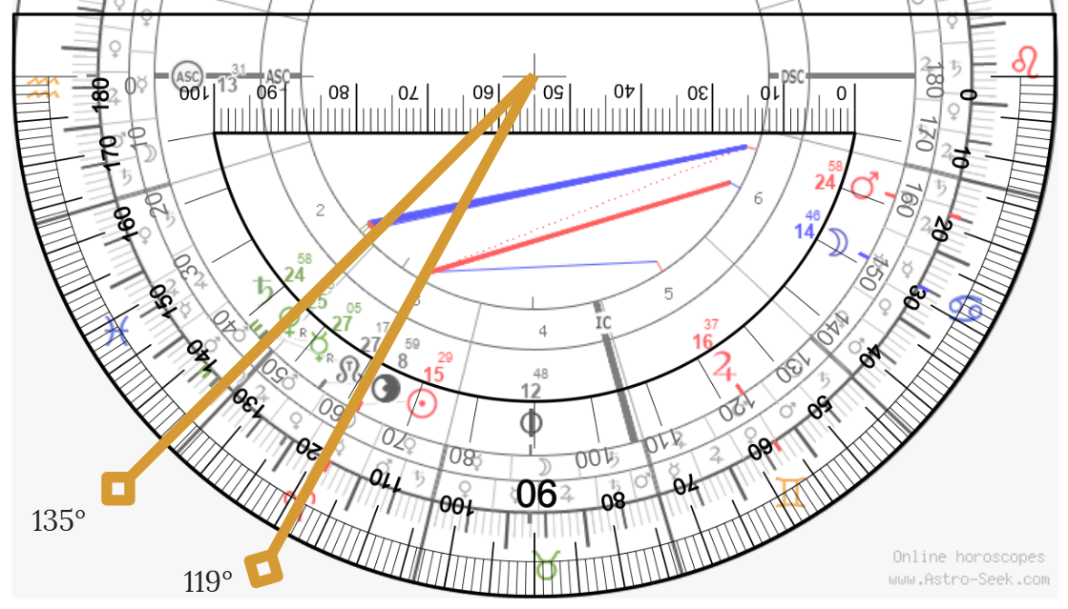
Figure 4: The lower half of an astrological chart, with indicators for the calculated ninth hour of the night on April 5, 2025 in Alexandria, Egypt at 119° and 135°. Graphic created by Whitney Hill. Astrological chart image courtesy of Astro-Seek.com, used with permission.

Valens referred to the second house as ‘the Gate of Hades’ and ‘the Place Rising After the Ascendant.’ Calling it the place rising after the Ascendant makes sense for an astrologer; this is quite literally the next sign or degree to rise on the eastern horizon as time passes. However, calling the second house the Gate of Hades—the gate out of the Underworld—begins to make more sense if we include the idea from the ancient Egyptians that the sun began rising out of the Duat at this point in the night. This would also unify with and reflect the opposing eighth house, representing death, in duality. Decanal stars or the sun start to die after they have stopped culminating and begin to fall into the West, and they start the journey to rebirth, whether sunrise or heliacal rising, when they pass the Gate of Hades—or, perhaps, the Gate of the Duat.
The given date is reasonably close to the spring equinox. Testing against the summer solstice of June 20, 2025, when nights are shorter, has the ninth hour of the night starting at 2:40am and ending at 3:29am, from 6 hours, 33 minutes to 7 hours, 22 minutes or 67-75% of the way through a 9-hour, 49-minute night.

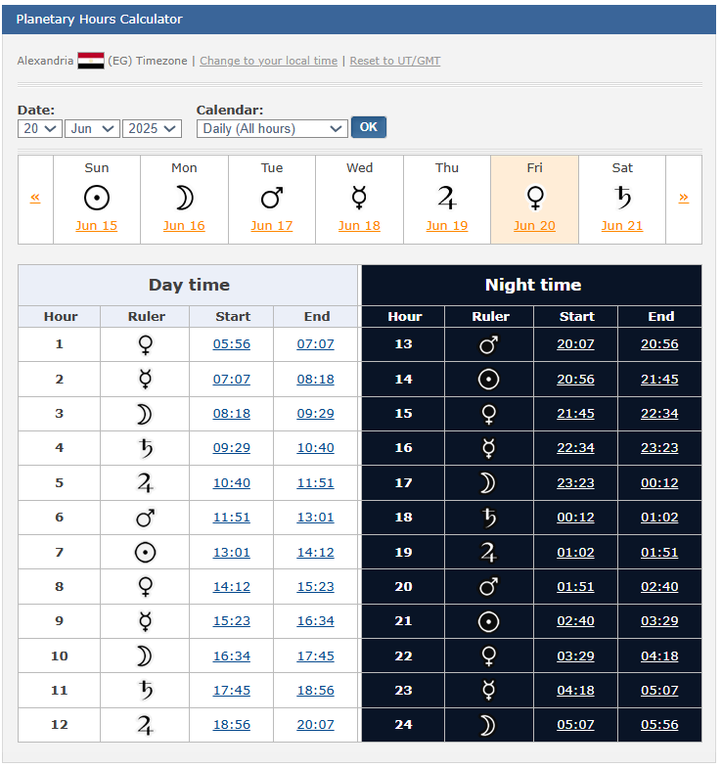
Figure 5: The planetary hours of the night of June 20, 2025, in Alexandria, Egypt with the ninth hour of the night outlined in red. Image of table courtesy of Astro-Seek.com; used with permission.

Despite the differing lengths of the night, the decanal system of hour-keeping appears to be consistent at different times of year despite almost 2 hours’ difference in night length, allowing the point at which the sun and stars exit the Duat—and thus the connection to the astrological second house—to remain consistent as well. This opens opportunities for connections to divinatory delineation.

Connecting Ancient Egyptian Cosmology to the Second and Eighth Houses in Hellenistic Astrology as Divination
Mapping out the possible influence of ancient Egyptian decan cosmology on two sections of the astrological conceptualization of the sky suggests where some of the interpretive elements of divinatory Hellenistic astrology may have come from. If the sun and stars ‘die’ and become idle after they stop culminating then, symbolically, placements in or transits to that part of an astrological chart are also in a place of death and may quite literally predict some form of death, or at least a decline in function, when astrology is used in a divinatory sense.
For example, Valens writes that ‘Benefics appearing in this place [the eighth] are ineffectual and weak’, that if Mercury is in the eighth house and ruling the Lot of Spirit ‘it makes fools and dullards’, and that if the Lot of Fortune is here, ‘the native, besides being dull, will also be stupid and poor’. Following ancient Egyptian cosmology, this is the point of the sky where the decanal stars stopped work and the sun began to die; they are losing effectiveness. In the vein of ineffectiveness, fourth-century astrologer Paul of Alexandria calls the eighth house ‘Idle’ and also gives planets in it significations related to death in addition to laziness. As noted with Rhetorius, while the reason given for the idleness is the disconnection from the rising sign (i.e. an inability to ‘see’ it via Ptolemaic aspect), this idleness also reflects the stoppage of work and beginning of the death of the decanal stars.
For the second house, Rhetorius and Valens both make associations with cemetery guards and those living outside of the city, a rather literal delineation for the place called the Gate of Hades—the place of the dead—and one which mainly makes sense in that context, given the stronger association of death with the eighth house opposite. Despite the Hellenistic sources also referring to the second house as an idle or inactive place due to its lack of aspectual connection to the Ascendant, ‘livelihood’ is also given as a matter covered by this house by Rhetorius, Paulus, and Firmicus; Valens mentions the ‘expenditure of the native’s resources’ in association with Jupiter here. The connection to the Gate of Hades and livelihood may come from a blending of Egyptian cosmology with Greek mythology: Hades was also associated with the wealth of the earth, and a name commonly associated with Hades (πλοῦτος or Ploutos) meant wealth. If the second house is associated with Hades, then by extension, it would also be a place of wealth or, given the connections to what comes from the earth, to life or livelihood. Astrology as a divinatory practice might then associate planets or calculated points like the Lots in the second house with matters of wealth.

Conclusion
While the varied influences contributing to Hellenistic astrology make it difficult to pin down a single definitive source for some of its interpretive principles, a review of the original function and cosmological connections of the ancient Egyptian decanal stars as well as the mathematics of how they worked offers some potential starting points for the names and significations of the eighth and second houses, which appear to have a strong connection to the decans and their cosmology. As the place in the sky where the decanal stars were considered to undergo a process of dying, the eighth place may have by extension become the place in divinatory practice associated with death. Similarly, as the place where the stars (and sun) cosmologically and mathematically began to come out of the Duat, the second house may have become the place associated with not only the keepers of such boundaries, but also with the wealth or livelihood connected to the associated deity when Egyptian cosmology met Greek mythology.
The original association of decans with deities offers a possible starting point for thinking about how they came to describe personality traits or events in a life; being under the influence of a god would likely bring with it certain outcomes or inclinations, which could be as true for astrological decans in natal charts as it was for astronomical decans and their associated decades.
It is worth adding that the argument here is not that the decans and Egyptian cosmology were the only influences over the establishment of meaning in Hellenistic astrology, simply that there is reason to make the given connections, particularly in cases like the eighth house where being in aversion to the Ascendant alone is not a satisfying reason for the house meaning of death and idleness, given the existence of three other places similarly situated.

Bibliography
Primary Sources
Julius Firmicus Maternus, Mathesis, trans. by James Herschel Holden (Tempe, AZ: American Federation of Astrologers, Inc, 2011)

Paul of Alexandria, Introduction to Astrology, trans. by James Herschel Holden (Tempe, AZ: American Federation of Astrologers, Inc, 2012)

Porphyry, Introduction to the Tetrabiblos and Serapio of Alexandria: Astrological Definitions, 2nd edn., trans. by James Herschel Holden (Tempe, AZ: American Federation of Astrologers, Inc, 2011)

Rhetorius the Egyptian, Astrological Compendium Containing His Explanation and Narration of The Whole Art of Astrology, trans. By James H. Holden, 4th edn. (Tempe, AZ: American Federation of Astrologers, 2009)

Vettius Valens, The Anthology, trans. by Mark T. Riley (Denver: Amor Fati Publications, 2022)

Secondary Sources
Barton, Tamsyn, Ancient Astrology (New York: Routledge, 1994)

Belmonte, Juan Antonio and José Lull, Astronomy of Ancient Egypt: A Cultural Perspective (Cham, Switzerland: Springer, 2023)

Brennan, Chris, Hellenistic Astrology: The Study of Fate and Fortune (Denver: Amor Fati Publications, 2017)

Campion, Nicholas, Astrology and Cosmology (New York: New York University Press, 2012)

Greenbaum, Dorian, Divination in Egypt and the Near East [Lecture to MA Cultural Astronomy and Astrology] HPCA7027: Magic, Cosmology, and Divination, Seminar 3 <https://moodle.uwtsd.ac.uk/mod/url/view.php?id=654131> [Accessed 28 February 2025]

Greenbaum, Dorian Gieseler, and Micah T. Ross. ‘The Role of Egypt in the Development of the Horoscope’ in Egypt in Transition: Social and Religious Development of Egypt in the First Millennium BCE, ed. by L. Bareš, F. Coppens, and K. Smolarikova, pp. 146-82 (Prague: Faculty of Arts, Charles University in Prague, 2010)

Heinrichs, Albert, ‘Hades’ in The Oxford Classical Dictionary, 4th edn., ed. by Simon Hornblower, Anthony Spawforth, and Esther Eidinow (Oxford: Oxford University Press, 2012) <https://www-oxfordreference-com.ezproxy.uwtsd.ac.uk/display/10.1093/acref/9780199545568.001.0001/acref-9780199545568-e-2911> [Accessed 12 April 2025]

Holden, James Herschel, A History of Horoscopic Astrology: From the Babylonian Period to the Modern Age, 2nd ed. (Tempe, AZ: American Federation of Astrologers, Inc., 2006),
Loewe, Michael and Carmen Blacker, Divination and Oracles, reprint edition (New York: Routledge, 2021)
Neugebauer, O. and Richard A. Parker, Egyptian Astronomical Texts, Vol I: The Early Decans (Providence: Brown University Press, 1960)

Neugebauer, O. and Richard A. Parker, Egyptian Astronomical Texts, Vol III: Decans, Planets, Constellations and Zodiacs (Providence: Brown University Press, 1969)

Soural, Petr, ‘Planetary Hours of the Day’, Astro-Seek.com (2025) <https://horoscopes.astro-seek.com/planetary-hours-today-astrology-calculator> [accessed 15 March 2025]

von Bomhard, Anne-Sophie, The Naos of the Decades: Underwater Archaeology in the Canopic Region in Egypt (Oxford: Oxford Centre for Maritime Archaeology, 2008)

James Herschel Holden, A History of Horoscopic Astrology: From the Babylonian Period to the Modern Age, 2nd ed. (Tempe, AZ: American Federation of Astrologers, Inc., 2006), pp. 12-13.
Dorian Gieseler Greenbaum and Micah T. Ross, ‘The Role of Egypt in the Development of the Horoscope’ in Egypt in Transition: Social and Religious Development of Egypt in the First Millennium BCE, ed. by L. Bareš, F. Coppens, and K. Smolarikova, pp. 146-82 (p. 156) (Prague: Faculty of Arts, Charles University in Prague, 2010).
Dorian Greenbaum, Divination in Egypt and the Near East [Lecture to MA Cultural Astronomy and Astrology] HPCA7027: Magic, Cosmology, and Divination, Seminar 3 , 00:20:06 <https://moodle.uwtsd.ac.uk/mod/url/view.php?id=654131> [Accessed 28 February 2025]
Nicholas Campion, Astrology and Cosmology (New York: New York University Press, 2012), p. 1.
Greenbaum and Ross, ‘The Role of Egypt in the Development of the Horoscope’ p. 153.
Juan Antonio Belmonte and José Lull, Astronomy of Ancient Egypt: A Cultural Perspective (Cham, Switzerland: Springer, 2023), p. 61.
O. Neugebauer and Richard A. Parker, Egyptian Astronomical Texts, Vol III: Decans, Planets, Constellations and Zodiacs (Providence: Brown University Press, 1969), pp. 105-153.
Belmonte and Lull, Astronomy of Ancient Egypt: A Cultural Perspective, pp. 237-304.
Anne-Sophie von Bomhard, The Naos of the Decands: Underwater Archaeology in the Canopic Region in Egypt (Oxford: Oxford Centre for Maritime Archaeology, 2008), p.62.
von Bomhard, The Naos of the Decades, p. 63.
von Bomhard, The Naos of the Decades, p. 64..
Greenbaum and Ross, ‘The Role of Egypt in the Development of the Horoscope’, p. 156.
Greenbaum and Ross, ‘The Role of Egypt in the Development of the Horoscope’, p. 156.
Michael Loewe and Carmen Blacker, Divination and Oracles, reprint edition (New York: Routledge, 2021), p. 1.
Tamsyn Barton, Ancient Astrology (New York: Routledge, 1994), p. 12.
Barton, Ancient Astrology, p. 13.
von Bomhard, The Naos of the Decades, p. 105.
von Bomhard, The Naos of the Decades, p. 127.
Nicholas Campion, A History of Western Astrology, Vol I: The Ancient World (New York: Bloomsbury 2008, p. 149.
Campion, A History of Western Astrology, Vol I, p. 164.
Campion, A History of Western Astrology, Vol I, p. 152.
Chris Brennan, Hellenistic Astrology: The Study of Fate and Fortune (Denver: Amor Fati Publications 2017), p. 279.
Rhetorius the Egyptian, Astrological Compendium Containing His Explanation and Narration of The Whole Art of Astrology, trans. By James H. Holden, 4th edn. (Tempe, AZ: American Federation of Astrologers, 2009), p. 10.
von Bomhard, The Naos of the Decades, p. 102.
O. Neugebauer and Richard A. Parker, Egyptian Astronomical Texts, Vol I: The Early Decans (Providence: Brown University Press, 1960), p. 41.
von Bomhard, The Naos of the Decades, p. 39.
von Bomhard, p. 41.
Holden, A History of Horoscopic Astrology, p. 94.
Petr Soural, Traditional Astrology: Free Natal Chart Calculator Online Software (2025) <https://horoscopes.astro-seek.com/traditional-astrology> [Accessed 5 April 2025].
Vettius Valens, The Anthology, 2: 9, trans. by Mark T. Riley (Denver: Amor Fati Publications, 2022), p. 56.
Julius Firmicus Maternus, Mathesis, 2: 21.9, trans. by James Herschel Holden (Tempe, AZ: American Federation of Astrologers, Inc, 2011), p. 67.
Rhetorius, Astrological Compendium, p. 84.
Rhetorius, Astrological Compendium, p. 84.
Porphyry, Introduction to the Tetrabiblos and Serapio of Alexandria: Astrological Definitions, 2nd ed., trans. by James Herschel Holden (Tempe, AZ: American Federation of Astrologers, Inc, 2011), pp. 47-48.
Chris Brennan, Hellenistic Astrology: The Study of Fate and Fortune (Denver: Amor Fati Publications, 2017), p. 336.
Neugebauer and Parker, Egyptian Astronomical Texts I, p. 41.
Neugebauer and Parker, Egyptian Astronomical Texts I, p. 35.
Petr Soural, ‘Planetary Hours of the Day’, Astro-Seek.com (2025) <https://horoscopes.astro-seek.com/planetary-hours-today-astrology-calculator> [accessed 5 April 2025]
Soural, Traditional Astrology: Free Natal Chart Calculator Online Software <https://horoscopes.astro-seek.com/traditional-astrology> [Accessed 5 April 2025].
Valens, The Anthology, 2: 15, p. 59.
Soural, ‘Planetary Hours of the Day’ <https://horoscopes.astro-seek.com/planetary-hours-today-astrology-calculator> [accessed 11 April 2025]
Valens, The Anthology, 2:9, p. 56.
Paul of Alexandria, Introduction to Astrology, trans. by James Herschel Holden (Tempe, AZ: American Federation of Astrologers, Inc, 2012), p. 51.
Rhetorius, Astrological Compendium, p. 56.
Valens, The Anthology, 2:15, p. 59.
Rhetorius, Astrological Compendium, p. 56.
Paul of Alexandria, Introduction to Astrolgy, p. 46.
Firmicus, Mathesis, 2: 21.3, p. 65.
Valens, The Anthology, 2:15, p. 59.
Albert Heinrichs, ‘Hades’ in The Oxford Classical Dictionary, 4th edn., ed. by Simon Hornblower, Anthony Spawforth, and Esther Eidinow (Oxford: Oxford University Press, 2012) <https://www-oxfordreference-com.ezproxy.uwtsd.ac.uk/display/10.1093/acref/9780199545568.001.0001/acref-9780199545568-e-2911> [Accessed 12 April 2025].

